This document will cover the building and implementation of my website. The website created is for musicians planning on travelling around Europe with their instruments on a budget.
Travelling with a Ukulele Website Report.
Understanding how my website was created.
Andrew Cooper (1704746)
Software Engineering
Introduction to Web Development
03/01/18
Contents
Introduction: 1

Introduction:
Within the report the reader will find information concerning the designing and implementation of the website that was created for aspiring travelling musicians. The reader will discover the purpose of the website that has been created as well as who the website is targeted towards. I will also create a site map and other visual aids to illustrate my website and how the pages link to each other. I will show you how I validated both my HTML for my home page and my websites main CSS by using http://validator.w3.org/ and http://jigsaw.w3.org/css-validator/. I will lastly give an evaluation of the website’s accessibility by making regular references to the WCAG 2.0.

Requirements:
The website I created is for people who want to be able to travel but feel they cannot afford to do so. I created the website to give viewers a better understanding of ways in which they could save money when travelling. Within the website I have displayed places in which I feel are good places to travel to should the person want to travel with their ukulele and play music in new places. The target audience for my website are people aged 18 – 28 who want to travel but may not be able to afford a trip around Europe the conventional way. For my website I feel that it is very relevant to the target audience as it gives them useful tips of how to travel while saving money.

Site Map:
Contact Page
contact.html
Where to Travel
whereToTravel.html
What Equipment should I Take? whatEquipment.html
Travelling on a Budget
travelOnBudget.html
Home Page
Index.html

All my pages on my website are linked together which means that no matter what page I am on, I can easily access all of the other pages. I have done this because I feel that it is a much easier way to navigate and is less time consuming for the users of my website.

Wireframe Diagram:
Nav Bar

Body.

Header.
Banner of a Hawaiian sunset.
Footer.
Image of ukulele.

Implementation:
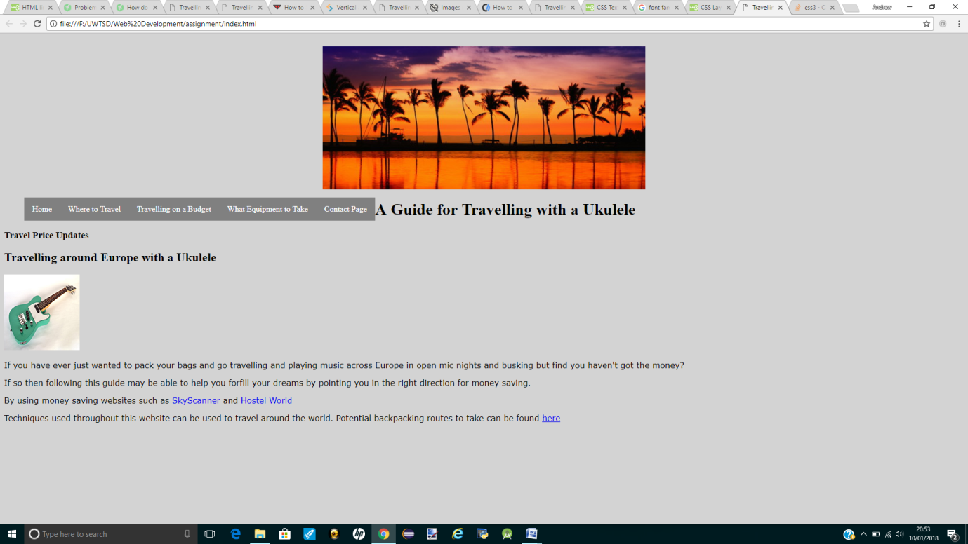

Headings :
I have used appropriate methods of identifying by using the <h1> and <h2> tags to make them standout. I have also changed the fonts of these headings.
Colours of the website:
This is the front page of my website and it is based on pure simplicity. As this is purely an informative website and would have no profitable gain, I have created it with a very simplistic design. I have used black and light grey as the text and background as I feel it is easy to read for my users.

Forms:
I have not used any forms in my website as I deemed them unnecessary for my website because of the nature of the information.

Navigation:
I have made my website very effortless to navigate through the pages. Each page is accessible from every page. I have also used hyperlinks within texts to also take users to the required pages. Within my website I have also created both written and image links to lead users to separate websites where they can use their services. To ensure that the user stays on my website I have ensured that the new websites open as in a new tab.

marking criteria and Student FEEDBACK

This section details the assessment criteria. The extent to which these are demonstrated by you determines your mark. The marks available for each criterion are shown. Lecturers will use the space provided to comment on the achievement of the task(s), including those areas in which you have performed well and areas that would benefit from development/improvement.

Common Assessment Criteria Applied (Assignment 1) | Marks available | Marks  awarded
1. Research-informed Literature
Extent of research and/or own reading, selection of credible sources, application of appropriate referencing conventions.
Unfortunately, there is no evidence of the use of appropriate reference sources. The submitted work does not include a reference list or bibliography. (Grade mark: 0.00%) | 5 | 0
2. Knowledge and Understanding of Subject
Extent of knowledge and understanding of concepts and underlying principles associated with the discipline.
Demonstrates only a very basic understanding of the standards used to design and implement a website. Some things to note: if you are creating a multi-page website, it is better to have a single, external style sheet page that you add all your CSS to and then link this single style sheet to all your pages. Although, you have a separate style sheet, it contains a limited number of style definitions and you have added a <style> element to every page with duplicated style definitions. If you had added this to your style sheet, you would only need to define these styles in one place. Generally, very little CSS has been used and some of it has not been used correctly. You also need to be careful to properly close and nest your HTML elements. (Grade mark: 30.00%) | 20 | 6
3. Analysis
Analysis, evaluation and synthesis; logic, argument and judgement; analytical reflection; organisation of ideas and evidence
The provided evaluation is too brief and basic and unfortunately does not really meet the requirements of the assignment brief. (Grade mark: 17.50%) | 20 | 3.5
4. Practical Application and Deployment
Deployment of methods, materials, tools and techniques; application of concepts; formulation of innovative and creative solutions to solve problems.
A basic attempt and there are a number of areas for further improvement. The main area for improvement include getting the structure and layout of information on the web page right. Consider using a grid as this will help you to properly align your content - alignment is an important principle of web design. Take care to ensure that you properly nest/close your elements. Aim to understand when to implement an image as a background instead of an image added to the page and remember to add an alt attribute to all images for accessibility. Also, consider having a logo for your website and make the logo link to the home page as users expect this behaviour in websites. (Grade mark: 34.00%) | 50 | 17
5. Skills for Professional Practice
Attributes in professional practice: individual and collaborative working; deployment of appropriate media; presentation and organisation.
The report lacks content and detail and generally, requires a number of improvements. Required sections are missing and the word count was 587 words. See your report for additional comments. (Grade mark: 30.00%) | 5 | 1.5

Assignment Mark (Assessment marks are subject to ratification at the Exam Board. These comments and marks are to give feedback on module work and are for guidance only until they are confirmed. ) | Late Submission Penalties (tick if appropriate) |  | 28%
 | Up to one week late |  | 28%
 | 1st/2nd/3rd attempt? |  | 28%

