ECAD6009/7003 2306058
How a school develops one aspect of its SDP: a report that critically reflects on the actions, impact and evidence base.
Introduction
The purpose of this essay is to critically evaluate the effectiveness of an aspect of an Unnamed Secondary school’s School Development Plan. In accordance with British Educational Research Association Guidelines, the school shall remain anonymous for duration of this essay (British Educational Research Association (2024)). We have opted to analyse Section 2 of Field 1, raising Literacy Standards. For this essay, we will be focusing primarily on raising reading standards. The school aims to achieve this by creating tasks that allow all students to increase their skills, they aim to track this through refining their use of data obtained from National Tests and Literacy Interventions (where required). The school also collects evidence from marking pupil’s work and books.
School Context
The Unnamed Welsh Language School is located in South East Wales. It is a 3-19 School, with approximately 700 pupils. According to Estyn (2017) the majority (59%) of the pupils come from non-Welsh Speaking backgrounds. (Estyn 2017, p.1) The average Literacy Score at School X is 44.4 and average Numeracy Score is 41 compared to national averages of 39.7 and 37.1 respectively. This data was compiled by Welsh Assembly Government for period September 2022-August 2023. It is worth noting that due to the school holding a higher-than-average literacy score, that inclusion of literacy on the SDP, leads to a less rigid than usual approach to this developmental point. Another pertinent point to note is that School X is a pioneer school and works closely with Welsh Assembly Government to implement Curriculum for Wales (CfW). Therefore, we can infer that the school will be familiar with Literacy and Numeracy Framework, which is a cornerstone of CfW, and applies across all subject areas.
Literature Review
The Welsh Assembly Government defines an SDP as a ‘school’s plan for improvement.’ Miles et al. (1987) describe it as ‘a systematic effort to improve learning conditions and achieve educational goals’ (p.3). Following the Education (School Development Plans) 2014, schools' governing bodies must create SDPs (Regulation 3). The Regulation offers guidance on drafting SDPs (see Appendix A). In 2022, the Welsh Government updated the framework to align with the Curriculum for Wales, planning to release new statutory guidance in September 2024. We will await this before commenting further on the new guidelines.
Evidentially, there needs to be consideration for guidelines when drafting SDPs, however these plans are often hyper localised within school or educational settings. Hopkins (2001) argues ‘strategies for school development need to fit the “growth state” or culture of the particular school. Strategies which are effective at one “growth state” are not necessarily effective at another.’. (Hopkins 2001, p.3). Put simply, schools themselves are best judge of what their school and pupils need to improve.
Harris (2002) argues that schools should emphasise continuous teacher development, aligning with Welsh CPD standards, and that leadership should be ‘shared and distributed’ (p.11). Leadership includes the headteacher, Senior Leadership Team, heads of department, and governors, all accountable to stakeholders such as students, parents, staff, and the local community. These stakeholders have a vested interest in the school's improvement. But how do schools decide what to include in their SDP?
Blanchard (2009, p.197) posits a simple series of questions to answer this question.
- What strategies are being used?
- What are the benefits?
- What is the evidence?
We will soon address these questions regarding School X’s SDP. First, let's discuss the nature of school development. Fullan (1997) asserts that educational change often fails at the implementation stage (p.vii). Despite the age of this source, Fullan is considered a key figure in educational development (Huberman, 1997, p.2). The approach to school improvement has ‘shifted from "tight planning" to a more adaptive, "rolling evolutionary" model’ (Huberman, 1997, p.2). This allows stakeholders to respond flexibly to development needs. School X exemplifies this approach by prioritising classroom-level adaptation to improve literacy. Harris (2002) supports focusing on teaching and learning while advocating for multi-level interventions (Fullan, 1992; Hopkins et al., 1994; Hopkins and Harris, 1997).
We now turn to discussing academia surrounding literacy within the confines of School Development. The first mention of such a curriculum wide language improvement policy was the Bullock Report (1975), which argued for ‘language policy across the curriculum’ (Inglis and Aers, 2008, p.128). This refers to the need for literacy across all subjects, and not just English. However, the Report is not a contemporary source, for that we must return to Literacy and Numeracy Framework (LNF).
The Literacy and Numeracy Framework (LNF) became statutory in 2013 following an assembly research paper. It addressed shortcomings of the non-statutory Skills Framework 2008, which Estyn critiqued for not deeply embedding skills across the curriculum. The implementation of the LNF across all subjects aimed to rectify this issue. Another driving factor behind the 2013 framework was Wales's low comparative PISA scores, which persist today. For instance, Wales's reading score in 2022 was 466, below the OECD average of 476 and lower than Wales's 2018 score of 483. Notably, Welsh scores also lag behind the rest of the United Kingdom. Jerrim (2023) notes that a significant minority of 15-year-olds take PISA tests in Welsh, and interestingly, those who took the test in Welsh, despite higher socio-economic backgrounds (usually an indicator of higher academic performance), scored roughly 60 points lower than those who took it in English. These factors warrant further exploration, although unfortunately that is beyond the scope of this essay.
Crawford (2003) perceives school development as a localised endeavour, advocating that those directly involved understand what's best for their school. However, Crawford emphasizes that this doesn't imply complete autonomy, as schools must still consider national policy, termed ‘external forces of school improvement.’ School X aligns with this perspective, tailoring literacy policies while also accounting for national aims.
Turning to the broader literature on literacy, Hall (1994, p.15) notes a recent ‘redefining’ of literacy, aligning with School X's approach. At School X, literacy is emphasised in all lessons, not just English and Welsh, echoing the Literacy and Numeracy Framework's focus on integrating literacy across all subjects.
Paulson (p.58) argues that there's no universally agreed definition of literacy, while Barton & Wooley (p.2) highlight literacy's dynamic nature and its impact on everyday life. Focusing on this impact, our SDP proposed various strategies to enhance literacy within the school, such as teachers displaying the books they're reading on their doors to promote reading for pleasure.
Senior (2005) emphasises that to cultivate lifelong readers, it's crucial to acknowledge and leverage children's reading preferences as the basis for encouragement. While Senior advocates for encouraging students to ‘read anything that sparks interest’ (Senior 2005, p.9), School X's approach focuses on teachers serving as reading role models. Furthermore, Senior suggests conducting whole-class audits to gather data on reader habits and potential class reads, a strategy more suitable for Key Stage 3 than for higher levels where curriculum alignment is paramount.
According to the National Literacy Trust (2023), only 43.4% of children and young people aged 8-19 enjoy reading, marking the lowest level since 2005. This presents a significant challenge for teachers and parents in fostering lifelong readers. Authors like Cremin (2020), Kucirkova (2020), and Senior (2005) have all advocated for reading for pleasure, suggesting that the current state of reading in the UK might disappoint these authors. Next, we turn to defining and analysing the specific contents of the school's developmental plan.

Dissection of the Development Point.
As previously stated, the author has opted to focus on Field 1, Section 2 of the SDP, improving literacy.
The school aims to improve literacy with a range of strategies, they are as follows:
- Crafting lessons and tasks which improve literacy.
- Increase data collection and monitoring.
- Implementation of literacy tasks once a week in registration, which focus on the 4 literacy skills.
- Utilising voice 21.
- Advertising what book said teacher is reading on each teachers’ door.
- Creation of a website by the literacy lead, with literacy ideas for staff.
- Staff can also update this website with their own ideas.
We shall focus our dissection on the strategy, ‘increase data collection and monitoring’. Harris (2002) emphasises the need for schools to be well-organised with efficient progress tracking systems. However, the school lacked concrete data collection on literacy beyond formative assessments and exam results. Earl and Katz (2002) argue that school leaders should ‘develop an inquiry habit and become data literate’. While the school has fostered a culture of inquiry, it falls short in data literacy, hindering effective reporting to stakeholders and analysis of improvement impacts. Creemers and Kyriakides (2012) stress the importance of evidence-based approaches to school improvement, echoed by Schildkamp (2019) who suggests that ‘acting without data is often ineffective’. Despite this, the positive literacy scores within the school, do demonstrate that literacy within school is at a good level, but this does raise questions as to how seriously the school are taking this action point of improving literacy.
We shall now turn our focus to addressing these points and their effectiveness, alongside offering some practical suggestions for improvement.
Reflection and Recommendations.
Despite listing literacy improvement in their plan, School X lacks a formulated policy for direct improvement. According to Harris (2002), ‘successful school improvement requires the will, skill, and persistence to enact change’ (Harris 2002, p.112). Without concrete data and a clear policy, it's challenging for School X to effectively implement their literacy improvement strategies.
School X demonstrates intentions to enhance learner performance but lacks sufficient resource commitment and clear staff guidance. Our first improvement suggestion involves convening heads of department to develop a comprehensive document outlining the current and planned literacy approach across the school. We advocate for an evidence-based approach, urging staff to collect data to inform improvement efforts. Frost et al. (2000, p.51) offer valuable data sources to inform the SDP, including:
- Pupil assessment data
- Comparative pupil performance data
- Pupil records
- Pupil’s work
- Home school correspondence
- Procedural documentation
- Developmental planning documentation
- Curriculum/teaching documentation
- Inspection reports
- Data from previous inquiry.
Following the review of available data, we propose conducting a whole pupil survey to gather input on desired inclusions within the literacy strategy. Authors like Marsh (2012), Lewis & Porter (2007), and Flutter (2007) advocate for pupil voice, which has shown to enhance engagement and attainment. School X has previously used such surveys for decision-making. This approach aligns with CfW's goal of fostering enterprising, creative contributors. Currently, the responsibility solely rests on the Literacy Lead, potentially limiting the variety of tasks. While not criticising the Literacy Lead, it's evident that additional responsibilities can impede effectiveness due to workload constraints.
As previously mentioned, School X conducts dedicated literacy sessions for all year groups during morning registration. The author observed that much of the content aimed to engage pupils, inform them about local traditions, and foster a sense of cynefin. While these sessions aim to inspire greater command and reverence for literacy skills, their impact is most tangible in the aforementioned literacy scores. To continue fostering this engagement, the school should maintain its focus on literacy during these sessions. This approach aligns with CfW's emphasis on literature as fuelling imagination and inspiring creativity.
It's important to note that the observed teacher was experienced and enthusiastic, potentially impacting the effectiveness of the tasks. However, without concrete data, we cannot effectively address one of Blanchard’s (2009) key questions for analysing the effectiveness of the SDP, using evidence (question three). However, we can and have answered question one and two. We have outlined the strategies and have discussed the merits of their implementation. Namely, the higher-than-average literacy scores and the active involvement of students in the registration sessions.
Another layer of complexity in the literacy improvement strategy is that all observed tasks were conducted in Welsh, without attention to English literacy skills. While School X primarily focuses on enhancing Welsh literacy skills, most students are from non-Welsh speaking homes as such this is important, however well modelled English and reading models may not exists at home either. With all lessons other than English conducted in Welsh, there are only 3-4 hours per week dedicated to English literacy improvement.
Drawing inspiration from ‘Literacy Saves Lives’ (1996), another recommendation for improving literacy is to allocate 5-10 minutes of each lesson for independent reading. Each pupil could bring or be provided with a book, allowing teachers to incorporate dedicated reading time into their lessons. Implementing this simple practice could significantly enhance literacy engagement at School X.
Additionally, School X could leverage the competitive spirit fostered by the Eisteddfod and introduce an English literacy competition. Given the popularity of the Eisteddfod at School X, building on this foundation to create an English Language Competition would be feasible and could further promote literacy development.
Conclusion
In this essay, we critically analysed an unnamed school's SDP, exploring literature on SDPs and literacy. Despite requests for evidence of the scheme's effectiveness, none was provided. However, the head of department expressed satisfaction with the state of literacy within the school, citing literacy scores and comparisons with similar schools. However, they acknowledged that the process of school development is cyclical and requires continuous holistic effort. This highlights the ongoing nature of school improvement.
Finally, the comprehensive exploration of SDPs and literacy strategies discussed in this essay has deepened the author’s understanding of effective school development practices. It emphasises the importance of evidence-based approaches, clear policy formulation, and continuous evaluation in driving educational improvement. Additionally, the insights gained from analysing various literacy strategies and their impact on student engagement and attainment have enriched the author’s professional toolkit. The author now feels more equipped to critically assess and implement literacy interventions in their own educational context, ensuring they are aligned with best practices and tailored to meet the specific needs of their students. Overall, this information has enhanced the authors ability to contribute meaningfully to school improvement efforts and promote literacy development among students.
Word Count:2310

Appendix A
Vision

Taken from School Development Plans Guidance Document 2014. P7
Welsh Assembly Government.
://efaidnbmnnnibpcajpcglclefindmkaj/https://www.gov.wales/sites/default/files/publications/2018-03/school-development-plans.pdf.

Stage 4:
Reviewing Impact
Stage 3:
Making improvement/action
Raising standards and improving learner outcomes
Stage 2:
Strategic Planning
Stage 1:
Self-Evaluation
Appendix B
Crawford’s Table of School Improvement.
p.140.
External Associates
LEA, DfES, TTA, QCA, other educational establishments, local businesses, Church Authorities.
School Leadership
Internal Associates
Parents, and the wider community, pupils governors, all members of staff.

Appendix C
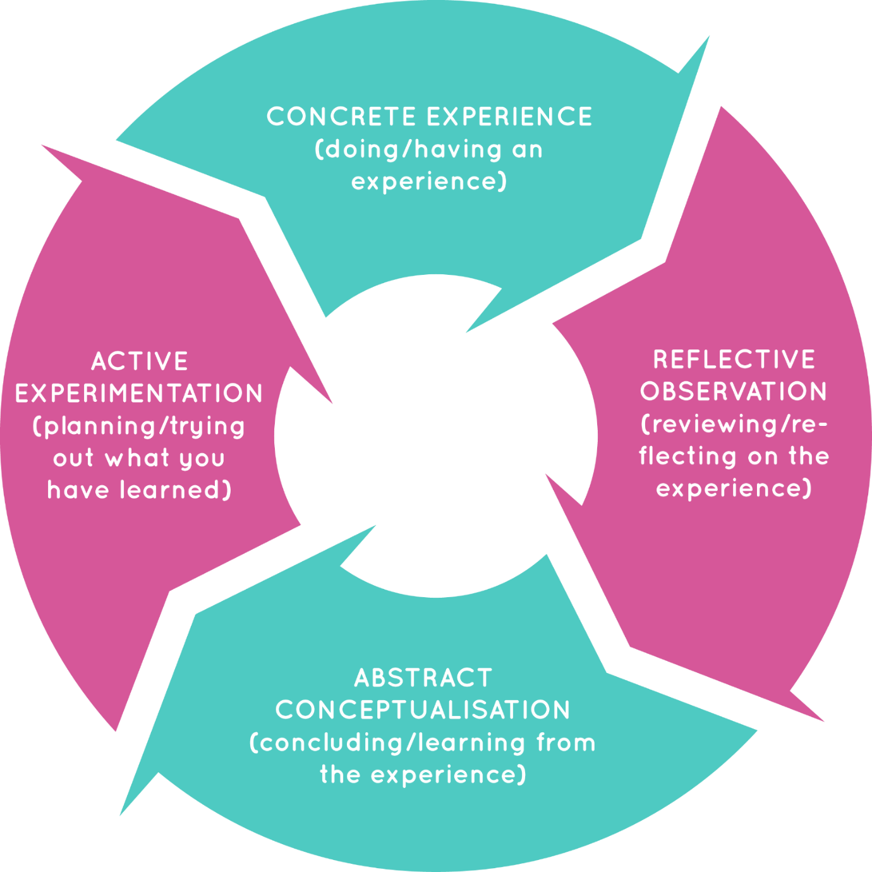

Kolb’s 1984 Cycle.
KOLBS EXPERNETIAL LEARNING MODEL - Search Images (bing.com)

Bibliography
A., Cooze (2007) 100+ Ideas for Teaching English. 2nd Edition. Continuum International Publishing Group.
A., Goodwyn & C., Fuller (2011) The Great Literacy Debate: A critical response to the literacy strategy and the framework for English. Routledge.
A., Green (2011) Becoming a Reflective English Teacher. McGraw Hill, Open University Press, p.26.
A., Harris & N., Bennett (2001) School Effectiveness and School Improvement: Alternative Perspectives. Continuum. London.
A., Harris (2002) School Improvement: What’s in it for schools? Routledge Falmer. P.1
A., Haworth, C., Turner & M., Whiteley (2004) Secondary English & Literacy: A Guide for Teachers. Paul Chapman Publishing.
A., Keane (2022) Watchdogs or Visionaries? Perspectives on the History of the education inspectorate in Wales. University of Wales Press.
A., Miller (2016) Six strategies for Differentiated Instruction in Project Based Learning. 8th ed. Edutopia.
Accelerated Reading Program. https://www.renaissance.com/products/accelerated-reader/ first accessed 03/01/2024
B., Stierer, J., Maybin and N., Hall. (1994) Language, Literacy and Learning in Educational Practice. Multilingual Matters. p.15-28.
British Educational Research Association (2024) Ethical Guidelines for educational research.5th edn. Available at: chrome-extension://efaidnbmnnnibpcajpcglclefindmkaj/file:///C:/Users/Jack%20Watkins-Hughes/Downloads/Ethical-Guidelines-for-Educational-Research-5th-edition.pdf (Accessed 28.05.24)
C., Senior (2005) Getting the buggers to read. Consortium. p.2.
D., Bridges, P., Smyers, & R., Smith. (2009) Evidence-based Education policy. What evidence? What basis? Whose policy? Wiley and Blackwell.
D., Hopkins (2001) School Improvement for Real. London. Fulmer Press. p.3
E., Bearne, H., Dombey & T., Grainger (2003) Classroom Interactions in Literacy. Open University Press.
Education (School Development Plans) (Wales Regulation) 2014
Estyn Report (2017) https://www.estyn.gov.wales/system/files/2020-08/Ysgol%2520Llanhari%2520en.pdf first accessed 01/01/2024.
F., Inglis & L., Aers (2008) Key Concepts in Education. SAGE Key Concepts. p.128.
G., Barton & G., Wooley (2017) Developing Literacy in the Secondary School. SAGE Publishing Ltd.
https://mylocalschool.gov.wales/?lang=en first accessed 28.05.24
https://mylocalschool.gov.wales/School/6745500 - first accessed 01/01/2024
https://www.gov.wales/examination-results-september-2022-august-2023-html#:~:text=The%20average%20Literacy%20indicator%20is,36.9%20points%20(Figure%202) first accessed 01/01/2024.
https://www.gov.wales/sites/default/files/publications/2018-03/school-development-plans.pdf first accessed 25/01/2024 p.3.
J., Blanchard (2009) Teaching, Learning and Assessment. Open University Press. p. 9-206.
J., Davidson (2011) Debates in English Teaching. Routledge.
J., Jerrim (2023) Were PISA reading scores in Wales as bad as they first seemed? Available at: https://ffteducationdatalab.org.uk/2023/12/were-pisa-reading-scores-in-wales-as-bad-as-they-first-seemed/#:~:text=Its%20reading%20scores%20were%20particularly,bad%20as%20it%20first%20seems. First accessed: 28.05.24
J., S., Bruner (1978) The Role of Dialogue in Language Acquisition: The Child’s Concept of Language. New York: Springer-Verlag.
J., Van den Brande, J., Hillary & C., Cullinane (2019) Selective Comprehensives: Wales: Access to top performing schools for disadvantaged pupils in Wales. p.5
K., Crawford (2003) Contemporary Issues in Education. An Introduction. Peter Francis Publishers. p.137
K., Schildkamp (2019) Data-based decision making for school improvement: research insights and gaps’ Education research, 61(3) pp. 257-273. Doi: 10.1080/00131881.2019.1625716
Kucirkova, N. and Cremin, T., (2020). Children reading for pleasure in the digital age: Mapping reader engagement. Sage.
L., M., Earl and S., Katz (2006) Leading schools in data-rich world. Corwin Press. California.
Lewis, A. and Porter, J., (2007). Research and pupil voice. 222-232.
M., G., Fullan (1997) Successful School Improvement. Open University Press. p.vii, p.2
M., Lewis & D., Wray (2000) Literacy in the Secondary School. David Fulton. Ch. 2,3,6,9,10.
M., Miles., Elkholm, M. and R., Vandenberge (eds) (1987) Lasting school improvement: exploring the process of institutionalisation. Leuven, Belgium: ACCO. p.3.
Marsh, H., (2012). Relationships for learning: using pupil voice to define teacher− pupil relationships that enhance pupil engagement. Management in Education, 26(3), pp.161-163.
National Assembly for Wales. (2013) Research Paper: Literacy and Numeracy in Wales. first accessed: 28.04.24
National Literacy Trust (2023) https://literacytrust.org.uk/research-services/research-themes/reading/#:~:text=Just%202%20in%205%20(43.4,matching%20levels%20seen%20in%202022. First accessed 28.05.24
Oxford English Dictionary (1990) Clarendon Press. Oxford.
R., Neate (1996) Literacy Saves Lives. United Kingdom Reading Association.
R., Steward (2020) The Gradual Art of School Improvement: A Practical Guide. David Fulton. Abingdon.
Sir A., Bullock (1975) A Language for Life. London. DES.
T., Cremin, T., (2020). Reading for pleasure: Challenges and opportunities. Debates in English teaching, pp.92-102.

