Exploring Barriers to Literacy

Portfolio

SJIE6002

Leah Delloy

Contents Page
Introduction………………………………………………………………… pg. 3
Overview of the learner and literacy programme……………………… pg. 3-4
Evidence………………………………………………………………….. pg. 4-5
Evaluation of Method……………………………………………………. pg. 5-6
Theory…………………………………………………………………….. pg. 7
Conclusion……………………………………………………………….. pg. 7-8
Reflective Diary………………………………………………………….. pg. 9-11
Reference List……………………………………………………………. pg. 12
Appendices………………………………………………………………... pg. 13-14

Introduction
This portfolio will firstly provide background information on the chosen literacy programme, as well as discussing its aims and how they intend to be met. It will then give a brief overview of the chosen learner who is undertaking the programme to improve their literacy skills and to develop to their full potential. Following this, the portfolio will provide evidence on how the child has progressed due to the RWI programme, before critically evaluating it as a whole. It will also discuss Vygotski’s (1978) theory based on the Zone of Proximal Development and demonstrate how it links to the RWI programme. Finally, the portfolio will include a reflective diary which will discuss challenges faced within a lesson of RWI.
Overview of the learner and literacy programme
The literacy programme that this portfolio will critically explore is Read Write Inc (RWI). The programme was developed by Ruth Miskin in the hope to effectively teach children how to read and write (Ruth Miskin, 2021, pg. 1). RWI has been used within a setting for several years and has proven to be effective with most children. Firstly, this programme aims to teach children letter sounds and their connections to mnemonic pictures (Ruth Miskin, 2021, pg. 1). It then aims to teach children how to read words through the skill of blending the sounds they have learned and how to break down words into smaller chunks to make spelling easier (VIAT, no date, pg. 1). As a result of this, the RWI programme suggests that the children will be able to focus more on the composition of their writing rather than worrying about their spelling (VIAT, no date, pg. 1). RWI also aims to teach children how to read high frequency words that do not correspond to the usual phonic patterns which should help children to read books and texts that are at the appropriate phonics level to them (VIAT, no date, pg. 1). Not only do children learn how to read books, but this programme also encourages them to make connections between the books and their own life experiences through the use of questioning (Ruth Miskin, 2021, pg. 1). Considering these aims, the setting believes that RWI provides children with the tools and the confidence to read and write successfully. Within a setting, RWI is taught for half hour a day for all children from reception age to year 6 if they still require it. The programme is taught gradually, and children are unable to progress to the next stage until members of staff are confident that they have a full understanding of what has already been taught and are ready to move on.
The chosen learner that will be discussed throughout this portfolio is an 8-year-old female in a year 3 class (child A). Child A is a popular, happy, funny, and bubbly character with many friends within the class and throughout the school. She is a hard-working pupil that always tries her best with all the tasks that she is faced with and is enthusiastic about learning. Despite her efforts, child A was born into a Bengali speaking family and therefore is an English as an additional language (EAL) pupil. As a result of this, child A finds literacy and language lessons extremely challenging and is behind her peers with her level of reading, which has knocked her confidence. Her attendance is also poor which again affects the level of education she receives and widens the gaps in her learning. Considering the barriers to learning that have been stated, the Read Write Inc intervention is important to help child A progress to her full potential.
Evidence
Child A has been part of the RWI programme since she was in reception and is now in year 3. She has shown slow progress throughout the years although it appears that she has thrived during this academic year. Despite this, it is estimated that by the time children reach KS2 they should have progressed onto the Literacy and Language stage of the RWI programme, which suggests that she still requires literacy support.
Child A was firstly assessed on the 6th of November 2020 and was recently assessed on the 20th of April 2021. The results of these assessments have shown an improvement in child A’s recognition of phonics (see appendix 1, box 1). During the first assessment child A knew the set 1 sounds i, n, c, k, u, b, p, g, o, m, a, s, d and t, whereas during the last assessment she was able to identify all set 1 sounds (see appendix 4). These sounds were taught to the child everyday using flash cards. Child A has also shown an improvement in her ability to blend sounds together to read words. This has been proven during the assessments as in assessment 1 (see appendix 1, Ditty Group box) child A was able to blend and read 3 words, however during assessment 2 she confidently read all 5 words (see appendix 4). Not only does child A now know all the set one sounds, but she can also identify all red group sounds as well as blend multiple words together containing the sounds (see appendix 4). The RWI programme also requires children to read ‘alien words’ or ‘nonsense words’ to ensure the children can confidently blend sounds together to make words. In the second assessment child A was able to blend all red group ‘alien words’ which she was unable to do in assessment 1 (see appendix 4), which would suggest the RWI programme is effective. As well as the red group sounds and words, child A has shown an improvement in reading green group, purple group, and pink group words. (see appendices 2 and 5). Child A has always struggled to comprehend words that are not on individual cards, and therefore the most surprising improvement is her ability to now read 17 words within a sentence or a paragraph (see appendix 6). Due to the progress child A has made within the 6 months of the two assessments, she was able to move to the next stage of the RWI programme and has also improved in the Oxford Reading Tree programme by moving up 2 stages.
Evaluation of Method
The RWI programme was introduced within a setting with the hope to raise literacy standards for all children. The setting has many children with English as an additional language (EAL) as well as children with speech and language difficulties, which the school believes has had a negative impact on National test results.
There are several positive and negative aspects to this programme and how it is implemented within a setting. One positive aspect of the RWI programme is that the children are assessed every term in order to identify their progress and areas of improvement. If the children have significantly improved within that term, they are able to progress onto the next RWI group which often gives the children a sense of achievement and the motivation to try their best within the sessions. Although, if a child has not improved to the extent that they are able to proceed to the next group, the member of staff teaching that group is given the assessment sheets so that they are aware of the area in which the child needs to improve. Children that do not move to the next RWI group often feel disheartened when other children progress and they have not, which is often seen as a negative to the programme. The RWI groups are also based on ability which can be perceived as both a positive and a negative aspect of the programme. Some people would argue that it is a positive as all children are at the same stage of development which can increase the pace of learning as well as boost confidence amongst the children (Teachnology, no date, pg. 1). Despite this, groups formed on ability rather than age often result in older children being placed in a group with children of a younger age which may damage their self-esteem and reduce their academic motivation (Snider and Schumitsch, 2006, as cited in UKEssays, 2018, pg. 1). Another positive to the RWI programme is that the majority of the learning is turned into fun games for the children. This method of teaching has proven to be effective within a setting as teachers believe that it has encouraged all children to engage in activities and enjoy learning. Victoria (2020) agrees with this statement and believes that turning learning into a game can also boost class motivation and creates a more positive learning environment for all. The programme also encourages members of staff to praise children throughout the session for their hard work, efforts, and success. It provides staff with ‘praise phrases’ such as a ‘give yourself a marshmallow clap’ and ‘give yourself a round of a claws’ which the children tend to enjoy and helps to keep them on task (The First Lower School, 2021, pg. 1). Morin (2021, pg. 1) suggests that praise can motivate and engage students, along with changing their behaviour and attitudes towards learning. A negative aspect to the RWI programme is that the children move to different groups within the school and work with staff that are not necessarily in their class. The programme also replaces literacy lessons and because of this, their class teacher may be unaware of their stage of development and where they need to improve. Another negative aspect is that that RWI sessions are intended to last for 1 hour a day, whereas in a setting staff are only allocated 30 minutes. This would suggest that the children are not gaining the full RWI experience.
Theory
The Read Write Inc programme displays clear connections with Vygotski’s Sociocultural and Zone of Proximal Development theory (1978) (McLeod, 2020, pg. 1). Vygotsky placed emphasis on how social interaction with a more able other benefits a child’s learning which is how RWI is taught. The programme relies on children imitating adults when learning new sounds and blending words, using the phrase ‘my turn your turn’. This would suggest that members of staff are assisting pupils to move through the Zone of Proximal Development (ZPD) (McLeod, 2019, pg. 1). The ZDP relates to what a child can achieve without any support, in comparison to what they can achieve with the support and guidance from an adult or a more skilled peer (McLeod, 2019, pg. 1). “Vygotsky believed that when a student is in the zone of proximal development for a particular task, providing the appropriate assistance will give the student enough of a "boost" to achieve the task”, which is how children are taught through the RWI programme (McLeod, 2019, pg. 1).
Conclusion
In conclusion, literacy resources and programmes used within schools are essential to give children the support they need to thrive and meet their full potential. The RWI programme was developed by Ruth Miskin and aims to teach children how to read and write through the use of fun games and repetition. Within a setting this programme has proven to be effective for the majority of children, especially child A. The two assessments discussed within this portfolio provide evidence of its success as child A made progress in all aspects of the RWI programme, including her recognition of sounds and her ability to read and blend words. She also made progress with the pace of her reading and has grown in confidence as a result of RWI sessions. Despite its success, there are elements of the programme that could be amended in order to make it more effective. The way in which the school implements the programme could be improved by allocating a full hour for each session rather than 30 minutes. This would be beneficial to the children as they are more likely to progress if the intervention Is delivered appropriately. Overall, the RWI programme has had a positive impact on literacy levels throughout the school.

Reflective Placement Diary

What happened?

What went well? | The Read Write Inc (RWI) session with child A was on a 1to1 basis to ensure that she was always on task and had constant adult support. Within a setting, several of the RWI groups work in the school hall whereas this 1to1 session took place in a quiet room to minimize distractions. Child A was engaged for most of the session and enjoyed the activities provided.
What were the main challenges / problems/ difficulties you faced? | As a result of child A not progressing through the RWI groups at the same rate as her peers, members of staff believed that she would benefit from 1to1 support. Child A recognized this change and was apprehensive at first. Another challenge faced was a distraction by a member of staff that had entered the room to collect a folder.
How did you react to the challenges? | To overcome the first challenge, I explained to child A that the school intends to support all pupils to reach their full potential, and that she is not the only individual that receives extra support to help them become the best that they can be. Once a member of staff had accidentally distracted child A, we played a phonics game to help her re-engage.
How did you feel? | When child A asked me why she was not working within a group of children for RWI and looked apprehensive, I was concerned that I would not make her realize that this was a positive change. After helping child A understand why we were working on a 1to1 basis I felt relieved that she approved of the change.
What surprised you? | I was surprised at how quick child A re-engaged in the activity after being distracted by a member of staff. I was also surprised by how confident she is with her learning when working 1to1, compared to when working within a group.
What were you familiar with? | I am currently the teaching assistant in child A’s class and because of this I am familiar with her abilities and the areas that she needs to improve in. I am also familiar of the way in which she learns best, and the strategies used to ensure she stays focused during an activity.
Have your beliefs and expectations changed or been challenged? | Yes, before the session I was unsure of child A’s level of ability and expected her to find some of the activities challenging. When completing the activities, I learned that she was a lot more capable than I expected.

Critiquing your experience

How well did you think you managed the challenging situation? | I believe that I managed the challenging situation reasonably well, although I was not convinced that child A would be so accepting of the change.
Has this experience changed your mind or opinion in any way? | Yes, this experience has changed my opinion about all children being taught RWI in groups. After working 1to1 with child A and how complaint she was with the change, I now believe that more children that are not progressing at the same rate as their peers should be taught RWI through a 1to1 approach.
Were you given any feedback (formal or informal)? Can you seek further advice from anyone in order to give you another perspective? | Yes, I was given verbal feedback from the class teacher about how I managed the situation and she reassured me that I did the right thing. I could seek further advice and ideas on how to handle the situation from the school ALENCo, who has more experience in explaining to children why receiving 1to1 support is beneficial to them.
Is there any other reading or research you could follow up regarding the subject matter? | I could research the benefits of children working 1to1 with an adult to give the child further information on why the change was made.
What skills do you need to develop to address this incident more effectively in the future? | I believe I need to develop my confidence in addressing situations and explaining changes to children.
What conclusions have you drawn? | The challenge faced has helped me to understand how resilient children can be and the importance of explaining why changes are made to their usual routine. It has also made me more aware of how beneficial 1to1 support can be in helping individuals meet their targets.

What next?

Given the same event; would you do anything different next time? | Next time, I would approach child A before making the change to get her opinion. This could make her feel more prepared and less anxious about the transition, as well as promoting pupil voice.
What are the key lessons learned for future use? | I have learned that some children require 1to1 or extra support with their learning in order to thrive. In the future I will be more observant to recognise who these individuals are and ensure extra help is put in place.
How might your learning feed into your assignment/s? | I believe that I now have a better understanding of the strategies used to help children progress with their learning, which I could include within other assignments.

Reference List:
- McLeod, S. (2020) Simply Psychology. Available at: https://www.simplypsychology.org/vygotsky.html (Accessed: 07 May 2021).
- McLeod, S. (2019) Simply Psychology. Available at: https://www.simplypsychology.org/Zone-of-Proximal-Development.html (Accessed: 08 May 2021).
- Morin, A. (2021) Understood. Available at: https://www.understood.org/en/school-learning/for-educators/classroom-management/the-power-of-effective-praise-a-guide-for-teachers (Accessed: 06 May 2021).
- Ruth Miskin (2021) Mission. Available at: https://www.ruthmiskin.com/en/about-us/mission/ (Accessed: 28 April 2021).
- Teachnology (no date) Does Grouping Children by Ability Work?. Available at: https://www.teach-nology.com/currenttrends/equity_excellence/tracking/ (Accessed: 05 May 2021).
- The First Lower School (2021) Read Write Inc. Available at: https://www.firslower.co.uk/page/?title=Read+Write+Inc%2E&pid=71 (Accessed: 06 May 2021).
- UKEssays (2018) Advantages and Disadvantages of Ability Grouping. Available at: https://www.ukessays.com/essays/education/advantages-and-disadvantages-of-ability-grouping-education-essay.php (Accessed: 05 May 2021).
- VIAT (no date) Phonics- Read Write Inc. (RWI). Available at: https://www.eastborough.viat.org.uk/2377/phonics-read-write-inc-rwi#:~:text=The%20overarching%20objectives%20of%20the,segmenting%20words%20are%20reversible%20processes. (Accessed: 28 April 2021).
- Victoria (2020) ‘11 Benefits to Playing Games in the Classroom (Resources Included)’, Teach Starter, 3 November. Available at: https://www.teachstarter.com/gb/blog/10-benefits-playing-games-classroom-gb/ (Accessed: 06 May 2021).

Appendices (Assessment 1)
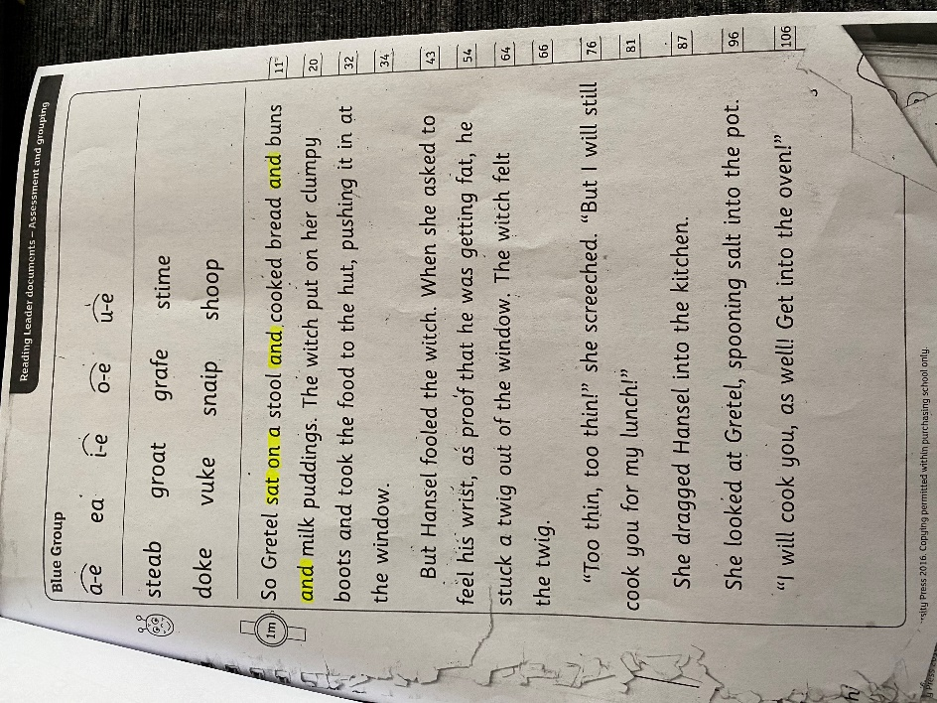
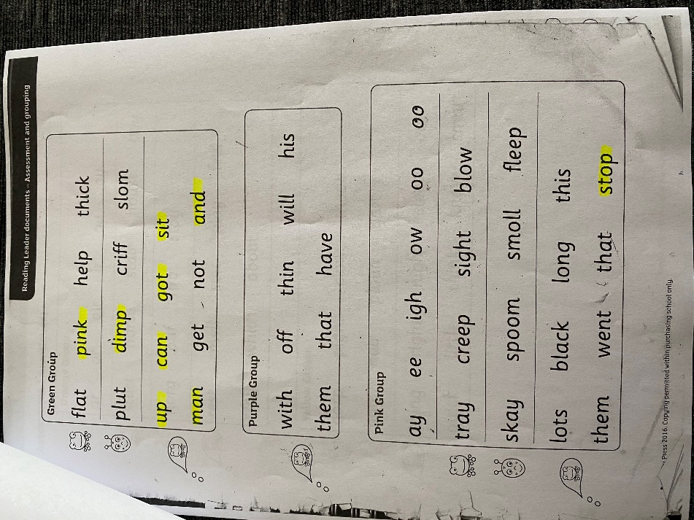
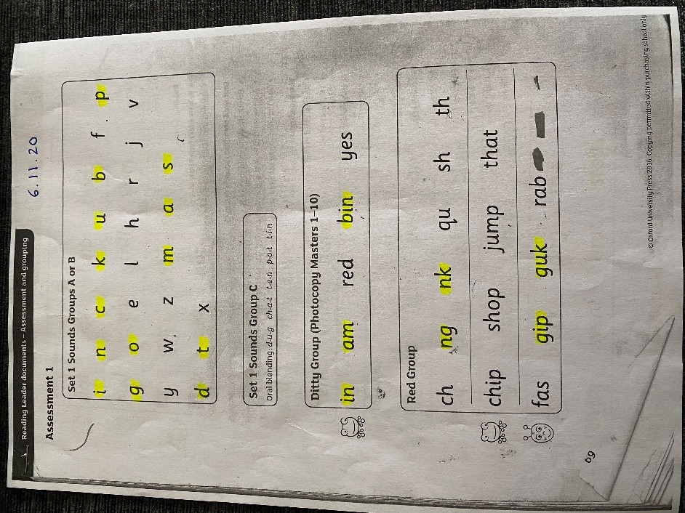
Appendix 2
Appendix 3
Appendix 1
Appendices (Assessment 2)
Appendix 5
Appendix 4

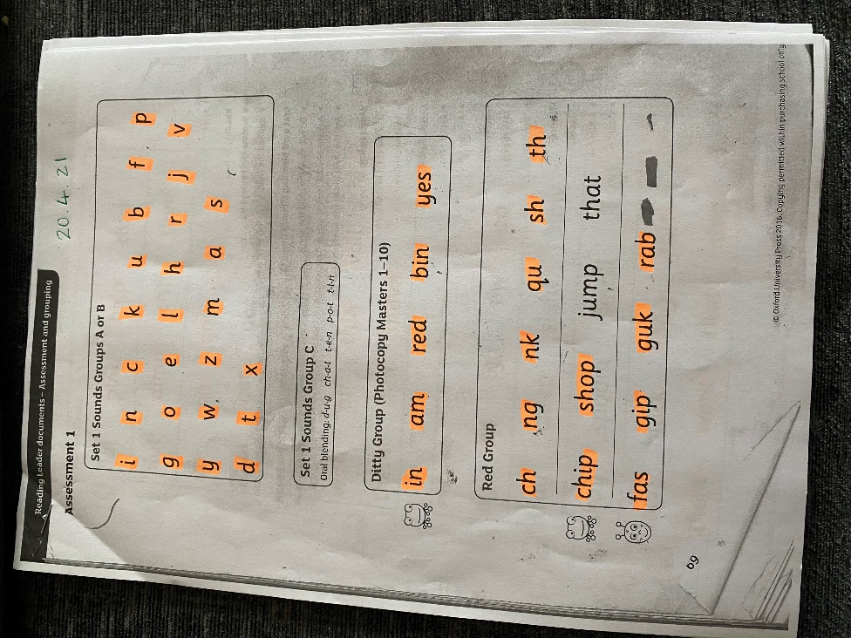
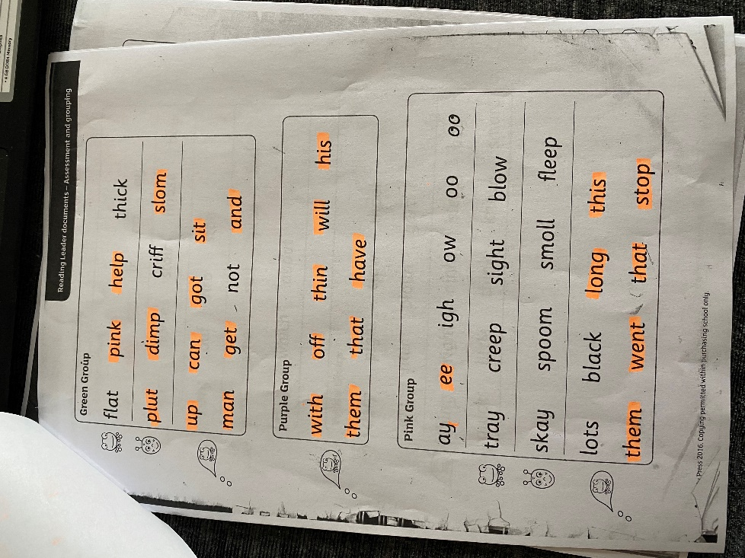

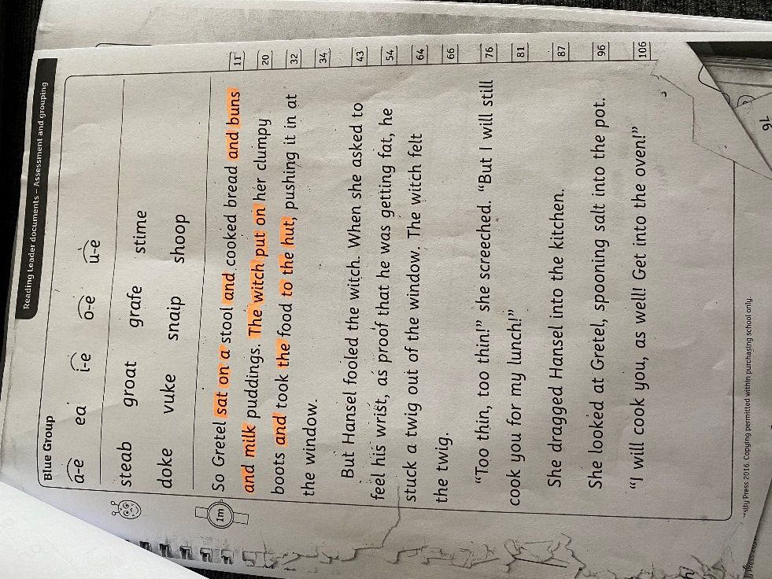
Appendix 6

