 | Student No: | 2233955
 | Module Title: | Hotel Administration and Front Office Operation
 | Module Code: | BMIH4004
 | Lecturer: | Scott James

Introduction
The assignment is based on the program International Hotel Management, which will highlight the evaluation of Hotel Administration and Front Office. The assignment consists of three components which include a learning log, an assessment of practical task scenarios and a portfolio. International Hotel Management involves understanding and managing the business operations of hotels on a global scale. It encompasses different factors such as marketing, finance, hospitality, and guest services. The professionals in this field ensure the smooth functioning of the service delivery, and exceptional customer experience while adopting a diverse business environment and culture. The assessment will identify the key skills required for the hotel front office and analyse using the Gibbs reflective model. Secondly, based on a practical task scenario, the assessment will respond to analysing skills for ownership employment and the application of problem-solving practices. Lastly, the portfolio will describe and evaluate the elements required for managing the stages of the hotel guest cycle.

Component one – Student Journal (learning log)

Creating a learning log about the major skills required to work in a hotel front office comes with excellent opportunities to understand my own experience and connect with individuals with theoretical principles and industry examples. The use of the Gibbs Reflective Cycle will be beneficial to engage in the process of reflection and evaluating learning experiences while discussing different business skills. The Gibbs Reflective Cycle will consist of six major stages including Description, Feelings, Evaluation, Analysis, Conclusion and Action Plan (Ningrum and Ariani, 2020). The evaluation and reflection on the experience skills and knowledge linked to the theoretical principles of Gibbs's reflective cycle are mentioned below.

Figure 1: Gibbs Reflective cycle
(Source: Ningrum and Ariani, 2020)
Description
In the stage of description, I will focus on explaining and describing the key skills while identifying the major requirements of knowledge and skills development for the post of hotel front office. The description stage highlights the skills including cognitive and intellectual skills, knowledge and understanding skills, management skills, practical skills, and transferable skills for professional practices (Bardi, 2011). Apart from that, I have found the customer service, communication skills, problem-solving, teamwork and multitasking skills that are crucial for managing the job role in the hotel front office.
Feelings
I have found that I am confident about some skills like clear communication, teamwork, practical skills, and cognitive and intellectual skills. However, I am quite nervous about my management abilities, multitasking, and problem-solving skills due to my lack of proficiency in Property Management Systems.
Evaluation
The critical principles will play a crucial role in hotel front office operations. Understanding the reservation systems, industry-specific terms and procedures regarding check-in/check-out is crucial (Tewan, 2009). My academic background in hospitality management will help me have a solid foundation, but I have found I need to learn especially about the technological ground in hospitality management. As an example, during an internship, I witnessed the ways in which a smooth check-in process was directly linked with the comprehensive knowledge of the staff regarding the reservation system that ensures efficient customer management. Analytical thinking is also crucial in handling the issues and complaints of the guest’s optimising occupancy and managing reservations. As an example, the abilities of the front office staff to analyse the booking patterns and service management will help in adjusting the pricing strategies and managing the opportunities to maximize the business revenue (Corgel et al., 2011). On the other hand, communication and interpersonal skills are crucial which reflects on recognising the satisfaction of the customers and helps manage team collaboration. I recognise that positive interaction with customers facilitates positive online reviews with a long-term impact on generating strong brand recognition for the business in the tourism market. My practical skills include hands-on experience with managing diverse customers, but I have been facing challenges in communicating with the different customers that might impact the overall guest experience.
Analysis
Communication and interpersonal skills are crucial and known as transferable skills across various industries including the tourism sector. I recognise that, the impact of guest satisfaction is dependable on positive interaction with the customers which contributes to the improvement in service experiences. Quickly analysing room availability during high-pressure demands, picking on spot decisions and abilities to analyse booking patterns are essential for managing the job role associated with the hotel front office (Williams et al., 2020). It is important to stay updated on industry trends by embracing emerging technology and improving communication abilities for better performance.

Conclusion
In conclusion of the reflective process, it can be stated that my understanding of the key skills required for front office management is well demonstrated. Acknowledging my strengths including the areas of improvement will help me in guiding through improving my professional development and future learning opportunities.
Action Plan
Enhancing my practical skills, technological knowledge, and communication abilities I can be able to perform efficiently managing PMS activities. In addition to this, actively seeking mentorship from experienced professionals will help to have valuable insights into managing the job role (Corgel et al., 2011). The skills development and crucial for managing the job role efficiently and improving the areas of weaknesses for better professional development in the long term.

Component two-Trip Advisor Review Response
Source: https://www.tripadvisor.com/Hotel_Review-g2052502-d571604-Reviews-Premier_Inn_London_Rainham_hotel-Rainham_Essex_England.html

RESPONSE
Premier Inn Rainham appreciates you writing a review to tell others about your enjoyable stay. We're happy to hear that your recent visit to our hotel was all you hoped it would be. Your comments will help us continue to improve our service and make sure all of our visitors have a pleasant stay. We are glad to hear you enjoyed the hotel's peaceful atmosphere and the fact that parking was free of charge. Your kind feedback on the cooked-to-order breakfast's presentation and flavor is much appreciated. Our hardworking team takes pleasure in their job, so hearing that you enjoyed working with them and found them to be kind and helpful is really rewarding. The safety and comfort of our visitors, especially lone travelers, are of paramount concern to us, and we are happy to hear that you felt welcome and secure throughout your stay. We hope you had a good time, and we'll do all we can to make your next visit just as memorable. Premier Inn Rainham appreciates your business.

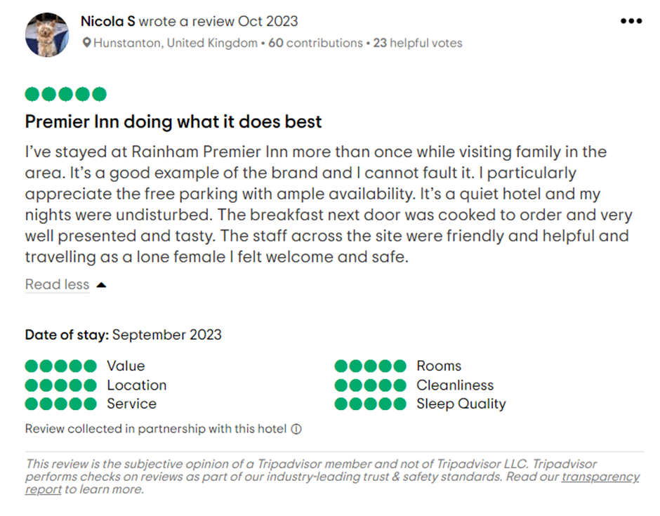
Letter of complaint response
Mr. Ronald Federick
17 Trinity Court Swansea
SA1 2AR
September 1st, 2023
Monica Georgiana Filip
Manager, Premier inn London Rainham
Subject: The Hotel's Reply to Your Recent Complaint
Dear Mr. Federick,
I hope this letter finds you happy and well. For the dissatisfaction and disappointment, you had during your stay at our hotel on August 26th, 2023, please accept my deepest apologies. I value your comments much and want to assure you that it will be used to improve the visitor experience. We sincerely apologize that your breakfast experience was less than satisfactory. The morning must begin with a hearty and satisfying breakfast for our visitors. I have informed our kitchen staff of your comments so that they may look into the issue and make improvements to our breakfast service.
I'm sorry that the noise from next door was an added source of frustration for you. We understand the significance of undisturbed sleep and we sincerely regret the inconvenience. To avoid such problems in the future and guarantee a relaxing stay for everyone, we're taking a closer look at how rooms are assigned. The things you said regarding the state of Room 205's cleanliness are just as worrying. We take pride in maintaining a clean and sanitary environment, so hearing that we fell short of your standards is disappointing. The cleaning staff will be made aware of the problem, and we will apply more stringent quality controls to make sure each room is spotless.
I want to reassure you that your comments will be heard and used to improve our services in the future. We will make the required changes to improve our customers' experience and avoid future occurrences of the same problems. Thank you for your persistence in helping us resolve these problems. In an effort to repay your patronage and show our gratitude, we would like to offer you a special rate at our hotel for your next visit. If you intend on visiting again, please don't hesitate to get in touch with us so that we can make your stay one to remember for all the right reasons. I am sorry that you had to deal with any problems throughout your stay. I hope to hear from you soon; your opinion is highly valued. If you have any more questions or would want to discuss your upcoming reservation, please don't hesitate to contact me personally at the number given at our website.
We appreciate you letting us know about your issues and contemplating a return visit so we can make things right.
Yours Sincerely,
Monica Georgiana Filip
Manager, Premier inn London Rainham

Component 3– Portfolio – 4 Elements
The hotel guest cycle indicates the stages from pre-arrival to departure. The figure below shows the stages of the hotel guest cycle which includes Pre-arrival, Arrival, and Duration of stay/In T house and Departure (Setupmyhotel, 2019). It initiates with pre-arrival and reservation services followed by arrival and duration of stay process. During the stay of the guests, the hotel aims to meet the expectations of the individuals by providing quality services. During the post-stay and check-out, the hotel requests the guests to provide their valuable feedback. Understanding and analysing the stages are crucial for the satisfaction and loyalty of the guests. Effective management through the hotel guest cycle involves a positive and seamless experience of the guest reflecting on the commitment of the individuals to hospitality excellence.
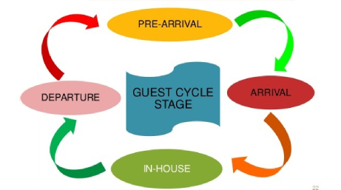
Figure 3: The stages of the hotel guest cycle
(Source: Setupmyhotel, 2019)
Importance of hotel guest cycle
The hotel guest cycle is important as it focuses on structuring the experience of the entire guest, influencing loyalty and satisfaction. A well-managed hotel cycle, from reservation and pre-arrival to post-departure will ensure effective operations of the hotels minimising service errors and enhancing the quality-of-service offerings. It allows individuals to improve the guest experience by understanding their needs and demands which leads to maximizing business revenue by optimising effective research allocation (Verevka, 2019). The cycle serves as an insight for continuous improvement of the business operations while prioritizing each stage of the cycle. Fostering repeat business and improving positive experiences with the services will help in influencing the reputation and success of the hotel in the hospitality establishment.
Evaluation of the stages with real industry examples

Element 1 – Pre-Arrival

In the tourism and hospitality industry, the pre-arrival stage is essential for meeting guest expectations and satisfaction while developing a positive experience for the individuals. It is found that the significance of reservation systems and clear communication with the guest helps in improving positive brand recognition for the business. Effective communication during the pre-arrival stage ensures the guests are well-informed about the special arrangements, amenities, and service facilities (Gato et al., 2022). The industry examples showcase the organisations in the tourism industry adopting technological advancement to improve the service experience and satisfaction of the guests. As an example, the leading hotel chain, Hilton Hotel, uses mobile applications that allow guests to book services and check-in through online applications by making specific room preferences, streamlining the arrival process and receiving digital key access to the hotel.
The pre-arrival engagement in the tourism industry promotes destination marketing to grab the attention of the customers. It is found that the role of pre-arrival information helps in shaping the perceptions of the individual guests. Tourism organisations utilise social media and official websites to present the attractions, local experience and accommodations, which directly influences the decisions of travellers before their arrival (Li et al., 2020). Highlighting a real industry example: the destination websites of TUI Group offer virtual assistants, interactive maps, and personalized experiences to the travellers, which directly help them to get an idea about the service qualities and facilities. The website also offers clear suggestions on the basis of individual user preferences that create a sense of excitement and dissipation before their arrival. In tourism, the pre-arrival stage helps in improving customer experiences that extend to the airline industry as well. The importance of effective flight scheduling with transparent communication regarding the amenities and services helps in improving customer satisfaction (Haryandika and Santra, 2021). The airline businesses employ personalised pre-flight applications and emails to inform the individual passengers regarding the details of the flights, in-flight services, baggage policies and others that enhance the overall travelling experience of the individuals. Effective communication, personalized experiences and technological innovation during the first stage, pre-arrival contribute to guest satisfaction and influence the perceptions of the travellers. It ultimately impacts the success of the tourism business or the hospitality services to provide a seamless service to the individual customers.

Element 2 – Arrival

The arrival phase throughout the hotel guest cycle is a crucial movement where the first and foremost impressions are created analysing the hospitality presented throughout the services. The significance of efficient service processes and personalized interactions with the guest during the arrival plays a pivotal role in improving the success of the organisation (Q4launch, 2019). The expedited and smooth check-in is crucial the technology plays a crucial role. Analysing the ways in which the hotels implement advanced technological solutions to improve reservation systems and mobile check-in options benefits to improve service experiences and customer satisfaction. For example, the mobile check-in services at Marriott International allow individual tourists to get services directly from the front desk, with an efficient and seamless arrival experience. The industry examples highlight the importance of personalized experience. The hotels in the tourism industry often focus on different aspects like providing proper training to the staff members to address the concerns of the guests and offering welcome amenities (Lee et al., 2020). The guest arrival stage also includes several components associated with hotel housekeeping inspection, interaction with the guests, managing guest experiences, hospitality management and hotel management as mentioned in the figure below. The Ritz-Carlton the renowned hotel services, exemplify personalized experiences of arrivals to the guests by anticipating the preferences and needs of the individuals to create a sense of exclusivity and warmth. The strategic planning to manage the arrival stage of the guests will facilitate enhancement in the overall experience of the customers with the service quality of the hotels. 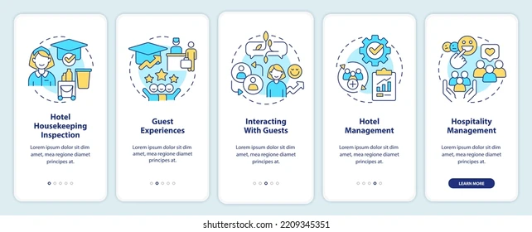
Figure 4: Important components in the arrival stage
(Source: Lee et al., 2020)
Element 3 – Duration of stay

The duration of stay is an important stage in the hotel guest cycle, compassing the entire experience of the guest during their time at visit. It is found that the importance of maintaining service quality throughout the stage is essential to improve the recognition and awareness of the services (Setupmyhotel, 2019). During this phase, the hotel organisations in the tourism industry aim to offer exceptional and consistent services. The role of quality management helps to develop a positive experience for the guests throughout their stay. It involves attentive room services, personalized guest interactions, and exclusive and luxurious service offerings to grab the attention of the individuals. For example, the hotels employing innovative strategies help enhance the experience throughout the duration of the stay (Haryandika and Santra, 2021). The luxurious resorts offer unique experiences like guided tours, spa treatments, innovative services and practising different festivals and cultural customs to improve service quality. The Premier Inn maintains immersive activities like providing exclusive and special services to repeat guests with seasonal discounts and offers on service booking that enhance the overall experience of the guests. Considering the airline industry, the duration of a passenger's flight is a crucial period for efficient service delivery. It ensures satisfaction and comfort during the entire service (Wood, 2013). Airlines like, British Airways prioritize flight entertainment, culinary experience and comfortable seating to improve the overall duration and experience of the passenger's journey.

Element 4 – Departure

The Departure stage indicates the conclusion of the cycle that holds immense benefits to shape the overall service experience of the guests. An efficient and unique contribution to guest satisfaction helps in getting the opportunity to leave a positive impression on hospitality services (Pantouvakis and Gerou, 2022). Emphasizing the need for clarity in expressing gratitude helps in managing experience during the departure stage. The hotels offer digital or contactless checkout options and send personalized emails for departure to express appreciation for the stay and benefit the customers with exclusive services. Generating a positive departure experience improves the satisfaction of the guests and contributes to the positive awareness of the business in the hospitality industry. Organisations in the tourism industry seek feedback from individual customers during this stage, which helps the individual businesses modify their service strategies and practices to satisfy the individual needs of the customers (Johnston et al., 2012). Moreover, ensuring a positive departure experience is crucial for improving business development and generating more business revenue with long-term business sales.

Conclusion
The assignment on International Hotel Management analysed varieties of operations associated with hotel administration and front office that has offered knowledge about the work-based skills development practices. The analysis of the key skills required for hotel front offices helped in improving knowledge about the practices for establishing a smooth service delivery and experience for the customers. Apart from that, the practical task scenario regarding responding to a positive service experience on Tripadvisor and a negative experience with hotel services are analysed to establish the concepts of employability skills, ownership and problem-solving tactics. The description of the hotel guest cycle offers in-depth knowledge about the four stages that help in improving the overall service experiences of the guests throughout their journey with the hospitality brand. Moreover, the assignment analysed the importance of business management which encompasses different factors that are highlighted in this assignment.

References
Bardi, J., (2011). Hotel Front Office Management, Wiley, London.
Corgel, J.B., Sturman, M.C. and Verma, R., (2011). The Cornell School of Hotel Administration on Hospitality: Cutting Edge Thinking and Practice, John Wiley & Sons, Incorporated, Hoboken.
Fallon, M. and Rutherford, D., (2011). Hotel Management and Operations, Wiley, London.
Gato, M., Dias, Á., Pereira, L., da Costa, R.L. and Gonçalves, R., (2022). Marketing communication and creative tourism: An analysis of the local destination management organization. Journal of Open Innovation: Technology, Market, and Complexity, 8(1), p.40.
Haryandika, D.M. and Santra, I.K., (2021). The effect of customer relationship management on customer satisfaction and customer loyalty. Indonesian Journal of Business and Entrepreneurship (IJBE), 7(2), pp.139-139.
Heymann, P., Bastiaens, E., Jansen, A., van Rosmalen, P. and Beausaert, S., (2022). A conceptual model of students' reflective practice for the development of employability competences, supported by an online learning platform. Education+ Training, 64(3), pp.380-397.
Hilton, B., Hajihashemi, B., Henderson, C.M. and Palmatier, R.W., (2020). Customer Success Management: The next evolution in customer management practice?. Industrial marketing management, 90, pp.360-369.
Johnston, R Clark, G. Shulver, M., (2012). Service Operation Management, Pearson, London.
Lee, S., Dudin, S., Dudina, O., Kim, C. and Klimenok, V., (2020). A priority queue with many customer types, correlated arrivals and changing priorities. Mathematics, 8(8), p.1292.
Li, M.W., Teng, H.Y. and Chen, C.Y., (2020). Unlocking the customer engagement-brand loyalty relationship in tourism social media: The roles of brand attachment and customer trust. Journal of Hospitality and Tourism Management, 44, pp.184-192.
Ningrum, Y. and Ariani, N., (2020). Reflective journal writing: A review of the literature. In NEELS (National English Education, Language and Literature Seminar) Proceedings (pp. 305-313).
Oxenswärdh, A. and Persson-Fischier, U., (2020). Mapping master students’ processes of problem solving and learning in groups in sustainability education. Sustainability, 12(13), p.5299.
Pantouvakis, A. and Gerou, A., (2022). The theoretical and practical evolution of customer journey and its significance in services sustainability. Sustainability, 14(15), p.9610.
Q4launch, (2019). What is the Guest Life Cycle in Hotels? [online] Q4Launch. Available at: https://q4launch.com/blog/guest-life-cycle/ [Accessed: 2 Nov. 2023].
Setupmyhotel, (2019). The Guest Cycle in hotel - Four Stages and Diagram. [online] Setupmyhotel.com. Available at: https://setupmyhotel.com/train-my-hotel-staff/front-office-training/131-the-guest-cycle-in-hotel.html [Accessed: 2 Nov. 2023].
Tewan, J., (2009). Hotel Front Office: Operations and Management, Oxford Higher Education Press.
Tripadvisor. (2023). THE TRINITY CITY HOTEL (Dublin) - Hotel Reviews, Photos, Rate Comparison. [online] Available at: https://www.tripadvisor.in/Hotel_Review-g186605-d212667-Reviews-The_Trinity_City_Hotel-Dublin_County_Dublin.html [Accessed: 2 Nov. 2023].
Verevka, T.V., (2019). Development of industry 4.0 in the hotel and restaurant business. IBIMA business review, 324071.
Williams, K, Woolliams, M and Spiro, J., (2020). Reflective writing, Macmillan International, Oxford.
Wood, R., (2013). Key Concepts in Hospitality Management, Sage, London.

