Right Care Right Approach: Are Police the most appropriate agency to deal with persons experiencing a mental health crisis


Benjamin Sherwood
2023949
BSc (Hons) Professional Policing Practice

Declaration
This work has not previously been accepted in substance for any degree and is not being concurrently submitted in candidature for any degree.
Signed:
Date:

STATEMENT 1
This dissertation is being submitted in partial fulfilment of the requirements for the degree of BA.
Signed:
Date:

STATEMENT 2
This dissertation is the result of my own independent work/investigation, except where otherwise stated.
Other sources are acknowledged by footnotes giving explicit references. A bibliography is appended.
Signed:
Date:

STATEMENT 3
I hereby give consent for my dissertation, if accepted, to be available for photocopying and for interlibrary loan, and for the title and summary to be made available to outside organisations.
Signed
Date:

STATEMENT 4
I hereby give consent for my dissertation, if accepted, to be available on the university’s IT system to those who have consent to use the system.
Signed:
Date:

Abstract
Despite the fact that there is a wealth of academic literature on mental health in general, it is reasonable to say that most research focuses primarily on the impact on individuals. However, there is little academic research or empirical literature on the best agency to support people going through a mental health crisis.
The purpose of this dissertation was to investigate police officers' opinions regarding whether they believe that the police are best equipped to deal with mental health issues, as well as what kind of supportive resources officers believe they need to help those in crisis. The researcher also looked at how police officers are currently responding to the rise in mental health-related incidents.
The researcher conducted a thorough analysis of relevant academic writing on the subject of police and dealing with mental. The researcher has gathered their own primary data by using a questionnaire to collect quantitative data, which was then compared with the secondary data to identify any emerging themes.
The project's findings were then documented, and recommendations were made to help support police officers in dealing with people experiencing mental health crises.

Contents Table
Declaration ……………………………………………………………………………………….……………………………………………..2
Abstract .…………………………………………………………………………………………………………………………………………..3
1. Chapter One: Introduction …………………………………………………………………………………….……………………..6
2. Chapter Two : Literature Review ……………………………………………………………………………………………………..
2.1 Background ………………………………………………………………………………………………………………………………….
2.2 Aims of Research …………………………………………………………………………………………………………………………
2.3 Discussion ……………………………………………………………………………………………………………………………………
2.3.1 Should Police be attending incidents when persons are suffering from mental health crisis? ....
2.3.2 Are Police relying on Section 136 powers too much? ………………………………………….……………………
2.3.3 What support services are police using and what more do they need? ……………………………………
2.4 Conclusion ………………………………………………………………………………………………………………………………….
3. Chapter Three: Methodology …………………………………………………………………………………………………………
3.1 Introduction ………………………………………………………………………………………………………………………………..
3.2 Research Approach ……………………………………………………………………………………………………………………….
3.3 Ethical Considerations …………………………………………………………………………………………………………………..
3.4 Research Strategy and Choice ……………………………………………………………………………………………………….
3.5 Sample …………………………………………………………………………………………………………………………………………
3.5.1 Limitations ………………………………………………………………………………………………………………………………..
3.6 Conclusion ………………………………………………………………………………………………………………………………..
4. Chapter Four: Analysis of Results …………………………………………………………………………………………………….
4.1 Introduction ………………………………………………………………………………………………………………………………….
4.2 Data Analysis ………………………………………………………………………………………………………………………………
4.3 Advantages of using Survey Monkey ………………………………………………………………………………………….
4.4 Disadvantages of using Survey Monkey ……………………………………………………………………………………
4.5 Questionnaire Findings ……………………………………………………………………………………………………………….
4.5.1 Should Police be attending incidents when persons are suffering from mental health crisis? ....
4.5.2 Are Police relying on Section 136 powers too much? ……………………………………………………………….
4.5.3 What support services are police using and what more do they need? ……………………………………
4.6 Conclusion ………………………………………………………………………………………………………………………………….
5. Chapter Five: Findings and Conclusion ……………………………………………………………………………………………
5.1 Introduction …………………………………………………………………………………………………………………………………
5.2 The achievement of objectives …………………………………………………………………………………………………….
5.3 Main Findings ………………………………………………………………………………………………………………………………
5.4 Recommendations / Further Research …………………………………………………………………………………………
5.4.1 Recommendation 1 ………………………………………………………………………………………………………………….
5.4.2 Recommendation 2 ………………………………………………………………………………………………………………….
5.4.3 Recommendation 3 …………………………………………………………………………………………………………………..
5.5 Limitations ………………………………………………………………………………………………………………………………….
5.6 Conclusions …………………………………………………………………………………………………………………………………
6. Bibliography ………………………………………………………………………………………………………………………………….
7. Appendices ……………………………………………………………………………………………………………………………………
7.1 Appendix One: Questionnaire …………………………………………………………………………………………………….
7.2 Appendix Two: Questionnaire Results …………………………………………………………………………………………

- Chapter One: Introduction

The purpose of this dissertation is to investigate how mental health is policed. It will go over the difficulties that police officers face when responding to incidents involving people suffering from mental illnesses, as well as the resources that officers require to provide the appropriate level of care.
According to research, police officers are frequently called upon to deal with mental health issues when they are not adequately trained to do so. The goal of this study is to see if police believe they are the best agency to deal with incidents involving mental health crises, and if there is enough support to help officers.
The researcher chose this topic because it is one that they have firsthand experience with. It is an important topic that requires further discussion about whether police are the appropriate agency and what officers on the frontlines require to provide the right care. Everyone is affected by mental illness, and there is an increasing demand on police to investigate incidents involving individuals suffering from mental illness.
Furthermore, mental health is becoming an essential part of everyday policing. It would be extremely beneficial for police officers to receive appropriate training and support in order to recognise individuals suffering from mental disorders. In order to deal with them appropriately and provide the best possible care. It is hoped that the appropriate care and approach will provide greater protection for individuals when they are most vulnerable.

- Chapter Two: Literature Review

2.1 Background

2.2 Aims of Research

2.3 Discussion

2.3.1 Should Police be attending incidents when persons are suffering from mental health crisis?

2.3.2 Are Police relying on Section 136 powers too much?

2.3.3 What support services are police using and what more do they need?

2.4 Conclusion

- Chapter Three: Methodology

3.1 Introduction
The previous chapter of this dissertation looked at the existing literature surrounding mental health and policing. This chapter will explain to the reader how the study will be carried out. This is referred to as the Methodology.

Advantages
Total anonymity
Minimum cost implications
Questionnaires can be completed at the individuals own pace and a convenient time therefore reducing the time burden on the researcher and the participants, making it simpler to collect data from a larger number of individuals.
Boost reliability and validity of research

Disadvantages
Limited depth of information – structured of predefined responses restrict participants ability to provide in-depth responses.
To try and accommodate this I have provided an other option on each question to allow participants to if the wish to give a more detailed answer.
3.2 Research Approach

3.3 Ethical Considerations

3.4 Research Strategy

3.5 Sample

3.5.1 Limitation.

3.6 Conclusion

- Chapter Four: Analysis of Results

4.1 Introduction
The research method and methodology were covered in the previous chapter. The purpose of this chapter is to investigate the question of whether police believe they are the best agency to handle mental health issues. The literature review made clear that there is a lack of empirical of data regarding the appropriateness of police response to situations involving individuals going through a mental health crisis. The increasing use focus of much research. section 136 police power to detain a person with a mental disorder in a public place has been the focus of much research.
To address the research questions, primary research has been conducted via questionnaires. The purpose of this study is to attempt to close the knowledge gap in the existing body of academic literature and to gain a deeper comprehension of the attitudes that police officers currently hold regarding managing mental health issues. It is hoped that by learning more about the requirements police officers must meet when interacting with mental health professionals, working strategies for improved support services will be developed and awareness raised.
This chapter will assemble, analyse, and present the findings of the primary research study. The researcher created an online questionnaire and asked current police officers to answer questions about how they should respond to mental health incidents. This resulted in 18 responses. The Appendix contains all of the questions and findings from the primary questionnaire.

4.2 Data Analysis

4.3 Advantages of using Survey Monkey

4.4 Disadvantages of using Survey Monkey

4.5 Questionnaire Findings

4.5.1 Should Police be attending incidents when persons are suffering from mental health crisis?

4.5.2 Are Police relying on Section 136 powers too much?

4.5.3 What support services are police using and what more do they need?

4.6 Conclusion
- Chapter Five: Findings and Conclusion

5.1 Introduction

5.2 The achievement of objectives

5.3 Main Findings

5.4 Recommendations / Further Research

5.4.1 Recommendation 1

5.4.2 Recommendation 2

5.4.3 Recommendation 3

5.5 Limitations

5.6 Conclusions

Bibliography

B. Menkes, D. and A. Bendelow, G. (2014) ‘Diagnosing vulnerability and “dangerousness”: Police use of section 136 in England and Wales’, Journal of Public Mental Health, 13(2), pp. 70–82. doi:10.1108/jpmh-09-2012-0001.
Cresswell, M. (2019) ‘Rise in the use of section 136 of the mental health act 1983 in England and Wales: A viewpoint on Loughran (2018)’, Medicine, Science and the Law, 60(2), pp. 140–146. doi:10.1177/0025802419896916.
Gov UK (2014) Supporting vulnerable people who encounter the police - gov.uk, Helping the police to support people with vulnerabilities. Available at: https://assets.publishing.service.gov.uk/government/uploads/system/uploads/attachment_data/file/405397/6.379_Supporting_guidance_web_doc_v3.pdf (Accessed: 02 June 2023).
GOV WALES (2015) Welsh Government and partners - GOV.WALES, Mental Health. Available at: https://www.gov.wales/sites/default/files/publications/2019-03/mental-health-crisis-care-concordat.pdf (Accessed: 02 May 2023).
GOV.UK (2017) Guidance for the implementation of changes to police powers and places of safety provisions in the mental health act 1983 - Gov.uk, Mental Health Act 1983: implementing changes to police powers. Available at: https://assets.publishing.service.gov.uk/media/5a81cf23ed915d74e62343a3/Guidance_on_Police_Powers.PDF (Accessed: 06 September 2023).
GOV.UK (2023) National Partnership Agreement: Right Care, right person (RCRP), GOV.UK. Available at: https://www.gov.uk/government/publications/national-partnership-agreement-right-care-right-person/national-partnership-agreement-right-care-right-person-rcrp#fn:1 (Accessed: 27 September 2023).
GOV.WALES (2019) Wales Crisis Care Concordat National Action Plan, Mental health crisis care agreement: action plan 2019 to 2022. Available at: https://www.gov.wales/sites/default/files/publications/2019-10/wales-crisis-care-concordat-national-action-plan-2019-2022.pdf (Accessed: 23 June 2023).
HMICFRS (2018) Policing and mental health: Picking up the pieces, His Majesty’s Inspectorate of Constabulary and Fire & Rescue Services. Available at: https://hmicfrs.justiceinspectorates.gov.uk/publications/policing-and-mental-health-picking-up-the-pieces/ (Accessed: 07 July 2023).
Kane, E., Evans, E. and Shokraneh, F. (2017) ‘Effectiveness of current policing‐related mental health interventions: A systematic review’, Criminal Behaviour and Mental Health, 28(2), pp. 108–119. doi:10.1002/cbm.2058.
Loughran, M. (2018) ‘Detention under Section 136: Why is it increasing?’, Medicine, Science and the Law, 58(4), pp. 268–274. doi:10.1177/0025802418790336.
McDaniel, J.L. (2018) ‘Reconciling Mental Health, public policing and police accountability’, The Police Journal: Theory, Practice and Principles, 92(1), pp. 72–94. doi:10.1177/0032258x18766372.
MIND.ORG (2022) Mind responds to annual detentions under section 136 of the mental health act, Mind. Available at: https://www.mind.org.uk/news-campaigns/news/mind-responds-to-annual-detentions-under-section-136-of-the-mental-health-act/ (Accessed: 16 October 2023).
Morgan, M. and Paterson, C. (2017) ‘“it’s mental health, not mental police”: A human rights approach to Mental Health Triage and section 136 of the mental health act 1983’, Policing: A Journal of Policy and Practice, 13(2), pp. 123–133. doi:10.1093/police/pax047.
Puntis, S. et al. (2018) ‘A systematic review of co-responder models of police mental health “street” triage’, BMC Psychiatry, 18(1). doi:10.1186/s12888-018-1836-2.
Senior, J., Noga, H. and Shaw, J. (2014) ‘When Two worlds collide: A twenty‐first century approach to mental health and policing’, Criminal Behaviour and Mental Health, 24(2), pp. 81–85. doi:10.1002/cbm.1897.
Wondemaghen, M. (2021) ‘Policing mental illness: Police use of section 136 – perspectives from police and mental-health nurses’, Medicine, Science and the Law, 61(4), pp. 266–274. doi:10.1177/0025802421993363.

Appendix 1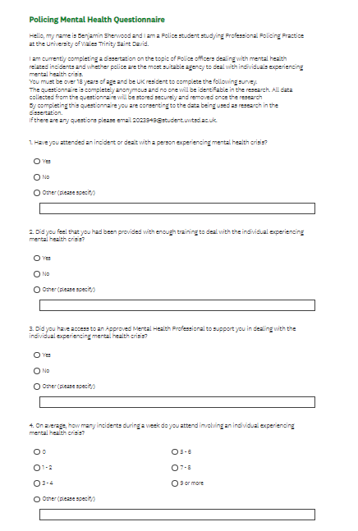

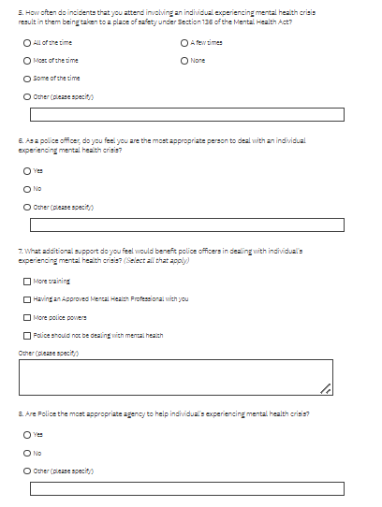

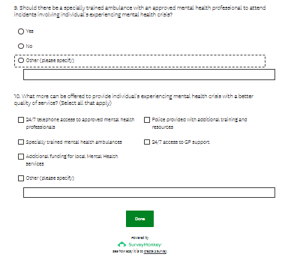

Appendix 2.


