Assessment One
Discussion Paper
Is Semiotic and Structural Analysis Enough to Understand the Meretseger Statuette?

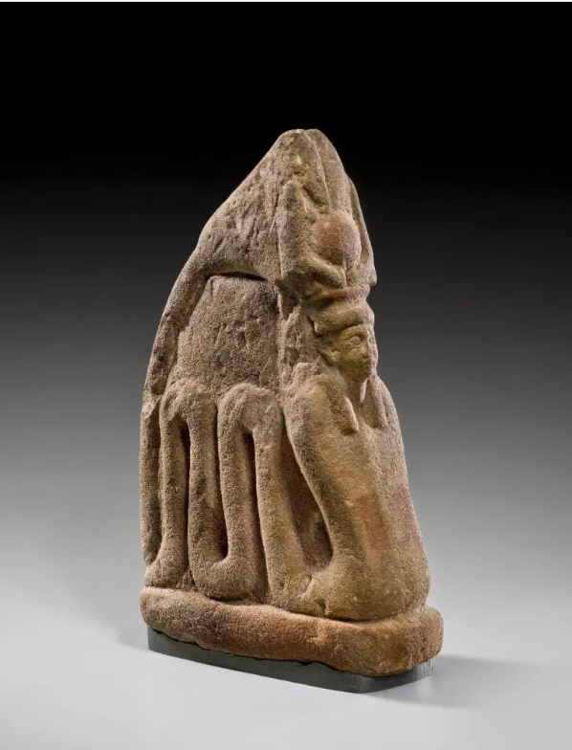
Statuette of Meretseger Brooklyn Museum

1450605 Alyson Greening
HPAH7015
Ancient Egyptian Religions
Meretseger, "She Who Loves Silence," served as the formidable divine guardian of the Theban Necropolis, her identity inseparable from the pyramid-shaped peak of el-Qurn. As a localised deity of Deir el-Medina, she embodied a powerful dualism: as nurturing protector analogous to Renenutet and a punitive force capable of striking transgressors with blindness. This paper examines a sandstone statuette of Meretseger from the Brooklyn Museum to explore how her hybrid iconography functioned within the village’s religious life. By applying a structuralist analysis of her symbolic attributes alongside Foucauldian theories of power and "docile bodies," this study argues that the sculpture was not merely a passive object of devotion. Rather, it acted as a "machine" of social control, internalising divine surveillance and enforcing the moral order of the royal tomb-builders. Further work will expand on these theories and further discuss the notion of agency and New Materialism within the context of the village of Deir el-Medina.
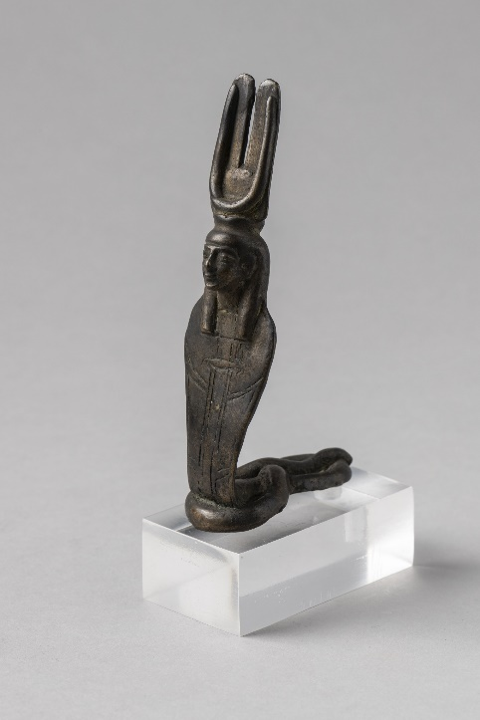
Meretseger occupied a fundamental position within the sacred landscape of the Theban Necropolis. Her identity was inherently linked to the limestone topography of the region, specifically the natural peak of el-Qurn. This mountain dominates the Valley of the Kings and was believed to Meretseger’s primary residence, earning her the description ‘The Goddess of the Peak.’ She can be associated with the goddess Renenutet, who also maintains a cobra identity and is identified with fertility and harvest. Unlike Meretseger whose cobra self is recognised with punishment and vengeance as well as protection of the tombs, Renenutet is known as the ‘snake who nourishes’. The opposing roles of Meretseger and Renenutet illustrate the ultimate duality of the Egyptian cobra who also represents the Solar Eye, and functions both as a punitive guardian of sacred silence who strikes down transgressors in the necropolis and as a nurturing presence who protects food sources, thereby ensuring food sources are maintained.
Statuette of the goddess Renenutet Egypt Museum
Meretseger’s presence extended across the funerary landscape to include the Valley of the Queens, where she was thought to inhabit the subterranean caves, effectively positioning her as a primary protector of the royal dead and along with Hathor and Amenophis I, she served as a central figure for votive rituals of the craftsmen building the royal tombs; some of which also adopted the responsibilities of priests. Meretseger was both protector and punisher, particularly associated with sins against the tombs of the kings. Unusually, she is also associated with confessional rituals and forgiveness of sins, as attested by the stela of Nefer-abu. where he is struck blind for his transgression but has his sight restored when he repents. 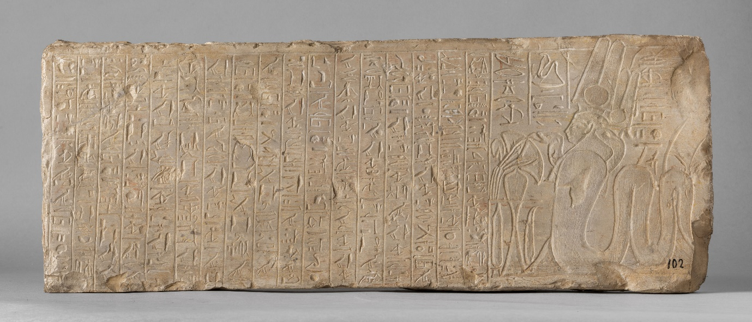
Stela of Nefer-abu with Meretseger on the right hand side. museo Egizio
Meretseger is usually represented as a cobra with a woman’s head, but she is also seen as a woman with a cobra’s head and very occasionally as a scorpion with a female head. Ultimately, the cult of Meretseger was lost when the village of Deir el-Medina was abandoned in the later stages of the 20th Dynasty at the end of the New Kingdom.
The dual nature ascribed to Meretseger facilitates the interrogation of this statue using both structural and post structural lens and it is to this that this paper will now turn.
Structuralism, posits that meaning is not inherent but is produced through a stable system which is formed through a sequence of steps, which in the case of Meretseger are as follows: ‘the source of emission [the sculptor], a channel of transmission [the sculpture itself, performance of ritual] and a point of reception’ [the villagers of Deir el-Medina]. Barthes argues that the manner of emission and reception are rooted in anthropological study but that the message (including the method of transmission) is a self-contained system made up of the relationship of its component parts which includes signifiers what these signify. Thus, meaning is contingent the rules governing the system. One must therefore approach our understanding through the lens of the ancient Egyptian religious and cult system rather than employing modern aesthetic standards. Whilst Barthes situates Meretseger within a system of signs and signifiers, for Foucault, she is an element in the ‘machine’ that exists to uphold the discursive systems of power and control through her messaging as both punisher and protector.
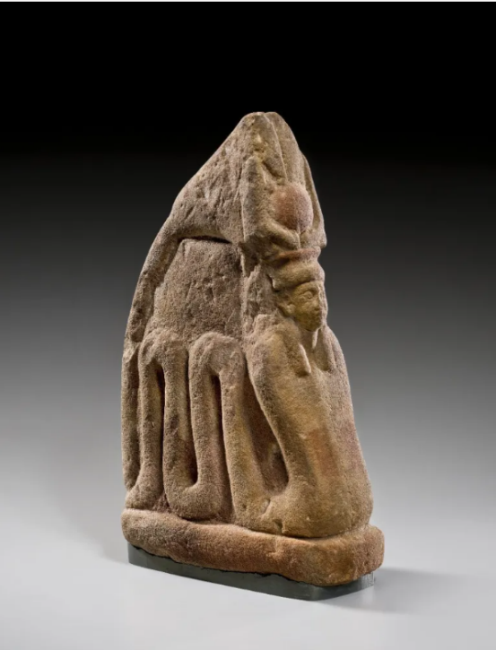
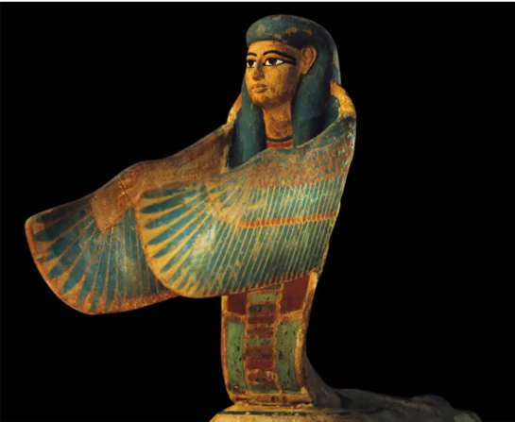
The statuette of Meretseger is made of yellow sandstone, is approximately 35cms high by 12cm deep and 22 cms long and it is thought that she dates from between 1479 and 1400 B.C.E. She is set on a rectangular plinth and seen from the side one can see her cobra body as two loops, enabling a deep sense of movement. She is represented wearing a tripartite wig and a crown which encompasses a solar disk. There are remnants of red paint on the front of the statue. This is not a smooth sculpture, and the sandstone can be seen to be pitted in places, an indicator of engagement with the statue, possibly because of ritual handling. The area behind her crown and above the coils are left uncarved, resulting in a form which is planar and lacking in three-dimensional depth unlike other sculptures of Meretseger (left) whose outstretched arms and curved cobra body draws the eye of the viewer into a more intimate space.
The translation of Meretseger’s name merits important consideration. Interpretated as "She Who Loves Silence," there are profound relationships between the personification of Meretseger and the silent, stealthy movement of snakes within the limestone landscape which in turn represent a quiet but deadly vigilance over the necropolis. In addition, the biological reality of Meretseger’s cobra form establishes a symbiotic relationship between the villagers and the sacred landscape; while the community remained acutely aware of the mountain’s divine authority, their participation in ritual ensures that she becomes a power for the protection of the community. Moreover, as previously discussed, she is capable of both formidable retribution and great mercy. The elements represented in Meretseger’s crown are also significant. Her horned crown connects her to Hathor who is the primary goddess of Thebes whilst the shuti represent the concept of Maat, serving to remind her worshippers that she is a deity of order and justice. The sun disk embodies her connection with Ra and the creation of life as well as her role as protector of the tombs. Her tripartite wig may serve practical as well as spiritual functions, including where her hair serves to blur the separation between her human and cobra form. Finally, the traces of red paint on the figure demonstrates how colour is also highly symbolic. Red was the colour of the desert, a place of chaos and danger. Since Meretseger was the "Mistress of the West” the colour red associates her with the harsh, unforgiving nature of the landscape. The red paint may also symbolise personal danger through her anger and wrath. However, it may also suggest rejuvenation and energy thus again reinforcing the dual aspects Meretseger’s personality.
Statue of the protective goddess Meretseger
Perhaps one of the most important elements of the figure is her ka which is embodied in the actual statue. By mimicking the natural geometry of the 'Peak of the West,' the figure’s planar form functions as a calculated semiotic device; it transforms her from a mere representation into a localized extension of divine authority and surveillance. Furthermore, the way in which the carving has been sculpted, with her undulating coils, creates a sense of dynamic energy, implying that she is in constant, watchful motion. Overall, this means that engaging with the ka of the figure was to engage with Meretseger and the mountain itself.
The Brooklyn Museum statuette of Meretseger functions as more than a passive religious figurine; it is a substantive participant in the complex discursive systems of power that ruled the villagers of Deir el-Medina. While structuralist frameworks effectively classify her iconography—the tripartite wig and the ka crown—as signs of divine authority, Foucault’s perspective argues that she is a crucial element in a "machine" of social control and internalized discipline. The presence of this deity, capable of striking a labourer like Nefer-abu blind for a "sickness in the heart," suggests a localized panopticism where the boundary between private conscience and state-monitored labour is entirely dissolved; a concept which will be explored in greater detail in the forthcoming thesis.
However, the "pitted" sandstone and remnants of red paint suggest a "vibrant" history of ritual handling that exceeds simple semiotic representation and is also deserving of further investigation: did the material presence of Meretseger merely represent authority, or did her physical form, as a "planar" extension of the limestone mountain el-Qurn, actively co-construct the "docile bodies" required for the Pharaoh’s service? Exploring Meretseger’s own agency will offer a connection to a wider investigation into how Egyptian material culture did not just reflect belief but fundamentally enforced the social and moral order of the Theban necropolis and the village of Deir el-Medina.

Bibliography
Statue of the Protective Goddess Meretseger2026 vols ) <https://egypt-museum.com/statue-of-the-protective-goddess-meretseger/> [accessed 11/03/2026]
A.G. McDowell, Village Life in Ancient Egypt: Laundry Lists and Love Songs (Oxford: Oxford University Press, 1999)
anon, Statuette of the Goddess Renenutet, 2026 vols ) <https://egypt-museum.com/statuette-of-the-goddess-renenutet/> [accessed 18/03/2026]
Badcock, C. R., Levi-Strauss: Structuralism and Sociological Theory (London: Hutchinson and Co. Limited, 1977)
Barthes, Roland, Music Image Text (London: Fontana Press, 1977)
Brooklyn Museum, Meretseger, 2026 vols 2025) <https://www.brooklynmuseum.org/en-GB/objects/4178> [accessed 10/03/2026]
Foucault, Michel, Discipline and Punish: The Birth of the Prison (Penguin, 1977)
John Romer, Ancient Lives. the Story of the Pharaohs Tombmakers (London: George Weidenfeld & Nicolson Ltd, 1984)
Museo Egizio, Stela of Neferabu, 2026 vols ) <https://collezioni.museoegizio.it/en-GB/material/Cat_1593> [accessed 18/03/2026]
Pinch, Geraldine, Egyptian Mythology: A Guide to the Gods, Goddesses, and Traditions of Ancient Egypt. (Oxford: Oxford University Press, 2004)
Richard H. Wilkinson, The Complete Gods and Goddesses of Ancient Egypt (New York: Thames Hudson, 2003)
Szpakowska, Kasia, 'Religion in Society:
Pharaonic', in A Companion to Ancient Egypt, ed. by Alan B. Lloyd (Wiley-Blackwell, 2010)
Wilkinson, Richard H., Symbol and Magic in Egyptian Art (New York: Thames Hudson, 1994)

&nbsp Szpakowska and Kasia, 'Religion in Society: Pharaonic', in A Companion to Ancient Egypt, ed. by Alan B. Lloyd (Wiley-Blackwell, 2010).
anon, Statuette of the Goddess Renenutet, 2026 vols <https://egypt-museum.com/statuette-of-the-goddess-renenutet/> [accessed 18/03/2026].
Geraldine Pinch, Egyptian Mythology: A Guide to the Gods, Goddesses, and Traditions of Ancient Egypt. (Oxford: Oxford University Press, 2004), p. 129.
A.G. McDowell, Village Life in Ancient Egypt: Laundry Lists and Love Songs (Oxford: Oxford University Press, 1999), p. 8.
John Romer, Ancient Lives. the Story of the Pharaohs Tombmakers (London: George Weidenfeld & Nicolson Ltd, 1984), p. 113.
A.G. McDowell, , p. 92
A.G. McDowell, Village Life in Ancient Egypt: Laundry Lists and Love Songs (Oxford: Oxford University Press, 1999), p. 100.
Richard H. Wilkinson, The Complete Gods and Goddesses of Ancient Egypt (New York: Thames Hudson, 2003), p. 224.
A.G. McDowell, , p. 239
C. R. Badcock, Levi-Strauss: Structuralism and Sociological Theory (London: Hutchinson and Co. Limited, 1977).
Roland Barthes, Music Image Text (London: Fontana Press, 1977).
(Barthes 1977: 15)
Statue of the Protective Goddess Meretseger2026 vols <https://egypt-museum.com/statue-of-the-protective-goddess-meretseger/> [accessed 11/03/2026].
Richard H. Wilkinson, Symbol and Magic in Egyptian Art (New York: Thames Hudson, 1994), p. 106.
Panopticism is a concept developed by Foucault which states that constant surveillance causes an individual to internalise control and self-regulate behaviour. It is fundamentally associated with the relationships between the powerful and the powerless and is a central facet of control. In this case, the control the Egyptian gods had over the people through ritual and cult.
Michel Foucault, Discipline and Punish: The Birth of the Prison (Penguin, 1977), p. 135.

