Maria Teresa Nsang (1908391)

THE IMPACT OF MOODLE ON STUDENT

A great number of students have blended with the Learning management system. ( LMS) That is because, in consideration of other learning method systems, Moodle is more convenient and more successful for academic learning; there are few students who more or less perceive the uses of Moodle, not ease.
Thus, there are many questions to be answered, for example: what the student understood about the uses of Moodle? What is the effect of Moodle? Are they contented with the use of Moodle, are they able to access Moodle, what is the impact of Moodle in the growth of the students in terms of competencies?

INTRODUCTION:
This report is to evaluate, explain, and estimate the acceptance of Moodle as a supplementary system in teaching at the University of Wales Trinity of Saint David. Presently student has increased to the use of technology and is changing lifestyles, causing the use of computers and the internet as integral parts of individual life. The Educational patterned had also changed the method of learning, directing to lean towards the use of Moodle.
To achieve the aim of this research and to evaluate the impact of Moodle on students. A questionnaire we designed through a website called Monkey survey. It was sent to some students through their email and whats-up. Out of the nine questionnaires that were sent to students, nine students responded based on their attitudes toward the use of Moodle.

1.0 AIMS AND OBJECTIVES
The aim and objective of this report are to find out the student view of the impact of Moodle. Primary and secondary data comparative- descriptive approach is to be used to explain student competencies and pe toward the uses of Moodle.
The student ability, awareness, and satisfaction of the usages of Moodle. Compare the student perception toward Moodle and the impact of primary data with that of the secondary data. The questionnaires that were sent out and the number of students who give back feedback and convert through Excel in percentage which is as follow,

1.
STUDENTS RESPONSE
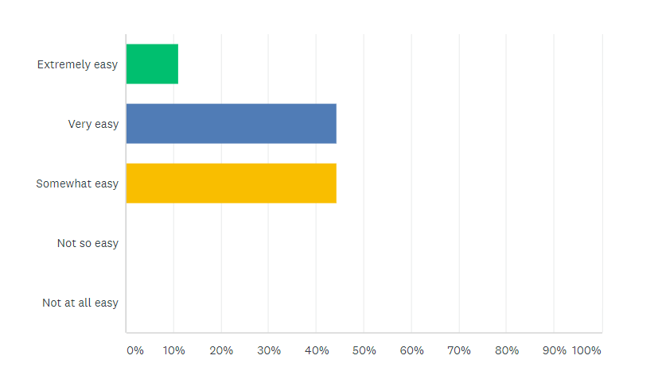

2. 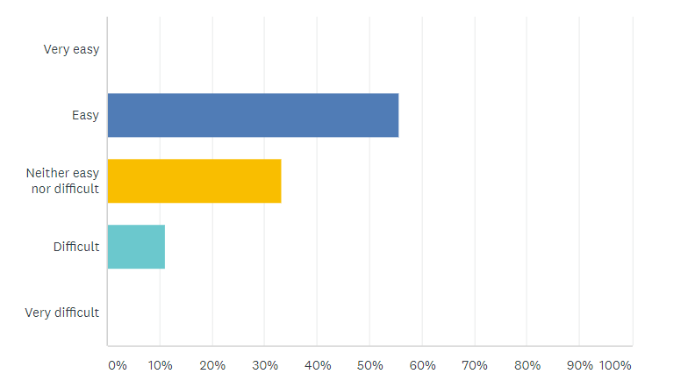

3. 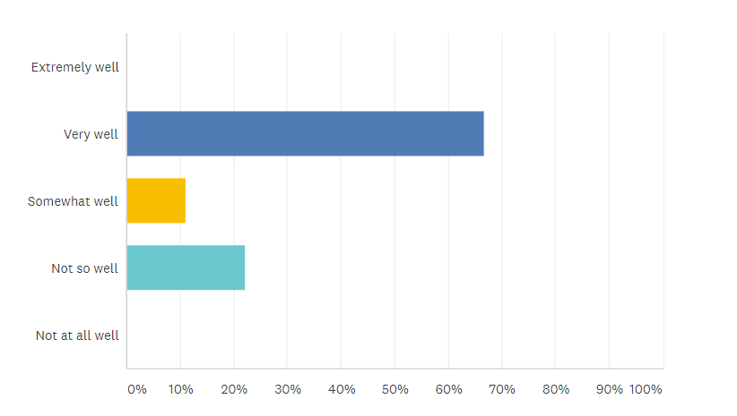
4. 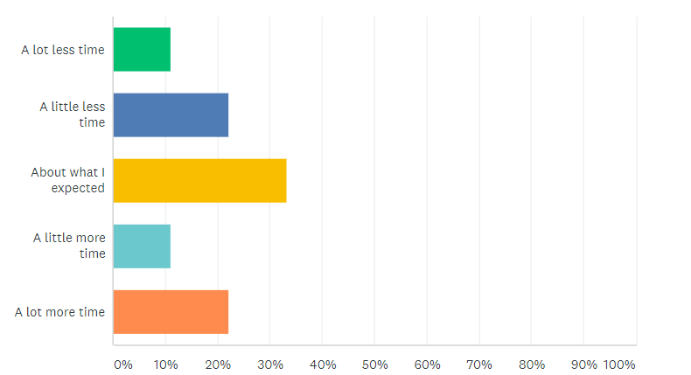
5. 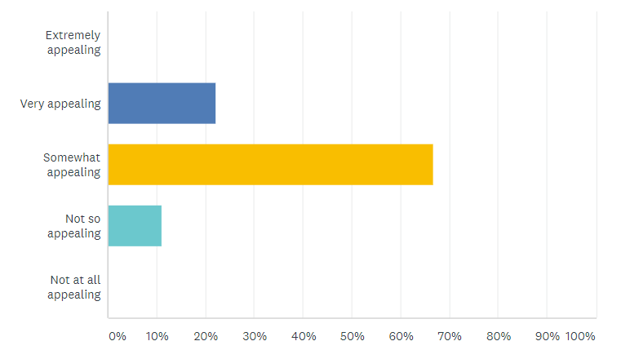

6.
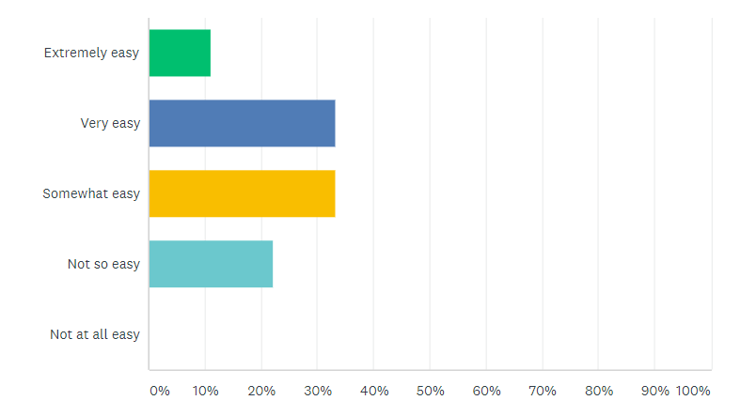
7. 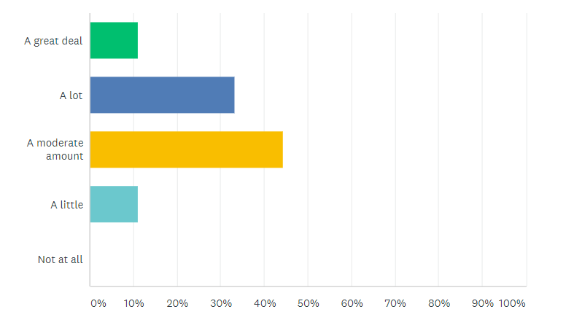
8. 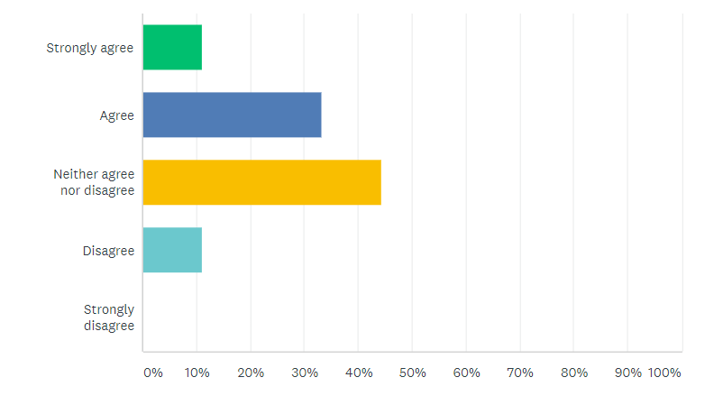

9.
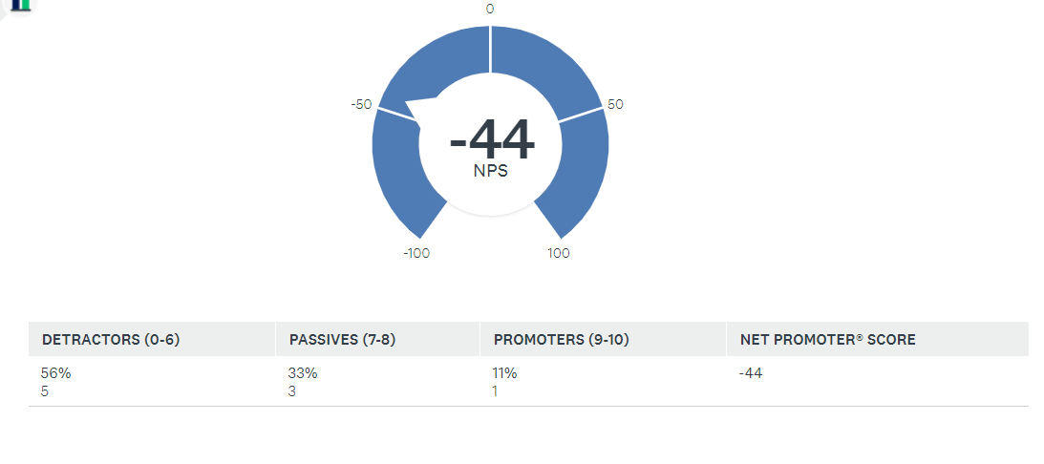

Source: Nsang. M. (2020).

2.0 FINDINGS:
I am going to use the result obtained from primary data in the above pie chart to explain student attitude regarding the knowledge and the perception toward the uses of Moodle. The percentage observed in the above pie chart, in the blue part, shows that the few students (11%) did not have any problem with the introduction of Moodle. While the grey color parts of the chart show that (33%) of students found it difficult and were not comfortable with the uses of Moodle at the beginning, of course.
The orange color showed that the majority of the student (56%) find it moderate base on their responses. This research will categorize the primary data into three sections. The first section is going to indicate students that find the use of Moodle easy. The second section is for the student who finds it Moderate while the third section are student who finds the use of Moodle difficult.

Students Attitude Towards Moodle

Section 1: Student who Find Moodle Very Easy

In the above pie chart, few students find it comfortable to use Moodle as a learning tool. The percentage is ( M=11% ), which indicates that few students acknowledge and understand how Moodle works and had a positive attitude at the introduction of Moodle as indicated above. That may be for the following reasons (a) they know how the new method of Learning work. (b) they have previously experienced, or they are freely familiar with digital technology.

Section 2: Student with Moderate Understanding

In the second part of the above pie chart, the orange color illustrated that majority of students have a moderate understanding, which is (M=56%). While the experience of digital technology uses is lacking example, the uses of computers. They were not familiar with the introduction of Moodle. It observed through students' responses.
They encounter some limitations at the beginning of the course. The reason may be the system was new to the student and did not have enough practical knowledge of the uses of Moodle before the procedure. The use of Moodle was less comfortable because they encounter some barriers.

Section 3: Student who find Moodle Difficult

The third part of the pie Chart with grey color showed (M=33%), which indicates that students find it difficult. That shows the student had no knowledge nor understand of the terminology Moodle or the introduction of Moodle and how to access it was new to them.
The cause may be as followed, lack of digital technology understanding, not having experience of the uses of computer, had left college for an extended period, and the barrier of a technical approach to the system. Students who find it difficult and those with moderate understanding need constant practices to be familiar with Moodle.

3.0 DISCURSION/ COMPARISON BETWEEN PRIMARY DATA AND
SECONDARY DATA.

According to research made from the International Journal of Digital Information and Wireless Communication, regarding student perception toward Moodle indicate as follows.

Table 1. Attitude Toward Moodle
The secondary data expressed that student attitude toward Moodle before the course was low (M=2.22). Toward the end of the term with much motivation and hard-working student attitude toward Moodle was improve to (M=4.70).

Table 2. Moodle and Learning
The secondary data show that at the beginning of the course, the overall opinion and awareness of students toward Moodle as a learning tool was poor (M=2.66). At the end of the course, they valued the effect of Moodle; their learning was joyful and improved to (M=4.69).

Table 4. Accessibility of Moodle
The student who can easily access Moodle at the beginning of the course was low(M=2.70). After some phase of the system, the student responded very high (M= 4.56). It was very remarkable to see that majority of students found Moodle accessible from any location at any time.
Comparing the primary data percentage in the above pie chart, with the blue color, the student who find the uses of Moodle easy was also low (M=11%)

The grey color in the pie chart illustrated that student perspective toward Moodle learning was also low(M=33%) because students find it difficult at the introduction of Moodle.
Also, the orange color in the pie chart shows that student accessibility of Moodle was Moderate (M=56%) at the introduction of Moodle. That means the primary data and the secondary data indicate percentage was low toward Moodle(M=2.22) at the beginning of the course in table 1 and table 2. At the end of the course, the student in the secondary data there was an improvement (M=4.70). That was because the student was having little knowledge of the use of Moodle before the course also.
It seemed that this was the main cause of the low mean attitude at the beginning of the course, but with more practice student was freely familiarized to Moodle towards the end of the system. The primary data did not indicate how students perceive Moodle toward the end of the course base on THE research.
The blue color in the above pie chart demonstrated that student who was able to access Moodle and find it easy was low (M=11%). Same with the secondary data (M=2.70%). That means students were freely familiarized with the use of Moodle, have enough knowledge before the course. It seemed from the student's response they perceived Moodle as an essential tool for learning, and they felt the ease of using it. That shows the positive ability toward Moodle.
The secondary data and the primary data revealed similarities of students' low percentage at the beginning of the course. Though the different methods of research and statistic. That shows that the introduction of Moodle learning at the beginning of the course was not familiar to both students. They did not have enough understanding at the beginning of the system. Students who knew digital skills with their previous experience were few and where those who find it easy to use Moodle.
That confirms that at the end of the term, students might improve and will be freely familiar with the new learning system in the secondary data. Though it did not resemble that of the primary data because the student has not yet ended the course, to indicate student progress has to be at the end of the term. In the secondary data, student availabilities and the usage of Moodle lead to more positive behavior toward the management of Moodle, which sequentially added to their better understanding and learning.

4.0 SUMMARY AND CONCLUSION
In conclusion, the secondary data, as mentioned above, students who were made known to the online learning environment through Moodle from the beginning were optimist, encouraging, and have positive approaches and ease behavior toward Moodle. Consecutively students had a more excellent approach and understanding of the uses of Moodle at the end of the course.
In the primary data, the student perspective toward Moodle at the beginning of the course was low, hoping to improve and understand the new system of learning. Which sequentially will contribute to their better understanding at the end of the course. Students in the primary data can escalate to an excellent level with more practice.
The information derived from this description-comparative work is to the upgrade skill advancement of the students. The importance of being able to tackle the full prospective that Moodle provides to the student. The need to be conscious of its academic limitations, that prove it will encourage the student to explore further methodological and access consequences of Moodle in the university.
To promote a more active role of the student in working together with other virtual learning environments as unique learning environments.
The study also drew special attention on few questions about academical use of Moodle from the viewpoint of students which are as follow:
- Understanding digital skills are useful to know how Moodle works as a precipitating factor.
- The new method of learning not only misspent the potential of Moodle but give some restriction tool for skill advancement and the invention of new knowledge and social intercommunication.
- According to Hofman (2002). Technical support has a positive result on the conscious, easy use of Moodle.
- The majority of the students prefer face to face approaches be assist with some online materials and activities.
- The mode of Education through Moodle and distance learning is becoming more famous and respected, which is more effective.

The result affirmative with student attitudes and approach toward the uses of Moodle was precisely negative as a learning tool at the beginning of the course, both in the primary data and in the secondary data. Even -though there was some barrier, they were confident to deals with a worthy approach to modern teaching and learning.
That means Moodle is useful but can-not replace face to face learning entirely. The most encouraging thing students emphasize is the availability of the absence of rigidity to access mostly the available teaching materials.
It is necessary to exercise and updates the information on the course and be able to use it from anywhere outside the classroom in collection of all learning materials in one place and give quick feedback.

REFERENCES:
-S. Liaw, G-D. Chen, and H.M Huang, "Users' attitudes toward Web-based collaborative learning system for knowledge management," Computers and Education, vol. 50. Apri. 2008, pp. 950-961, DOI: 10.1016/j.compedu.2006.09.007.

2. P. Cowan, Factors influencing Pre-Service teachers' attitudes towards using a Moodle environment for teaching and learning", Proc. Of Society for Information Technology and Teacher Education International Conference, Chesapeake VA: AACE, Mar. 2006, pp. 2817-2824, htt://www.editlib.org/p/22507.

3. Davis, F. D., Bagozzi, R.P., & Warshaw, P.R. (1989). User acceptance of computer technology: System characteristics, user perceptions, and behavioral impacts. International Journal of Man-Machine Studies, 38(3), 375-487. Doi: 10.1006/imms.1993.1022

4. Martin-Blas, T., and Serrano-Fernandez, A. (2009) 'The role of new technologies in the learning process: Moodle as a teaching tool in Physics Computers and Education, 52, 35-44. Doi: 10.1016/j.compedu.2008.06.C

5. Carvallio, A., Da Silva, A., and Freitag, P. (2013) 'Accessibility in Virtual Moodle Learning Environment,' Literature Review. Journal of Nursing UFPE, 969.

6. Ahmad, N. and AI-Khanjari, Z. (2011) 'Effect of Moodle on learning,' An Oman Perception, International Journal of Digital Information and Wireless Communications (IJDIWC), 1(4), pp. 746-752.
7. Romero, Cristobal, S. Ventura, and E. Garcia., Data mining in course management system: Moodle case study and tutorial. Computers and Education, 51(1), 368-384., 2008.

