

Student Name: Md Abdulla Al Mamun

Student ID: 2503784

Module Name: Marketing Management

Module Code: LCMB7024

Lecturer’s Name: Dr Muhammed Tariq

Assignment Title: Assessment component 2: Marketing Strategies Portfolio

Term 1

Word Count: 2748

Table of Contents
Introduction 2
Element 2: Segmentation, Targeting, Differentiation and Positioning (STDP) 3
2.1 Market Segmentation 3
Geographic 3
Demographic 3
Psychographic 3
Behavioral 4
2.2 Targeting 4
2.3 Differentiation 5
2.4 Positioning 6
Element 3: Marketing Mix — 7Ps Analysis 7
3.1 Product 7
3.2 Price 8
3.3 Place 9
3.4 Promotion 9
3.5 People 9
3.6 Process 10
3.7 Physical Evidence 10
Element 4: Critical Reflection 11
Conclusion 14
References 15
Appendix A: Apple Health+ Brand Extension Poster 17

Introduction
This portfolio constructs a critical marketing strategy for Apple Inc., focusing on brand development as a driver of business growth. The brand extension under consideration is called Apple Health+, which represents a personalized health and wellness service subscription, utilizing the Apple ecosystem including its popular watch, iPhone, and health apps, in order to penetrate into the booming digital health market, expected to grow beyond $800 billion by 2030 (Grand View Research, 2023). According to the framework developed by Kotler et al. (2024), Apple Health+'s brand extension model is a new type of product that was released under an established brand name. This portfolio critically analyses the extension across three elements: a Segmentation, Targeting, Differentiation and Positioning (STDP) analysis (Element 2); a 7Ps marketing mix evaluation (Element 3); and a critical reflection using Gibbs' (1988) Reflective Cycle (Element 4). The poster presentation is reproduced as Appendix A.

Element 2: Segmentation, Targeting, Differentiation and Positioning (STDP)
The STDP framework provides a systematic basis for identifying and critically justifying an organization’s most strategically valuable market opportunities (Kotler et al., 2024). For Apple Health+, rigorous application demands not only describing segments but evaluating why those segments are prioritized, what trade-offs the choices entail, and how the resulting strategy is defensible against competitive alternatives.

2.1 Market Segmentation

Geographic:
Apple Health+ will focus on entry into the United Kingdom, United States and Canada markets that share high Apple device penetration, clustered digital health regulatory infrastructure (CQC/NHS; FDA/HIPAA) and historical post-COVID-demand for remote care. The UK is given priority due to ongoing pressure on NHS capacity, which has structurally elevated consumer willingness to meet these needs via supplementary digital health provision (NHS England, 2023). However, geographic segmentation acts as a compliance scoping filter and not as an independent strategic driver; rather, more granular psychographic and behavioral variables provide greater analytical purchase on consumer intent.

Demographic:
The primary demographic target is adults aged 25–54 with above-median household income, combining high iPhone ownership (approximately 55% of UK smartphones; Statcounter, 2024), digital literacy, and subscription payment capacity. However, Kotler et al. (2024) caution that demographics are increasingly unreliable predictors of digital purchasing behavior. Demographic segmentation is therefore retained as a secondary scoping filter, not the primary basis for audience definition.

Psychographic:
Extrapolating Rogers' (1962) Diffusion of Innovations, the primary psychographic segment consists of innovator and early adopter's consumers who are intrinsically motivated to self-manage their health using technology. Perhaps one of the biggest limitations is that psychographic data tends to be inferential in nature, rather than observational. Apple partly addresses this by leveraging first-party behavioral data concerning usage of the health app and patterns of App Store use, which serve as a more robust proxy for treatment response than traditional attitudinal surveys.

Behavioral:
The most strategically effective variable for Apple Health+ is Behavioral Segmentation. The highest value segment is current Apple Watch users who are actively using health tracking features ECG, Blood Oxygen and Sleep Monitoring. These consumers have already indicated a desire to monitor their health, and they are also generally past the initial hurdles of adoption. Critically, the incremental persuasion required to convert them from free health tracking to a £9.99/month subscription is substantially smaller than acquiring a new digital health consumer from scratch, yielding superior conversion economics.
Critical Analytical Note - Segmentation Trade-off:
Broader segmentation increases the addressable market but dilutes resonance; narrower segmentation means maximum relevance but limited scale. The chosen approach deliberately balances these tensions: broad enough to access the $800bn digital health TAM (GVR, 2023), precise enough to target consumers with genuine behavioral propensity and high CLV.

2.2 Targeting
Primary Segment — Health-Conscious Urban Professionals (25–44): This segment offers the best possibility of conversion, the best digital health literacy level, and the most robust subscription track record. The $85.2 billion generated by Apple's Services business in fiscal year 2023 (Apple, 2024) indicates that customers who are already using the product do not hesitate to spend huge amounts in subscriptions. Value increases for AI health data depending on how long a person uses the platform.

Secondary Segment — Adults Managing Chronic Conditions (45–65): NHS England (2023) estimates 26% of UK adults live with at least one long-term condition approximately 14 million potential users with high telehealth engagement propensity. The targeting risk is lower digital proficiency, requiring onboarding investment that must not compromise Apple's simplicity mandate.
A differentiated targeting strategy is adopted (Kotler et al., 2024) because an undifferentiated proposition 'a health app for everyone' would fail to resonate with either segment.

2.3 Differentiation
- Ecosystem Integration (Structural Moat): Apple Watch biometric continuity creates switching costs (Shapiro and Varian, 1999) that no rival platform can replicate without equivalent hardware ownership.
- Privacy-First Architecture: On-device AI processing ensures biometric data never leaves the user's device, directly addressing the Deloitte (2022) finding that privacy concern is the primary barrier to digital health adoption. Google and Amazon cannot credibly replicate this without abandoning their data-monetization models.
- Clinical Credibility: NHS-accredited clinician partnerships and CQC-registered telehealth provision lend legitimacy absent from consumer wellness apps, creating a regulatory entry barrier.
- Design Accessibility: Apple's HIG-compliant interface communicates complex biometrics clearly. Digital health dropout is strongly associated with interface complexity (Eysenbach, 2005), making design a functional retention driver.
Critically, differentiation on privacy is only sustainable if Apple maintains its architectural commitments under competitive pressure. Any move towards cloud-based data processing to match rivals' AI capability would erode the central trust proposition and should be treated as a red line in product governance.

2.4 Positioning
Apple Health+ is positioned as the sweet spot between clinical credibility, AI-based personalization and uncompromised data privacy given their normal simplicity of use. On a perceptual map of privacy-trust against clinical credibility, Apple Health+ is clearly high-high (above the data-monetizing platforms (Google Fit) and more consumer-accessible than the purely clinical tools. Critically, Kotler et al. (2024) note that, Intended and perceived positioning often diverge meaning NPS, and brand tracking must remain continual operational tasks.

Element 3: Marketing Mix — 7Ps Analysis
Booms and Bitner's (1981) extended 7Ps framework, developed in recognition that the traditional 4Ps are inadequate for service products, is applied critically below. Grönroos (1997) argues that the framework's true value lies not in mechanical completion of each element but in the degree to which all seven are mutually reinforcing and coherently aligned to the brand extension strategy. Where tensions between elements arise, they are explicitly evaluated.
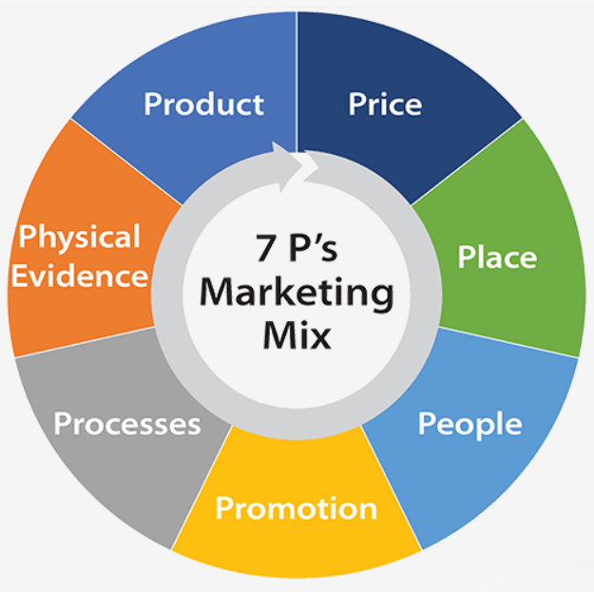


3.1 Product
Levitt's (1980) Total Product Concept provides the most analytically useful lens. At the core level, Apple Health+ delivers personalized health intelligence and qualified clinical access. At the expected level, consumers require accurate biometric analysis, reliable telehealth response times, and assured privacy. The augmented product encompasses Apple's differentiators: on-device AI, ecosystem integration, NHS-accredited consultations, and family health management. The potential product longitudinal AI-driven early disease prediction, represents the platform's highest-value, longest-horizon opportunity.
Critically, the most significant product risk is the tension between Apple's scalability culture and healthcare's requirement for individual clinical judgment. As the platform scales, the risk of reducing telehealth consultations to high-throughput, low-quality transactions rise, a failure mode that would damage the brand disproportionately, as health errors carry reputational consequences that technology failures typically do not. Robust clinical governance frameworks, independent of Apple's technology product teams, are therefore a structural product design requirement rather than a compliance afterthought.

3.2 Price
Apple Health+ adopts value-based pricing (Nagle and Müller, 2018), anchoring price to perceived clinical and AI value rather than cost of production:

Tier | Price / Month | Key Features
Essential | £9.99 | AI insights, wellness content, fitness coaching
Plus | £19.99 | All Essential + 2 telehealth GP consultations/month
Family | £29.99 | All Plus features for up to 6 family members

The £9.99 entry tier implements Gabor and Granger's (1966) price acceptance theorem by applying a psychologically anchored threshold for trial risk reduction/initial adoption. Annual billing 2 months free vs monthly revenue recognition, increases switching costs Importantly, value pricing to £9.99–£29.99/month generates an access gap: some 22% of UK households (DWP, 2023) are actively barred from taking part due to relative poverty and unable to pay through medium-term deterrents like credit-driven plans (where there is a maximum credit method/amount not usage-based charging). The absence of such a graded distribution or an NHS-partnership access pathway represents a significant clash between Apple's professed social values and its monetization policy.

3.3 Place
Apple Health+ distributes exclusively through Apple's own digital channels, App Store, iPhone, Watch, iPad, Mac, adopting a direct-to-consumer (DTC) model that affords complete control over customer experience quality (Rosenbloom, 2011). But crucially, DTC-only distribution shuts off major routes to acquisition those competitors are successfully pursuing: tens of millions of users at practically zero marginal cost by way of employer wellness partnerships, insurer integrations and NHS referral pathways. What would have worked better was a phased approach: initial DTC launch to set the quality bar, coupled with targeted opening of employer and insurer channels in Year 2 for a better balance of speed and control among key stakeholders.

3.4 Promotion
Promotional planning is grounded in a pull strategy (Kotler et al., 2024) and anchored within Keller's (2013) Brand Resonance Model Brand salience is structured via cinematic digital advertising (Instagram, YouTube, TikTok); performance and imagery associations are instilled through NHS clinical endorsements and wellness professional partnerships; judgements and feelings addressed through a health content editorial platform (blog, podcast, weekly briefings), resonance drawn from community embeds & long term subscriber loyalty rewards. The published health content (on a commercial platform) is within ASA guidance and NHS information quality standards requires an established editorial governance structure, that on the part of Apple must be invested in from Day 1 not retroactively.

3.5 People
Vargo and Lusch's (2004) Service-Dominant Logic (SDL) establishes that value in services is co-created through each interaction between provider and consumer, not embedded in the product itself. For Apple Health+, the clinical consultation, coaching session, and support interaction collectively constitute the product quality experienced by the consumer. This creates a governance challenge Apple is not culturally equipped for by default: its engineering-precision culture does not map onto the empathetic, ethically complex domain of clinical healthcare. NHS-accredited clinicians must maintain professional clinical autonomy within Apple's operational framework, a dual accountability structure requiring explicit governance design, continuing professional development investment, and robust clinician feedback channels.

3.6 Process
Process design is a competitive differentiator for Apple Health+, masking the complexity of clinical and data management behind Apple's signature simplicity. Onboarding leverages existing Health app data to create a personalized health baseline within minutes. Telehealth appointments must be bookable within three taps, targeting sub-four-hour wait times requiring a phased clinical capacity build (500 clinicians at launch, scaling to 5,000 by Year 3) rather than full-service delivery from Day 1. Privacy-by-Design (Cavoukian, 2009) is embedded architecturally: on-device AI processing via Apple's Neural Engine ensures biometric analysis occurs locally. Critically, this architectural commitment imposes real constraints on-device processing is computationally bounded relative to cloud models — which may limit AI insight sophistication. Apple must be transparent with consumers about this trade-off rather than implying unlimited AI capability.

3.7 Physical Evidence
Physical evidence tangible cues through which consumers evaluate service quality (Lovelock and Wirtz, 2016) operates primarily at the interface level for Apple Health+. The application's design, developed to Apple's Human Interface Guidelines, constitutes the primary quality signal and creates a halo effect transferring Apple's established brand equity to the health service. NHS partnership logos, CQC registration badges, and App Store Privacy Nutrition Labels function as third-party validation signals what Zeithaml et al. (1990) term 'search qualities', evaluable before purchase. Critically, these signals raise consumer expectations commensurate with Apple's established premium standard: any design inconsistency will damage confidence disproportionately relative to a competitor that set lower design expectations at launch.

Element 4: Critical Reflection
This reflection applies Gibbs' (1988) Reflective Cycle in full Description, Feelings, Evaluation, Analysis, Conclusion, and Action Plan to critically evaluate my experience developing the Apple Health+ brand extension strategy.
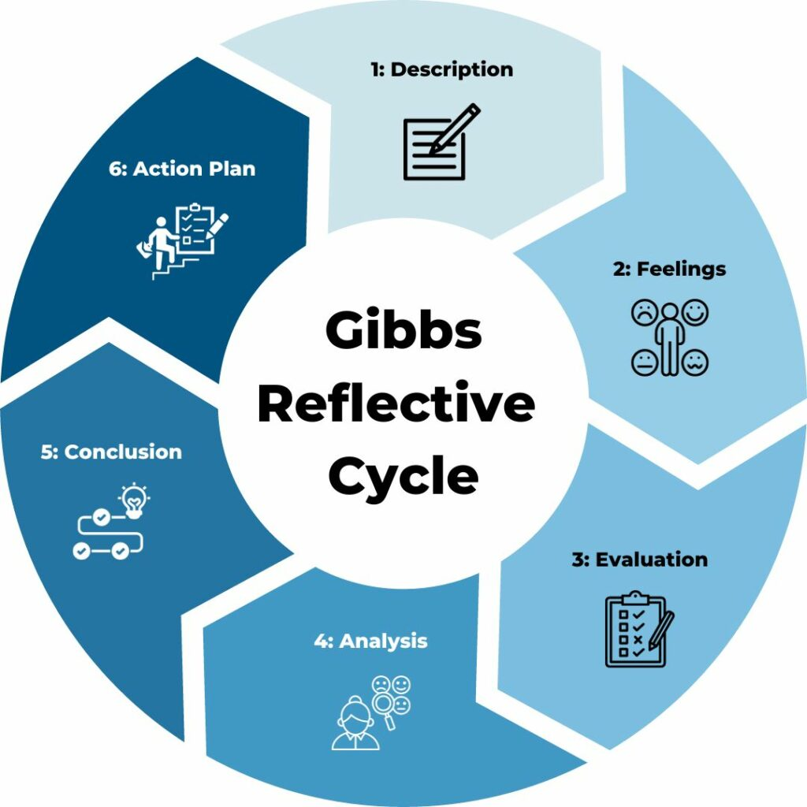

Stage 1 — Description: What happened?
For my assignment I had to create an entire brand development portfolio for a technology business of my choice based on which was comprising a poster presentation and combined with the STDP, 7Ps marketing mix and reflection. The exercise was to choose a brand of my choice and a company that has good traction (market buzz) and then pitch on the "brand extension" in classes, so I chose Apple Inc. for my category, and suggested Apple Health+ a subscription health platform as the brand extension. My initial feedback indicated that my work lacked critical analysis to move past mere description, theoretical frameworks were predominantly used despite underlying concerns of their limitations.

Stage 2 — Feelings: What was I thinking and feeling?
At first, my reaction to the negative feedback was defensive: I had followed the frameworks and included all required parts. Reflected upon, this defensiveness is at least a learning signal. I knew the content inside and out, but I was unease making the differentiation between applying criteria accurately and evaluating research critically something I had never been made to face overtly in work before.

Stage 3 — Evaluation: What was good and bad?
Overall, the range and relevance of academic sources was good, STDP and 7Ps frameworks were accurately identified and methodically applied, and the brand extension idea itself was credible with sound support. But, in a negative aspect much of the analysis used more descriptive frameworks were simply deployed rather than interrogated. For instance, the use of Levitt's (1980) Total Product Concept was without consideration of whether a model alive in a manufacturing environment needed modification for a digitally delivered health service. The poster presentation followed suit, with an emphasis on completeness over impact rendering a non-persuasive but dense visual artefact.

Stage 4 — Analysis: Why did things happen this way?
Using Bloom's Taxonomy (Anderson and Krathwohl, 2001) as a guide, I observe that I was functioning at the lower-order levels of knowledge and comprehension not at the analysis, synthesis and evaluation levels needed to produce Level 6 academic work. Kahneman (2011) refers to this type of thinking as System 1 thinking fast, pattern matching and confident rather than the System 2 thinking slow, analytical and self-questioning required for critical academic writing. I began with a conclusion (Apple Health+ is a strong extension) and marshalled evidence to support it, exhibiting confirmation bias rather than genuinely evaluating competing positions. In the poster presentation, my difficulty distinguishing the essential from the interesting reflected an encyclopedic rather than hierarchical understanding of the strategy a distinction central to both effective academic argument and strategic communication.

Stage 5 — Conclusion: What else could I have done?
A more rigorous application of what is essentially a 'steel-man' approach constructing the strongest counter argument against every strategic claim prior to committing it to paper would have surfaced some of these tensions earlier, for example between Apple's rhetoric on social inclusion and its premium pricing model. I could have framed the narrative of the poster around a single superordinate claim like 'Apple Health is the only platform for health that achieves clinical credibility and uncompromised privacy' with all evidence supporting it, rather than juxtaposing parallel lines of evidence without an argumentative thread.

Stage 6 — Action Plan: What will I do differently?
As the first move, I shall practice a discipline of 'tension identification' across every analytical writing that follows from here onwards: Before I crystallize any strategic section, I will clearly turn over the card of discovering both primary counterarguments as well as evidencing simultaneous tensions within the strategy. Second, in order to build argument credibility which, the STDP lacks as it relies on psychographic segment assumptions, I will conduct a regression based Primary Consumer Research (n≥80), targeting Apple Watch users aged 25-54. This experience will develop primary research design skills that my skill stack needs. Third, I will finish the financial modelling module (CFI online) and will study till my next submission to integrate CAC, LTV and break-even analysis into discussions on pricing strategy so that I can provide more quantitatively rigorous strategic recommendations than conceptual.

Conclusion
Apple Health+ represents a strategically compelling and critically evaluated brand extension. The STDP analysis demonstrates that Apple's combination of ecosystem lock-in, privacy-first architecture, and established consumer trust creates a defensible and differentiated market position in a sector growing at 18.6% CAGR one that no direct competitor can replicate without abandoning core business model commitments. The 7Ps analysis confirms that the extension is viable across all operational dimensions, whilst honestly identifying the tensions between scale and clinical quality, premium pricing and social inclusion, DTC control and distribution reach that must be actively managed as the platform scales.

References
Aaker, D.A. (1991) Managing Brand Equity. New York: Free Press.
Anderson, L.W. and Krathwohl, D.R. (eds.) (2001) A Taxonomy for Learning, Teaching, and Assessing. New York: Longman.
Apple (2024) Apple Q4 FY2024 Earnings Release. Available at: https://investor.apple.com (Accessed: 12 March 2026).
Booms, B.H. and Bitner, M.J. (1981) 'Marketing strategies and organization structures for service firms', in Donnelly, J.H. and George, W.R. (eds) Marketing of Services. Chicago: AMA, pp. 47–51.
Cavoukian, A. (2009) Privacy by Design: The 7 Foundational Principles. Toronto: Information and Privacy Commissioner of Ontario.
Deloitte (2022) 2022 Global Health Care Consumer Survey. London: Deloitte Insights.
Department for Work and Pensions (2023) Households Below Average Income: 2022/23. London: HMSO.
Eysenbach, G. (2005) 'The law of attrition', Journal of Medical Internet Research, 7(1), p. e11.
Gabor, A. and Granger, C.W.J. (1966) 'Price as an indicator of quality', Economica, 33(129), pp. 43–70.
Gibbs, G. (1988) Learning by Doing: A Guide to Teaching and Learning Methods. Oxford: Further Education Unit.
Grand View Research (2023) Digital Health Market Size, Share & Trends Analysis Report. San Francisco: GVR.
Grönroos, C. (1997) 'Value-driven relational marketing', Journal of Marketing Management, 13(5), pp. 407–419.
Kahneman, D. (2011) Thinking, Fast and Slow. London: Allen Lane.
Keller, K.L. (2013) Strategic Brand Management. 4th edn. Harlow: Pearson.
Kotler, P., Armstrong, G., Harris, L.C. and He, H. (2024) Principles of Marketing. 9th European edn. Harlow: Pearson.
Levitt, T. (1980) 'Marketing success through differentiation', Harvard Business Review, 58(1), pp. 83–91.
Lovelock, C. and Wirtz, J. (2016) Services Marketing. 8th edn. London: World Scientific.
McKinsey & Company (2022) Telehealth: A Quarter-Trillion-Dollar Post-COVID-19 Reality? New York: McKinsey.
Nagle, T.T. and Müller, G. (2018) The Strategy and Tactics of Pricing. 6th edn. New York: Routledge.
NHS England (2023) NHS Long Term Workforce Plan. London: NHS England.
NHS Digital (2023) Health Survey for England 2022. London: NHS Digital.
Rogers, E.M. (1962) Diffusion of Innovations. New York: Free Press.
Rosenbloom, B. (2011) Marketing Channels. 8th edn. Mason, OH: South-Western Cengage Learning.
Shapiro, C. and Varian, H.R. (1999) Information Rules. Boston: Harvard Business School Press.
Statcounter (2024) Mobile OS Market Share UK. Available at: https://gs.statcounter.com (Accessed: 14 March 2026).
Vargo, S.L. and Lusch, R.F. (2004) 'Evolving to a new dominant logic for marketing', Journal of Marketing, 68(1), pp. 1–17.
Zeithaml, V.A., Parasuraman, A. and Berry, L.L. (1990) Delivering Quality Service. New York: Free Press.

Appendix A: Apple Health+ Brand Extension Poster
The following poster was created for the Element 1 brand extension poster presentation and is reproduced here as an appendix to the portfolio in line with submission requirements. The poster was submitted separately under the designated Element 1 submission link for presentation purposes.



