Database Coursework Submission Template
1. Student Details
- Name: Giulia Marchio
- Student ID: 2436462
- Module: Introduction to Web and Database
- Lecturer: Fahad Ahmed
2. Table of Contents
- Scenario
Explanation ………………………………………1
- Task 1: implementation
Guide……………………………………2
  - Scenario
Analysis……………………………2
  - ERD & Data
Structure……………………….3
  - Normalization
(3NF) ……………………………..3
  - Query
Development……………………..4
- Design Decisions & Reflection………………….5
- References…………………………………….6

3. Introduction
- Overview of MediLink Pharmacy scenario
Medlink Pharmacy is a local pharmacy that has recently stated expanding and opening new branches. At the moment, most of their work is still done manually using paper records. This has led to several mistakes, especially when tracking medicine stock or recording customer information’s. As the business continues to expand or grow, this manual system is no longer reliable or efficient. A more organized and accurate system is needed to manage daily operations and avoid these errors.
- Purpose of the database system
The purpose of developing this Microsoft Access database is to improve how pharmacy works. By replacing paper-based records with digital system, the chances of human errors will be less. Staff will be able to quickly check which medicines are available, which items are low in stock, and what needs to be reordered. In addition, customer transactions can be recorded accurately and stored securely.
This system will also help pharmacy mangers generate clear reports, monitors sales, and ensure that all records are properly secured or maintained. Overall, the database will make the pharmacy more efficient, reliable, and better prepared for future growth.
4. Scenario Analysis
- Identify entities
These are the four main tables I decide to build in the database
- Medicines: to keep track of the medicines in the shop.
- Vendors: to store details of companies that sell medicines to the pharmacy.
- Customers: to hold info about the people buying prescriptions.
- Sales: to record each time a transaction happens.

- Attributes of each entity
For this system, I decided that the most important thing to track is the medicine. I will need to know the name of the drug and how much we have left on the store. Why this is important because I include phone number for customers so the pharmacist can contact them if there is a problem or any issue with their prescription.
- Medicines: Medicine ID, Company name, contact person, and phone number
- Vendors: Vendor ID, first name, contact number, and phone, number.
- Customers: Customer ID, first name, last name, full home address, contact number, and emergency contact number.
- Sales: Sales ID, date of sales, total cost, and which customer bought it.
- Relationships between entities
The relationships between those would be, how the tables talk to each other:
- Vendors and Medicines: one vendor can provide many different medicines.
- Customers and Sales: one customer can come back several times to make different purchases.
- Medicines and Sales each sale record will show which medicines were taken from the inventory.
ID | Name | Category | Price | Stock | SupplierID
1 | Paracetamol | Analgesic | £2.50 | 150 | S001
2 | Amoxicillin | Antibiotic | £10.00 | 45 | S002
3 | Ibuprofen | Anti-inflammatory | £3.75 | 120 | S001
4 | Insulin | Antidiabetic | £25.00 | 30 | S003
5 | Cetirizine | Antihistamine | £5.20 | 85 | S002
- Entity Relationship Diagram (ERD)
An entity relationship diagram is just a simple visual drawing that shows all the main parts of the database and how the link to each other. For medilink pharmacy, my ERD shows the 4 main tables I planned earlier: medicines, vendors, customers and sales.
On the diagram, I use lines to show how the connect. For example, there is a line between vendors and medicines because every medicine that sell comes from one specific supplier. There is also a line between customers and sales, so it can be easily known exactly which customer made which purchase. I also added a separate table called sale details because one single purchase can have a lot of different medicines in it.
I made sure to use simple labels in my diagram so anyone looking at it can understand exactly what each part means.
I set up primary keys for every table so every record is unique. I then used foreign keys to link the tables so the system knows who to order stock form.
The relationships are mostly ‘One to Many’, meaning one supplier sends many medicines. For the sales and medicines connection, I used a junction table to handle ‘Many to Many’ relationship so the data stays clean.
When designing the data structure and normalization, I used normalization rules to make sure all the information is stored correctly and there is no repeated data. I worked through the three standard levels:

First Normal Form (1NF): I made sure every single column only holds one type of information. Like, in the customer table, I split names into separate first name and last name columns, instead of having them written together in one box.

Second Normal Form (2NF): I moved any extra details that didn’t belong to the main topic into their own tables. For example, the information about suppliers doesn’t belong in the medicine table, so what I did was to move all supplier details in their own separate table.

Third Normal Form (3NF): This is the last level I used. I made sure there is no information that relies on something that isn’t the main ID of the table. For example, I didn’t put the supplier phone number inside the medicine table.
- Data Structure Design
- Tables created

I created the following five tables in Microsoft access to store all the information needed for the pharmacy:
- Tblmedicines - to store details about all drugs and stock.
- Tblvendors - to keep records of the companies we buy from.
- Tblcustomers - to hold personal details of patients and clients.
- Tblsales – to record every transaction made at the counter.
- Tblsaledetails – to list exactly which items were inside each sale.
- Field names and data types

I designed each table carefully, choosing the correct data type for every field so the information is stored properly.

TBLMEDICINES
Field Name | Data Type | Example Data
MedicineID | AutoNumber | 1, 2, 3
MedicineName | Text | Paracetamol, Ibuprofen
Category | Text | Painkiller, Antibiotic
UnitPrice | Currency | £2.50, £5.00
StockQuantity | Number | 100, 50
SupplierID | Number | 1, 2

TBLSUPPLIERS

Field Name | Data Type | Example Data
SupplierID | AutoNumber | S01, S02
SupplierName | Text | PharmaCare Ltd
ContactName | Text | Mr. John Smith
PhoneNumber | Text | 07123456789
Email | Text | info@pharmacare.com

TBLCUSTOMERS
Field Name | Data Type | Example Data
CustomerID | AutoNumber | C001, C002
FirstName | Short Text | Sarah, Ali
LastName | Short Text | Jones, Khan
Phone | Short Text | 07987654321
Address | Short Text | 12 London Road

TBLSALES
Field Name | Data Type | Example Data
SaleID | AutoNumber | 1001, 1002
CustomerID | Number | 1, 2
SaleDate | Date/Time | 29/04/2026
TotalAmount | Currency | £15.00, £22.50

TBLSALEDETAILS
Field Name | Data Type | Example Data
DetailID | AutoNumber | 1, 2, 3
SaleID | Number | 1001
MedicineID | Number | 1
QuantitySold | Number | 2
- Relationships and constraints
I linked the tables together using the relationships window in access. This ensures that the data connects correctly and no mistakes happen.

The relationships:
- Tblsuppliers linked to tblmedicines the reason is one company can supply many different medicines.
- Tblcustomers linked to tblsales the reason is one customer can make different purchase over time.
- Tblsales linked to tblsalesdetail. One to many
- Tblmedicines linked to tblsaledetails the reason is this handle the fact that one sale can have many items, and one item can be in many sales.
7. Normalisation (Up to 3NF)
- Show steps of normalization
First formal form (1NF)
- Ensured every cell hold only one value.
- Split full names into first name and last name.
- Added a unique ID number (Primary Key) to every record.

Second Normal Form (2NF)
- Split data into separe tables based on what they are about (example: medicines, suppliers, customers).
- Removed repeated data. Example, supplier details are store once, not next to every medicine.

Third Normal Form (3NF)
- Removed any columns that did not depend on the Primary Key.
- Ensured that information like phone numbers or addresses stays in their correct tables only.

- Explain decisions
I normalized to 3NF to make the database clean and error free.

- Saves space: no duplicate information’s means the file size stays small and organized.
- Easy to update: if a supplier changes their number, I only edit it once in the supplier table.
- Prevents Mistakes: it stops wrong data from being entered because everything is linked properly.
- Professional Structure: it follows standard database rules, making the system easy to use and maintain.

8. Sample Data
tblMedicines
MedicineID | MedicineName | Category | UnitPrice | StockQuantity | SupplierID
1 | Paracetamol | Painkiller | £1.50 | 100 | 1
2 | Ibuprofen | Painkiller | £2.20 | 85 | 1
3 | Amoxicillin | Antibiotic | £8.90 | 40 | 2
4 | Loratadine | Allergy | £4.50 | 60 | 2
5 | Omeprazole | Stomach | £6.80 | 30 | 3

tblSuppliers
SupplierID | SupplierName | ContactName | Phone | Email
1 | MedSupply Ltd | David Brown | 07111222333 | info@medsupply.com
2 | PharmaGlobal | Sarah Lee | 07444555666 | orders@pharmaglobal.com
3 | HealthLine | Mike Ross | 07777888999 | sales@healthline.com
4 | BioCare Ltd | Emma Clark | 07222333444 | contact@biocare.co.uk
5 | DirectMed | Tom Evans | 07555666777 | help@directmed.com

tblCustomers
CustomerID | FirstName | LastName | Phone | Address
1 | James | Smith | 07999111222 | 10 London Road
2 | Emily | Jones | 07888222333 | 25 High Street
3 | Mohammed | Khan | 07777333444 | 5 Park Avenue
4 | Lisa | Wong | 07666444555 | 12 Main Road
5 | Robert | Taylor | 07555555666 | 8 Queen Street

tblSales
SaleID | CustomerID | SaleDate | TotalAmount
101 | 1 | 28/04/2026 | £12.50
102 | 2 | 28/04/2026 | £8.90
103 | 3 | 29/04/2026 | £15.40
104 | 5 | 29/04/2026 | £22.00
105 | 4 | 29/04/2026 | £6.70

tblSaleDetails
DetailID | SaleID | MedicineID | QuantitySold
1 | 101 | 1 | 2
2 | 101 | 2 | 1
3 | 102 | 3 | 1
4 | 103 | 5 | 2
5 | 104 | 4 | 3

9. Queries
- List queries created
- qryMedicinelist
- qrylowstock
- qrycustomersales
- qydailytotal
- Purpose of each query
- qrymedicinelist
- purpose: shows a full list of all medicines and their prices.
- Why: so, staff can check what is available without searching manually.

- qryLowStock:
- purpose: shows items where stock is less than 50 units.
- Why: to warn the manager when it is time to reorder more stock.

- qryCustomerSales
- purpose: links customer names to their purchase history.
- Why: to see exactly who bought what and when.

- qryDailyTotal
- purpose: calculates the total money taken in one day.
- Why: to check sales performance easily.

screenshots
- 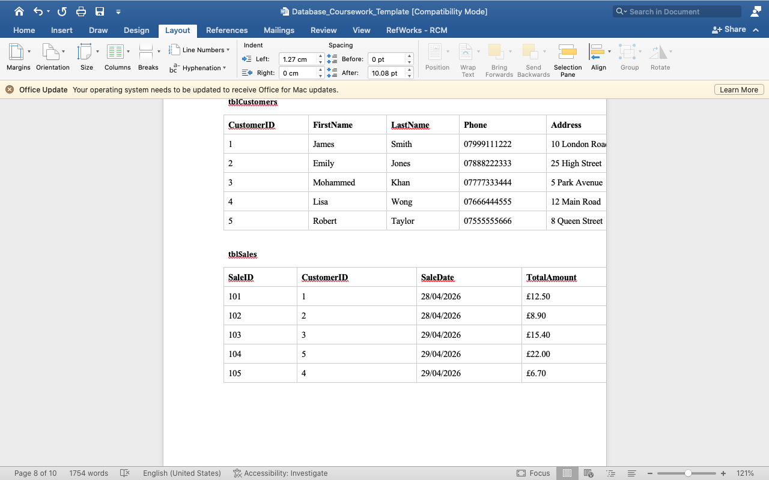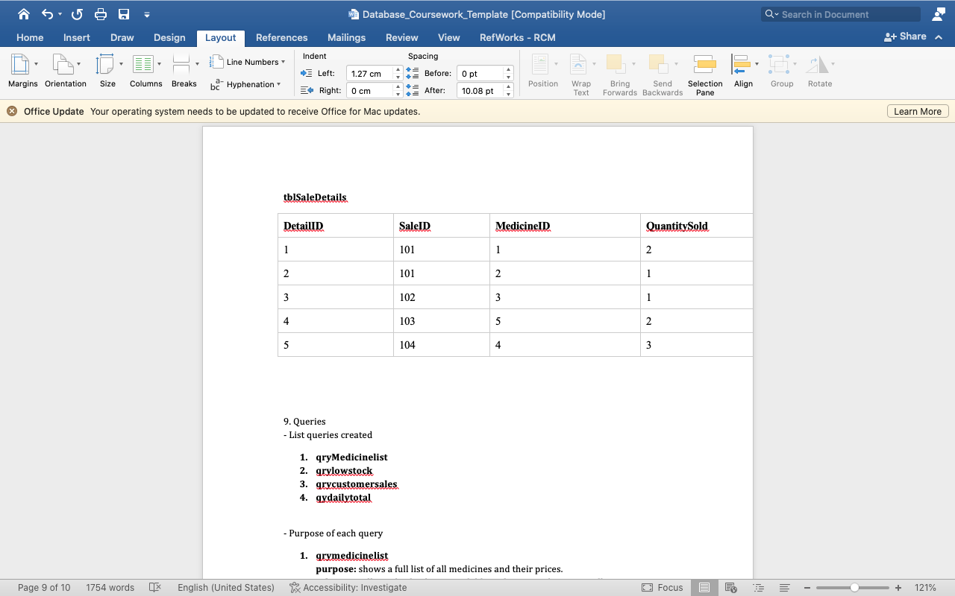
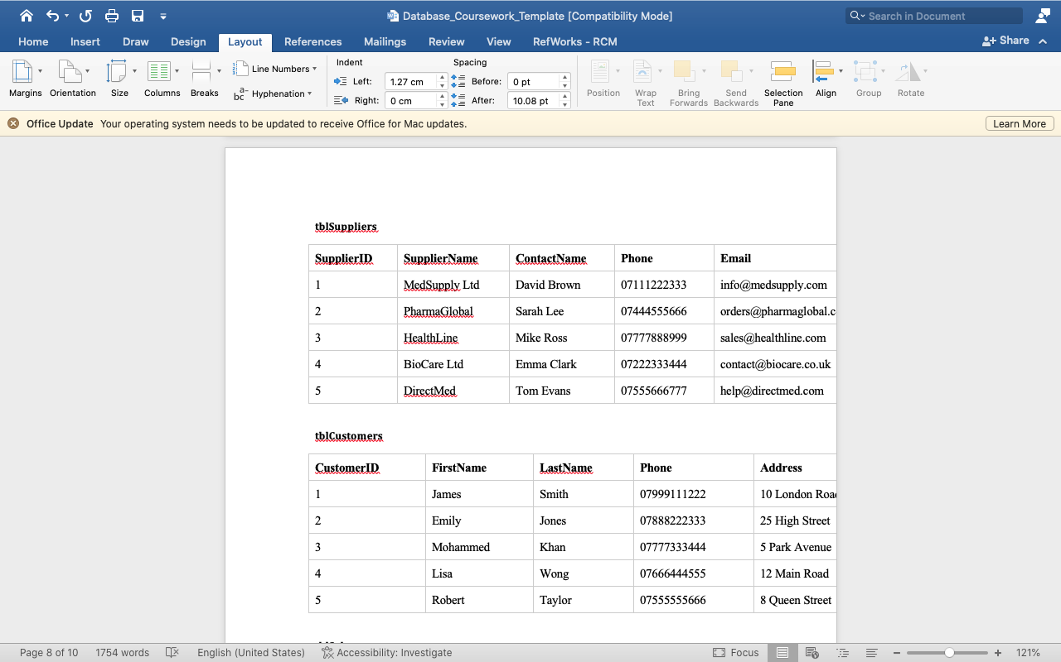
10. Forms and Reports
- Screenshots of forms
- Screenshots of reports
- Explanation of functionality
This is the main screen used at the counter. It lets you select a customer and choose which medicines they are buying. It automatically links everything together so the system knows exactly what was sold.
11. Validation and Testing
I teste the system carefully to make sure it works correctly and is easy to use.
- Testing methods
I used two main ways to test it:
- Normal Data: I entered correct information like names, prices, and dates to see if it saves properly.
- Erroneous Data (Validation): I tried to enter wrong data on purpose to check if the system stops mistakes.

Example: tried to type letters into the price box.
- Results
- Data Entry: all information saves correctly into the tables.
- Relationships: the links between tables work perfectly when I select a supplier, it shows the right medicines.
- Queries: all searches return the correct results quickly.
- Validation Rules: the system successfully shows error messages if wrong data is entered, preventing mistakes.

- Issues found and fixes
Issue Found | How I Fixed It
Duplicate Records | I set the Primary Key correctly so the same ID cannot be used twice.
Data Too Long | I changed the Field Size property so text fits properly without being cut off.
Wrong Format | I set Validation Rules (e.g., must be a number between 0 and 1000) to stop errors.
Relationship Errors | I made sure both fields had the same Data Type before linking them.
The system is reliable, fast, and stops most errors automatically. It is ready for pharmacy to use.
12. Reflection
- Challenges faced
- Relationships: linking tables was difficult at first because data types had to match exactly.
- Normalization: splitting data into the correct tables took time to understand properly.
- Queries: writing the SQL code and joins required a lot of testing to get right.

- Improvements for future
- Security: ad a login system with password to protect the data.
- Design: make the forms look more professional with better colors and buttons.
- Backup: set up automatic saving so information is never lost.

13. Conclusion
the MediLink Pharmacy system is now complete and works successfully.
I created all the necessary tables, queries, forms, and reports. The database is normalized to 3NF, which keeps the data clean and organized.
- The system helps staff:
- Keep track of stock easily
- Record sales quickly
- Find customer information fast

Testing showed that the system is reliable, user friendly, and ready to use.
Overall, the project met all the requirements successfully.

14. References
1] Microsoft, "Access Help & Learning", Available: https://support.microsoft.com/en-us/access [Accessed: 29-Apr-2026].
[2] W3Schools, "SQL Tutorial", Available: https://www.w3schools.com/sql [Accessed: 29-Apr-2026].
[3] T. Connolly and C. Begg, Database Systems: A Practical Approach to Design, Implementation, and Management, 6th ed. Harlow: Pearson Education, 2015.
[4] BBC Bitesize, "Database Concepts", Available: https://www.bbc.co.uk/bitesize [Accessed: 29-Apr-2026].
[5] TutorialsPoint, "Normalization Process", Available: https://www.tutorialspoint.com/dbms [Accessed: 29-Apr-2026].

