IMPACT BEHAVIOUR INVESTIGATION OF TOOL STEEL ARMOUR-PIERCING PROJECTILES USING a fINITE eLEMENT aNALYSIS MODEL
For:
ACDB4007 – Physics
Produced By:
Leo Oliver Smith (2217998)
On:
10th May 2023

Abstract

Armor-piercing (AP) ammunition is a family of small arms rounds specifically designed to provide increased penetration against hardened targets such as light armor and vehicles. Steel cores are popular as they have no secondary hazards unlike Depleted Uranium or Tungsten Heavy Alloy’s which can produce toxic dust. They do, however, have far lower ballistic efficiency.
Research into the penetration ability of steel cores has been widely studied and in order to further explore this a finite element analysis software Abaqus was used. A common tool steel (C45) in the shape of a 7.62 NATO AP core was incident upon 6mm of both rolled homogeneous armor (RHA) steel and aluminum (AL) at 300m/s and the results analysis.
The RHA absorbed 99.3% of the rounds kinetic energy (KE) defeating the projectile and causing rebound whereas the AL was defeated by the round absorbing 75% of the KE in the process. In both cases the most probable cause of failure would be a star shaped crack on the back face caused by high tensile stresses.

Table of Contents
Abstract 2
Table of figures 3
Table of Tables 4
1.0 Introduction 5
1.1 Armor-Piercing Rounds 5
1.2 Non-ferrous projectile cores 5
1.3 Steel projectile cores 6
2.0 Methodology 7
2.1 Materials 7
2.2 Material Models and Properties 7
2.3 Model set up 9
2.4 Shot Plan 12
3.0 Results and discussion 13
3.1 Projectile velocity 13
3.2 Stress Strain Within Plates 15
3.3 Critiques of the model 18
4.0 Conclusion 19
Appendix A – Impact Stress Imagery 20
Shot 1 20
Shot 2 25
Appendix B – Further Research Conducted 32
References 33

Table of figures
Figure 1 9
Figure 2 9
Figure 3 10
Figure 4 11
Figure 5 11
Figure 6 13
Figure 7 13
Figure 8 14
Figure 9 14
Figure 10 15
Figure 11 16
Figure 12 17
Figure 13 17
Figure 14 20
Figure 15 20
Figure 16 21
Figure 17 21
Figure 18 22
Figure 19 22
Figure 20 23
Figure 21 23
Figure 22 24
Figure 23 24
Figure 24 25
Figure 25 25
Figure 26 26
Figure 27 26
Figure 28 27
Figure 29 27
Figure 30 28
Figure 31 28
Figure 32 29
Figure 33 29
Figure 34 30
Figure 35 30
Figure 36 31

Table of Tables
Table 1 6
Table 2 6
Table 3 7
Table 4 7
Table 5 11

Introduction

1.1 Armor-Piercing Rounds

Armor-piercing (AP) ammunition is a family of small arms rounds specifically designed to provide increased penetration against hardened targets such as light armor and vehicles.
As with ball ammunition a soft copper jacket, designed to provide aerodynamic efficiency and interact with a weapons rifling, contains a core that delivers the effect. Unlike Ball rounds that use soft lead cores, AP rounds use hardened projectiles to deliver large amounts of kinetic energy to a low target area.
During impact the AP core erodes, flattening the projectiles point. This flattening increases the contact area and reduces the forces exerted decreasing penetration .As such AP cores are extremely hard to resist erosion remaining sharp and optimizing energy transfer.
AP cores are often long and thin to provide a greater mass and hence kinetic energy whilst having low frontal areas and sharp points. It is common for harder cores to be denser and hence have lower velocity as propellant charges are fixed. There greater efficiency however results in deeper penetration regardless.

1.2 Non-ferrous projectile cores

Non-Ferrous cores are often used due to there increased hardness and density. The two most common being Depleted Uranium (DU) and Tungsten Heavy Alloys (WHA)
DU is the most efficient core available for use providing unparalleled hardness and density. This ultimately means it delivers the greatest kinetic energy and penetration. DU however is a byproduct from enriching uranium making it radioactive waste. Due to this it has health and environmental implications. Upon impact it ignites producing toxic metal oxide dust and radioactively contaminating the surrounding area. In conflict this may be acceptable but the effects limit the use case for the round.
Tungsten alone has a hardness and melting point that can’t be worked with so WHA is made by holding tungsten dust in a cobalt alloy metal matrix. This alloy produces a highly efficient core with less secondary risks than DU making it a more popular choice. It should be noted WHA dusk is toxic if inhaled and so this round like DU shouldn’t be used in confined spaces.

1.3 Steel projectile cores

Steel AP cores are made up of high carbon alloys that are often heat treated to specified harness levels. These cores do not have the density or hardness of their non-ferrous counterparts and as such fall short regarding ballistic efficiency. They are still a valuable solution, posing many benefits.
Steel AP cores do not have the same secondary hazards as DU or WHA producing no harmful metal oxides or contaminants upon impact. This makes them popular for training and armor testing, two scenarios where inspection of the impact site and hence, risk of contact with secondary hazards are likely.
These cores are also cheap compared to alternative solutions due to their inexpensive material cost and similarity to mass produced industrial grade steels used in applications such as high-speed machining. Due to their low cost and safety steel core AP behavior has been extensively studied against a range of targets in order to both test armor and projectile solutions.
One such study conducted by Di Benedetto et al. [1] noted that the majority of work related to tool steel cores focuses of the macroscopic effects of the target plate, disregarding the mechanisms of the plate failure or the specific behavior of the projectile material. As such they conducted experimental work to compare the ballistic efficiency and fracture mechanics of hardened tool steels with identical projectile shapes.
The work produced within this paper aimed to learn from their practical experiments and focuses on the ballistic impact of tool steel cored AP rounds against two different targets. Due to practicality this experiment was conducted using a finite element analysis (FEA) package Abaqus produced by Dassault Systemes.

2.0 Methodology

2.1 Materials
The materials listed below were chosen for both their applicability to the problem and their well characterized material properties. This is essential as FEA uses a combination of material models to solve the problem and unknown or inaccurate material properties can cause the model to fail or behave unexpectedly.
Table 1
Material | Part | Justification
C45 medium carbon steel (approximately equivalent to AISI 1045) | AP Core Projectile | The lowest performing tool steel grade in the work of Di Benedetto et al. This means the projectile will show high erosion allowing for clear analysis.
Rolled Homogenous Armor (RHA) steel | Target Plate | The most common material used for armor testing. This allows an insight into the cores effect on miliary grade targets and can easily be compared to other works.
Aluminum 6061-T6 | Target Plate | A similar material to that use by Di Benedetto et al. to allow comparison with their work and the harder RHA plate.

2.2 Material Models and Properties

2.2.1 General Properties
These standard material properties are used to calculate parameters such as the mass of parts and support the further material models listed. The relevant values are as follows:
Table 2
Material | Mass Density [KG/M³] | Youngs Modulus [GPa] | Poissons Ratio
C45 medium carbon steel | 7870 [2] | 206 [3] | 0.29 [3]
Rolled Homogeous Armor Steel [4] | 7980 | 210 | 0.33
Aluminum 6061-T6 [5] | 2699 | 68 | 0.36

2.2.2 Johnson-Cook Plasticity
As the timescale in this ballistic collision is low, so strain rates are high. The Johnson-Cook (JC) plasticity model specializes in calculating stress strain values in these conditions so was chosen for this model [6]. The relevant JC Plasticity parameter values for the materials used are as followed:
Table 3
Material | A [MPa] | B [MPa] | n | θ_{melt} [K] | θ_{transition} [K] | m | C | Ε₀ [1/s]
C45 medium carbon steel [7] | 553 | 600 | 0.234 | 1733 | 293 | 1 | 0.0134 | 0.001
Rolled Homogeous Armor Steel [8] | 980 | 2000 | 0.830 | 1800 | 300 | 1.4 | 0.0026 | 0.0001
Aluminum 6061-T6 [5] | 262 | 162.1 | 0.2783 | 925 | 293.2 | 1.34 | 0.002 | 1

2.2.3 Johnson-Cook Damage
The Johnson-Cook dynamic failure model was used due to its integration into the JC Plasticity model. Suitable for high strain rate environments this damage model allows for progressive failure, better modeling realistic behaviors [6]. The relevant parameters for the materials used are as follows:
Table 4
Material | d₁ | d₂ | d₃ | d₄ | d₅ | Reference Strain Rate | Fracture Energy [J]
C45 medium carbon steel [7] | 0.6 | 3.31 | 1.96 | 0.0018 | 0.58 | 1 | 9.5 [9]
Rolled Homogeous Armor Steel [8] | 0.05 | 0.8 | 0.44 | 0.046 | 2.9 | 1 | 0*
Aluminum 6061-T6 [5] | -0.77 | 1.45 | 0.47 | 0.0 | 1.6 | 1 | 0*

2.3 Model set up

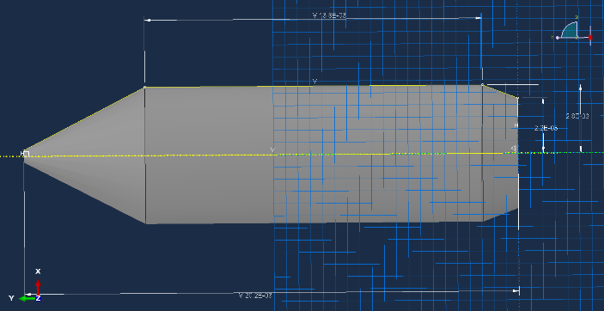
2.3.1 Parts
Figure 1
The AP core (Figure 1) was made using a 360⁰ solid fill rotation around the Y-axis. The shape corresponds to civilian 0.308 Winchester or 7.62 NATO standards. No copper jacket was used as it too soft to effect penetration and in practical work has little effect ,3-5%, of projectile velocity [10].
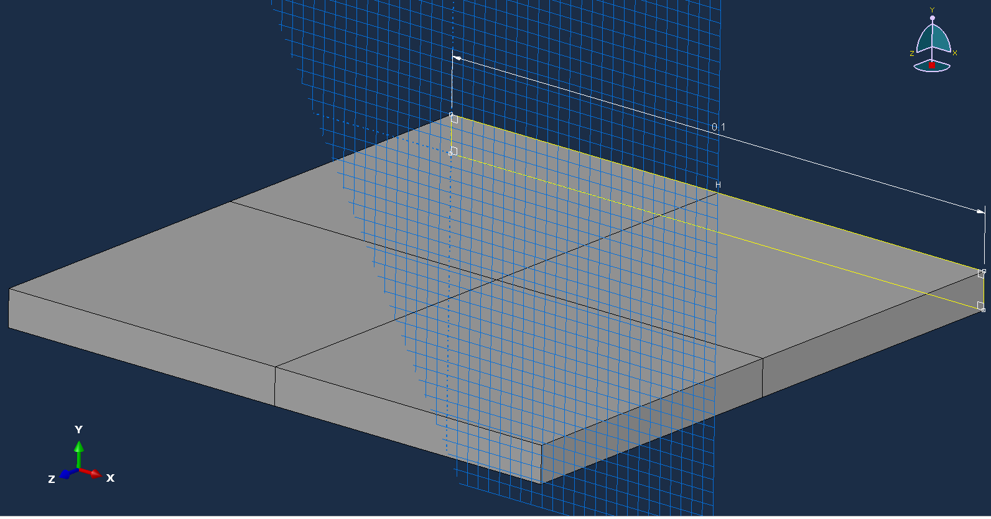
Figure 2
The target plate (Figure 2) was made to be 100 x 100 x 6 mm. This allowed the mesh size to be appropriately small whilst lowering the number of nodes compared to a larger plate decreasing run time. At 6mm thick the plate was consistent with the work of Di Benedetto et al. [1] allowing for comparison.

2.3.2 Meshing
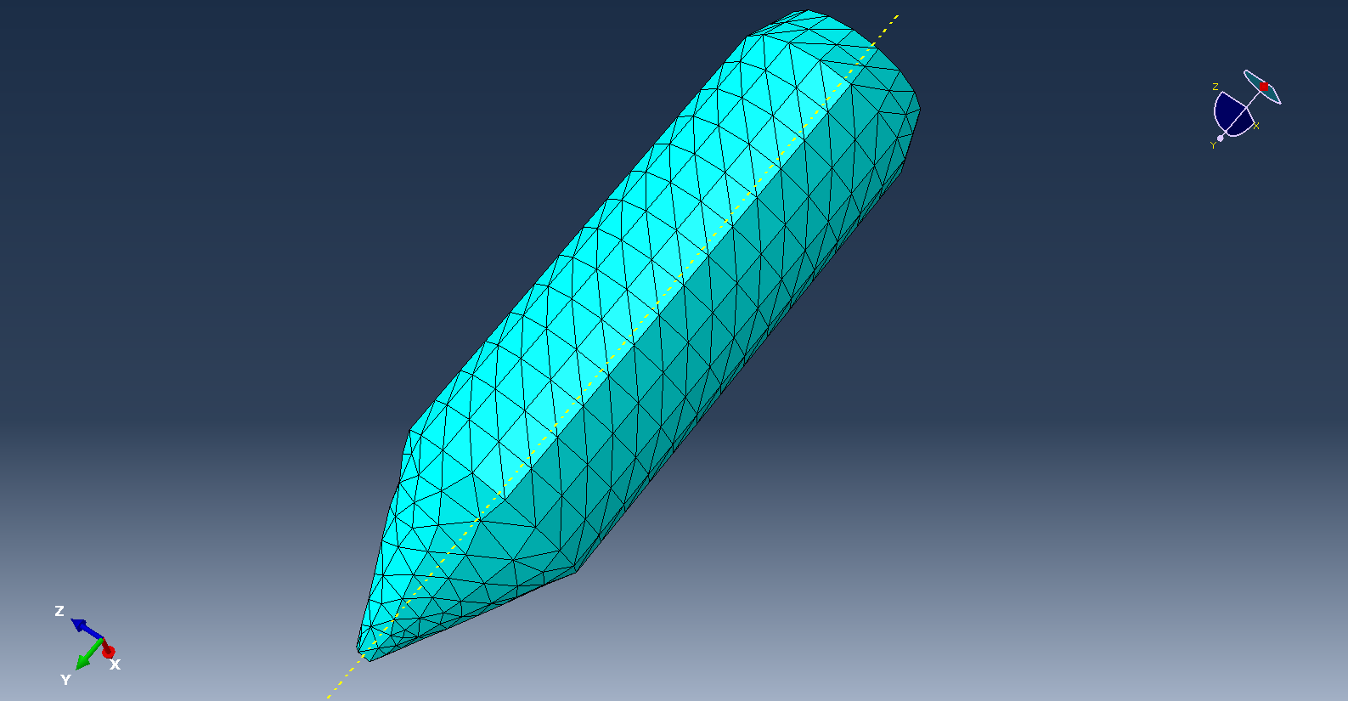
Figure 3
The AP core (Figure3) was meshed using a tetrahedral mesh as this allowed the sharp curves of the projectile to be followed with good accuracy. A reduced mesh seeding distance and as such a greater number of meshing elements would have improved the model’s accuracy but was impractical to the resources available.
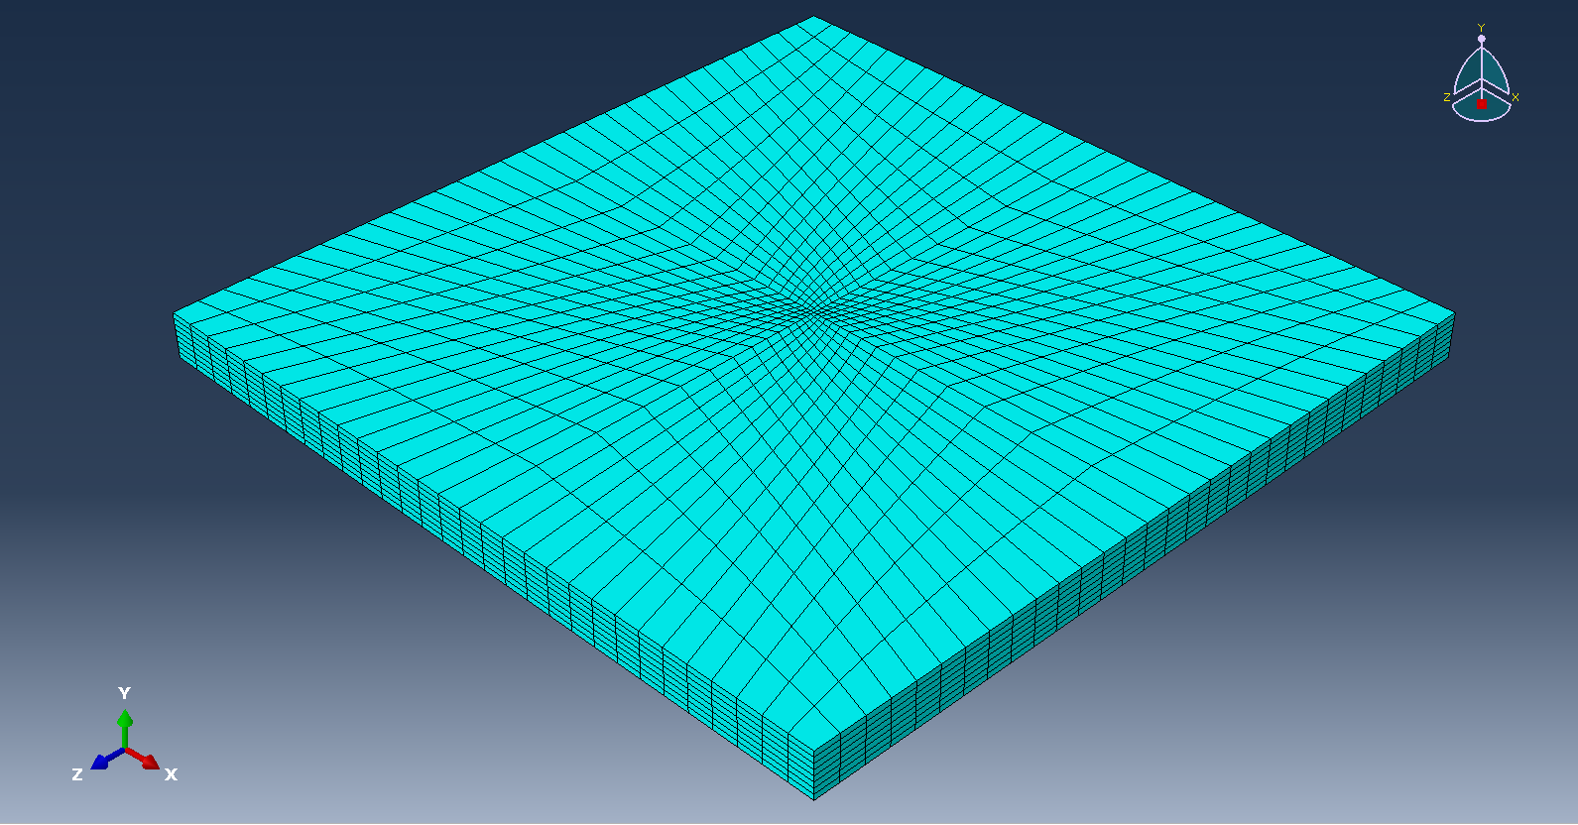
Figure 4
The target plate (Figure 4) was meshed using Hexahedral elements due to is regular shape. This in combination with the variable mesh density reduces the required computing power speeding up run time. The variable density also allows for high resolution analysis of the impact site where the collision occurs. This increased detail allows for better analysis and understanding of the collision.

2.3.3 Assembly
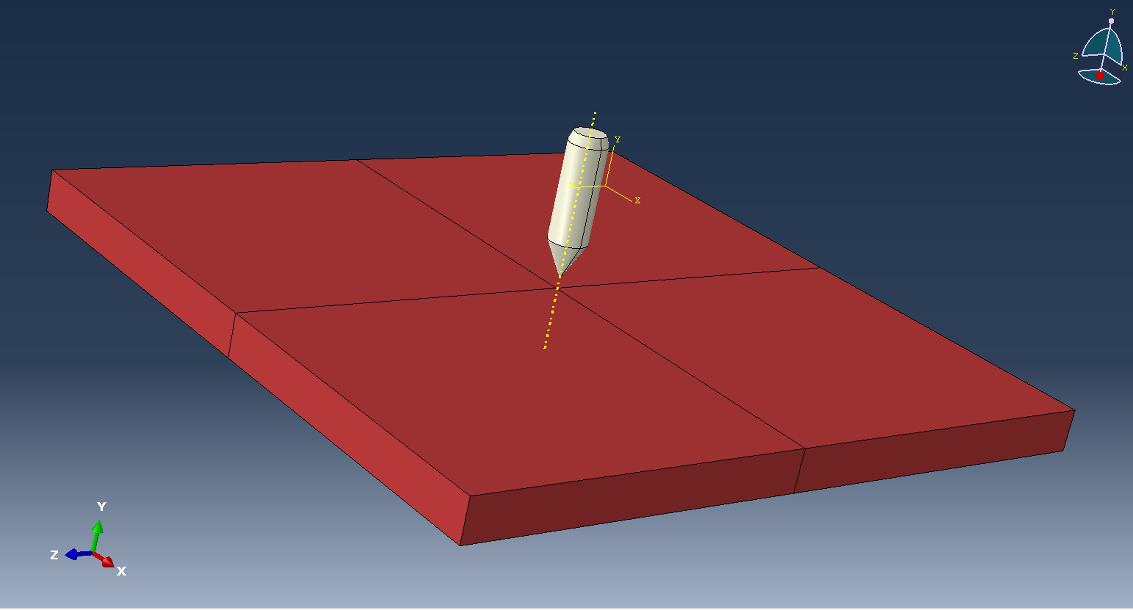
Figure 5
Figure 5 shows the final assembly of the ballistic problem. The projectile impacts the plate perpendicular to the surface simulating a square on shot. It is also positioned centrally as to hit the area of highest mesh density and allow any stress waves to propagate equally in all direction reducing any potential effects of reflected stress waves. It should also be notes the edges of the plate are fixed in place and can’t move helping simulate it being clamped or part of a larger sheet.

2.4 Shot Plan
Two separate shots where conducted. The condition of each simulated shot is given below:
Table 5
Shot | Projectile Material | Target Material | Impact Velocity  [m/s]
1 | C45 medium carbon steel | Rolled Homogeous Armor Steel | 300
2 | C45 medium carbon steel | Aluminum 6061-T6 | 300

3.0 Results and discussion

3.1 Projectile velocity

3.1.1 Shot 1
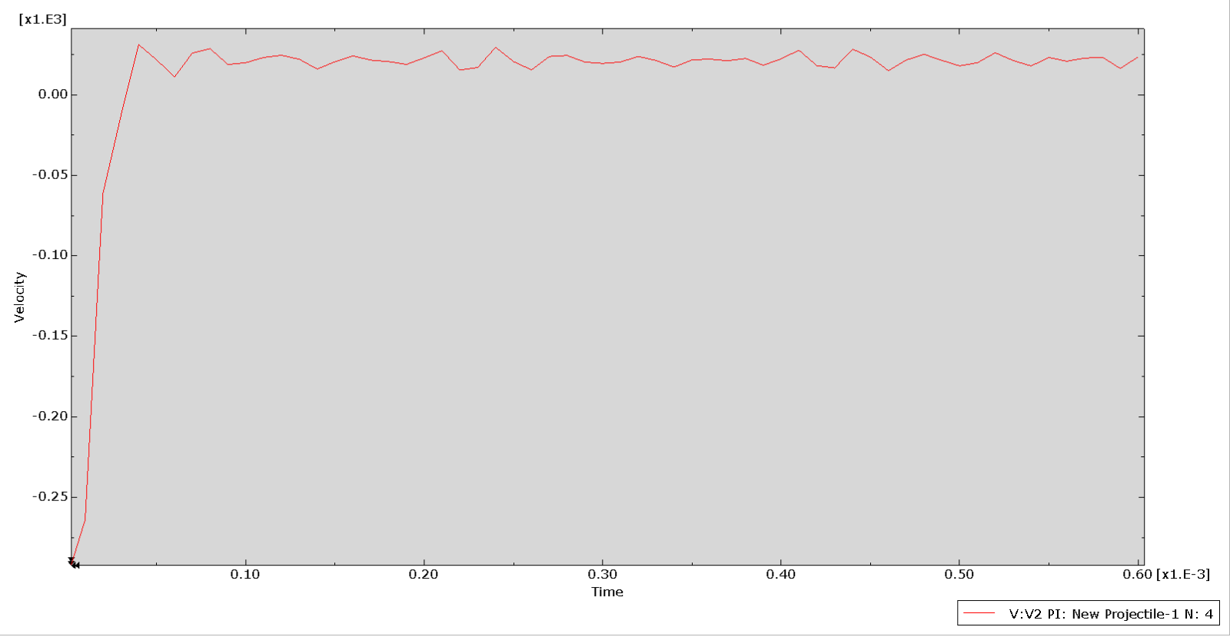
Figure 6
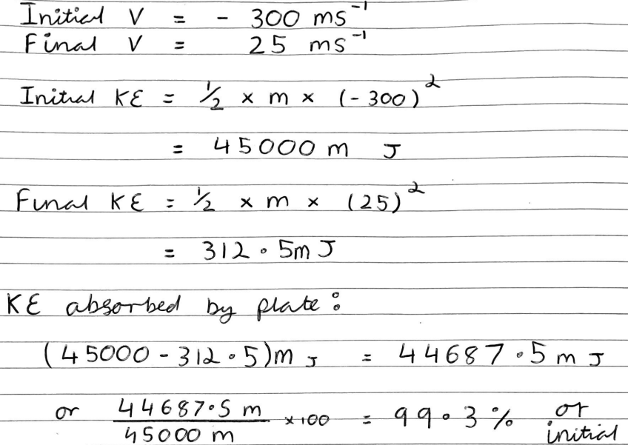
Figure 7

3.1.2 Shot 2
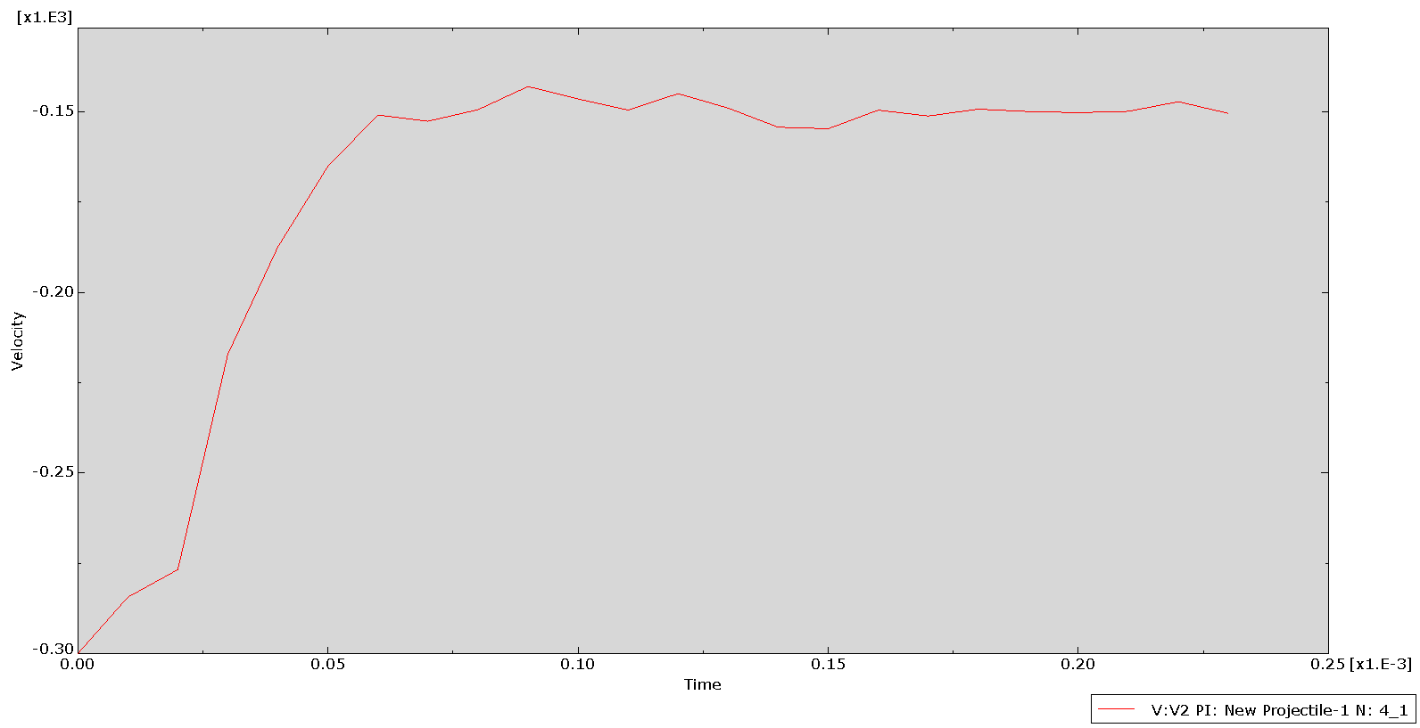
Figure 8
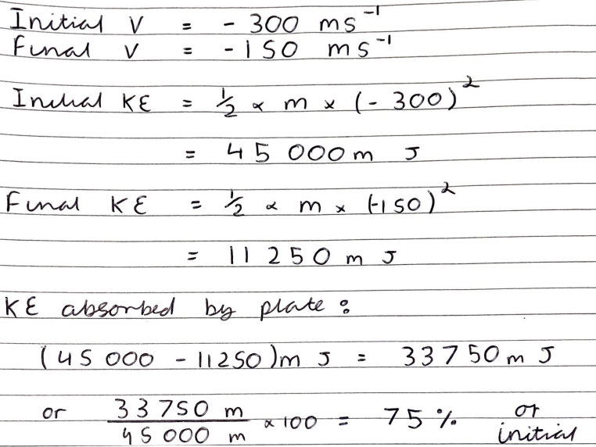
Figure 9

3.1.3 Velocity Discussion
The RHA plate in Shot 1 exerts an impulse on the projectile sufficient to reverse the direction of the projectile with it bouncing off at a velocity of 25 m/s after impacting at 300m/s. This means the plate itself absorbed 99.3% of the projectiles Kinetic energy (KE) without experiencing failure. This was likely possible due to the hardness of the plate causing the point of the projectile to crush and deform, in doing so it increases the contact area of the projectile allowing more energy to be absorbed with lower damage to the plate.
The Aluminum (AL) 6061-T6 plate in Shot 2 however was unable to provide such an impulse and failed allowing the projectile to pass through. The final velocity of 150m/s shows that the plate absorbed 75% of the incoming KE before this failure which is far lower than the 99.3% of the RHA in Shot 1. This is likely due to the AL plate being fa softer and eroding the projectile tip to a far lower extent. This allows the projectile to transfer its energy over a smaller are resulting in the failure of the plate.

3.2 Stress Strain Within Plates

3.2.1 Shot 1
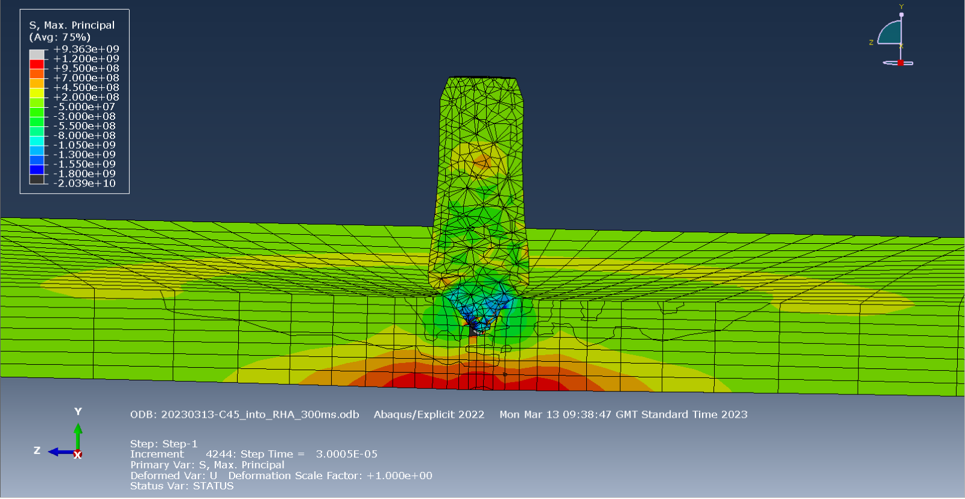
Figure 10
Figure 10 shows the Max. Principal stress at the point of greatest penetration into the RHA target plate. The max principal stress is the maximum value of normal stress acting on a principal plane where the value of sheer stress is zero [11]. As such positive values show tensile forces and negative values show compression. At this point the maximum tensile stress is around 1.000e+09 Pa on the back of the RHA plate. This force is lower than the max tensile strength of the plate and as such the RHA does not fail. If it was however this tensile force on the rear face would cause a star crack.
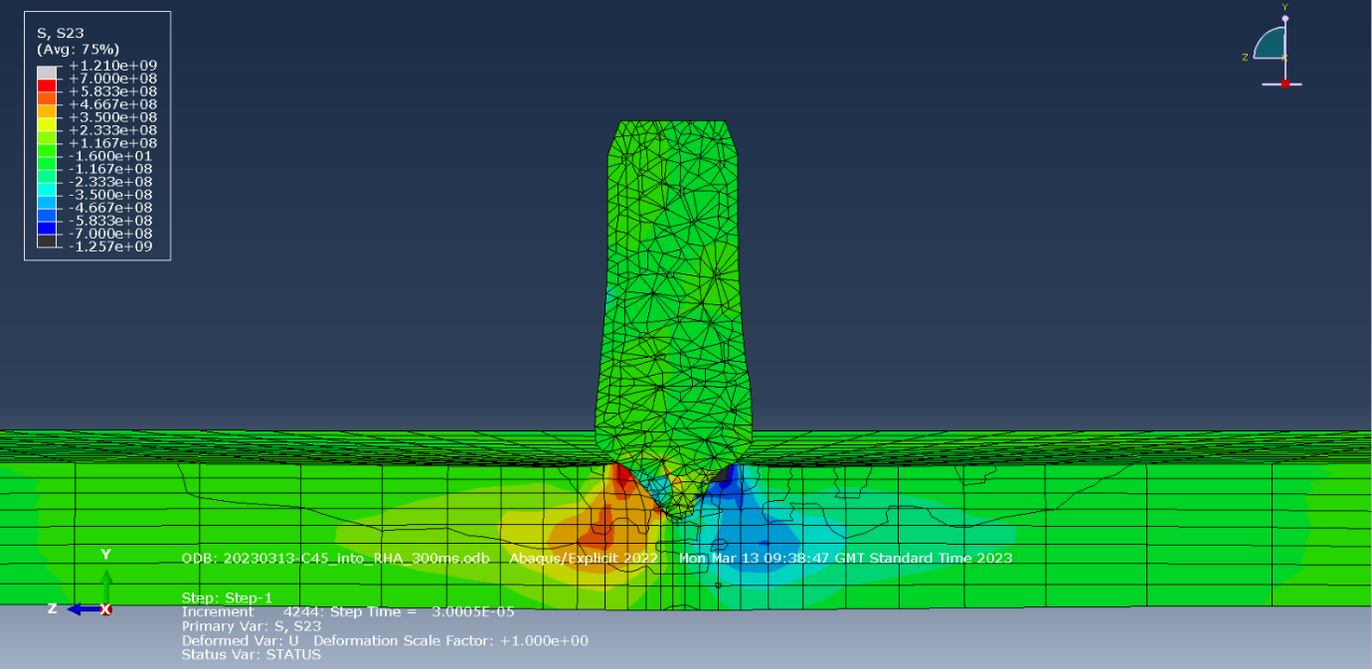
Figure 11
Figure 11 shows the S23 stress forces at the same point as figure 10 when the forces are at there most. S23 shows the shear stresses so on the right we have a stress of +7.00e+8 Pa and on the left -7.00e+8 Pa. These forces are working in opposite direction and if their magnitude was great enough could eventually cause a conical crack causing material failure. This however does not occur within the RHA plate.

3.2.2 Shot 2
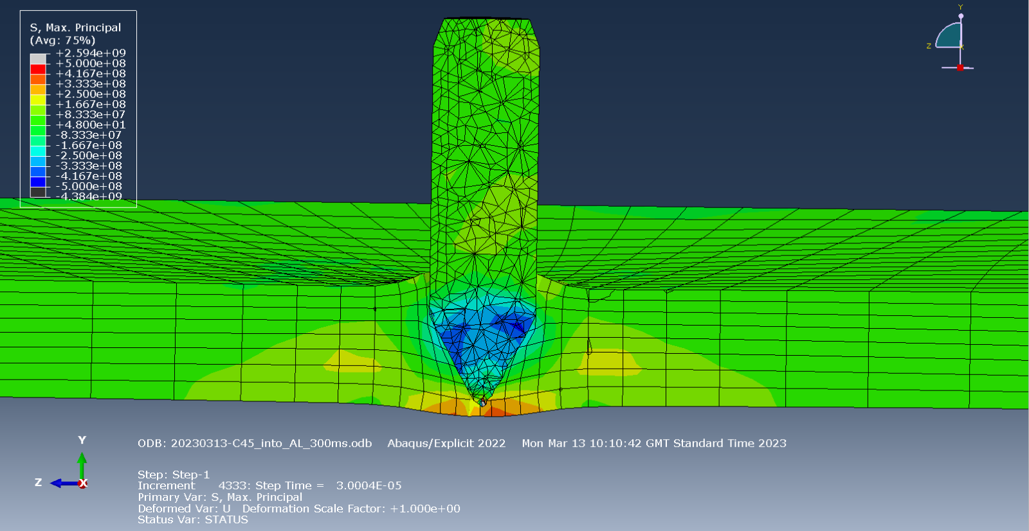
Figure 12
Figure 12 shows the Max. Principle stresses within the AL plate immediately before full penetration. Here the maximum tensile stress on the back face is +5.000e+8 Pa. Although this is an order of magnitude less than the forces in the RHA of shot 1 the far weaker and so will fail. This failure is most likely due to a star crack induced by the tensile forces.
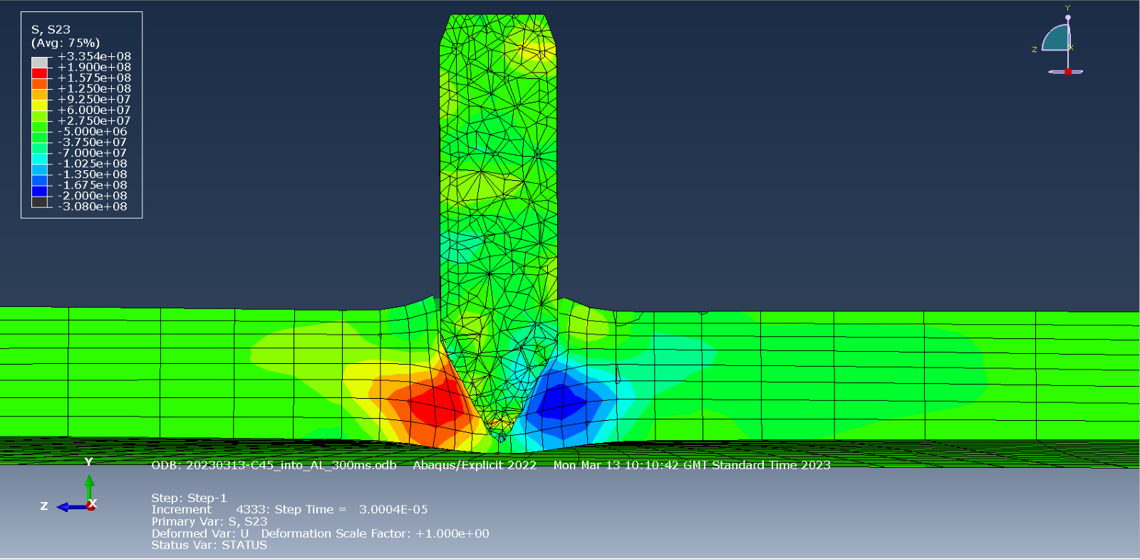
Figure 13
Figure 13 shows the S23 shear forces at the same point as figure 12. Here the maximum shear stresses are roughly +/- 1.600e+8 Pa. This value is lower than the +5.000e+8 tensile forces, which would suggest the main fracture mechanism would be the star cracking of the back face rather than a conical crack from the shear forces.

3.3 Critiques of the model
Although the model ran and functioned as intended there were adaptations and compromises made to ensure this. Points of improvement would be:
- Increasing impact velocity to better represent AP ammunition which is usually around 847m/s [12].
- Increasing the size of the plate to better represent a real-life continuous armour sheet.
- Increase mesh density on both the projectile and target. This would create a more accurate model with increased resolution.
- Better material models ideally using one source as to reduce the chance of mis matched variables. Some variables where missed such as fracture energy which produces non ideal results with elements not undergoing progressive damage.

4.0 Conclusion
Generally, Abaqus provided a good basis for this test with two successful models produced. More time, however, may yield models closer to real world conditions with greater impact velocity and resolution.
Steel AP cores provide a good compromise of performance and safety with much reduced secondary hazards when compared to other popular core materials.
The hardness of the steel grade is important however as low hardness steels such as C45 have a lower ballistic efficiency performing poorly against hard targets such as RHA.
C45, however, is a low-cost solution and for non-critical applications such as training or testing can provide a valuable solution.
From the modeling conducted it can be noted that harder target materials are far more effective at preventing projectile penetration.
They seem to do this by heavily eroding and deforming the projectile to give a larger contact area and hence dissipating the energy whilst having lower maximum stresses.
It can also be noted that from the two shots star cracks on the back face of plates due to tensile stress appears to be the main failure mechanism. Further research would be required however, to see if this was a unique characteristic of this experiment or a wider trend.

Appendix A – Impact Stress Imagery
This appendix contains all the Max principle and S23 stress imagery collected from both Shot 1 and 2. The most relevant are used and reference in the main document but all are shown here to provide further context.

Shot 1

Max. Principal Stress
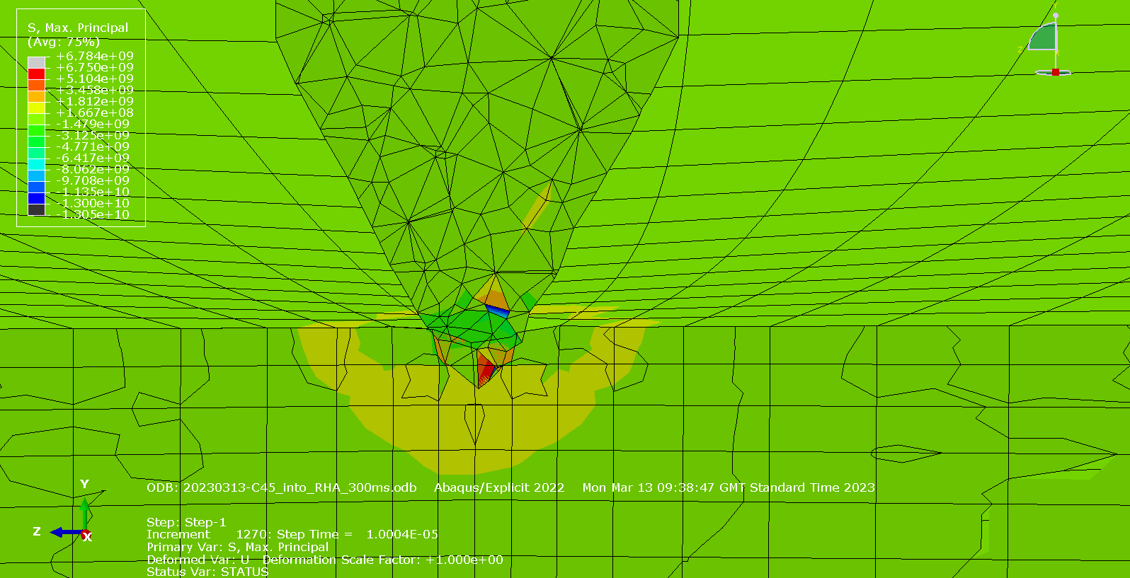
Figure 14
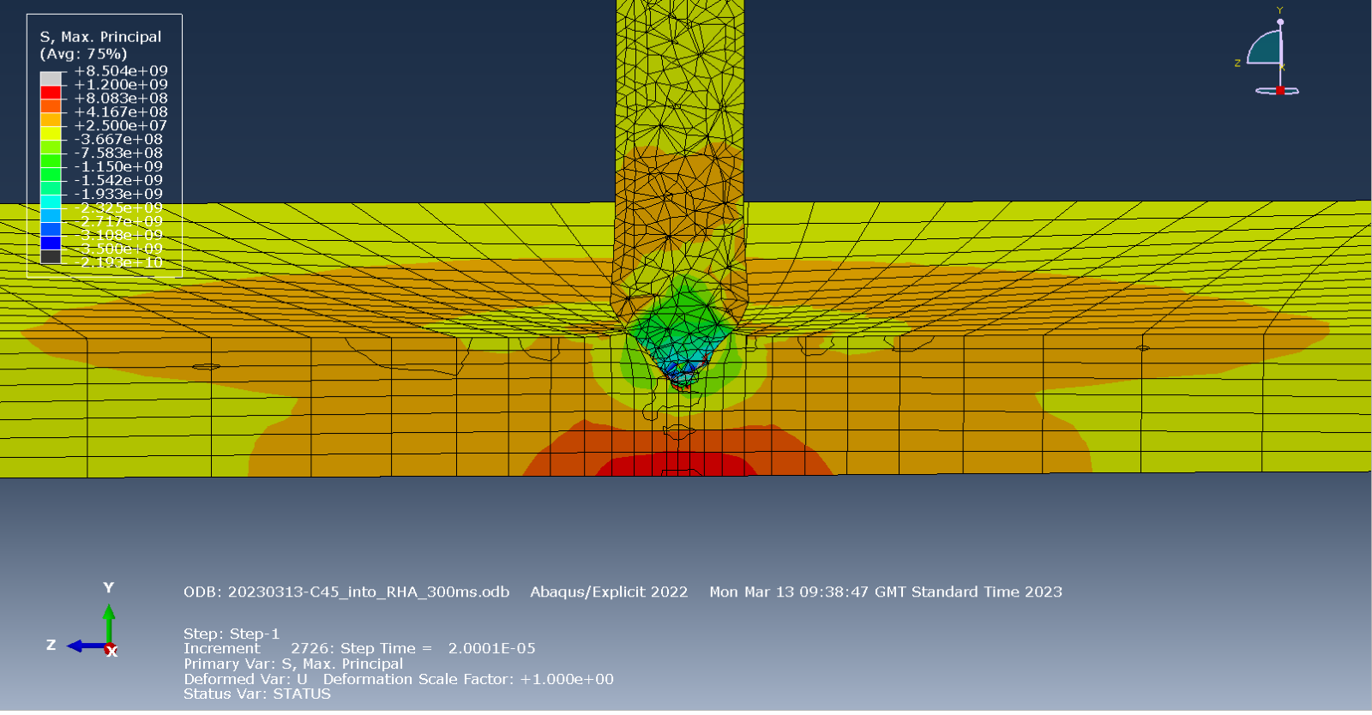
Figure 15
Figure 16
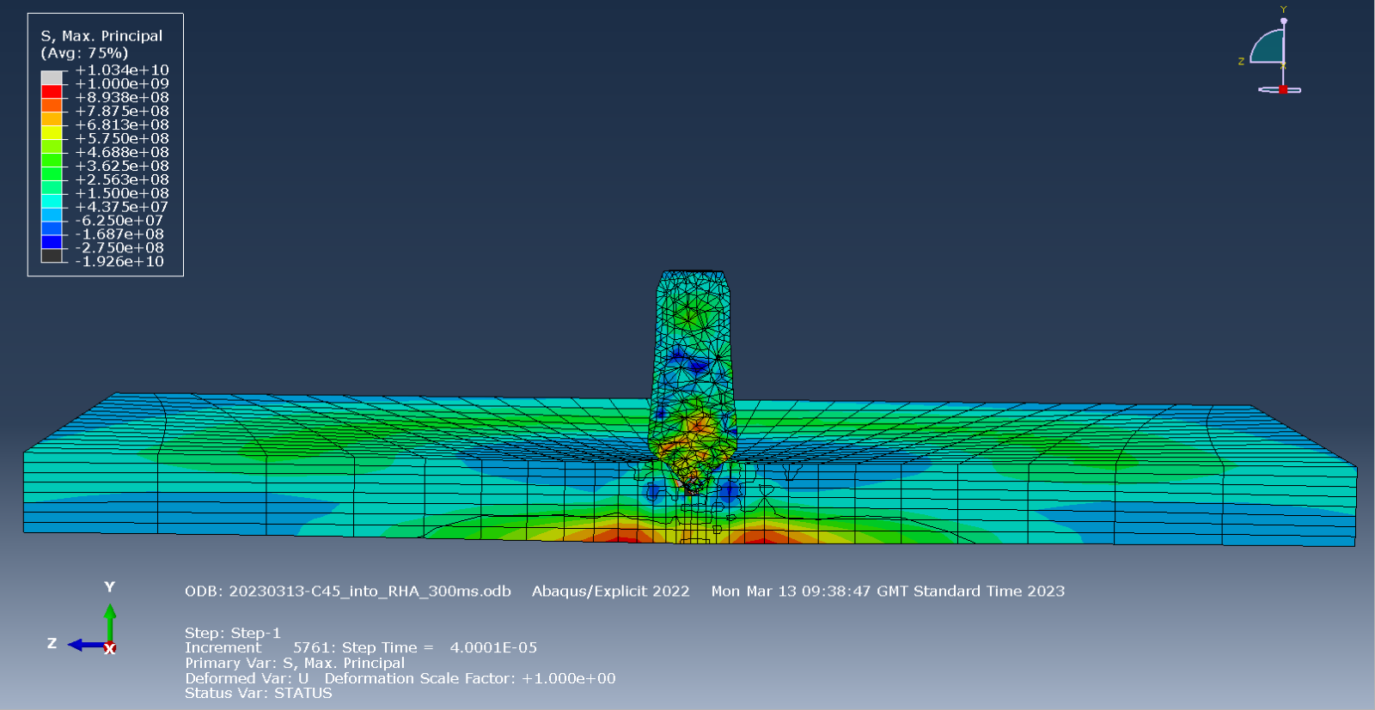
Figure 17
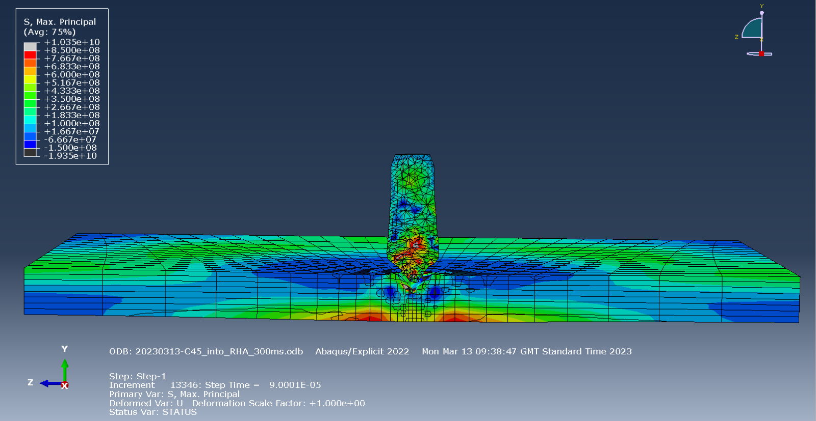
Figure 18

S23 Stress

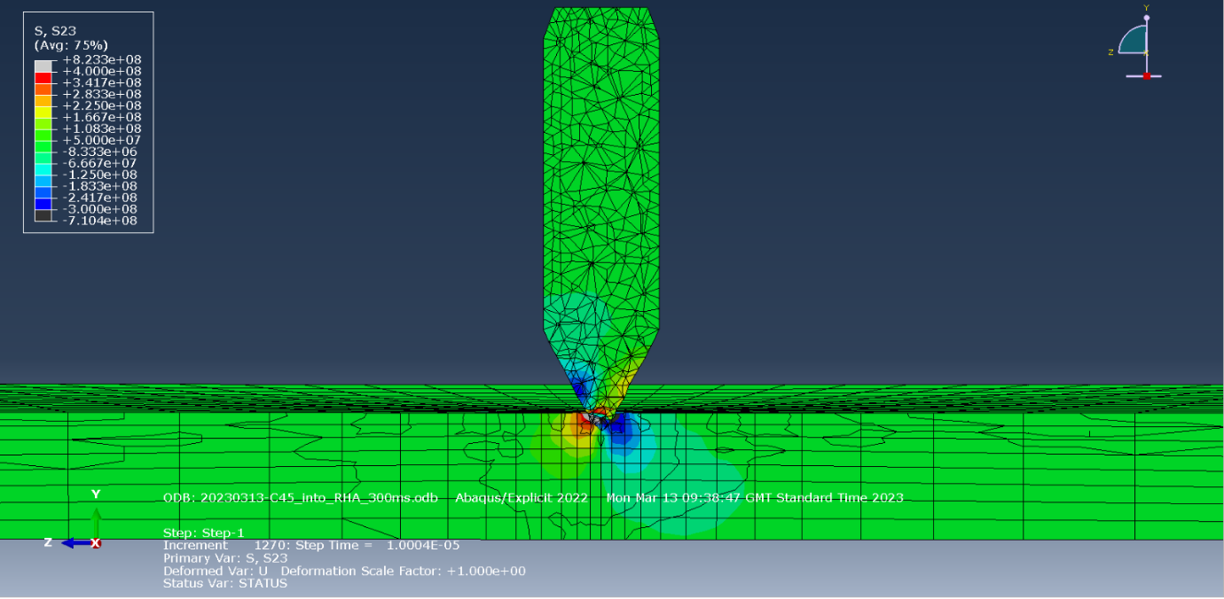
Figure 19
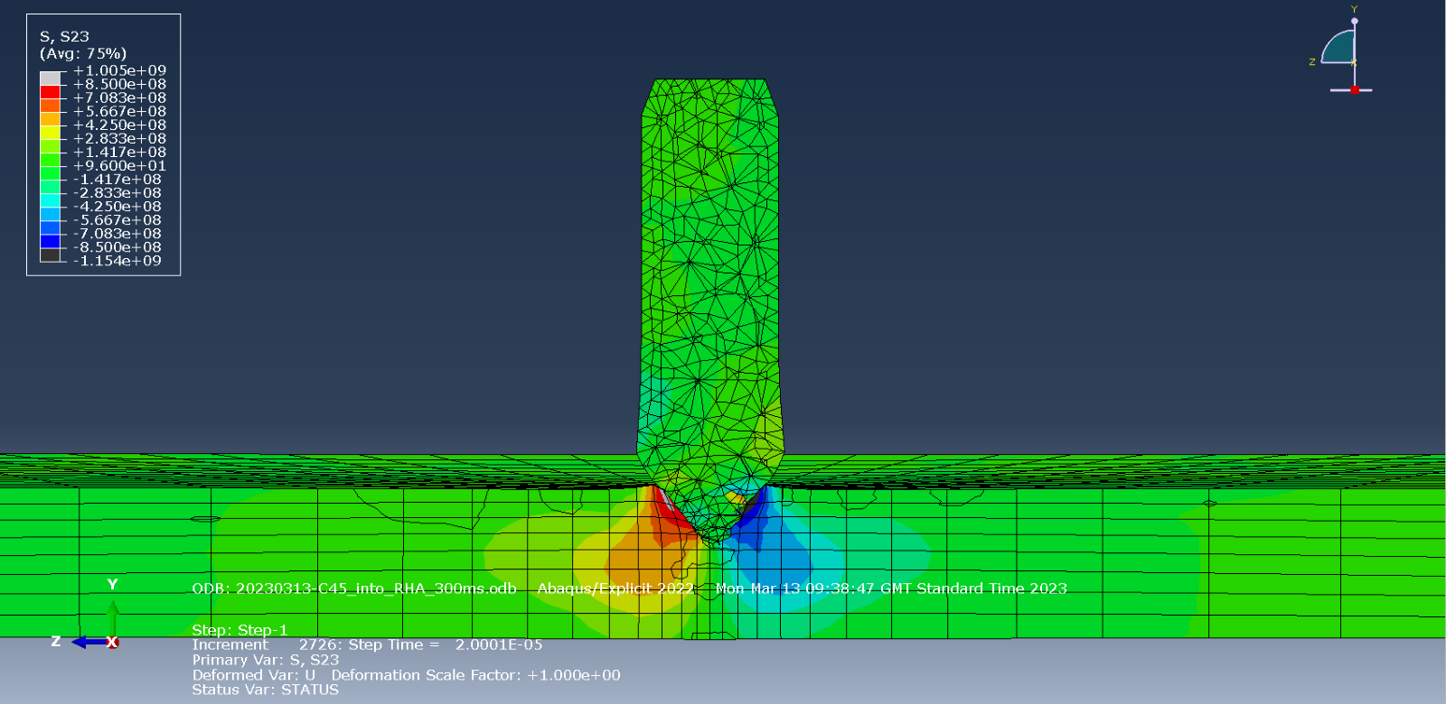
Figure 20

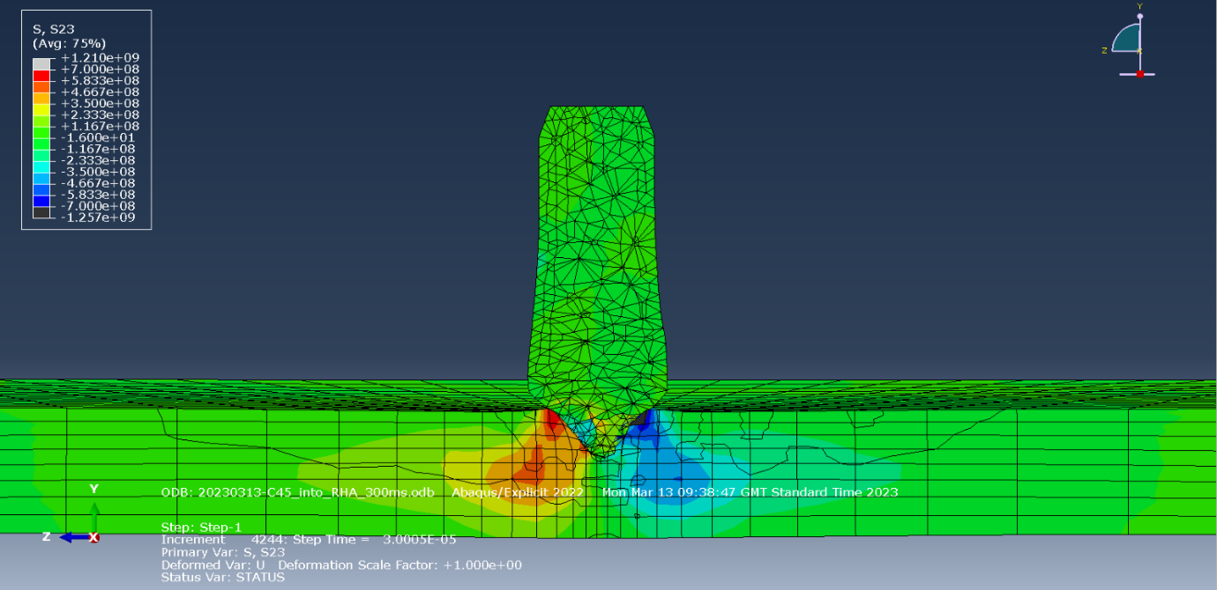
Figure 21
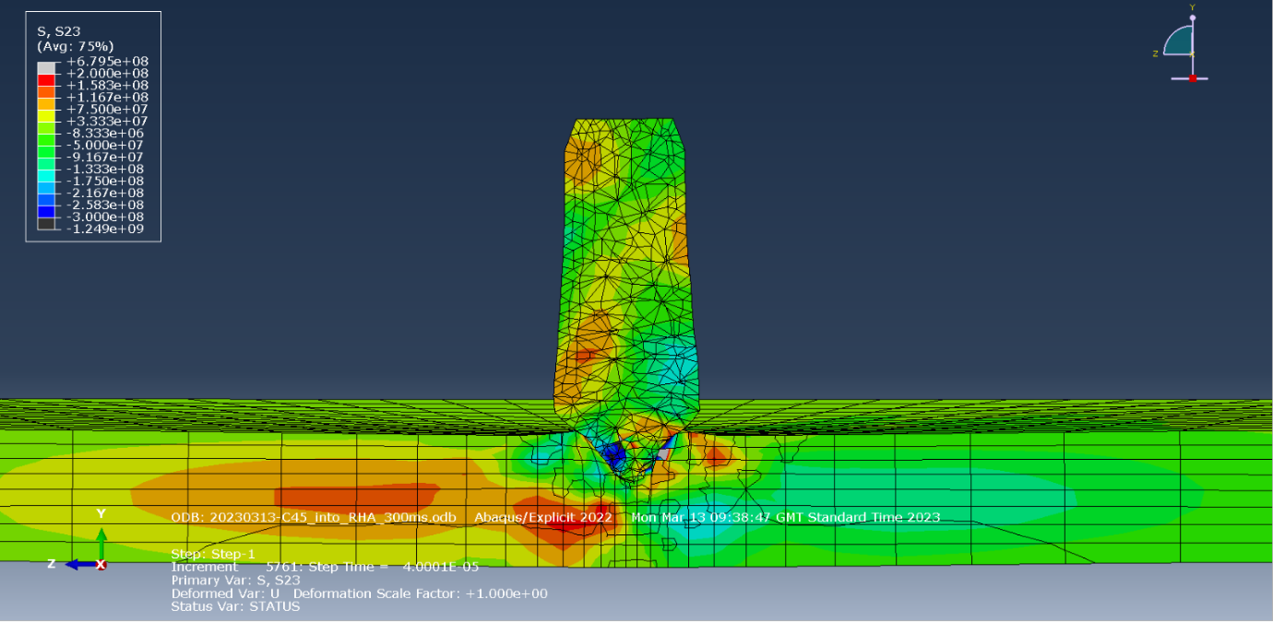
Figure 22

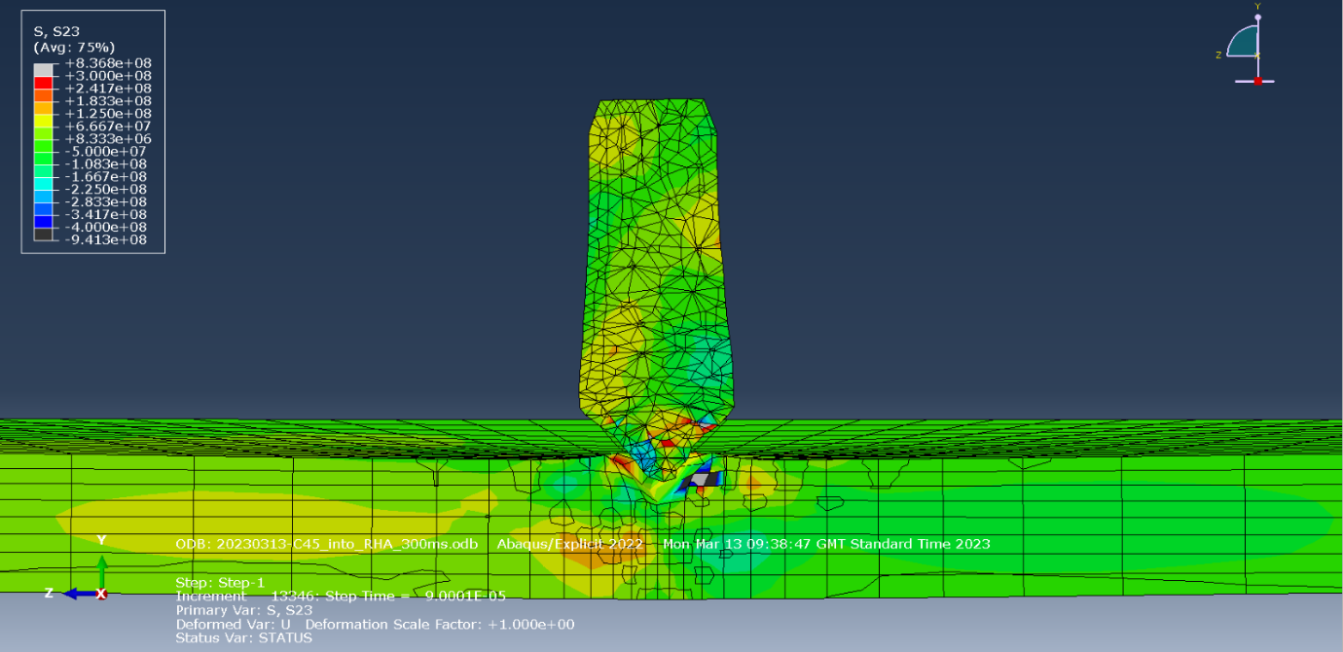
Figure 23

Shot 2

Max Principal Stress
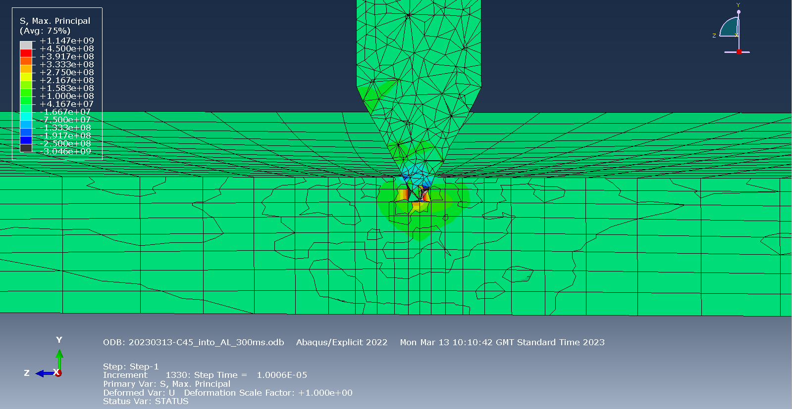
Figure 24
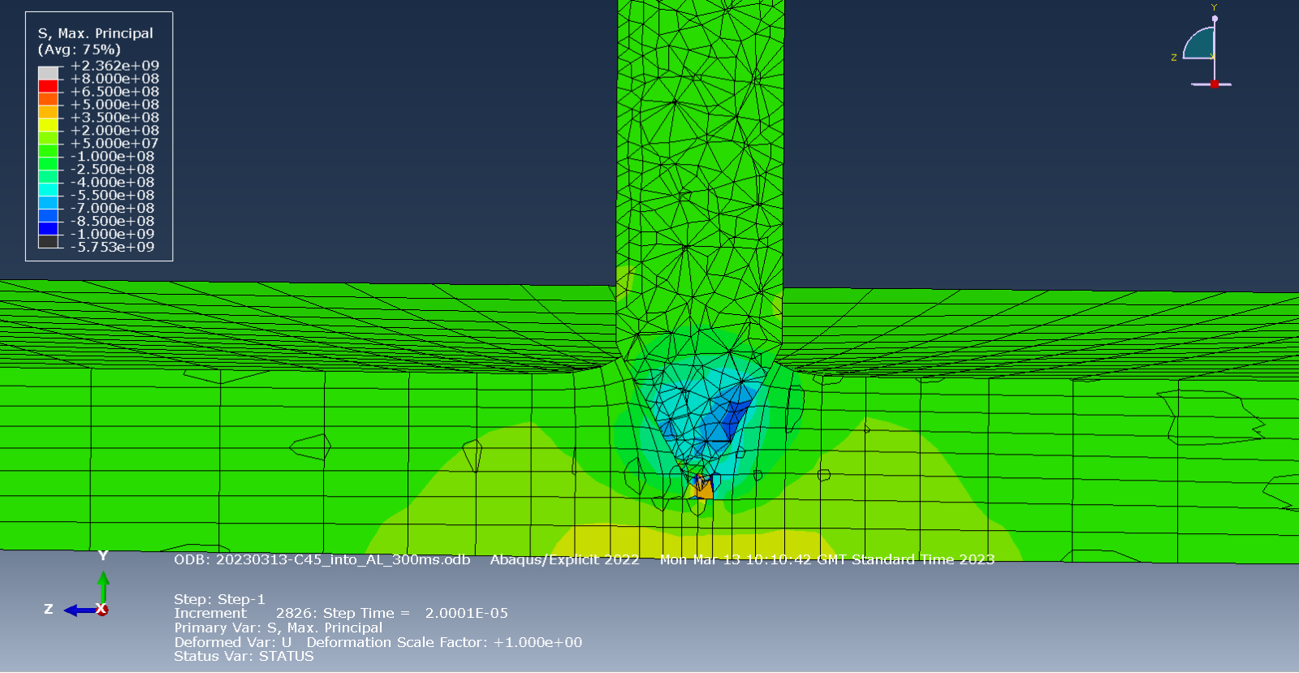
Figure 25
Figure 26

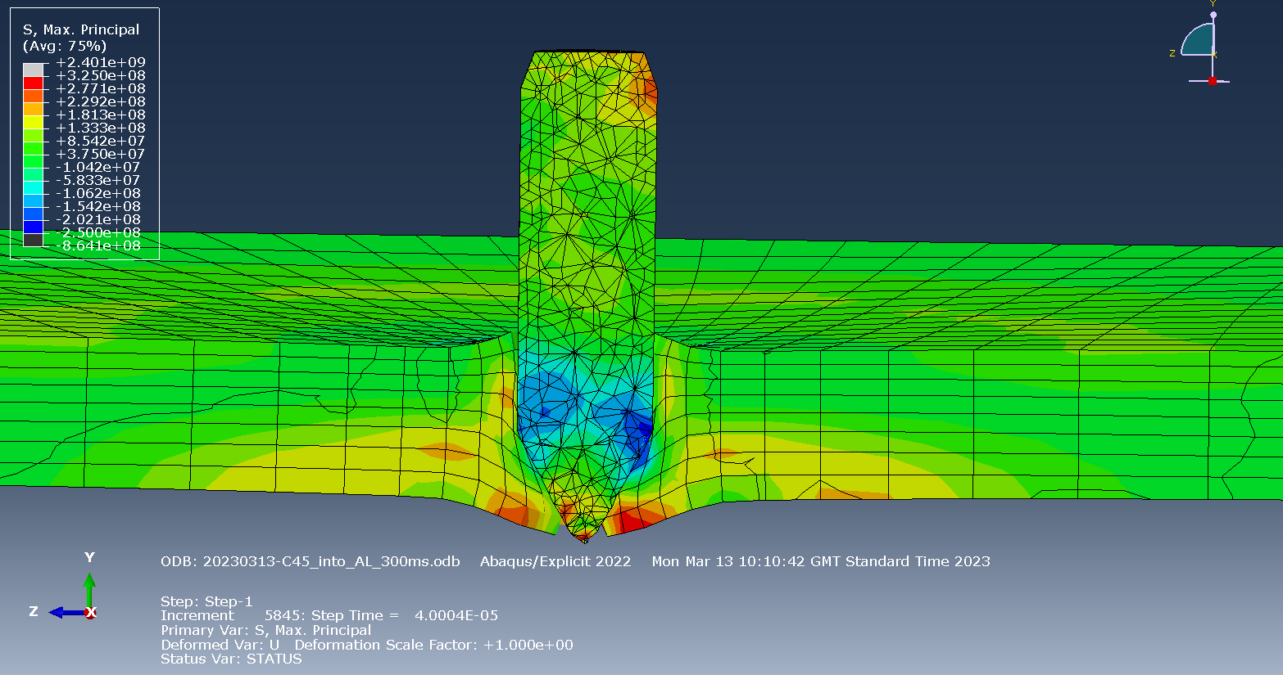
Figure 27
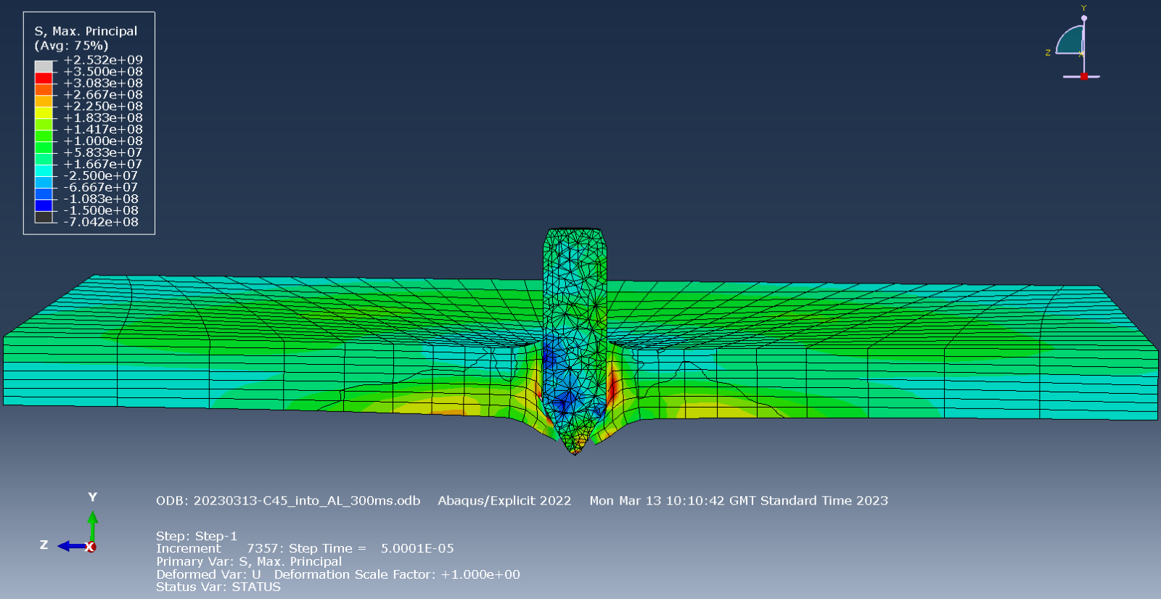
Figure 28

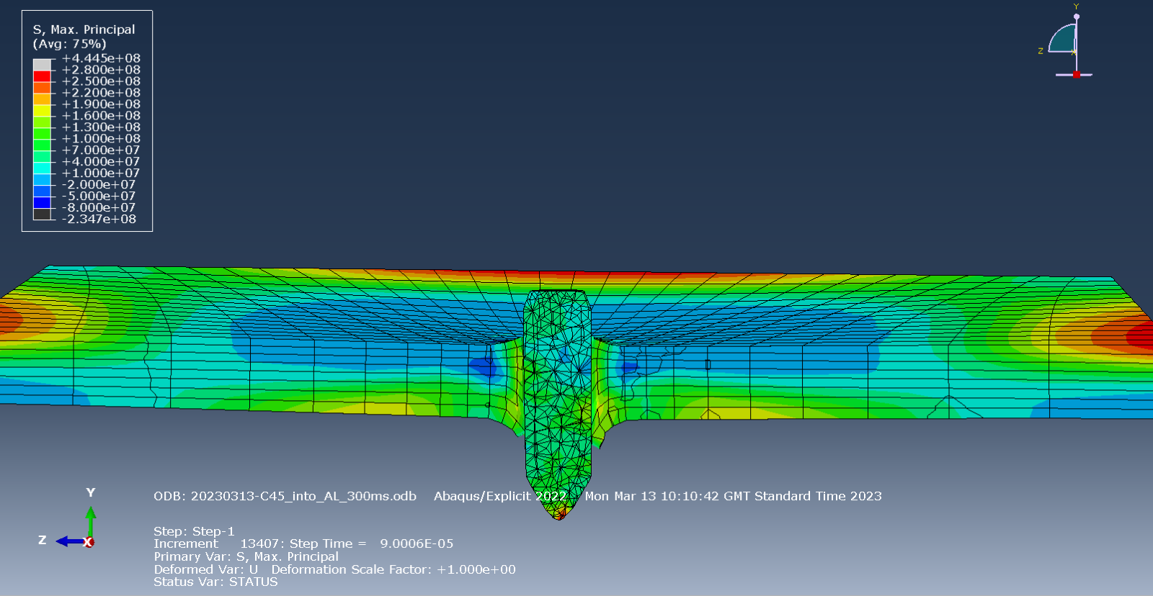
Figure 29
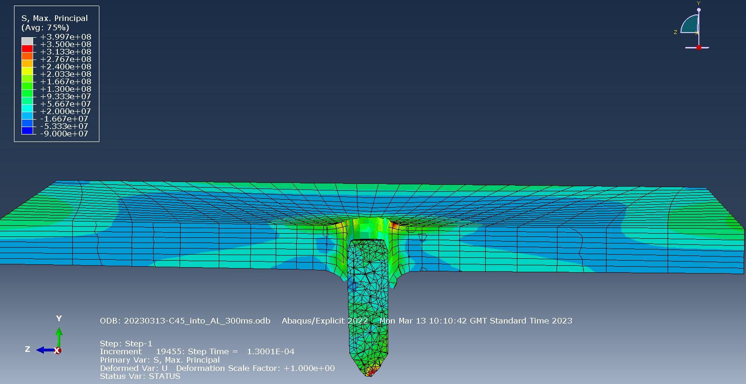
Figure 30

S23 Stress

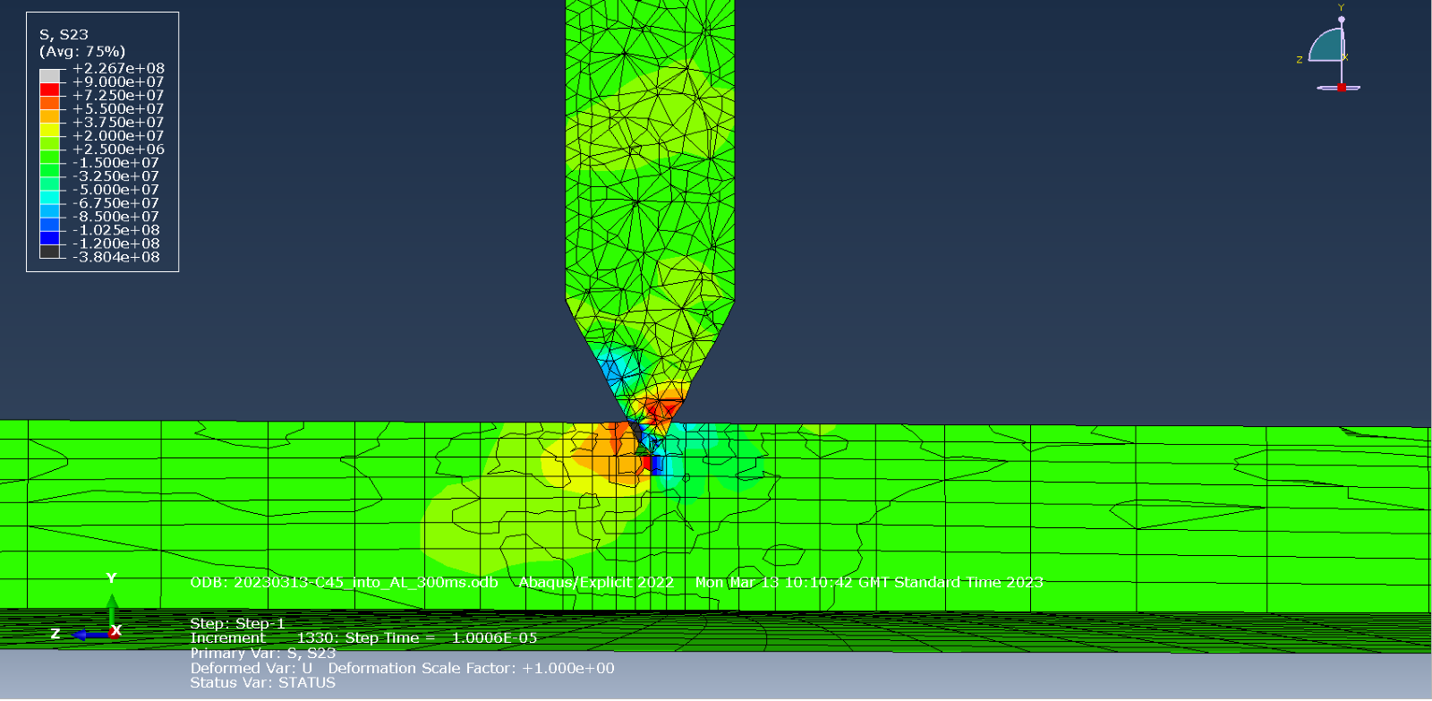
Figure 31
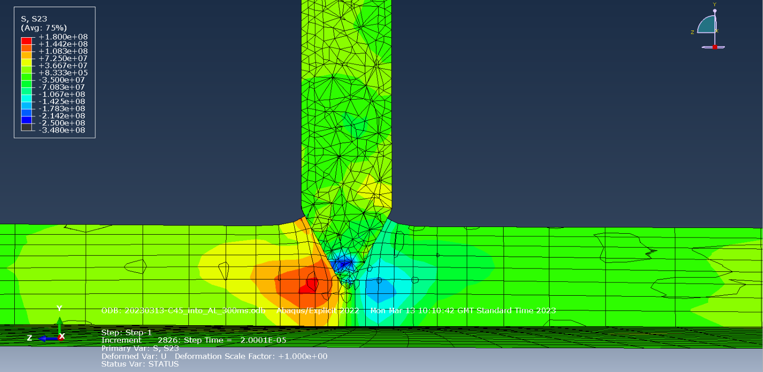
Figure 32

Figure 33
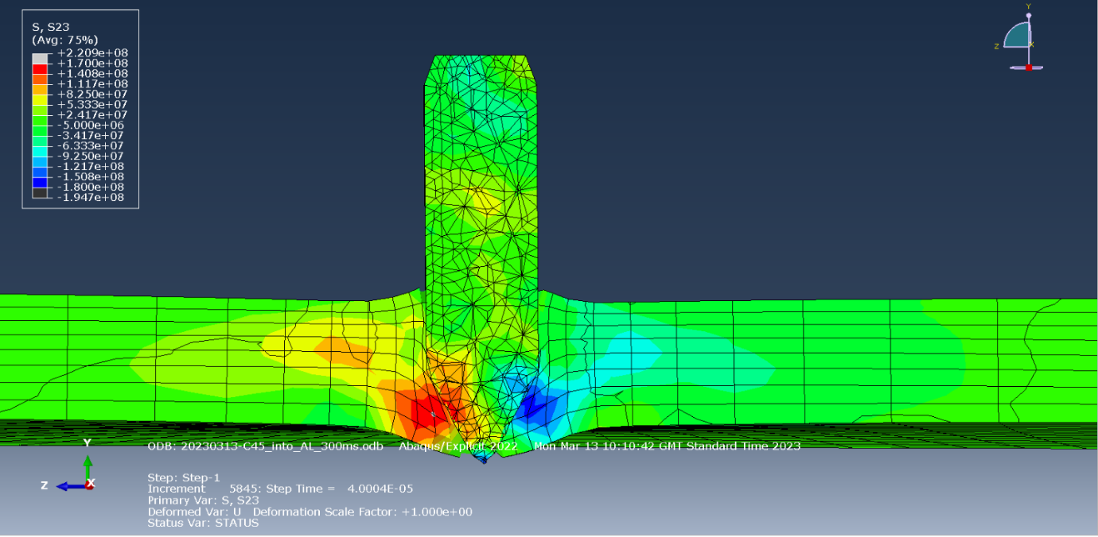
Figure 34
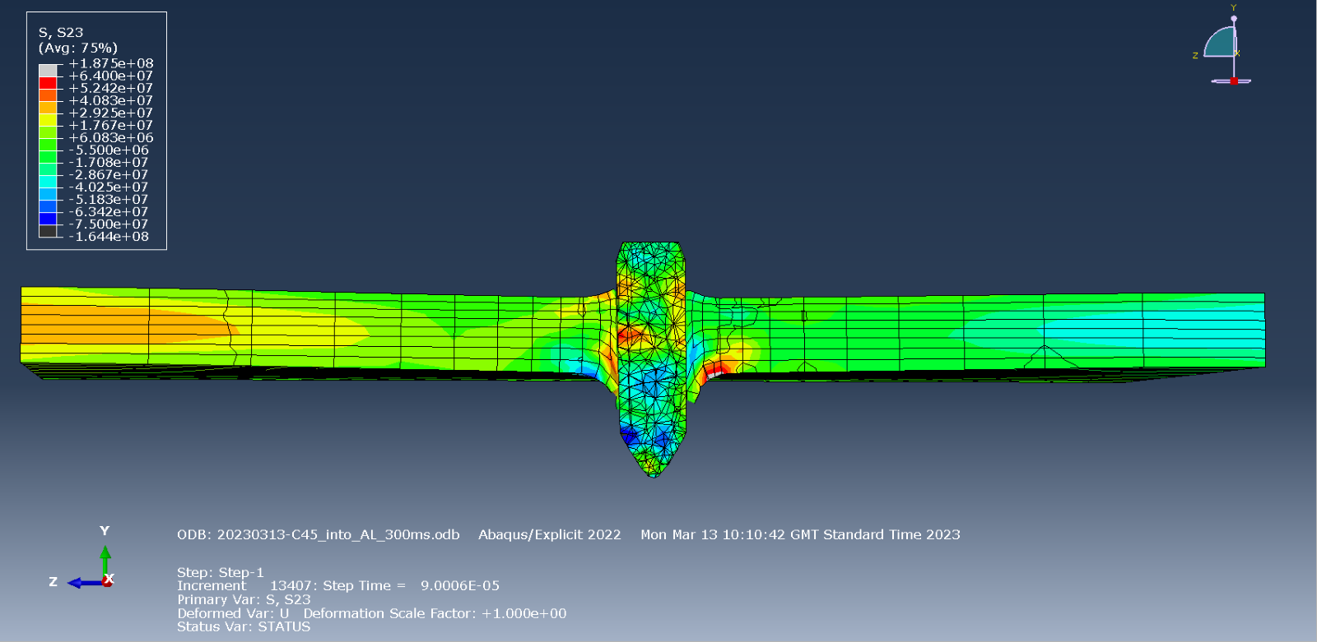
Figure 35
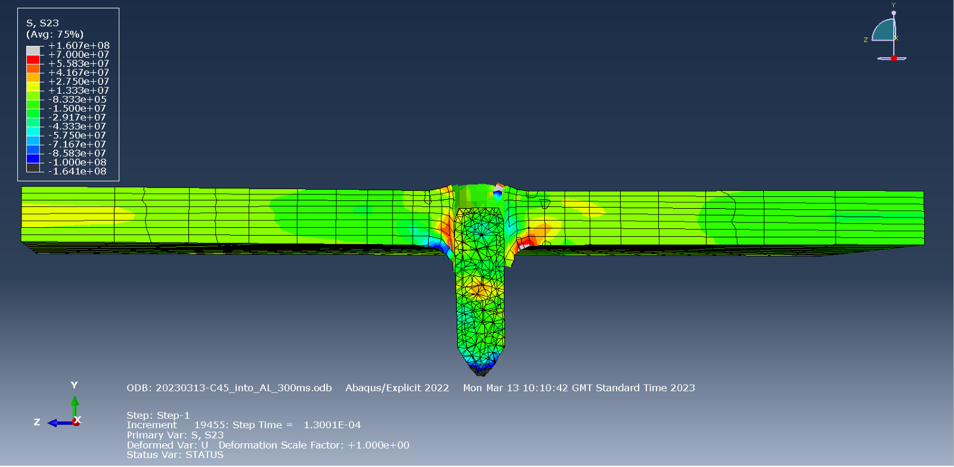
Figure 36

Appendix B – Further Research Conducted
Johnson-Cook Parameters for Brass [13] – Initially considered using a brass jacket.
Further reports on the Johnson-Cook Values of C45 [14] [15] [16] [17]– Not used due to a more complete set of values found.
Further reports found on the Johnson-Cook Values of RHA [18] [19] [20]– Not used due to a more complete set of values found.
In the case of [18] modified JC equations being used. These aim to be more accurate than standard JC but where not applicable this this work.
Material Properties for Tungsten Carbide (Wc-Co) – Original plan had been to compare the performance of C45 and Wc-Co against RHA. This however was not possible due to Wc-Co being too brittle and causing the model to regularly crash.
Wc-Co Johnson-Cook Plasticity - [21]
Wc-Co Johnson-Cook Damage - [22]
Wc-Co Fracture Energy - [23]

References

[1] | G. Di Benedetto, P. Matteis and G. Scavino, “Impact behavior and ballistic efficiency of armor-piercing projectiles with tool steel cores,” International Journal of Impact Engineering, no. 115, pp. 10-18, 2018.
[2] | Waldun Steel, “AISI 1045 Carbon Steel,” [Online]. Available: https://waldunsteel.com/products/aisi-1045-carbon-steel/. [Accessed 6 3 2023].
[3] | M. Storchak, P. Rupp, H.-C. Mohring and T. Stehle, “Determination of Johnson–Cook Constitutive Parameters for Cutting Simulations,” MDPI Metals, no. 9, p. 473, 2019.
[4] | A. Saxen, S. P. Dwivedi, A. Kumaraswamy, A. K. Srivastava and N. K. Maurya, “Influence of SD effect on Johnson–Cook hardening constitutive material model: Numerical and experimental investigation for armor stee,” Mechanics of Advanced Materials and Structures, vol. 2, no. 29, pp. 285-302, 2020.
[5] | Dassault Systemes SIMULIA, “Simulation of the ballistic perforation of aluminum plates with Abaqus/Explicit,” Dassault Systemes, 2012.
[6] | Massachusetts Institute of Technology, “Johnson-Cook plasticity,” [Online]. Available: https://abaqus-docs.mit.edu/2017/English/SIMACAEMATRefMap/simamat-c-johnsoncook.htm. [Accessed 10 May 2023].
[7] | C. Z. Duan, T. Dou, Y. J. Cai and Y. Y. Li, “Finite Element Simulation and Experiment of Chip Formation Process during High Speed Machining of AISI 1045 Hardened Steel,” International Journal of Recent Trends in Engineering, vol. 1, no. 5, 2009.
[8] | A. Banerjee, S. Dhar, S. Acharyya, D. Datta and N. Nayak, “An experimental determination of Johnson Cook material and failure model constants of armour steel,” Applied Mechanics and Material, Vols. 592-594, no. 1662-7482, pp. 990-995, 2014.
[9] | M. E. Kassner, K. E. Thiehsen and R. S. Rosen, “The Mechanical behaviour of U-6Nb alloy and AISI 1045 and 1215 steels at high strain rates,” Journal of Materials Science Letters, no. 11, pp. 125-128, 1992.
[10] | T. Borvik, S. Dey and A. H. Clausen, “Perforation resistance of five different high-strength steel plates subjected to small-arms projectiles,” International Journal of Impact Engineering, no. 36, pp. 948-964, 2009.
[11] | Pratik, “Principal stress: Definition, Equation, Example, Explained,” Mech Content, [Online]. Available: https://mechcontent.com/principal-stress/?utm_content=cmp-true. [Accessed 10 May 2023].
[12] | D. Gregori, R. Scazzosi, S. G. Nunes, C. S. Amico, M. Giglio and A. Manes, “Analytical and numerical modelling of high-velocity impact on multilayer alumina/aramid fiber composite ballistic shields: Improvement in modelling approaches,” Composites Part B: Engineering, vol. 187, 2020.
[13] | M. Annoni, G. Biella, L. Rebaioli and Q. Semeraro, “Microcutting force prediction by means of a slip-line field force model,” 14th CIRP Conference on Modeling of Machining Operations (CIRP CMMO) , no. 8, pp. 558-563, 2013.
[14] | F. H. Abed, M. H. Saffarini, A. Abdul-Latif and G. Z. Voyiadjis, “Flow Stress and Damage Behavior of C45 Steel over a range of Temperatures and Loading Rates,” Journal of Engineering Materials and Technology, 2016.
[15] | M. Murugesan and D. W. Jung, “Johnson Cook Material and Failure Model Perameters Estimation of AISI-1045 Medium Carbon Steel for Metal Forming Aplications,” MDPI Materials, vol. 12, no. 609, 2019.
[16] | T. Bergs, M. Hardt and D. Schraknepper, “Determination of Johnson-Cook material model parameters for AISI 1045 from orthogonal cutting tests using the Downhill-Simplex algorithm,” 48th SME North American Manufacturing Research Conference, NAMRC 48 , no. 48, pp. 541-552, 2020.
[17] | M. Weber, T. Hochrainer, P. Gumbsch, H. Autenrieth, L. Delonnoy, V. Schulze, D. Lohe, J. Kotschenreuther and J. Fleischer, “INVESTIGATION OF SIZE-EFFECTS IN MACHINING WITH GEOMETRICALLY DEFINED CUTTING EDGES,” Machining Science and Technology, no. 11, pp. 447-473, 2007.
[18] | B. McDonald, H. Bornstein, A. Ameri, A. Daliri and A. C. Orifici, “Plasticity and ductile fracture behaviour of four armour steels,” International Journal of Solids and Structures, pp. 135-149, 2019.
[19] | J. P. Riegel III and D. Davison, “Consistent constitutive modeling of metallic target penetration using empirical, analytical, and numerical penetration model,” Defenece Technology, no. n/a, p. n/a, 2015.
[20] | M. Jutras, “IMPROVEMENT OF THE IMPROVEMENT OF THE JOHNSON-COOK MODEL,” FACULTE DES SCIENCES ET DE GENIE UNIVERSITE LAVAL, QUEBEC, 2008.
[21] | E. Postek and T. Sadowski, “Thermomechanical effects during impact testing of WC/Co composite material,” Composite Structures, no. 241, 2020.
[22] | E. Postek and T. Sadowski, “HIGH-VELOCITY IMPACT OF 2-PHASE WC/Co COMPOSITE PLATE - BEGINNING OF THE PROCESS,” Arch. Metall. Mater., vol. 1, no. 65, pp. 265-274, 2020.
[23] | C.-S. Kim, T. R. Massa and G. S. Rohrer, “Modeling the relationship between microstructural features and the strength of WC–Co composites,” International Journal of Refractory Metals & Hard Materials, no. 24, pp. 89-100, 2006.

