Marketing Essentials BMIH4005 -Essay

Topic: A comparison of the marketing methods of two multinational hotel brands.

Student Name: Aurelia Bogatu
Student ID Number: 2231922
Module title: Marketing Essentials BMIH4005
Lecturer’s Name: Ruth Taylor Davies
Word Count: 1495

Six Senses is the award winning hotel group that offers their customers with very unique experiences in terms of exquisite locations such as coral fringed bays, inspiring city districts, romantic valleys and majestic mountains. The company is owned by Neil Jacobs who founded the company in 1995 and is headquartered in Bangkok, Thailand (Minner and Nayak, 2019). The company’s annual revenue is over £243.11 million. The company offers integrated wellness to enhance the people's experiences in all aspects to make them feel immediate, and real benefits. Moxy is the playful, stylish and affordable hotel brand that is established to provide the customers with everything they desire. Moxy is the brand which is owned by Marriott International Inc, founded in 1969 by Birger Hatlebakk (Jobber and Ellis-Chadwick, 2020). The company is headquartered in Elnesvagen, Norway. The company’s annual revenue is £293 million per year.
This essay will discuss the company's marketing strategy in relation to the segmenting and positioning of their products and services. The essay will analyse both the company’s marketing choices they make to stabilise their market position. Lastly, the essay will analyse the overall changes they made in their marketing strategies currently.

Main Body
The company marketing decision is ruled by their 7 Ps of marketing. Product refers to the item that is offered by the company for sale. The Six Senses brands consist of Six Senses Resorts, Spas and Residences. They provide their customers with exotic resorts as well as spas in private clubs with luxurious residences. For the products, the marketing decisions the Six Senses makes is relative to the integrated wellness positioning strategy where they make a harmonious and holistic approach to life (Green et al., 2019). On the other hand, Moxy offers timeshare vacations, flights and hotel packages, hotel reservations and car rental services. For the unique services, the market decisions the company has undertaken the approach where they have upgraded their communication infrastructure with Avaya IX Workplace products.
Price refers to the value for which the company offers their products or services to their customers. The Six senses charges extra prices for the spas excluding the cribs and extra beds (Jobber and Ellis-Chadwick, 2020). They use the competitive pricing policy in which they base their products and services prices on the basis of their competitors pricing strategy. Whereas, Moxy offers their products and services at attractive prices using the premium pricing policy in which they keep the products prices artificially high in order to influence favourable perceptions among the purchasers.
Place refers to the market region where the company targets their consumers. Six Senses is headquartered in London, Whiteley. The customers can book their rooms or other services through the website booking.com of Booking Holdings Inc. They launched the Social media aggregator on their company’s website which helped them to gain direct feedback from their customers about their experiences they had during the visit in the hotel. Whereas, Moxy hotel is headquartered in London and features a shared lounge. Their marketing campaign “Great British Road” provides the customers with a city guide for two to three short trips.
Promotion refers to the entire set of activities that helps companies to communicate about their brands or services. Moxy runs an advertisement campaign called “30 days 300 stays” in their main markets through the Amadeus GDS; this helps them to advertise about their brand every time the customers book through the system.
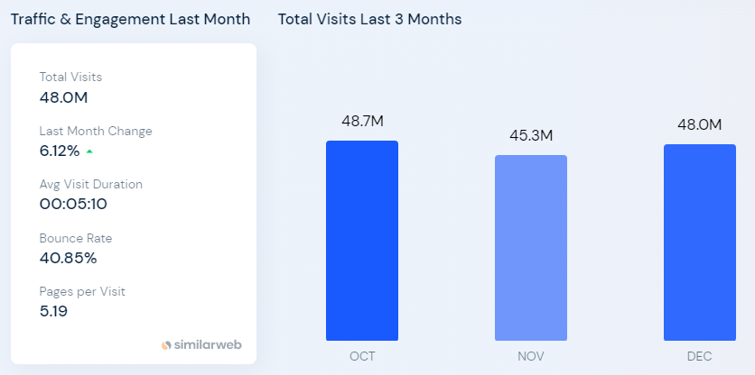
Figure No.1- Traffic & Engagement of Moxy
(Source: Ryan, 2012)
Thus from the above data it is analysed that the company through their successful campaign “30 stays 30 days” was able to increase engagement of the customers by 6.12%.
Contrastingly, Six Senses uses social media marketing such as they advertise their brand on different platforms like Instagram and informs them about their contributions towards sustainable and environmental operations. The campaign started by the company was called “Protect Maldives Seagrass” to meet and fulfil their projected aims and goals.
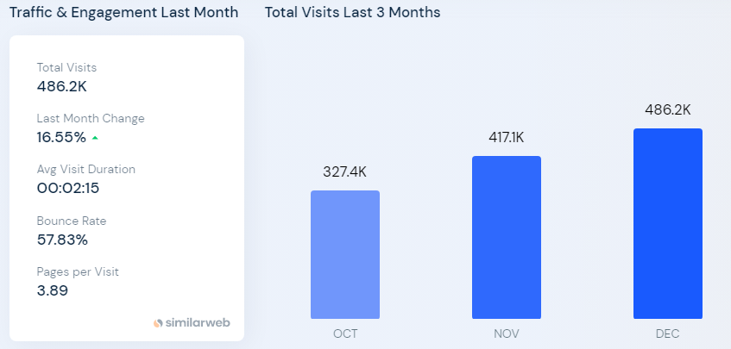
Figure No.2- Traffic & Engagement of Six Senses
(Source: Pereira et al., 2020)
Thus from the above data it is analysed that the company through their campaign “Protect Maldives Sea Grass” was able to increase engagement of the customers by 16.55%.
Both the company uses the similarweb software that allows them to know exactly where they are in the market to examine their performances of social media marketing campaigns against their competitors and the industry as well. The software puts the company's site performances in a wider context.
Physical Evidence refers to the tangible goods that influence customers to purchase the goods provided by the company. Moxy appeals to the young generations by providing hotels with combined sound-absorbing multi-layer technology with 17 dB sound rating which helps the customers to avoid any vibrations or system noise ((Bowie et al., 2017). On the other hand, Six Senses uniqueness lies in the places their hotels are established. The customers get the experience of close nature and great beauty.
People refer to those who come in touch directly or indirectly with the targeted customers. Moxy hotels employees come in direct contact with their customers and provide services based on the legal and ethical conduct of their actions. While Six Senses hotel also approaches their well trained employees to provide their customers with quality services.
Processes refer to how the company delivers their products with finest experience to the customers (Chaffey and Ellis- Chadwick, 2019). The rooms in Moxy hotel are equipped with premium MUK bath amenities, walk-in-shower, HDTV with YouTube and Netflix, open wall closet and high thread count bedding. On the other hand, Six Senses Resorts and Hotels offers their customers a wide range of rejuvenation, holistic wellness and beauty treatments which are administered under the expert therapist’s guidance.
Moxy applies the user-generated content to capture the attention of millennials (Smith et al., 2020). They use the M Live through which they monitor the presence of the brand through various channels. In case if a customer is at the hotel and has issues related to a particular thing, they can post it on the M Live which the company can recognise and do something special for the guest to make a difference (Zhang et al., 2020). On the other hand, Six Senses hotels use the traditional marketing strategy where they use the offline media to reach to the targeted audiences. After the covid-19 crisis, they started the “Plan now Play later” campaign to provide their customers with an extra 20% bonus certificate so as to use it against upgrading of rooms and for staying later.

STP of Moxy Hotels
Segmentation: The targeted customer of the company comprises millennial vacationers or travellers of higher income group.
Targeting: They have integrated the geographic segmentation strategy by establishing the newest and economic lifestyle to meet the demand of the customers (Kotler et al., 2020).
Positioning: The Company assesses products or services offered by their competitors such as the Menin hospitality and Coconut Beach Resort.
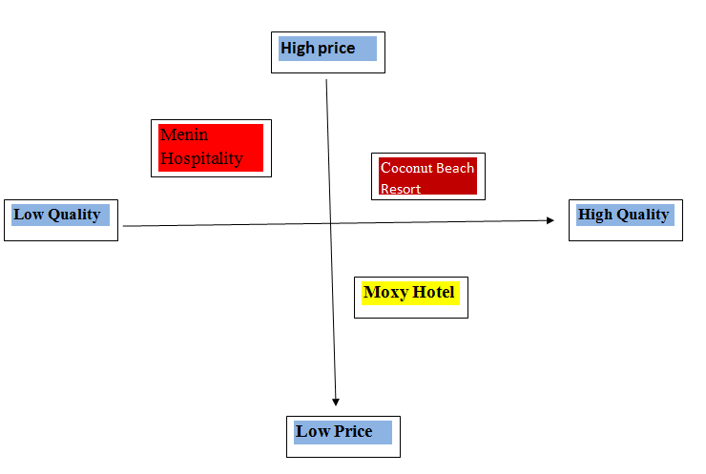
Figure No.3- Positioning of Moxy Hotel
(Source: Created by the Learner)

STP of Six Senses
Segmentation: The targeted customers of the company are the group of young adults.
Targeting: They have integrated the demographic segmentation strategy where they split their clients based on their genders, age or income (Chaffey et al., 2019).
Positioning: The top competitors of the company comprise four seasons, Ritz-Carlton and St. Regis Monarch Beach.
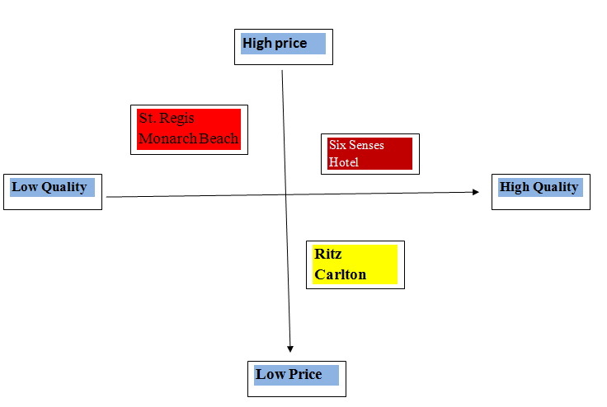
Figure No.4- Positioning of Six Senses Hotel
(Source: Created by the Learner)
Moxy Hotel resorted to restricting their operations in Russia as they found it difficult to carry on their process in the Russian market (Piccoli et al., 2022). They have shifted their focus to putting the people first and they now focus on introducing the existing products to the new markets. On the other hand, Six Senses paused their investment in Russia however; their suspension of operations in Russia was full of complexity. The company has developed strategies to maximise their revenue through verticals such as event spaces, leisure facilities and occupancy of rooms.
With regard to the sustainability issues, Moxy Hotels have reduced the water usage by 15% and they also decreased the intensity of carbon by 30% (Purvis et al., 2020). The company has started the marketing campaign “Serve 360” which signifies doing well in every direction, the campaign has been undertaken to register issues of carbon emissions. Whereas, Six Senses Resorts are free from toxins, waste and plastic and full of celebration, joy and spirituality. They have been continuously making efforts to conserve energy and reduce the waste by using organic amenities.
Conclusion
This essay has made distinction between the two companies; Six Senses and Moxy. This essay has analysed the marketing strategies that both the companies have applied. The prospective marketing strategies of both the companies have also been considered to highlight their contributions towards sustainability and green messaging. Lastly, the essay has examined both the company’s activities and operations post pandemic and how they inform their customers about the crisis to provide them safe products and services.
References
Bowie,D. Buttle,F. Brookes,M &amp; Mariussen,A (2017), Hospitality Marketing. 3 rd ed, Routledge, London
Chaffey, D and Ellis- Chadwick, F. (2019) Digital Marketing. 7 th ed, Pearsons, London.
Green, K.M., Crawford, B.A., Williamson, K.A. and DeWan, A.A., 2019. A meta-analysis of social marketing campaigns to improve global conservation outcomes. Social Marketing Quarterly, 25(1), pp.69-87.
Jobber, D. and Ellis-Chadwick, F (2020), Principles and practice of marketing. 9th ed. London:
Kotler, P., Armstrong, G., Harris, L. and He, H., 2020. Principles of marketing. 8 th European ed, London: Pearson Education Limited.
Minner, M. and Nayak, M., 2019, March. Lifestyle brands in the hotel industry-Critical success factors for Generation Y at the Moxy Frankfurt East. In ISCONTOUR 2019 Tourism Research Perspectives: Proceedings of the International Student Conference in Tourism Research (Vol. 7, p. 85). BoD–Books on Demand.
Pereira, P., Bašić, F., Bogunovic, I. and Barcelo, D., 2022. Russian-Ukrainian war impacts the total environment. Science of The Total Environment, 837, p.155865.
Piccoli, G.B., Brunori, G., Gesualdo, L. and Kalantar-Zadeh, K., 2022. The impact of the Russian–Ukrainian war for people with chronic diseases. Nature Reviews Nephrology, 18(7), pp.411-412.
Purvis, B., Mao, Y. and Robinson, D., 2019. Three pillars of sustainability: in search of conceptual origins. Sustainability science, 14, pp.681-695.
Ryan, D. (2012) Understanding Digital marketing: Marketing Strategies for Engaging The Digital Generation. Kogan Page, London.
Smith PR &amp; Zook ZE (2020) Marketing Communications. 7 th ed, Kogan Page, London
Zhang, Y., Xiong, Y. and Lee, T.J., 2020. A culture-oriented model of consumers’ hedonic experiences in luxury hotels. Journal of Hospitality and Tourism Management, 45, pp.399-409.

