Laura Jones
1701632

BA Graphic Design

Word Count: 2032

Sarah Thombs and Louise Burton

High and Low Culture
•1. “the best that has been thought and written in the world”—is in danger, or is indeed already “lost,” because of widespread popular education, popular communications systems, and what is often called “mass society.” On High and Popular Culture: Raymond Williams 1974

•newrepublic.com/article/79269/high-and-popular-culture

•Development of technology has spread all aspects of culture to a much wider audience. Are the terms high and low culture now redundant?

•1. “the best that has been thought and written in the world”—is in danger, or is indeed already “lost,” because of widespread popular education, popular communications systems, and what is often called “mass society.” On High and Popular Culture: Raymond Williams 1974

•newrepublic.com/article/79269/high-and-popular-culture

•Development of technology has spread all aspects of culture to a much wider audience. Are the terms high and low culture now redundant?

Now that social media has become an integral part of society, it is evident that the line and differentiation between the terms ‘high culture’ and ‘low culture have been blurred, who is deciding what the definition of these terms are now? Some would go as far to say that these terms no longer exist. Aspects of high culture and low culture are experiencing crossovers due to ‘mass culture’. Through technology, aspects of high culture are now available to lower culture, and vice versa. These aspects are able to reach a now wider audience so that it is no longer just defined to one particular group. In this essay I will be arguing that the terms high and low culture have no place or given slot within society and are now superfluous. This idea of the terms being deemed unnecessary will be argued through the topics of art, fashion, branding, and education.

Different mediums of art have been viewed as an essential part of high culture and it is often thought to be followed by or affiliated with aristocratic behaviour. Contemporary art is often recognised by the high culture and would include historical pieces that were not appreciated by the mass culture. In the novel Popular Culture and High Culture: An Analysis and Evaluation of Taste Revised and Updated (1999) it is stated by Gans that ‘The visual order of a De Kooning painting is interpreted as disorder by lower taste cultures, and the visual order of calendar art is not considered art by high culture.’ (1999:80). Taking this quote into consideration and looking at the bigger picture, just because a painting can be celebrated by people of ‘high culture’ does it now mean that it cannot be enjoyed by the popular culture? Looking closer at the mention of a De Kooning painting being a piece that only the elite can enjoy and view as a painting of order, it is possible that now the pieces of art within that sector are being reprinted and reused, being placed on calendars, postcards, and birthday cards, it has become a part of low culture.

Source: Willem De Kooning, Composition, 1955

Classical music is based on western musical traditions, in the 1700s to the early 1800s a high level of intelligence and refinement was required to listen to such a genre. During this time attending the opera and playwrights would often fall into the category of the high society, something that only the privileged class would attend. This idea of this activity only being enjoyed or accessed by the higher class poses the question of, if operatic song or performance is considered to be ‘high culture’, now that it can be accessed through the click of a button using technology does that now mean that it is considered to be ‘low culture’ as it is so accessible? Everything is even more accessible nowadays and the world is so interconnected that it is in fact possible that the terms ‘high culture’ and ‘low culture’ do not simply fit to different sectors of society anymore. If they do not fit into a given slot in society, it is clear that these terms are in fact being made redundant.

During the eighteenth-century art and fashion were separated into different cultural sectors. In the 1960s Yves Saint Laurent reproduced artist Piet Mondrain’s image of an abstract grid composition and printed it onto mini dresses. This relates back to the idea of technology advancing which is enabling the terms of high and low culture to become redundant. Now that technology has advanced, and it is now possible to mass produce and reproduce pieces that fall under the category of high culture. Within the novel British Fashion Design: Rag Trade or Image Industry? (1998) it was said by author Angela McRobbie that ‘Fashion design in Britain exists in a milieu largely designed by the values of popular rather than high culture.’ (1998:182). This discusses the point that the fashion industry relies on elitist traditions and values. For example, the company ‘Vogue” largely relies on presenting fashion styles that emulate a life of privilege and luxury, whereas standard fashion magazines want to relate to the mass and aim to relate to the wider audience. Relating back to the notion of high culture pieces being reproduced and available to the low culture, some of the most famous pieces of historical art have been used to produce fashion statements that relate to the mass. Louis Vuitton, famous fashion designer teamed up with American artist Jeff Koons to produce a collection of lavish handbags made from reproducing famous pieces of art. Even though famous pieces art being reused, because the bag has been made by a luxurious company does it then mean that it is still considered a high culture piece? No, this bag is still available to the masses and relates to popular culture, just because it is expensive and often people who live a lavish lifestyle would be likely to purchase one, does not mean that a person of ‘low culture’ cannot afford or appreciate the design. Perhaps by using an image of lower culture printed on an expensive item bigger brands are playing on the idea that there is no hierarchy of culture. Now technology has advanced, and we are now able to reprint and reuse pieces that have only been available to people of a privileged culture it is becoming more evident that the differentiation between high and low culture is quickly being made redundant as time goes on, however, this does not mean they the terms no longer exist. These expensive handbags are sold at an unaffordable price and are more likely to be sold to the more privileged. Due to taking a piece of low culture are and placing it on an expensive high culture product, are bigger brands alluding to the idea that there is still a hierarchy within this culture?


Source: Louis Vuitton X Jeff Koons Collection, 2018

High and low culture can relate and fit into many different topics and can create almost a divide within different sectors. High and low culture even fits into the element of Graphic Design within the publication Graphic Design: Reproducition and Representation Since 1800 (1996) it is said by Paul Jobling that ‘in the 1920s and 1930s [designers] consciously took the opportunity to work with the mass reproducible forms of print precisely because in this way they would reach a wider audience’. (1996:272) Discussing the idea that designers would often use prints that can be reproducible so that their work can appeal to the masses. Taking Andy Warhol as a case in point. His work is continuously being reused by designers and printed onto anything imaginable, why do some designers use this strategy? To simply appeal to the mass culture. It is no longer about ‘this is available to this person due to them having a privileged background’ or ‘this is available to this person because they are a person who enjoys something popular within their culture’, it could be argued that it is now about money and becoming more widespread to fit into popular culture.

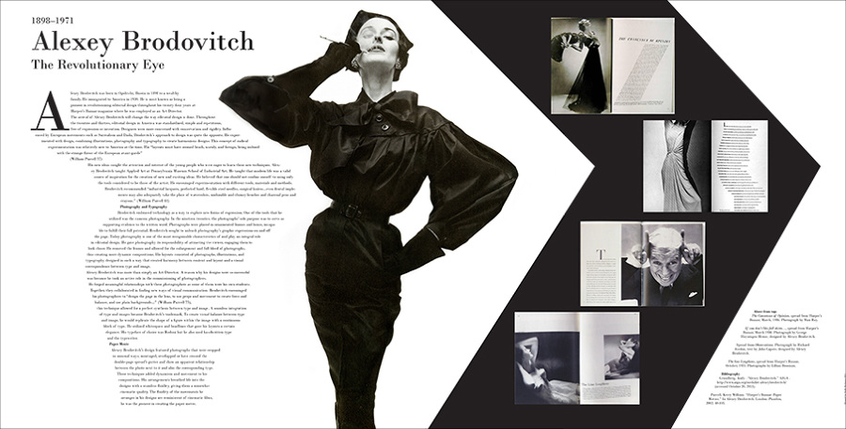

Taking a look at Alexey Brodovitch a Graphic Designer that is most well known for creating higher class designs for the prestige magazine ‘Harper’s Bazaar’. Brodovitch aims to create beautiful and well thought out upper class designs that look closely at high fashion and cultural content. The magazine spreads are visually innovative and due to the design has been recognised as this, producing pages that are not generic with boring layouts. He has been recognised as a high class designer due to these factors. However, looking at the work of Dave Perrilo, he is clearly influenced by popular culture which is showcased through his designs. Within the novel Inventing Popular Culture: From Folklore to Globalization (2003) it is said by John Storey that ‘the idea of popular culture is often a way of categorising and dismissing the cultural practises of ‘ordinary people’’ (2003:12). This leads to the notion that being influenced or inspired by popular culture can often lead to the work being dismissed or deamed not up to par with higher culture pieces. Even though Perrilo’s designs are heavily inspired by pop culture does it mean that Brodovitch is a better designer as his designs are for a respected piece of publication? Just because one designer is influenced by the mass culture, does not mean their work should be categorised or dismissed. Where does the boundary lay between work of high and low culture? This is why the terms are now being made redundant within society.

The same belief of the terms becoming unnecessary also applies to the topic of education. During the Victorian era in the 1800s only the wealthy would attend school and gain a respected education. Often children of a higher class would be sent to boarding schools and became qualified. Children who were of a lower class with considerably less money would be placed in a ‘Lower class school’. Upon leaving school, higher education such as university was an option only available to the people displayed at the top of the chain, the wealthy. Times have now changed since this era, and attending university isn’t only an act of the higher class but is in fact something that is offered to all classes. People who cannot afford university can apply for loans, grants, and bursaries in order to attend, meaning that the educational system and gaining qualifications is now available to everyone and ‘high and low culture’ can no longer apply to this.
To conclude, now that the terms and ideas surrounding high and low culture have been discussed through art, fashion, and education, this poses the question of ‘are these terms now redundant? Now that we are living within a world where everything is so accessible and interconnected, the terms ‘high culture’ and ‘low culture’ simply do not fit within today’s society. The terms in some respects can be deemed at worst offensive, and at the very best could be considered pointless and a way of categorising people. Often the term ‘low culture’ is surrounded by negative connotations, when the reality is a person of ‘low culture’ or part of the ‘mass culture’ is just simply someone who has access to high culture resources in a civilisation where in fact things that are considered ‘high culture’ can now be accessed by the mass. When looking for the definition of “high culture’ words related to this include ‘aristocracy’, ‘privileged’, and ‘cultured’. Does this mean that a person who enjoys something that is placed in the sector of ‘low culture’ is someone who is now labelled ‘uncultured’? The idea that someone could be seen as uncultured or of a lower class for appreciating a popular work of art is absurd. However, it is possible that through the aesthetic of low culture being employed by brands and often selling items that are unaffordable, the hierarchy still may continue to exist. The demographic of people who attend operas and art galleries is still not balanced in terms of race, class, and ethnicity, allowing the hierarchy to still exist with lines that are still blurred. During the article On High and Popular Culture: Raymond Williams (1974) it is said by Williams that “the best that has been thought and written in the world”—is in danger, or is indeed already “lost,” because of widespread popular education, popular communications systems, and what is often called “mass society.” This concept of the ‘best’ creative pieces or respected pieces of writing are ‘lost’ due to ‘lower culture’ having access to them is nonsensical. For this reason, using the terms are at best very meaningless, and inconsequential, because there is no less of an appreciation for a piece of art or a well written novel just because it can now be accessed for less money, and by more people. The terms have been made less clear in today’s community, are only used to segregate, and do not have a place within todays culture, and as it would appear people of the elite who live an aristocratic lifestyle are the people who are against these terms being made verbose.

Bibliography

Gans, Herbert (1999) Popular Culture and High Culture: An Analysis and Evaluation of Taste Revised and Updated. Basic Books, New York.

McRobbie, Angela (1998) British Fashion Design: Rag Trade or Image Industry? Routledge 11, London.

Jobling, Paul (1996) Graphic Design: Reproduction and Representation Since 1800. Manchester University Press, Manchester.

Storey, John (2003) Inventing Popular Culture: From Folklore to Globalization. Blackwell Publishing Ltd. New Jersey.

Williams, R (1974) On High and Popular Culture: Raymond Williams (1974). Available at: https://newrepublic.com/article/79269/high-and-popular-culture (accessed 9th December 2018)

