Student name: Ana-Maria Budau
Student ID: 2030929

STRATEGIC MANAGEMENT & SUSTAINABILITY
(SELECTED COMPANY: MARKS & SPENCER GROUP PLC)
Executive summary
This report focused on the strategic practices of Marks and Spencer to identify the key strategic choices of this company. They also maintain sustainability in the food products along with exceptional quality and value. The online stores of Marks & Spencer have increased the market segment. They penetrated the Asian market through online channels. A Porter’s value chain analysis and VRIO has been conducted for the analysis of the resources of the company. This showed that companies need to develop their resources in order to develop their competitive advantage. The 4 principles of CSR such as philanthropic responsibility, ethical, economic and environmental responsibility have been elaborated in the context of M&S.

Table of Contents
Introduction 4
Company Background 4
Main Body 4
Identifying Key Business and Corporate Strategies (Strategic Choice) 4
Porter’s Generic Model 4
Ansoff matrix 5
Analysing Resources and Capabilities (Alignment with Strategy) 6
Porter's Value Chain model analysis 6
VRIO analysis 9
Evaluating Strategy in Action 10
SAF (Suitability, acceptability and Feasibility) framework 10
Evaluating Sustainability Efforts 11
Conclusion 12
References 13

Introduction
This report focuses on the strategic practices of Marks and Spencer to identify the key strategic choices of this British Plc. Accordingly, the resources and capabilities of this Plc will be analysed to understand the alignment of resources with its strategic choices. After that, by using the value chain analytical tool, the resource allocation of this company can be recognised. Moreover, the strategic practices of this company will be evaluated. Furthermore, the SAF analysis of the strategic practices will be done in this report to analyse the effectiveness of the applied strategies in this company.

Company Background
Marks & Spencer is the leading retailer in the UK that brings quality, great value food retail and homeware items to millions of customers around the entire world. This PLc has a current share price of 261.00 GBP (Marks and Spencer 2024a). It has more than 405 retail stores and over 100 websites that are operated in the global context (Marks and Spencer 2024a). Besides the local market, it also operates in 70 different markets in different countries through the online platform. Marks & Spencer Group Plc is engaged with the retail and wholesale business of food, clothing and homewards. This company is headquartered in London (Forbes, 2024. Hence, this is British plc which has the UK segment of UK retail businesses and franchise operations. Therefore, this British PLC is a leading company which has prominent business growth in the global context (Marks and Spencer 2024a). This company has recently rotated their strategy in order to exploit the momentum they have built up over the past few years. It has accelerated the store rotation plan to deliver its Omni-channel objectives (Retail Week, 2024). Therefore, this company has been selected in this report, in order to analyse the alignment of the strategic practices of the British plc with its strategic practices.

Main Body

Identifying Key Business and Corporate Strategies (Strategic Choice)

Porter’s Generic Model
Cost Leadership strategy:
Marks and Spencer is using the strategy of cost leadership in order to compete with the other retail stores in the UK. this company has a pricing architecture that is clear and offers value on the entry price points on each product such as clothing and also in the home ware ranges. On the other hand, through the "lowering cost programme, it has delivered a sales growth of about 10.1% that is combined with the improved margin mix (Marks and Spencer, 2022). With the cost reduction in the supply chain of Marks & Spencer, store operation quality has been enhanced. In this cost leadership strategy, this company aims to fund the exit costs of the legacy estate by means of increasingly active assets. In the current situation of Brexit-related cost pressure, this PLc has generated a 4% retail sales growth along with its partners (Marks and Spencer, 2022). In this business growth, the cost reductions in the supply chain and the improvement of the overall operation have a positive impact. In this way, the cost leadership strategy has helped companies to ensure positive business growth and to increase the competitive edge of the firm.
Differentiation strategy:
Strategic management contributes to the identification of a unique strategy considering the complex and unstable forces (Ralph, 2011. Marks & Spencer mainly follows the technique of differential quality and lower prices (Marks and Spencer, 2022). Cutting prices of the products can act as an effective differentiation strategy that can help the firm differentiate its products and services from the other firms (Martin, 2023). Therefore, the premium quality of the products at lower prices in comparison with its competitors may help the company increase its competitiveness in the retail sector in the UK.

Ansoff matrix
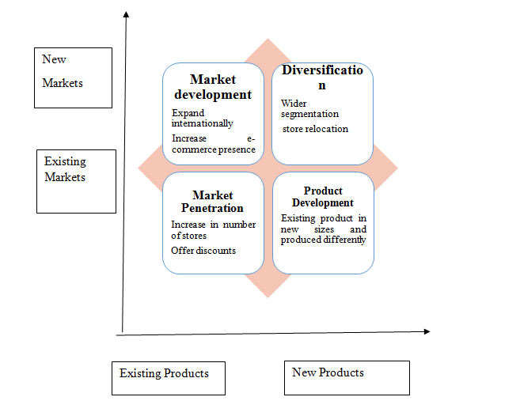
Figure 1: Ansoff matrix analysis of Marks & Spencer
(Source: Self-developed)

As per the above-mentioned ansoff matrix analysis of Marks& Spencer, the company has been found to have a strategy of market penetration through e-commerce development. In this company, more than 100 websites are developed to connect businesses with global customers (Marks and Spencer 2024a). In this way, they penetrated the Asian market through online channels. Moreover, the integration of online business with brick-and-mortar stores has helped the company to widen its segment in the internal and the UK context. They operate 405 stores in the local market of UK through the retail and franchises. On the other hand, the online stores of Marks & Spencer have increased the market segment. Moreover, theft has relocated its stores to well-located sites in order to increase its business reach. In order to develop products differently, this company mostly relies on data-driven technologies (Marks and Spencer, 2022). In this technological advancement, they are utilising their resources in food development as per the requirements of their customers. Moreover, they also maintain sustainability in the food products along with exceptional quality and value through the protein, deli and dairy, and in-store bakeries (Marks and Spencer, 2022). On the other hand, this product development strategy helps it to increase the quality of products that are delivered to the customers at the lower process. In this way, the product differentiation strategy has been developed by this retail company to increase its competitiveness in the retail market.

Analysing Resources and Capabilities (Alignment with Strategy)

Porter's Value Chain model analysis
Supportive Activities
Firms Infrastructure:
Marks and Spencer has been running operations in the retail industry of the global market through “1,487 stores” and “98 websites” (Marks and Spencer, 2023a). The company \ company has support centres and warehouses all over the world.
Human Resource Management
The company has a proper feedback system, which is provided by the survey and listening groups within the workplace (Marks and Spencer, 2019). The workers are also able to directly talk to their managers about their issues in the company.
Technological development:
The company has incorporated artificial intelligence technology in their 500 stores for the optimisation of its store operations (Businesswire, 2024). The company also formed collaboration with “SymphonyAI Retail CPG” for the development of their “Store Intelligence capabilities”
Procurement
The company followed the principles of global sourcing and the company now has almost 60 factories from where it procures the products (Marks and Spencer, 2024b). On the other hand, the company also accessed the factories in Bangladesh.
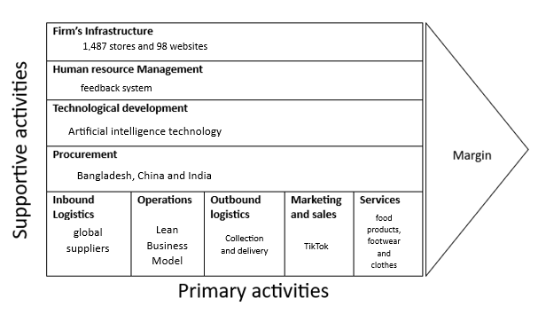
Figure 2: Porter's Value Chain model analysis of M&S
(Source: Self-developed)
Primary activities
Inbound logistics:
M&S have a whole category of global suppliers from Asian countries. The company has 196 retailers for clothes and home products solely in China while in India the company has 94 factories (Smith, \2024). Thus the country has been the top supplier of the M&S according to the reports of 2024.
Operations:
The operations of M&S followed the Lean Business Model which mainly focused on the n integrated system, delivery of sustainable products and making profitable improvements for the company (Marks and Spencer, 2024c). The principles of the lean business model such as the shared vision, ups and downs in the supply chain, and tools aligned as per the needs of the company have been followed by M&S in their business operations.

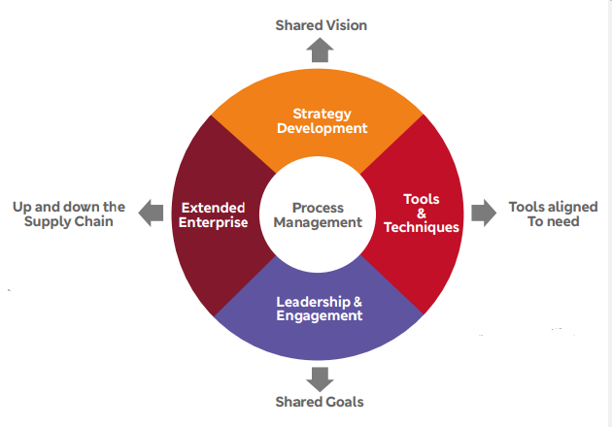
Figure 3: Lean business model of M&S
(Source: Marks and Spencer, 2024c)
Marketing and sales:
The sales of M&S were £11,988.0m in 2023 due to their success in marketing their products to global customers (Marks and Spencer, 2023b). The company recently joined TikTok to implement virtual influencers (Gilliland, 2024 ). The social media advertising of the company has increased their brand awareness and enhanced digital engagement.
Services:
M&S has become an effective retailing company for serving its customers high-quality and valued food products, footwear and clothes (Marks and Spencer, 2024a). The company has their services available through the stores and online platforms throughout the global platforms.
Outbound logistics
The company have a help desk for the “Collection & Delivery” related tasks. The company offers free home delivery of their products in the UK with the facilities of tracking the orders and collecting them (Marks and Spencer, 2024). On the other hand customers outside the EU may have to pay duty changes while shipping products.

VRIO analysis
Category | Resources | Valuable | Rare | Imitability | Organised
Tangible | Technological advancement | Yes | No | No | yes | Competitive parity
Tangible | Financial conductions | Yes | No | No | Yes | Competitive parity
Tangible | Human resources | Yes | No | No | No | Competitive parity
Intangible | Brand value | Yes | Yes | no | Yes | Competitive parity
Intangible | Customer services | Yes | No | No | Yes | Competitive parity

Table 1: VRIO analysis of M&S
(Source: Self-developed)
M&S has incorporated advanced technologies in their business operations. “Artificial intelligence, big data, cloud computing, IoT, and payments” are major technologies that are included in the new business process of the company (Global Data, 2024). On the other hand, Tesco Plc also used the cloud, big data and other disruptive technology. This indicated that technology used in M&S is not rare and led to competitive parity (Global Data 2023). In addition, the Human resource of M & S includes 65,000 colleagues from all over the world. The company has been accused of exploiting its workers through policies of breaks and the work environment (Cityam, 2020). Hence, this indicated the lack of organised Human resource management of M&S. The brand value of M&S is currently worth 2.15 billion U.S. dollars in 2022 (Statista, 2022a). ASDA also acquired 2.61 billion U.S. dollars in 2022 in terms of its brand values (Statista, 2022b). Thus, in the case of resources related to brand values remain competitive parity due to Barnard values which is not rare. On the other hand, The customer services of the M&S remain open for 24 hours for any kinds of queries regarding shopping, gift cards and coupons (Marks and Spencer, 2024d). Hence this can be said that companies have a long-term competitive advantage as the customers are satisfied with the performance quality of M&S’s Customer Services. Hence, regarding the analysis of the resources the company still needs to develop their unique technology, improve the brand values and enhance the human resource management for gaining competitive advantages.

Evaluating Strategy in Action

SAF (Suitability, acceptability and Feasibility) framework
Suitability:
The main challenge faced by Marks & Spencer is the lack of engagement of their customers. due to these issues, they have high customer dissatisfaction issues (Russon, 2023). However, in the strategic reshaping of businesses, they have incorporated technology in product development in order to develop products in a data-driven way. Through this strategy, the company can easily mitigate the issues of lack of engagement of their customers. Hence, this strategy of data-driven product development as per the needs of the customers can be beneficial to mitigate the issues of high food waste and to increase the satisfaction of the modern customers of retail. In the current situation, the company has relocated their stores to well-built sites (Marks and Spencer, 2022). Previously, they have faced challenges due to the lack of excellence in their stores which has been reported to harm the purchasing experiences of the customers (Russon, 2023). Therefore, the strategy of relocation to the well-built stores can be suitable for the company to increase the satisfaction of their customers by providing a seamless shopping experience with the stores.
Acceptability:
In Marks & Spencer, the difference in product quality with a lower pricing strategy has been implemented in order to increase the purchasing behaviour of the customers. In the UK, consumers' spending has been projected by 1.3% which is lower than the previous year's (Ball. 2023). Therefore, the high price of the products can affect the purchasing capacity of the UK consumer. The low pricing strategy with the higher product quality is helping the company to attract more and more retail consumers to purchase products from this company. As a result of the pricing strategy, the overall sale of this firm has been increased. Through the "lowering cost programme”, it has delivered a sales growth of about 10.1% that is combined with the improved margin mix (Marks and Spencer, 2022). Hence, the low piercing and cost-cutting strategy used by the company is suitable to increase the overall sales of the business by influencing the purchasing behaviour of the customers.
Feasibility
In the current situation, sustainability is the major concern of businesses in order to ensure long-term business growth (Bloomberg, 2023). Marks & Spencer has implemented sustainability in their practices in order to reduce the negative impact of businesses on the environment and society. Therefore, the sustainable approach of the strategies implemented in this company can help it increase the business profit and ensure long-term business growth as sustainability is considered as the practical strategy of the business to increase reputation and business. Sustainability is an essential factor that is required to be done on the basis of the outcome on the environment and society. Therefore, this strategy can be feasible for the company and can improve the stakeholder's satisfaction and emergency to the company.

Evaluating Sustainability Efforts
Environmental Responsibility
The company has been following the goal of achieving Net Zero emissions from its supply chain by 2040. In order to reach the sustainability goal, the company has been using sustainability in sourcing products and lowering negative impacts on nature through farming (Marks and Spencer, 2023c.). This may have lowered the Scope 3 emission while for Scope 1 and Scope 2, the company incorporated the zero-emission from their supplying vehicles. This also indicated that M&S has united to take urgent action for combating climate change and its impacts which aligns with the 13th of the SDG. In addition, M&S committed to making their 100% packing of the products recycled by the end of 2025. The volume of plastic has already been reduced to 30% already for achieve the sustainability goals (Marks and Spencer, 2023c).
Philanthropic Responsibility: M&S has been dominating the clothes and “business surpluses” to the communities for the money they raised from the sales and cycling of the garments (Fibre2fashion, 2024). The recycling products sales are directly assessed to funds of “400 pieces of equipment” This initiative has been taken by the company for the development of living conditions of disabled children.
Economic Responsibility: M&S in the gallbladder platform took the decision to raise the pay of their workers by 7% in 2023 (BBC, 2024). The company has been providing a salary worth £13.15 per hour to their workers in the stores. The company earned a revenue of almost 12 billion British pounds in 2023 (Statista, 2024). In the UK only M&S earned 10.9 billion British pounds in 2023.
Ethical Responsibility: The Company has been following ethical standards in the case of a supply of their cotton products. The ethical trade has been driving the company towards long-term sustainability (Marks and Spencer, 2023c). The suppliers of the company have to declare their sourcing points of the products and data in case to prevent the unethical sourcing of products. The Supplies of cotton have gone through the test of OritainTM lab to prove their natural ingredients are present in raw materials. On the other hand, the company has also been following the “United Nations Guiding Principles on Business” and “Human Rights” in order to run their business ethically. The workforce exploitation of the company has been damaging the ethical image of the brand. Thus, the company has been able to develop its suitability in business by improving its business ethics.

Conclusion
The Porter generic framework in the report has concluded that MS has been approaching cost leadership and following different strategies through the lower price of the products along with their high quality. On the other hand, VRIO analysis has identified that M&S have lower competitive advantages in their human resource management. Technology and brand values but the high customer service quality has been improving the competitiveness of the company. The business target of relocation of the store is to suitable to customer engagement challenges on the other hand the company has also been unethical in their business process which hinders the way sustainability

References
Ball. H. (2023). How cost of living pressures will impact UK consumer spending.Available at: https://www.ey.com/en_uk/growth/ey-item-club/how-cost-of-living-pressures-will-impact-uk-consumer-spending (Accessed: 21 April 2024).
BBC, (2024). Marks & Spencer raises pay in battle for supermarket staff. Available at: https://www.bbc.com/news/business-68404573. (Accessed: 22 April 2024)
Bloomberg, (2023). Building a Future Marked by Practical Sustainability. Available at:https://sponsored.bloomberg.com/article/infosys/building-a-future-marked-by-practical-sustainability (Accessed: 24 April 2024).
Businesswire, (2024). Marks & Spencer Digital Transformation Strategy Analysis Report 2023: Innovation Programs, Technology Initiatives, Estimated ICT Budget, and Major ICT Contracts - Research AndMarkets.com. Available at: https://www.businesswire.com/news/home/20240105108329/en/Marks-Spencer-Digital-Transformation-Strategy-Analysis-Report-2023-Innovation-Programs-Technology-Initiatives-Estimated-ICT-Budget-and-Major-ICT-Contracts---ResearchAndMarkets.com#:~:text=M%26S%20is%20implementing%20AI%2C%20including,for%20its%20Store%20Intelligence%20capabilities.(Accessed: 19 April 2024)
Cityam, (2020). Tesco, M&S and Sainsbury’s face allegations of worker exploitation in India. Available at: https://www.cityam.com/tesco-ms-and-sainsburys-face-allegations-of-worker-exploitation-in-india/. (Accessed: 22 April 2024)
Fibre2fashion, (2024). Corporate Social Responsibility. Available at: https://fashiongear.fibre2fashion.com/brand-story/mands/corporate.asp#:~:text=Clothing%20and%20equipment&text=M%26S%20donates%20returned%20clothing%20and,for%20disabled%20children%20each%20year. (Accessed: 24 April 2024)
Forbes, (2024). Marks & Spencer. Available at: https://www.forbes.com/companies/marks-spencer/?sh=87316d77de14 (Accessed: 21 April 2024).
Gilliland, N., (2024). How Marks & Spencer has innovated its social media presence. Available at: https://econsultancy.com/marks-spencer-social-media-innovation/#:~:text=From%20TikTok%20to%20virtual%20influencers,it%20continues%20its%20brand%20turnaround.&text=Mark%20%26%20Spencer%20has%20upped%20its,awareness%20and%20increase%20digital%20engagement. (Accessed: 23 April 2024)
Global Data (2023). Tesco Plc - Digital Transformation Strategies. Available at: https://ww w.globaldata.com/store/report/tesco-plc-enterprise-tech-analysis/#:~:text=Tesco%20Plc.,at%20%241.9%20billion%20for%202023. (Accessed: 24 April 2024)
Global data, (2024). Marks & Spencer – Digital Transformation Strategies. Available at: https://www.globaldata.com/store/report/marks-and-spencer-enterprise-tech-analysis/. (Accessed: 24 April 2024)
Marks and Spencer, (2019). M&S People Principle. Available at: https://corporate.marksandspencer.com/sites/marksandspencer/files/marks-spencer/our-people/mns-people-principles.pdf. (Accessed: 20 April 2024)
Marks and Spencer, (2022). Marks and Spencer Group plc Annual Report & Financial Statements 2022. Available at: https://corporate.marksandspencer.com/sites/marksandspencer/files/marks-spencer/investor/m-and-s-ar22-strategic-report.pdf (Accessed: 20 April 2024).
Marks and Spencer, (2023a). Shaping the - Marks & Spencer. Available at: https://corporate.marksandspencer.com/sites/marksandspencer/files/marks-spencer/m-and-s_ar22_full-ar.pdf. (Accessed: 20 April 2024)
Marks and Spencer, (2023b). M&S DELIVERS STRONG RESULTS AS IT RESHAPES FOR GROWTH. Available at: https://corporate.marksandspencer.com/media/press-releases/marks-and-spencer-group-plc-full-year-results-52-weeks-ended-1-april-2023. (Accessed: 22 April 2024)
Marks and Spencer, (2023c) Marks and Spencer Group plc. Available at: https://corporate.marksandspencer.com/sites/marksandspencer/files/marks-spencer/investor/Annual%20Report%202023/M%26S%20Sustainability%20Report%202023.pdf (Accessed: 21 April 2024).
Marks and Spencer, (2024a) About Us. Available at: https://corporate.marksandspencer.com/about-us (Accessed: 23 April 2024).
Marks and Spencer, (2024b). Our Approach to Sourcing. Available at: https://corporate.marksandspencer.com/our-approach-sourcing. (Accessed: 21 April 2024)
Marks and Spencer, (2024c). System for success. Available at: https://corporate.marksandspencer.com/sites/marksandspencer/files/marks-spencer/supporting-food-supply/m-and-s-systems-for-success-lean-toolkit-support.pdf. (Accessed: 23 April 2024)
Marks and Spencer, (2024d). Contact customer services. Available at: https://www.marksandspencer.com/c/help-and-support/contact. (Accessed: 24 April 2024)
Marks and Spencer, (2024e). Collection & delivery. Available at: https://www.marksandspencer.com/c/help-and-support/collection-and-delivery#intdelivery. (Accessed: 21 April 2024)
Martin, R, (2023). Cost-Effective Differentiation. Available at:https://rogermartin.medium.com/cost-effective-differentiation-10eb69a2ccd (Accessed: 21 April 2024).
Ralph. D. Stacey, (2011) Strategic Management and Organisational Dynamics: The Challenge of Complexity. Pearson Education UK.
Retail-week, (2024) Marks & Spencer. Available at: https://www.retail-week.com/retail-navigator/marks-and-spencer/marks-and-spencer-strategy/7038340.supplierarticle#:~:text=It%20wants%20to%20reduce%20the,sq%20ft%20'renewal'%20format.(Accessed: 23 April 2024).
Russon, M. (2023). M&S: Five reasons the retailer is struggling.Available at: https://www.bbc.com/news/business-53478403 (Accessed: 21 April 2024).
Smith, P., (2024). Marks & Spencer: number of manufacturing factories 2023, by country. Available at: https://www.statista.com/statistics/1102485/number-of-suppliers-of-marks-and-spencer-by-country/#:~:text=The%20British%20retailer%20Marks%20%26%20Spencer,of%20suppliers%2C%20with%2094%20factories. (Accessed: 20 April 2024)
Statista, (2022a). Marks & Spencer brand value 2018-2022. Available at: https://www.statista.com/statistics/1337876/marks-and-spencer-brand-value/ . (Accessed: 24 April 2024)
Statista, (2022b). ASDA brand value 2018-2022. Available at: https://www.statista.com/statistics/1337838/asda-brand-value/#:~:text=In%202022%2C%20ASDA%20%2D%20a%20British,2018%20%2D%202.59%20billion%20U.S.%20dollars. (Accessed: 24 April 2024)
Statista, (2024). Marks and Spencer - Statistics & Facts. Available at: https://www.statista.com/topics/3707/marks-and-spencer/#topicOverview.(Accessed: 21 April 2024)

