

BSc (Hons) Ordnance, Munitions & Explosives – EMR

Chinese Balloons over North America

Thomas Beswick – 1910566
30/04/2023

Contents
1 Background 3
2 Issue 3
3 Recommendation 4
4 Timing 4
5 Discussion 4
6 References 10

Background

Chinese weather balloons have been spotted in various areas over North America, first spotted in Alaska on 28th January, with an estimated trajectory shown in Figure 1. They have been estimated to be 60 meters tall and likely to be weighing approximately 450kg [1]. This type of activity is not unusual as it is claimed to have occurred at least 4 times previous in recent years [2] and while Chinese officials are claiming these balloons to be for “civilian use”, this report will investigate the potential uses of the balloons, the information they could collect or transmit and why this occurrence seems to have caused such a high profile reaction.

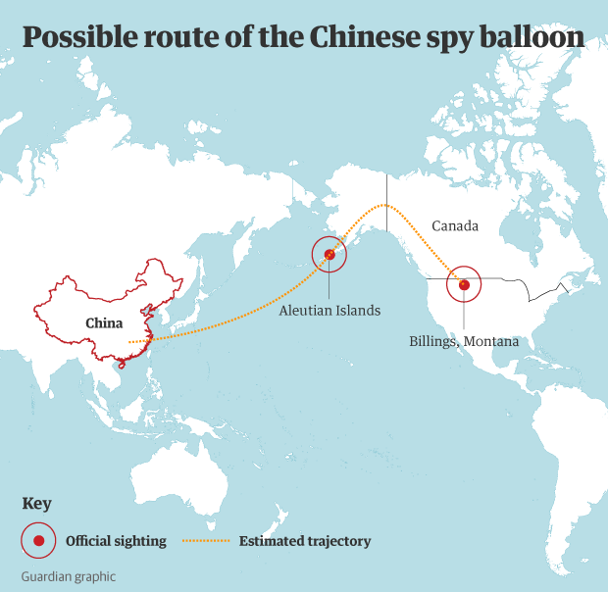
Figure 1 - Possible trajectory of Chinese balloon [3]

Issue

The purpose of the balloons remains unknown. They could be used to collect sensitive data such as communications, military locations, and movements. Some news outlets have claimed that the balloons could “contain biochemical weapons” [4], while others speculate that they are intended to ‘test the US military response’ [5]. This report will draw conclusions on the realistic capabilities of the balloons and determine how concerned this business ought to be about them.

This report also works on the assumption that there are no significant developments in technology being used on these balloons, therefore recommendations are based upon the information on existing technologies available.

Recommendation

It is recommended that no significant reaction is required by this company. The balloons do not pose any immediate threat to us or our customers. They were likely sent to test the response of the US miliary. It is unlikely that the technology available to the originators of the balloon can capture any useful sensitive information, and even then, would be unable to transmit this back to the source.

Timing
As discussed in the recommendations, not significant reaction is required and therefore there are no time constraints to actions because of this report.

Discussion

Size, and lifting capability

The first step to analysing the capabilities of the balloon is to understand the size and lifting ability using the available information. General Glen VanHerck of the North American Aerospace Defence Command claimed that the balloon was approximately 60 meters tall, carrying a payload of up to 1,000kg at 18,3000 meters in altitude [6]. When the balloons were shot down by the US air force [7] there was no violent reaction from the gas inside the balloon, therefore it can be assumed the lift was generated by helium as opposed to hydrogen. This means that the maximum height of the balloon will have been approximately 15,000 meters due to the air density above this altitude being less than that of helium.

When lift is calculated based on helium at 15,000 meters, carrying a payload of 1,000kg, the resultant balloon must have a total volume of 50,0000m³ of gas, for a perfect sphere balloon this would be a 45-meter diameter. This added on to the payload attached below, as seen in Figure 2. allows us to assume the 60-meter-tall estimation to be relatively accurate. Equation 1and Equation 2 show these calculations.

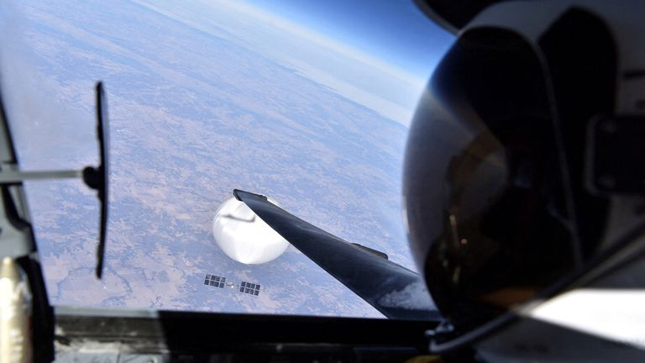
Figure 2 - Image of 'spy' balloon from US fighter jet [8]
Equation 1 - Balloon volume

$$Volume=\frac{Mass}{\left(Air Density-Lifting Gas Density\right)}=\frac{1000}{\left(0.2-0.18\right)}=50,000m^{3}$$
Equation 2 - Balloon diameter

$$Balloon Diameter=2*\sqrt[3]{\frac{3}{4}}*\frac{volume}{π}=2*\sqrt[3]{\frac{3}{4}}*\frac{50000}{π}=45.71m$$

From the confirmation of these calculations, it can be assumed that there are no additional hidden weapons or payloads being carried by the balloon. Therefore, the possibility of the balloon cannot be considered a biochemical, electromagnetic pulse generator or nuclear weapon.

Gamma, X-rays, and UV

To consider if the balloons are capable of generating an dispersing gamma rays looking at one the gamma ray generators, HERMES III [9], shows us that it is highly unlikely that the ‘small’ 1,000kg payload carried by the balloon is unable to produce gamma rays in an significant quantity. The generator for the HERMES III occupies a space of 400m³. For this generator to weight 1,000kg most of its construction must have a density of 2.5k/m³, similar to that of carbon dioxide. Therefore, it can be assumed that the balloons are not capable of generating gamma rays.

X-rays take less power to generate, and may be generated by the balloons however, there is no useful information or significant damage they could impart from 15,000m altitudes. If the balloon was able to carry the world strongest x-ray source of 6 GeV [10], the x-rays will attenuate relative to the inverse square law, meaning that at ground level the intensity of the radiation will be 26 eV, where the weakest medical x-ray is often seen at 60 KeV [11].

Similar to the above, generation of ultraviolet radiation is going to have a miniscule effect by the time the rays reach the ground. Especially when in contrast the UV radiation emitted by the sun. In the same way, receiving the UV radiation as information would be unlikely to provide any useful or sensitive information due to the abundance in the atmosphere.

Visible Light

In the visible light spectrum, there is a variety of data that can be collected. This includes the locations and activities of military bases, as well as the potential movements of sensitive information. If it can be seen by the sky, then it is possible that this balloon was released to survey it as a subject. However, there are factors that will affect the payloads’ ability capture suitable images at useful resolutions. If the images it can capture have little detail due to its altitude, the information will be no more detailed than that found on Google maps.

The first potential obstacle for the visible light spectrum is the presence of clouds. Visible light is penetrated through clouds and therefore any images taken will be blocked by any clouds in the sky. As stated by the Manchester University Centre for Atmospheric Science, low level clouds are often found at 6,500ft (2,000m) and the high-level clouds at 20,000ft (6,000m) [12] which are both significantly below the altitude claimed for these weather balloons.

A further question is the usefulness of visible light images gathered by a weather balloon when the China Aerospace Science and Technology Corporation (CASC) have satellites at their disposal. Even as of March 2023, China has launched multiple ‘mysterious Earth-mapping’ satellites which may be used for gathering information in the visible light spectrum [13]. The ability to record and transmit this data will be superior on these satellites over a weather balloon, as will be discussed later in this report.

To greater understand the ability of these balloons of capturing useful visible light images, the Rayleigh criteria can be applied to calculate the necessary lens diameter in order to resolve an image at 15,000m in altitude. Some of the best spatial resolutions available in orbital satellites is 30cm, therefore in these calculations, a resolution of distance of 30cm will be used. This means that, if two objects are closer to together than 30cm, then the lens will be unable to distinguish between the two objects.
Equation 3 - Angle calculation

$$θ=\tan^{-1}\left(\frac{0.3}{15000}\right)=2*{10}^{-5}rad$$
Equation 4 - Rayliegh's criteria

$$D=1.22\frac{λ}{sinθ}=1.22\frac{500*{10}^{-9}}{sin⁡(2*{10}^{-5})}=1.75m$$

Equation 3 and Equation 4 show that, to match the resolution of a high-quality satellite, a lens diameter of 1.75m is required to resolve 30cm distances on Earth surface. Considering the 1,000kg payload the balloon could carry, the chance that the balloon was carrying a lens of this size to capture images is not unlikely. However, the question arises on how useful these images would be as satellites are capturing similar images every day, therefore any sensitive activities or equipment will be moved and used undercover to avoid visibility from overhead imaging.

Infrared

Infrared radiation is the often described as invisible heat rays, or thermal radiation that sits above red light in the spectrum with wavelengths between 780nm and 1mm. If the balloons were capable of carrying an imaging device for infrared, they would be able to detect the heat signatures of vehicles, military bases or other sensitive information on Earths surface. The difficulty in this comes from the increased wavelengths of the infrared spectrum. Most of the heat signatures produced by infrared on Earths surface for detection in this sense will be in the ‘far’ regions of 3,000nm to 1mm. Equation 5 shows the Rayleigh’s criteria calculation again for wavelengths in the infrared range, with a lens diameter of 3,495m. Despite the 1,000kg carrying capacity, the balloons will not be able to lift a lens of this size to resolve infrared images at the altitude they were found at. Figure 3 demonstrates the standard infrared imaging taken from orbital satellites, with limited resolution, they are only capable at detecting difference across large areas.
Equation 5 - Rayliegh's criteria for IR

$$D=1.22\frac{1*{10}^{-3}}{sin⁡(2*{10}^{-5})}=3495m$$

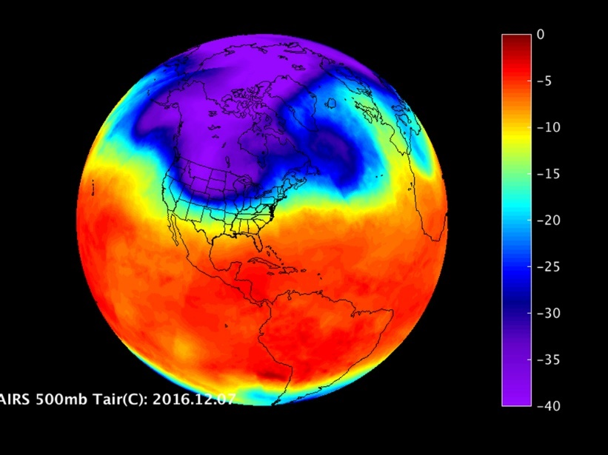
Figure 3 - Infrared image of earth [14]

It could be possible that the balloons were sent to determine the infrared signatures of the jets sent to shoot them down. As the distance between the balloons and jets will be significantly smaller than the balloons to Earth, the lens size will be much smaller and therefore would be able to resolve that image. If this was the purpose, it is highly likely that this information was captured by the balloon when shot down. The jet engines will produce a unique heat (infrared) signature that imaging is able to capture. If the information was then recovered, this could then be used in future to determine when those specific jets are in use, as well as for use in seeker missiles.

Microwaves

When discussing the potential for a microwave receiver on the balloons, the main focus will be on intercepting communications. This form of radiation occurs in the 300MHz to 300GHz frequency spectrum and is commonly found as the method of communication in mobile devices, leading to the assumption that any receiver or transmitter on the payload would not need to be of any significant size.

It is possible that the payload was launched with the purpose of monitoring mobile communications, including public or sensitive military communications. It is known that for long distance communication, microwave transmissions required a typical repeater spacing of 20 to 30 miles [15]. This means that unless there was another balloon in 20 to 30 miles of the initial receiver to relay the signal back to a storage device, the information would have to be stored on the balloon and transmitted via a different method. Microwave communications often require directional transmitter and receivers to overcome the effects of the inverse square law attenuating the waves. Unless the payload has a received pointed for a specific target, it is likely that any microwave communications intercepted would have been untargeted.

It is also claimed that the US military tracked the balloon from it’s launch on Hainan Island [16], which allowed them to track the range of possible communications and stop any sensitive information being broadcast when in range. This also meant that they were able to block or ‘jam’ communications by sending an interference wave toward the balloon, so any data received is overwhelmed by the intensity of the ‘noise’ generated by the jammer.

Overall, while microwave transmissions are easy to intercept and receiver, the usefulness of the information is limited. As the balloon was tracked, it’s unlikely that any signification information was received, if any was recoverable through the noise. The ability to then transmit that information back towards the source of the balloon would have required multiple repeaters along the route.

Radio

For communications in the radio frequencies of the spectrum, it is assumed that this is used for transmitting as opposed to receiving radio frequencies. Most military communications will occur over low power (5 or 10 radios) where commercial radio will operate at 5000 watts to achieve the distances required for transmission. At 15,000m altitude, the only signal possible of being received by radio are these high-powered broadcasts.

If the balloons were transmitting radio signals back towards China, the most likely frequencies would be in the VHF region of 30-300MHz. In marine and aviation communications, VHF is used for its superiority in line-of-sign, open terrain communication. At 15,000m altitude, it is possible that the balloon had line of sight of a receiver or repeater to pass the message along. For further calculations, a frequency of 30MHz will be used.

Within these frequency bands, the antenna as a ½ dipole would be between 0.5 to 5 meters in lengths. Equation 6 shows the calculation for this value. These lengths would have been easily carried by the 1,000kg payload.
Equation 6 - Antenna length calculation

$$Antenna Length=\frac{Wavelength}{2}=\frac{\left(\frac{3*{10}^{8}}{30*{10}^{6}}\right)}{2}=5m$$

To transmit on the radio frequencies, the transmitter will require power which can be powered based on the distance, gain of transmitter and receiver, and wavelength. The Roumoules radio transmitter in France is one of the most powerful transmitters in the world and can transmit clearly across Europe, especially at night. With power supplied by 220kV power lines, it can be assumed that the power of the transmitter on these balloons will not be close to the power of Roumoules, which generally operated at 700kW however, for the purpose of these calculations this lower end will be used to calculate the power of signal received from Alaska to China.

Using the longer wavelength of 10 meters, an assumed high-end gain of 40 for both the transmitter and receiver with a separation of 4,000miles, the received power is only 1W of power. This level of signal will be easily lost and overpowered within the noise of surround communications. Equation 7 shows the calculations. The only other option of transmitting the information would be for gathered intel to be stored on a hard drive to be recovered later, which was not possible due to the balloon being destroyed by the US air force.
Equation 7 - Friis transmission calculation

$$P_{r}=\frac{P_{t}G_{t}G_{r}λ^{2}}{{\left(4πR\right)}^{2}}=\frac{700000*40*40*{10}^{2}}{{\left(4π*4000\right)}^{2}}=1.07W$$

Lastly, assuming this power was able to be received as intended by the source of the balloon, the 30MHz frequency is capable of a data rate of 30 megabits. With the potential for clear visual light images being captured by the balloons, these could have been transmitted across this frequency. A 1080 x 1920-pixel photo with 8-bit colour depth is approximately 15megabits.

Summary

There is very limited information these weather balloons would be able to capture. Especially when considering the security around sensitive communications. Their lack of stealthing abilities mean that military operations are able to track, block and destroy the balloons as required and in the even they were able to record any valuable information it would be extremely difficult for them to recover this information without physical access to the balloon as being shot down.

References

[1] | J. Robinson, “Chinese 'spy balloons' spotted over five continents, say US officials,” SkyNews, 8 February 2023. [Online]. Available: https://news.sky.com/story/chinese-spy-balloons-spotted-over-five-continents-say-us-officials-12806265. [Accessed 30 April 2023].
[2] | G. Myre, “This wasn't the first Chinese balloon over the U.S. Why were the others ignored?,” NPR, 6 February 2023. [Online]. Available: https://www.npr.org/2023/02/06/1154767882/this-wasnt-the-first-chinese-balloon-over-the-u-s-why-were-the-others-ignored. [Accessed 30 April 2023].
[3] | The Guardian, “Pentagon says it is monitoring Chinese spy balloon spotted flying over US,” 3 February 2023. [Online]. Available: https://www.theguardian.com/us-news/2023/feb/02/pentagon-chinese-spy-balloon. [Accessed 1 May 2023].
[4] | A. Bosotti, “China spy balloons could 'contain biochemical weapons' as Beijing got 'what it wanted',” Experess, 8 February 2023. [Online]. Available: https://www.express.co.uk/news/us/1732070/China-spy-balloon-explosive-biochemical-weapons-Beijing-surveillance-dxus. [Accessed 6 May 2023].
[5] | 1news, “China's balloon intended to 'test US response' - expert,” 1news, 6 February 2023. [Online]. Available: https://www.1news.co.nz/2023/02/06/chinas-balloon-intended-to-test-us-response-expert/. [Accessed 6 May 2023].
[6] | Reuters, “Explainer: What we know and don't know about the Chinese balloon,” Reuters, 8 February 2023. [Online]. Available: https://www.reuters.com/world/what-we-know-dont-know-about-chinese-balloon-2023-02-08/. [Accessed 6 May 2023].
[7] | Sky News, “Moment China 'spy balloon' is shot down by fighter jet,” YouTube, March 2023. [Online]. Available: https://www.youtube.com/watch?v=h7_K26Eg1UI. [Accessed 6 May 2023].
[8] | US Air Force, “US releases photo of Chinese 'spy balloon' taken by pilot before it was shot down,” Sky News, 3 April 2023. [Online]. Available: https://news.sky.com/story/us-releases-photo-of-chinese-spy-balloon-taken-by-pilot-before-it-was-shot-down-12817535. [Accessed 6 May 2023].
[9] | Sandia National Laboratories, “Workhorse gamma ray generator HERMES III fires its 10,000th shot at Sandia Labs,” Phys.org, 9 September 2015. [Online]. Available: https://phys.org/news/2015-09-workhorse-gamma-ray-hermes-iii.html. [Accessed 6 May 2023].
[10] | Guinness World Records, “Brightest x-ray source,” [Online]. Available: https://www.guinnessworldrecords.com/world-records/most-powerful-x-ray-generator#:~:text=The%20brightest%20x%2Dray%20source,most%20powerful%20x%2Dray%20source.. [Accessed 6 May 2023].
[11] | M. A. Z. W. C. D. &. M. S. T. Thüring, “X-ray phase-contrast imaging at 100 keV on a conventional source,” Scientific Reports, vol. 4, 2014.
[12] | CAS, “Centre for Atmospheric Science,” Manchester University, [Online]. Available: http://www.cas.manchester.ac.uk/resactivities/cloudphysics/background/classification/. [Accessed 7 May 2023].
[13] | A. Jones, “China launches pair of mysterious Earth-mapping satellites (video),” Space.com, 12 March 2023. [Online]. Available: https://www.space.com/china-launches-tianhui-mapping-satellites. [Accessed 7 May 2023].
[14] | NASA, “A Look at the U.S. Cold Snap from NASA Infrared Imagery,” NASA, 13 December 2016. [Online]. Available: https://www.nasa.gov/feature/goddard/2016/a-look-at-the-us-cold-snap-from-nasa-infrared-imagery. [Accessed 7 May 2023].
[15] | J. S. Sobolewski, “Data Transmission Media,” Encyclopedia of Physical Science and Technology (3rD), 2003.
[16] | S. H. J. S. Ellen Nakashima, “U.S. tracked China spy balloon from launch on Hainan Island along unusual path,” Washington Post, 14 February 2023. [Online]. Available: https://www.washingtonpost.com/national-security/2023/02/14/china-spy-balloon-path-tracking-weather/. [Accessed 7 May 2023].

