DS 1 Template

My Screenshots/Photos
- Please add 4–6 screenshots or photos of your digital life.
- You can use your phone or laptop.
- For each screenshot, write one or two sentences explaining what it shows.

Screenshot/Photo 1
[Screenshot 1 Microsoft Word]
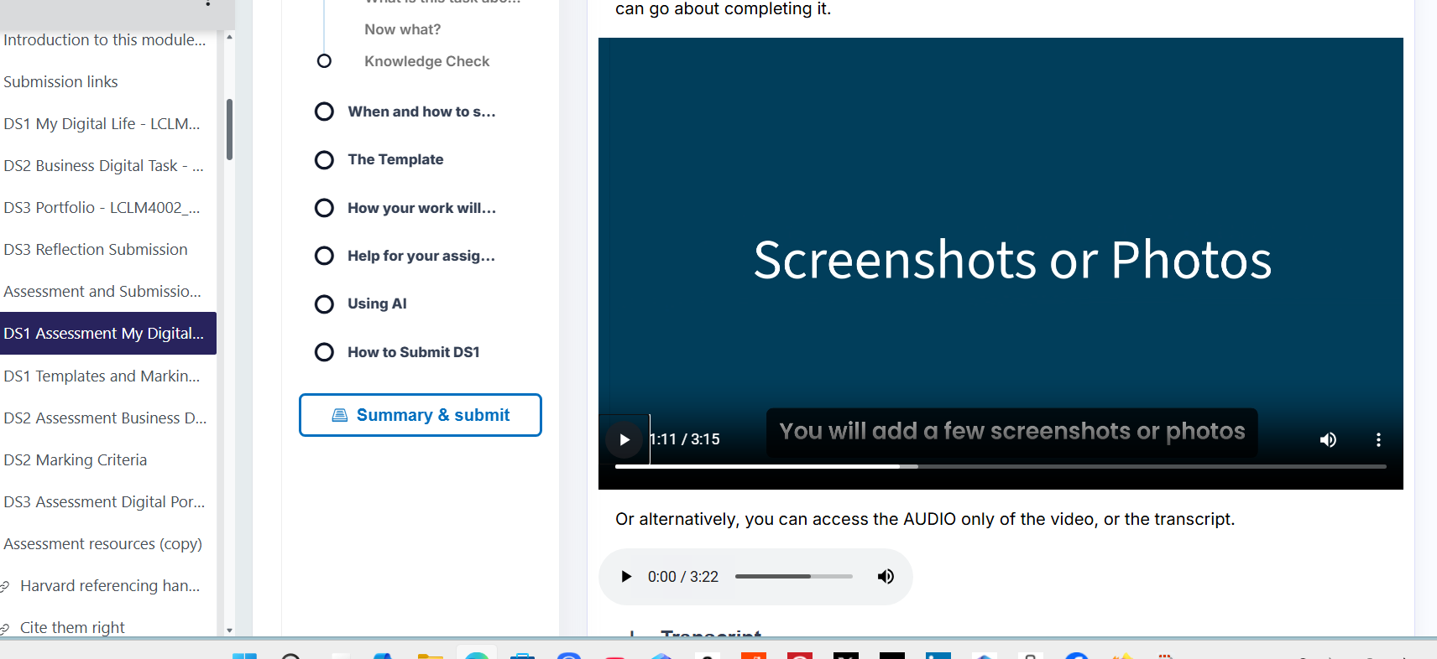
In this screenshot, I have been doing my work in Microsoft Word

Screenshot/Photo 2
[Screenshot 2 Editing]
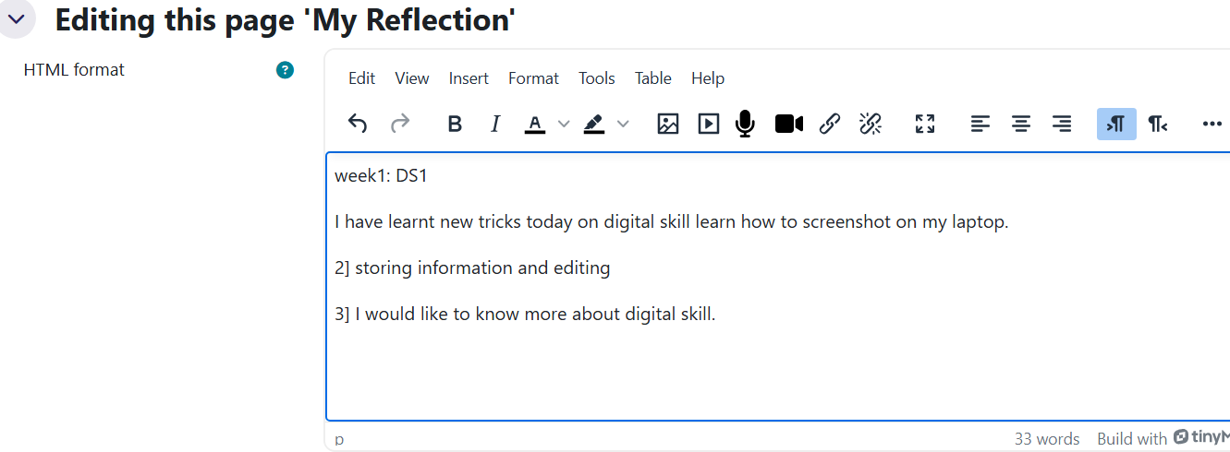
In my second screenshot, I practised using editing. I took this screenshot from my university webpage.

Screenshot/Photo 3
[Screenshot 3 use of social media]
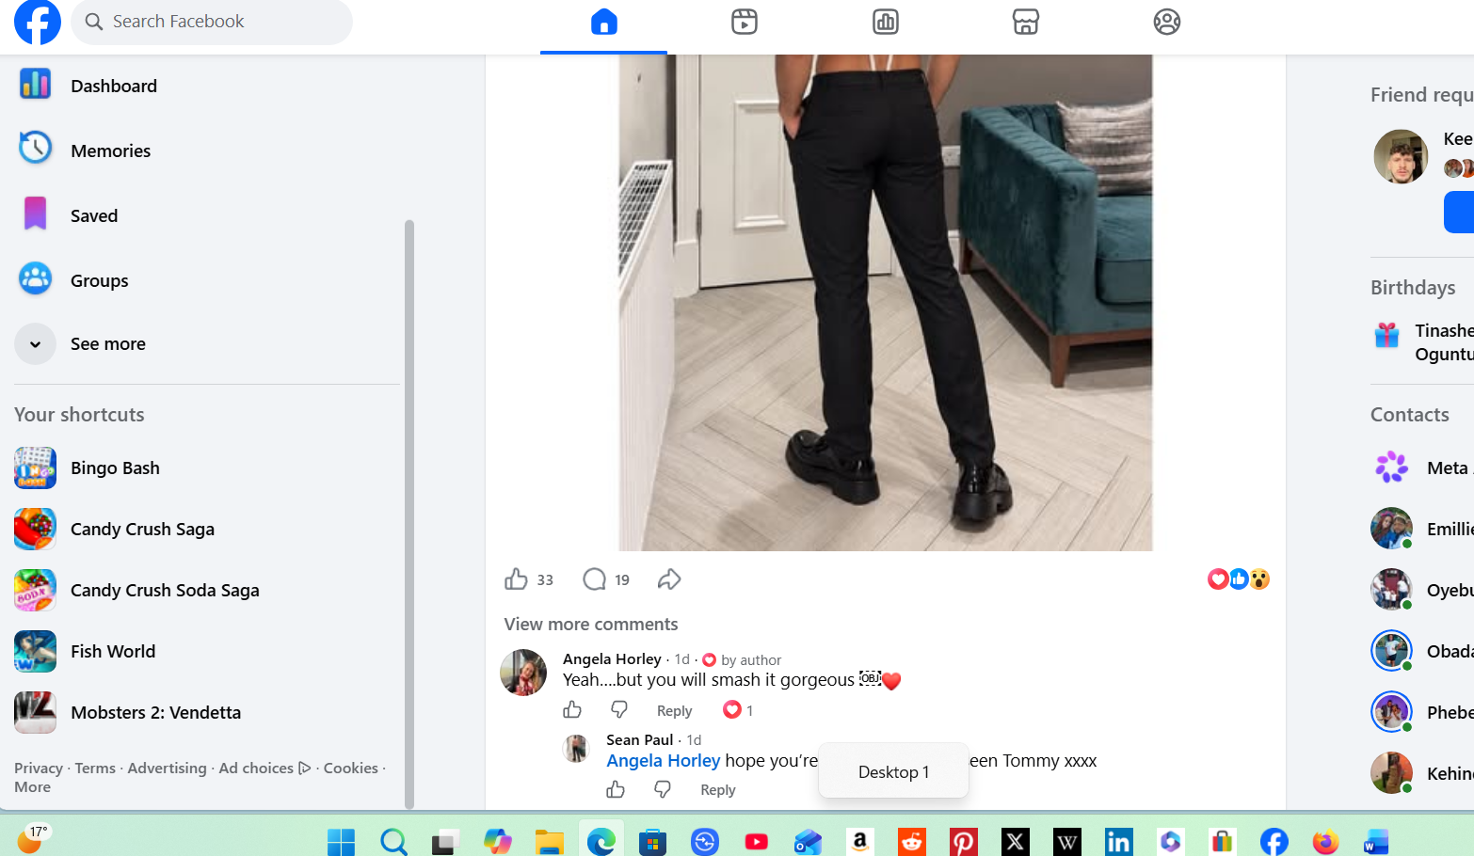
[I had to log into Facebook, this shows I have the knowledge and the use of social media networks]

Screenshot/Photo 4
[Screenshot 4 shows that I know how to access the university portal online]
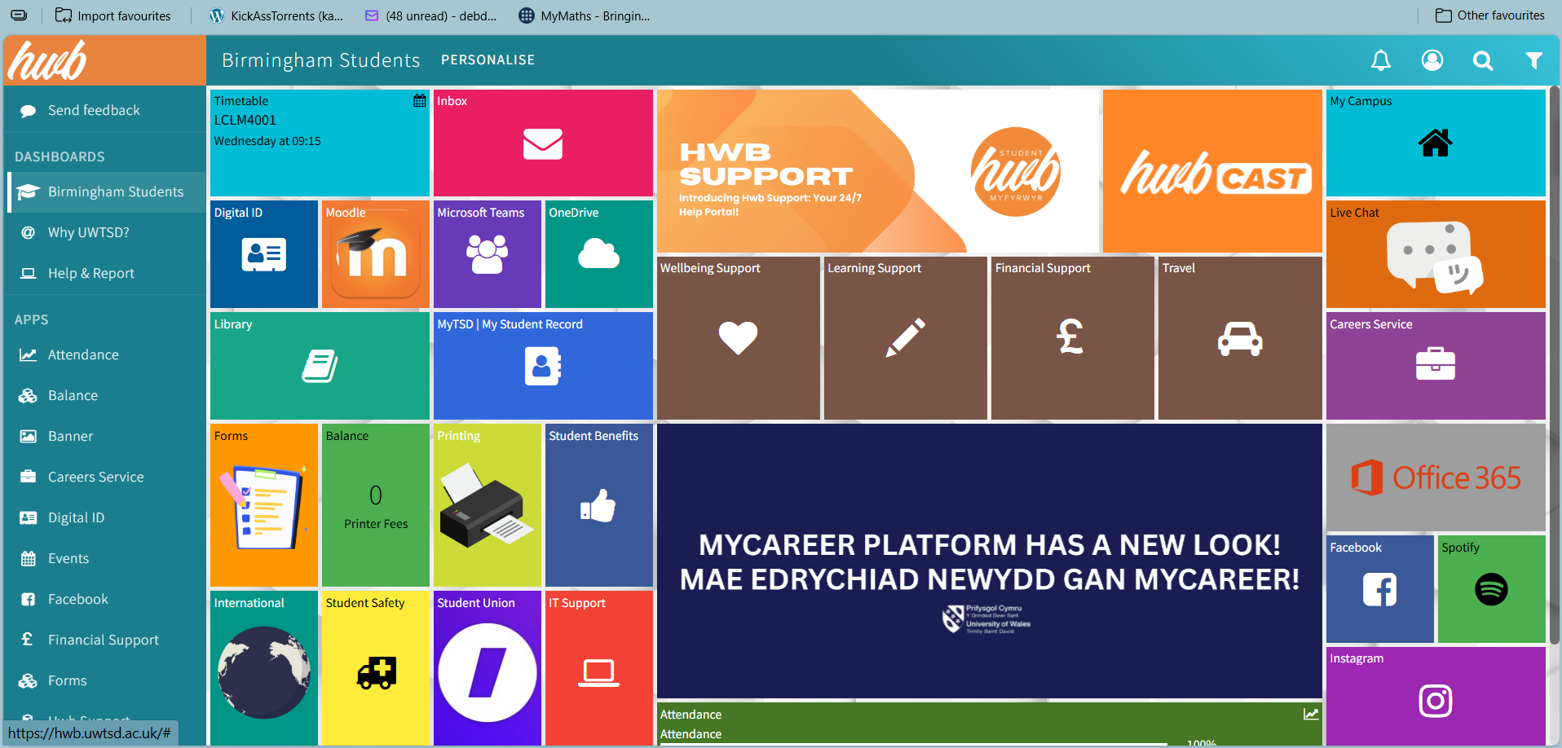
[This screenshot shows that I can navigate my way around the university portal and Moodle]

Screenshot/Photo 5
[Screenshot 5 shows I use Email]
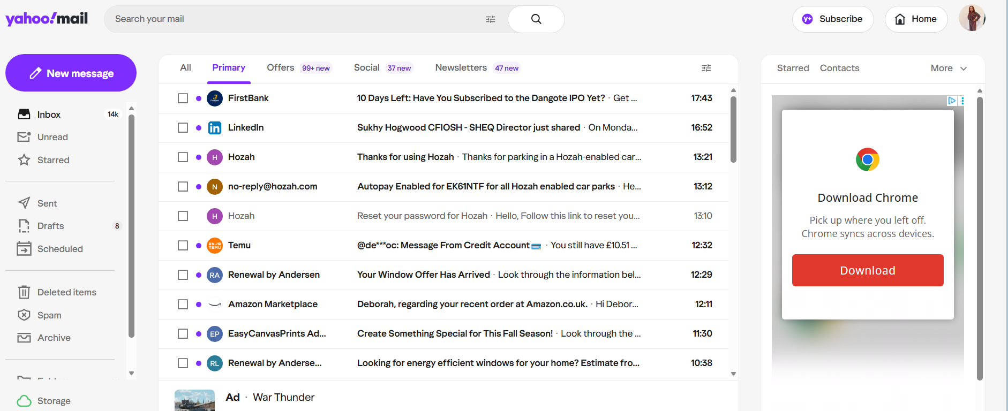
[This screenshot shows that I can use digital skills in accessing my emails for personal or business purposes]

Screenshot/Photo 6
[Photo 6 I took a picture with my laptop camera]
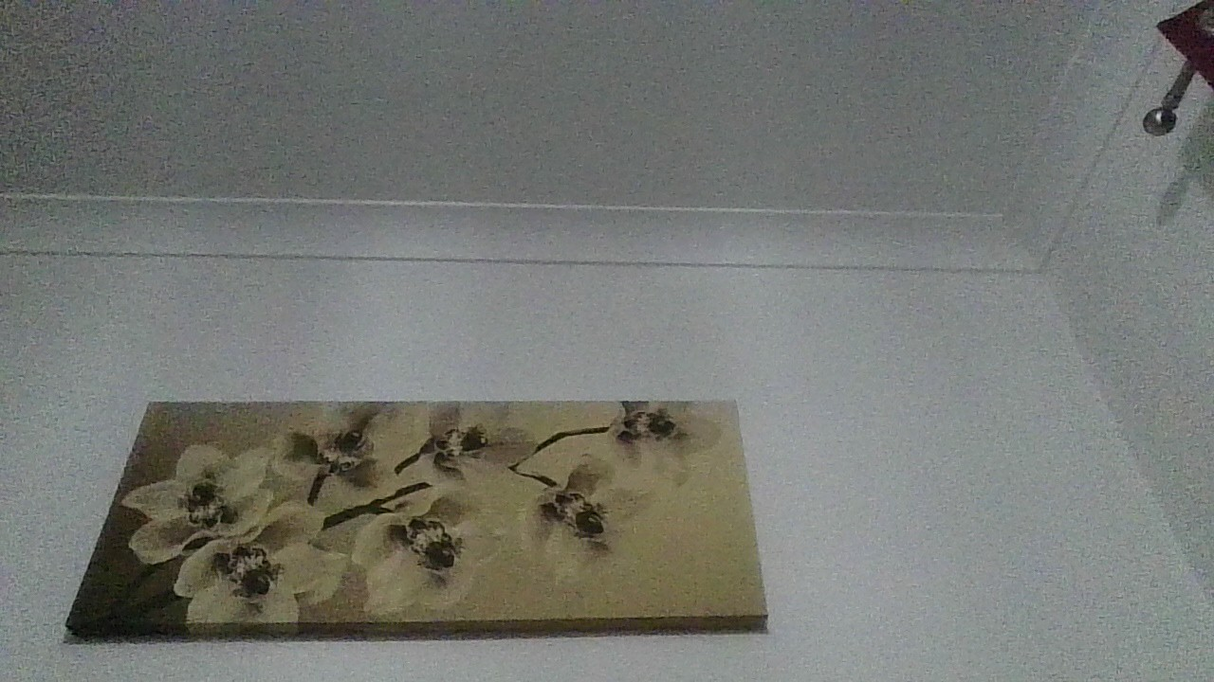
[I used my laptop camera to take a picture and then upload it to my assignment template. This shows that I have general knowledge of how to upload pictures or an image that can be sent as an attachment]

My Short Reflection
- Write 5–8 simple sentences about your digital life.
- You can use the sentence starters below if helpful.
Digital Skills teaches you how to use digital tools in our everyday life
I use digital tools daily on my phone and laptop and I am very familiar with most of the navigation tools on both. But I feel there is more to learn
I do occasionally use the web to access my email; in doing so, I am able to open my emails and send attachments if needed
I would like to learn more about using Microsoft Word, PowerPoint, and Excel to improve my digital skills and my personal and business life.
I would like to know how to make tables in Excel.
I still feel a little scared to use new digital tools, but I am eager to learn more as I continue my studies at the university.
Digital skills are very vital for my business and daily life,

Sentence starters
- I use digital tools to …
- I feel confident when I …
- I want to improve …
- I often use these tools: …
- I sometimes feel nervous about …
- I hope this module will help me …
- Digital skills are important for me because …
You can write more if you want.

Submission Checklist
Before you submit, please check:
​​​ ☒ I added 4–6 screenshots
☒ I wrote short sentences for each screenshot
☒ I wrote my short reflection
☒ My work is my own
☒ My file opens correctly
​​☒ My file opens correctly

