

Student Name: Md Mohaiminul islam Bappy

Student ID: 2431568

Module Name: Marketing Management

Module Code: LCMB7024

Lecturer’s Name: Dr Laila Maazous

Submission Date: 15.12.25

Table of Contents
1.Introduction 3
2. Strategic STDP Analysis for Unilever’s New Brand ‘NaturaSip.’ 3
2.1 Introduction to Unilever 3
2.2 Concept of the New Brand – ‘NaturaSip.’ 3
2.3 Segmentation 4
2.4 Targeting 4
2.5 Differentiation 5
2.6 Positioning 5
3. The 4Ps Marketing Strategy for ‘NaturaSip’ by Unilever 6
3.1 Product 6
3.2 Price 7
3.3 Place 7
3.4 Promotion 8
4. Marketing Strategy Pitch 9
5. Reflection 9
6.Conclusion 11
7.References 12

1.Introduction
This portfolio offers a strategic brand development plan for NaturaSip, a functional drink that has been proposed under the Unilever company. The project will also involve segmentation, targeting, differentiation, and positioning (STDP) analysis, a 4Ps marketing mix plan, a compelling pitch to investors and customers, and a self-reflecting analysis. All the aspects can show how innovative, ethical, and digital marketing can be integrated to make a compelling and sustainable brand that will easily satisfy the needs of contemporary consumers.

2. Strategic STDP Analysis for Unilever’s New Brand ‘NaturaSip.’

2.1 Introduction to Unilever
Unilever is a multinational manufacturer of fast-moving consumer goods (FMCG), operating in more than 190 countries and possessing a heterogeneous assortment of brands in the food, beauty, and home care sectors. The company is also known to be employing the initiatives of sustainability, innovation, and consumer wellbeing (Tan, 2025). Unilever Sustainable Living Plan (USLP) has formed the strategy of developing its products, which centre around health, environmental responsibility, and social responsibility (Unilever, 2020). With the increase in the health and wellness sector, it is evident that Unilever can capitalise on the increasing need for functional drinks among environmentally conscious and health-aware consumers.

2.2 Concept of the New Brand – ‘NaturaSip.’
NaturaSip is a novel functional beverage (plant-based nature) supplemented by natural nootropics and adaptogens, including ashwagandha, ginseng, and matcha. It is made to work with cognitive control, lighten the mood, and give more natural energy. The idea reacts to the new trends in wellness, according to which the consumers (particularly younger generations) want to have the beverage that does more than just quench a thirst, that it should have physical and mental health effects (Thomas, 2024; Lorca et al., 2023). NatureSip has concurred with Unilever's purpose of supporting healthier and sustainable product design and responsible sourcing (Tan, 2025).

2.3 Segmentation
Segmentation Type | Details
Geographic | Urban centres in the UK and Western Europe
Demographic | Aged 18–35, students, young professionals, health-focused consumers
Psychographic | Values sustainability, productivity, mental wellness, and natural living
Behavioural | Daily users of wellness products, fitness-oriented, digital lifestyle buyers
Table 1: Segmentation Type
The functional drinks market specifically applies to the urban areas that have access to high-end retail and health-oriented services. The age group of Generation Z and Generation Y (18-35) is determined as the most responsive group since the two are very concerned about cognitive performance and overall health (Fathin, Muflikhati, and Herawati, 2023). Their purchasing behaviour is fuelled by sustainability, the use of natural ingredients, and brand transparency (Halicka, Jeewska-Zychowicz, and Suek, 2025). Other routines that functional drinks are associated with include exercise, yoga, and study/work productivity, which are practised by these segments (Dimitrova et al., 2023).

2.4 Targeting
Segment | Key Characteristics
Young Professionals | 22–35 years old, work in high-pressure environments, seek productivity enhancers
University Students | 18–25 years old, study-intensive, mental clarity, and focus-driven purchases
Table 2: Targeting Type
NaturaSip will apply the focus approach by promoting itself to a niche market using an in-depth targeted marketing mix that will attract students and young-career professionals living in major cities. The groups are not only extremely health-conscious but also technologically inclined; they tend to experience things and are among the early adopters online (Doan et al., 2025). Their values, such as authenticity, eco-responsibility, and functionality, will be addressed by digital campaigns, and they will have a strong product-market fit (Lopes, Silva, and Pereira, 2024).

2.5 Differentiation
Differentiation Factor | NaturaSip Value
Ingredients | 100% natural nootropics and adaptogens
Sustainability | Recyclable packaging, QR-code traceability, carbon-conscious production
Brand Reputation | Built on Unilever’s ethical sourcing and trust-based consumer relationships
Health Focus | Non-sugar, vegan, brain-supporting functionality
Table 3: Differentiation Factor
The key distinction that NaturaSip makes with a standard competitor like Red Bull or Monster is the removal of artificialities and caffeine overload. Rather, it dwells upon the science of the natural cognition support (Lorca et al., 2023) and on the environmental responsibility, which are priorities of the Generation Z (Fathin, Muflikhati, and Herawati, 2023). All these characteristics make NaturaSip a premium lifestyle drink - a segment that grows exponentially (Thomas, 2024).

2.6 Positioning
Element | Positioning Statement
Target Audience | Health-conscious Gen Z and Millennials
Brand Promise | Natural mental boost, zero artificial additives, planet-friendly choices
Core Benefit | Enhanced focus, clarity, and sustainability
Positioning Statement | “NaturaSip – The Natural Boost for a Smarter You”
Table 4: Positioning Statement
The positioning of NaturaSips is based on two advantages: mind wellness and planet care. It will take a middle-ground between performance drinks and mindfulness drinks, establishing emotional connection and lifestyle fit. This is close to the green preferences of Gen Zs, which are tendencies frequently found on concealed personal principles like confidence and openness (Lopes, Silva, and Pereira, 2024). NaturaSip is not only a beverage, but a day-to-day stress relief.

3. The 4Ps Marketing Strategy for ‘NaturaSip’ by Unilever
Marketing mix refers to a strategy of converting the positioning of a brand into actual customer-facing aspects. In the case of product-based brands such as NaturaSip, 4Ps (Product, Price, Place, Promotion contribute to bringing consistency and a competitive edge to all touchpoints (Wichmann et al., 2022). The functional beverage launch strategy of Unilever's is as detailed below.
Element | Strategy for NaturaSip
Product | Plant-based functional drink with ginseng, ashwagandha, matcha; recyclable packaging; minimalist design; QR-coded traceability
Price | Value-based pricing at £2.49 per bottle; bundle offers (6-pack); psychological pricing; subscription models
Place | Multichannel: NaturaSip.com, Amazon, health food chains (Holland & Barrett), supermarkets (Waitrose); events, pop-ups in gyms and campuses
Promotion | Digital-first: TikTok/Instagram influencers; eco-campaigns; content marketing (blogs, guides); tree-planting CSR; referral discounts and sampling campaigns
Table 5: 4Ps Marketing Strategy for ‘NaturaSip’

3.1 Product
NaturaSip is a new generation functional drink that has been developed using natural nootropic ingredients, that is, ginseng, ashwagandha, and matcha, which are known to increase cognitive functions, relieve stress, and promote mental acuity (Lorca et al., 2023). These ingredients are gaining popularity with consumers in the age brackets of 18-35 who are interested in clean-label functional wellness products. It is carbonated, sugar-free, vegan, and non-carbonated, which offers support to its health-focused identity.
The packaging is appealing to the eye and also ecologically responsible. The bottle is recyclable in 100 percent bioplastic with QR codes that provide information of more transparency on the source of the ingredients and the carbon footprint. With its minimalistic design in soft botanical colours, it is oriented towards Gen Z design and the preferences towards sustainability (Halicka, Jeewska-Zychowicz, and Suek, 2025). This design and sustainability commitment will help Unilever's much wider objectives under its Sustainable Living Plan (Tan, 2025), and NaturaSip will fit into the ethical brand category of the company.

3.2 Price
The actual pricing is value-based and combines a high quality of natural ingredients with the affordable price needed by the young population making up the target audience (NaturaSip). Every 250ml bottle will be priced at GBP2.49, which will position it at the mid-premium segment- branding it below the luxury brands but above the mass market, sugary energy drinks.
To generate trial and long-term participation, Unilever will have multi-pack discounts (e.g., GBP12 in case of 6 pack) and a subscription scheme through NaturaSip.com. This model will offer price incentives and foster repeat purchase, particularly among the regular wellness consumers. Moreover, the subtly higher perceived value will be created with the help of psychological pricing (GBP 2.49 and not GBP 2.50) (Pitri and Firmansyah, 2025).
Such a model of price also includes the presence of the willingness of customers to pay a higher price for green and functional products when there is a system of trust and transparency (Nguyen et al., 2025). Customers in the Gen Z generation and Millennials are justifying increased spending with brands that meet their ethical and lifestyle needs (Doan et al., 2025).

3.3 Place
The use of a multichannel distribution strategy will make sure that NaturaSip is found anywhere the target audience does their shopping, including online and offline shopping. Naturasip.com and Amazon, which are convenient, have a national and user-customisable core digital channels, will be utilised. Cyberspace is also used to collect data to make personalised promotions and retargeting (Wichmann et al., 2022).
In brick and mortar, NaturaSip will be available in chains of health and wellness stores such as Holland and Barrett and Whole Foods Stores; high-end supermarkets, such as Waitrose and Sainsbury. The placements are also tactical, since they appeal to consumers who are already doing mindful and health-oriented shopping.
In order to create brand intimacy and promote sampling, the Unilever Company will engage direct-to-consumer pop-ups at gyms, co-working spaces, and universities. These pop-ups will offer free samples, create a buzz on social media, and enable direct face-to-face communication with the brand. Experiential touchpoints, in addition to the resulting trial, can stimulate emotional bond and authenticity, which are key motivating factors in Gen Z markets with brand equity (Nguyen et al., 2025).

3.4 Promotion
The NaturaSips approach to promotion is oriented to digital-first and values-driven campaigns with the emphasis on storytelling, influencer interaction, and sustainability stories. The messaging of its brands will focus on mental sharpness, natural energy, and environmental awareness, all put into the context of the lifestyle of its young, digitally native audience.
Some of these channels are Instagram and TikTok Tok where Unilever will work with wellness micro-influencers, student bloggers, and nutritionists to help communicate their experience as users. Such influencer content will demonstrate the product in real-life situations, such as studying, yoga, or in the mornings, which perfectly fits the lifestyle branding (Cai et al., 2025).
Simultaneously, NaturaSip will create such content with high SEO values as the brain health blogs, nootropic guides, and green living articles on its page and in a newsletter. These are meant to inform and capture the customers, build deeper credibility and brand beyond mere product promotion (Pitri and Firmansyah, 2025).
One of such CSR activities is the Drink to Reforest campaign, according to which one tree is planted in the ground for every hundred bottles sold. The customers will also be given a code to monitor their tree to provide a physical feeling of influence and connection. This campaign is a direct reaction to Gen Z's environmentally conscious activism, where the cause marketing will be embedded in the brand's DNA (Doan et al., 2025; Thomas, 2024).
Other forms of promotion would be referral vouchers, loyalty points, and student vouchers, which would promote eWOM (electronic word-of-mouth) and social sharing (Cai et al., 2025).
Unilever's NaturaSip has a strong brand proposition, which is sustainable, based on wellness, and with strategic positioning of its Product, Price, Place, and Promotion. The blend indicates an appreciation of the contemporary marketing environment- one that is becoming more authentic, purposeful, and digitally savvy to reach the values and lifestyles of Generation Z and Millennials.

4. Marketing Strategy Pitch
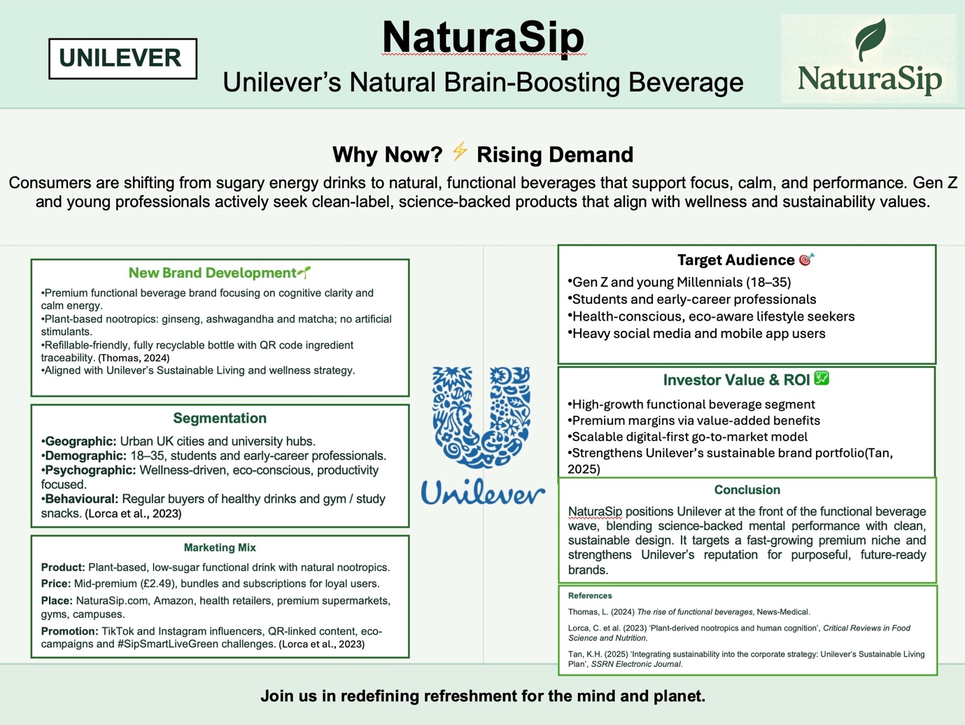

5. Reflection
This reflection reflects on the experience associated with the creation of the brand name NaturaSip and the presentation of the marketing strategy, using Gibbs' (1988) Reflective Cycle, with the emphasis being put on the learning outcomes, emotional response, evaluation, analysis, conclusions, and improvement in the future.
- Description
In this evaluation, I designed a new brand concept- NaturaSips, under Unilever, and prepared a complete marketing plan based on the 4Ps model and the STDP model. I also designed a visual pitch, which was created through Canva, and presented it as a 3-minute pitch. I wanted to make the brand meet the current market needs of consumers and the sustainability targets of Unilever.
- Feelings
At first, I was excited and somehow overwhelmed. The notion of building a brand by itself was ambitious. Nevertheless, my confidence increased when I started subdividing the task with the help of the structured tools and Canva templates. I was proud when I made the pitch but feared time limitations and the reaction of the audience.
- Evaluation
The brand-building stage was successful. I was able to use the theories of segmentation and positioning well and chose a product that conformed to the market trends. The clarity and attractiveness of the presentation were improved by using Canva. Hinchcliff and Mehmet (2023) point to Canvas as the tool that facilitates creative thinking and active learning, which I have personally experienced. Nevertheless, it was not easy to develop the pitch script within the time constraint, and I struggled to elaborate complex strategies within a couple of minutes.
- Analysis
The assignment helped me gain skills in translating theory into practical marketing. A study in the field of Gen Z behaviours, green marketing, and digital interaction taught me to create a data-based customer profile. Dialogic learning was also facilitated by such tools as Canva, in which I interacted more thoughtfully with the content (Jamaludin and Sedek, 2023). The use of the 4Ps and the way they can be applied in relation to the values of NaturaSips made me understand the need to be consistent in branding. The pitch gave me confidence in speaking before an audience and telling a story.
Besides, the exercise provided ethical learning activities. The decision to use sustainable packing and a socially minded campaign (planting trees) made me consider the topic of responsible marketing, as Farache, Boulocher-Passet, and Aydin (2025) claim that the future marketer must have. Digital and ethical parameters were also introduced, which made the experience even richer and enhanced my learning.
- Conclusion
In general, the project helped me to improve my strategic thinking and communication skills. It also taught me that it is possible to be creative and work around a limited scope and produce a professional, investor-ready idea. I found out that creative thinking could be organised with the help of templates, models, and Canva tools, and make complex marketing ideas easier to convey and more effective.

- Action Plan
In future projects, I plan to:
- Practise time-controlled speaking more to improve pitch delivery.
- Use more audience feedback during planning stages.
- Explore additional Canva features to improve layout and interactivity.
- Engage earlier with ethical frameworks to enhance marketing responsibility.
According to Rosario and Dias (2024), marketing activities based on problems facilitate real-life preparedness. This was affirmed in this assignment. I can say that this reflection enabled me to feel better prepared to work on brand innovation tasks and strategic presentations that I will face in the future.

6.Conclusion
This portfolio has enhanced my knowledge of brand development through the integration of strategic marketing concepts and practice. Through the idea development to the strategy development process (STDP) in a developed report, marketing mix, and a sales pitch, all these aspects enhanced my ability to be creative, sustainable, and engaging to the audience. Meditating using Gibbs' model also helped me develop better thinking and understanding of myself. On the whole, this experience has equipped me to face future marketing projects with a confident, creative, and ethical regard.

7.References
Cai, S. et al. (2025) ‘Leveraging customer green behavior toward green marketing mix and electronic word-of-mouth (eWOM)’, Sustainability, 17(6), 2360. Available at: https://www.mdpi.com/2071-1050/17/6/2360 (Accessed: 26 November 2025).
Dimitrova, I., et al. (2023) ‘Consumption behaviour towards branded functional beverages among Generation Z’, Innovative Marketing, 19(4), pp. 40–51. Available at: https://www.businessperspectives.org/index.php/innovative-marketing (Accessed: 26 November 2025).
Doan, T. T. H. et al. (2025) ‘Sustainable food consumption behaviors of Generations Y and Z: a comparative analysis’, Sustainability, 17(5), 3120. Available at: https://www.mdpi.com (Accessed: 26 November 2025).
Farache, F., Boulocher-Passet, V. and Aydin, G. (2025) ‘Empowering marketing students via ethical reflection: a genai-driven assignment design’, Marketing Education Review. Available at: https://doi.org/10.1080/10528008.2025.2554189 (Accessed: 26 November 2025).
Fathin, F., Muflikhati, I. and Herawati, T. (2023) ‘The role of health consciousness and trust on Gen Y and Gen Z intention to purchase functional beverages’, Journal of Consumer Sciences, 8(1), pp. 43–60. Available at: https://journal.ipb.ac.id/index.php/jcs (Accessed: 26 November 2025).
Gibbs, G. (1988) Learning by doing: A guide to teaching and learning methods. Oxford: Oxford Further Education Unit.
Halicka, E., Jeżewska-Zychowicz, M. and Sułek, M. (2025) ‘Investigating the consumer choices of Gen Z about sustainable food’, Nutrients, 17(1), article e70140. Available at: https://www.mdpi.com (Accessed: 26 November 2025).
Hinchcliff, M. and Mehmet, M. (2023) ‘Embedding Canva into the marketing classroom: a dialogic and social learning approach to classroom innovation’, Higher Education, Skills and Work-Based Learning, 13(6), pp. 1174–1186. Available at: https://www.emerald.com/insight/content/doi/10.1108/HESWBL-10-2022-0213/full/html (Accessed: 26 November 2025).
Jamaludin, N. F. and Sedek, S. F. (2023) ‘CANVA as a digital tool for effective student learning experience’, Journal of Advanced Research in Computing and Applications, 33(1), pp. 22–33. Available at: https://akademiabaru.com/submit/index.php/arca/article/view/5064 (Accessed: 26 November 2025).
Lorca, C. et al. (2023) ‘Plant-derived nootropics and human cognition: a systematic review’, Critical Reviews in Food Science and Nutrition, 63(22), pp. 5521–5545. Available at: https://doi.org/10.1080/10408398.2021.2021137 (Accessed: 26 November 2025).
Lopes, C., Silva, R. and Pereira, H. (2024) ‘The hidden reasons behind Generation Z’s green choices’, Journal of Cleaner Production, 437, 140123. Available at: https://www.sciencedirect.com (Accessed: 26 November 2025).
Nguyen, K. M. et al. (2025) ‘The impact of 7Ps green marketing mix on customer commitment and willingness to pay a premium price: evidence from Vietnam’, Journal of Promotion Management, 31(4), pp. 433–457. Available at: https://doi.org/10.1080/10496491.2025.2484712 (Accessed: 26 November 2025).
Pitri, T. and Firmansyah, M. A. (2025) ‘The evolving marketing mix in the digital age and customer mix: how does it affect purchase intention?’, International Journal of Business, Law and Education, 6(1), pp. 348–366. Available at: https://www.ijble.com/index.php/journal/article/view/1003 (Accessed: 26 November 2025).
Rosário, A. T. and Dias, J. C. (2024) ‘Implementing problem-based learning in marketing education: a systematic review and analysis’, Education Sciences, 14(11), 1139. Available at: https://doi.org/10.3390/educsci14111139 (Accessed: 26 November 2025).
Tan, K. H. (2025) ‘Integrating sustainability into the corporate strategy: a critical analysis of Unilever’s Sustainable Living Plan’, SSRN Electronic Journal. Available at: https://doi.org/10.2139/ssrn.4935832 (Accessed: 26 November 2025).
Thomas, L. (2024) ‘The rise of functional beverages’, News-Medical. Available at: https://www.news-medical.net/health/The-Rise-of-Functional-Beverages.aspx (Accessed: 26 November 2025).
Unilever (2020) ‘Unilever celebrates 10 years of the Sustainable Living Plan’, Unilever Global Press Release, 5 May. Available at: https://www.unilever.com/news/news-search/2020/unilever-celebrates-10-years-of-the-unilever-sustainable-living-plan/ (Accessed: 26 November 2025).

