
Figure 1 - University of Wales Trinity Saint David Logo (UWTSD, 2017)

University of Wales Trinity Saint David
School of Engineering
Polymer Bottle Assembly
Christopher Price
1809108
BEng Materials Science
30th November 2018
Materials & Introduction to Manufacturing (M4X01163)

Contents
- Introduction 1
- Manufacturing process
2.1. Material choice 2
2.1.1. Material choice – PET 2
2.2. Manufacturing assembly choice 2
2.3. PIM and IBM 3
2.3.1. Step 1 – PIM 3
2.3.2. Step 2 – IBM 5
2.4. Quality control and assurance 6
2.5. Recyclability of PET and environmental impact 6
3. Conclusion 8
4. References 9
5. Bibliography 13

- Introduction
This report discusses the materials and processes used in polymer moulded bottle assembly. It will also be used to understand the methods used to manufacture bottles on a vast scale, and the choice of materials to make the product. It is of particular interest to see what large corporations are doing to try and mitigate the impact plastic has on the environment. Coca Cola, specifically, are the largest soft drinks producer in the world, producing over 110 billion plastic bottles each year (Kentish, 2017), all of which use approximately 25% recycled PET and 75% virgin PET (Coca Cola, 2017). Coca Cola own 900 bottling manufacturing facilities worldwide (Coca Cola, 2012). On average each bottling plant produces 122 million bottles per year.
This report will investigate the variety of materials used to manufacture large volumes of bottles, and the type of assemblies that are used. Once the optimal material has been identified, various assembly processes will be examined to determine the most effective manufacturing system.
- Manufacturing process
  - Material choice
Table 1 - Physical properties of thermoplastics (Charest, et al., 2010).
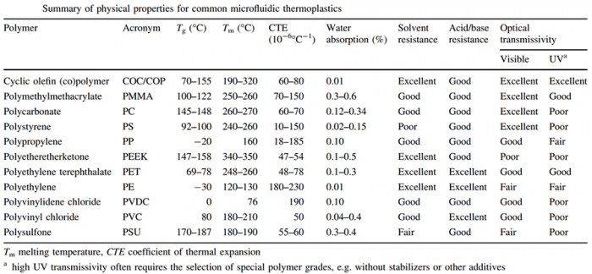

Crystalline polymers like PET are known to have properties that make the material stiff, tough, hard, high Young’s modulus and increased tensile strength (Berghmans, et al., 1974).
PET has a low glass transition temperature compared to most thermoplastics. This means that the material starts to liquify from a solid state at 69-78°C. Low glass transition (GT) gives favourable mechanical properties like increased impact resistance compared to materials like Polyactide (PLA) (Byrne, et al., 2007). Low GT means a decrease in energy consumption during the manufacturing process (Wellen, 2014). Electricity consumption is also reduced due to low melting and GT temperatures. PET possesses a low coefficient of thermal expansion meaning the material will not shrink as much as materials like polymethylmethacrylate.
    - Material choice - PET
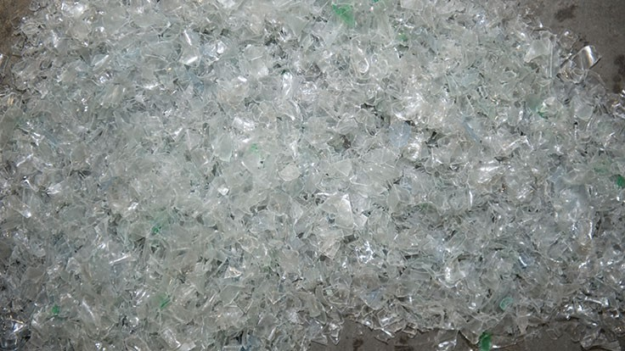
30% of PET produced globally is used in bottle manufacturing (Ji, 2013). PET is widely used in the packaging industry due to its excellent mechanical properties. Densities of PET range from 1290-1400 kg/m³ (CES EduPack, 2015). PET itself is a clear plastic which makes this attractive to soft drinks manufacturers (Chifei, et al., 2009).
Figure 2 - PET in clear pelletised form. (Toto, 2018)
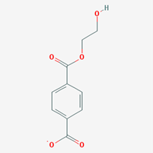
PET is formed by the polymerisation of terepthalic acid and ethylene glycol by a process called esterification (Kim, et al., 2001). The ethylene terephthalate polymerises into repeating carbon chains, typically 100-140 repeating carbon chains (Brandau, 2017). PET is a thermoplastic as it can be heated and then cooled back to solidify the material (Strutt & Vlachopolous, 2003). Thermosetting plastics can not be softened by reheating, rendering this type of material unsuitable for bottle manufacturing (Arrighi & Cowie, 2007). Each monomer of PET has an aromatic ring which gives the plastic its characteristic strength. PET’s has a low melting temperature of 260°C (McCurry, 2011).
Figure 2 - 2D representation of PET (PubChem, 2018).
2.2 Manufacturing assembly choice
The selection process of a manufacturing technique is determined by the shape, size and properties of the desired product. Table 2 shows the optimum criteria for a plastic bottle;
Table 2 - criteria for bottle (CES, 2018).
Material Class | polymer (thermoplastic)
Process Class | primary, discrete
Shape Class | 3D-hollow or sheet-dished
Mass | 0.02 – 0.04 kg
Minimum Section (thickness) | 0.75 – 0.85 mm
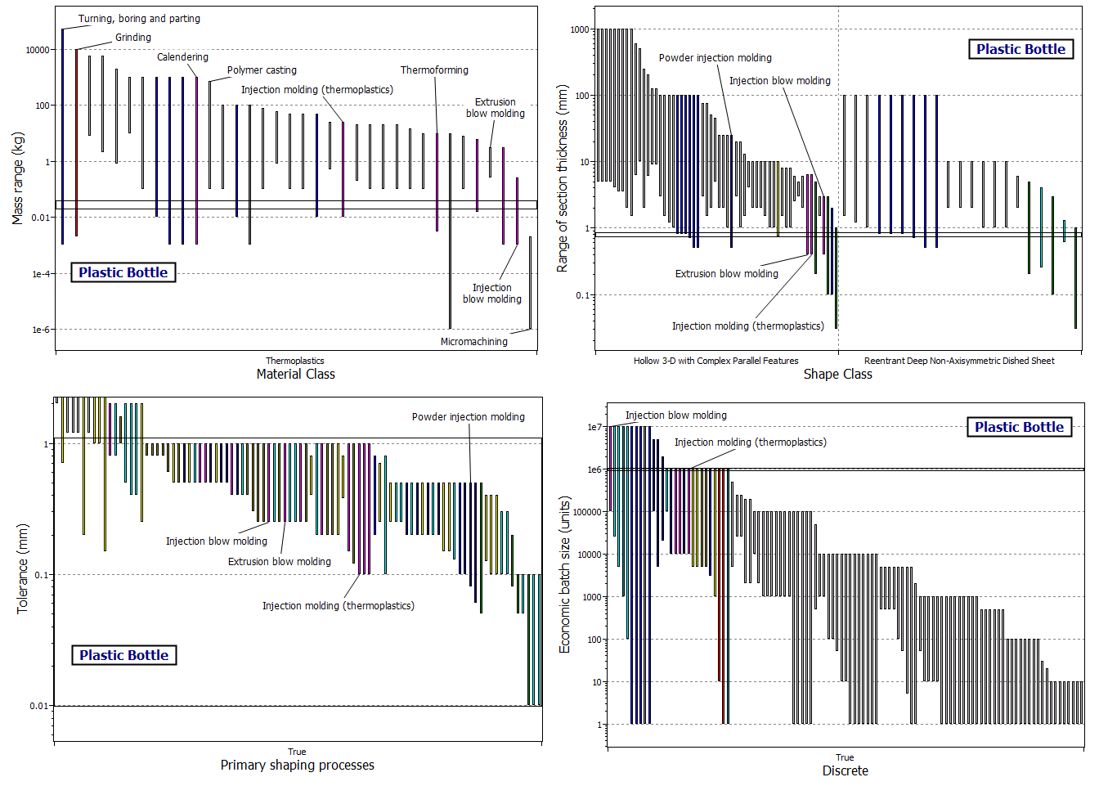

Figure 3 - four graphs assessing the capabilities of each assembly technique (CES, 2018).
Polymer injection moulding (PIM) and injection blow moulding (IBM) are the only techniques capable of satisfying all of the criteria outlined in Table 2. Coca Cola manufacture their bottles using these moulding techniques for this reason.

  - PIM and IBM
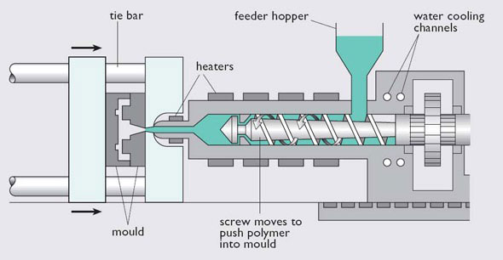
    - Step 1 - PIM
PIM is the current process used by Coca Cola to mould the PET into a preform (Coca Cola India, 2017). A preform is a moulded test-tube-like plastic formed prior to the injection blow moulding process (Menary, et al., 2017). The process begins by loading the hopper with pelletised PET. The plastic enters the barrel which contains a reciprocating screw. The screwing motion begins either by an electric or hydraulic motor (British Plastics Federation, 2018). The polymer is heated in stages as it progresses through the main barrel to allow the plastic to solidify. This part of the process is called the injection phase. The melted polymer then exits the barrel through the nozzle via a sprue and is fed through a gate into a series of runners. The material then flows into the split mould cavity. The plasticised PET flows into the mould tool to form the desired shape. Once the PET has been injected into the mould tool, it is held in place for a predetermined amount of time to allow the material to cool sufficiently. The screw is retracted and the mould tool then opens, ejecting the preform from the tool.
Figure 4 - process schematic of PIM (Pentagon Plastics Ltd, 2017).
Controlling the temperature ensures the final product is robust and has good surface quality. One of the biggest disadvantages of PIM is shrinkage. Shrinkage is caused by thermal contraction when the melt starts to solidify from a liquid. Pressure distribution within the mould can also play a part in shrinkage (Ansari, et al., 2017). This phenomenon is common in the production of thin walled plastics like bottles (Khe, et al., 2016). The areas that affect shrinkage the most are flow direction and differential cooling (Erzurumlu, et al., 2007). Differential cooling is where there’s a difference in temperature between the upper and lower level of the moulded plastic, which induces shrinkage. A bend in the final product becomes visible after it’s extracted from the tool (Erzurumlu, et al., 2007). In order to prevent severe warpage and shrinkage it is important to predetermine the materials properties, along with the correct process conditions, tooling and part design (Erzurumlu, et al., 2007).
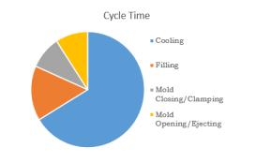
The cycle time of PIM is largely dependent on the type of material used, and the wall thickness of the desired product. For a large bottle assembler like Coca Cola, it is paramount that cycle times are quick to increase the volume of production. The majority of the cycle time is taken up by the cooling process (Panitapu, et al., 2015). Increasing the wall thickness of the moulded part increases the amount of cooling time, thus increasing energy costs and extending the cycle time.
Figure 5 - breaks down of cycle time using PIM (Panitapu, et al., 2015).
“The cooling time is proportional to the square of the thickest wall of the part and the largest runner diameter powered of 1.6, and inversely proportional to the thermal diffusivity of the polymer melt.” (de Souza, et al., 2015, p. 565)
By using this formula, the cooling time of the moulded part is quadrupled when the wall thickness is doubled (de Souza, et al., 2015).
All moulding tools are purpose-built depending on the type of product that is being produced. Due to improving technology, manufactures are able to assemble more complex parts. The Design for Manufacture and Assembly guidelines enable manufacturers to assemble complex final parts using fewer parts, thus reducing assembly costs (Fagade & Kazmer, 2000). However, the greatest cost of the whole manufacturing process is tooling (Fagade & Kazmer, 2000). The cost drivers for manufacturing plastic bottles can be expressed by the following equation (Fagade & Kazmer, 2000);
Table 3 - key for equation (Fagade & Kazmer, 2000).
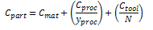
Equation 1

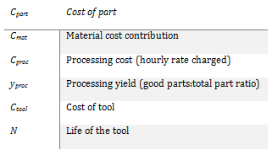

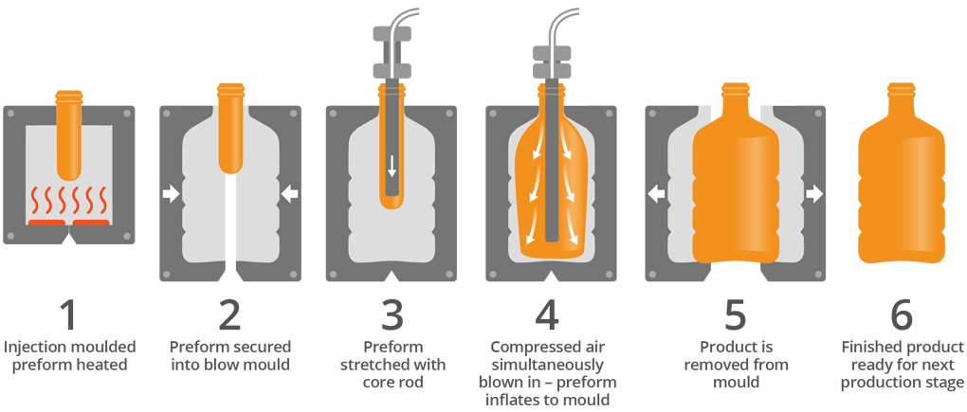
    - Step 2 – IBM
Figure 6 – injection blow moulding process (Robinson, 2018).

The PET preform is transferred to an IBM machine which uses a very high pressure to blow the preform into the desired bottle shape (Coca Cola Hellenic, 2018). The preform is secured into the blow mould, and is then expanded slightly using a core pin. The preform is then simultaneously blown with air under 40 atmospheres of pressure, and heated to approximately 240°C to ensure that the PET is sufficiently melted, and is able to fully inflate to line the entire perimeter of the mould wall (Coca Cola Hellenic, 2018).

  - Quality control and assurance
Companies that manufacture bottles using PIM need to be cost effective whilst maintaining high quality standards (Bharti, et al., 2012). Manufacturers should aim to meet the ISO 9001:2015 family of standards which sets out the criteria for quality management systems (ISO, 2018). Coca Cola abides by these QA systems (Coca Cola HBC, 2018). Therefore it is essential that injection moulding companies have good quality control systems in place (Bharti, et al., 2012). There are four key parts to ensuring the best quality control; these are mould design, tooling part design, machine performance and processing conditions (Bharti, et al., 2012). Each assembly line has assigned quality, project and manufacturing engineer who are responsible for putting a flowchart of the process together, along with a Failure Mode and Affects analysis before anything is actually manufactured (Timm, 2018). Having set parameters ensures a repeatable process, thus ensuring good quality control. The parameters are set up in computer software designed for the desired moulded piece (Meyer, 1999). Manufacturers using PIM have automated handling systems which allow the tooling mechanism to work robotically, eliminating the involvement of humans (Meyer, 1999).
  - Recyclability of PET and environmental impact
One of the main advantages of using PET in manufacturing is it’s recyclability. Coca Cola use recycled PET in their bottled products in 44 of the 200 countries they operate in (Laville & Taylor, 2017). Japan’s recycling rate is much higher than Europe, UK and US as shown in table 4 because they introduced several recycling laws in 1997 forcing businesses to segregate their rubbish (McCurry, 2011). It is also expensive excavating a site for landfill due to underlying volcanic rock (Dvorak, et al., 2009). Using landfill is seen as unsustainable and frowned upon ethically (Halden & North, 2013).
Table 4 - 2016 PET recycling rate (McCurry, 2011)
Japan | Europe | US | UK
72% | 48% | 29% | ~35-40%

Recycling PET bottles gives a net benefit in greenhouse emissions of 1.5t of CO₂-e per tonne of recycled PET (Dvorak, et al., 2009). A LCA showed that using 100% recycled PET as opposed to 100% virgin PET would reduce the CO₂ emissions by 27% during its life cycle (Dvorak, et al., 2009). Cost of recycling is mainly driven by the cost of recycled and virgin PET, along with the cost of other disposal types like landfill. Putting plastic in landfill is easier and cheaper, but ethically frowned upon. The recycling rate of PET is dependent on the world’s oil prices. If oil prices drop significantly, it becomes cheaper to make PET bottles from virgin PET (Kramer, 2016). Waste Management, the largest haulier in the US lost recycling revenues of $59 million in 2015 due to falling oil prices (Manavalan & O'Leary, 2015).
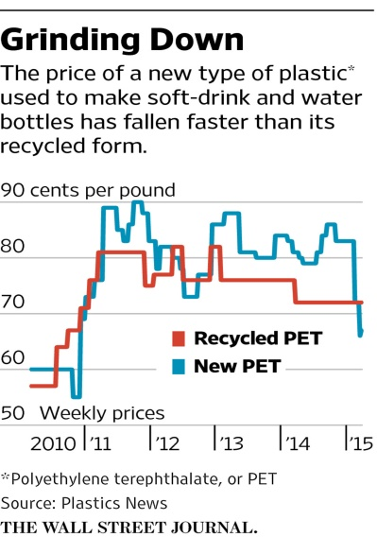
Recycled PET from bottles has also been known to be used in eco-road construction (Aladegboye, et al., 2016). It has been found that plastic mixed with the bitumen and aggragates reduces voids in the road, pothole formation, and increases the strength of the road (Anand & Sathya, 2017).
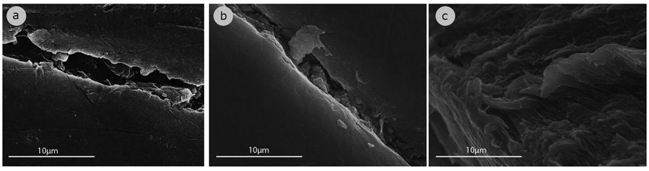
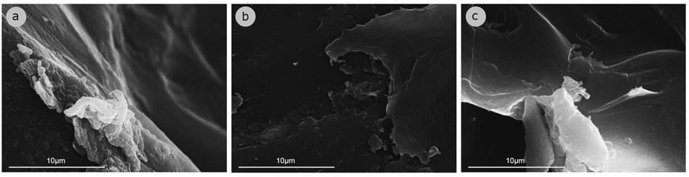
There is little information on the materials life cycle in a marine environment (Fotopoulou, et al., 2016). Fotopolouu et al (2016) claim that PET is able to maintain its structural integrity for approximately 15 years in sea water; after that, the functional groups that belong to PET (ester groups) start to break down or disappear entirely.
Figure 7 - prices of recycled and virgin PET (Kantchev & Ng, 2015).

Figure 8 - surface topology of PET bottles exposed in a marine environment. Top row - 15 year exposure. Bottom row – under 15 years exposure (Fotopoulou, et al., 2016).

When producing PET bottles, manufacturers need to take into account the electricity consumption needed to create the final product. Reducing costs of electricity will not only reduce production costs for the bottle assembler, but reduce the environmental impact. EcoInvent is a database which assesses the life cycle (LCA) of materials to quantify the impact the material has on the environment (Clavería, et al., 2018). By looking at the life cycle of three materials; polyvinylchloride (PVC), PET and polypropylene (PP), it deduces that average energy consumption to be 1.47kWh/kg when using PIM (Clavería, et al., 2018).
Alternatives to PET include glass and aluminium. Glass is infinitely recyclable, but it weighs more than plastic, therefore it difficult to transport large volumes. Aluminium is another option. It’s very light, making it desirable for transportation. The major disadvantage is that most bottle companies want clear products.
- Conclusion
PET is one of the most commonly used polymers used in Cola bottle assembly, and the method of using PIM and IBM possesses the best processing conditions for creating plastic bottles.
Quality assurance and quality control is a prerequisite in ensuring that the best standards of manufacturing are followed to create the best quality product, whilst maintaining the best cost effectiveness.
There are many ways in which PET can be recycled, and as new technologies develop, the ability to recycle more efficiently will become possible. There are already a number of industries that rely on using recycled PET in their products. The cost of using recycled PET however is dependent on the world’s oil market.

References
Aladegboye, O. J., Nwobodo, S. E. & Sojobi, A. O., 2016. Recycling of polyethylene terephthalate (PET) plastic bottle wastes in bituminous asphaltic concrete. Cogent Engineering, 3(1), p. 1.
Amico, S. C., Barboza, E. S., Ferreira, C. A. & Lopez, D. R., 2009. Determination of a recyclability index for the PET glycolysis. Resources, Conservation & Recycling, 53(3), pp. 122-128.
Anand, R. M. & Sathya, S., 2017. Use of plastic waste in bituminous pavement. International Journal of ChemTech Research, 10(8), pp. 804-811.
Ansari, M. N. M., Mohan, M. & Shanks, R. A., 2017. Review on the Effects of Process Parameters on Strength, Shrinkage, and Warpage of Injection Molding Plastic Component. Polymer-Plastics Technology and Engineering, 56(1), pp. 1-12.
Arrighi, V. & Cowie, J. M. G., 2007. Polymers: Chemistry and Physics of Modern Materials. 3rd ed. Boca Raton: CRC Press.
Berghmans, H., Groeninckx, G., Overbergh, N. & Smets, G., 1974. Crystallization of poly(ethylene terephthalate) induced by inorganic compounds. I. crystallization behavior from the glassy state in a low-temperature region. Journal Polymer Science, 12(1), pp. 303-316.
Bharti, P. K., Khan, M. I. & Singh, H., 2012. Recent methods for optimization of plastic injection molding process -- A retrospective and literature review.. Popular Plastics & Packaging, 57(9), pp. 26-37.
Brandau, O., 2017. Stretch Blow Molding. 3rd ed. New York: William Andrew.
British Plastics Federation, 2018. Injection Moulding. [Online]
Available at: http://www.bpf.co.uk/plastipedia/processes/injection_moulding.aspx
[Accessed 18 November 2018].
Byrne, F. et al., 2007. Comparative study of the processing conditions required for PLA and PET polymers , Dublin: University College Dublin.
CES EduPack, 2015. Polymers and elastomers. Cambridge: Granta.
CES, 2018. Case Study: A Plastic Bottle. [Online]
Available at: http://www.grantadesign.com/education/InDepth/html/indepth/processinfo/processcasestudy_bottle.htm
[Accessed 20 November 2018].
Charest, J. L., Jeon, J. S. & Kamm, R. D., 2010. ...3D cyclic olefin copolymer (COC) microfluidic chip fabrication using hot embossing method for cell culture platform, Massachusetts: MIT Press.
Chifei, W., Hongsheng, Z., Weihong, G. & Zhang, Y., 2009. Influence of chain extension on the compatibilization and properties of recycled poly(ethylene terephthalate)/linear low density polyethylene blends.. Polymer Degradation and Stability, 94(7), pp. 1135-1141.
Clavería, I. et al., 2018. Electricity Consumption Estimation of the Polymer Material Injection-Molding Manufacturing Process: Empirical Model and Application. Materials, 11(9), pp. 1-13.
Coca Cola HBC, 2018. Plants and processes. [Online]
Available at: https://it.coca-colahellenic.com/en/our-activities/plants-and-processes/production-processes/
[Accessed 20 November 2018].
Coca Cola Hellenic, 2018. 1. Moulding. [Online]
Available at: https://ru.coca-colahellenic.com/en/operations-in-russia/production-step-by-step/1-moulding/
[Accessed 26 November 2018].
Coca Cola India, 2017. The Perfect Bottles for Your Favourite Beverages. [Online]
Available at: https://www.coca-colaindia.com/choices/the-perfect-bottles-for-your-favourite-beverages#
[Accessed 20 November 2018].
Coca Cola, 2012. Office & Bottling Plants. [Online]
Available at: https://www.coca-colacompany.com/stories/offices-bottling-plants
[Accessed 20 November 2018].
Coca Cola, 2017. What are Coca-Cola bottles and cans made of?. [Online]
Available at: https://www.coca-cola.co.uk/faq/what-are-coca-cola-bottles-and-cans-made-of
[Accessed 29 November 2018].
de Souza, A. F., Marques, S., Miranda, J. & Yadroitsau, I., 2015. Design of conformal cooling for plastic injection moulding by heat transfer simulation. Polímeros, 25(6), pp. 564-574.
Dvorak, R., Hopewell, J. & Kosior, E., 2009. Hopewell, Jefferson et al. “Plastics recycling: challenges and opportunities” Philosophical transactions of the Royal Society of London. Series B, Biological sciences. Plastics recycling: challenges and opportunities, 364(1526), pp. 2115-2126.
Erzurumlu, T., Oktem, H. & Uzman, I., 2007. Application of Taguchi optimization technique in determining plastic injection molding process parameters for a thin-shell part. Materials & Science, 28(4), pp. 1271-1278.
Fagade, A. A. & Kazmer, D. O., 2000. Early cost estimation for injection molded components. Journal of Injection Molding Technology, 4(3), pp. 97-98.
Fotopoulou, K. N. et al., 2016. The degradation potential of PET bottles in the marine environment: An ATR-FTIR based approach. Scientific Reports, 6(23501), pp. 1-8.
Govaert, L. E. & van der Vegt, A. K., 2005. Polymeren: van keten tot kunststof. 1st ed. Delft: VSSD.
Halden, R. U. & North, E. J., 2013. North EJ, Halden RU. Plastics and environmental health: the road ahead. Rev Environ Health, 23(i), pp. 1-8.
ISO, 2018. ISO 9000 family - Quality management. [Online]
Available at: https://www.iso.org/iso-9001-quality-management.html
[Accessed 19 November 2018].
Ji, L. N., 2013. Study on Preparation Process and Properties of Polyethylene Terephthalate (PET). Applied Mechanics and Materials, Volume 312, pp. 406-410.
Jomar, 2013. Injection Blow Molding. [Online]
Available at: http://www.jomarcorp.com/injection-blow-molding/
[Accessed 26 November 2018].
Kantchev, G. & Ng, S., 2015. Recycling Becomes a Tougher Sell as Oil Prices Drop. [Online]
Available at: https://www.wsj.com/articles/recycling-becomes-a-tougher-sell-as-plastic-prices-drop-1428279575
[Accessed 29 November 2018].
Kaplan, R., 2017. Solving the recycled plastics puzzle. [Online]
Available at: https://www.greenbiz.com/article/solving-recycled-plastics-puzzle
[Accessed 18 November 2018].
Kentish, B., 2017. Coca-Cola 'increases production of plastic bottles by a billion'. [Online]
Available at: https://www.independent.co.uk/news/business/news/coca-cola-bottles-plastic-increase-coke-total-number-world-yearly-a7981561.html
Khe, C. S. et al., 2016. Optimization of injection molding process parameters for a plastic cell phone housing component. Kuala Lumpur, AIP Publishing.
Kim, J.-Y., Kim, H.-Y. & Yeo, Y.-K., 2001. Identification of kinetics of direct esterification reactions for PET synthesis based on a genetic algorithm. Korean Journal of Chemical Engineering, 18(4), pp. 432-441.
Kramer, S., 2016. The one thing that makes recycling plastic work is falling apart. [Online]
Available at: http://uk.businessinsider.com/low-oil-prices-hurt-plastics-recycling-2016-4?r=US&IR=T
[Accessed 29 November 2018].
Laville, S., 2017. Coca-Cola increased its production of plastic bottles by a billion last year, says Greenpeace. [Online]
Available at: https://www.theguardian.com/environment/2017/oct/02/coca-cola-increased-its-production-of-plastic-bottles-by-a-billion-last-year-say-greenpeace
Laville, S. & Taylor, M., 2017. A million bottles a minute: world's plastic binge 'as dangerous as climate change'. [Online]
Available at: https://www.theguardian.com/environment/2017/jun/28/a-million-a-minute-worlds-plastic-bottle-binge-as-dangerous-as-climate-change
[Accessed 29 November 2018].
Manavalan, R. & O'Leary, L., 2015. One victim of falling oil prices? Recycling. [Online]
Available at: https://www.marketplace.org/2015/09/04/sustainability/one-victim-falling-oil-prices-recycling
[Accessed 29 November 2018].
McCurry, J., 2011. Japan streets ahead in global plastic recycling race. [Online]
Available at: https://www.theguardian.com/environment/2011/dec/29/japan-leads-field-plastic-recycling
[Accessed 18 November 2018].
Menary, G. H., Nixon, J. & Yan, S., 2017. Assessing the stretch-blow moulding FE simulation of PET over a large process window. Dublin, AIP Publishing.
Meyer, D., 1999. From quality control to quality assurance in injection molding. In: J. Karger-Kocsis, ed. Polypropylene. Polymer Science and Technology Series. Dordrecht: Springer, pp. 264-265.
Panitapu, B., Reddy, G. A. & Reddy, K. P., 2015. Investigation of cooling rate enhancement in thermoplastic injection moulds with different core and cavity insert cooling channel designs. Thiruvananthapuram, s.n.
Pentagon Plastics Ltd, 2017. Injection Moulding Process. [Online]
Available at: https://www.pentagonplastics.co.uk/injection-moulding-process/
[Accessed 18 November 2018].
PubChem, 2018. Poly(ethylene terephthalate). [Online]
Available at: https://pubchem.ncbi.nlm.nih.gov/compound/22062452#section=Top
[Accessed 10 November 2018].
Robinson, 2018. Injection stretch blow moulding. [Online]
Available at: https://robinsonpackaging.com/plastics/injection-stretch-blow-moulding/
[Accessed 26 November 2018].
Sissell, K., 2012. Coke Joins with Multinationals in push for Biobased PET. Chemical Week, 174(16), p. 15.
Strutt, D. & Vlachopolous, J., 2003. Polymer processing. Materials Science and Technology, 19(9), pp. 1161-1169.
Timm, A., 2018. An Inside Look at Injection Molding QA/Testing Process [VIDEO]. [Online]
Available at: https://www.kaysun.com/blog/injection-molding-quality-assurance-process
[Accessed 20 November 2018].
Toto, D., 2018. Updated: China to allow imports of recycled PET flake, plastic pellets. [Online]
Available at: https://www.recyclingtodayglobal.com/article/china-recycled-pet-flake-imports/
[Accessed 18 November 2018].
Wellen, R. M. R., 2014. Effect of polystyrene on poly(ethylene terephthalate) crystallization. Materials Research, 17(6), pp. 1620-1627.

Bibliography
Aladegboye, O. J., Nwobodo, S. E. & Sojobi, A. O., 2016. Recycling of polyethylene terephthalate (PET) plastic bottle wastes in bituminous asphaltic concrete. Cogent Engineering, 3(1), p. 1.
Amico, S. C., Barboza, E. S., Ferreira, C. A. & Lopez, D. R., 2009. Determination of a recyclability index for the PET glycolysis. Resources, Conservation & Recycling, 53(3), pp. 122-128.
Anand, R. M. & Sathya, S., 2017. Use of plastic waste in bituminous pavement. International Journal of ChemTech Research, 10(8), pp. 804-811.
Ansari, M. N. M., Mohan, M. & Shanks, R. A., 2017. Review on the Effects of Process Parameters on Strength, Shrinkage, and Warpage of Injection Molding Plastic Component. Polymer-Plastics Technology and Engineering, 56(1), pp. 1-12.
Arrighi, V. & Cowie, J. M. G., 2007. Polymers: Chemistry and Physics of Modern Materials. 3rd ed. Boca Raton: CRC Press.
Berghmans, H., Groeninckx, G., Overbergh, N. & Smets, G., 1974. Crystallization of poly(ethylene terephthalate) induced by inorganic compounds. I. crystallization behavior from the glassy state in a low-temperature region. Journal Polymer Science, 12(1), pp. 303-316.
Bharti, P. K., Khan, M. I. & Singh, H., 2012. Recent methods for optimization of plastic injection molding process -- A retrospective and literature review.. Popular Plastics & Packaging, 57(9), pp. 26-37.
Brandau, O., 2017. Stretch Blow Molding. 3rd ed. New York: William Andrew.
British Plastics Federation, 2018. Injection Moulding. [Online]
Available at: http://www.bpf.co.uk/plastipedia/processes/injection_moulding.aspx
[Accessed 18 November 2018].
Byrne, F. et al., 2007. Comparative study of the processing conditions required for PLA and PET polymers , Dublin: University College Dublin.
CES EduPack, 2015. Polymers and elastomers. Cambridge: Granta.
CES, 2018. Case Study: A Plastic Bottle. [Online]
Available at: http://www.grantadesign.com/education/InDepth/html/indepth/processinfo/processcasestudy_bottle.htm
[Accessed 20 November 2018].
Charest, J. L., Jeon, J. S. & Kamm, R. D., 2010. ...3D cyclic olefin copolymer (COC) microfluidic chip fabrication using hot embossing method for cell culture platform, Massachusetts: MIT Press.
Chifei, W., Hongsheng, Z., Weihong, G. & Zhang, Y., 2009. Influence of chain extension on the compatibilization and properties of recycled poly(ethylene terephthalate)/linear low density polyethylene blends.. Polymer Degradation and Stability, 94(7), pp. 1135-1141.
Clavería, I. et al., 2018. Electricity Consumption Estimation of the Polymer Material Injection-Molding Manufacturing Process: Empirical Model and Application. Materials, 11(9), pp. 1-13.
Coca Cola HBC, 2018. Plants and processes. [Online]
Available at: https://it.coca-colahellenic.com/en/our-activities/plants-and-processes/production-processes/
[Accessed 20 November 2018].
Coca Cola Hellenic, 2018. 1. Moulding. [Online]
Available at: https://ru.coca-colahellenic.com/en/operations-in-russia/production-step-by-step/1-moulding/
[Accessed 26 November 2018].
Coca Cola India, 2017. The Perfect Bottles for Your Favourite Beverages. [Online]
Available at: https://www.coca-colaindia.com/choices/the-perfect-bottles-for-your-favourite-beverages#
[Accessed 20 November 2018].
Coca Cola, 2012. Office & Bottling Plants. [Online]
Available at: https://www.coca-colacompany.com/stories/offices-bottling-plants
[Accessed 20 November 2018].
Coca Cola, 2017. What are Coca-Cola bottles and cans made of?. [Online]
Available at: https://www.coca-cola.co.uk/faq/what-are-coca-cola-bottles-and-cans-made-of
[Accessed 29 November 2018].
de Souza, A. F., Marques, S., Miranda, J. & Yadroitsau, I., 2015. Design of conformal cooling for plastic injection moulding by heat transfer simulation. Polímeros, 25(6), pp. 564-574.
Dvorak, R., Hopewell, J. & Kosior, E., 2009. Hopewell, Jefferson et al. “Plastics recycling: challenges and opportunities” Philosophical transactions of the Royal Society of London. Series B, Biological sciences. Plastics recycling: challenges and opportunities, 364(1526), pp. 2115-2126.
Erzurumlu, T., Oktem, H. & Uzman, I., 2007. Application of Taguchi optimization technique in determining plastic injection molding process parameters for a thin-shell part. Materials & Science, 28(4), pp. 1271-1278.
Fagade, A. A. & Kazmer, D. O., 2000. Early cost estimation for injection molded components. Journal of Injection Molding Technology, 4(3), pp. 97-98.
Fotopoulou, K. N. et al., 2016. The degradation potential of PET bottles in the marine environment: An ATR-FTIR based approach. Scientific Reports, 6(23501), pp. 1-8.
Govaert, L. E. & van der Vegt, A. K., 2005. Polymeren: van keten tot kunststof. 1st ed. Delft: VSSD.
Halden, R. U. & North, E. J., 2013. North EJ, Halden RU. Plastics and environmental health: the road ahead. Rev Environ Health, 23(i), pp. 1-8.
ISO, 2018. ISO 9000 family - Quality management. [Online]
Available at: https://www.iso.org/iso-9001-quality-management.html
[Accessed 19 November 2018].
Ji, L. N., 2013. Study on Preparation Process and Properties of Polyethylene Terephthalate (PET). Applied Mechanics and Materials, Volume 312, pp. 406-410.
Jomar, 2013. Injection Blow Molding. [Online]
Available at: http://www.jomarcorp.com/injection-blow-molding/
[Accessed 26 November 2018].
Kantchev, G. & Ng, S., 2015. Recycling Becomes a Tougher Sell as Oil Prices Drop. [Online]
Available at: https://www.wsj.com/articles/recycling-becomes-a-tougher-sell-as-plastic-prices-drop-1428279575
[Accessed 29 November 2018].
Kaplan, R., 2017. Solving the recycled plastics puzzle. [Online]
Available at: https://www.greenbiz.com/article/solving-recycled-plastics-puzzle
[Accessed 18 November 2018].
Kentish, B., 2017. Coca-Cola 'increases production of plastic bottles by a billion'. [Online]
Available at: https://www.independent.co.uk/news/business/news/coca-cola-bottles-plastic-increase-coke-total-number-world-yearly-a7981561.html
Khe, C. S. et al., 2016. Optimization of injection molding process parameters for a plastic cell phone housing component. Kuala Lumpur, AIP Publishing.
Kim, J.-Y., Kim, H.-Y. & Yeo, Y.-K., 2001. Identification of kinetics of direct esterification reactions for PET synthesis based on a genetic algorithm. Korean Journal of Chemical Engineering, 18(4), pp. 432-441.
Kramer, S., 2016. The one thing that makes recycling plastic work is falling apart. [Online]
Available at: http://uk.businessinsider.com/low-oil-prices-hurt-plastics-recycling-2016-4?r=US&IR=T
[Accessed 29 November 2018].
Laville, S., 2017. Coca-Cola increased its production of plastic bottles by a billion last year, says Greenpeace. [Online]
Available at: https://www.theguardian.com/environment/2017/oct/02/coca-cola-increased-its-production-of-plastic-bottles-by-a-billion-last-year-say-greenpeace
Laville, S. & Taylor, M., 2017. A million bottles a minute: world's plastic binge 'as dangerous as climate change'. [Online]
Available at: https://www.theguardian.com/environment/2017/jun/28/a-million-a-minute-worlds-plastic-bottle-binge-as-dangerous-as-climate-change
[Accessed 29 November 2018].
Manavalan, R. & O'Leary, L., 2015. One victim of falling oil prices? Recycling. [Online]
Available at: https://www.marketplace.org/2015/09/04/sustainability/one-victim-falling-oil-prices-recycling
[Accessed 29 November 2018].
McCurry, J., 2011. Japan streets ahead in global plastic recycling race. [Online]
Available at: https://www.theguardian.com/environment/2011/dec/29/japan-leads-field-plastic-recycling
[Accessed 18 November 2018].
Menary, G. H., Nixon, J. & Yan, S., 2017. Assessing the stretch-blow moulding FE simulation of PET over a large process window. Dublin, AIP Publishing.
Meyer, D., 1999. From quality control to quality assurance in injection molding. In: J. Karger-Kocsis, ed. Polypropylene. Polymer Science and Technology Series. Dordrecht: Springer, pp. 264-265.
Panitapu, B., Reddy, G. A. & Reddy, K. P., 2015. Investigation of cooling rate enhancement in thermoplastic injection moulds with different core and cavity insert cooling channel designs. Thiruvananthapuram, s.n.
Pentagon Plastics Ltd, 2017. Injection Moulding Process. [Online]
Available at: https://www.pentagonplastics.co.uk/injection-moulding-process/
[Accessed 18 November 2018].
PubChem, 2018. Poly(ethylene terephthalate). [Online]
Available at: https://pubchem.ncbi.nlm.nih.gov/compound/22062452#section=Top
[Accessed 10 November 2018].
Robinson, 2018. Injection stretch blow moulding. [Online]
Available at: https://robinsonpackaging.com/plastics/injection-stretch-blow-moulding/
[Accessed 26 November 2018].
S&S Plastics. (2018). S&S Plastics Injection Moulding Process. [Online Video]. 18 February 2015. Available at: https://www.youtube.com/watch?v=f1OVifTBVBs. [Accessed 8 November 2018].
Schmidt, L. R., 1998. Opportunities for the next decade in injection molding. Plastics Engineering, 54(10), 99.27.
Sissell, K., 2012. Coke Joins with Multinationals in push for Biobased PET. Chemical Week, 174(16), p. 15.
Strutt, D. & Vlachopolous, J., 2003. Polymer processing. Materials Science and Technology, 19(9), pp. 1161-1169.
Timm, A., 2018. An Inside Look at Injection Molding QA/Testing Process [VIDEO]. [Online]
Available at: https://www.kaysun.com/blog/injection-molding-quality-assurance-process
[Accessed 20 November 2018].
Toto, D., 2018. Updated: China to allow imports of recycled PET flake, plastic pellets. [Online]
Available at: https://www.recyclingtodayglobal.com/article/china-recycled-pet-flake-imports/
[Accessed 18 November 2018].
Wellen, R. M. R., 2014. Effect of polystyrene on poly(ethylene terephthalate) crystallization. Materials Research, 17(6), pp. 1620-1627.

