ECEY4009
Student Number – 1805798
Portfolio with three parts.
Part 1 – Personal development plan – 500 words
Part 2 – 1000 words
Part 3 – What is Professional Practice? 1500 words

Part 1 – Word count 661
Objective | Actions (how will I achieve this objective/what needs to be done?) | Why ? / Rationale | Resources (what support and resources are needed to achieve this objective? | Target Date for achieving objective | Success criteria (How will I know I have achieved this goal; how will I review this?)
Becoming more confident in Welsh and learn more Welsh  Yn fod fwy hyderus gyda siarad cymraeg and dysgu  Fwy | To achieve this goal, I plan to attend Welsh classes regularly and remain consistent with my learning. I am committed to independent study and lectures. Completing a placement in a Welsh-medium setting will further my language skills and confidence. I also aim to develop a piece of academic work through the medium of Welsh to strengthen my communication abilities. | I want to become more confident in Welsh to support my children with their schoolwork, as they attend a Welsh-medium school. Living in a Welsh-speaking area, I also aim to improve my fluency to communicate more effectively. Strengthening my Welsh skills will further enhance future employment opportunities especially when I pursue my PGCE course. | The resources I need to achieve this would be completing a Welsh foundation language course (Dysgu Cymraeg, 2025). Attend regular revision sessions and I would then like to complete regular courses to keep my Welsh up to date. | I would like to become more confident in Welsh speaking and learn more Welsh by the time I successfully qualify in the Early Years Education and Care degree, which is a 2-year course. | I will know I have successfully achieved this goal when I have completed my Welsh language course, and I am more confident in communicating through the medium of Welsh.
Qualify in Early Years Education and Care | For me to successfully qualify in Early Years Education and Care (University of Wales Trinity Saint David, 2025), I must demonstrate consistent commitment to my course by attending lectures and dedicating time to my independent studies. I would like to fully engage with all tasks given to ensure I work my best. By having a strong work ethic and reflecting frequently on my work, it will strengthen both my professional practice and academic learning, which is a crucial part of achieving this qualification. | I would like to qualify in the Early Years Education and Care because this has always been a long-term goal of mine, and I feel that now is the right time for me to attend the course. | To achieve this goal, I will be required to attend university one evening a week for lectures and then additional self-study work at home, where I will be doing assignments. I will also have mentor support and 1-2-1 support weekly to help ensure I do my best, keeping me organised, as these are things I struggle with. | The target date to achieve this is 2027, as this course is a two-year course. | I will know I have achieved this when I have graduated from Early Years Education and Care and have received my certificate.
Become a qualified Primary Teacher | To achieve this goal of becoming a qualified teacher, I will first need to gain a qualification in Early Years Education and Care, which will provide me with the knowledge and skills that are required. Following this, I intend to apply for a PGCE course at the University of Wales Trinity Saint David. I will prepare thoroughly for the interview process, as this will be a crucial part of securing a place on the course. I will then start the PGCE course. I aim to complete this qualification and progress to becoming a fully qualified primary teacher. | I want to become a primary teacher as it is a career I have always been passionate about pursuing. I have felt that I have not yet achieved a successful work role, however, I believe that qualifying as a teacher would allow me to reach my goal, and I would feel I have accomplished a rewarding and successful career. | The resources needed for this course include full attendance at the university lectures and fully completing all assignments, which I believe will enable me to achieve my goal. | My target to complete this goal is 3 years (2028), as my first course is a two-year qualification, and then the PGCE course is 1 year. | I will know I have achieved this when I have qualified from my PGCE and can apply for teaching roles and teach primary-age children.

Reference list – Part 1
Dysgu Cymraeg (2025) Croeso. Available at: Welcome | Learn Welsh (Accessed: 07 October 2025).
University of Wales Trinity Saint Davids. (2025) Early Years Education and Care (Full-Time) (BA Hons). Available at: Early Years Education and Care (Full-time) | University of Wales Trinity Saint David (Accessed on: 01st October 2025).
University of Wales Trinity Saint Davids. (2025) PCGE Primary with QTS (Full-Time) (PGCE). Available at: PGCE Primary with QTS (Full-time) | University of Wales Trinity Saint David (Accessed on: 01st October 2025).

Part 2 – word count 989
What is reflection and reflective practice?  Reflection is a process of carefully examining past actions or experiences to identify the strengths and weaknesses, helping us to understand our work more deeply and develop future progression (NHS London 2025). According to Thompson (2022), reflection is a vital and continuous tool for professional development, as it allows individuals to build upon existing knowledge and enhance their skills over time. Through Reflection, we can thoughtfully review past actions and experiences to pinpoint specific areas where improvement is needed, as well as recognise what has been done effectively. Engaging in regular reflection is particularly important as practice, technologies, and societal expectations evolve; therefore, reflecting enables us to adapt, learn, and ensure that our methods remain relevant and effective in a changing environment. | What is reflection and reflective practice?  According to Paige-Smith and Craft (2011), reflection is a key component of effective Early Years practice, as practitioners need to adapt to the continuous changes that occur in the world. Early-year practitioners must reflect regularly to enhance their professional development. Through reflection, practitioners ensure they remain up to date with relevant policies and procedures.  Reflection in the Early Years also enables practitioners to evaluate the lessons and activities they provide and consider several important aspects, such as the main purpose of the task, which parts were successful, and which areas may require further improvement. It also helps assess how well the children were engaged in the activity, and if it was age-appropriate for the group of children.  Reflection helps recognise self-awareness, encourages improvements in all aspects of the practice, and enhances the children’s development outcomes. As Paige-Smith and Craft (2011) mention, there are several ways to reflect, one example being when a child’s parent and the practitioner discuss the child’s development.
The theory of reflective practice:

There are several well-established models for reflection that can be used to support personal and professional growth; however, the two that will be focused on specifically are Kolb’s experiential learning cycle and Gibbs' reflective cycle. Both models provide structured approaches to analysing experiences and drawing meaningful learning from them. The Gibbs reflective cycle consists of six description, feelings, evaluation, analysis, conclusion, and an action plan that are designed to guide individuals step by step through the process of reflection of actions, outcomes and experiences (BiteSize Learning 2024). This structured framework helps practitioners to discover not only how they felt but also what happened, what went well and what could be improved in future situations. As noted by the University of Hull (2025), Kolb’s theory is known as the Experiential Learning Cycle, which contains of four different stages: concrete experiences, reflection observation, abstract conceptualisation, and active experimentation. This model features the importance of learning through experience and continuous reflection, and to also pushes individuals to apply new understanding to future practice.

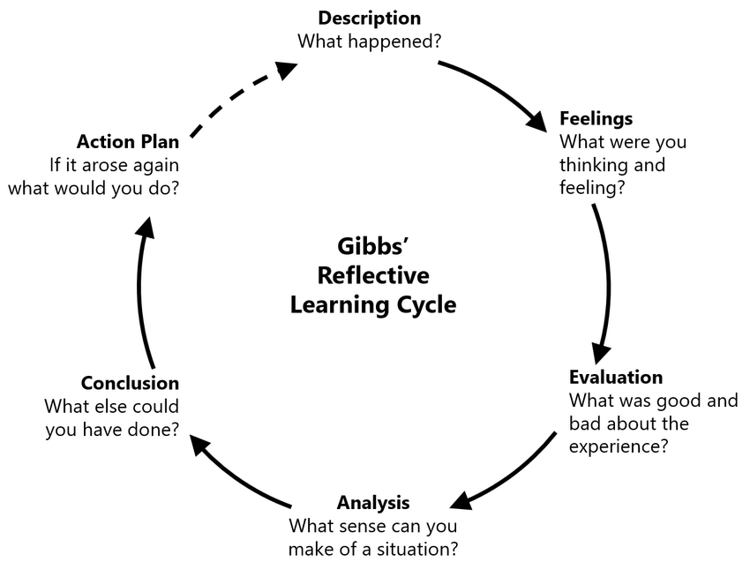  Gibbs’ model  Learning to learn better (2023) | 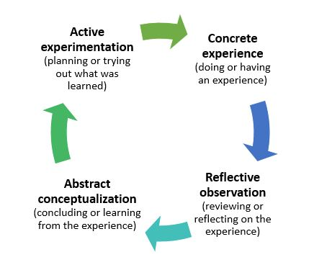  Kolb’s model  Kurt (2020)
Analysis of models – compare/contrast/pros/cons:

First, I will be discussing the Gibbs model. Gibbs’ Reflective learning cycle was developed in 1988 by Professor Graham Gibbs and is one of the most used reflection cycles, particularly within professional development, nursing and education (The University of Edinburgh, 2024). His cycle includes six different stages, and these are Description, feelings, evaluation, Analysis, Conclusion and Action plan (Structured learning 2024). One of the pros of the Gibbs Reflective learning cycle is that it provides a structured, clear framework which is straightforward to follow. It encourages continuous improvement by prompting users to explore their outcomes, actions, and emotions in depth (The University of Edinburgh 2024). The cons for this reflection cycle are that it can be time-consuming due to its in-depth reflection. This model also focuses more on past events, so this could be considered a con (LondonDeanery). As Bite size learning (2024) mentions, a critique of the Gibbs Cycle is that it can lead to a direct focus on negative portions of an event. Secondly, it will be discussed the Kolbs Model, Kolbs learning cycle was created in 1984 by David A. Kolb, his method consists of four stages, which are Concrete Experience, Reflective Observation, Abstract Conceptualisation and Active Experimentation (Cherry, K. 2024). Kolbs' Theory explores that individuals learn through a continuous process, and by integrating the stages from Kolbs' theory, it helps emphasise the importance of active engagement and effective learning outcomes, which then makes it a valuable framework for learners and educators (Cherry,K. 2024). SkillsGuides (2025) suggest that the reflection can be used to structure you’re thinking, which requires the individual to work through each stage, or it can be used as a basic structure for a reflective essay. Another benefit of this reflection cycle is that it promotes continuous improvement, allowing individuals to repeat the cycle for ongoing growth. It also encourages self-awareness, helping individuals recognise their strengths, weaknesses and different learning styles. Some of the cons are this reflection cycle can be time consuming due to each point needing reflection and planning, it will also say that if can be difficult to follow without guidance or coaching. Gibbs’ and Kolbs' theories have several sections in common, one of them being that they both focus on learning from experience, promote self-awareness and professional growth.
Conclusion
In Conclusion, reflection is a crucial process that enables professionals to assess their experiences, pinpoint their advantages and disadvantages, and modify their methods to accommodate the evolving demands of young learners and the early childhood sector. Both Kolb’s experiential learning cycle and Gibbs’ reflective cycle offer useful frameworks that promote lifelong learning and professional growth. Gibbs’ model is especially helpful for practitioners who are new to reflective practice since it provides a structured and clear approach that leads practitioners through the process step-by-step. Kolb’s model, on the other hand, highlights learning through experience and the continuous, cyclical character of learning. Both approaches promote critical thinking, self-awareness, and ongoing development in spite of certain drawbacks, such as the amount of time needed for productive reflection. Regular reflection in early childhood practice guarantees that practitioners stay up to date with changing policies, have a deeper understanding of children’s needs, and continuously improve the standard of care and instruction they offer.

Reference List – Part 2
BiteSize Learning. (2024) The Gibbs Reflective Cycle, Explained. Available at: The Gibbs Reflective Cycle, explained — BiteSize Learning (Accessed 10th October 2025).
Cherry, K. (2024) What is Kolb’s Learning Cycle and How Does it Work? Available at: What is Kolb's Learning Cycle and How Does it Work? (Accessed 11th October 2025).
Kurt, S. (2020) Kolb’s Experiential Learning Theory & Learning Styles. Education. Available at: Kolb’s Experiential Learning Theory & Learning Styles - Educational Technology (Accessed on 09th October 2025).
Learning to Learn Better, (2023) What is the Gibb’s reflective cycle. Available at: What is the Gibb’s Reflective Cycle? | by Learning To Learn Better | Medium (Accessed on 09th October 2025).
London Deanery. Getting Started On Reflection. Available at: https://londonprofessionaldevelopment.hee.nhs.uk/sites/default/files/reflection-and-reflective-practice.pdf (Accessed: 11th October 2025).
Main, P. (2023) Gibbs’ Reflective Cycle. Available at: https://www.structural-learning.com/post/gibbs-reflective-cycle (Accessed: 11th October 2025).
NHS London. Reflective writing skills. LondonDeanery. Available on: https://londonprofessionaldevelopment.hee.nhs.uk/sites/default/files/reflection-and-reflective-practice.pdf (Accessed 09th October 2025).
Paige-Smith, A. and Craft, A. (2011) Developing reflective practice in the Early Years. 2nd edition. England.
SkillsGuide. (2025) Reflective writing: Kolb. Available at : Kolb - Reflective writing - Library at University of Hull (Accessed: 11th October 2025).
The University of Edinburgh, (2024) ‘Gibbs’ Reflective Cycle’ Available at: Gibbs' Reflective Cycle | Reflection Toolkit | Reflection Toolkit (Accessed: 11th October 2025).
Thompson, C. (2025). Reflective Practice for Professional Development. London.
University of Hull, (2025) Reflective writing: Kolb. Available at: Kolb - Reflective writing - Library at University of Hull (Accessed 10th October 2025).

Part 3 – 1500 words – 197
In this section of the portfolio, we will discuss what it means to be a professional within the Early Years sector, as well as the key aspects of professional practice involved. It will be considered effective communication, reflective practice, key qualities, values and behaviour that define professionalism, which will include ethical conduct, and commitment to ongoing professional development and Polices. Furthermore, it will be discussed why professional practice is essential in an Early Years setting. I will highlight how it contributes to high-quality care and education, as well as the safety and well-being of children and colleagues, fostering positive relationships with children, colleagues, and families, and creating a strong, supportive environment that provides holistic development for every child.
Several values are important for a professional practitioner, the first one I will be discussing is valuing children’s rights, as UNICEF describes it as a legally binding agreement which is signed by over 196 countries, setting out the rights of every child, regardless of their abilities, race or religion. The UN has 54 articles covering all different aspects of a child’s life, also explaining how governments and adults must work together to ensure all children experience all their rights.

Reference list
Part 3
UNICEF. How We Protect Children’s Rights. Available at: UN Convention on Rights of a Child (UNCRC) - UNICEF UK (Accessed: 12th October 2025).

Notes
Notes part 3
Intro – look at mindmap
Fun – to be enthusiastic, enjoy your job, if you are happy people around you will be happy, being a good role model . (Who says we need to be fun)
Knowledgeable – understanding – knowledgeable of what your doing- without knowing the curriculum you wont no what your doing , have the understanding of what children need to learn and grow
Caring
Trained –
Role of a professional – curriculum for wales , UNCRC need to keep children safe
National minimum standards – we do all this to be professional
VALUES –
Value children’s rights
Ethical thinking- there rights – there beliefs - whats right and wrong , if you do a activity with a group of children, didn’t ask consent to take pictures that’s not being ethical
Inclusions and respect – include everyone and respect everyone of there rights
COMMUNICATION AND RELATIONSHIP –
Children’s needs
Discuss progress – be able to communicate to be able to no where the child is at to be able to plan around Childrens needs
Meeting the needs of children – having a good relationship – so they trust you – communication with parents and staff can communicate with different agencys to help assist the child –
no what they can/cannot do
get to no there likes and dislikes
positive working environment –

communicating is important to be able to share info to get a full understanfding to meet specific needs to each individual child ,
tracking the developmental stages –
bronforbenit – support system

INDEPTH KNOWLEDGE AND UNDERSTANDING
- To be able to grow with the needs to society
- Professional identity
- If you have a apprentice they follow your knowledge you need to insure your teaching them proper knowledge
- Boundaries
MULTIAGENCY
Holistic development for the children – holistic approach – whole environment –
The more experience/ people we have means we will have more influences, help support each other with different knowledge. Its important because its teamworking – supporting each other , sharing ideas, listening, communicating with each other, recognising strengths and weaknesses, gaining more knowledge – learn from others
OBS AND PLANNING
To be able to identify needs, identify who the child is/ there likes/dislikes/strengths/weaknesses,
Uniqure child, individual child
So we can reflect and recognise and move forward with next levels of ability – to be able to put systems in place

UNCRC
- To have awareness of UNCRC we are able to meet the needs, recognise the needs to be able to keep the child safe …. As uncrc state children have the right to play

