

Programme: Master of Business Administration
Module Code: LCMB7026
Module Title: International Marketing: Principles and Practices

Student name: Md Shadhin
Student ID number: 2505230

Tutor Name: Tushara Balendran

Word Count: 5715

Table of Contents
Introduction 3
Background Information about IKEA 3
Section 1: Comparative Analysis of IKEA’s Home Country (Sweden) and Host Country (United Kingdom) Using PESTEL 5
STP and the International Marketing Mix (7Ps) Analysis for IKEA in Sweden and the United Kingdom 10
(c) Analysis of the Brand’s Directional Development Strategy in the United Kingdom 20
(d) Ethical Issues in IKEA’s Marketing Mix 22
Recommendations for Future International Marketing Strategy of IKEA 24
Section 2: Reflective Account Using Gibbs’ Cycle 25
References 29

Introduction
The term “International Marketing” can be defined as the process of planning and delivering of products or services across national borders with the responding to the differences in consumer behaviour, culture and external market conditions (Jonsson and Foss, 2011). In the case of multinational retailers, this entails striking a balance between international standardisation and localisation as a strategy that succeeds in one country might not always succeed in another (Burt, Johansson and Thelander, 2011). This applies well to IKEA whose expansion globally has been established upon a standardised low-cost, Scandinavian retailing concept, but its performance in the markets is determined by how well it can adjust to the country-specific conditions (Edvardsson and Enquist, 2011). Sweden is the home country of IKEA and the UK is its host country in this assignment which provided a good comparison between a culturally compatible domestic market and a big yet more difficult foreign one. As such, the particular purpose of this report is to compare PESTEL environment of Sweden and the UK to determine which of the two markets is more favourable towards IKEA and how social and cultural differences determine its marketing strategy in each country. There will be an application of the Hofstede model, segmentation, targeting, positioning, the marketing mix, directional development strategies, ethical issues and a reflective account using Gibbs reflective cycle.

Background Information about IKEA

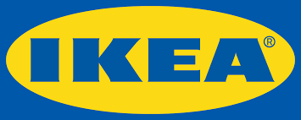
Figure 1: Brand logo of IKEA, source: (IKEA, 2025)
IKEA is a Swedish international retail store established in 1943 by Ingvar Kamprad in the Swedish town of Älmhult, and today based in the Dutch city of Delft, with its brand and product development heritage deeply rooted in Sweden (Jonsson and Foss, 2011; Inter IKEA, 2025). It specialises in low-price functional and self-assembly home furnishings and the marketing of its products is based on the concept of democratic design, which integrates form, purpose, quality, sustainability and low cost, which is a Swedish value of simplicity and practicality (Edvardsson and Enquist, 2011). The vision of IKEA is to make a better everyday life of the many people, and its mission is to provide a large variety of designed, practical home-furnishing products at as low a price as possible to the many people (Inter IKEA, 2025; Edvardsson and Enquist, 2011). This mission is explicitly what informs the cost leadership and value-based strategy of IKEA, where it is possible to be accessible without losing the design or sustainability. As of FY2025, IKEA had an operational presence in 63 markets, had approximately 473 stores and about 216,000 co-workers around the world (Inter IKEA, 2025). Despite its globally standardisation, its internationalisation is based on a form of flexible replication, where it selectively adapts to local markets particularly in the UK (Jonsson and Foss, 2011). According to the FY2025, the IKEA UK recorded retail sales of an amount of 2.25 billion in 2025a year on year, although, this fall has been offset by a 4% increase in sales volumes due to ongoing affordability activities, four new store openings and 101 Collect Near You points (IKEA UK, 2025a). It proves that the IKEA strategy in the UK is quite sensitive to the local cost-of-living conditions and Sweden is the cultural and organisational core of the company.
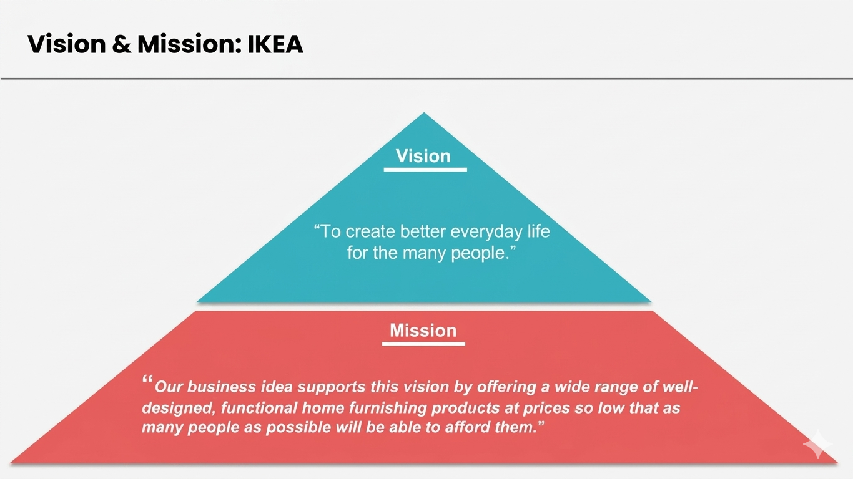
Figure 2: Vison and Mission statement of IKEA; Source (Inter IKEA, 2025)

Section 1

Comparative Analysis of IKEA’s Home Country (Sweden) and Host Country (United Kingdom) Using PESTEL

This section provides a comparative analysis of IKEA’s home country, Sweden, and its host country, the United Kingdom, using the PESTEL framework to examine political, economic, social, technological, environmental, and legal factors affecting the business environment in each market.

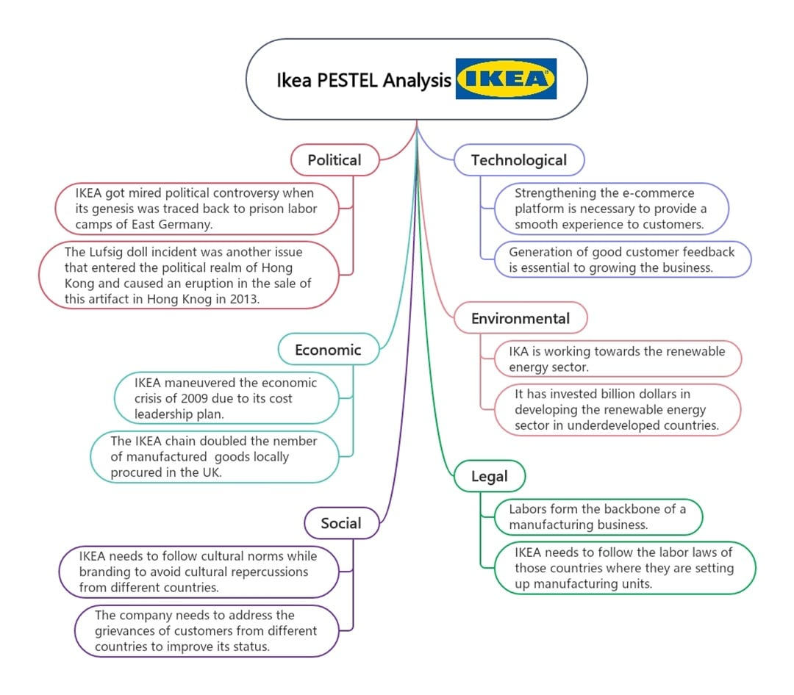
Figure 3: IKEA’s PESTEL Model; Source ((IKEA UK, 2025a)

Political Factors: Sweden is favorable for political environment to IKEA as it is the home market and institutional environment, with good policy continuity, high quality of governance and close to Nordic welfare-capitalist values, which contribute to long-term business planning (OECD, 2025a). According to OECD (2025a), the economic fundamentals of Sweden have been stable even though the economy has stagnated recently, with the government stability in policies contributing to investment in housing, skills and climate transition, which are all pertinent to the IKEA home-furnishing ecosystem. In the case of IKEA, it is beneficial as its brand ideology of affordability, sustainability and social responsibility are appropriate in the institutional context of Sweden (Edvardsson and Enquist, 2011).
The UK is also politically favourable, yet, relatively more complex. UK is a well-developed, rule-based market with well-established retail institutions, but slower growth, post-Brexit trade frictions and pressure on policy costs, exert more uncertainty on import-based retailers like IKEA (OECD, 2025c). The impediments to the home-furnishing market in FY2025 were explicitly recognized by IKEA UK itself, which admitted that limited UK economic growth, high interest rates and increasing living costs were limiting the market (IKEA UK, 2025a). Thus, politically Sweden is a better place to predict the domestic environment and the UK is an attractive but less policy-comfy country to a huge foreign retailer.
Economic Factors: Though both markets show high purchasing power; there is also a difference in macroeconomic conditions in terms of stability and sensitivity of demand. Swedish market conditions are is comparatively favourable IKEA. The GDP growth was marked to recover to an approximate of 1.8% in 2025 after the stagnation, with inflation being stable at 2% (OECD, 2025a; Sveriges Riksbank, 2026). This is low and restrained inflation boosts consumer confidence, and discretionary spending in furniture. Since the demand of IKEA is directly related to the housing activity, the gradual recovery of Sweden and the better development of e-commerce growth there are positive signs of a strong demand (PostNord, 2025). Therefore, the macroeconomic coherence and predictable demand in Sweden are favourable in the long-term planning of IKEA.
Conversely, UK is favourable but more volatile at a conditionally. The growth in GDP is lower at about 1% with inflation remaining too high at about 3-4% (OECD, 2025c; OECD, 2025d). The increase in the inflation rates and interest rates lower real income and dampen the furniture demand, directly impacting the performance of IKEA in terms of sales (IKEA UK, 2025a). Nevertheless, the volume growth has been maintained by the big scale of retailing in the UK and IKEA investments of 117 million and a reduction of the prices by 10 percent (IKEA UK, 2024; Inter IKEA, 2025).

Social Factors: Both Sweden and United Kingdom are favourable markets to IKEA in terms of social factors, although they need various strategic responses. Sweden is favourable with the initial value proposition of IKEA. Minimalism, functionality, sustainability and frugality are all consistent with Swedish consumption patterns, which enhances brand image and cultural compatibility (Edvardsson and Enquist, 2011). The United Kingdom on the other hand exhibits a more varied and price sensitive consumer behaviour and thus more sensitive in both marketing and operations (Burt, Johansson and Thelander, 2011).
As per the Hofstede Cultural Dimensions, Sweden and the United Kingdom have low and high-power distance, respectively, with the former favoring equality and participative decision making and the latter having a bit of hierarchy tolerance (Hofstede Insights, 2025). The two nations are very individualist and promote personal decision making in furnishing of the home.
Nonetheless, Sweden is a highly feminine culture, where quality of life, sustainability and low-key consumption are highly regarded, which is in alignment with the IKEA philosophy. United Kingdom is a more masculine country, achievement and value money play a greater role in decision making when purchasing.
Sweden is not very high in uncertainty avoidance; this implies that consumers are ready to embrace new innovations like self-assembly furniture. The UK is moderate in terms of uncertainty avoidance and therefore customers would want to be assured by service quality and through return policies. The two countries are both long term oriented, but Sweden is more focused on sustainability, whereas United Kingdom balances between a future value and affordability. Sweden is also more conservative, and the United Kingdom is comparatively hedonistic, and more convenient and digital shopping channels (Office for National Statistics, 2026; IKEA UK, 2025a).
Therefore, the benefit of the Hofstede model is that it offers a fairly straightforward theoretical framework of comparison of national cultures and international strategy guidance. One of the drawbacks is that it could be too simplistic in cultural differences and fails to capture fully evolving and changing consumer behaviours especially in a multifaceted market like the United Kingdom (Burt, Johansson and Thelander, 2011).

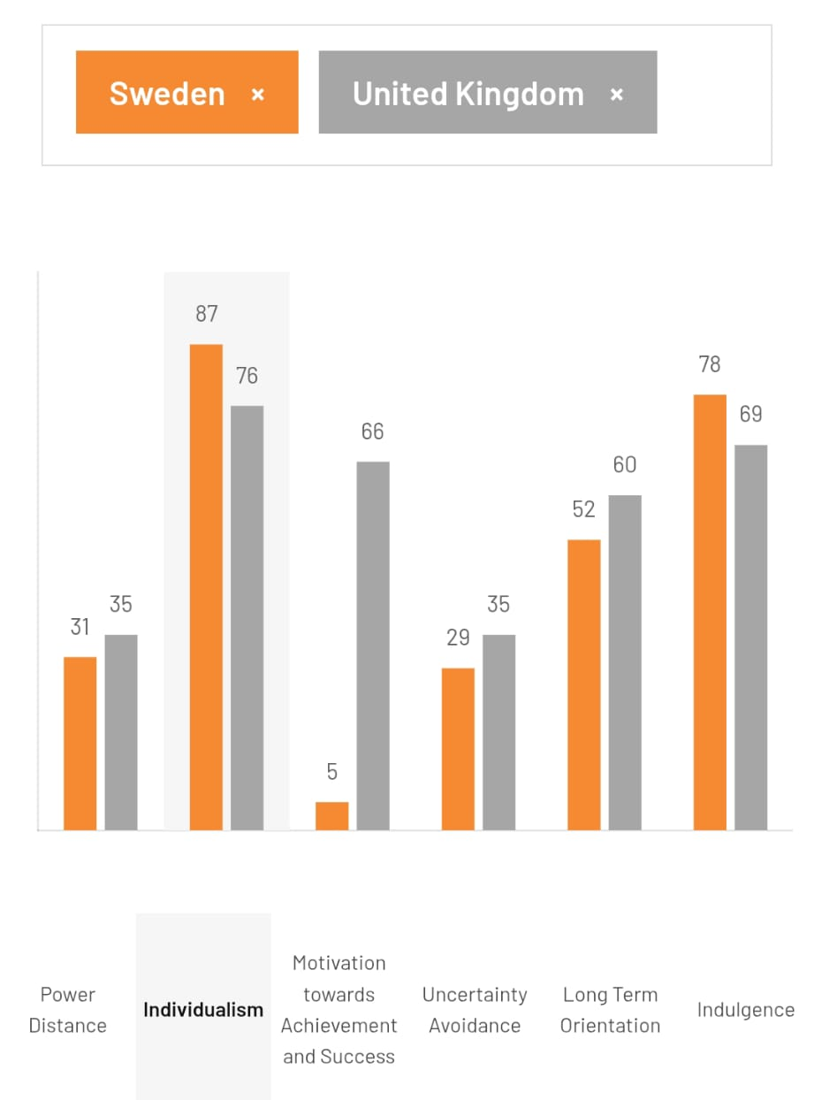
Figure 4: Hofstede’s Cultural Model; Source (Hofstede, 2001)

Technological Factors: The technological environment in the two countries is also very favourable as they are digitally developed in retail markets. The robust e-commerce recovery in Sweden, particularly in furniture and home furnishings, underpins the integrated stores-plus-digital model at IKEA (PostNord, 2025). The UK is, perhaps, even more technologically exacting due to its highly developed online retail behaviour, where online retail penetration in total retail sales is 27.4% in 2025 (Office for National Statistics, 2026). This opens the prospect of IKEA omni-channel expansion but also demand of responding quickly, click-and-collect and the smoothness of the digital experience. Therefore, both are favourable towards technology, but the UK needs to adapt to services faster.
Environmental Factors: Though the environmental factors are favourable but operationally challenging. IKEA gets benefits from its sustainability-based brand, which is supported by both UK and Swedish consumers who are becoming increasingly environmentally conscious about circularity and low-waste consumption (Edvardsson and Enquist, 2011). Sweden is especially favourable since the producer-responsibility norms and the circular-economy expectations are based on the long-term sustainability narrative of IKEA; the Swedish Environmental Protection Agency focuses on the producer responsibility as the key tool of resource efficiency and waste reduction (Naturvardverke, 2023; 2026).
The same expectations, however, can enhance compliance and redesign expenses. Environmental demands are also increasing in the UK however, consumer pressures in regards to affordability may pose a conflict between sustainable products and price sensitivity. The two markets are therefore good in terms of brand legitimacy as far as the environment is concerned yet they have to be invested in.
Legal Factors: Both markets are favourable in legal terms since they are transparent and highly regulated, but the UK is more complex to operate in, as far as it concerns furniture retail. IKEA has to adhere to certain product and safety regulations in the UK, including the Furniture and Furnishings (Fire) (Safety) (Amendment) Regulations 2025, which revised the flammability and labelling regulations as of 30 October 2025 (GOV.UK, 2025a; 2025b). These impose compliance costs, but also ensure consumer confidence.
As an EU market, Sweden functions within harmonised product, sustainability and waste systems, which are challenging, but fairly similar to those currently in place within IKEA in Europe. Thus, the legal environment is conducive in both nations, although the UK poses greater localised compliance pressure to a foreign retailer.
IKEA’s similarities and differences in both Countries: Sweden and the UK are equally good markets to IKEA, though Sweden is institutionally and culturally more favourable whereas the UK is more commercially larger yet economically and operationally difficult. In the case of IKEA, the brand transfer is not the only factor that would make it successful in the UK, rather, it should be sustained with additions of affordability, omni-channel convenience and local regulation.

STP and the International Marketing Mix (7Ps) Analysis for IKEA in Sweden and the United Kingdom

STP Analysis for IKEA in Sweden and the UK
This section presents the critical comparison between the Segmentation, Targeting and Positioning (STP) and the International Marketing Mix (7ps) strategies of the Swedish and the UK market, which relates market orientations, consumer dynamics and competitive conditions to actual strategic results.
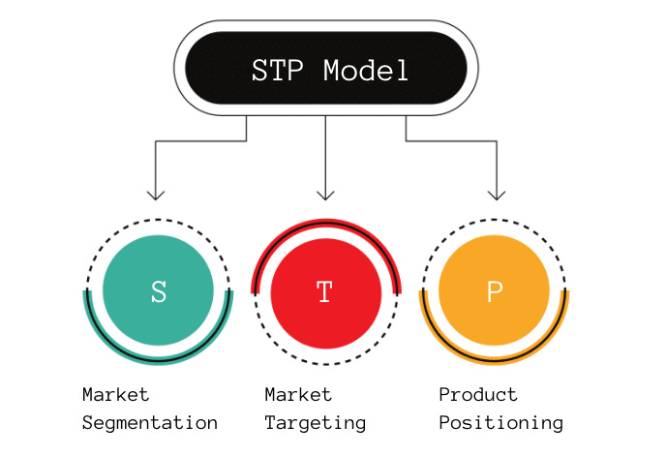
Figure 4: STP Framework, Source (Baack, 2018)
Segmentation: Market segmentation helps companies to match value propositions with the different consumer needs (Wind and Douglas, 1972). IKEA targets design oriented and environmentally conscious consumers in Sweden. Swedish furniture market was approximately 26 billion Swedish kronor in 2024, and IKEA produced almost 7.8 billion Swedish kronor, which is better than other competitors like Jysk and Mios AB (Statista, 2025). Swedish customers are environmentally aware and ready to spend on long-lasting products that have a lesser environmental footprint.
Segmentation in the United Kingdom is more price sensitive and digital. In the UK, the furniture market was estimated at approximately 21.5 billion in 2024, with the furniture and lighting making major sales every month (Statista, 2025). Consumers experience the pressure of cost of living and are becoming more and more dependent on online channels. Internet retailing is becoming an increasingly high share of the overall retail sales, which solidifies the behavioural segmentation on the basis of shopping patterns (Office for National Statistics, 2026).
Targeting: IKEA in Sweden is aimed at consumers, who are sustainability oriented and whose choices rely on quality and environmentally friendly performances. Although the prices of furniture are increasing, the demand stays the same, which promotes the same targeting approach (Statista, 2025).
In the UK, IKEA is focusing on price conscious families, youthful buyers and those who are digitally savvy. In 2025, the revenue was 2.25 billion, and price cuts (approximately 20 per cent in over 3,400 products) helped to boost the sales volumes by 4 per cent (IKEA UK, 2024; IKEA UK, 2025a). This is an aspect of adaptive targeting in reaction to economic pressures.
Positioning: The globalization of IKEA is premised on democratic design. In Sweden, this is strengthened by the adherence to such cultural values as sustainability and equality (Hofstede Insights, 2025). Positioning in the United Kingdom is focused on affordability and convenience in a highly competitive retail market that has companies like Howdens and Dunelm among others (Statista, 2025). The trend of increasing online furniture sales to approximately 8.64 billion USD shows the significance of digital positioning (Statista, 2025). A perpetual Perceptual Map of IKEA’s UK market has been presented below:
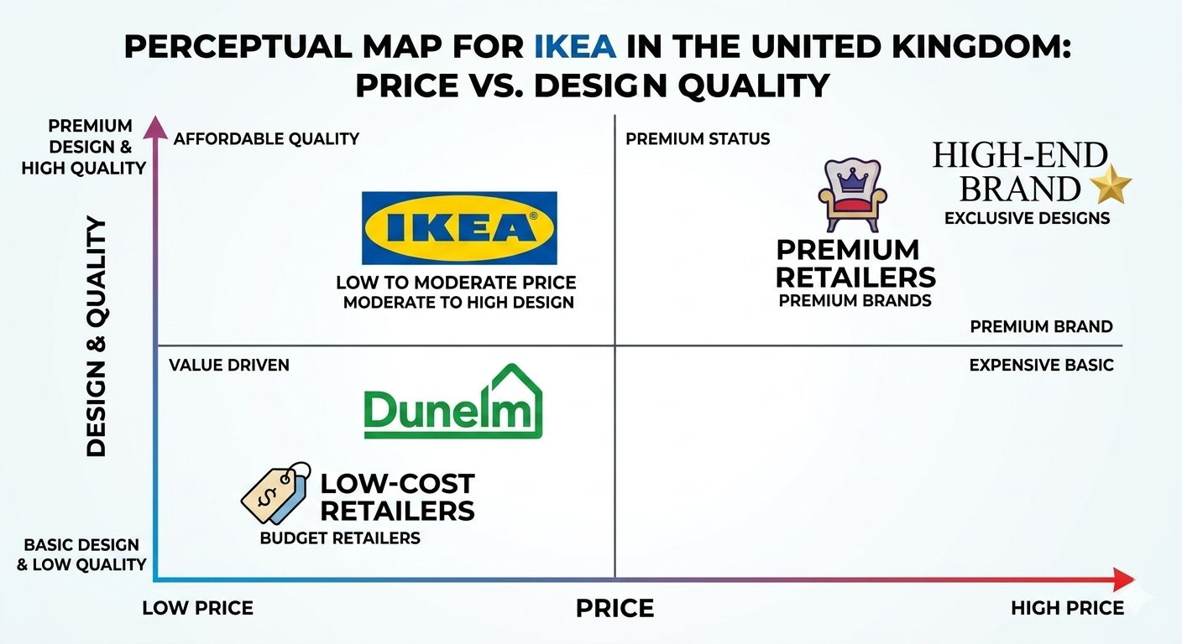
Figure 5: Perceptual map for IKEA in the UK; (OECD, 2025d)
Map description: The perceptual map locates IKEA in comparison with its rivals with regards to two dimensions such as the price and quality of design. Horizontal axis shows Low-high price and the Vertical axis shows simple to high quality design. IKEA is located in the low to moderate price and moderate to high design quadrant. Rivalry like Dunelm may be positioned at low price and low design where as high price and high design place premium retailers. This map shows that IKEA is unique in that it provides relatively high quality of design at low prices, which will help it in its value proposition in the UK market. It also points to the issue of competitive pressure by both low-cost retailers and high-end brands which supports the necessity of balanced positioning.
Similarities and Differences
Similarities: Both United Kingdom and Sweden represent a high-level of compatibility with IKEA world strategy of democratic design. Both markets use the segmentation based on behavioural and demographic dimensions and both are based on the brand consistency with the help of global positioning. Also, in both countries, digital transformation affects consumer engagement albeit at varying levels.
Differences: The major differences are found in the priorities of consumers and market dynamics. Sweden is more sustainability oriented; the demand is stable and the cultural fit is high to promote long term value-based strategies. Conversely, the United Kingdom is more price sensitive and competitive and needs frequent tactical price and promotion changes. Moreover, the digital channel significance is more significant in the United Kingdom that requires more intensive integration of the omnichannel. These variations indicate that IKEA has a standard core strategy but it is tactical in response to local economic and cultural environments (Czinkota, 2011).

Marketing Mix (7Ps)

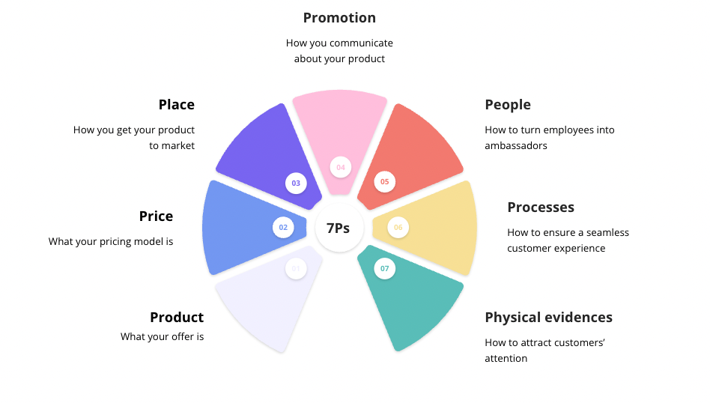
Figure 6: 7P’s of Marketing Framework; Source (Doole and Lowe, 2012)
Product: The product strategy of IKEA is based on customer-oriented design offering functional and design led furniture that is a combination of quality and affordable prices. In Sweden, it has a strategy of using eco certified materials and sustainable production. In 2024, Sweden had a furniture consumption of 26 billion Swedish kronor, which is high demand on products that are environmentally friendly (Statista, 2025). IKEA Sweden has a large product mix, with eco lines, such as KUNGSBACKA kitchen fronts and sturdy sofas like KLIPPAN sofa, indicating breadth across the categories and depth in sustainable lines.
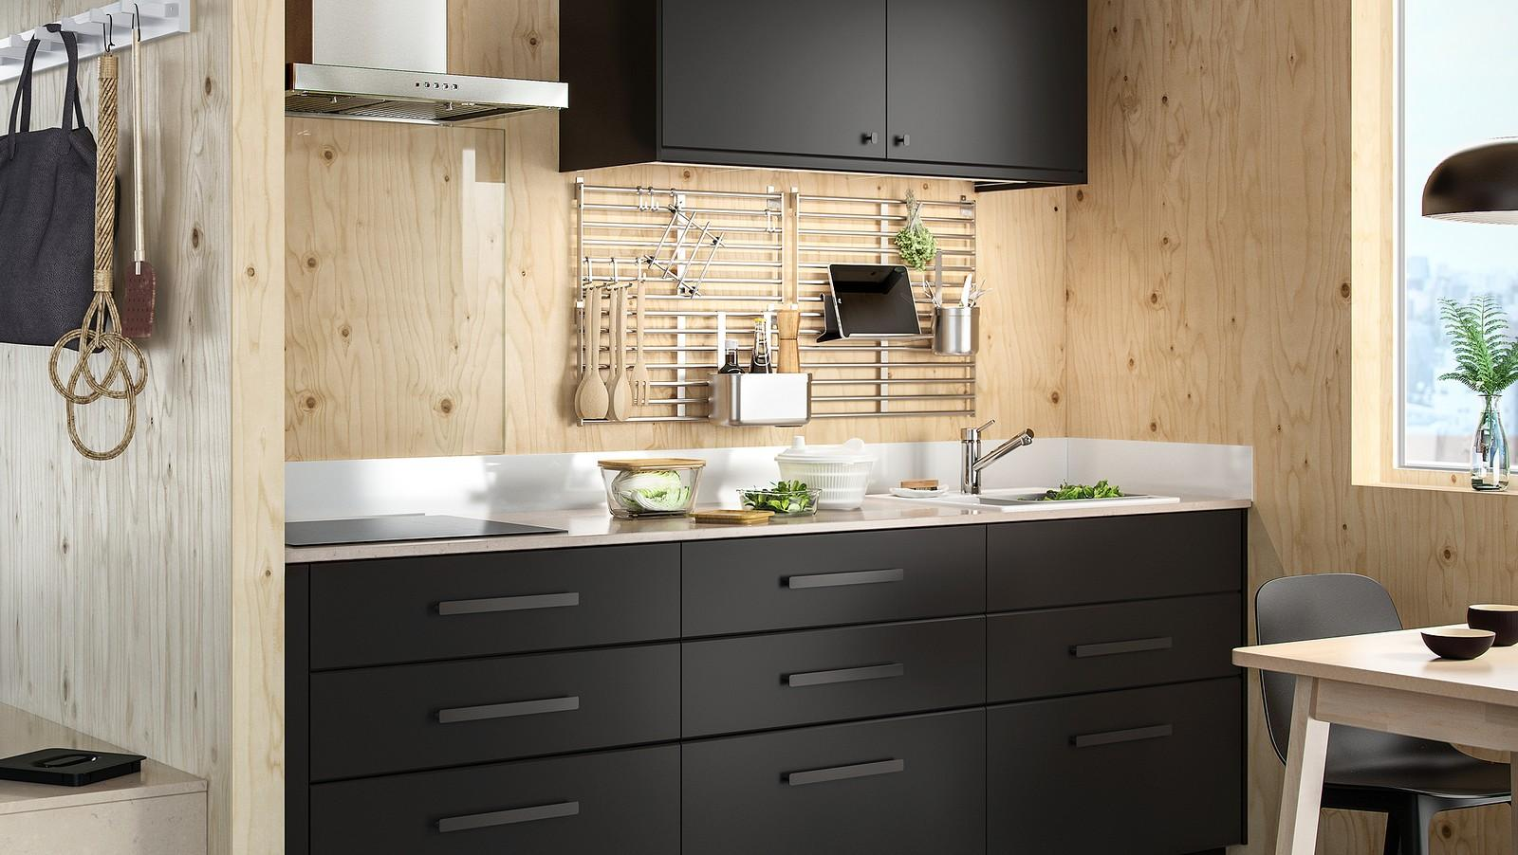
Figure 7: KUNGSBACKA kitchen of IKEA, Source: (Inter IKEA, 2025)
Space saving and multifunctionality are being targeted by product strategy in the United Kingdom because of the constraints of living in urban areas. The bed (MALM) and shelving unit (KALLAX) demonstrate more significant differences in size, storage and configurations. This brings out more depth in chosen categories as well as a broad product selection of the furniture types. The consumers of UK appreciate flexibility and small-scale solutions, particularly on apartments (ResearchAndMarkets, 2024; 2025).
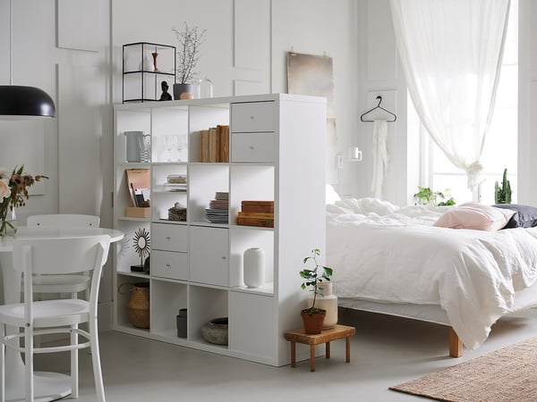
Figure 8: The bed (MALM) and shelving unit (KALLAX) of IKEA in UK, Source: (IKEA UK, 2024)
These product pictures demonstrate that in Sweden sustainable product width is more emphasised whereas in the UK depth and adaptability are favoured, reflecting the varying needs of different consumers and market factors.
Price: IKEA has a competitive edge based on pricing, with the aid of efficient sourcing, flat-pack logistics and global economies of scale. Pricing in Sweden is based on affordability and high value of sustainability. To illustrate, eco-certified KUNGSBACKA kitchen fronts cost on average about SEK 1,500-3,500 per set, which varies in size and design, and the KLIPPAN sofa costs about SEK 2,500-4,000 (IKEA UK (2024). Such prices prove that Swedish customers are ready to buy durable and environmentally friendly furniture as well as functional design.
Cost-of-living pressures, and urban affordability requirements make pricing in the UK more competitive and demand-driven. The MALM bed costs around 99 to 399 based on size and storage options, and the KALLAX shelving unit costs between 25 and 120 based on its modular design, and option to customise to different sizes. The price investment of £117 million made by IKEA UK in 2024 also helps to keep the products in such core product lines affordable (IKEA UK, 2024). In general, Sweden prioritises value and sustainability in cost, and the UK affordability and accessibility in basic furniture collections.
Product | Sweden Price (SEK) | UK Price (£) | Pricing Focus
KUNGSBACKA kitchen fronts | 1,500 – 3,500 | 120 – 280 | Sustainability & premium value
KLIPPAN sofa | 2,500 – 4,000 | 150 – 300 | Durable value-based pricing
MALM bed | 1,200 – 4,800 | 99 – 399 | Affordable modular pricing
KALLAX shelving unit | 300 – 1,200 | 25 – 120 | Low-cost space-saving solution
Table 1: IKEA Product Pricing Comparison (Sweden vs UK); Source (Office for National Statistics, 2026a)
Place: IKEA distribution is a combination of big-box stores and omni-channel fulfilment. In Sweden, flagship stores like IKEA Kungens Kurva (Stockholm) and the traditional store of Älmhult promote the main products, like KUNGSBACKA and KLIPPAN, with the effective online ordering and delivery options.
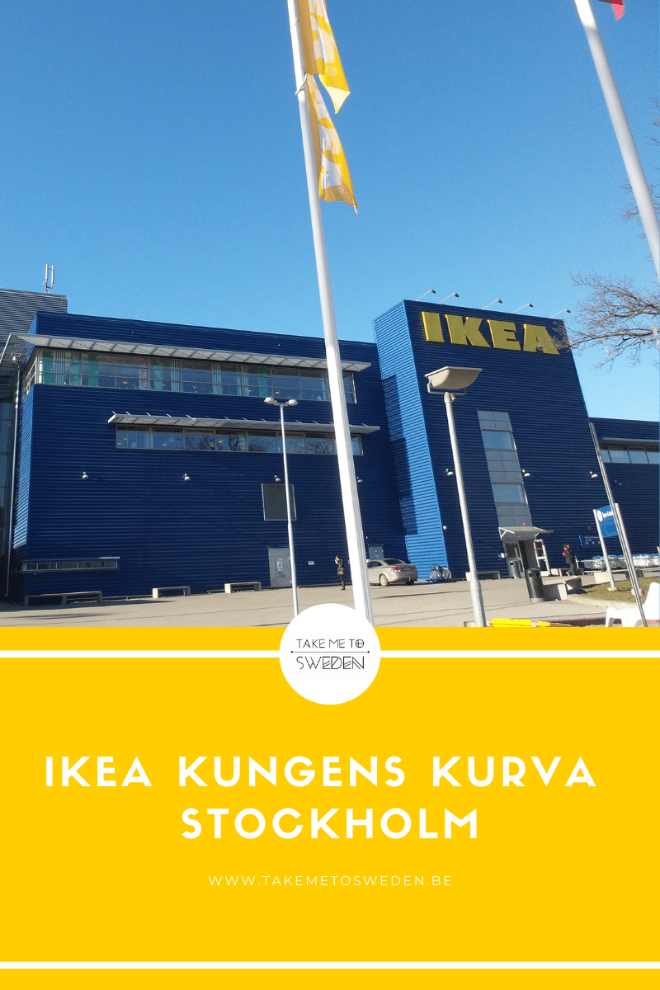
Figure 9: IKEA’s Kungens Kurva storeroom, Stockholm, Sweden, Source (Inter IKEA, 2025)
IKEA Wembley and IKEA Tottenham Court Road city stores in the United Kingdom are conveniently located to offer core products like MALM and KALLAX, which are well favored by urban shoppers due to high demand on small retail format. Both nations incorporate click-and-collect, home delivery, and online shopping, yet Sweden focuses on destination-oriented shopping and the UK focuses on convenience and accessibility in hybrid city shopping.
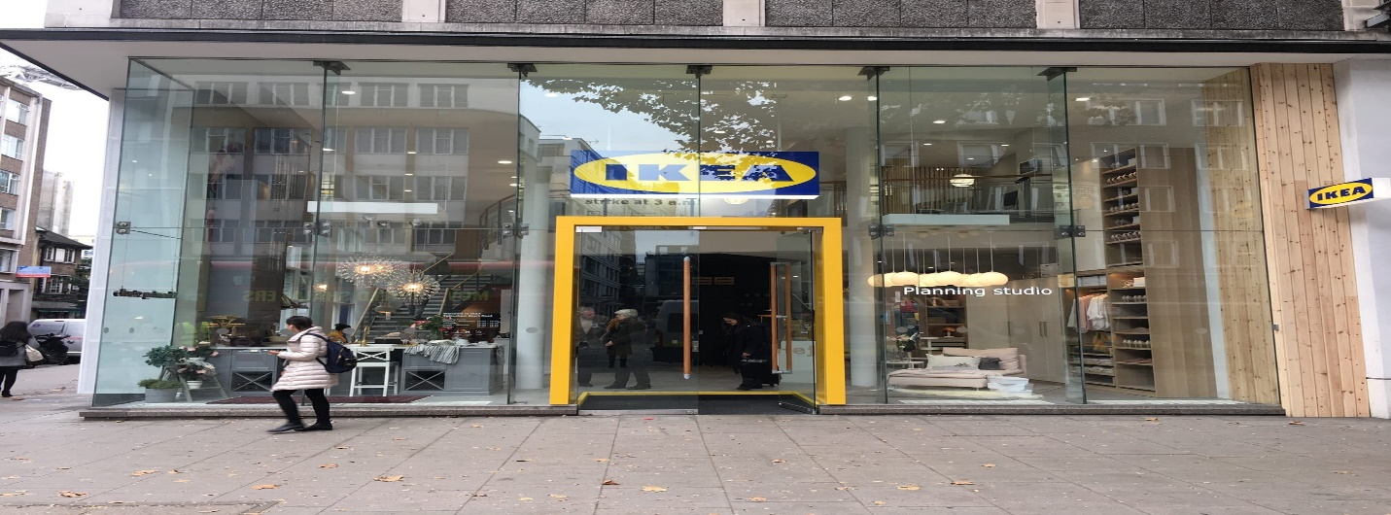
Figure 10: IKEA’s Tottenham Court Road city store, Source: (Inter IKEA, 2025)
IKEA’s distribution strategy combines large format stores with omni-channel fulfilment. In Sweden, IKEA’s regional store networks are complemented by online ordering and delivery or collection services that reflect a balance of physical presence and digital convenience (Mintel, 2025). Sweden’s strong infrastructure and moderate population dispersion support this hybrid distribution model.
Promotion: In Sweden, promotion leverages design heritage and sustainability narratives, reinforcing cultural values of ecological responsibility. IKEA Sweden’s promotional materials and store communications highlight eco-certified product lines and functional design innovation, which resonate with segments that prioritise lifestyle values over price alone (OECD, 2025c).
In the United Kingdom, promotion emphasises value messaging, digital advertising, loyalty programmes and targeted campaigns that resonate with price-sensitive and omni-channel consumers. Digital media engagement, including personalised email campaigns and social media content, supports IKEA UK’s efforts to maintain brand relevance across diverse consumer journeys.
People: Customer experience is influenced by people strategy in accordance with local expectations. In Sweden, IKEA has about 8,000-10,000 employees, who are educated in consultative selling and sustainability expertise, as Sweden is characterized by the focus on egalitarian and informed interactions in the service sector (Retail Sector, 2025). Staff functions are aimed at giving professional advice and customer trust over the long term within a fairly predictable and experience-based retail setting.
The number of IKEA employees in the United Kingdom is more than 10,000 to serve a bigger and more sophisticated urban retail operation (Mintel, 2025). The employees are trained to provide omni-channel service, where they provide support to the customers both on the digital platform and at the physical stores.
Process: Process entails systems that provide uniform customer experiences in the market. The processes at IKEA Sweden are designed on the principles of self-service efficiency, ethical returns policy, and sustainability education and make sure that the operation design is in line with their brand promise (Edvardsson and Enquist, 2011). Most customer complaints are normally addressed using organized in-store resolution desks, and online services in which customer complaints like returns, refunds, or defective products are addressed under clear and customer-friendly policies (Burt, Johansson and Thelander, 2011).
Process innovation in the UK is oriented towards omni-channel fulfilment, click-and-collect, fast delivery and responsive digital customer support to eliminate friction at touchpoints (CBRE, 2025). The major complaints that customers make are addressed with online support systems, live chats, and in-built after-sale services, which helps resolve the customers faster in the digital-first customer retail experiences. In general, Sweden is focused on the transparency and sustainability-driven processes in the services, whereas the UK is focused on the speed, accessibility, and digitally-oriented systems of complaint management.
Physical evidence: Physical evidence means the physical aspects that influence customer perception of the IKEA brand in-store and on-line. Scandinavian-based design concepts are also demonstrated in flagship stores like IKEA Kungens Kurva (Stockholm), featuring sparse designs, use of nature, and heavy sustainability advertising, which amplify the environmental identity of IKEA. Product displays, which feature eco-friendly solutions and circular economy initiatives, are also experienced by customers, which are part of the brand positioning of IKEA Sweden (IKEA Sweden, 2026).
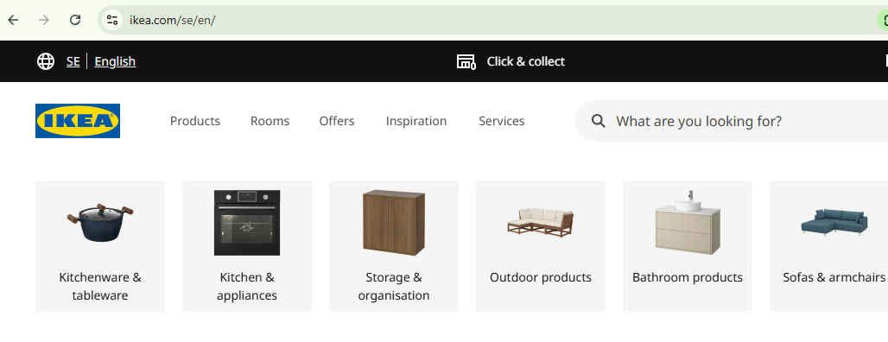
Figure 11: IKEA’s Swedish website interface, Source: (Inter IKEA, 2025)
The IKEA Wembley and IKEA Tottenham Court Road stores in the United Kingdom have more physical evidence that are technology-driven to facilitate quick decision-making and shopping in the city, including interactive digital planning kiosks, self-service, and smart signs. The features make the customers more convenient and are indicative of a robust omni-channel retail environment in the UK (IKEA UK, 2026).
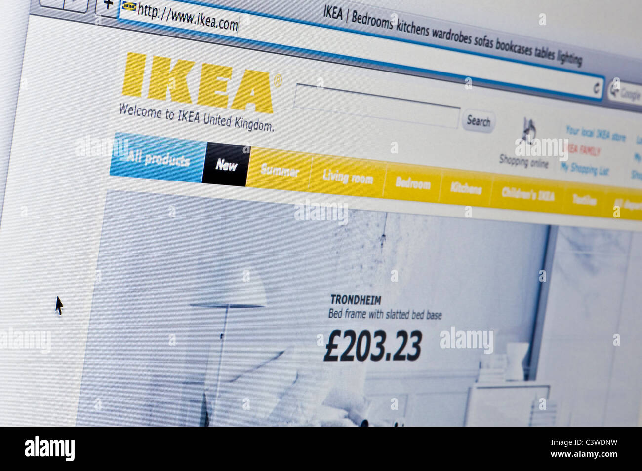
Figure 12: IKEA’s UK website interface, Source: (Inter IKEA, 2025)
Core Similarities and Differences of IKEA in both Countries
In both Sweden and the UK, IKEA have a common global strategy of design-led, affordable and functional furniture backed by omni-channel retailing (Doole and Lowe, 2012). Large-format stores, digital platforms, and integrated services, like click-and-collect and home delivery, are used in both markets to guarantee a consistent customer experience across the channels (CBRE, 2025). Nevertheless, there are major differences in the adaptation of the market. Sweden focuses on sustainability-oriented product design and product pricing based on values, whereas the UK focuses on price, space-saving products, and promotional pricing approaches (IKEA UK, 2024) due to the high level of eco-conscious consumerism. Likewise, Swedish retail outlets emphasize on physical setting which is experiential and design-driven, and UK stores and websites emphasize on digital convenience and quicker decision-making devices (IKEA Sweden, 2026; IKEA UK, 2026).

(c) Analysis of the Brand’s Directional Development Strategy in the United Kingdom
A directional development strategy defines how a company chooses to grow and achieve long-term goals in a specific market by adjusting products, target markets and competitive approaches. The Ansoff Matrix is an established framework that categorises growth into four strategic directions: market penetration, product development, market development and diversification. It helps businesses evaluate how to expand in existing markets with existing products or explore new opportunities with new offerings (Ansoff, 1957).
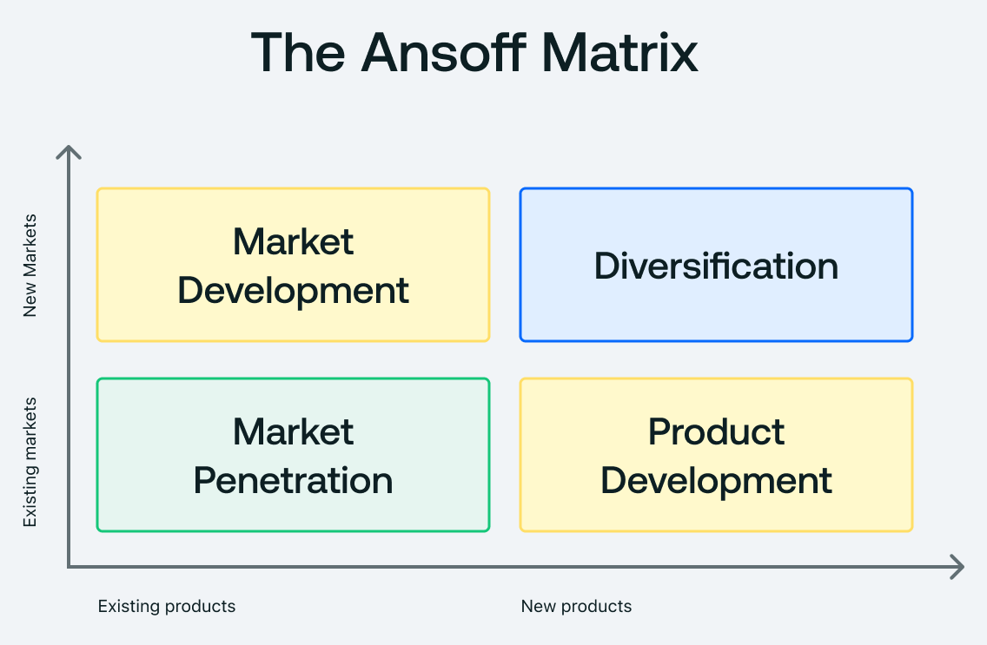
Figure 13: Ansoff Matrix Framework; Source (Ansoff, 1957)

Market Penetration
In the United Kingdom, IKEA’s directional development strategy is highly focused on market penetration to strengthen its leadership in the mature European furniture retail sector. This involves deepening sales of existing home furnishing products to existing customers by enhancing omni-channel reach, investing in competitive pricing, and increasing brand visibility. For example, IKEA UK invested over £117 million in price reductions in FY2024, an aggressive measure designed to increase volumes and defend market share amidst economic pressure and slowing retail growth (IKEA UK, 2024).

Product Development
IKEA UK emphasises product development, regularly introducing new product lines tailored to British lifestyles where space constraints and urban living demand compact, multifunctional furniture. Industry data indicates UK furniture retailers increasingly target urban professionals and first-time homeowners, many of whom favour low-cost, space-efficient products (Mintel, 2025). This product innovation aligns with IKEA’s broader democratic design philosophy and responds to unique UK living patterns, ensuring products are both functional and affordable.

Market Development
Market development is evident in IKEA UK’s expansion into urban micro stores and high street pickup points, extending access beyond large suburban outlets to capture residents who rely on convenience and public transport. Research from CBRE shows that proximity to consumers and omni-channel infrastructure improves both footfall and online purchase conversion which is a vital factor for IKEA’s development in dense UK cities (CBRE, 2025). These initiatives also support urban shoppers who prefer shorter trips, click-and-collect services, and digital engagement.

Diversification
A subtle form of diversification exists through auxiliary services such as in-store planning workshops and partnerships with assembly service providers like TaskRabbit, reflecting IKEA’s move into service extensions adjacent to its core product offerings. These services complement existing products without shifting the company into entirely new markets, representing incremental diversification that enhances customer convenience and engagement.
Therefore, IKEA UK’s directional development strategy prioritises market penetration and product development, reinforced by pricing, design adaptation and omni-channel accessibility. This approach allows IKEA to navigate competitive pressures and respond effectively to changing consumer behaviour in the UK market.

(d) Ethical Issues in IKEA’s Marketing Mix
Ethical considerations in marketing mix strategies concern whether company actions respect social, environmental and consumer welfare standards. IKEA’s global strategy includes several ethical initiatives as well as notable controversies, meaning its marketing mix cannot be viewed as entirely unproblematic.

Ethical Practices in IKEA
One ethical strength in IKEA’s mix is ethical procurement and supply chain governance. IKEA’s IWAY supplier code of conduct enforces standards for labour conditions, environmental protection, and human rights across its global supply network, reflecting a strategic commitment to ethical sourcing that enhances brand legitimacy (Inter IKEA Group Ethics and Integrity). This initiative aligns with broader corporate social responsibility research that links ethical supply chain practices to competitive advantage and stakeholder trust. Additionally, IKEA’s sustainability communications — emphasising circular economy principles and reduction of carbon emissions — reflect ethical product and environmental commitments that resonate with socially conscious consumers.
A second ethical example appears in IKEA UK’s pricing strategy. The £117 million investment to lower prices in 2024 targeted affordability during cost-of-living pressures, representing an ethical use of price as a tool to support consumers rather than purely to maximise short-term profit (IKEA UK, 2024).

Unethical Practices in IKEA
However, ethical challenges have surfaced. IKEA has been criticised for supplier sourcing practices, including allegations of illegal logging and unsustainable wood procurement in Eastern Europe, which raise concerns about the environmental and social integrity of supply chains tied to the marketing mix’s product and physical evidence decisions (Criticism of IKEA).
Secondly, historical ethical lapses have involved IKEA’s advertising and branding decisions in international markets perceived as insensitive or discriminatory, such as past catalogues that were criticised for excluding women in certain regional editions, raising questions about cultural sensitivity in marketing communication.
In conclusion, while IKEA demonstrates ethical leadership in areas such as supplier governance and consumer pricing strategies, there have been valid concerns related to sourcing transparency and past promotional ethics. Marketing mix strategies must therefore balance ethical commitments with operational realities to ensure positive stakeholder impact and long-term brand trust.

Recommendations for Future International Marketing Strategy of IKEA
United Kingdom
To enhance hyper-localised omni-channel integration, IKEA UK needs to increase the number of Hyper-localised omni-channel integration hubs called Collect Near You in highly populated urban areas like London, Birmingham, and Manchester to minimise delivery delays and accessibility. It is advisable to implement a dynamic pricing engine that can adjust price dynamically according to the demand, competitor pricing and cost-of-living indicators to remain competitive in a highly price sensitive market (IKEA UK, 2024). Another move that IKEA should make is creating a UK-specific modular product line dashboard online that would enable customers to design space-saving furniture online prior to making a purchase, which enhances the rates of conversion. Moreover, IKEA UK ought to consider investing in AI-based complaint handling chatbots with live human escalation, which minimizes response time and enhances satisfaction in the after-sales experience in a digitally dominated retail setting (CBRE, 2025).
Sweden
IKEA Sweden needs to consolidate its status as a sustainability beacon market further by increasing its premium-quality eco-certified product lines especially in the circular furniture lines such as the kitchen systems and sofas. It is suggested to provide a product lifecycle transparency tool on the Swedish site, where customers can see carbon footprint, recyclability and material sourcing at product level to enhance the trust in sustainable consumption (Edvardsson and Enquist, 2011). IKEA Sweden also needs to improve in-store sustainability consultation desks where employees offer customised eco-design advice, which are also in line with the strong environmental consciousness of Swedish consumers. Moreover, IKEA needs to invest in reuse and refurbishment furniture services on subscription and promote product return and reuse cycles, facilitate circular economy leadership and enhance customer loyalty in the long term in the domestic market (OECD, 2025a).

Section 2

Reflective Account Using Gibbs’ Cycle
Reflection is a critical instrument of academic and professional growth, which helps practitioners to analyze experiences in a systemic way. The reflective cycle by Gibbs Reflective Cycle (Gibbs, 1988) offers a systematic approach that consists of six steps including Description, Feelings, Evaluation, Analysis, Conclusion, and Action Plan that facilitate critical reflection and ongoing improvement. This reflexive journal extends Gibbs model to the research, analysis, and writing of Section 1 of this assignment on international marketing strategy of IKEA.

Figure 6: Gibbs’ Reflective Cycle; Source: (Gibbs, 1988)
Description: When formulating the comparative analysis of the home country (Sweden) and the host country (United Kingdom) of IKEA, I started by examining the scholarly literature and market reports to develop a theoretical and empirical base. Jonsson and Foss (2011) provided a perspective on the flexible approach of replication by IKEA and how the company balances between standardisation and local adaptation. Burt, Johansson, and Thelander (2011) presented evidence of the implementation of marketing strategies by IKEA in various countries. To assess political, economic, social, technological, environmental, and legal conditions in the markets of IKEA, I also included recent operational and financial data of Inter IKEA (2025), IKEA UK (2025a), Statista (2025), and OECD reports (2025a, 2025c). It was a synthesis of various sources, the connection of the macro-environmental analysis to the STP and 7Ps marketing strategy, and the correspondence of the results with the directional development strategy of IKEA and ethical issues.
Feelings: First, I was confident due to the previous acquaintance with concepts of international marketing and the international operations of IKEA. Nevertheless, I had some confusion in balancing conflicting data points, especially regarding UK market dynamics in the context of post-Brexit economic strains and increased cost-of-living problems. I was also challenged to apply the Hofstede dimensions of culture critically as I realised that these national indices may be simplistic to describe consumer behaviour. This discomfort promoted more critical consideration of sources and critical thinking, making sure that the conclusions were not speculative.
Evaluation: The process of research and analysis presented strengths and weaknesses. The incorporation of both theoretical and empirical information, which allowed the nuanced interpretation of the market processes, could be regarded as a strength. The utilisation of primary IKEA reports provided precise information on operations, whereas secondary sources put the macroeconomic and socio-cultural factors in context. The use of Hofstede model also created limitations because in this model the national culture is over-generalised and it does not take into account subcultural and regional variations particularly in the UK. However, the analysis was able to indicate differences between the institutionally and culturally harmonized market of Sweden, where consumers are sustainability-driven, and highly competitive, price-sensitive and omni-channel-focused market segment of the UK.
Analysis: The comparison of STP and 7Ps marketing strategies presented the way in which the environmental conditions motivate tactical implementation. Jonsson and Foss (2011) explained why IKEA used a flexible approach to replication and this has helped me to make sense of market penetration, product adjustment, and ethical marketing efforts. In Sweden, the emphasis on sustainability and eco-certified products were in line with cultural and consumer needs, whereas in the UK, pricing interventions, urban micro stores, and digital solutions answered the affordability stress and omni-channel demand (IKEA UK, 2025a; CBRE, 2025). The corporate social responsibility perspective conceptualized the ethical considerations, including responsible sourcing and low pricing policies, and supported the necessity to balance operational and ethical goals (Inter IKEA Group Ethics and Integrity). This phase highlighted the importance of practice in context to make evidence-based recommendations.
Conclusion: Considering this process will help prove that systematic evidence-based research is essential in the analysis of international marketing. I was taught that global marketing cannot be successful without incorporating the PESTEL knowledge, consumer behaviour knowledge, marketing mix adjustment and ethical practice. The framework by Gibbs helped to identify the strengths and weaknesses of the analysis, especially in terms of cultural interpretation and data synthesis. In the future, the effectiveness of international market analyses can be enhanced by adding qualitative consumer insights and competitor benchmarking.

Action Plan
Area for Improvement | Action Steps | Timeline | Expected Outcome
Cultural Analysis | Include qualitative consumer surveys in addition to Hofstede scores | 3 months | Richer understanding of local market nuances and subcultural differences
Data Synthesis | Cross-verify multiple secondary sources and reconcile discrepancies | Ongoing | More accurate and reliable market assessment
Ethical Assessment | Review recent supply chain audits and ESG reports | 2 months | Enhanced integration of ethical insights into marketing strategy
Digital Market Insights | Track omni-channel performance metrics and online consumer behaviour | 3 months | Better alignment of STP and marketing mix with digital trends
Comparative Frameworks | Apply complementary frameworks (e.g., Porter’s Five Forces, VRIO) | Next project | Stronger strategic justification for market recommendations

References
Baack, D. G. (2018). International marketing., 2nd edition. London: SAGE Publications.
Bilsky, W. and S. H. Schwartz, “Values and Personality,” European Journal of Personality 8 (1994): 163–181.0
Burt, S., Johansson, U. and Thelander, Å. (2011) ‘Standardized marketing strategies in retailing? IKEA’s marketing strategies in Sweden, the UK and China’, Journal of Retailing and Consumer Services, 18(3), pp. 183–193. Available at: https://doi.org/10.1016/j.jretconser.2010.09.007
CBRE. (2025). How changes in omni-channel retail are shaping retail and logistics real estate. https://www.cbre.co.uk/insights/articles/how-changes-in-omnichannel-retail-are-shaping-retail-and-logistics-real-estate
Czinkota, M.R. (2011) International Marketing. Hampsire: Cengage Learning.
De Búrca, S., Fletcher, R. and Brown, L. (2004) International marketing : an SME perspective. 1st ed. Harlow, England: FT Prentice Hall.
Doole, I. and Lowe, R. (2012) International marketing strategy : analysis, development and implementation. Cengage Learning.
Dudovskiy, J. (2022). IKEA segmentation, targeting and positioning. Research-Methodology.net. https://research-methodology.net/ikea-segmentation-targeting-positioning-targeting-cost-conscious-customers/
Edvardsson, B. and Enquist, B. (2011) Values-based service for sustainable business: Lessons from IKEA. 2nd edn. London: Routledge. Available at: https://www.routledge.com/Values-based-Service-for-Sustainable-Business-Lessons-from-IKEA/Edvardsson-Enquist/p/book/9780415893510
Euromonitor International. (2025). Furniture in Sweden. https://www.euromonitor.com/furniture-in-sweden/report
Gibbs, G. (1988). Learning by doing: A guide to teaching and learning methods. Oxford Polytechnic.
Hofstede Insights (2025) Country comparison: Sweden and United Kingdom. Available at: https://www.hofstede-insights.com/country-comparison/
Hofstede, Geert (2001). Culture's Consequences: Comparing Values, Behaviors, Institutions and Organizations Across Nations. SAGE Publications
Hoj, S., Kvist, J., Thøgersen, J., & Poulsen, R. (2014). Why consumers choose or reject recycled products. Journal of Consumer Behaviour, 13(5), 393–402. https://doi.org/10.1002/cb.1504
IKEA UK (2024) IKEA UK invests more than £117 million in lowering prices throughout financial year 2024. Available at: https://www.ikea.com/gb/en/newsroom/corporate-news/ikea-uk-it-invests-more-than-117-million-pounds-in-lowering-prices-pub20b45e30/
IKEA UK (2025a) In FY25 IKEA UK continued long-term accessibility journey, and returned to growth in final quarter. Available at: https://www.ikea.com/gb/en/newsroom/corporate-news/ikea-continued-long-term-accessibility-journey-pub773f0040/
Inter IKEA (2025) IKEA retail sales figures for FY25. Available at: https://www.ikea.com/global/en/newsroom/corporate/ikea-retail-sales-fy25-251016/
Jonsson, A. and Foss, N.J. (2011) International expansion through flexible replication: Learning from the internationalisation experience of IKEA. London: Routledge. Available at: https://www.routledge.com/International-Expansion-through-Flexible-Replication-Learning-from-the-Internationalisation-Experience-of-IKEA/Jonsson-Foss/p/book/9780415893176
Kale, S.H. (1995) ‘Grouping Euroconsumers: A Culture-Based Clustering Approach’, Journal of international marketing (East Lansing, Mich.), 3(3), pp. 35–48.
Keegan, W.J. and Green, M.C. (2013) Global marketing. 7th ed., global ed. Boston, Mass. ; London: Pearson.
Ko, E., Kim, E., Taylor, C. R., Kim, K. H., & Kang, I. J. (2007). Cross-national market segmentation in the fashion industry: A study of European, Korean, and US consumers. International Marketing Review, 24(5), 629–651.
Mathur, U. C. (2008). International marketing management : text and cases. SAGE.
Mintel (2025) UK Furniture Retailing Market Report 2025. Available at: https://store.mintel.com/report/uk-furniture-retailing-market-report
OECD (2025a) OECD Economic Surveys: Sweden 2025. Paris: OECD Publishing. Available at: https://doi.org/10.1787/75e94b2f-en
OECD (2025b) OECD Economic Outlook, Volume 2025 Issue 1: Sweden. Paris: OECD Publishing. Available at: https://www.oecd.org/en/publications/2025/06/oecd-economic-outlook-volume-2025-issue-1_1fd979a8/full-report/sweden_e5e4d5ab.html
OECD (2025c) OECD Economic Outlook, Volume 2025 Issue 1: United Kingdom. Paris: OECD Publishing. Available at: https://www.oecd.org/en/publications/2025/06/oecd-economic-outlook-volume-2025-issue-1_1fd979a8/full-report/united-kingdom_a5598730.html
OECD. (2025d). OECD Economic Surveys: United Kingdom 2025. OECD Publishing.
https://www.oecd.org/economy/surveys/United-Kingdom-2025-OECD-economic-survey-overview.pdf
Office for National Statistics (2026a) Internet sales as a percentage of total retail sales (ratio). Available at: https://www.ons.gov.uk/businessindustryandtrade/retailindustry/timeseries/j4mc/drsi
Office for National Statistics. (2026b). Retail sales, Great Britain: February 2026.
https://www.ons.gov.uk/businessindustryandtrade/retailindustry/bulletins/retailsales/february2026
Retail Sector (2025) Ikea UK FY sales fall 2.1% to £2.25bn despite strong final quarter. Available at: https://www.retailsector.co.uk/678843-ikea-uk-fy-sales-fall-2-1-to-2-25bn-despite-strong-final-quarter/
Statista. (2025). Furniture and homeware retail sales value in the United Kingdom. https://www.statista.com/statistics/314707/furniture-and-homeware-retail-sales-value-uk/
Sveriges Riksbank (2026) Current inflation rate. Available at: https://www.riksbank.se/en-gb/monetary-policy/the-inflation-target/current-inflation-rate/
Verhoef, P. C., Kannan, P. K., & Inman, J. J. (2017). From multi-channel retailing to omni-channel retailing. Journal of Retailing, 93(2), 174–181. https://doi.org/10.1016/j.jretai.2016.12.002
Wind, Y., & Douglas, S. P. (1972). International market segmentation. European Journal of Marketing, 6(1), 17–25.

