

MODULE CODE: Digital Skills for Personal Development and Business Growth BMSW4008

ASSESSMENT COMPONENT: PORTFOLIO
STUDENT NAME: Cristina Mihaela Severin
STUDENT NUMBER:2504651

LECTURER: Philippa Fitzgerald

DATE:11.12.2025

Task 1 - Assessment of Digital Skills

JISC Discovery Tool Reports
The JISC Discovery Tool aided in evaluating my digital literacy, revealing strengths in basic computing but pinpointing areas for growth like data analysis and multimedia creation. This feedback clarified my skill level and indicated development areas that could aid academic and career success. I intend to seek training to improve these skills.

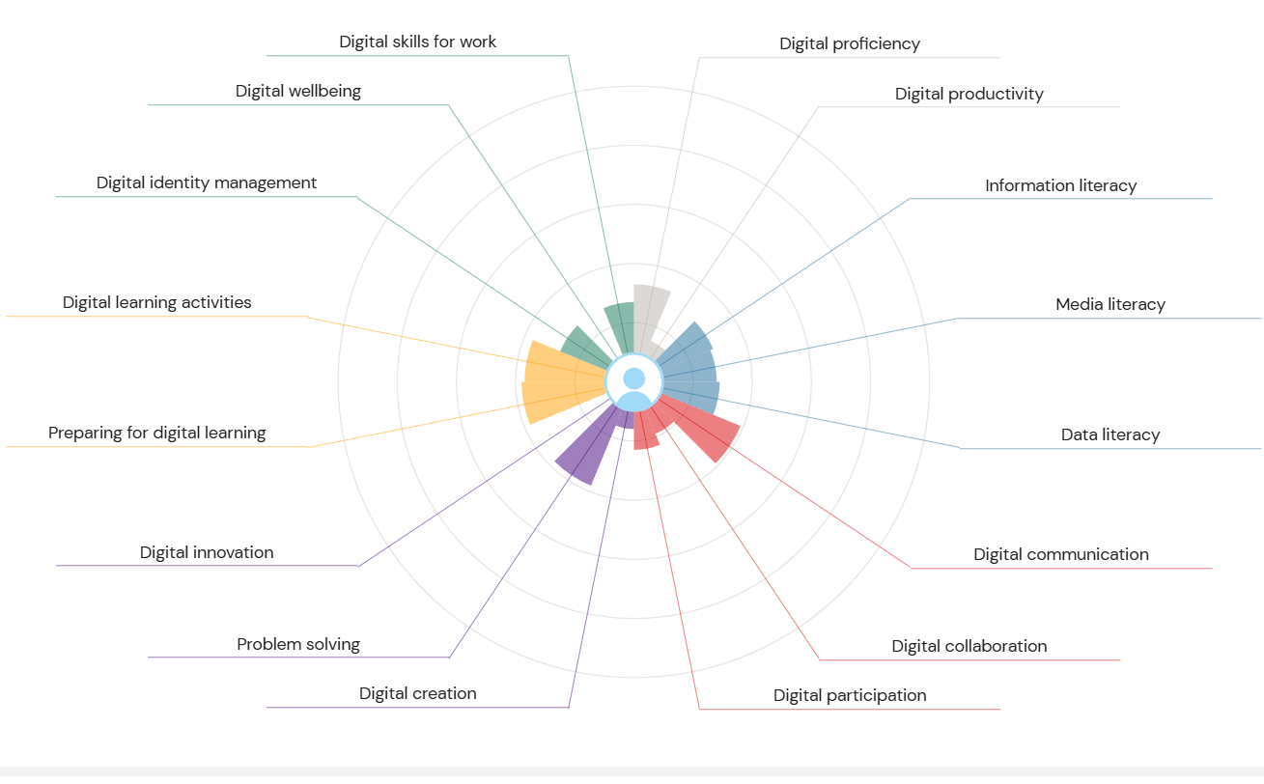
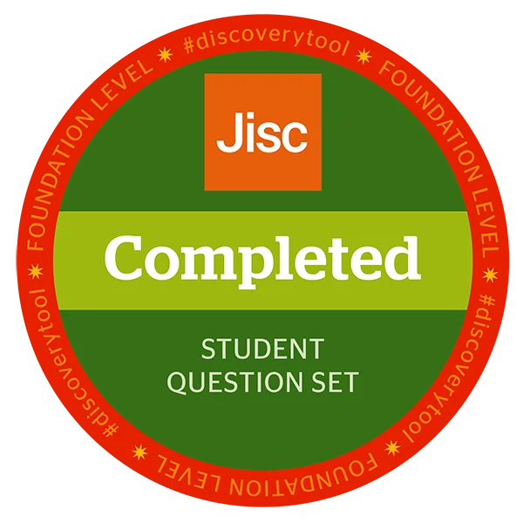
JISC Discovery Tool - Student Question Set Completion Badge

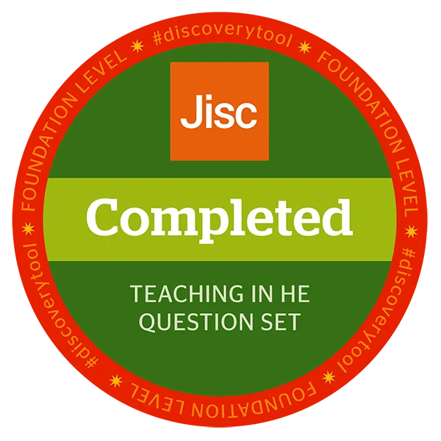
JISC Discovery Tool - Teaching in HE Question Set Completion Badge

Assessment of Digital Skills and Recommendations

Through the JISC Discovery Tool assessment, I gained valuable insights into my digital capabilities across multiple domains. The evaluation revealed my strengths in basic digital literacy while highlighting opportunities for growth in more advanced areas. This comprehensive self-assessment has been crucial in understanding where I currently stand in my digital skills journey and what steps I need to take to enhance my capabilities for both academic and professional success.

Digital Identity and Wellbeing

The evaluation showed I'm more aware of managing my digital identity and staying safe online. I now understand how to maintain a professional online image and protect my personal details. Still, the JISC tool suggested I learn more about data privacy rules and controlling my digital footprint. So, I'm paying closer attention to what I post online and checking the privacy settings on my social media accounts. In the future, I intend to take extra classes on digital citizenship and online security to build on what I already know.

Information and Media Literacy

One of my strongest areas, as identified by the assessment, is information literacy. I'm comfortable searching for academic resources, evaluating source credibility, and using library databases effectively. The JISC recommendations encouraged me to expand my skills in critical evaluation of digital media and understanding misinformation. I've addressed this by completing the Critical Thinking for Better Judgment and Decision-Making course on LinkedIn Learning, which has enhanced my ability to analyse information critically and make evidence-based decisions. This skill is particularly relevant in today's information-saturated environment, where distinguishing reliable sources from misleading content is essential.

Digital Creation and Innovation

The evaluation showed a need for improvement in one area. I was comfortable with basic software, but I needed confidence in making complex digital content and using tech for fresh ideas. The JISC tool suggested getting better with the Microsoft Office Suite. I did this through LinkedIn Learning courses. I finished basic training in Word, Excel, and PowerPoint for Microsoft 365. This made me much better at making professional documents, examining data, and designing interesting presentations. These skills are already helping with my schoolwork, and I can now create better assignments.
Communication and Collaboration
The evaluation revealed that I have some skills in digital communication and teamwork. I know how to use email, messaging apps, and simple video calls. Yet, JISC's advice pointed out that I should get better at using digital workspaces and project management tools for teamwork. I got some good practical skills during the module. When Storm Claudia stopped classes, and we started using Microsoft Teams, I got useful experience with teamwork platforms. This helped me learn how to talk and work with people online. This skill is becoming more important in school and work.

Learning and Career Development

The JISC assessment pushed me to think of digital skills as part of my career growth, not just something I learn once. This change in how I see things has been very helpful. Now, I'm always searching for ways to learn online, and I know it's key to keep up with tech changes. I've finished several LinkedIn Learning courses, which shows I'm dedicated to learning all the time. I’ve also begun to create a digital portfolio to display my skills. This will be useful for my career later. The assessment's focus on how digital skills relate to careers made me realise these skills aren't only good for school but are important for any job.

Future Development Plan

Drawing from JISC suggestions and my module experience, I’ve created a plan to improve my digital skills. I will start by getting better at Excel, focusing on data visualisation and formulas for business analytics. I also want to learn project management tools and software for teamwork that people use at work. Plus, I plan to learn more about artificial intelligence and how it can help with productivity and creative work. The JISC framework gives me a guide for getting better, and I will keep checking my skills and setting new goals. The JISC Discovery Tool helped me see my digital skills clearly. I now understand what I’m good at and how to address the areas I need to work on. Completing certificates and earning badges shows that I’m serious about following the assessment’s guidance. This collection of work proves I’ve gained real skills that will help me in my schoolwork and career.

References

- Beetham, H. and Sharpe, R. (2020). 'Digital literacies in higher education'. In: Beetham, H. and Sharpe, R. (eds.) Rethinking pedagogy for a digital age: Principles and practices of design. 3rd edn. London: Routledge, pp. 227-243.
- Helsper, E.J. and Eynon, R. (2021). 'Digital natives: Where is the evidence?', British Educational Research Journal, 36(3), pp. 503-520. doi: 10.1080/01411920902989227.
- Jisc. (2024). Discovery tool: Digital capabilities. Available at: https://digitalcapability.jisc.ac.uk/our-service/discovery-tool/ (Accessed: 10 December 2025).
- LinkedIn Learning. (2025). Critical thinking for better judgment and decision-making. Available at: https://www.linkedin.com/learning/ (Accessed: 28 November 2025).
- Prensky, M. (2022). 'Digital wisdom and homo sapiens digital'. In: Thomas, M. (ed.) Deconstructing digital natives: Young people, technology and the new literacies. London: Routledge, pp. 15-29.

LinkedIn Learning Certificates

Critical Thinking for Better Judgment and Decision-Making

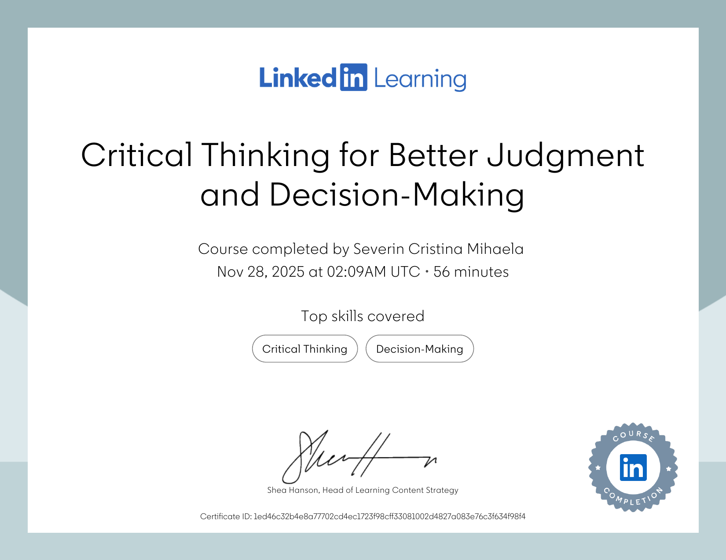

PowerPoint Essential Training (Microsoft 365) (2023)

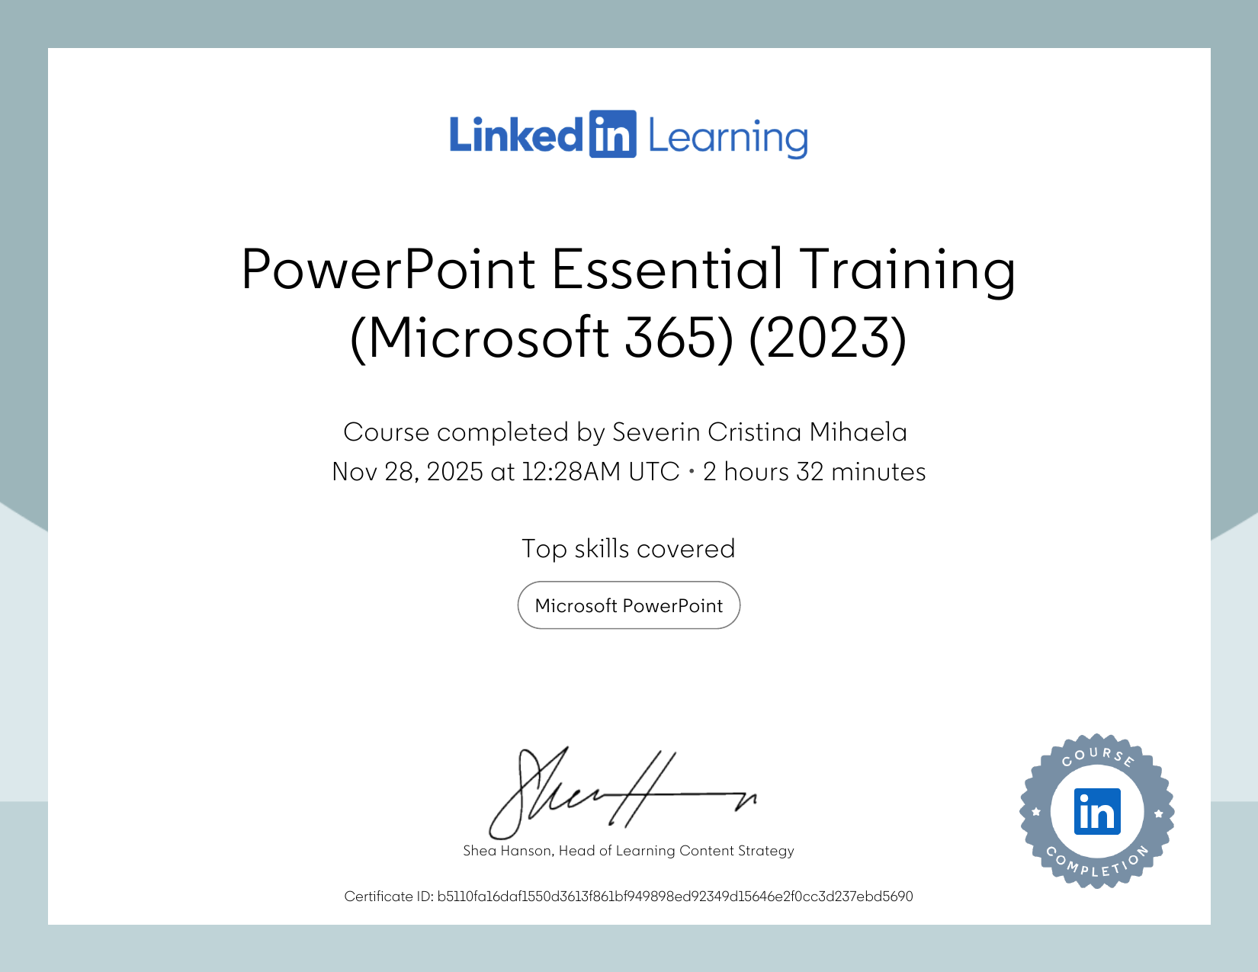

Excel Essential Training (Microsoft 365)

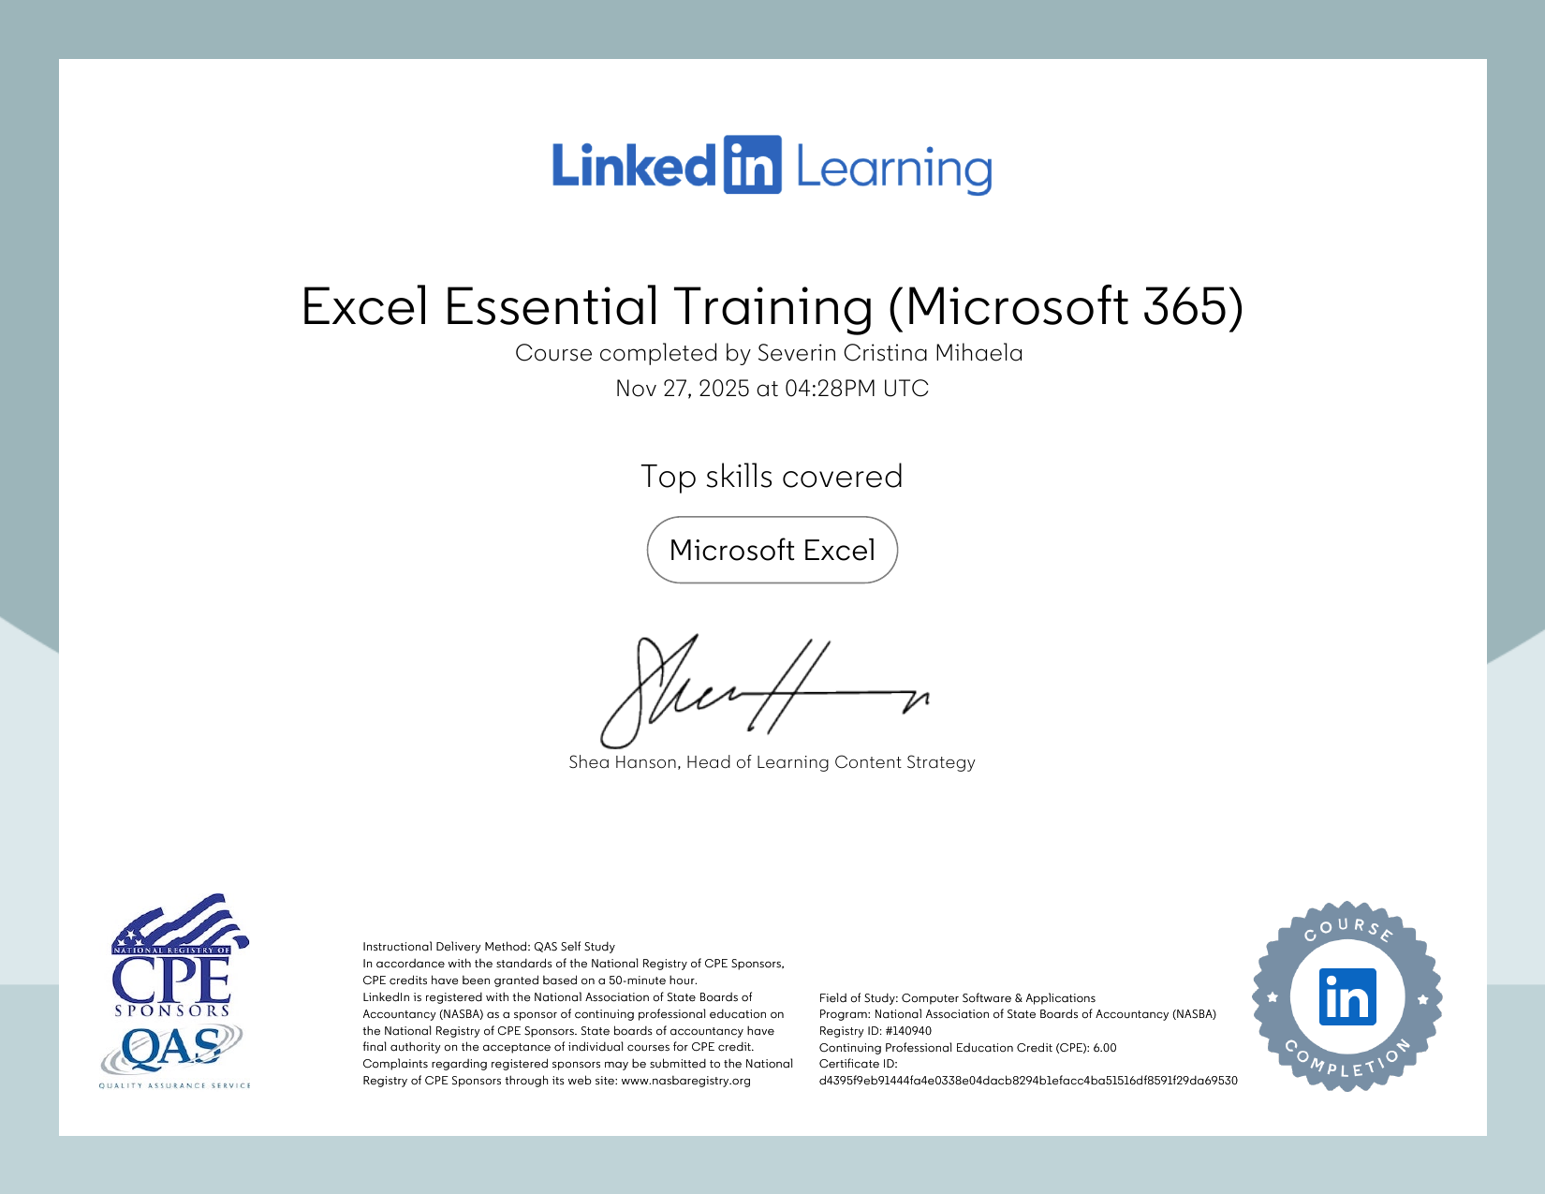

Excel Essential Training (Microsoft 365) - Advanced

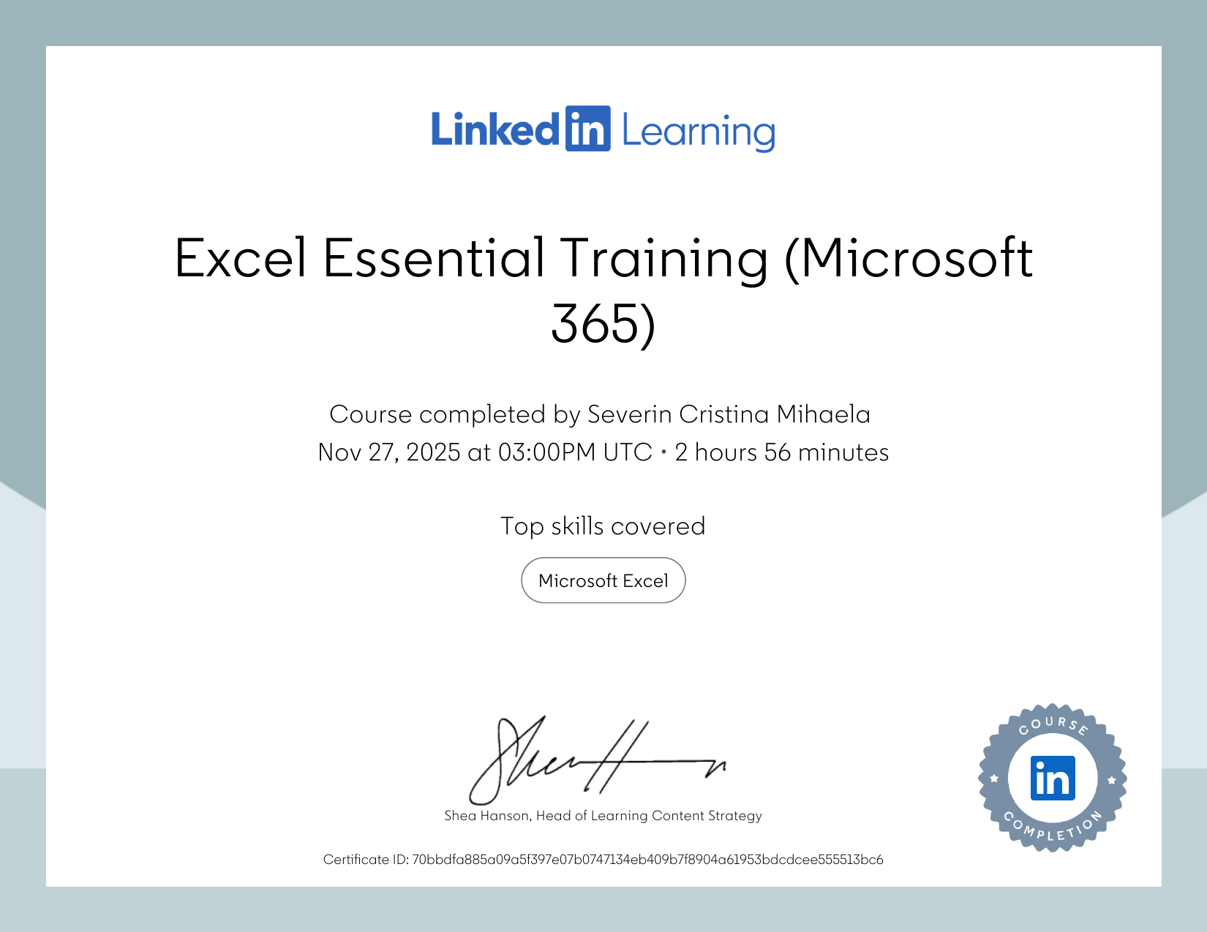

Word Essential Training (Microsoft 365) (2023)
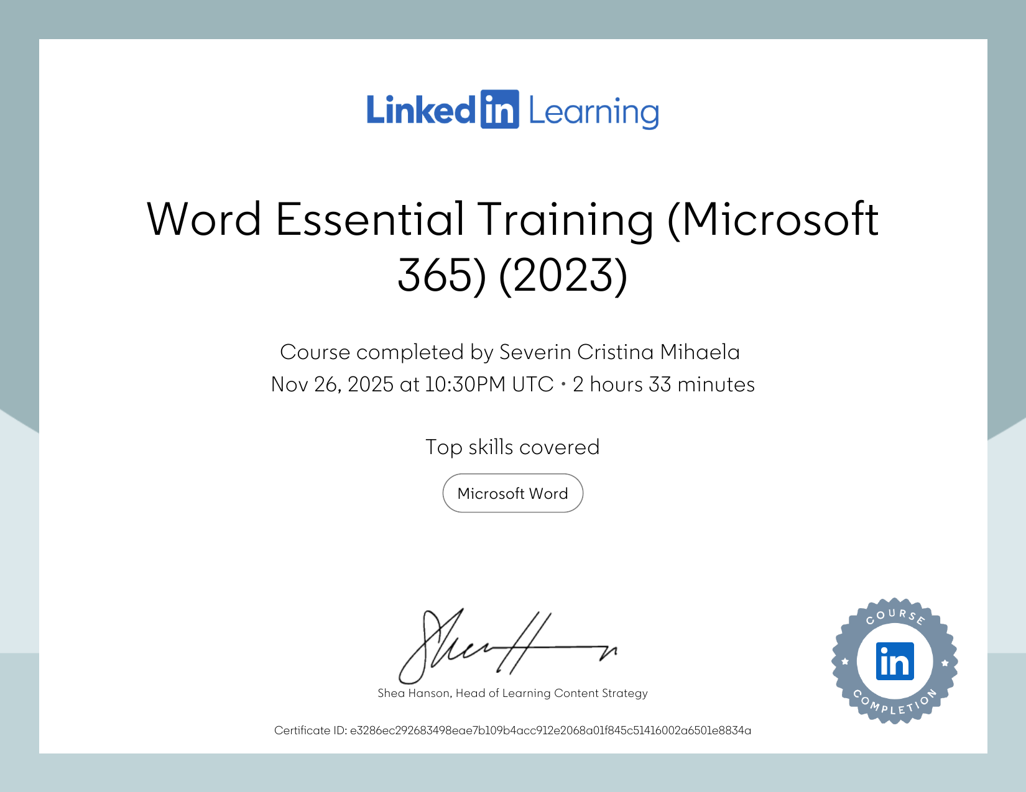
Relevance of Excel in Professional and Personal Life

Introduction
Microsoft Excel is a tool that's very important for managing and understanding data, both at work and in our personal lives. Since it came out in 1985, Excel has changed a lot. Now, it's not just a basic spreadsheet program; it's also a strong platform for things like financial analysis, data charts, project management, and making smart choices. This writing will look at how Excel is used today, covering its uses in businesses and for individuals. It will also share my own experiences using Excel while working at DHL. Knowing what Excel can do and how to use it well is now a key skill. It helps people be more productive, think more clearly, and make good choices in all parts of life.

Excel in Professional environments
Excel is a key tool in almost all jobs and fields. Finance experts use it for creating models, predicting trends, and studying budgets. They use its special features to study possible situations and judge risks. Its power to deal with big sets of info helps accountants keep track of money matters, watch costs, and make reports for interested parties. Marketing teams use Excel to check how well campaigns are doing, track info on customers, and sort groups by actions. HR divisions depend on it for planning staff needs, comparing salaries, and watching how workers are doing. Its flexible nature stretches to running projects, where units use it to draw charts, keep up with goals, and assign resources. Studies show that knowing Excel is listed in most job postings, showing how important it is at work. Its value is boosted by how well it mixes with systems and databases. Workplaces depend on decisions based on information, and Excel acts as a link between data and helpful ideas. It works with planning systems, customer platforms, and business tools, making it a key part of the workflow. People who learn its features, like tables and formatting, get a leg up in their careers. Also, its scripting skills let people make usual tasks automatic, which raises output and cuts mistakes.

My Professional Experience with Excel at DHL
During my time at a DHL site, I gained experience with Excel in logistics and operations. Excel proved valuable in several functions, including team management, stock control, and supplier interactions. The IT team supported us by creating Excel systems and providing training. As a team leader, I used Excel for daily tasks like staff allocation, attendance tracking, and monitoring productivity. Initially, I tried manual tracking, but it was time-consuming. The IT team then developed automated Excel sheets with formulas, which made the work much faster. They trained us in data entry, formula functions, and results interpretation. This support enabled me to understand work rates and improve resource allocation and training. In my role as an administrator, Excel was key for tracking stock, managing purchase orders, and logging stock deliveries. The IT team built systems to monitor stock levels, track purchase orders, and record handling details. They provided training on using formulas to update counts, signal low stock, and reconcile orders with deliveries. This reduced errors and enhanced work quality. The systems improved supplier performance tracking and stock control throughout the processes. My experiences as a team leader and administrator showed me the power of Excel in resolving problems, due to IT team's support. Although I didn't create the formulas, learning to use and understand these systems added my skills with Excel and showed me the value of effective training.

Excel in Personal Life
Although I've used Excel a lot at work, I haven't used it as much for personal tasks. I see that it could be great for managing my finances and planning at home. Many find it useful for making budgets to track what they earn and spend. This helps them spot where their money goes and where they can save. My skills from DHL could help me track home expenses and watch my savings goals. In schools, Excel is a key tool for research and checking data. It helps organise experiment info, run stats, and create charts. Also, it allows students to grasp math ideas using pictures, and many schools teach Excel because it is a skill that can be used in many jobs.

Developing Excel
Completing the LinkedIn Learning courses for this module aided me in solidifying and broadening my hands-on skills. I was introduced to the core ideas for creating formulas, something I had previously only observed at DHL. This mix of practical work experience and formal learning has grown my understanding of Excel's flexible nature. I am most impressed by its ability to scale; the same ideas that our IT group used at DHL can be applied to personal budgets, school research, or detailed money models.

Conclusion
Excel remains quite relevant today. My time leading teams and working in administration at DHL, along with the IT team's training, showed me how Excel changes slow manual tasks into quick automated systems. From watching teamwork speed to keeping track of warehouse stock and handling orders from many suppliers, Excel helped keep things right and allowed decisions based on data. Since data is more vital for choices everywhere, knowing Excel is more than just a skill; it's a must for getting by now. Excel is useful, and I plan to keep learning how to use it better in my job and life as I go back to work after my leave and find new chances.
Excell Sheet

References

- Burning Glass Technologies. (2023). The human factor: The hard time employers have finding soft skills. Boston, MA: Burning Glass Technologies.
- Carlson, J. and Kaplan, S. (2022). 'Spreadsheet software in business education: Past, present, and future', Journal of Business Education, 45(2), pp. 78-92.
- Levitin, D.J. (2021). The organized mind: Thinking straight in the age of information overload. London: Penguin Books.
- Microsoft Corporation. (2024). Microsoft Excel 365: User guide and documentation. Available at: https://support.microsoft.com/en-us/excel (Accessed: 10 December 2025).
- Nash, J.C. (2020). 'Spreadsheets in statistical practice: Another look', The American Statistician, 60(3), pp. 287-289. doi: 10.1198/000313006X136133.
- Winston, W.L. (2022). Microsoft Excel 2019 data analysis and business modelling. 6th edn. Redmond, WA: Microsoft Press.

Presentation Screenshots



