Case Study Report

Student Name: Mariyam Fatima Hussain
Student ID: 2016749
Module Code: BMSW 4003_BIRM
Lecturer’s Name: Rebecca Kavanagh

Contents Page

1) Introduction .......................................................................2

2) Social Identity Theory ……………………………................3

3) Attribution Theory............................................................... 5

4) Frustration Aggression Hypothesis......................................7

5) Statistical Suicide Rates and Benefits from Counselling.....9

6) Conclusion ..........................................................................10

7) References...........................................................................11

Introduction

In this report is will be discussing the opinions surrounding the case study to support the decision being made against a member of staff on whether she should be upheld or dismissed. The service user has a disease called Emery-Dreifuss Muscular Dystrophy (EDMD) which is one of the muscular dystrophies. This is a group of rare, inherited muscle diseases (myopathies) EDMD effects weakness in children’s shoulders, upper arms and calves and can also cause long term cardiac and spinal problems. The illness also affects rigid joints that can’t move well (contractures). (Emery-Dreifuss Muscular Dystrophy in Children | Cedars-Sinai, 2021). There will also be a discussion about the statistical rates of suicide within the age group of 15 years old, which can initiate through counselling sessions. In this report will also be talking about the three behaviour theories which are the Social Identity Theory, Attribution Theory and also the Frustration Aggression Hypothesis.

Social Identity Theory

Study emphases on social thinking and communication, motivational and macro-social aspects of life. He also stated that this theory was developed by Henri Tajfel in the early 1970’s. Tajfel scientifically found that prejudice and discrimination also attributed towards the social identity theory. This is what helped motivated Tajfel by researching over 45 years to come up with the conclusion of significant theories. This has advanced and developed theoretically and has inspired and continues to assure an extraordinary quantity of research. Though originally a European study of intergroup relations since the early 1990s it has developed fully and recognised around the world as one of the conventional social psychology’s most substantial common theories of the relationship (Hogg, 2018).

Though, the recognition is occasionally taken through incoherence amongst certain interpretations of public individuality notions and the thoughts. The section will define social identity theory’s crucial conceptions. The system has binary focal nonetheless theoretically well-matched emphases: (a) the Social Identity Theory of intergroup associations. In addition, the Social Identity Theory (SIT) states other individuals remain ready to examine the intelligent and activities of the main clusters to see that they understand the action of their individual set such as unlawful as well as variable, then it arises to label their selves then additional crowd in positions of a mutual Social Identity-as ‘us’. In such conditions, SIT recommends, personalities remain to grind self-possessed through additional fellows of their team to attempt to trial the scheme (Gross, 2010).

The Social Identity Theory applies to the case study by the 58 year old staff member and the 15 year old service user has a big age difference between them. The staff member is at the mature stage of her life and the service user is at the rebellious stage where he is stubborn, bossy, hormones could be playing up which is why he has spoken towards the staff member the way he did. The staff member has seen a lot of behaviours and has not defensible by answering aggressively towards the service user which can be understood in the equal intergroup. This differs amongst the social behaviours and personality traits of them both.

Figure 1: Social Identity Theory diagram
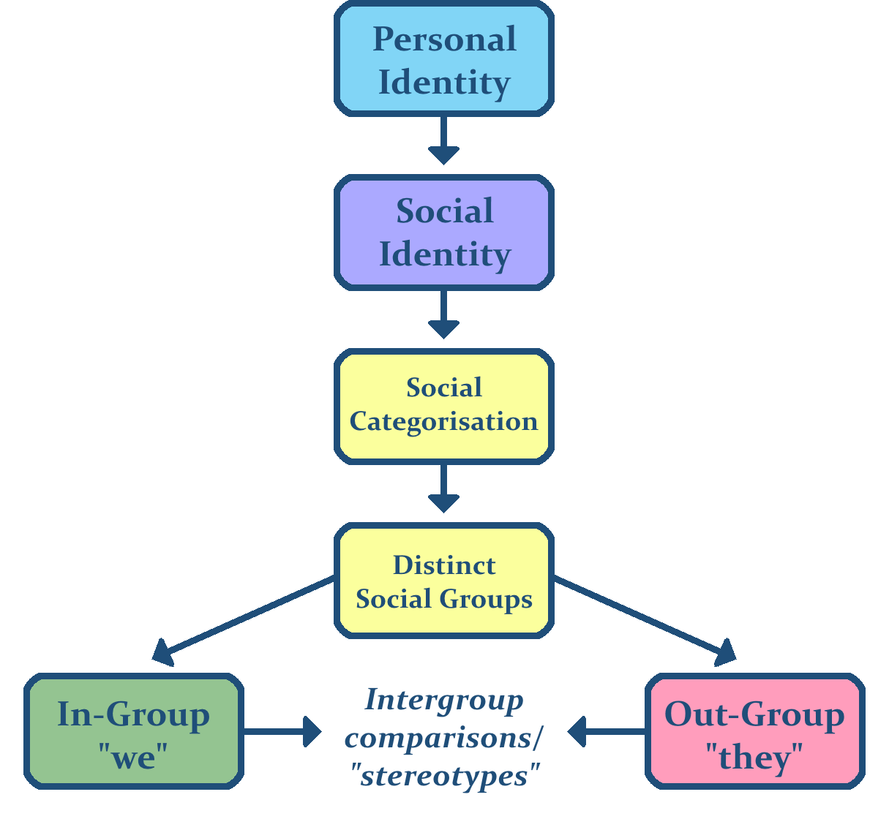

(Baxter, 2016)

Attribution Theory

Weiner’s (1986) philosophy is actually a request of simple attributional values to human feeling and inspiration. The source of attribution thought for consciousness was Fritz Heider and his ground-breaking book: The Psychology of Interpersonal Relationships (Heider, 1958). Still, at hand has remained a old-style theoretical importance in the study of casual reasoning and even prior to Heider a number of experimental studies were apprehensive with perceived connection (e.g. Michotte, 1946). Agreeing to Weiner, the attributions we sort around our individual besides others achievements and let-downs make precise types of responsive reactions, yet such attributions remain extra composite when defined by Heider, Jones and Davis or Kelly. For Weiner, here are three measurements of connection. They are:
- The locus dimension: causes can be internal or external (person or situation)
- The stability dimension: causes can be stable or transient (permanent or temporary)
- The ability to control the element: origins can be well-disciplined or uncontainable.
There may be liability dissatisfaction in a test on a really challenging paper (exterior, constant, intense), which is possible to make us feel furious. We may blame the brutal annoyance with the morning of the test (interior, unbalanced, uncontainable), which may feel both furious as well as upset. Then a third prospect is we blame our disappointment for the undeveloped absence of capability (interior, steady, overpowering), that is possible to make them feel rather discouraged. What’s significant here is that not all interior or exterior reasons are from the same kind. For Weiner, causes are multidimensional (Gross, 2010).

Therefore Attribution Theory discusses to a field of query instead of an exact logical formation. During the attention of the study doubts cognitive source of events and results, together with achievement-related accomplishment and disappointment, the outcomes of these views, the pitch of attribution is of crucial worry to educationalists. Indeed, a great deal of existence in the schoolroom can be examined from an attribution viewpoint (Weiner, 2010).

This can reflect on the case study because the service user might be thinking of the internal facts thinking the staff member is showing attitude or being dictatorial without knowing it could be the external facts it’s out of her control as she does not make the rules, she’s just following them and making others follow them. The staff member might be thinking ‘a typical teenager’ who doesn’t want to follow the rules and that his bad individual which is internal. The external reasons could be wearing a mask affects the service user he may not be able to breathe, and he may have problems sitting down due to his illness. The staff member and the service user both went for the internal and both misunderstood each other.

Figure 2. Attribution Theory diagram.
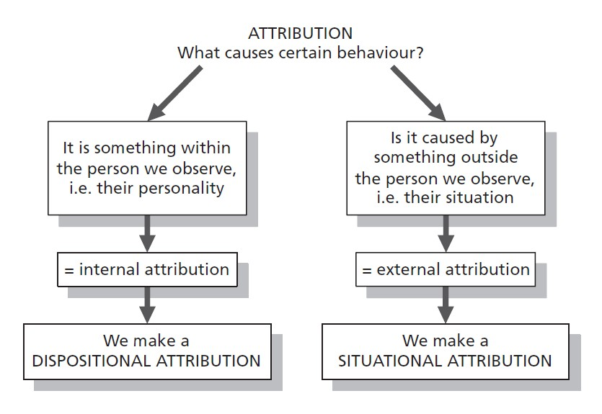

(Rice, 2016)

Frustration Aggression Hypothesis

Dollard Et Al., (1939) stated, Frustration-Aggression Hypothesis, frustration constantly stretches increase to hostility, and aggression is always caused by frustration. The source of frustration might regularly be seen as an equally foremost risk or might be hard to recognise. Moving towards Freudian theory, Dollard Et Al., also claimed, when we need to let out our frustration but are incapable to do this right, we do so circuitously by fluctuating it on to an additional aim (Gross, 2010).

As the name of this theory suggests, it is argued that frustration is what leads to aggressive behaviour. The idea stemmed from the work of Dollard Et Al., (1939), who claimed that after we feel frustration near a specific individual or occurrence, aggression will start. If it is not appropriate to display aggression towards the particular mark, the aggression will simply be re directed towards a more lifelike target – known as displaced aggression (Dollard Et Al., 1939)

This can apply to the case study because Frustration Aggression Hypothesis is related to becoming frustrated that can cause aggression. This could be because the staff member thinks the service user is not following rules. She may be at high risk of Covid 19 due to her age. Staff member is trying to do her job properly and wants to keep her job. Staff member might be feeling frustrated because the service user is not doing as his told, he cursed at the staff member where she was not directly aggressive. The service user provoked her by swearing at her. The Service user may be exempt from facemasks as feels breathless, having to wait might be causing his legs to hurt and remind him of his illness. His wanting to end his life that’s why his having counselling sessions. His hormones might be playing up as his hit puberty stage; his also lost his place in his football team. The service user suffers from depression and anxiety. This usually occurs when they have a rising dependency on health professionals and try to discover the emotional tendencies from them (Morrison and Bennett, 2016).

Figure 3. Frustration Aggression Hypothethis.

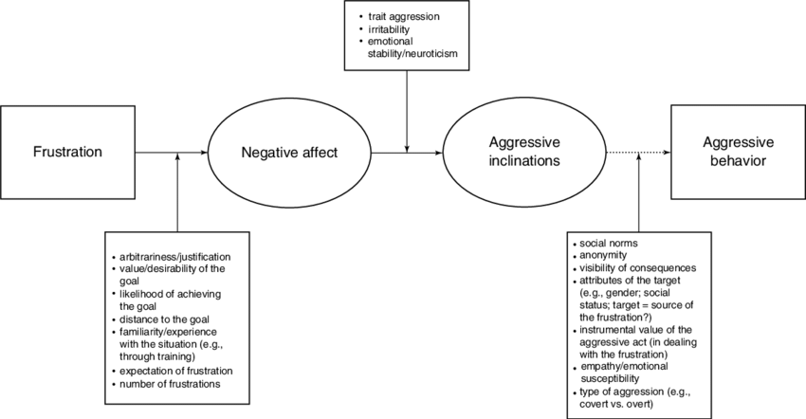

( Breuer Et Al., 2017)

Statistical suicide rates for teenagers

This figure shows the suicide ratio amongst those aged 15-19 years old in the United Kingdom (UK) from 1998 to 2016.The suicide rate for this stage has commonly dropped over the given time distance. In 1998, the rate of suicide amongst 15–19-year-olds was 6.21 out of 1000,000, whereas by 2016 the rate had dropped to 4.62 for every 100,000 (Statista, 2021).

Figure 4: Shows statistics of suicide from 1998-2016.

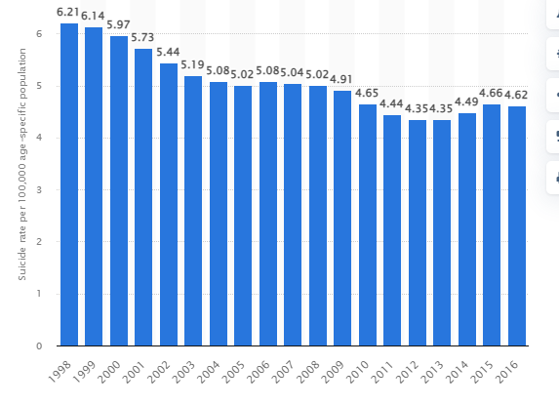
(Statista, 2021)

Benefits from Counselling

Paulson and Worth (2011) stated that there a 3 key processes of therapeutic aids to help an individual in counselling. They evaluated research and they found that in order to help an individual from suicide is to understand the behaviours and evaluate the concerning frustrations. By evaluating these, this can help by turning around the creation of suicide by keeping focus on:
- Relationships
- Understand the emotions of the individual
- Create a different individuality (give purpose)
(Paulson and Worth, 2011)
Conclusion

This report is that they both miscalculated each other, by the 58 year old not knowing what the diagnosis of the illness of the 15 year old service user, and the 15 year old service user not complying to Covid - 19 government guidelines. The complaint about the staff member should be upheld as they both misunderstood each other it was beyond her control she was following the rules and was trying to do her job properly. Could possibly be that the service user is exempt from wearing a mask because he gets out of breath quickly, and him sitting around can cause cramping pain in his legs which was reminds him of his illness. Teenagers at that age don’t understand the rules and regulations and think they know what is best as they are young adults and can make their own choices. The reason why this should be upheld is that the staff member is new in her job-role and may not understand the different setting she is in. She needs to be conscious about the tone of voice being used and how she expresses herself towards patients in the establishment. The 15-year-old boy needs to understand that even though he has a lifetime illness but not to use aggression to any staff in this establishment.

References

Baxter. D., (2016), File: Social Identity Theory.png, [Online] Available at: https://en.wikiversity.org/wiki/File:Social_identity_theory.png (Accessed On 7th December 2021)

Breuer, Johannes & Elson, Malte. (2017). Frustration-Aggression Theory, [Online] Available at: https://www.researchgate.net/figure/The-frustration-aggression-hypothesis-according-to-Berkowitz-1989-as-a-multistage_fig1_321776001 (Accessed On 7th December 2021)

Cedars-sinai.org. 2021. Emery-Dreifuss Muscular Dystrophy in Children | Cedars-Sinai. [Online] Available at: https://www.cedars-sinai.org/health-library/diseases-and-conditions---pediatrics/e/emery-dreifuss-muscular-dystrophy.html#:~:text=Emery%2DDreifuss%20muscular%20dystrophy%20(EDMD,t%20move%20well%20(contractures). (Accessed On 6th December 2021)

Dollard, J., Miller, N. E, Doob, L., W., Mowrer, O. H., & Sears, R. R. (1939). Frustration and aggression. Yale University Press. [Online] Available at: https://psycnet.apa.org/record/2004-16227-000 (Accessed On 7th December 2021)

Gross, R., (2010), Psychology the science of mind and behaviour, 6th edition, Hodder Education. [Book].

Hogg, M., and Vaughan, G., (2014), Social Psychology, 7th edition, Harlow, Pearson Education. [Book]

Hogg, M. (2018), Contemporary Social Psychological Theories, 2nd edition, Stanford University Press: Stanford California [Online] Available at: https://www.degruyter.com/document/doi/10.1515/9781503605626-007/html (Accessed On: 16th November 2021).

Morrison, V., and Bennett, P., (2016), Introduction to Health Psychology, 4th Ed, Harlow: Pearson, [Book]

Paulson, B.L., and Worth, M., (2011) Counseling For Suicide: Client Perspectives [Online] Available at:
https://onlinelibrary.wiley.com/doi/abs/10.1002/j.1556-6678.2002.tb00170.x?casa_token=HRrdBNp3d_4AAAAA:RLjzGDtSDwDcv92OwM0zX9sIfMR52ekNKpsd65lcGj5Tzf8VgkH1yrFdwpSFKf2CPTO2gZRI9PKSyX4 (Accessed on: 7th December 2021)

Rice, K.E., (2016) Integrated SocioPsycholgy Blog & Pages: Attribution Theory, [Online] Available at:
https://www.integratedsociopsychology.net/theory/meta-states-and-the-cognitive-triad/attribution-theory/

Statista. 2021. United Kingdom: Teenage suicide rate 1998-2016 | Statista. [online] Available at: https://www.statista.com/statistics/974551/united-kingdom-teenage-suicide-rate/#statisticContainer [Accessed On: 6th December 2021].

Weiner. B, (2010), Social and emotional aspects of learning, University of California, Los Angeles, [Online] Available at: https://books.google.co.uk/books?hl=en&lr=&id=y_S1pFc7LNIC&oi=fnd&pg=PA9&dq=attribution+theory&ots=3jfNzGcmLk&sig=b_1vDPbShFZqzJU-Tvbucf82kVY#v=onepage&q=attribution%20theory&f=false (Accessed On: 16th November 2021).

