CertHE Skills for the Workplace
Effective Teamwork and Communication Assignment 1 Report
BMSW4002
Name: Cristian Suciu
Student ID: 2129234
Lecture: Saqib Shamim

Table of Contents
Introduction 3
Models of Communication 4
Shannon and Weaver Communication 4
Schramm Communication Model 5
Berlo's SMCR Model of Communication 7
Communication Skills 8
Verbal Communication 9
Non-Verbal Communication 9
Listening Skills 10
The Advantages and Disadvantages of Technology in Communication 10
Conclusion 12
References 13

Introduction
Teamwork, also known as group work, is the combined efforts of multiple people directed at a single objective. Teamwork and collaborative projects are essential to the success of any modern business or academic institution. The efficacy of a message could be significantly impacted by barriers to communication. Geographic distance, cultural differences, linguistic hurdles, psychological barriers, and lack of passion or attention generate communication problems. Due to a lack of communication, tasks may be incomplete or improperly completed. Lack of trust between coworkers and employees due to inadequate communication can also contribute to an unpleasant working environment. A hostile work environment is often the result of poor communication between employees and management.
This study will look into the significance of effective workplace communication, the value of working together in teams, and the factors that contribute to successful organizational cooperation as a whole. The research also hopes to provide light on the concept of effective communication proposed by Shannon, Weaver, Berlo, and Schramm.

Models of Communication
The communication model depicts the process through which two or more individuals communicate information. It may be used as a guide to ensure efficient communication in every setting, outlining the numerous components that contribute to successful communication. The communication model consists of five fundamental components: sender, message, medium, receiver, and feedback (Yasri and Maneejak, 2020).

Shannon and Weaver Communication
Shannon and Weaver proposed the concept of a six-part communication paradigm. The Transmitter, Recipient, Encoder, Decoder, Channel, and Noise are some of these components. These six components are discussed in further detail below:
Sender: The "sender" is the person who created the content being sent. The two participants in the communication exchange talk to one another. The sender must have a way to send the message. There are numerous channels for communication. Formats include text, audio, video, and other types.
Encoding: All messages must be encrypted before being sent. Because the internet can only interpret binary code communications, any text transmitted from a computer or mobile device must first be converted into binary numbers or pulses before being delivered (Sullivan, 2012).
Channel: The sender has several channels via which to communicate any message. When we use cellular phones to communicate with others, the phone just serves as a medium.
Noise: The Shannon and Weaver communication matrix function is cumbersome to employ. The network may alter our message, preventing the recipient from getting it. It's possible we won't detect the network problem if we use mobile phones (Rahn, 2016).
Decoder: To understand the message, the recipient will require a decoder. The decoder converts the binary data into understandable text.
Receiver: The individual who receives a communication from a sender is known as the recipient. To read the message, the recipient must have access to a specified medium, such as a computer, phone, or similar device. The receiver will contact the sender after the communication has been received (Sullivan, 2012).
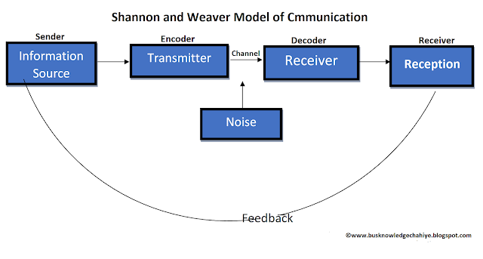
Figure 01: Shannon and Weaver Communication (Yasri and Maneejak, 2020)
Maria and Pedro's case study serves as an illustration of how noise might affect a pair's ability to communicate. This was shown when Maria asked Pedro to pick up 'chicken' from the store, but he misread as 'kitchen' He made the error because he couldn't clearly hear her over the noise from the neighbouring building site (O'Neill, Goffin, and Gellatly, 2012). Maria and Pedro were close together, but the surrounding noise made it difficult for them to communicate clearly. People must therefore assess their environment and modify their communication as necessary.
To effectively communicate a message, there are several things to keep in mind. First of all, one must make sure to focus and pay great attention to what the other person is saying (Mclanders, Sanderson and Liley, 2017). From personal experience, I can say that when my employer gave us our daily responsibilities, a situation almost just like this one occurred. The occurrence of latency problems was influenced by unclear communication.

Schramm Communication Model
According to Schramm, the sender begins contact by sending content to the receivers (such as text, audio, video, etc.). This matrix is divided into three sections. Each of them is listed in detail below:
Encoder: The encoder is installed at the point of transmission, or the point at which the message is transmitted. When delivering data via a network, an encoder is necessary so that the system can comprehend it.
Decoder: Without a decoder, the sender's code cannot be read. If the intended receiver does not have a decoder, the message cannot be read. situations in which there is still some uncertainty
Message: The content or message of the transmission is what is actually transferred from one party to another. An effective information exchange, according to Schramm, needs the recipient to reply after they have received the sender's message. A decoder is required by the transmitter to receive feedback, whereas an encoder is required by the receiver to transmit a message (Lingard et al., 2012).
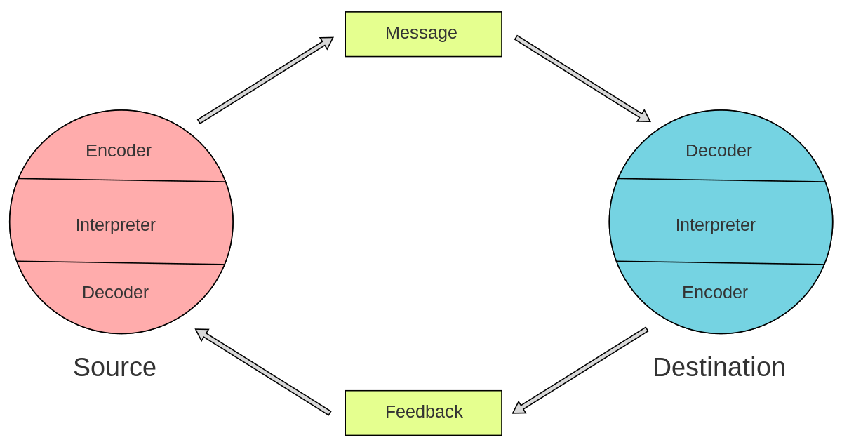
Figure 02: Schramm Communication Model (Lairamore et al., 2013)
However, Schramm's model of communication provides a radical departure from the linear model proposed by Shannon and Weaver (S & W). While S&W considers communication to be unidirectional, Schramm views it as a two-way street. He emphasizes that the sender, the recipient, and the message all play critical roles in any kind of communication (Kholed et al., 2017). As opposed to a one-way, unidirectional interaction, Schramm's paradigm welcomes input from a wide variety of senders and receivers.
The Communication Model of Schramm can be utilized to avoid misunderstandings. According to Schramm's theory, successful communication occurs when the sender, the message, the channel, and the recipient are all in sync (Jopkiewicz and Stelmaszczyk, 2017). Using Maria and Pedro as an example, Pedro may have contacted Maria and inquired whether she meant Kitchen. From personal experience, I can report that a circumstance virtually identical to this one occurred when my employer assigned us our daily obligations. Insufficient communication clarity contributed to the occurrence of latency issues.

Berlo's SMCR Model of Communication
Berlo's SMRC communication model consists of four sections. These are the sender, message, channel, and receiver. These are discussed below:
Sender: A sender is a person who sends information to the receivers. This is the source where the message is generated to send. There have some factors which affect the sender such as communication skills, knowledge, attitudes, and social systems. If the communication skills of the sender are better then he or she can send a message to the receiver appropriately (Famitangco, 2015).
Message: Message is the life of any communication matrix. This is the thing that is sent by the sender to the receiver. It can be audio, text, video, etc. The factors in this section are content, elements, code, structure, and treatments.
Channel: Channel is a medium through which the message can be sent. It can be a mobile phone, computer, or the World Wide Web. In physical communication, there have five senses of the human body that treats as a channel. These are Hearing, touching, seeing, tasting, and smelling (Cooley, 2012).
Receiver: A receiver is a person or place where the message is received. The factors that affect the receiver are communication skills, knowledge, attitudes, and social systems. It is like the factors of the sender (Jopkiewicz and Stelmaszczyk, 2017).

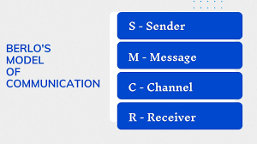
Figure 03: Berlo's SMCR Model of Communication (Chiu, 2012)
There are a number of key areas in which Berlo's Model of Communications differs from that of S/W and Schramm. In his theory of communication as a system, Berlo identified six main players: the sender, the message, the channel, the receiver, and the decoder. Berlo's model considered both parties involved in the transmission and reception of a message (Bovbjerg and Sørensen, 2019). A two-way flow of data between the sender and the receiver was also facilitated by the feedback component of Berlo's paradigm.
From the professor’s case study, In the scenario presented by the professor, misunderstandings may be avoided via clear and open dialogue. Professors and students should check in with one another to make sure they have clear expectations for one another (Asrori and Tjalla, 2020). From my personal experience, I had a similar experience with my manager while she was allocating daily tasks to us. Lack of communication transparency influenced latency issues.

Communication Skills
Nowadays, being able to communicate effectively is a must. People who can transmit and perceive information clearly have a leg up in life. Relationships with friends, family, coworkers, and clients, as well as all other types of people, may all benefit from improved communication.
Non-verbal clues like body language and facial emotions are also part of effective communication (Benoliel and Schechter, 2018). Strong listening skills are a prerequisite to good communication since they allow one to fully comprehend the thoughts and emotions of others.

Verbal Communication
Effective verbal communication in the workplace is essential for getting things done. Communicating with coworkers, clients, and business associates requires a level of professionalism and courtesy (Mclanders, Sanderson and Liley, 2017). Asking clarifying questions and offering a brief summary are other great ways to show that you're listening

Non-Verbal Communication
Communicating effectively in the workplace using non-verbal means may be just as effective as using words. Nonverbal communication includes non-vocal cues such as facial expressions, gestures, posture, and spatial proximity between speakers. Relationships in the workplace may be profoundly impacted by the misinterpretation of nonverbal clues. Making direct eye contact is a universal sign of interest, sincerity, and trust (Cooley, 2012).
The case study 'A Day with the Chief' demonstrates the importance of verbal and nonverbal communication in determining the quality of a conversation. The Chief used verbal communication, namely study, to ask his people about their work and issues. This improved his understanding of the difficulties and his capacity to design solutions that benefited all parties involved. The Chief showed his employees he valued their ideas by maintaining eye contact, nodding in agreement, leaning forward, and smiling when appropriate. He was able to comprehend his employees' perspectives on their work and design solutions that would benefit all parties by actively engaging with them through both verbal and nonverbal cues (Yasri and Maneejak, 2020).

Listening Skills
In the workplace, listening skills are of paramount importance. Active listening, attentiveness, and empathy can have a tremendous impact on the performance of a business and the morale of its employees. Active listening involves focusing on both verbal and nonverbal information, such as body language, gestures, and facial expressions (Famitangco, 2015). Active listening also demands empathy and allows the speaker to express themselves fully and uninterruptedly.
According to the case study of "Max, the multi-tasker," Max struggled to develop proper listening skills in his setting. He often missed important facts and seemed disinterested in chats. These issues hampered his ability to absorb and recall information when it was required (Mclanders, Sanderson and Liley, 2017). Lack of listening skills cost him a career and personal opportunities. I can relate from my experience that I had a circumstance similar to this one with my employer while she was assigning us our daily obligations (Bovbjerg and Srensen, 2019). Her untransparent communication contributed to latency issues.

The Advantages and Disadvantages of Technology in Communication
The way in which individuals communicate with one another has been completely transformed by technological advancements. The use of technology to facilitate communication comes with a number of benefits as well as drawbacks (Jopkiewicz and Stelmaszczyk, 2017). On the plus side, developments in technology have made it possible for us to maintain a real-time connection with people located all over the world.
It is now quite simple for us to communicate with other people by making video calls, sending emails, or using instant messaging applications. This kind of technology has even made it feasible for members of the same family to keep in touch despite the existence of physical distance. On the other hand, some people get the impression that communicating through technical means is impersonal and does not include the same amount of caring as talking to someone face-to-face does. Miscommunication is much more likely to take place when facial clues and body language are absent (Sullivan, 2012). Additionally, for some people, technology can be a distraction, which results in time and energy being stolen away from true human contact. This is an unavoidable consequence of the use of technology.

Conclusion
For members of a corporation or organization to cooperate and exert collective effort, its operations must be efficient. The group's capacity to communicate effectively will be crucial to achieving its goals. The research's findings have provided us with a solid platform upon which to build better communication channels. Participating in this exercise may afford us the opportunity to examine the importance of teamwork, good communication, as well as the reasons and benefits of teamwork.

References
Asrori, M. and Tjalla, A. (2020). Increasing Teamwork Capacity of High School Students through Collaborative Teamwork Learning. American Journal of Educational Research, 8(1), pp.46–50.
Benoliel, P. and Schechter, C. (2018). Teamwork doubting and doubting teamwork. Improving Schools, 21(3), pp.225–239.
Bovbjerg, K.M. and Sørensen, M.S. (2019). Collegiality and teamwork – Two logics in educational teamwork. Nordic Studies in Education, 29(01), pp.120–136.
Chiu, C.H. (2012). The effects of collaborative teamwork on business. Journal of Computer Assisted Learning, 18(3), pp.262–271.
Cooley, C. (2012). Teamwork – what teamwork? Cancer Nursing Practice, 1(1), pp.18–18.
Famitangco, R.F. (2015). Improving Patient Care Through Teamwork, Collaboration, and Engagement. Critical Values, 9(1), pp.10–12.
Jopkiewicz, S. and Stelmaszczyk, M. (2017). Analysis of development potential of an organisation in the aspect of relationship between teamwork, knowledge sharing and team innovations. Management Forum, 5(3), pp.1–6.
Kholed, S.N.S., Hassan, N.M., Ma’on, S.N. and Hamid, N.Z.A. (2017). Teamwork and Collaboration in Healthcare: Elements of Inter-Professional Teamwork. Advanced Science Letters, 23(11), pp.10834–10837.
Lairamore, C., George-Paschal, L., McCullough, K., Grantham, M. and Head, D. (2013). A Case- based Interprofessional Education Forum Improves Students’ Perspectives on the Need for Collaboration, Teamwork, and Communication. MedEdPORTAL Publications.
Lingard, L., McDougall, A., Levstik, M., Chandok, N., Spafford, M.M. and Schryer, C. (2012). Representing complexity well: a story about teamwork, with implications for how we teach collaboration. Medical Education, 46(9), pp.869–877.
Mclanders, M., Sanderson, P. and Liley, H. (2017). Importance of ‘scene organisation’ for neonatal resuscitation teamwork. Australian Critical Care, 30(2), p.118.
O’Neill, T.A., Goffin, R.D. and Gellatly, I.R. (2012). The Knowledge, Skill, and Ability Requirements for Teamwork: Revisiting the Teamwork-KSA Test’s validity. International Journal of Selection and Assessment, 20(1), pp.36–52.
Rahn, D.J. (2016). Transformational Teamwork. Journal of Nursing Care Quality, 31(3), pp.262– 268.
Sullivan, E.E. (2012). Teamwork and collaboration. Journal of PeriAnesthesia Nursing, 17(5), pp.344–345. doi:10.1053/jpan.2002.35489.
Yasri, P. and Maneejak, N. (2020). The uSAP model: a ubiquitous observation protocol for improving teamwork skills, time management and accuracy in high fidelity simulation among nursing students. International Journal of Mobile Learning and Organisation, 14(4), p.478.

