Formula Sheet
BEng.(Hons.) in Electrical and Electronics Engineering
ACDA4006
Ohm’s Law  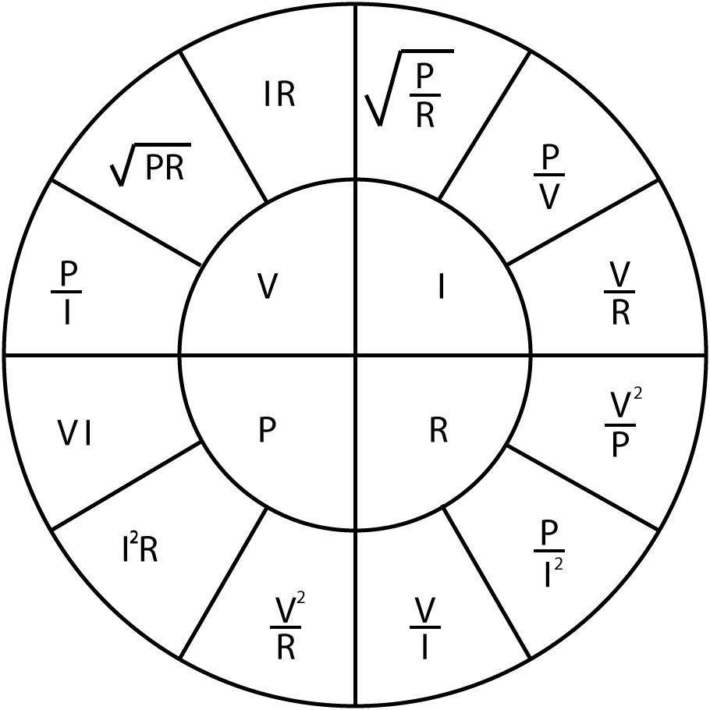 |  | Series Resistors  $$R_{T}=R_{1}+R_{2}+…+R_{n}$$  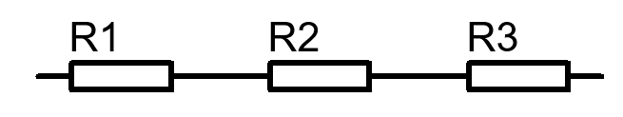 | Potential Divider  $$V_{1}=V\frac{R_{1}}{R_{1}+R_{2}}$$  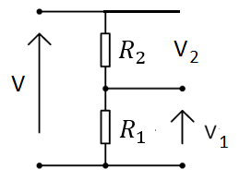
 |  | Parallel Resistors  $$\frac{1}{R_{T}}=\frac{1}{R_{1}}+\frac{1}{R_{2}}+…+\frac{1}{R_{n}}$$  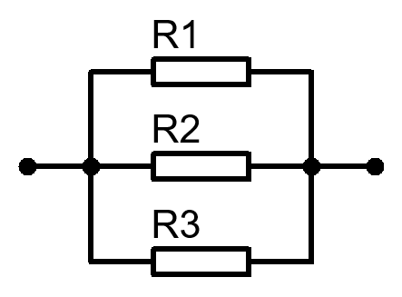 | Current Divider  $$I_{1}=I\frac{R_{2}}{R_{1}+R_{2}}$$  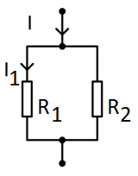
Capacitive Reactance  $$X_{C}=\frac{1}{2πfC}$$  $$X_{C}=-j\frac{1}{ωC}$$ | Inductive Reactance  $$X_{L}=2πfL$$  $$X_{L}=jωL$$ | Series Capacitors  $$\frac{1}{C_{T}}=\frac{1}{C_{1}}+\frac{1}{C_{2}}+…+\frac{1}{C_{n}}$$  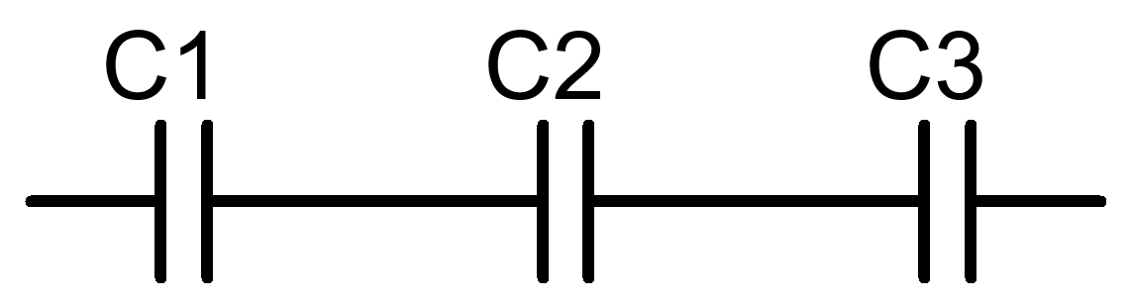 | Series Inductors  $$L_{T}=L_{1}+L_{2}+…+L_{n}$$  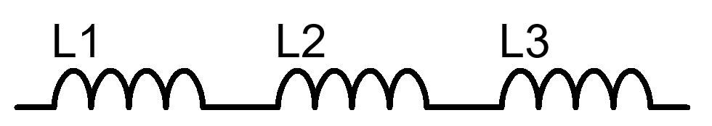
Angular Frequency  $$ω=2πf$$ | Capacitance  $$C=\frac{Charge}{Voltage}$$ | Parallel Capacitors  $$C_{T}=C_{1}+C_{2}+…+C_{n}$$  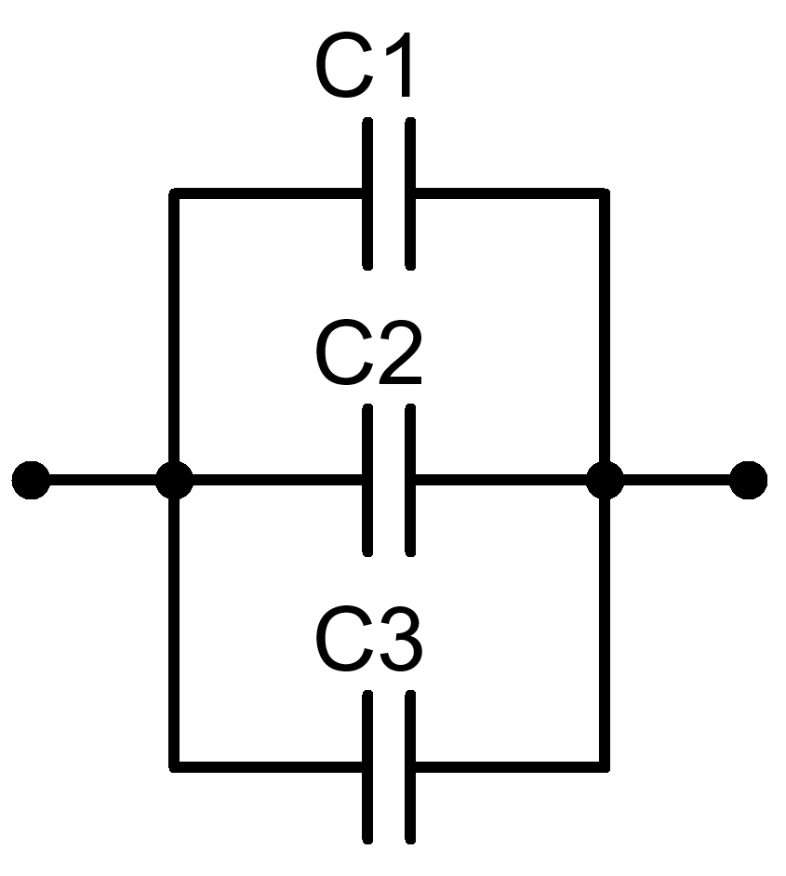 | Parallel Inductors  $$\frac{1}{L_{T}}=\frac{1}{L_{1}}+\frac{1}{L_{2}}+…+\frac{1}{L_{n}}$$  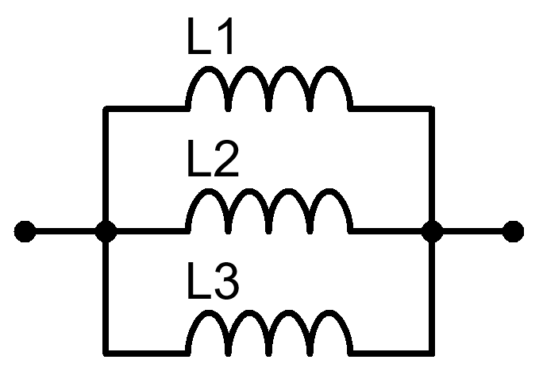
Frequency  $$f=\frac{1}{T}$$ | Voltage across Inductor  $$V=L\frac{di}{dt}$$
Voltage Equation  $$V=V_{m}sin⁡(2πft)$$  $$V=V_{m}sinωt$$  $$V=V_{m}\sin\left(ωt+ϕ\right)$$ | Current Equation  $$I=I_{m}sin⁡(2πft)$$  $$I=I_{m}sinωt$$  $$I=I_{m}\sin\left(ωt+ϕ\right)$$ | RMS value of Current  $I=I_{rms}=\frac{I_{m}}{\sqrt{2}}$  $I_{rms}=\frac{V_{rms}}{X_{C}}=\frac{V_{rms}}{X_{L}}=\frac{V_{rms}}{R}$ | RMS value of Voltage  $$V=V_{rms}=\frac{V_{m}}{\sqrt{2}}$$  $$V_{rms}=I_{rms}X_{C}$$  $V_{rms}= I_{rms}X_{L}=I_{rms}R$
Active /Real Power  $$P=VI Cos∅$$ | Apparent Power  $$\left|S\right|=\sqrt{P^{2}+Q^{2}}$$  $$\left|S\right|=VI$$ | Total Power Loss  $$P_{Loss}=P_{IN}-P_{OUT}$$ | Efficiency  $$Efficiency=\frac{P_{OUT}}{P_{IN}}$$
Peak Current  $$I_{m}=\frac{V_{m}}{R}$$  $$I_{m}=\frac{V_{m}}{ωL}=\frac{V_{m}}{X_{L}}$$  $$I_{m}=\frac{V_{m}}{X_{C}}$$ | Instantaneous Current  $$I=\frac{V}{R}$$  $$I=\frac{1}{L}\int{vdt}$$  $$I=C\frac{dV}{dt}$$ | Instantaneous Voltage  $$V=IR$$  $$V=L\frac{di}{dt}$$  $$V=\frac{1}{C}\int{Idt}$$ | Instantaneous power  $$P=V×I$$  $${P=V}_{m}I_{m}\sin^{2}ωt$$  $$P=-\frac{V_{m}I_{m}}{2}sin2ωt$$  $$P=\frac{V_{m}I_{m}}{2}sin2ωt$$
Impedance  $Z=\frac{V}{I}=\frac{V_{m}}{I_{m}}=R$  $Z=X_{L}=ωL=2πfL$  $Z=\frac{1}{ωC}{=X}_{C}=\frac{1}{2πfC}$  $\left|Z\right|=\sqrt{R^{2}+X_{L}^{2}}$  $\left|Z\right|=\sqrt{R^{2}+X_{C}^{2}}$  $$\left|Z\right|=\sqrt{R^{2}+{{(X}_{L}-X_{C})}^{2}}$$ | Resistivity  $ρ=\frac{RA}{L}$ | Voltage Drop across a capacitor  $V_{C}=IX_{C}$ | Diode Circuit Equation  $$V_{R}=V_{S}-V_{D}$$
 | Phase Angle  $$Phase angle=\frac{t}{T}×360$$  $$ϕ=\tan^{-1}\left(\frac{X_{L}}{R}\right)$$  $$ϕ=-\tan^{-1}\left(\frac{X_{C}}{R}\right)$$  $ϕ=\tan^{-1}\left(\frac{X_{L}-X_{C}}{R}\right)$  $$ϕ_{1}=\tan^{-1}\left(\frac{V_{L}}{V_{R}}\right)$$  $$ϕ_{1}={Sin}^{-1}\left(\frac{X_{L}}{Z_{LR}}\right)$$  $$ϕ_{1}={Cos}^{-1}\left(\frac{R}{Z_{LR}}\right)$$ | Voltage Drop across an Inductor  $$V_{L}=IX_{L}$$ | From the Current triangle  $$tanϕ=\frac{I_{L}}{I_{R}}$$  $$Cosϕ=\frac{I_{R}}{I}$$  $$Sinϕ=\frac{I_{L}}{I}$$  $$tanϕ=\frac{I_{C}}{I_{R}}$$  $$Cosϕ=\frac{I_{R}}{I}$$  $$Sinϕ=\frac{I_{C}}{I}$$
Q Factor  $$Q=\frac{X_{L}}{R}$$  $$Q=\frac{X_{C}}{R}$$  $$Q=\frac{f_{R}}{f_{U}-f_{L}}$$  $$Q=\frac{1}{R}\sqrt{\frac{L}{C}}$$  $$Q=\frac{2πf_{r}L}{R}$$ |  | Voltage  $$V^{2}=V_{R}^{2}+{(V_{L}-V_{C})}^{2}$$
Average Power
$$P_{avg}=V_{rms}I_{rms}cosϕ$$

Current  $$I=\sqrt{I_{R}^{2}+I_{L}^{2}}$$  $$I=\sqrt{I_{R}^{2}+I_{C}^{2}}$$  $$I=\left|I_{L}-I_{C}\right|$$ | Inductor Current  $$I_{L}=\frac{V}{X_{L}}$$  $$I_{LR}=\frac{V}{Z_{LR}}$$ | Current at Resonance  $$I_{r}=\frac{V}{R_{D}}$$ | Resonant Frequency  $$f_{r}=\frac{1}{2π\sqrt{LC}}$$
 | Capacitor Current  $$I_{C}=\frac{V}{X_{C}}$$ | Peak-Peak Value  $Peak to Peak value= 2×Peak Value$ | Transformers Turns Ratio  $$\frac{V_{S}}{V_{P}}=\frac{N_{S}}{N_{P}}$$

