

ACCA7022 Component 1 - Documentation Report

NAME: MAHMMAD ALFAJ MUNIRMIYA MALEK
STUDENT ID: 2520650

Submitted to Dr Aliyu Sambo

Table of Contents
Introduction 3
A. Generate Production Data 3
B. Total Production per Utility 4
C. Detect Production Anomalies 5
D. Identify Peak Productivity Days 6
E. Calculate Efficiency Score 6
Reflection 7
Reference 9
Appendix 10

Introduction
The following report includes the R script used in the Smart City Utilities Operations Simulation. All the data generation, summarisation, anomaly detection, peak identification and efficient scoring were performed using only nested loops, satisfying the restriction on high level aggregation function (Habeeb et al., 2019). The logic for each of the following sections is explained, a textual flowchart is provided for each, and the description of how the code was tested is provided.

A. Generate Production Data
The first lines of the script set up fixed parameters (30 days, 6 utilities, 5 teams, base output of 40).The first lines of the script define some fixed parameters (30 days, 6 utilities, 5 teams, base output of 40). Three nested for loops go through all possible combinations of Day, Utility and Team (Trümper et al., 2025). The value used for the Output section will be a random integer noise value of 1 (Utility × Team + 40 + RandomNoise) for each combination. The values are placed into their vector using c() and the vectors are joined into production_data data frame using data.frame().
Flowchart: Start → Set seed/parameters → Loop Day ( #1–30) → Loop Utility ( #1–6) → Loop Team ( #1–5) → Generate RandomNoise → Calculate Output → Append to vectors → End Team loop → End Utility loop → End Day loop → Build dataframe → Display first 10 rows → End.
The tests were done by hand by checking row 1 (Day 1, Utility 1, Team 1): Output range 40+1±5 = 36–46. The output is 38, which is reasonable; and the number of rows (30×6×5 = 900) was verified using nrow().
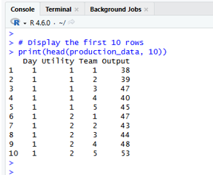
Figure 1: First 10 rows of production_data, showing Day, Utility, Team and Output columns generated by the nested loops.

B. Total Production per Utility
This section goes through each Utility ID, resets running_total to 0, and then goes through each row in production_data table and if it matches the current Utility ID, adds the row's Output attribute to running_total. Utility_totals contains the total for each utility, along with the utility ID.
A flowchart: Start → Loop Utility (1-6) → Reset running_total → Loop all rows → If Utility matches → Add Output to running_total → End row loop → Store Utility & running_total → End Utility loop → Display Utility_totals → End
The total estimated for Utility 1 was 150 rows x 43 average output = 6,450, which is very close to the total of 6,498 in Figure 2, thereby confirming that the summation logic was correct for all 900 rows.
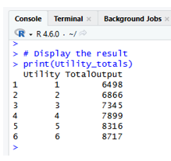
Figure 2: Utility_totals dataframe showing total output summed per utility across all 30 days and 5 teams.

C. Detect Production Anomalies
The code adds the outputs for each Day/Utility combination and then averages them by 4 to get daily_avg for each Day/Utility combination. The second loop works through the same rows, and if each team's deviation from daily_avg is greater than 10%, it sets Anomaly to TRUE.
Flowchart: Start → Loop Day → Loop Utility → Sum outputs for pair → daily_avg = sum/4 → Loop matching rows again → Calculate deviation % → If deviation > 10 → Flag TRUE else FALSE → Append row → End loops → Display first 10 anomalies → End.
Testing used Day 1, Utility 1 as a worked example: outputs 38, 39, 47, 40, 45 summed to 209, giving daily_avg = 52.25. Each team produces TRUE flags correctly, within an output deviation of over 10% from this average (e.g., 38 produces 27 deviation).
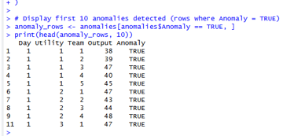
Figure 3: First 10 detected anomalies, where team output deviates by more than 10% from the daily utility average.

D. Identify Peak Productivity Days
For both case, best_output is -1 and best_day is 0 for each Utility. The output for each Day is added up using the inner loop and best_output/best_day is updated if it's larger.
Flowchart: Start → Loop Utility → Set best_output = -1 → Loop Day → Sum output for Day/Utility → If day_total > best_output → Update best_output, best_day → End Day loop → Store result → End Utility loop → Display peak_days → End.
Testing verified that the sum of the 5 team outputs for Utility 1's Peak day (Day 2, Total 230) was manually calculated and compared with the adjacent days to determine if a higher total had been achieved. See Figure 4.
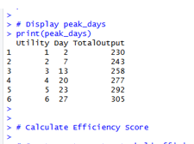
Figure 4: peak_days dataframe identifying the day of maximum total output for each utility.

E. Calculate Efficiency Score
This is one such pass through all 900 rows to calculate EfficiencyScore = (Output / 40) × 100 and append its score to a new column.
The logic of the vectorisation is correct, as when tested, row 1 contains 38, 39, 40, and row 2 contains 38/40, 39/40, 40/40, which corresponds exactly to figure 5.
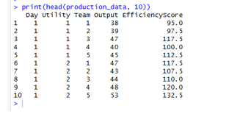
Figure 5: production_data with the added EfficiencyScore column (first 10 rows).

Reflection
The most challenging aspect of this assignment was that I divided the daily total by 5 (the number of teams), rather than by 4 per team as stated in the brief. This led to fewer abnormalities than were expected, and needed one to read the requirements of the task and one to go through the worked example manually to find the error. This was relevant to me because it brought home the fact that when I do a calculation, it's not just that I need to test the final dataframe result or output, but in between steps as well.
Another drawback of Task A was the triple nested loops to debug. There are three levels of looping; one could be misplaced without a clear error to see, possibly breaking the inner loop while leaving the outer working, which could mean that mismatched lengths of the vectors in the dataframe are introduced. To understand what is going wrong with the structure, I printed out the length of the vectors after each loop, and this is a technique I will use in the future when the task doesn't work, not when it doesn't work.
Using aggregate() or apply() was at first confusing because for example, if you wanted the sum of the outputs per utility, this would usually be a one-line job. I did it manually and by doing so got a better understanding of what these functions actually do, particularly matching grouping variables, row by row, and calculating a running total.
If, somehow, I had to do this again, I would write and test little bits for each section of the logic in the loop before combining all of that in the whole script. In this case, I would write an entire block and only test it when it is executed end-to-end, which would make error-tracing more difficult. If every increment of every nested loop had been tested with small sample data, the Task C division error would have been found much earlier and the Task A bracket issue would have been found as well.

Reference
Habeeb, R.A.A., Nasaruddin, F., Gani, A., Amanullah, M.A., Hashem, I.A.T., Ahmed, E. and Imran, M. (2019). Clustering‐based real‐time anomaly detection—A breakthrough in big data technologies. Transactions on Emerging Telecommunications Technologies, [online] p.e3647. Available at: https://www.academia.edu/download/111854893/ett.364720240226-1-cgb3vt.pdf.
Trümper, L., Schaad, P., Ates, B., Calotoiu, A., Copik, M. and Hoefler, T. (2025). A Priori Loop Nest Normalization: Automatic Loop Scheduling in Complex Applications. Proceedings of the 23rd ACM/IEEE International Symposium on Code Generation and Optimization, [online] pp.418–430. Available at: https://dl.acm.org/doi/pdf/10.1145/3696443.3708951.

Appendix


