LCBB6001

International Business Communications
Assignment 1
Student names: Nikola Bachvarov
Student ID:1914252

Contents
International Business Communications 1
Introduction 3
Brief about Romania 4
Application of theories 5
Hofstede model 5
Intercultural mediation 6
Critical evaluation of cultural sensitivity for business purpose 7
Barriers to communication 9
Strategies for Appropriate communication 11
Conclusion 12
References 13

Introduction
International commerce refers to trade conducted beyond national borders and on a global scale (Cavusgil et al, 2014). The transfer of goods and services from one nation to another is known as cross-border trade. Because of the varied frames of knowledge that each person's culture offers, it is practically inevitable that people from different cultures will view the same object in radically different ways. Businesses that manage their communications well are better equipped to react rapidly to market changes. A food processing business called 2 Sisters Food was founded in 1993. It brought in about £2.69 billion in revenue. Most of its manufacturing facilities are in the UK. It has plans to relocate the industrial facility to Romania, a developing nation. The suitability of the nation, cultural disparities, and communication hurdles will all be covered in the report. The paper offered some solutions to the issues as well.

Brief about Romania
A nation that is growing in order to participate in international trade is fundamentally considered an emerging market. It shares some traits with developed countries, but not all of them. Several industrialized countries had significant GDP losses as a result of the Covid 19 lockout, although Romania did not suffer much from a decline in economic growth. Investors find it simpler to extend their businesses into other member states of the European Union thanks to the country's geographic location. With a population of over 21.5 million, it is extremely dense, which results in a highly skilled and low-cost labor force. According to Romania Insider (2020), international corporations contribute 44% of the value created in the nation. Most of the enterprises in this situation are controlled primarily by Ireland, Hungary, and other EU nations. Security, easy access to skilled labor, and a respectable return on investment are some of the most alluring factors to consider when making an investment (Hurduzeu, 2021). International investors considering a transfer to Romania are mainly concerned with the fact that the nation has a stable political environment, a supply of skilled labor, affordable business supplies, and other factors. The country is particularly appealing to manufacturing enterprises for the reasons listed above as well as the country's effective supply chain (Romania insider, 2020). Additionally, the nation has been making large investments in the infrastructure that support the growth of the economy rather well. As a result, communication throughout the nation is now quite effective. The nation is also spending money on digital technology so that its enterprises can grow at the same rate as those of other nations. The nation also has very effective crisis management plans. Romania handled the pandemic problem in a way that prevented it from having the same devastating effects as other wealthy nations in Europe. These are the primary explanations for why 2 Sisters Food decided to move their manufacture to romaine.

Application of theories
Numerous variables and theories are effective for Romanian intercultural and international communication. To effectively communicate with the people in this nation, the company must take the theories into account. Both the host nation and the visiting nation will have a big impact on how the country communicates.

Hofstede model
The Hofstede model highlights regional characteristics that influence both the country's culture and its population's behavior. Six primary things make it up. The factors in relation to Romania are depicted in the graph below.
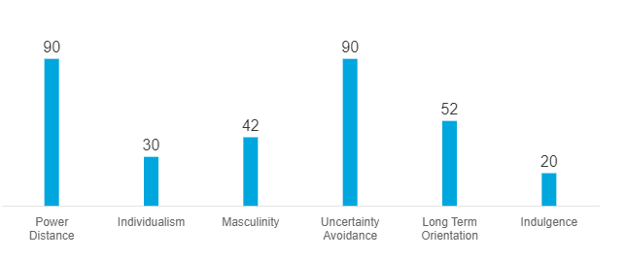
Figure 1: Hofstede insights about Romania
Source: (Hofstede, 2022)
Romania's high power distance demonstrates that its citizens are accustomed to a hierarchical structure. The system will allow people to justify their positions without any further input from them. The majority of the organizations in the nation are centralized, and the staff prefers precise instructions on their duties. Low individualism reflects a cooperative culture in Romania (Hofstede, 2022). The people like interacting with one another and working as a team. They anticipate that one another will share their loyalty. This nation's offices are large enough for teams to work there. The masculinity score reveals a modest feminism in the nation's culture. They mostly concentrate on personal lives as opposed to professional lives. The management make an effort to reach consensus. In Romanian culture, cooperation and negotiation are the most efficient means of resolving disputes. The staff values holidays, time spent with family and friends, and other things. The focus is on happiness, and there is no indicator of social rank given (Cavusgil et al, 2014). In all situations, avoiding ambiguity is highly valued in the nation. According to the study, it clings to rigid standards of thought and behavior and is uncomfortable with unusual behavior and ideas. Romania has a moderate long-term orientation that emphasizes the civilization's past and future. It rates really poorly for indulgence. Relaxed societies give little thought to vacations and exercise strict control over the fulfillment of their wants. These people think that society norms are limiting what they can do.

Intercultural mediation
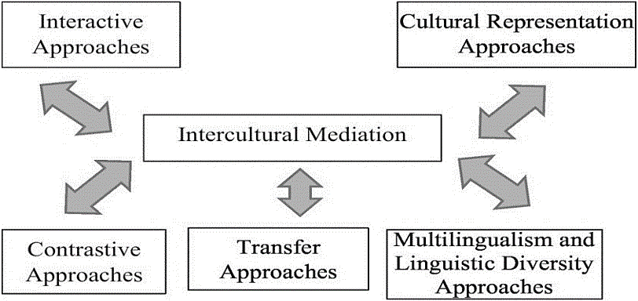
Figure 2: Intercultural mediation
Source: (Samovar et al, 2016)
It is described as any kind of interaction between individuals from different cultural backgrounds that happens to be for business in this case (Samovar et al, 2016). The two internet services that best represent this mediation are translation and interpretation. Intermediaries between various cultures and the parties attempting to close negotiations are interpreters. Intercultural mediation can also take the form of using a shared language. The company's managers will benefit in this situation. Since English is widely regarded as a second language, it is expected that Romania's educated population will be familiar with it. Unfortunately, the majority of individuals in Romania are able to speak Romanian. There are further intercultural mediation strategies. The transfer technique, which requires the organization to demonstrate its openness to adapt new ideas alongside the Romanian employees, is another strategy that could be utilized in this situation.

Critical evaluation of cultural sensitivity for business purpose
Despite having a communist heritage, Romania has undergone a significant transformation recently. It also joined the EU. However, its culture still reflects elements of the past in a number of ways. The cultures of Romania and Britain share a number of similarities and differences. Here are some explanations:
Romanians, who have a strong emphasis on family, rely heavily on their interpersonal relationships. The nation's citizens, however, exhibit incredible loyalty and confidence after a link is made for the foreseeable future (Ghemawat, 2018). The corporate world upholds it as well, treating new hires formally until they have a chance to get to know one another and establish a working relationship. While being on time is valued in this culture, a little tardiness is tolerated in meetings. But these gatherings are regarded as being very formal. The meeting must begin with a handshake and the exchange of business information. In order to ensure that the staff members are acting professionally when necessary, 2 Sisters Food Group must keep this in mind. As was already established, the culture and people place a greater emphasis on the family than on their jobs. They put in about 41 hours per week to balance work and life (Hurduzeu, 2021).
Romanians take their jobs seriously and put in more time than is called for by the typical workweek. This nation's laws governing the workplace are relatively similar to those of other European countries. If they come from countries that have developed best practises and considerable knowledge in the sector, they welcome foreigners and view them as skilled individuals. They value them more for their skills than for their position or country of origin. Generally speaking, business situations in this nation are very formal (Cavusgil et al, 2014). Examples include the lack of intimate relationships between managers and employees and the relative lack of decision-making authority granted to lower-level employees. Most options require many levels of clearance. Employees may find themselves in a difficult situation if new concepts are introduced or the plan is drastically altered since they cannot commit until they have gained approval from the authorities. Business relationships on a personal level are crucial in Romania. Without the capacity to network, it would take a lot of resources to solve common problems, get around administrative roadblocks, and speed up procedures. This is true even if the objective is perfectly legitimate and fair. Favoritism is frequently a consideration when deciding how information is exchanged inside a corporation. Personal connections may be the only source of drive in some situations, allowing progress to be made despite a stalemate in negotiations. In the country, a more liberal approach to deadlines and output is not unusual. Employees in a company could take lengthy breaks or miss deadlines (Babcock and & Du-Babcock, 2018). There are rumours that absenteeism is a major problem in corporate culture as well. 2 Sisters must take these factors into account and establish a formal culture inside the organisation to deal with these circumstances.

Barriers to communication
The corporation will have a number of communication barriers when conducting business in Romania for a number of reasons. These obstacles consist of:
Language barriers: It will serve as the main obstacle. The majority of the population speaks Romanian, as was previously noted. Because it is a Latin language, it shares many characteristics with languages like French and others (Babcock and & Du-Babcock, 2018). However, as was previously indicated, the usage of English could act as a sort of intercultural mediator. In this circumstance, the company's executives will have an advantage. Since English is widely regarded as a second language, it is logical to presume that educated people in Romania are also familiar with it. However, if an expat manager attempts to operate in a foreign nation without knowing the language, it may cause them a lot of difficulties. The key to efficient communication in Romanian is language proficiency, albeit it is not a requirement. Understanding the native tongue is, nevertheless, seen as a big benefit and a sign of respect by his or her colleagues when conducting business in a foreign country.
Body language: It's crucial for the person communicating to be conscious of their expressions when they're conveying a message (Dalton and Kennedy, 2017). It can be especially important when travelling because some behaviours that are considered courteous in one country may not be in another. One needs to be conversant with regional idioms of expression and body language in order to conduct business efficiently. Romanians are renowned for having affable and warm personalities. Therefore, if someone feels offended if someone touches them during a conversation, it may be a barrier to dialogue. Directly telling them no is regarded as disrespectful behaviour because of their friendly attitude. Simply put, being direct can hinder communication in this situation.
Culture differences: Communication is usually hampered by cultural differences. The UK has a largely work-oriented culture. They labour arduously. However, that does not imply that the businesses do not interact with one another personally (Hoecklin, 2015). However, they are devoted to the business and give their all at work. In Europe, people in the UK put in the most time at work—more than 48 hours per week. The work schedule in Romania is fairly flexible. These cultural differences will hinder communication within the company in many ways. When conducting business in Romania, these ideals should not be at odds with one another.
Geographical distance: The business will need to establish a lot of virtual teams as a result of advances in digital technology. For the business, this makes communication more difficult. When the team is virtual, it can be challenging to consistently work together (Ovidiu-Iliuta, 2019). Such groups, which connect through various technologies, could also feel left out. Due to the fact that they operate in various locations and cannot see one another, the team members may feel as though their coworkers aren't making a contribution. Time zone differences could occasionally cause issues.

Strategies for Appropriate communication
A lot of obstacles prevent employees in the organisation from communicating with one another, as was previously mentioned. The corporation will need to use effective communication techniques to remove the barriers before moving the manufacturing facility to Romania.
In order to be successful in business, one must not only be able to see and exploit opportunities, but also create favourable first impressions and set the foundation for lasting partnerships. Corporate customs are based on decency and manners (Popa, 2020). The country's communist dictatorship had a huge impact, escalating poverty and encouraging corruption. Since the collectivist regime was overthrown, the nation has undergone enormous development, and the business community has realised that established relationships can be maintained as long as both parties treat one another with kindness and respect. When interacting with the Romanian culture, the company must take these factors into account.

Another tactic will be to give the foreign managers the essential training they need to understand the local culture. Knowing the culture will help managers better manage communication and identify any body language or attitudes that should be avoided (Ghemawat, 2018). The expat managers will also assist the other managers in establishing relationships with the Romanian workers. They will require more family time. The corporation will be motivated to give employees more family time as a result of the cultural differences to encourage them to work harder.
The business requires hire some supervisors with strong English language skills. It will facilitate more effective communication between the businesses. Given that the workforce would primarily speak the dialect, the translators must be fluent in both languages. When contrasted to the official Romanian language, the local tongue can vary greatly. Teams cannot be entirely virtual. To ensure that communication between the teams is flawless, the team leader should at the very least be physically present with them (Littrell and Valentin, 2019).

Conclusion
Power distance and uncertainty avoidance in Romania are highly rated, suggesting that individuals there feel at ease with a hierarchical structure but not with alternative ideas. Other factors in Romania range from moderate to low. Romanians frequently rely extensively on their social networks due to the importance they place on family. Personal connections are extremely important in Romanian business. Without the ability to form connections, it would require a significant amount of resources to address common issues, get over bureaucratic obstacles, and accelerate procedures. The cultures of Romania and the UK differ greatly from one another. While people in the UK work the most in Europe, Romanians prefer to maintain a more informal balance between work and life. The biggest obstacles in the process are language hurdles, body language, cultural differences, geographic distance, etc. A corporation can successfully overcome obstacles with the help of proper training and commercial relationships.

References


