MODULE TITLE: Introduction to Health and Social Care
MODULE CODE: LCHS4003

STUDENT NAME: MAJDA OSMAN
STUDENT NUMBER: 2422432
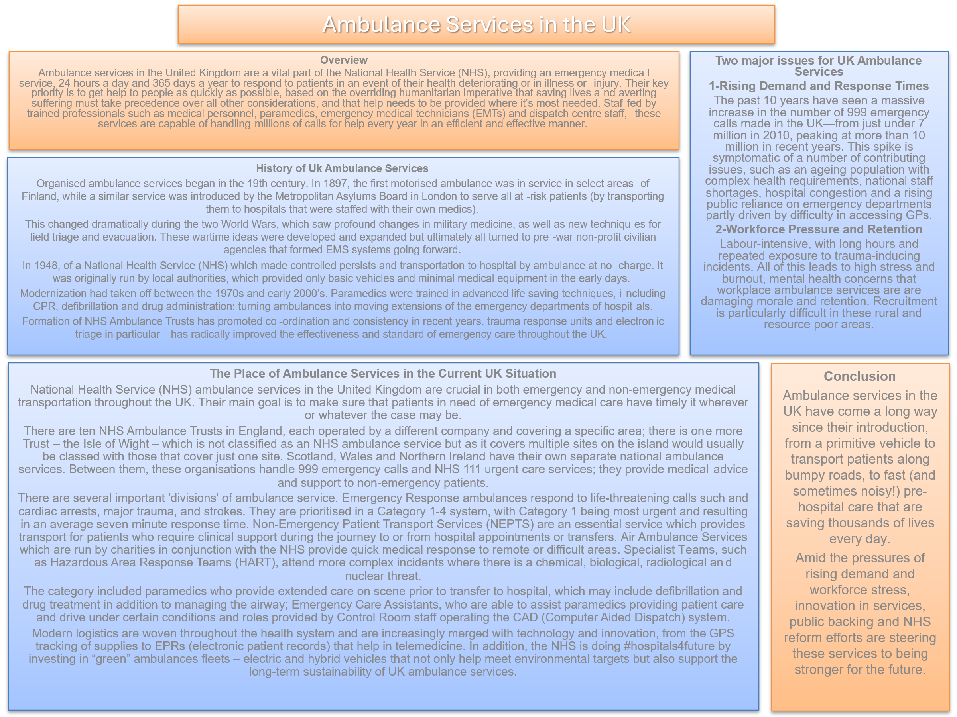
THE ESSAY
The NHS: How It Got There, What It Stands For, and Where It Is Heading
The (NHS) is the UK’s biggest legacy of commitment to welfare. Based on the principle that everyone should receive care no matter how much (or little) we earn, the NHS represents fairness and social justice. Since its inception, it has mirrored the social and political changes of society, enduring constant reform and criticism.
Historical Context and Origins
The NHS was established in 1948 as a response to the suffering of World War II and the poverty of the interwar years. The postwar Labor government, under Clement Attlee sought a system to enable national recovery and diminish social inequality. The Beveridge Report of 1942, written by sir William Beveridge, identified five “giant evils”: Want, Disease, Ignorance, Squalor and Idleness. Its recommendations led to the creation of a comprehensive healthcare service which would look after all its citizens “from the cradle to the grave”.
The founding principles of the NHS were radical:
It has to meet everyone’s health care needs.
It has to be free at the point of delivery.
Access should be based on clinical need, not financial ability to pay.
These tenets revolutionized the interaction between government and citizens, becoming a model for other countries to follow. From the start, the NHS depended on a diverse workforce, including international recruits, to keep pace with increasing patient needs.
Core Principles and Values
The NHS is still mostly being true to its founding principles of universalism, comprehensiveness and free at the point of delivery. It waits to embrace openness and accountability to the people. These perennial ideas inform all discussions of policy and function as criteria for judging reforms.

Structure and Functioning in 2025
From a system built around hospitals and local authorities, the NHS has transformed into one which is more joined-up and data-driven. 2025 Its rule and composition are being transformed by a series of significant changes.
Key changes include:
The Secretary of State for Health and Social Care has increased oversight, bringing decisions into the center of government.
NHS England, once responsible for commissioning and performance management, is to be abolished, with its duties 'becoming part of' the Department of Health and Social Care.
The ICBs will replace the existing Clinical Commissioning Groups and will be accountable for local health strategies.
National guidance on clinical and cost effectiveness continues to be provided by the National Institute for Health and Care Excellence (NICE).
The 2025–26 operational model will seek to drive efficiency through digital reform, local control and preventative care. It is also to eliminate bureaucracy and support community-led health programs.
Challenges and Future Outlook
Yet in 2025, as successful as the NHS is, there are some significant challenges. Under-staffing alongside growing patient numbers, and a shortage of funds is putting the quality of services in jeopardy. Escalating expenses, pay bickering and inflation add to these problems. Public reporting systems, such as league tables, designed to enhance transparency are frequently criticized for oversimplifying complex performance data and reducing staff morale.
Transformation is a fuzzy concept with lots of caveats, and widely welcomed reforms to promote prevention and digitalization do not guarantee long-term sustainability or fairness. They say the NHS needs to focus on its people’s health, get better at governing itself and bring in members of the public more directly in making it fit for the future.
And in the end, despite contemporary pressures, that old promise of a British health care for all universal and free at the point of delivery has not been broken.

References:

1. Department of Health and Social Care (2025) Road to recovery: the government’s 2025 mandate to NHS England. https://www.gov.uk/government/publications/road-to-recovery-the-governments-2025-mandate-to-nhs-england/road-to-recovery-the-governments-2025-mandate-to-nhs-england
2. HFMA (2025) Working together in 2025/26 to lay the foundations of reform – summary. HFMA, April. https://www.hfma.org.uk/publications/working-together-202526-lay-foundations-reform-summary
3. NHS Confederation (2025) A new operating model for health and care. https://www.nhsconfed.org/publications/new-operating-model-health-and-care
4. NHS England (2025a) Update on the draft Model ICB Blueprint and progress on the future NHS operating model. https://www.england.nhs.uk/long-read/update-on-the-draft-model-icb-blueprint-and-progress-on-the-future-nhs-operating-model/
5. NHS England (2025b) Working together in 2025/26 to lay the foundations for reform. 1 April. https://www.england.nhs.uk/publication/working-together-in-2025-26-to-lay-the-foundations-for-reform/
6. Peart, L. (2025) ‘Blueprint document sets out changes to ICB functions’, Healthcare Management UK, 7 May. https://www.healthcare-management.uk/blueprint-document-sets-changes-icb-functions

References :
- Care Quality Commission (2024) State of Care 2023/24: Access, secondary care and urgent and emergency services. London: CQC. https://www.cqc.org.uk/publications/major-report/state-care/2023-2024/access/secondary

- East of England Ambulance Service NHS Trust (2025) About us. https://www.eastamb.nhs.uk/about-us

- Hansard (2025) Ambulance Response Times. https://hansard.parliament.uk/Commons/2025-03-06/debates/984BB757-AE11-408C-8BA6-56885FB4A999/AmbulanceResponseTimes

- London Ambulance Service NHS Trust (n.d.) Our History – A timeline. https://www.londonambulance.nhs.uk/about-us/our-history/our-history-a-timeline/

- NHS England (n.d.) Improving ambulance services. https://www.england.nhs.uk/urgent-emergency-care/improving-ambulance-services/

- NHS Providers (2024) Ambulance sector — NHS Activity Tracker, December 2024. https://nhsproviders.org/resources/nhs-activity-tracker-202425/december-2024/ambulance-sector/

