Assignment 2- Gender Race, and Religion
Why is there an increase in hate crime in the uk?
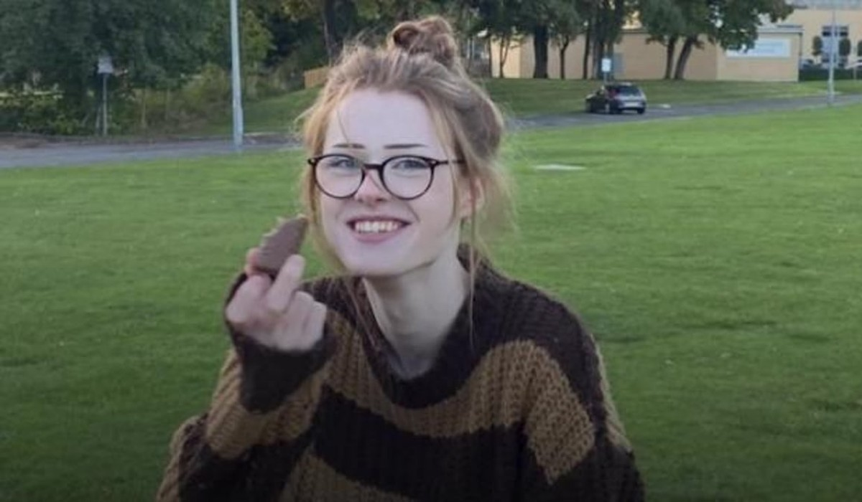
In recent years, the UK has witnessed a concerning and rapid increase of hate crime incidents. As of 2020/2021, hate crime in England and Wales had reached record highs of approximately ‘150,000’ police recorded cases. As of 2022/2023, there has been a slight decrease of ‘5%’ to a figure of ‘145,214’ police recorded cases (Home Office, 2023). However, this statistic only considers police recorded cases, so the figure is most likely a lot higher, due to crimes going un-reported. This issue poses a significant amount of challenges to the social fabric of the UK, including that of the values of diversity and inclusion. Out of the entire population of both England and Wales in 2021, ’81.7% was White; ‘9.3% was Asian; ‘2.9%’ was of mixed or multiple ethnic groups; ‘4%’ was Black; and 2.1% are of other ethnic groups (Barton, 2023). This shows that 18.3% of the population are of the entire population are of a different origin and could be at risk to racist abuse. Yet, this statistic doesn’t consider other aspects that may make someone different, including their religion or beliefs, and sexual orientation and preference that may also make them vulnerable to abuse.

This essay will evaluate the rise of hate crime in the UK, to explore understandings of race, religion, and gender, explain key sociological and criminological theories around diversity as well as understanding specific definitions of hate crime and how they have developed over time. This essay will also discuss the murder of Brianna Ghey as an example of hate crime to evaluate key definitions and concepts of diversity and hate, as well as the police response to explore the relationship between them and diverse communities in the UK. This will help determine why there is an increase in hate crime in the UK.

To get a better understanding on the issue, it is important to understand what cultural groups are vulnerable to hate crime and abuse, and understand what defines them. A number of different groups are discriminated against in the UK, solely for aspects that make them different, such as their race, religion and sexual orientation. In terms of Race, racism is discrimination solely due to a person’s skin colour, hair colour or type, or county of origin. Due to this, anyone who may be of a different skin colour or characteristic are more likely to experience racial prejudice and discrimination. Although diversity is encouraged, since 1988 ‘Black and Minority Ethnic’ (BME) people are at a “higher risk of victimisation than white people”. Moreover, BME groups are “more likely to experience repeat and multiple victimisation” and “perceive themselves more at risk of victimisation (Davies, et al., 2007). This is proven today in crime statistics. Home office recorded ‘109,843’ racially motivated hate crimes in 2021/2022, which showed an increase by ‘19%’ from the year before (Home Office, 2022). From a historical perspective, racism in society has shown in different events, such as slavery in the 1600s to 1800s when it was abolished, and the segregation that followed where black people were viewed as ‘Separate But Equal’ (History.com Editors, 2009). In terms modern criticisms of diversity in UK is treatment of Black people from the Police. Research shows that in that in the year 2020/2021, the arrest rate per 1000 people for black people reached ‘22.5’. in comparison, white people, who’s population is a lot higher than that of black communities in the UK, the rate was only ‘8.7’. This raised speculation that the police services around the UK were institutionally racist. Another example of possible police racism in the UK came from the police in ‘Brixton Riots’ in 1981, which created further divide with the police force and black communities. On the 10 April 1981 “rumours of police brutality against a black man resulted in an angry crowd confronting the police”. This escalated further in the night as the streets of Brixton erupted into violence. The riots continued for ‘3 days’ where “300 people were injured”, and the damage came to an estimated cost of ‘7.5 million’ (CBBC, 2021). The rioters mostly consisted of black men fighting metropolitan police which divided both the black community and police, and its effects still show today, as there is huge distrust between black communities and the Police. This also has an impact on the way white people who are not racist, view different ethnic, and emigrant groups, as due to ethnic group crime rates, it may put them under the presumption that they mean them harm, which subconsciously creates ‘unconscious bias’ against ethnic groups (Devlin, 2018). There also may be fear of certain ethnic and racial groups are associated with external groups, such as Black people being associated with gangs, or Irish being associated with the IRA.

Religious discrimination is also a common example of prejudice and hate crime in the UK. Religion can be defined as the “various historical attempts to organise a set of doctrines, rituals, and specific behaviours that are supposed to be the right way to live” (Spalek, 2008). As of 2021 in England and Wales, ’46.2%’ of the population is Christian; ‘6.5%’ are Muslim; ‘1.7%’ are Hindu, ‘0.9%’ are Sikh’s; ‘0.5%’ are Jewish and Buddhist’s; ‘0.6%’ are of other religions; and ‘37.2%’ are not religious (Zayed, 2023). This shows that England and Wales are very diverse with people of many different backgrounds, faiths and opinions. However, this could lead to someone’s religion being motivation for hate crime. Currently, with the Gaza and Israel conflict ongoing, “Anti-Semitic hate crimes rose sharply in the month after Hamas attack on Israel”, mostly ‘Islamophobia’. In the news article, it stated “Greater Manchester Police recorded 74 antisemitic incidents compared with 15 during the same period the previous year”. It has also been recorded that “53 antisemitic offences, up from 10 in 2022” (Swann & Atkinson, 2023) by West Yorkshire Police. This shows that abuse isn’t specific to just one area, the issue is nationwide. This explains why there is such a rapid rise in religious hate crime to Muslims currently, especially due to minority number of Muslims in the country due to Christians and those who are non-religious, but does not exclude abuse from other groups. There is also fear in Peterborough that Muslims “are not reporting hate crime”. Victims say they have not reported “Islamophobic Incidents as they have not realised they were hate crimes” stated the community leader. Furthermore, another reason for the lack of reporting is because when it is reported “people feel let down by authorities that nothing is being done” (Ahmed, 2023). This hatred for certain religious groups such as Muslims may also come from past events such as their perceived association with terrorist organisations like Al Qaeda and ISIS when they have no association at all with these groups.

Discrimination against someone’s sexuality is also a huge example of hate crime in the UK. Someone’s sexuality is hard to define as it is a multi-faceted debate, as it means something different to different groups, and religions. From a survey asking about people’s sexuality in the UK in 2022, “93.4% of the UK household population aged 16 years and over identified as heterosexual” and ‘3.3%’ identified as ‘lesbian, gay, or bisexual’ (Office for National Statistics, 2023). This shows that people who identify as gay, lesbian, and bisexual are in the minority in the UK compared to heterosexual people in the UK. However, this data fails to recognise transgender people who are, if not more, vulnerable than the other groups mentioned. New data shows that there currently a rise in hate crime towards the LGBTQ+ community in the UK. Hate crime against trans people has apparently increased by ‘11%’ in the last year, and ‘186%’ in the last 5 years. On top of that, overall, the amount of hate crimes targeting someone based on their sexual orientation over the last 5 years has increased by ‘112%’ despite a slight decrease this year of ‘6%’ (Stonewall News, 2023). Determining the cause to the rise of hate crime to the LGBTQ+ community isn’t that simple either, obvious reasons include that of religions, that may prohibit it and say it is wrong, and dislike for how some members may behave in the media and on social media. However, that does not justify the case of Brianna Ghey.

16-year-old Brianna Ghey, who was transgender, was “stabbed 28 times in broad daylight in Culcheth Linear Park in Cheshire on the afternoon of the 11 February” 2023 (Hirst, 2023). She was killed by 2 teenagers who were identified 24 hours after the killing. Brianna was a shy girl who “suffered with anxiety”. This is revealed by her mother, Esther Ghey, who messaged her daughter on the day she died. Brianna, who didn’t go out much went on a bus to take her to the place to meet the girl, she thought to be her friend, who participated in the murder. Brianna texted her mother “I’m on the bus, I’m scared” to which her mother responded “that’s well good”, with no idea that she was about to be murdered (Wells & Nsubuga, 2023). Her anxiety could have made her vulnerable to manipulation from one of the killers. It was later revealed that Girl X and Boy Y, the killers whose names have not been revealed to the public due to their ages, had planned to kill her. A plan was found in Girl X’s room, a piece of paper that stated she was to meet Boy X before meeting up with Brianna, they were to wait for Brianna to get off the bus to walk to Linear Park, towards a pipe/tunnel area, it then states “I say code word to [Y]. He stabs her in the back as I stab her in the stomach”. They had also planned to hide her body by covering the area ‘with logs’ (Pidd, 2023). This shows that they had a motive. It was later shown in texts between the culprits, that they fantasised, over killing. She stated in one text message saying “I love watching torture vids, real ones, on the dark web” (Channel 4 News, 2023). Girl X also stated in text messages that she wanted to “stab her at least once even if she’s dead, jus coz its fun, lol” (Vaughan, 2023). Detectives would soon unravel the crime after the killers had believed they had covered their tracks, however the murder weapon in Boy Y’s bedroom, a hunting knife, that still had Brianna’s DNA on “the handle of the knife” (Okell, 2023). They were charged with the murder. This is a clear example of hate crime towards Brianna’s sexuality, as Boy Y had referred to Brianna as ‘it’, and saying they would use the word ‘gay’ as co-word to know when to kill her, further belittling her.

In terms of how the police dealt with the case, they were efficient in identifying what happened, and found the culprits within a 24-hour period, and there has been mostly praise from the LGBTQ+ community. However, this hasn’t been the case in the past. The experience for LGBTQ+ communities, in relation to hate crime, criminal justice, and victimisation have been ‘marginalised’, in favour of “reflecting bias towards heterosexuality that dominates western media” (Spalek, 2008). This leads to a serious number of unreported hate crimes towards the Transgender Community. Stats show from the LGBT+ survey, out of ‘108,100’responses, ‘88%’ of transgender people did not report the most serious type of incident. ‘48%’ of transgender people were not satisfied with the Police response after reporting the most serious types of incidents (Home Office, 2023).

In conclusion, the reasoning behind the sudden rise in hate crime, across minority communities in the UK, is because of a variety of different reasons. Media coverage of events, although informative, can create tension for social groups in the UK. With the development of social media and online platforms, it’s easier than ever to spread your opinion on someone, no matter how harmful it may be, and could be encouraging hate speech. In terms of more serious, often violent examples such as the Brianna Ghey case, there needs to be more effort from schools, and forms of education for everyone, to better understand minority groups within our society. Finally, The Government must do more to protect people at risk of hate speech, such as new updated legislation, as some are outdated, and do not integrate with modern issues. People are scared of things they do not understand, so they need to be educated about it. By doing this, society will be able to develop passed its current and old fashioned ‘unconscious bias’, that applied to a generation a long time ago.

Bibliography
Ahmed, S., 2023. Fears Muslims in Peterborough are not reporting hate crime. [Online]
Available at: https://www.bbc.co.uk/news/uk-england-cambridgeshire-67314244
[Accessed 3 January 2024].
Barton, C., 2023. Constituency data: Ethnic groups, 2021 census. [Online]
Available at: https://commonslibrary.parliament.uk/constituency-statistics-ethnicity/#:~:text=Across%20England%20and%20Wales%2C%2082,20%20constituencies%20by%20ethnic%20group
[Accessed 3 January 2024].
CBBC, 2021. Brixton riots 1981: What happened 40 years ago in London?. [Online]
Available at: https://www.bbc.co.uk/newsround/50035769
[Accessed 5 January 2024].
Channel 4 News, 2023. Two teenagers found guilty of murdering Brianna Ghey. [Online]
Available at: https://www.youtube.com/watch?v=WNqKT6t-fxI
[Accessed 8 January 2024].
Davies, P., Francis, P. & Greer, C., 2007. 'Race', Ethnicity, Victims, and Crime. In: P. Davies, P. Francis & C. Greer, eds. Victims, Crime and Society. London: Sage Publishers Ltd, p. 110.
Devlin, H., 2018. Unconscious bias: what is it and can it be eliminated?. [Online]
Available at: https://www.theguardian.com/uk-news/2018/dec/02/unconscious-bias-what-is-it-and-can-it-be-eliminated
[Accessed 6 January 2024].
Hirst, L., 2023. Brianna Ghey: The young killers who tried to get away with murder. [Online]
Available at: https://www.bbc.co.uk/news/uk-england-manchester-67727331#:~:text=Sixteen%2Dyear%2Dold%20Brianna%2C,been%20convicted%20of%20her%20murder.
[Accessed 9 January 2024].
History.com Editors, 2009. Black History Milestones. [Online]
Available at: https://www.history.com/topics/black-history/black-history-milestones
[Accessed 4 January 2024].
Home Office, 2022. Hate Crime, England and Wales. 2021 to 2022. [Online]
Available at: https://www.gov.uk/government/statistics/hate-crime-england-and-wales-2021-to-2022/hate-crime-england-and-wales-2021-to-2022
[Accessed 4 January 2024].
Home Office, 2023. Hate crime, England and Wales, 2022 to 2023 second edition. [Online]
Available at: https://www.gov.uk/government/statistics/hate-crime-england-and-wales-2022-to-2023/hate-crime-england-and-wales-2022-to-2023
[Accessed 3 January 2024].
Home Office, 2023. Hate crime, England and Wales, 2022 to 2023 second edition. [Online]
Available at: https://www.gov.uk/government/statistics/hate-crime-england-and-wales-2022-to-2023/hate-crime-england-and-wales-2022-to-2023
[Accessed 9 January 2024].
Office for National Statistics, 2023. Sexual Orientation. [Online]
Available at: https://www.ons.gov.uk/peoplepopulationandcommunity/culturalidentity/sexuality#:~:text=2021%20and%202022-,What%27s%20in%20the%20bulletin%3F,increase%20from%202.1%25%20in%202017.
[Accessed 7 January 2024].
Okell, N., 2023. Police release picture of knife used to murder Brianna Ghey. [Online]
Available at: https://www.warringtonguardian.co.uk/news/24003588.police-release-picture-knife-used-murder-brianna-ghey/
[Accessed 9 January 2024].
Pidd, H., 2023. Jury in Brianna Ghey murder trial given note of alleged plan to kill her. [Online]
Available at: https://www.theguardian.com/uk-news/2023/dec/07/jury-in-brianna-ghey-trial-given-note-of-alleged-plan-to-kill-her
[Accessed 8 January 2024].
Spalek, B., 2008. Faith Identities, Crime and Criminal Justice. In: B. Spalek, ed. Communities, Identities and Crime. Bristol: The Policy Press, p. 162.
Spalek, B., 2008. Lesbian, gay, bisexual and transgender communities: crime, victimisation and criminal justice. In: B. Spalek, ed. Communities, Identities, and Crime. Bristol: Policy Press, p. 189.
Stonewall News, 2023. New data: Rise in hate crime against LGBTQ+ people continues, Stonewall slams UK Gov ‘inaction’. [Online]
Available at: https://www.stonewall.org.uk/about-us/news/new-data-rise-hate-crime-against-lgbtq-people-continues-stonewall-slams-uk-gov-
[Accessed 9 January 2024].
Swann, S. & Atkinson, E., 2023. Police record rise in religious hate crimes after Israel-Gaza war. [Online]
Available at: https://www.bbc.co.uk/news/uk-67836607
[Accessed 5 January 2024].
Vaughan, H., 2023. Brianna Ghey: How teenagers with a 'thirst for death and murder' plotted killing on their phones. [Online]
Available at: https://news.sky.com/story/brianna-ghey-how-teenagers-with-a-thirst-for-death-and-murder-plotted-killing-on-their-phones-13033534
[Accessed 2 January 2024].
Wells, A. & Nsubuga, J., 2023. ‘I dont think she ever saw it’: Brianna Ghey’s mum recalls final message before teen's ‘murder’. [Online]
Available at: https://uk.news.yahoo.com/brianna-ghey-mum-final-message-before-killed-153201228.html?guccounter=1&guce_referrer=aHR0cHM6Ly93d3cuZ29vZ2xlLmNvbS8&guce_referrer_sig=AQAAAKuC9j6twoH9ZIR1SDPdU7YAMAB5hyLaLd02TWLZhrxooxSTiDrQC7mL4c_CfQaMe0DidUrkCxP9Aq_wXnrnMMuV
[Accessed 6 January 2024].
Zayed, Y., 2023. Constituency data: Religion, 2021 census Data dashboards. [Online]
Available at: https://commonslibrary.parliament.uk/constituency-data-religion/
[Accessed 9 January 2024].

