

Managing People-Individual Presentation

MODULE CODE: LCBB5004

Student Name: Dan Joita
Student ID: 2124449
Lecturer: Mushfiqur Rahman

Table of Contents
Slide 1: Introduction 3
Slide 2: What is Talent Acquisition? 4
Slide 3: Three strategies for short-term talent acquisition with special reference to Greggs 5
Slide 4: Three strategies for long-term talent acquisition with special reference to Greggs 6
Slide 5: Incentives and rewards 7
Slide 6: Two monetary methods with special reference to Greggs 8
Slide 7: Two non-monetary methods with special reference to Greggs 9
Slide 8: Conclusion 10
Slide 9: References 11

Slide 1: Introduction

The employees can be considered to be the true asset of a business organisation (Hongal and Kinange, 2020). The following presentation will first elaborate on talent acquisition along with identifying and further exploring three short-term and three long-term strategies of talent acquisition. Furthermore, it will aim to identify two monetary and two non-monetary means of incentives and rewards which can motivate the employees to use their full potential. Greggs will be referred to while explaining all these pointers.

Slide 2: What is Talent Acquisition?
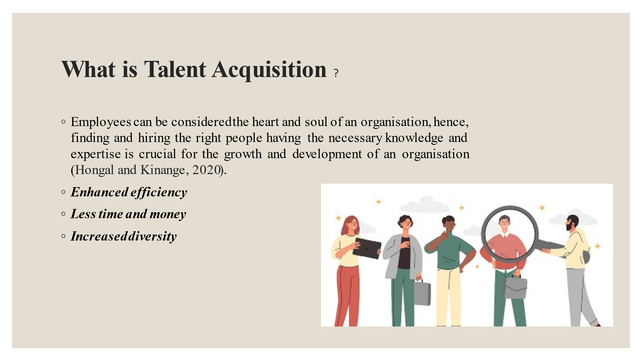
Employees can be considered the heart and soul of an organisation, hence, finding and hiring the right people having the necessary knowledge and expertise is crucial for the growth and development of an organisation (Hongal and Kinange, 2020). Without the right employees, an organisation is more likely to struggle with poor productivity and performance which directly affects the organization. There are multiple benefits of having an effective talent acquisition process and some of the most important ones are being discussed here:
Enhanced efficiency
Once organisations start strengthening their talent acquisition process, their hiring will automatically become much smoother and more effective (Gilch and Sieweke, 2021). For organisations that are not able to do it internally, they are advised to hire a talent acquisition specialist who will have the necessary expertise to hire the right candidates for the same.
Less time and money
Contrary to the popular belief, a good talent acquisition process can help organisations to save money in the longer run (Hongal and Kinange, 2020). Nowadays, there are a wide variety of platforms available from which such talents can be found and further hired. For example, various recruiting software and tools, social media platforms, advertising job posts, and so on.
Increased diversity
Past studies have highlighted that having a diverse work culture is crucial for the success of an organisation (Ette, 2022). An effective talent acquisition process will ensure that organizations hire candidates who have diverse backgrounds and experience.

Slide 3: Three strategies for short-term talent acquisition with special reference to Greggs
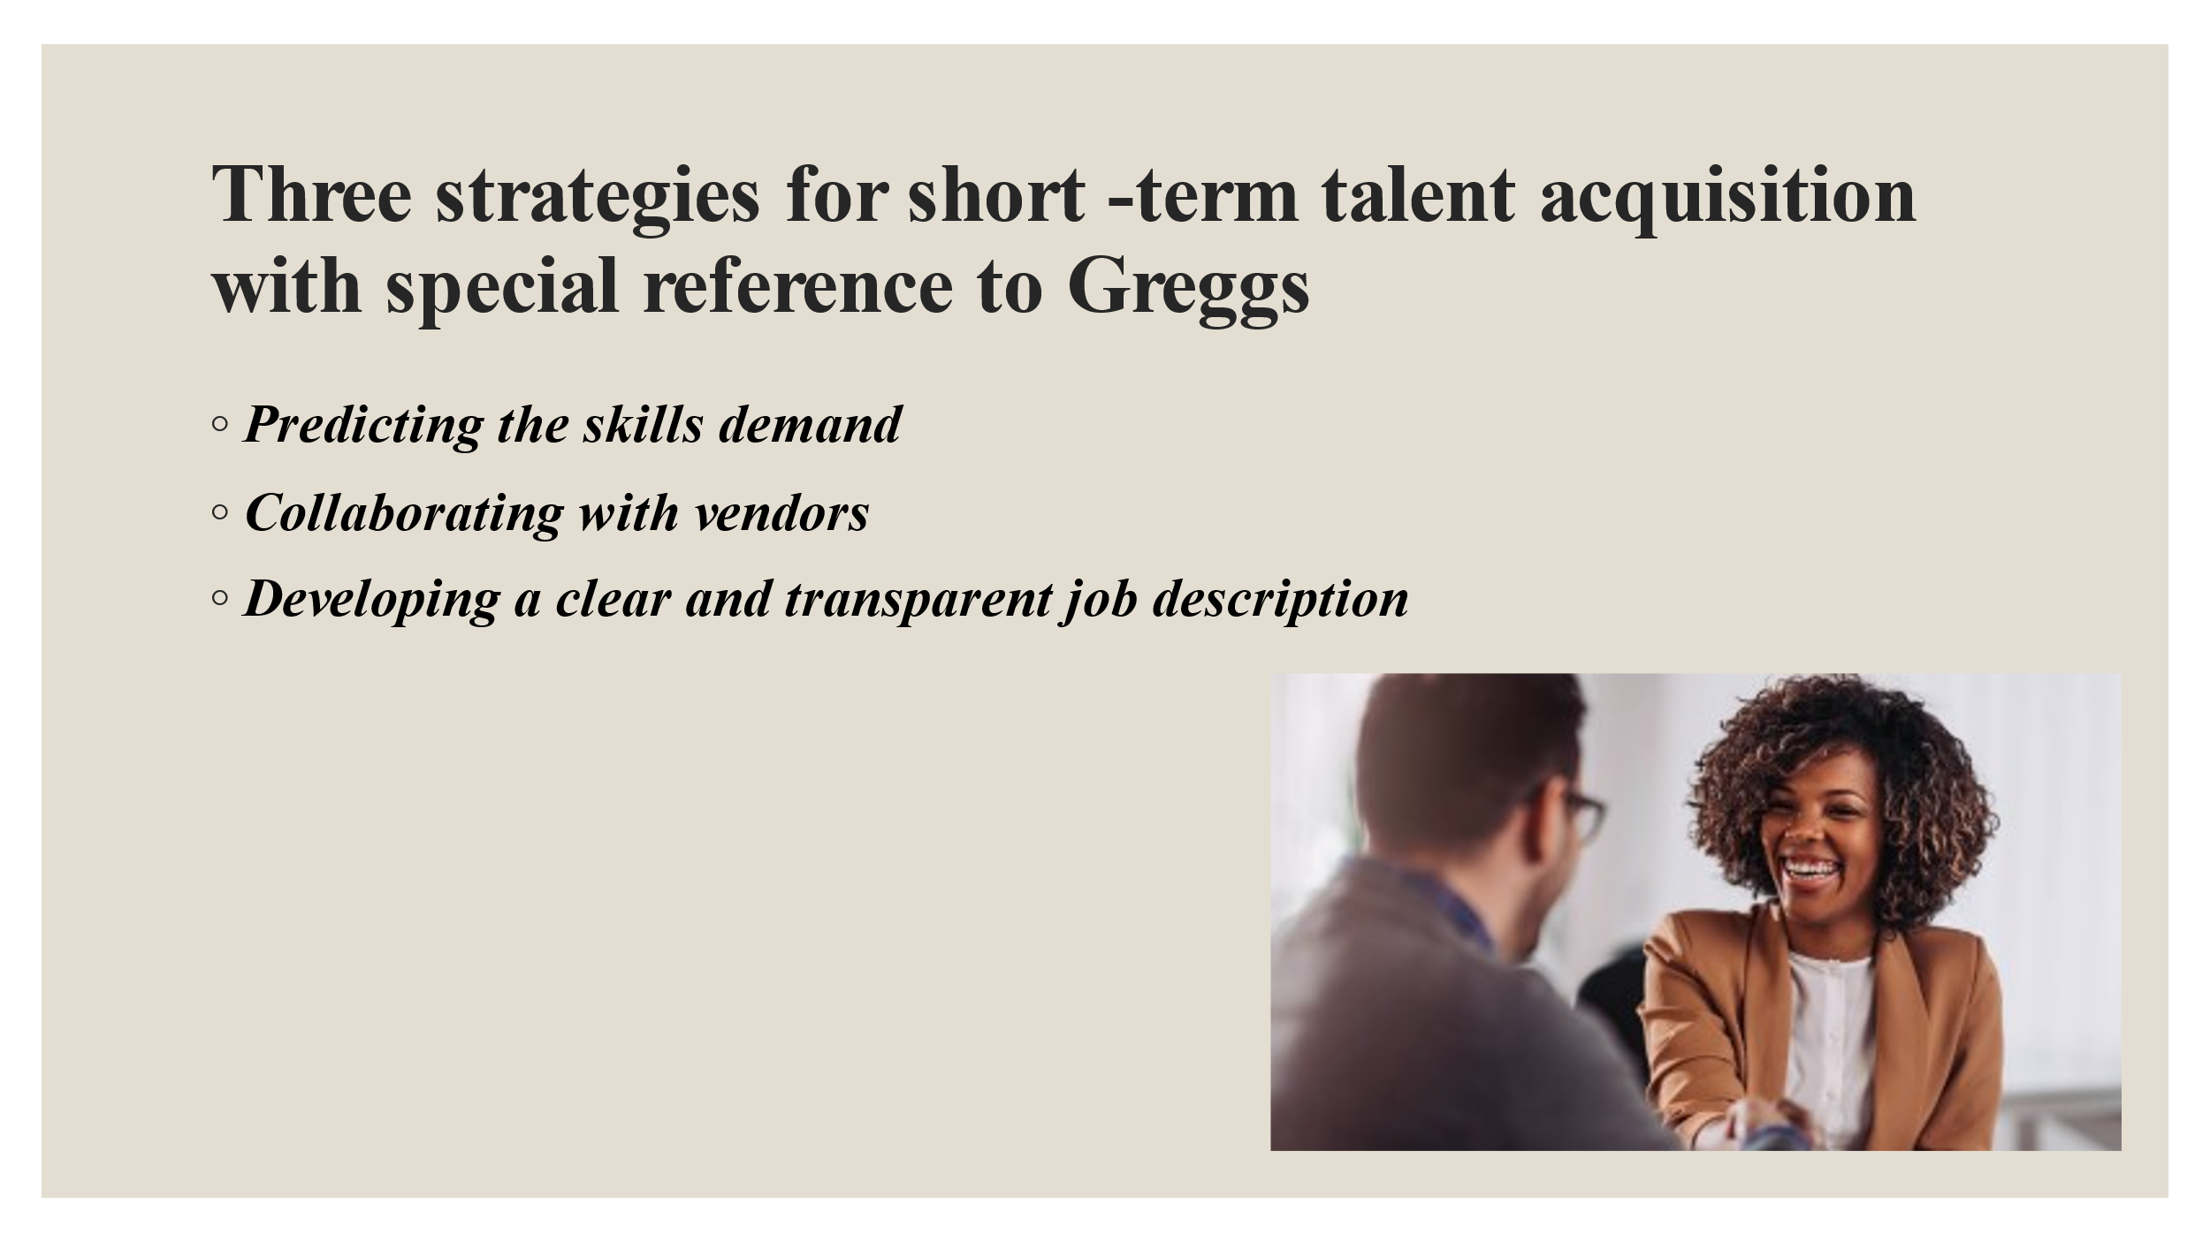
Short-term talent acquisition strategies are of great importance for the recruitment of temporary or seasonal employees. Three short-term strategies that can be recommended to Greggs are being discussed here:
Predicting the skills demand
Before formulating any talent acquisition strategy, Greggs must analyze the "Capacity vs Demand" gap with the intention to recognize the skill requirements. It will also help the organisation determine whether they are one-time or recurrent (Mujtaba and Mubarik, 2022). After deciding whether they want permanent or temporary or contractual employees, they can recruit within a very short time span.
Collaborating with vendors
One of the most fruitful short-term talent acquisition strategies is to collaborate with vendors. In this context, it is important to note that not all contingent vendors are going to meet the skill requirements. To avoid this, organisations may take the contract formats, service charges, and success rates into account. Furthermore, Greggs can partner with five to six best-fit expert vendors, so that they can contact them immediately to fulfill the short-term hiring needs of the company.
Developing a clear and transparent job description
A job description can be considered to be the most important element of the whole hiring process as it helps the candidates determine whether they are suitable for the vacant position or not (Shet, 2020). Hence, the hiring managers of Greggs are advised to ensure that their job descriptions are accurate, complete, and up to date. They are further advised to include all the important elements of a good job description like job title, skills and expertise, roles and responsibilities, work experience, remuneration, and so on.

Slide 4: Three strategies for long-term talent acquisition with special reference to Greggs

Long-term talent acquisition strategies are different from short-term ones and such strategies are generally targeted to hire permanent employees, hence, are crucial for the success of an organisation. Three long-term talent acquisition strategies that can be beneficial for Greggs are briefly explained here:
A long-term hiring plan and hiring calendar.
Long-term recruitment is a continuous process that typically requires additional planning and preparation beforehand. However, before making such plans, the hiring managers of Greggs must analyse and further estimate the resources that are required by the individual departments. Based on such data, a recruitment calendar may be developed in which all important details will be incorporated such as the positions that are needed to be hired per quarter or the total headcount of each department (Gilch and Sieweke, 2021).
Enhanced employer branding
Past studies have proved that employer branding has a significant role to play in any sort of talent acquisition strategy as it deeply influences how candidates perceive a brand. Hence, Greggs must work on improving its brand reputation so that the organisation is able to attract top talents. To do this, the organisation may survey its existing staff members and further draw conclusions from the survey results to enhance its brand image. In addition to this, they may also upload testimonials of the existing employees on various social media platforms like Facebook, Twitter, and Instagram to attract top talents.
Using multiple online job portals that are available.
In this modern age, there is a wide range of online portals available with the help of which business organisations can hire the right candidates (Chilson and Wehner, 2020). Greggs may use such online portals to post their job vacancies and kickstart their hiring process. These online portals can create a social presence for Greggs which will eventually help the company to significantly widen its horizons and further attract global resources.

Slide 5: Incentives and rewards
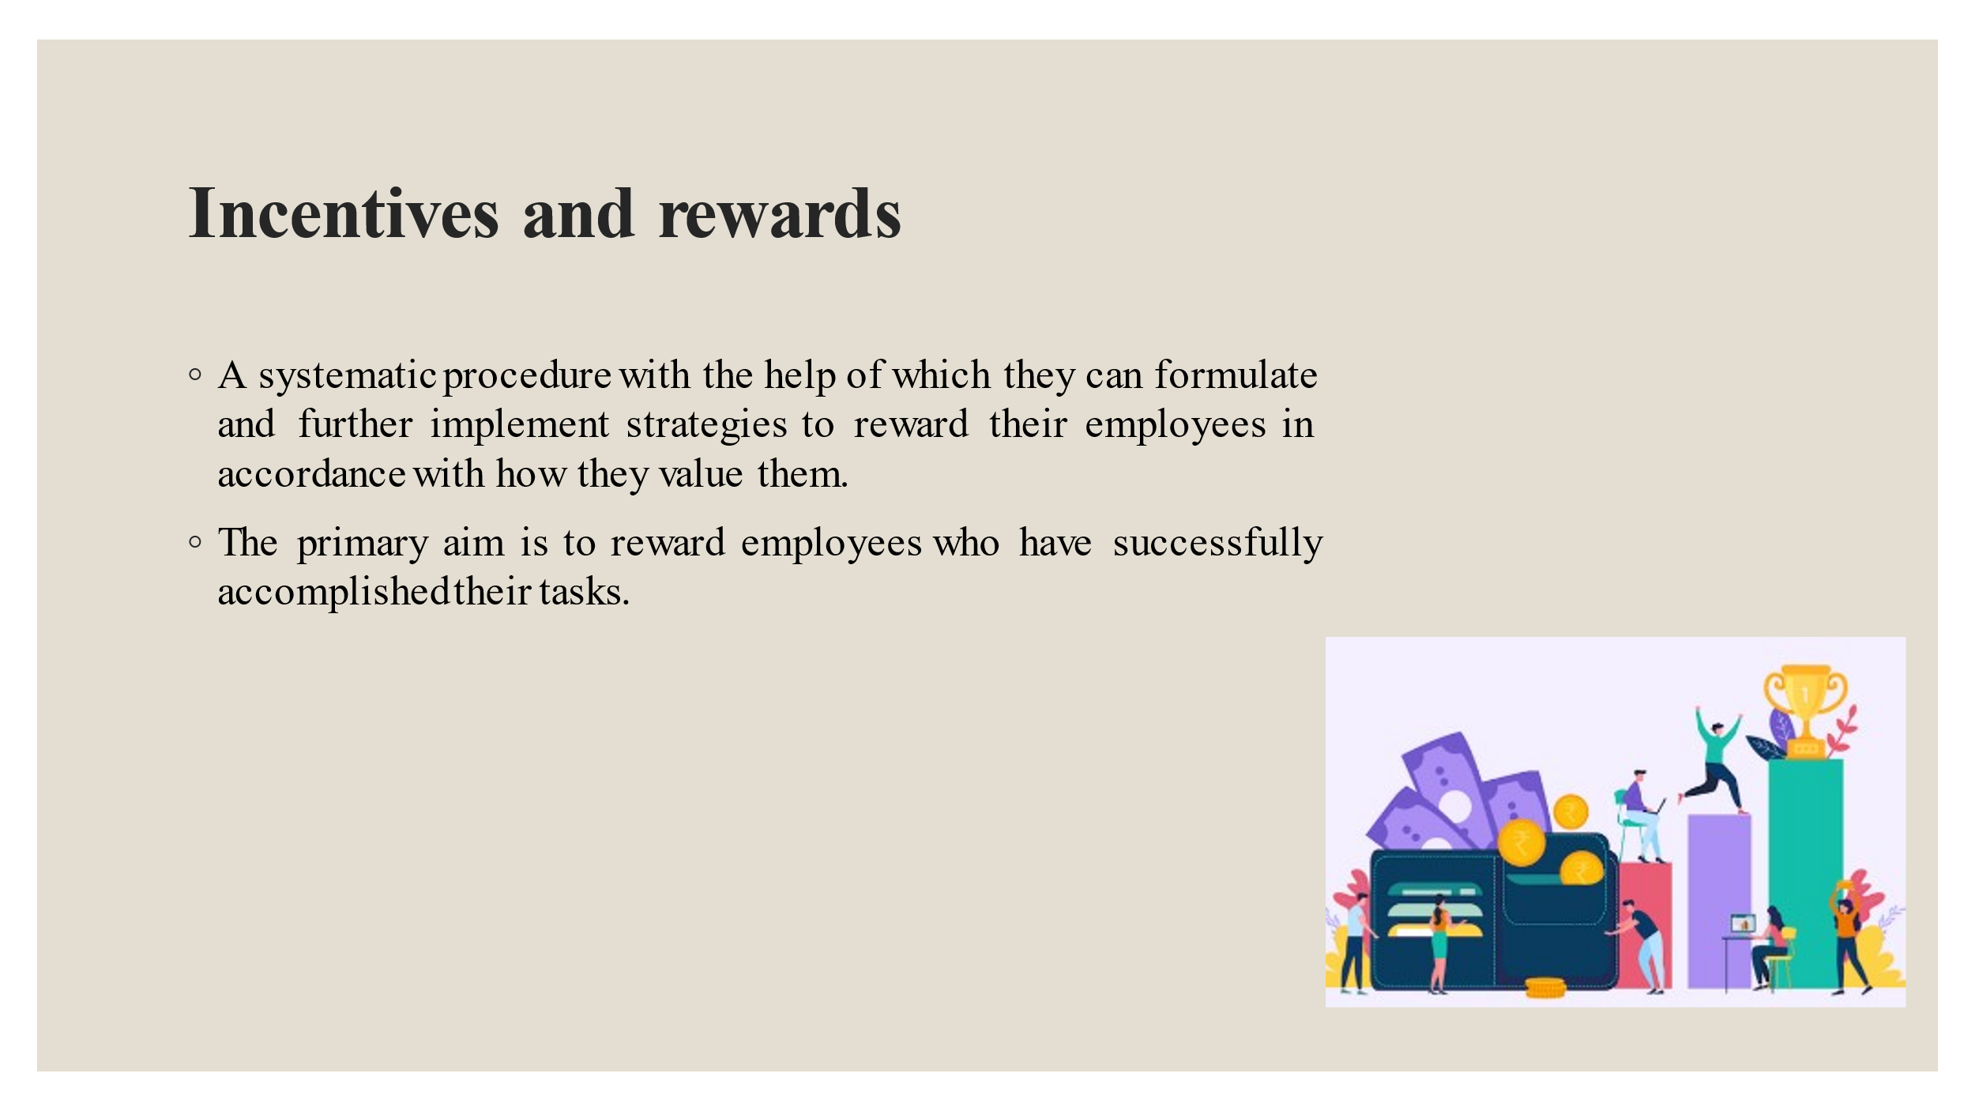
The incentive or reward system of a business organisation can be defined as a systematic procedure with the help of which they can formulate and further implement strategies to reward their employees in accordance with how they value them. Such systems should be maintained in a completely fair and unbiased manner. The primary aim is to reward employees who have successfully accomplished their tasks. Therefore, it motivates the employees to work harder and make use of their full potential every day (Sivathanu and Pillai, 2020). In this context, it is important to note that incentives or rewards not only include financial rewards like payout, but they also include non-financial rewards like employee recognition and appreciation, employee training and development, increased job responsibility, and so on.

Slide 6: Two monetary methods with special reference to Greggs
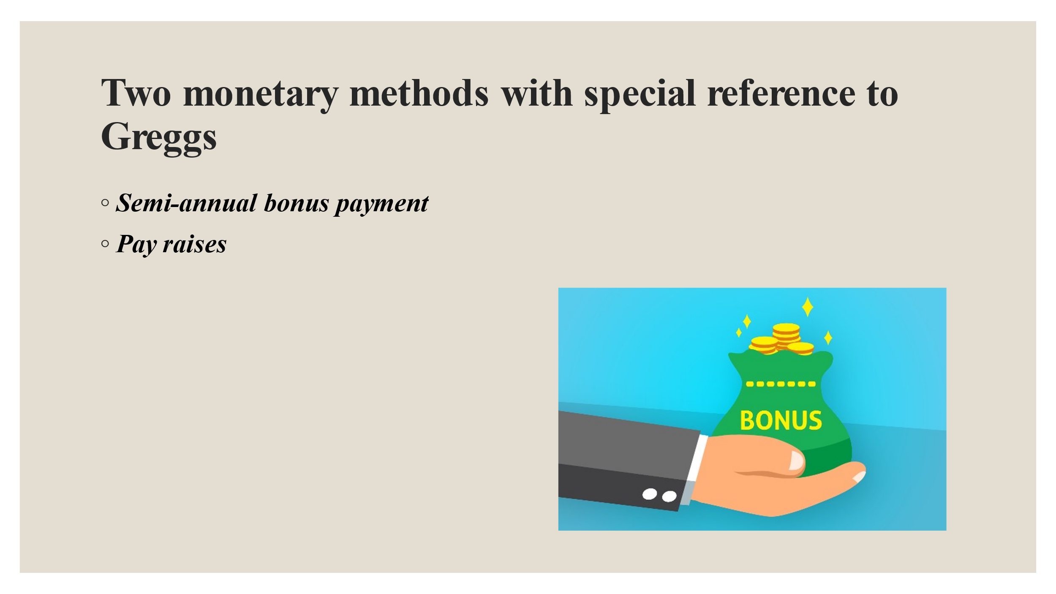
Monetary methods of incentive or reward systems work best for employees who are motivated by money. Two monetary methods that can be recommended to Greggs are being discussed here:
Semi-annual bonus payment
Semi-annual bonus payment basically means bonus compensation, that if earned, is typically paid, after the end of every second and fourth quarter. This particular type of bonus generally encourages healthy and fair competition among the employees in regard to their overall productivity and performance (Awan et al., 2020). With the help of such a monetary reward method, Greggs can influence their employees to compete with each other which eventually can help the organisation to sustain itself for a much longer period of time.
Pay raises
To be able to earn a living is the sole reason why an individual goes to work every day. Therefore, it is quite natural for them to expect to be compensated well for the efforts which they put in on a daily basis. This can easily be done by competitive pay raises. Greggs must conduct research to determine and further understand the market rates to ensure that they are paying their employees in accordance with the found standards. If not done, their employees can become demotivated which can lead to high staff turnover.

Slide 7: Two non-monetary methods with special reference to Greggs
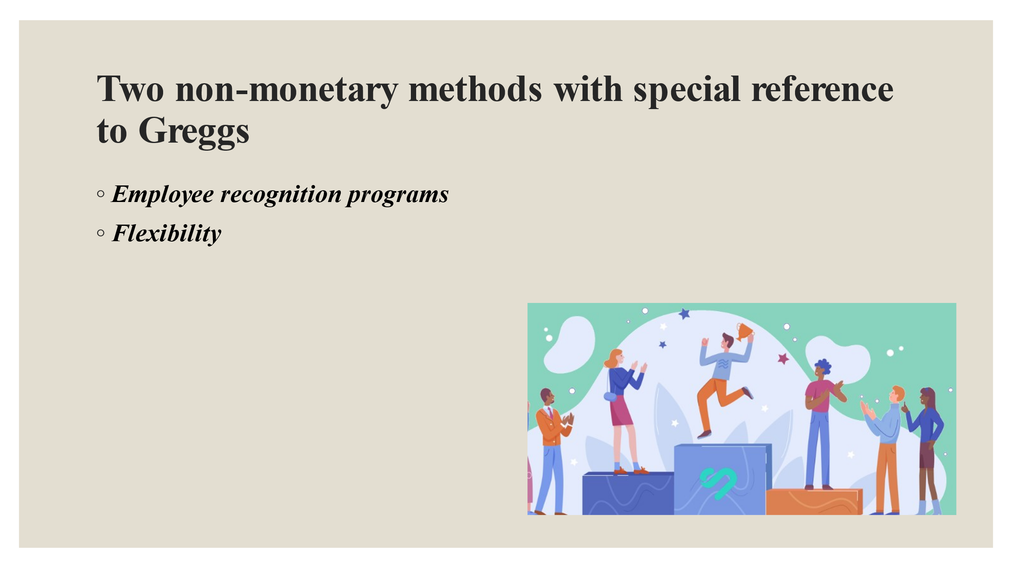
Apart from the monetary means of rewards, employees expect other forms of rewards as well which helps to develop a relationship of trust and care with their employers (Hussain et al., 2019). Two non-monetary reward means that can be useful for Greggs are being discussed here:
Employee recognition programs
Giving recognition and appreciation to the employees can be done both by verbal praise or by organizing formal award ceremonies. Such programs are usually held on a daily or weekly or monthly or yearly basis, whichever is convenient for the business organisations. Hence, Greggs must give adequate recognition to their employees who have met all the necessary standards to boost their morale and self-esteem.
Flexibility
Giving flexibility at work is another popular means of reward system. Past studies have highlighted that one of the biggest reasons why employees leave their jobs is their inability to fulfill both their personal and professional commitments (Paais and Pattiruhu, 2020). Greggs can easily eliminate this dilemma by offering work from home or remote working or flexible working opportunities to their employees.

Slide 8: Conclusion
The following presentation has briefly explained talent acquisition along with identifying and further exploring three short-term and three long-term strategies of talent acquisition. Furthermore, it has identified two monetary and two non-monetary means of incentives and rewards which can motivate employees to use their full potential.

Slide 9: References
Awan, S.H., Habib, N., Shoaib Akhtar, C. and Naveed, S., 2020. Effectiveness of performance management system for employee performance through engagement. SAGE open, 10(4), p.2158244020969383.
Chilson, A. and Wehner, J., 2020. Managing your talent supply chain: Why you should care. Journal of Supply Chain Management, Logistics and Procurement, 2(3), pp.202-210.
Ette, S. (2022) Third of businesses to reduce opening hours over Christmas due to staff ... Available at: https://www.ukhospitality.org.uk/news/625938/THIRD-OF-BUSINESSES-TO-REDUCE-OPENING-HOURS-OVER-CHRISTMAS-DUE-TO-STAFF-SHORTAGES.htm (Accessed: March 15, 2023).
Gilch, P.M. and Sieweke, J., 2021. Recruiting digital talent: The strategic role of recruitment in organisations’ digital transformation. German Journal of Human Resource Management, 35(1), pp.53-82.
Hongal, P. and Kinange, U., 2020. A study on talent management and its impact on organization performance-an empirical review. International Journal of Engineering and Management Research, 10.
Hussain, S.D., Khaliq, A., Nisar, Q.A., Kamboh, A.Z. and Ali, S., 2019. The impact of employees’ recognition, rewards and job stress on job performance: Mediating role of perceived organization support. SEISENSE Journal of Management, 2(2), pp.69-82.
Mujtaba, M. and Mubarik, M.S., 2022. Talent management and organizational sustainability: role of sustainable behaviour. International Journal of Organizational Analysis, 30(2), pp.389-407.
Paais, M. and Pattiruhu, J.R., 2020. Effect of motivation, leadership, and organizational culture on satisfaction and employee performance. The Journal of Asian Finance, Economics and Business, 7(8), pp.577-588.
Shet, S.V., 2020. Strategic talent management–contemporary issues in international context. Human Resource Development International, 23(1), pp.98-102.
Sivathanu, B. and Pillai, R., 2020. Technology and talent analytics for talent management–a game changer for organizational performance. International Journal of Organizational Analysis, 28(2), pp.457-473.

