‘Islam does not permit the representation of human figures’ is this statement true? Discuss the following statement in reference to examples of Islamic art you have studied.

There is a common misconception made about Islamic art which is that they do not have any figural representation. This is not true as figural representation can be found in Islamic art in a number of ways and in numerous forms. The imagery that can be found varies in type and there are many influences from different cultures. These include Persian influence and Chinese influence. There is very little written in Islamic texts on what should be done in terms of figurative depiction and what should and should not exist. The little guidance there is on the subject tends to have to be found in the Hadith but there is no clear-cut view on what should be produced and what should not. There tends to be a view taken in that there is a prohibition on figurative imagery in terms of the decoration within the Mosques and the Qur’an. Although this does not extend to palaces or non-religious buildings, in certain texts and in pieces of art made around the Islamic world.
There is very little written in terms of whether Muslims should depict figures in their art. There is also little guidance on whether there are any figures that should not be depicted in their art. In the core Islamic text, the Qur’an, there is little to no mention on figural representation and the approach that should be taken in regard to it. The only comment that the Qur’an makes on the issue of figural representation is to “condemn idolatry and uses the term mussawir (maker of forms, or artist) as an epithet for God.” (Metropolitan Museum of Art, 2001). This does not provide clear guidance as it is mostly stating that God is the creator of forms but does not elaborate on whether images count in this description. Therefore, the advice on whether there can be any figural representation and if so how this should be approached is non-existent. This can be problematic due to conflicting views on whether there should be any figural representation in Islam. The Hadith are the traditions of the Prophet and is the only text which specifically passes comment on the issue of figural representation. In the Hadith painters are challenged to “breath life” (Metropolitan Museum of Art, 2001) into their depictions. The interpretation that seems to be taken in this regard is that there should not be any figural representation that could be deemed to be real. This however, lead to the question of what can be assumed to be a realistic depiction. This varies dramatically in many cultures and religions therefore what is realistic or an image that has had life breathed into it is debateable. There are a number of examples of Islamic art with figural imagery meaning that it is still used but to what extent is unknown. These texts therefore form the basis of how figurative imagery should be dealt with in Islamic art, but the guidance they provide is limited and what classes as an image that someone has breathed life into and the images that are acceptable in Islamic art is undefined in these texts and there does not appear to be any clear definition. Some may interpret the text as a prohibition against images of any kind and others may view it as the images must be stylised to prevent them from becoming too lifelike. “The prohibition of representational art has therefore been explained in terms of the aesthetic function and the politics and historical function of Islam.” (Modj-ta-ba Sadria, 1984). This can lead to the view that the prohibition of figurative imagery does not derive from a religious perspective but the political and historic role of Islam and what the figurative imagery may result in as the reason for the prohibition.
The designs and imagery that are used in Mosques tend to be very decorative in nature. These however, tend not to be figurative and rely more on using script in a decorative manner. The interior of the Dome of the Rock, for instance, has many patterns throughout and uses Arabic script as another form of decoration. However, nowhere within the internal decoration is their figurative imagery. This is because when figurative imagery is approached a widespread view is that there is a prohibition against any figurative imagery in any Mosques. The reason for this may be interpreted as being due to the Mosques being a house of God. Therefore, using any figurative imagery would be deemed to be disrespectful as it is believed that God breathed life into people and therefore any figures not of God’s making are not permitted in a house of God. However, this is a contrast to the buildings built by the Umayyads as “the magnificent buildings and desert palaces of the Umayyad caliphs were decorated in the style of Christian Late Antiquity, which abounded in images.” (The David Collection, N/D). This therefore shows how although there are a number of rules that must be followed and a prohibition against the use of figurative imagery in mosques, that this does not stand in all buildings. The elaborate buildings that were built by the caliphs could have figurative imagery and there is evidence that some of them did. This can also be seen by the sculptures at Khirbat al-Mafjar. This site has many sculptures of figures and this shows how figurative imagery could be used in the grand palaces of the caliphs. Therefore, if the caliphs were allowing figurative imagery into their palaces then their must not have been a total prohibition on figurative imagery. This therefore, indicates that the view on figurative imagery that is taken is dependent on the individual and that there is no clear-cut right or wrong. The only clear view is that there should be no figurative imagery in Mosques and in the Qur’an as that would be defying God.

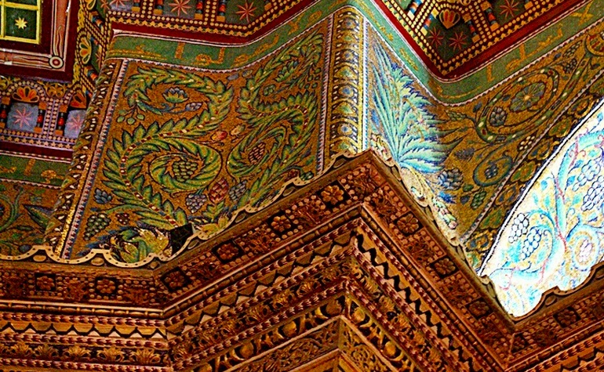
Figure 1 – Some of the internal decoration of the Dome of the Rock

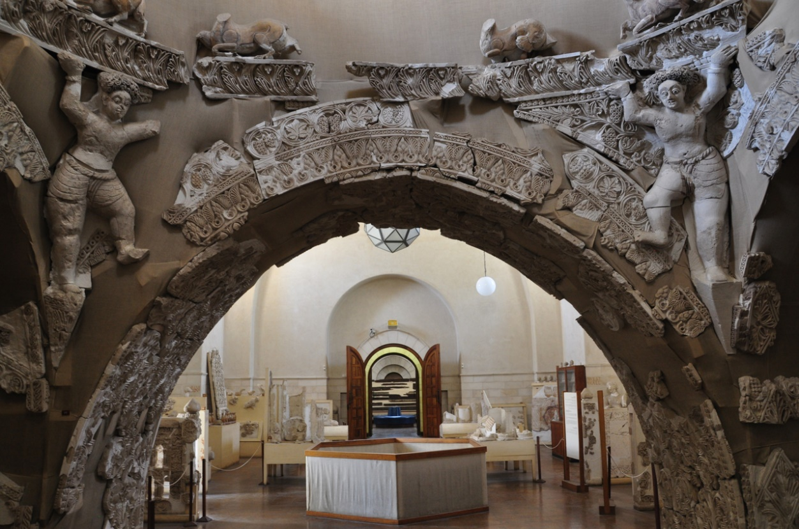
Figure 2 – Figurative Sculpture from Khirbat al-Mafjar

There are a number of examples of figurative imagery that can be seen. These can depict important figures such as the images of Muhammad. They can also draw their influence from cultures that have influenced the region. Two of the main influences for this are Persia and China. Both of these had close links with the Islamic world as initially much of the Islamic world was in the Persian empire. The influence from China comes from the fact that the Silk Route goes directly through some of the Countries that are part of the Islamic World. This route connects China to the Mediterranean world and therefore a lot of trade from China will have had to pass through those Countries and trade would have had an influence on everything that they produced. There are a number of images of Muhammad that can be found. This may show that the use of figurative imagery is permitted as they have depicted the Prophet who is one of the most important figures in Islam. This therefore may show that figurative images were allowed, just not to be mass produced. There is a depiction of Muhammad leading other key figures, including Jesus, Abraham and Moses, in prayer. This depiction can be found in a manuscript and is Persian in origin. This plays a significant role in the view of figurative imagery as although some interpret there being a complete prohibition on figurative imagery, whether this covered the entirety of the Islamic world is uncertain. This being produced in the East may provide an explanation in that the Countries in the East, particularly Iran, hold onto some influence from pre-Islamic times. The Persian influence can also be seen in many ways as figurative imagery was produced in the east and the faces in this image tend to be in the style that can be seen in Persian imagery. The use of figurative imagery causes much debate among scholars as by looking at the modern motifs and decoration used in Islam there is no indication that any figurative imagery had ever been used and yet, as mentioned above, not only did they make figurative imagery but they depicted the Prophet who passed on the word of God. There is a further image of Muhammad which depicts the destruction of the idols at the Kaaba. This image shows the destruction of any idols that are not God. This event depicted in a figurative illustration though seems to support the portrayal of a message through figurative imagery.

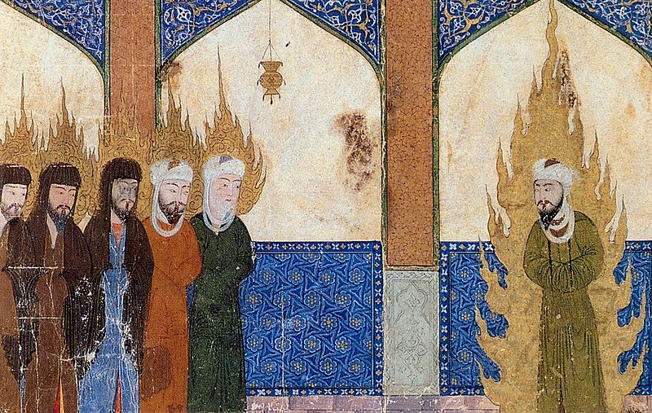
Figure 3 – Muhammad leads Jesus, Abraham and Moses in prayer
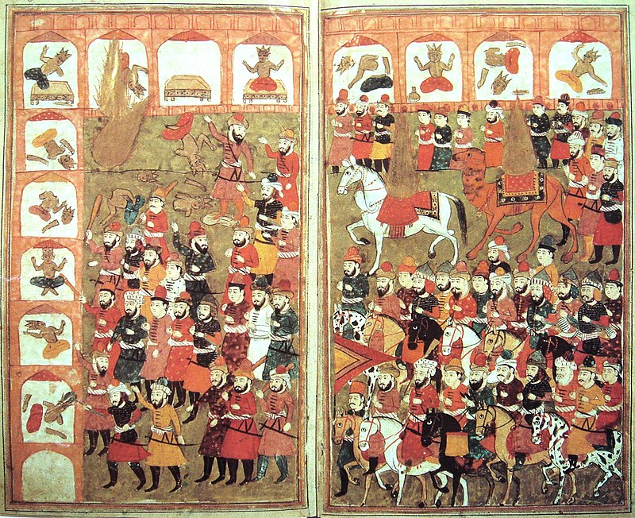

Figure 4 – The Destruction of the Idols at the Kaaba
There is another example of figurative imagery which includes images that are influenced by Chinese art. There are a number of pieces of figurative imagery that have Chinese style faces and seem to be oriental in style. This shows an influence on Islamic art from a different region. This is likely caused by the Silk Route. It can be believed that “the sudden appearance in the Islamic world of new methods of visual representation was the product of increased contact with China.” (Cai, 2010). The development of Islamic art did not take centuries to develop as with many other cultures, instead it developed through the influence of other cultures. A clear link between Islam and China can be seen in the image Bahram Gur Wrestling before King Shangol of India. This is found in the manuscript of the Shahnameh that was found in Iran. This image by name links the piece of figurative imagery not with China but with India. However, the style of the image is very Chinese. The faces of the figures can be seen to be very similar to those that are found in oriental imagery. The style of the woman in the top left of the image is very Chinese in nature. She is wearing clothing that looks very similar to an oriental dress and her hair is coloured and styled in the same way as many Chinese women in their own imagery. The style of clothing worn by the others in the image, including that of the Indian King, appear to be Chinese in nature as well. Therefore, making it stylistically linked to China and not Iran. This emphasises a connection to China as this was a completely different style of figurative imagery than that which had been produced previously as the faces and clothing styles were different to that of the aforementioned image of Muhammad teaching prominent figures.
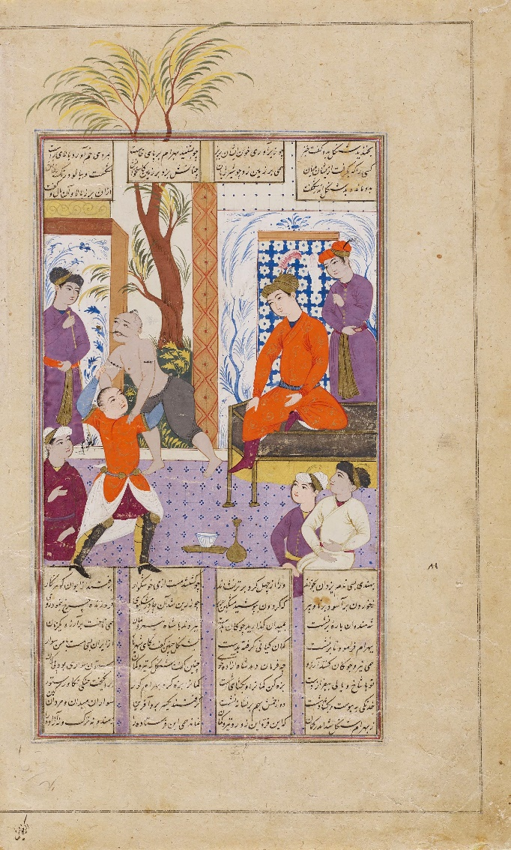
Figure 5 – Bahram Gur wrestling before King Shangol of India
Overall, there was figurative imagery in Islamic culture but there was also a prohibition in certain areas and more recently a near total prohibition against figurative imagery. This figurative imagery came in many styles and with many figures being depicted. The prohibition initially started in places of worship or items important to do with worship with figurative imagery being prohibited in Mosques and within the Qur’an itself. The view of a total prohibition on imagery is not shown throughout Islamic history. There are a number of figurative images that are created and this must not have meant a total prohibition on figurative imagery. Some of the caliphs even had figurative imagery in the palaces that they built for themselves, if the representatives of the Prophet had figurative imagery then this must have been permitted to some extent. There is very little written guidance on what the view is on figurative imagery. The Qur’an makes little to no comment and the Hadith does make a comment but it does not clearly guide on whether there should be no Islamic figurative imagery or whether it should all be stylised. Therefore, it is not a case that Islam does not permit the representation of human figures it is that there can be no lifelike portrayal of human figures.

Bibliography
Aga Khan Museum. N/D. Bahram Gur Wrestling Before King Shangol of India. [webpage] Available at: <https://www.agakhanmuseum.org/collection/artifact/bahram-gur-wrestling-before-king-shangol-akm449> [Accessed 13 February 2018].
Cai, L., 2010. The Journey of Maps and Images on the Silk Road by Philippe Forêtand Andreas Kaplony. [article] Available at: <http://www.jstor.org/stable/40784729> [Accessed 07 February 2018].
Hanawalt, B., 1998. The Middle Ages An Illustrated History. Oxford University Press. Oxford.
Islamic Landmarks. 2018. Interior of the Dome of the Rock. [webpage] Available at: <https://www.islamiclandmarks.com/palestine-masjid-al-aqsa/interior-of-the-dome-of-the-rock> [Accessed 13 February 2018].
Israel Tours. N/D. Hisham’s Palace in Jericho. [webpage] Available at: <https://israel-tourguide.info/2013/08/07/hisham-palace-jericho/> [Accessed 13 February 2018].
Sadria, M., 1984. Figural Representation in Islamic Art. [article] Available at: <http://www.jstor.org/stable/4283032> [Accessed 07 February 2018].
The David Collection. N/D. The Religious Prohibition against Images. [webpage] Available at: <https://www.davidmus.dk/en/collections/islamic/cultural-history-themes/image-prohibition> [Accessed 13 February 2018].
The Metropolitan Museum of Art. 2001. Figural Representation in Islamic Art. [essay] Available at: <https://www.metmuseum.org/toah/hd/figs/hd_figs.htm> [Accessed 13 February 2018].
Unknown. 1808. Histoire Geographie 5ieme Nathan. [image] Available at: <http://www.bowincars.org/mediawiki-1.6.12/extensions/Fetch.php?topic=File:Muhammad_destroying_idols_-_L%27Histoire_Merveilleuse_en_Vers_de_Mahomet_BNF.jpg> [Accessed 13 February 2018].

