

Programme:
BA Business Management
Module: Accounting Fundamentals
LCBB4001
Assignment A1

Lecturer: Rita Ukachi Lois
Student name: Olga Andronic
Student Number: 2119164
Date of submission: 29.08.2022

Table of Contents
Question 1 3
Income statement for the year ended 31st December 2021 3
Financial position balance 6
Question 2 8
Ratios for Sweets plc for 2021 and 2020 8
ROCE 8
ROE 8
Earnings per share 9
Net profit margin 10
Asset turnover 10
Stock holding days 11
Debtor’s collection period 11
Current ratio 12
Gearing ratio 12
Interest cover 13
Financial performance and position of Sweets plc 14
Reference list 15

Question 1

Income statement for the year ended 31st December 2021
An income statement is a kind of financial statement that is well recognised for the value it delivers in displaying a company's revenue and costs in a way that is both clear and concise. This type of statement is well known for its worth. It is also helpful for illustrating whether an organisation was profitable or unprofitable during a certain period of time, which is something that is beneficial (Ogneva et al. 2020). The income statement also goes by the terms profit and loss statement, statement of comprehensive income, statement of changes in financial result or income, and statement of operations. These are all just different ways of referring to the same item. The creation of an income statement may assist business owners in reaching a conclusion on how best to maximise their profits, whether that be via an increase in revenue, a decrease in costs, or any mix of the two approaches. It is essential because it illustrates how well a company's plan was implemented at the beginning of the financial year (Phillips et al. 2019). This is a synopsis of Wales Plc's income statement, which can be seen below:
Wales Plc
Income Statement
For the year ended 31.12.2021
Particulars | £ | £
Sales | 800000
Cost of Sales | 578650
Gross Profit (A) |  | 221350
Operating Expenses:
Administrative Expenses | 30000
Interest Paid | 2000
Director's Remuneration | 5000
Distribution Costs | 28000
Commission to Salesman | 3000
Total Operating Expenses | 68000
Less: Other Income | 980
Total Expenses |  | 68980
Net Income before Tax |  | 152370
Corporate Tax |  | 100000
Net Income after Tax |  | 52370

Figure 1: Wales Plc’s Income Statement
(Source: Self Created)
The statistics shown up top indicates that the company in question generated a total of £52,370 in earnings during the 2020 fiscal year. When it comes to a company's ability to generate a profit, one of the most crucial things to consider is the efficiency with which it handles its operations (Kadirovich and Kahramonjonugli 2022). After calculating the net profit of a company, the owners will likely have a better idea of where their money is coming from and will be able to devise strategies for how it will be divided among them. An increase in the company's earnings is the primary factor that encourages investors to put their money into the firm in the belief that they will reap a given level of profits after a particular length of time has passed. This belief is based on the expectation that the firm will continue to grow in the future.
It is common practise for financial professionals and accountants to recommend to stock investors that they prioritise increasing their net profit as a primary criterion of investing prior to purchasing stock. This recommendation is made with the intention of encouraging investors to make more profitable investments (Beale and Hiers 2021). Investors in stocks are provided with this piece of guidance. When determining whether or not a company is eligible for a loan, the net income of the organisation is another crucial consideration that has to be taken into account. If creditors chose to utilise it in this capacity, they may use it as a reliable predictor of debtors' predicted ability to pay off their outstanding bills in the future, which would allow them to use it for this purpose. The figure that is assigned to the monthly net profit may be included into the estimation of one's disposable income, which can then be used to the calculation of one's monthly loan amortisation. The number may also be used directly if it is more convenient. Therefore, it is feasible to show that Wales Plc is well positioned everywhere throughout the particular market by making use of the information that is created by the income statement of the current organisation.
This record may also be referred to as a "balance sheet," which provides information on the equity, liabilities, and assets held by a business as of a certain date (Semenyshena et al. 2020). Assets include things like equipment, buildings, shares of stock, money, and anything else that the business may spend its money on. Assets also include anything else that the corporation may spend its money on. Financial assets are also considered to be a part of this category. On the other hand, liabilities are obligations that a company owes to other parties such as creditors, lenders, suppliers, and other persons or organisations. These parties might be either individuals or other organisations. The term "equity" refers to the owner's remaining financial interest in the company after deducting the total amount of the company's obligations from the total value of the assets owned by the company (Zaynab 2021). In other words, equity is the amount of the owner's remaining financial interest in the company. The data that is included in the statement of financial status can be used for a variety of different financial analyses. Two examples of comparisons that can be found in the statement are a comparison of current commitments to current assets and a comparison of debt to equity. The data that is included in the statement can be used for both of these comparisons. We are able to monitor Wales Plc's financial health over time and recognise any changes that may occur as a consequence of these monitoring efforts due to the fact that the findings of all significant studies are exhibited mostly along a trend line (Stone 2020). When carrying out an analysis of the financial statement belonging to the relevant organisation, the following considerations are taken into account:
Wales Plc
Statement of Financial Position
For the year ended 31.12.2021
Particulars | £ | £
Current Assets
Stock | 330600
Trade Receivable | 170125
Cash and Bank | 76250
Total Current Assets |  | 576975
Non-Current Assets
Plant and Equipment | 632730
Total Non-Current Assets |  | 632730
Total Assets |  | 1209705
Current Liabilities
Trade Payable | 171355
Total Current Liabilities |  | 171355
Non-Current Liabilities
4% Debentures | 100000
Short-Term Debt | 3980
Total Non-Current Liabilities |  | 103980
Total Liabilities |  | 275335
Equity
Share Capital (400000+300000) | 700000
Retained Earnings | 132000
Payment of Ordinary Dividend | 20000
Payment of Preference Dividend | 30000
Profit/(Loss) for the current year | 52370
Total Equity |  | 934370
Total Liabilities and Equity |  | 1209705

Figure 2: Statement of Financial Position of Wales Plc
(Source: Self Created)
According to the information shown up above, Wales Plc had a total asset value of 1,209,705 pounds sterling and a total liability value of 275,335 pounds sterling for the financial year that ended in December of 2021 (Harlan 2020). It is a sign that the value of the potential components obtained by the management of the existing company is more than the value that is owed by the present organisation. Because it offers ongoing updates to equity, liability, and asset accounts, the statement of financial position is an effective tool for use in an organisation that makes effective use of the double-entry accounting system. The relevant statement also helps to deliver useful information at the time it is prepared by adhering to the fundamental accounting rules required by accounting frameworks such as "International Financial Reporting Standards" or "Generally Accepted Accounting Principles," Both of these accounting frameworks are examples of accounting frameworks.

Financial position balance
All measurable resources possessed by the firm or those are anticipated to be acquired by the company are included on the balance sheet as assets. On the other hand, liabilities consist of items like debt, wages, payables, and taxes that the corporation is required to pay in the future (Stewart 2020). This section of the balance sheet is concerned with the amount of earnings that are kept by the firm as well as the value of the capital that is distributed to the shareholders. It is essential for the overall worth of an organization's assets to be equal to the whole amount of its liabilities plus the equity held by its shareholders for the balance sheet of that business to reflect a condition of financial equilibrium. To put it another way, the principle of double entry in accounting is the engine that drives a balance sheet that is accurate and complete.
Within the suitable accounting system, each and every conceivable transaction is first recorded in at least two distinct accounts, and these accounts are then monitored as a relevant check to verify consistency within the entries (HYK 2020). The technique of accounting that is referred to as "double entry" is one in which every conceivable transaction is documented in at least two entries, each of which includes two components, as the phrase "double entry" suggests (Credit and Debit). Every transaction that results in a debit must, in accordance with the applicable principle, also result in a credit that is equal to or larger in value. A double-entry accounting system ensures a logical and scientific approach to record-keeping and documentation of financial transactions. When it is comes to the more comprehensive type of accounting, the system that is in place places a significant emphasis on documenting both sides of the transaction.

Question 2

Ratios for Sweets plc for 2021 and 2020

ROCE
“The Return on Capital Employed (ROCE)” is a financial statistic used to assess how well a company is recouping the money it invests in its operations. If Sweets Plc's return on capital employed (ROCE) is greater than that of its peer companies, then means the division in question is more profitable than its peers on average (Suvorova 2019). For the company's bottom line, this is a far better scenario since it means more earnings.
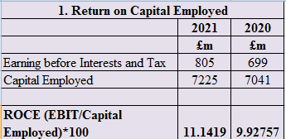
Figure 3: ROCE of Sweet Plc
(Source: Self-Created)

ROE
“Return on Equity (ROE)” may be thought of as a possible measure of a company's profitability by dividing its net worth by the value of its shareholders' equity.
Growing return on equity shows that Sweets Plc is getting more money out of its existing capital (Campebell 2019). For the current business, this means that resources are being used more effectively.
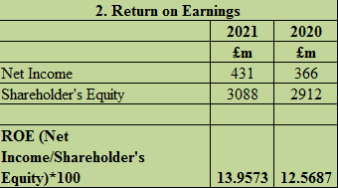
Figure 4: ROE of Sweet Plc
(Source: Self Created)

Earnings per share
“Earnings per share (EPS)” is a measure of the company's profitability relative to the number of shares of stock in circulation. Earnings per share (EPS) evaluations may be done either annually or quarterly.
When the number of earnings per share grows at a firm, it means that the organisation is generating more money to distribute to shareholders. For investors considering buying stock in the firm, this may be encouraging news.
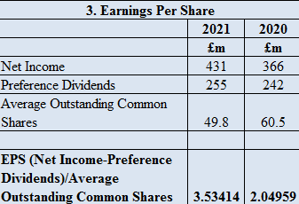
Figure 5: Earnings per Share
(Source: Self-Created)

Net profit margin
The value of Sweets Plc's net income in the 2020-21 fiscal year is determined by the margin associated to the net profit (ODO 2018). If a company's net profit margin is higher than the industry average, it means that it is more effective at turning its sales into actual profits over a certain time period. Effectiveness may be evaluated over a predetermined time frame.
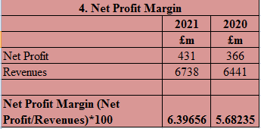
Figure 6: Net profit margin
(Source: Self-Created)

Asset turnover
The ratio of total sales or revenues to the typical amount of assets might be thought of as the most important ratio, and asset turnover can be considered to represent that ratio. It is helpful for investors to evaluate the company's performance in terms of how well it uses its assets to generate revenue because of the information provided by this measure (Li 2022). The high level of asset turnover ratio indicates that Sweets Plc is actively engaged in making more effective use of its assets throughout the course of the specified time period.
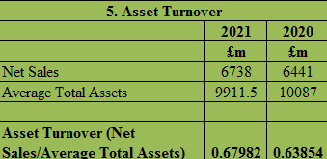
Figure 7: Asset Turnover of Sweet Plc
(Source: Self-Created)

Stock holding days
It is a ratio that determines the number of days, on average, that a business keeps the amount of inventory before beginning to make sales.
The fact that Sweets Plc has a greater day in stock holding demonstrates that the company is unable to quickly convert its amount of inventory into revenues in a timely way (Huefner et al. 2021). It is possible that the most significant reason for a company to have a larger stock holding days total is due to the acquisition of a big quantity of inventory or to a bad performance in sales.
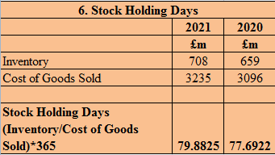
Figure 8: Stock holding days
(Source: Self-Created)

Debtor’s collection period
The amount of time an organisation waits before extending credit to new customers for the purpose of paying off existing debt is referred to as the collection period for debtors. The preceding financial data demonstrates that the firm in question is actively working to collect money from its customers in a short amount of time.
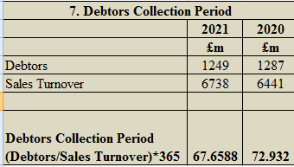
Figure 9: Debtor’s collection period
(Source: Self-Created)

Current ratio
The current ratio evaluates an organization's capacity to meet its immediate financial commitments by determining whether or not it has sufficient liquid assets to meet its short-term liabilities when they come due (Dong et al. 2019). The current ratio at Sweets Plc has been showing an upward trend recently, which is an indication that the company is becoming more capable of meeting its short-term commitments in an exact way. The company is able to improve its current ratio by implementing a number of prospective tactics, some of which include cutting down on a number of expenses, paying off obligations, and a great deal of other things.
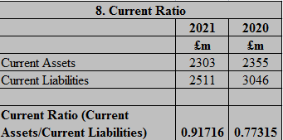
Figure 10: Current Ratio of Sweet Plc
(Source: Self-Created)

Gearing ratio
The gearing ratio is an important tool for determining the extent to which the total amount of long-term borrowing has contributed to the financing of the organization's assets that have been invested in by the organisation. The value of the gearing ratio significantly drops when Sweets Plc makes an efficient payment of its obligations, which in turn leads to a drop in the value of the ratio (Toshpulatov 2020). Increasing the number of shares that are made available to the general public has the potential to boost shareholder equity, which the company may then use toward the payment of organisational debt.
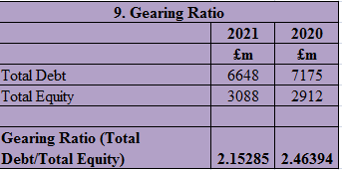
Figure 11: Gearing ratio
(Source: Self Created)

Interest cover
The interest cover ratio is a prospective ratio that is used inside the firm to assess the performance of the company in terms of its capacity to make the payment of interest on its existing obligations proportionately. The ratio is referred to as the interest coverage ratio. One way to look about the interest cover ratio is as a prospective ratio. This is a possibility.
It is plainly clear that Sweets Plc is significantly overburdened by the expenditures of debt in additional to the smaller quantity of capital that has to be used by the present business in an exact manner as a result of the lower percentage of interest coverage (Black et al. 2019). This is a combination of factors that has resulted in the current firm having a lower interest coverage ratio.
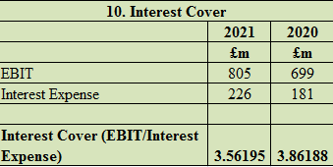
Figure 12: Interest cover
(Source: Self-Created)

Financial performance and position of Sweets plc
In light of the company's financial results, Sweets Plc's current management team has done a good job of keeping the ship afloat by effectively managing the necessary operational and financial aspects to enhance the company's income. This was accomplished with the help of Sweets Plc's financial performance. This is shown by the fact that there has been a rise in the total amount of revenues (Ogneva et al. 2020). It is possible that an improvement in the percentage of a company's income that is kept as net profit may be seen as a component that is beneficial for the organisation that is currently in place. This would be the case due to the fact that it would pique the interest of potential investors as well as other stakeholders in the specific firm. Developing an efficient level of returns from the concerned profitable organisation over a certain amount of time would be advantageous from the point of view of the relevant stakeholders and investors. This would be the case since it would be beneficial.
It is of the utmost importance that the leadership role of Sweets Plc establishes addressing the challenges faced in order to deal with the important problems that may emerge inside the organisation, for example as a consequence of variables such as inflation, the economic slump, and a great number of other causes (Phillips et al. 2019). Sweets Plc may confront these difficulties as a direct result of a wide variety of factors, including but not limited to: If this is done, the organisation will be able to better cope with the critical difficulties that may come up in the future. It would be vitally necessary for the leadership of the relevant company to run the financial operations in such a manner that greatly increased the level of income while simultaneously considerably reducing the number of costs. This would be an absolute need. New shareholders and investors may be enticed to participate in the firm if dividends and returns on investments made by existing shareholders and shareholders were distributed fairly (Harlan 2020). After a given amount of time has elapsed, this, in turn, will result in an improvement to the reputation of the company.

Reference list
Beale, D.K. and Hiers, R.S. (2021). Some Fundamentals of Aeropropulsion Force Accounting. In AIAA Scitech 2021 Forum (p. 0984).
Black, P.W., Meservy, T.O., Tayler, W.B. and Williams, J.O., Surrogation Fundamentals: Measurement and CognitionSurrogation Fundamentals: Measurement and Cognition. Journal of Management Accounting Research.
Campebell, J.G. (2019). The Fundamentals of Financial Accounting: A Case Report Series.
Dong, N., Bai, M., Zhang, H. and Zhang, J. (2019). Approaches to learning IFRS by Chinese accounting students. Journal of Accounting Education, 48, pp.1-11.
Harlan, G.A. (2020). The Fundamentals of Financial Accounting: A Compilation of Case Studies.
Huefner, B., Rueenaufer, M. and Boesch, M. (2021). Does the Incongruence of Market Expectations with Fundamentals explain Stock Return Patterns?. Available at SSRN 3741355.
HYK, V. (2020). Conceptual Fundamentals of Institutional Theory of Accounting. Облiк i фiнанси, (4), pp.17-21.
Kadirovich, R.N. and Kahramonjonugli, K.S. (2022). Fundamentals of Improving Accounting in Uzbekistan on the Basis of International Financial Reporting Standards. European Multidisciplinary Journal of Modern Science, 6, pp.618-620.
Li, K. (2022). Textual fundamentals in earnings press releases. Advances in Accounting, 57, p.100591.
ODO, J.O., 2018. NATURE OF ACCOUNTING, BANK RECONCILIATION STATEMENT (FUNDAMENTALS OF ACCOUNTING).
Ogneva, M., Piotroski, J.D. and Zakolyukina, A.A. (2020). Accounting fundamentals and systematic risk: Corporate failure over the business cycle. The Accounting Review, 95(5), pp.321-350.
Phillips, F., Libby, R. and Libby, P. (2019). Fundamentals of Financial Accounting, 6e.
Semenyshena, N., KHORUNZHAK, N. and Sadovska, I. (2020). Evaluation of the adaptability of scientific theories for the development of Accounting Institute. Intellectual Economics, 14(1), pp.113-129.
Stewart, N. (2020). SASB Releases Significant Updates to the Fundamentals of Sustainability Accounting (FSA) Credential.
Stone, E.J. (2020). An Analysis of the Fundamentals and Professional Applications of Financial Accounting.
Suvorova, A.A. (2019). FUNDAMENTALS OF ACCOUNTING OF FIXED ASSETS. In Современная наука: актуальные вопросы и перспективы развития (pp. 238-241).
Toshpulatov, D. (2020). FUNDAMENTALS OF ORGANIZATION OF PROBLEM ASSETS ACCOUNT IN COMMERCIAL BANKS. International Finance and Accounting, 2020(4), p.29.
Zaynab, E. (2021), April. ACCOUNTING FOR RECOGNITION OF ENTERPRISES INCOME (ACCOUNTS) IN ACCOUNTING WITH INTERNATIONAL STANDARDS AND “FINANCIAL REPORTING CONCEPTUAL FUNDAMENTALS. In Euro-Asia Conferences (Vol. 3, No. 1, pp. 137-139).

