Athletes Plate for Athletes
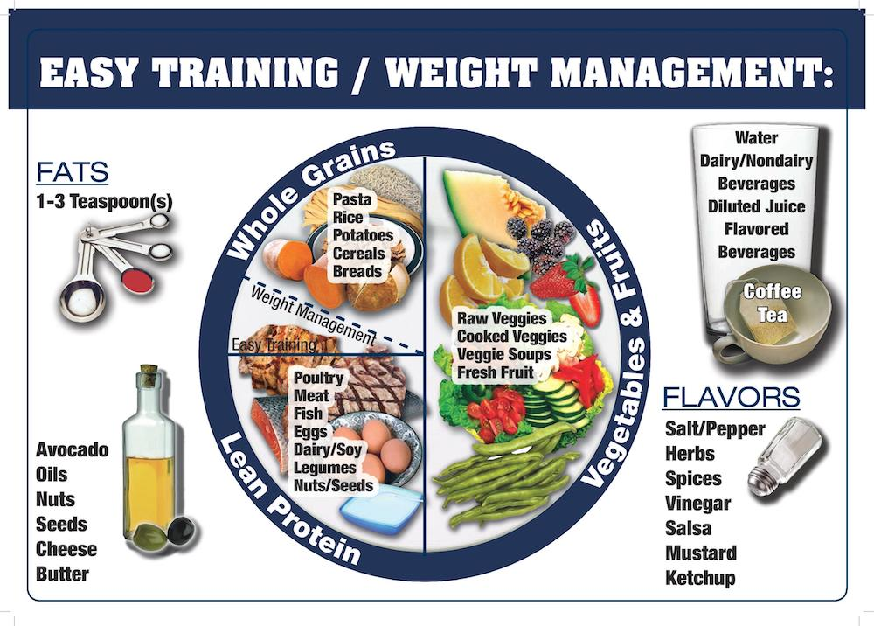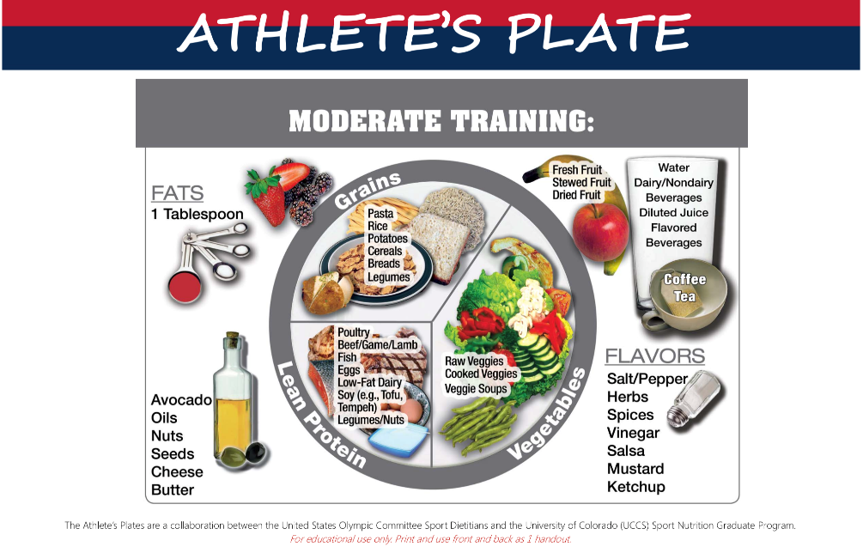
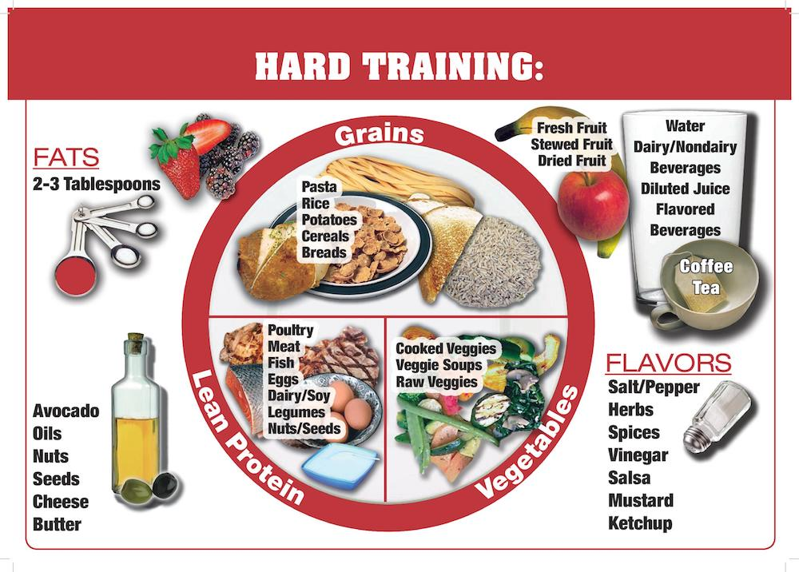
What are the key differences between these plates?
Explain why these differences may be important
Dietary Plan and Timings
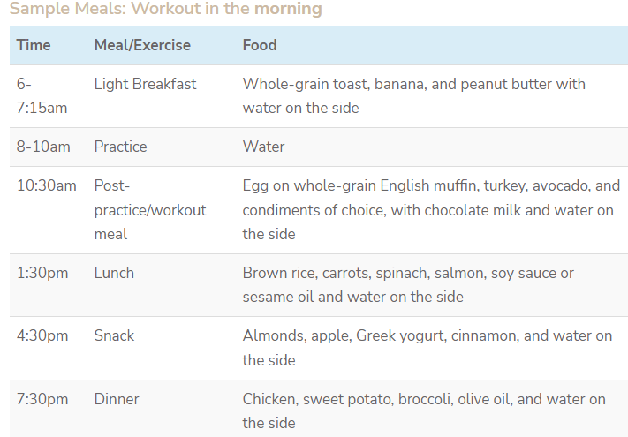

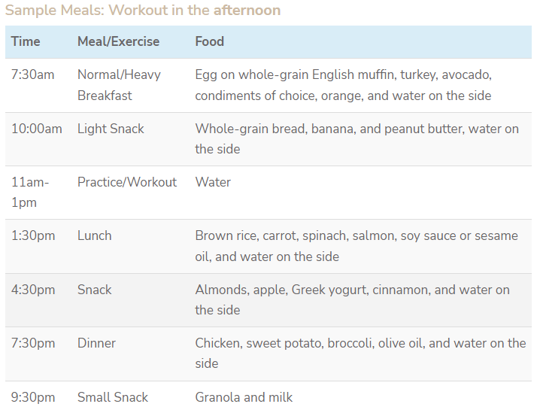

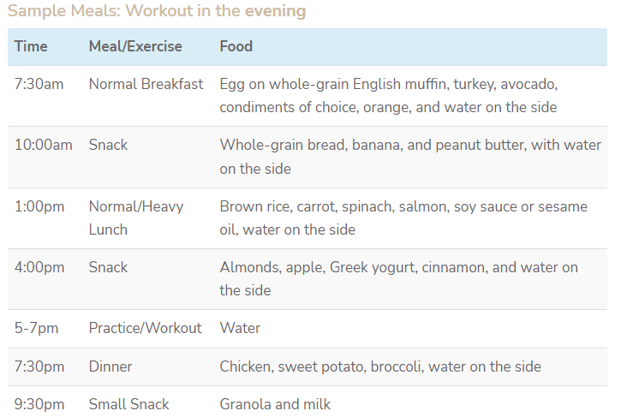

Why is it important to manipulate the relationships involving diet, meal / snack time and training?
What are the key differences in these meal plans?
What are the key objectives of these meal plans.?

