Software Engineering
L6 - Software Engineering Principles and Practice ACCA6027
Shamuel Hashan 1803153
cOURSE - wEB dEVELOPMENT
lECTURER - mIKE dACEY
2021
Contents
2 Introduction 2
3 Design evaluation 3
4 Testing evaluation 7
4.1 Black Box testing 7
4.2 White box testing 10
4.3 Testable code 13
4.4 Testing cases 14
5 Version control 17
6 Conclusion 20
7 Appendix 21
7.1 Bibliography 21

Introduction

There are various approaches when it comes to developing software. It is important to plan how the software will be coded and design what is needed first. This can be done with the use of design methods. These can include creating user stories, CRC cards or creating a wireframe of the website. After the software is designed it can be created but testing will need to be done to ensure that the software works sufficiently. There are various testing methods such as black box testing and white box testing. A web application to play connect 4 was designed as the connect 4 application was coded to see test the strengths and weaknesses of the approach that is being taken.

Design evaluation

It is important that the application is user friendly and also functional. To ensure that there was functionality in the application it was designed first using user stories, CRC grids and wireframe design examples.
  - User stories.
User story mapping was used to plan what would be needed of the application. It helped set out user activities, user tasks and user stories to help see what would be needed for the user and provide us with an idea on how to implement them. From the user stories, it can be seen what is expected of the connect 4 application.
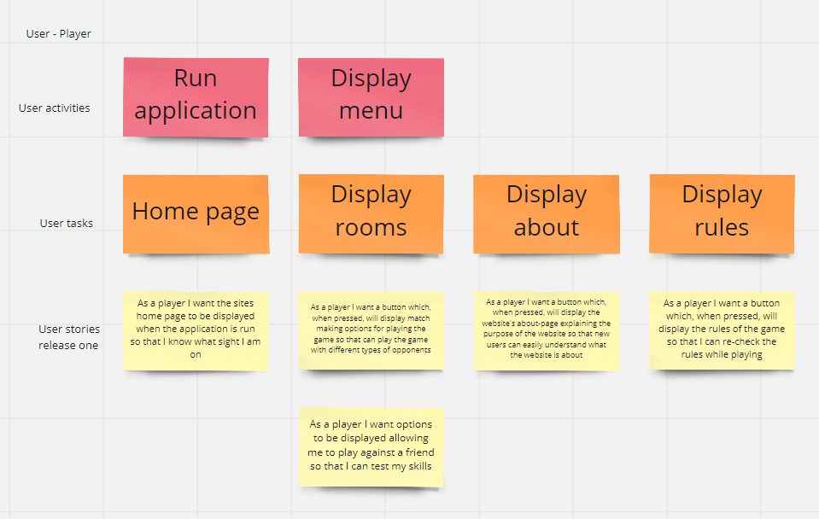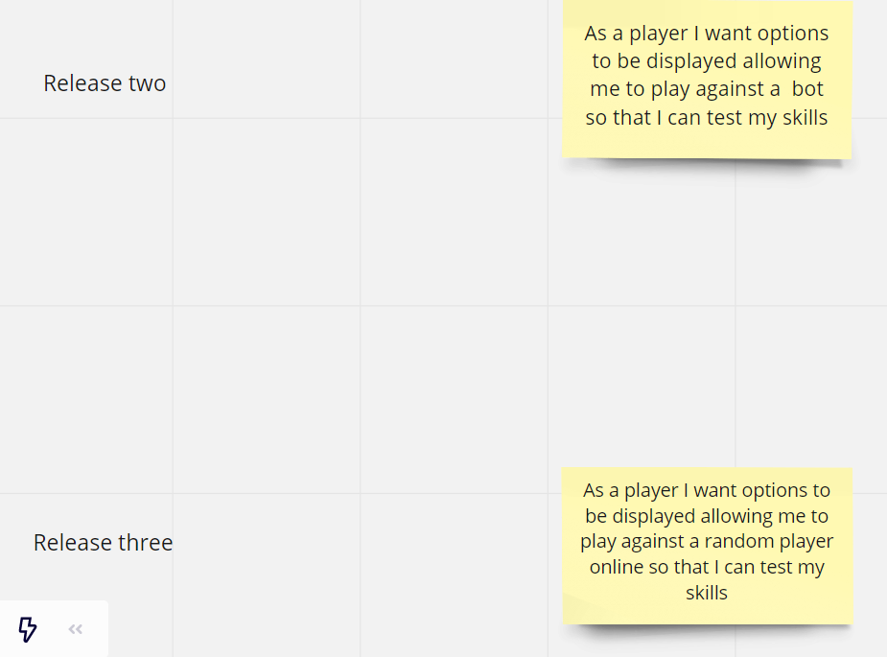
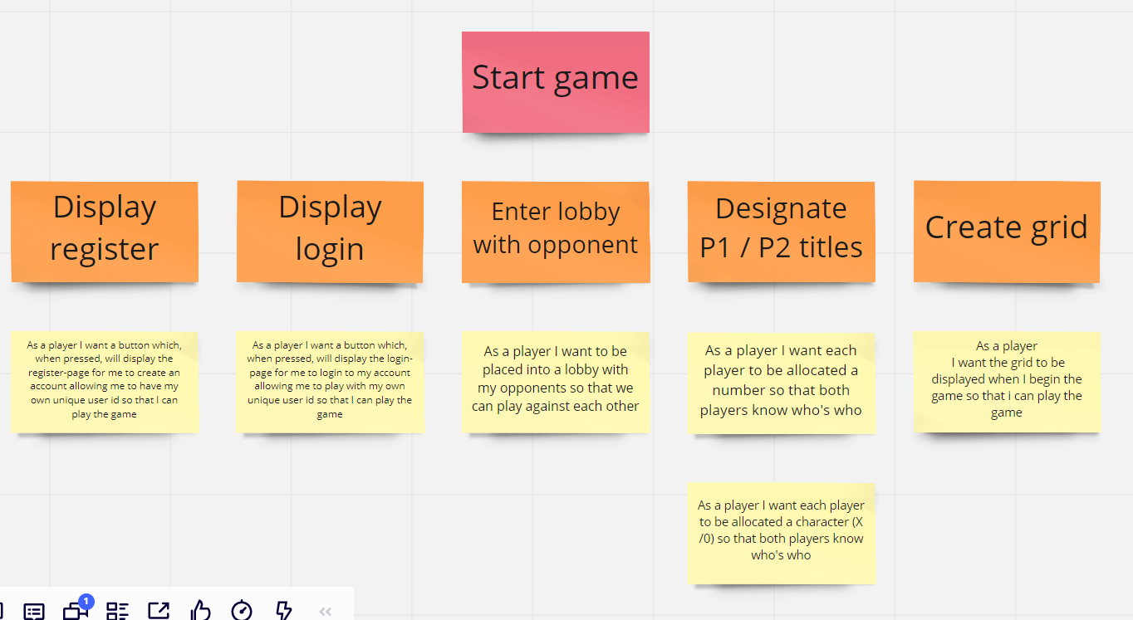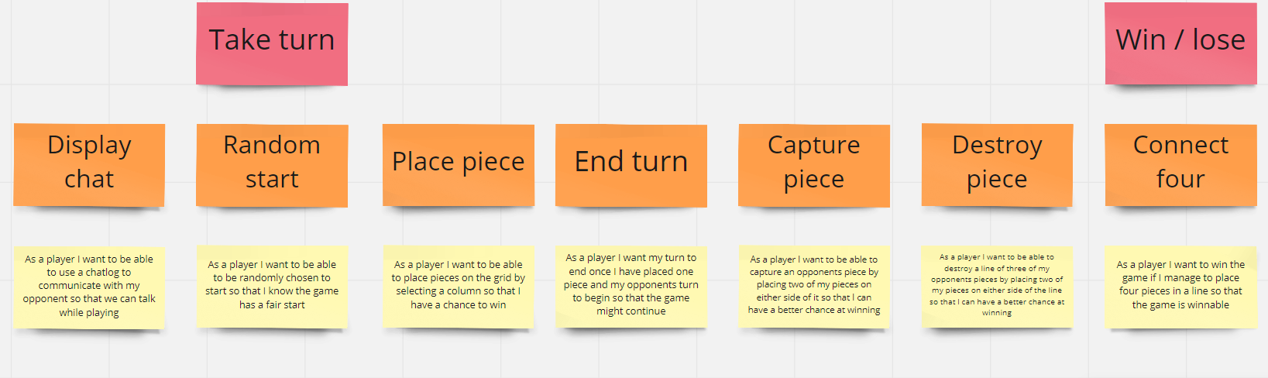
In the user stories here. It is shown that the first release of the connect 4 application would allow the user to play against their friends with plans to implement a feature for them to play against a bot in the second realise and a feature to play against random players in release three.

  - CRC cards

The “as a [blank], I want...” structure was used so the CRC cards can be defined to provide an idea with what cards will be needed to ensure that the data is not wasted by duplicate cards. The details on the card are adequate as it is easy to follow. Developers should be able to follow it to create the connect 4 code and have it tested since the CRC cards do include everything that is expected for connect 4. The responsibilities in the CRC cards of the classes follows the criteria that was identified in the user stories. For example, there is a user story on creating the grid and the is a CRC card for the grid class and one of the responsibilities there is to create a build and display a grid. Another of example criteria that the user stories identified that was then implemented would be that the one of the criteria’s that the user stories identified was to allow a player to capture a piece. There is a CRC card that is about capturing the pieces. The classes that were implemented here are classes that would be used in the code for the software. For example, the Grid class was stated in the user stories and in the code, the grid was used and did exactly what it said it would do in the responsibilities in the CRC cards.
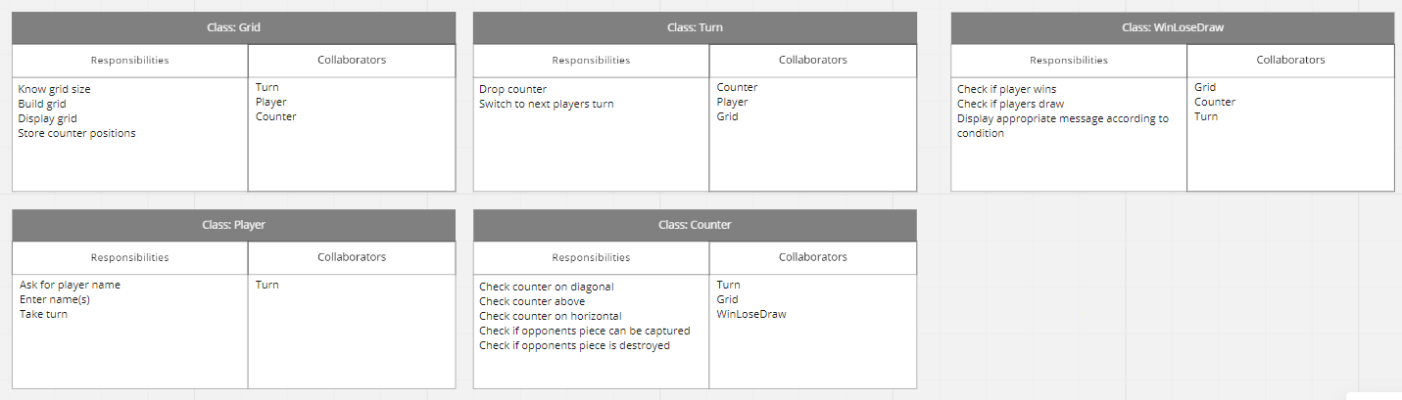

  - Wireframe
Wireframe designs of how the website were going to look was also designed. These were designed in accordance with the criteria that the user story identified. The wireframe designs has features that were included in the user stories. For example, it includes rooms for the user to play against other players. Release three of the user stories identified the need to allow players to play against random players.
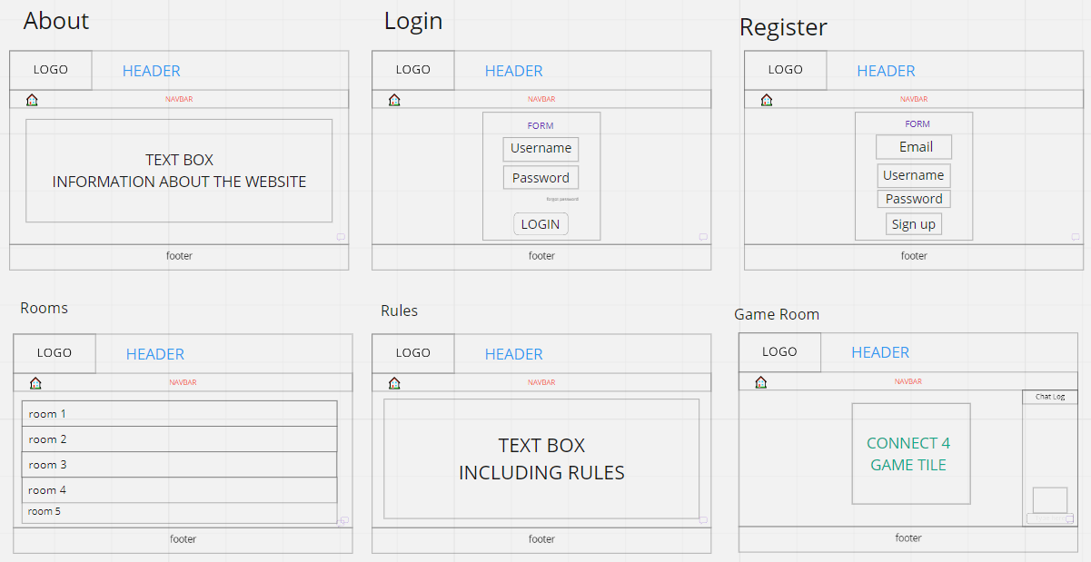

  - Final thoughts on the design process
The overall process of designing a connect 4 game went well. The group communicated well overall to come up with the user stories which was then converted into CRC cards. The team did well to proof read eachothers work to make sure what was written is correct and goes with the rest of the plans. While the team did have a sufficient amount of meetings to design Connect 4. More meetings could have been planned to improve the efficency of the work.

Testing evaluation

When it comes to coding software, it is important to make sure the software is tested to ensure that all the features work as well as ensuring that there are no errors once it is published. All the features in the software must be tested to ensure that there are not any errors and then fix any errors if there are any errors found. This would make the software more efficient. Testing the software can also reduce any costs on having to fix any errors that are found in the future after the software is put out into the public. The longer it takes to fix any bugs in the software, the more it will cost. It is important to find any bugs in the software as early as possible as it is very cheap to fix in the later stages, but it can cost a lot more in the later stages such as after the release. Static testing is when code is tested when the code is not running. This could just be looking at the specification or looking over the design and code and reviewing them. Dynamic testing is performed using the software while the software is running.

Black Box testing
There are many different methods for software testing such as black box testing and white box testing. Black box testing in software is data driven. It does not bother with how the code internally is written. It is more focused on looking at the software’s behaviour to see if it is within accordance to the specification. There are two types of black box testing are functional testing and non-functional testing
Functional testing is one of the types of black box testing. This is normally done to test the applications behaviour and the features on the application. In this test a set of inputs would be given, and a button will be clicked to see if the correct data is displayed. For example, put 4+4 in a calculator and see if it outputs 8.
Non-functional testing does not have any relations to a specific function as it is more interested in the overall performance of the software. The systems operations would be tested instead of the systems behaviours and features.
  - Test strategy
There are various testing strategies such as the test to pass and the test to fail.
One of the first tests that are performed on the software would be the test to pass. This test is to see of the if certain features work and should not break any of the code. The user should have an idea on what the input should be and have an idea on what the output should be judging by the input. This is the happy path that is being tested and it should pass. This is normally the first test that is performed.
Another strategy for testing is the test to fail. This method is designed to force bugs to come out and reveal themselves. The goal of this strategy is to see if the code can be broken. This method is referred to as error-forcing as well. This strategy is normally performed after the test to pass method. Examples of this would be to enter invalid inputs. Maybe put numbers in a text only field.

  - Data Testing

Functionality testing is one of the testing types in black box testing. There are various ways to test the data input on functionality testing. They can be done by clicking buttons such as the add button. The text that has been entered is also an example of test data input. This could be a name. The numbers on a spreadsheet can also be tested. The data being output will also be tested. The output data being tested would be the file created as well as the data being written into the database.

  - Performance testing
Performance testing would be non-functional testing and there is a lot of variety of tests to perform when it comes to performance testing.
Repetition testing is one of them. This is the process of performing the same action again and again.
Stress testing is when the code is being run in the least ideal conditions. Like being ran on a slower CPU or being ran with low memory. Applications will be running on the lowest spec hardware’s as those are the ones a lot of the customers might be using.
Load testing is a test where the largest files possible are tested. The goal is to feed the software with the maximum that it can handle.
Usability testing is also another test that should be performed on the application to ensure that the software is usable. End users will test this application to look for any errors.
Fuzz testing is the test where the software would be given invalid data to test to see how it reacts to that.
Race conditions and bad timing is specific to a select few languages in various scenarios. This will perform multiple actions at once. For example, being able to click buttons as a file is being loaded by the software.
Security testing is also an example of performance testing that is quite essential as it can make the software more secure from attacks as it will face risk of being attacked once the software is being put in the public.

  - Advantages
There are many advantages to black box testing such as the fact that users do not have to have much technical knowledge on the software to test the software as it is mostly about testing the software from the perspective of the user.
An advantage is that there is no need for the tester to access the software code.
The testing of the software and the development of it are both independent activities so the testing is done once the development of the software is complete. This separates the perspective of the user with the perspective of the developer.
Another advantage of black box testing is that after the specification and before the development, the testers can generate test cases as opposed to doing it during the development or after the code is finished.
  - Disadvantages
There also a few disadvantages to black box testing. For example, the coverage on it is limited as only a select amount of test cases are done.
There is also a risk that the testing is inefficient as the person testing the software might only know a limited amount about the software so might not be able to test everything.
Another disadvantage is that specific parts of the code might not be able to be targeted to have tested by the tester so the coverage might be a bit blind.

White box testing

White box testing is also known as logic-driven testing. This is software technique where the software internal structure would be examined so the flow of what is being input and output can be verified which well then help the usability, security and the design of the software improve. There is a risk that the tests being performed are tailored to suit the operation of the code as opposed to doing what is being required due to the tester being biased. Ensuring the applications workflow is verified is one of the goals for white box testing.
White box testing does test the low-level functions in the software as well as the libraries. The top-level software can be tested too with the test cases being adjusted depending on the code’s operation. White box testing will also use real variables and state information taken from the code. These would help to test if those are correct.
White box testing will test:
- The internet security,
- The paths structured poorly or broken paths
- The flow of inputs in the code
- The output that is expected
- The conditional loops functionality
- Each functions, objects and statements on individual basis.
White box testing is done at various levels of the development of the software. These levels are the system, unit and integration levels. Inputs will be tested to see if it results in an expected output or not. If the output is not the expected output, then there is a chance that there is a bug.

  - Unit testing
There are various types of white box testing.
Unit testing is one of the testing types used for white box testing. This test is normally performed first on software. This is performed as each bit of code is being developed. Each function or object would be tested before on going the unit testing as it will help find more bugs that could be in the software while early in the lifecycle of the development of the software. Arrays of characters that are converted into a string by a utility function is an example of what could be tested in unit testing. This method will ensure the functions in the software are working as they are expected. Unit tests are used by many software developers. These tests would normally be performed throughout the development of the software. The units that are being tested could be individual functions, objects, modules, procedures or methods. This is a white box testing method that the developers would perform. Unit testing is also the first level of testing that is performed and then the integration testing would come after in the SDLC, STLC and V model.
There are many reasons to use unit testing. One of these reasons is that it will reduce expenses spent as it will detect bugs early in the software’s development allowing it to be fixed earlier as opposed to finding it later in the development and having to spend more to fix this issue. Changes can be made more quickly as the software developers would have a better understanding of the testing code base. There are two types of unit testing and these are manual and automated.

There will also be tests for memory leaks. Applications running slow can be due to memory leaks. It could be very important to get a QA specialist that is experienced when it comes to having memory leaks detected when the software is running slow.

  - Path testing
One basic white box testing method is path testing. This is testing method will test each branch of the code is tested to ensure that all the executable path is covered. Programs might have various points that the user can use to exit or enter the program. Path testing will allow all these points to be covered which means that there will be maximum coverage. The test cases will be defined judging on the software’s logical paths or the flows in the software. The number of redundant tests that developers would have to perform will decrease with the use of path testing.
This is the flow diagram for the connect 4 game showing the various paths.
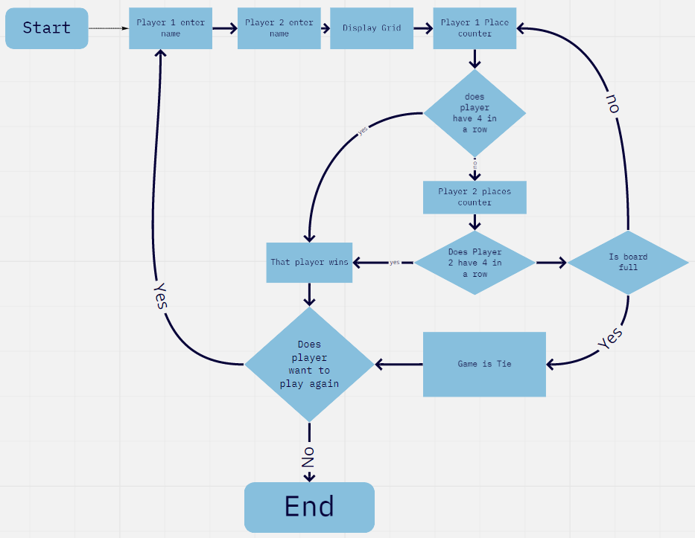

  - Advantages
- One advantages of white box testing is that the code will be more optimized. More errors will be found if and will be able to be fixed which would result in the code being more optimized.
- Since the tests in white box testing is done by the developers. This would mean that they have knowledge on the code so they can easily decide which type of data will be needed to test the software in the most effective way.
- An advantage of white box testing is also that it can allow the tester to remove lines of code which could result in hidden defects coming to light.
- The tests in white box testing will also have more coverage than black box testing would get as it is being tested by people who have knowledge of the code so the tests scenarios should be able to get maximum coverage.
- Another advantage of white box testing is that they can be automated easily.
- The white box testing method is also thorough as it does cover all the code paths.

  - Disadvantages
- There are also many disadvantages with white box testing
- One of these disadvantages is that it can be expensive as well as complex to perform. The fact that skilled testers are needed to perform the tests will increase the costs of the tests in white box testing which can make it more expensive than black box testing.
- Another disadvantage is that professional resources are required and a fair amount of understanding with the software and implementing the software is needed.
- The time it takes to perform white box testing which is also a disadvantage as it is time consuming. The larger the application then the longer it will take, and it takes a fair amount of time to completely test big software. It is not possible to look at all of the code and test everything sometimes so there is a chance that some paths might not be tested.
- The white box testing is mostly done by developers are not that detailed and it can lead to errors with the production.

Testable code

  - What is testable code
Testing the code should be as quick and as easy as possible to test. It would be ideal to know why a test fails so the error can be fixed sooner. This would verify the behaviour of small units in the code. There are various practices to creating testable code such as making sure the code is readable or making the object construction simpler or working with dependencies. Good testable code can be made by following the SOLID principles. For example, ensuring that the code has been split into small blocks that are oriented around specific tasks. These lines should not be too long.

Testing cases

These series of tests should display examples of how each of the testing methods were used to test the code.
Functionality Tests
Functionality testing is a black box testing method that was used to test the Connect 4 game.
Test no. | Input | Expected Result | Actual result
1 | Player 1 name | The game should ask the user for their name and display the name input whenever referring to this player till the game ends | The game asked the user for their name and displayed the name that was input till the end of the game.
2 | Player2 name | The game should ask the user for their name and display the name input whenever referring to this player till the game ends | The game asked the user for their name and displayed the name that was input till the end of the game.
3 | Display the grid | When the game starts there should be a grid displayed. | A grid was displayed once the game started
4 | Placing a counter | The user should be able to place a counter on the grid in a column of their choice. | The user was able to place a counter on the grid where they requested.
5 | End game as a tie | The game should end as a draw when the board is full, but no one got 4 in a row | The game ended when the board was full, and no player got 4 in a row.
6 | Game ending when there is 4 in a row | The game should end when one player gets a 4 in a row | The game ended when one player got 4 in a row.

  - Unit test case steps

Test ID. | Test Case | Test Condition | Expected Outcome | Actual Outcome | Pass
1 | Test to see if the player can input their name | Enter the players name | The name should be displayed when it is that players turn | The name is displayed when it is that players turn | Y
2 | Test to see if the grid is displayed | Press enter after player 2 has entered their name | A grid should be displayed | A grid was displayed | Y
3 | Test to see if a player can drop a counter in their selected column | Select 1 to enter it in the 1st column | The counter should drop in the first column | The counter dropped in the first column | Y
4 | Test to see if the game checks for a counter below before a player drops a counter | Drop a counter on the same column as another counter | The counter should go on the row on top the counter below it | The counter went on the row on top the counter below it | Y
5 | Test to see if the game says the column is full when a player tries to place a counter on a column that is full | Drop a counter on a full column | There should be a message saying the role is full | There was a counter saying the row is full. | Y
6 | Test to see if the game ends when there is a 4 in a row | Have 1 player get 4 in a row | The game should end, and the active player should be announced as winner | The game ended and the active player was announced as winner | Y
7 | Test to see if the player can play again | Press 1 to play again when the messaged asking if the player wants to play again is received | The player should play again with the loser starting first | The player did play again with the loser starting first | Y
8 | Test to see if the game ends | Press 2 to end the game when the messaged asking if the player wants to play again is received | The game should end | The game ended | Y
9 | Test to see if the game ends in a draw when the board is full | Fill the board with counters with no 4 in a row | The game should end as a draw | The game ended as a draw | Y

Version control

  - What is version control
Version control is a key tool in the software development process. It is used by many software developers. This is used so changes made in the software can be tracked. Software developer teams will use version control as it will allow them to manage the changes being made to the source code as time goes on. This will also allow fellow developers to work together using the latest version of the code.
Every change made in the software will be tracked and be put into a special database. The developers would be able to go back and look at the earlier versions of the code if any errors were made allowing the error to be fixed with minimal impact on the other developers in the team being disrupted.
Version control will use a file tree which is a folder structure that will organise all the new projects code or software components that the developers would have been working on. The developers will be working on different parts of the project. For example, one of the developers might be working on implementing a new feature to the software while a different developer works on fixing bugs in the software. The changes made by these developers will go on different parts of the skill tree.
Even when working independently, it is still a good idea to use version control as it does not take too long to set up a repository for the code. It can then be cloned and put into a server if needed to share with someone.
  - Advantages
- The source code is protected by version control to avoid any issues that could result in harmful consequences for the code. The master version of the software should be on the server so the developers would always be able to use that if anything happens to the bit of code that they are developing.
- Using version control would allow the developers to reduce the time spent developing the software and the number of successful deployments would increase due to the increase of development environments.
- Version control will improve the workflow for software developers. Developers can work on the same file at the same time so this reduces the time that would have been lost waiting for it to be free to use. The changes made to the files will then be merged to make a common version of the file.
- The workflow will also be safer with the use of version control as code can be committed in small testable increments easily. The code can be backed out effortlessly if there are any issues caused
- Version control also allows developers to experiment with the code a bit more as there is a lot less risk of the work being ruined as the work can always be reverted to a version that works. A copy of the code can just be cloned from the master repository.
- When there are issues found with the software, the developers can look at previous versions of the software, so they can discover when the issue was first turned up. The developers can then look at the code and see what has caused the error and come up with a solution to fix it.
- Version control will allow multiple versions of the software to be managed which will be useful for developers when there are more than one stream of the software development progressing without meddling with the other streams. Some developers will have a tested version of the software while others will have a version of the software that is still being developed.

  - Disadvantages
- One of the disadvantages of version control is that traditional models might not be as sufficient for remote workers, outsourced teams or distributed teams as they will need to have access to the server so that it can be used by them. These workers might not be able to have access the server. However, better internet access might make this issue less severe.
- Version control might not be the most flexible. Creating a copy of the repository might be difficult as it is impossible for a repository to merge with another repository unless extra tools are used.
- The software developers will not be able to save any versioned changes if the main server is down when using centralized version control systems.
- There is a risk of losing the history in the database if the central database gets corrupted due to security issues in centralised version control systems.
- When working on a distributed version control system, one disadvantage is that new developers that are not as experienced with using might find it hard to learn to use.
- Another disadvantage is that when it can take a long time to clone a big project that has a lot of history on distributed version control systems. It can also take up a lot of space.

  - Final thoughts on Version control.
The statement about “version control software is a key tool in the software development process” is correct as there are so many advantages to using it. Especially when working in a team as it allows the workflow to increase and will ultimately result in a more productive team. It is a good idea to use version control as it can safely sav any code that was created as the developers can always go back to a working version of the code if there are any issues with the code.

  - Git
There is various version control software. Git is an example of one of these. Git is one of the most popular version control systems used. This could be since it is open source, and it is also free which makes it more accessible for anyone. However, the security might lack, and it is not possible to scale.

Here is the Connect 4 code being stored in a repository in GIT
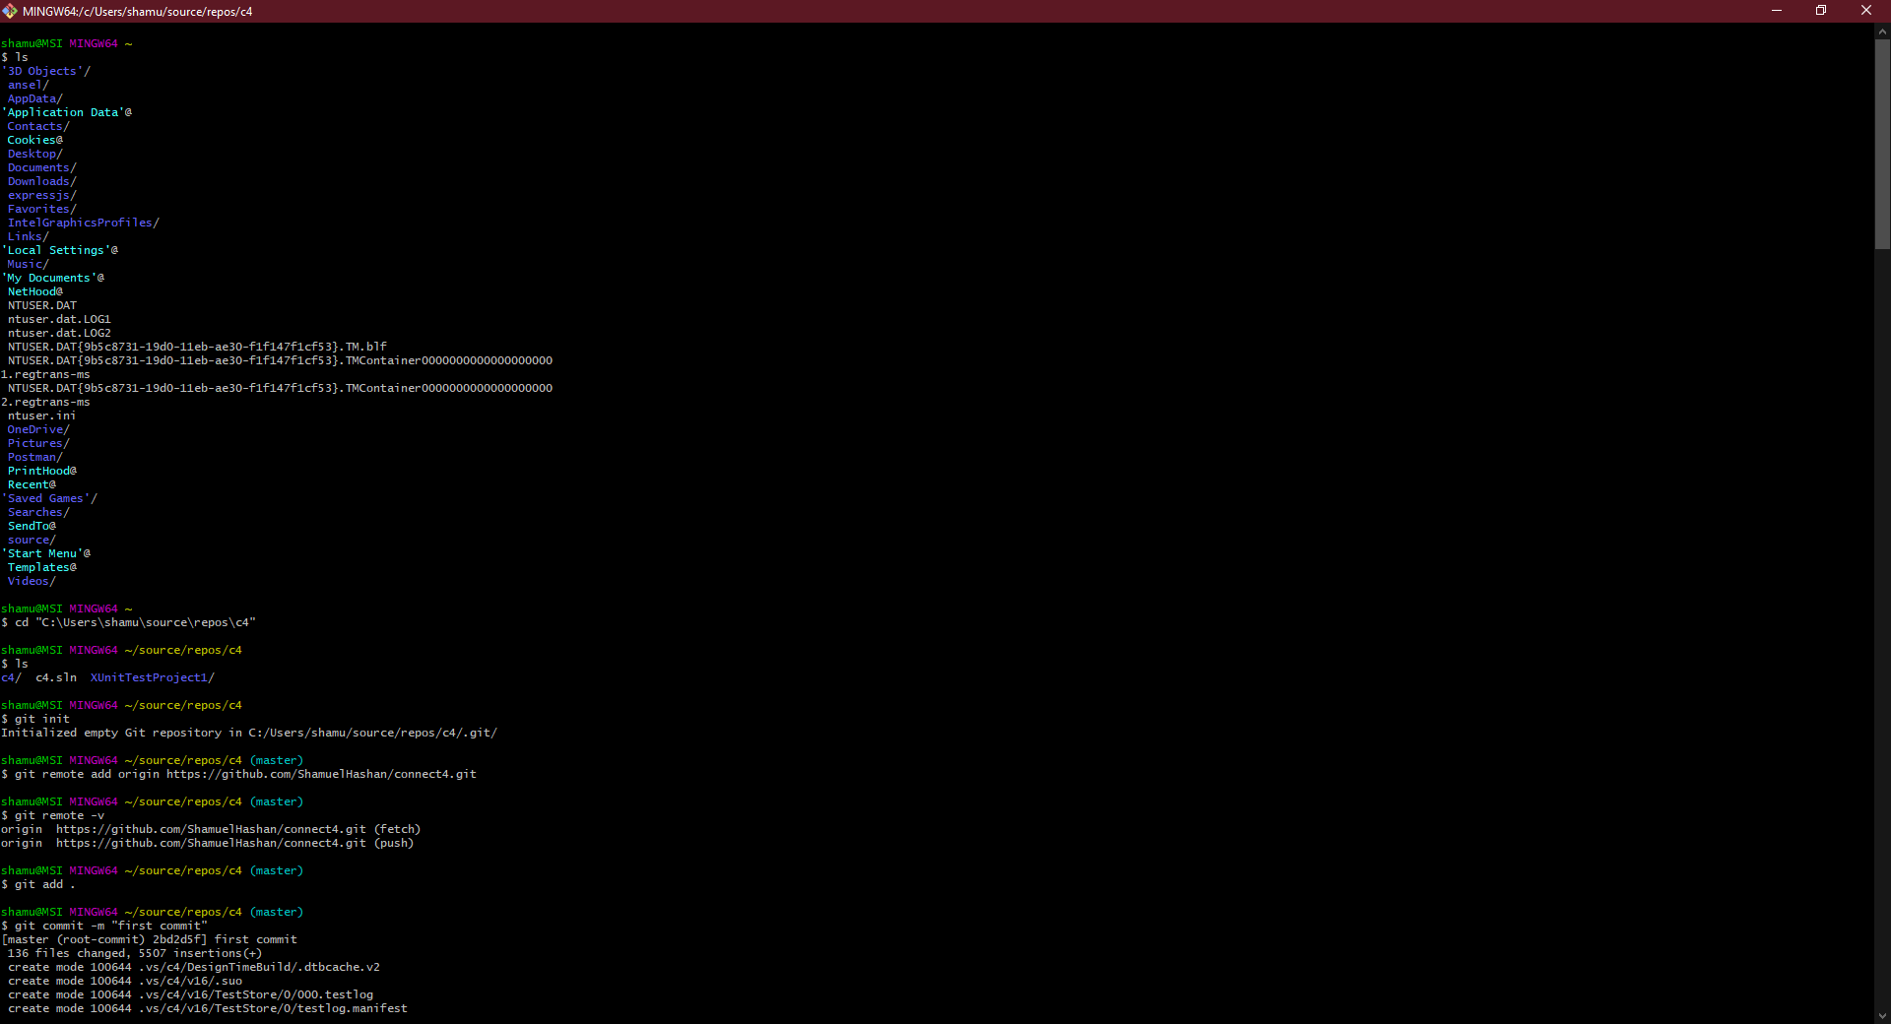

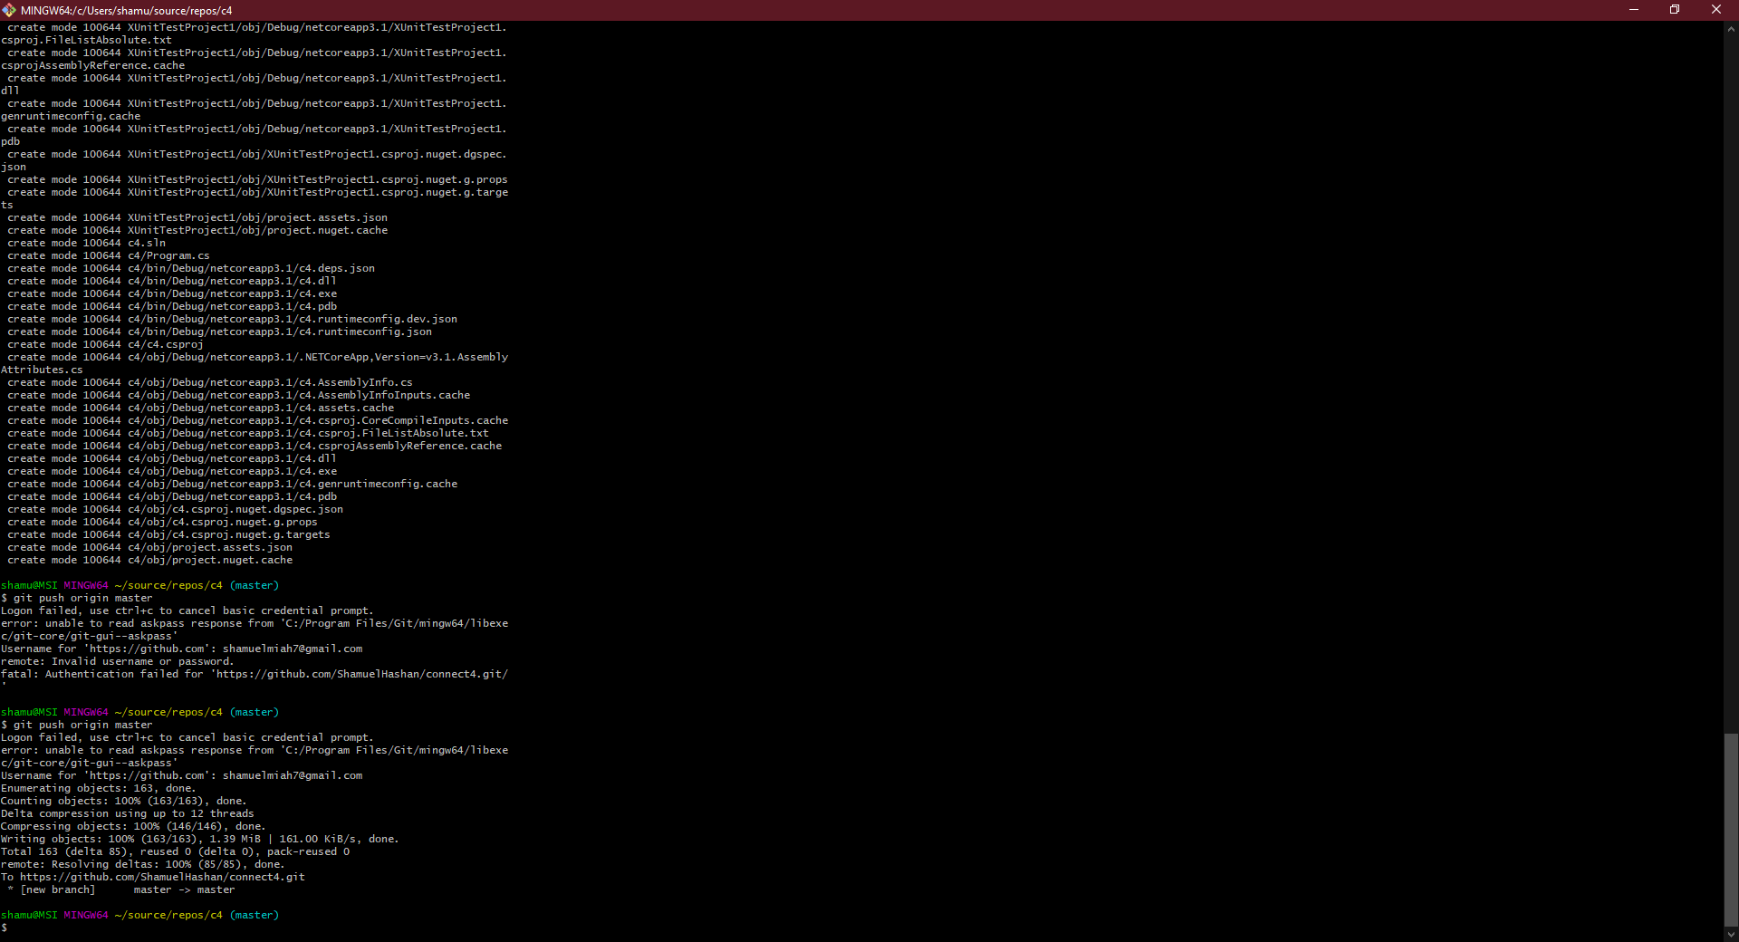
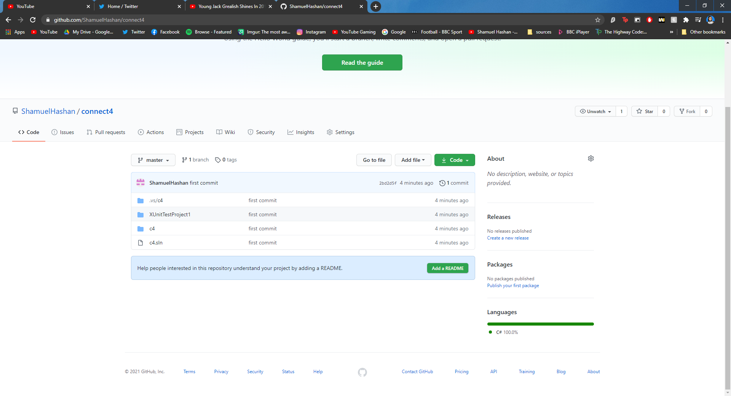

Conclusion

Many various approaches when it comes to designing and testing software in this report. The Connect 4 game has been designed sufficiently using the appropriate methods such as user stories, CRC cards and wireframes which was then used to develop the code following the design. Various testing methods were also looked at such as the white box and black box testing methods. Version control was also covered it concluded that the phrase “Version Control software is a key tool in the software development process” was correct.

Appendix

Bibliography

[1] | F. D. Garm Lucassen, “The Use and Effectiveness of User Stories in Practice,” Springer, 2016.
[2] | S. KOLODIY, “Unit Tests, How to Write Testable Code and Why it Matters,” Topal, [Online]. Available: https://www.toptal.com/qa/how-to-write-testable-code-and-why-it-matters. [Accessed 4 January 2021].
[3] | Guru99, “Unit Testing Tutorial: What is, Types, Tools & Test EXAMPLE,” Guru99, [Online]. Available: https://www.guru99.com/unit-testing-guide.html#2. [Accessed 1 January 2021].
[4] | P. Câmara, “Writing Testable Code,” Medium, 30 April 2019. [Online]. Available: https://medium.com/feedzaitech/writing-testable-code-b3201d4538eb. [Accessed 2 January 2021].
[5] | S. W. Ambler, “CRC Modeling: Bridging the Communication Gap,” AmbySoft Inc. White Paper, 1998.
[6] | D. Spinellis, “Version control systems,” IEEE Software, vol. 22, no. 5, pp. 108 - 109, 2005.
[7] | S. Misra, “Unit Testing in Global Software Development Environmen,” in REDSET 2017, Gurgaon, 2017.
[8] | S. Nidhra, “Black Box and White Box Testing Techniques - A Literature Review,” nternational Journal of Embedded Systems and Applications, vol. 2, no. 2, pp. 29-50, 2012.

