EAEE4005: The young mathematician: exploration and problem solving

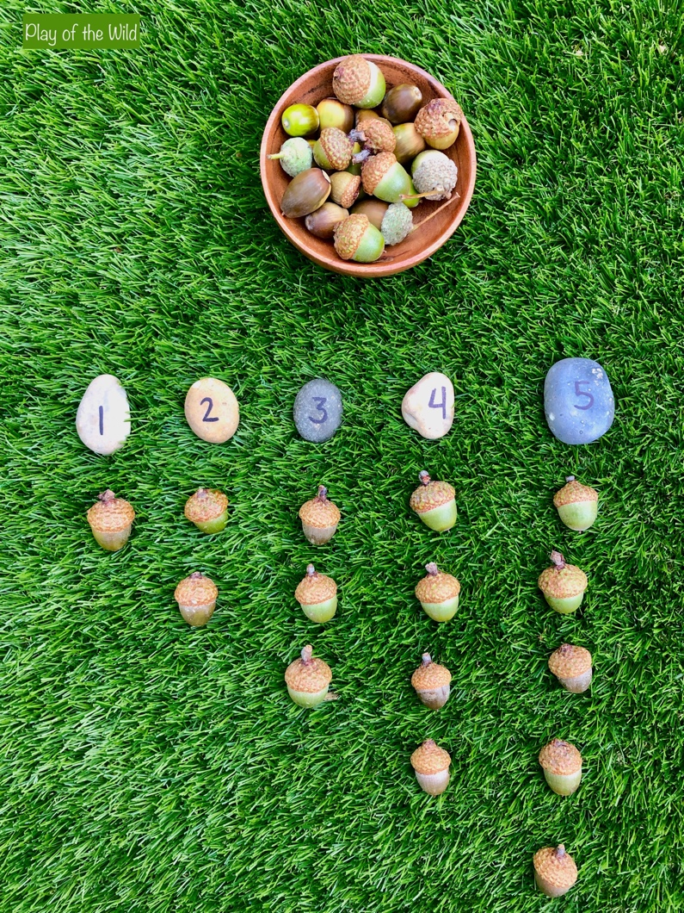

(Source: Play of the wild, 2020)

Contents Page

Activity Plan 3

Evaluation 4

Resources 7

Role of the adult 10

References 12

Activity Plan
Activity: Creating patterns to explore different mathematical concepts such as symmetry and shape.

Number of children: 8 | Age of children: 5 – 6 years | Number of adults: 1
Location: School yard | Preparation time: 10 minutes | Activity time: 30 minutes
Resources:
Suitable clothing, appropriate footwear, stones, leaves, grass, flowers or sticks.

Aim/s of activity:
The children are to use the resources provided to create a pattern. They can put the resources into size order to make a pattern or they can make up their own pattern. To teach the children mathematical vocabulary such as: length, shape, measurements and symmetry.

Links to outcomes:
For the children to learn patterns as well as textures and sizes of various natural resources. Current national framework states that children should be provided with opportunities to help with:
- Critical thinking
- Problem solving
- Creativity and innovation

Differentiation:
Children are to use the resources provided to create a pattern.
Fewer resources can be made available to them if required.
SEN children can touch and feel the objects and make a pattern if they wish.

Health and safety:
Ensuring that children are made aware that the objects are to only be used for making patterns and are not to be eaten or put into their mouths. Also ensuring that objects are not too small so that children can choke on them. Chat with the children beforehand to point out the possible risks and to ensure that they listen and take care at all times. Ensure to check the yard prior to the activity for any potential risks.

Role of adult/adults:
Ensuring the safety of the children at all times. Helping the children if they are unsure and answering any questions which they may have. Support and scaffold the children during the activity. Ensure that all adults understand the aims of the activity and introduce the child to new mathematical vocabulary.

The activity:
The children are to create a pattern using the various resources being made available to them. A demonstration pattern will be made to show them what different patterns they can make, they are then to have a go themselves. They can work in groups, pairs or individually.

Evaluation

This is an evaluation based upon the activity plan which was created to complete a maths activity ‘creating patterns.’ The children are encouraged to create patterns using various natural resources from the outdoors.
The activity plan pointed out vital information regarding the activity such as:

- The activity.
- Aims of activity.
- Links to outcomes.
- Differentiation.
- Health and safety.
- Role of the adult.

Underneath the resources section of the activity plan, there are a range of various natural resources. These include stones, leaves, grass, flowers and sticks. This supports Tucker (2014) who states that the best resources are those which are aesthetic. Natural resources are far easier to access and are indeed free to use. Using natural resources also increases the learning which can be achieved as you can incorporate science and learning about the environment also.
Community Playthings (2020) states that all areas of maths can be explored using loose parts. Natural and open-ended resources provide a wide range of opportunities for children of all ages and abilities. Letting children play with loose parts means that children can use their imagination as best that they can. The children can also go into the environment and collect the resources themselves, whilst learning about nature and the world around them. However, Community Playthings (2014) also states that loose parts are in fact the opposite of toys, as toys are designed for specific purposes. Children decide what to do with loose parts and see possibilities which an adult may miss.
Fox and Wirth (2015) state that a more organized and accessible environment will help children to feel safe and secure well as helping them to understand the world around them. Fox and Wirth (2015) also state that by children having access to nature-filled outdoor learning space, it can encourage positive attitudes and behaviour around nature too.
Loose parts can be a mixture of both man-made objects and natural resources. Montessori (1870, cited in 1907) states that children learn best through a holistic approach using objects which have a specific goal for the children to achieve. Montessori (1870) believed that items designed specifically for maths such as number rods provide simple yet effective learning. The benefits of loose parts are that it is very much child led and experimental for the child, providing various amounts of playing and problem solving. Children’s House (2016) states that children can play with loose parts alone or with others.
The activity plan is based upon a group of eight children participating in this activity. This supports Vygotsky (1934, cited in 1978) who believed that children learn best when learning socially. He believed that social interaction is fundamental to cognitive development and that children learn best through physical interaction and that learning is a social process which needs the support of parents, carers and teachers.
Bilton (no date) believed that outdoor play is essential to childhood development and learning outdoors has many beneficial factors that should be taken advantage of whenever possible. Bilton (no date, no page) states:

There are so many different benefits to be had from using the outdoors; for example, health in terms of light, fresh air and exercise. Cognitively there is so much to learn about in terms of nature and the environment. When outside, children behave differently and are more competent socially and emotionally. They have more of a can-do approach, so children are successful, academically, emotionally and physically.
(Bilton, no date, no page)

Within the health and safety section, it mentions that children are to be made aware of the objects that they are using and that they are not to be eaten or put into their mouth. The practitioner should also ensure that objects are not too small for the child to choke if this does occur. Pilcher (2021) states that all providers have a direct responsibility and a duty of care to those in the setting and those that receive a service. Pilcher (2021) also claims that premises and equipment should be clean and that a health and safety policy should be in place. Risk assessments should be carried out to decide what can cause harm and how to prevent that from happening. The practitioner should have a brief discussion with the children beforehand to let them know of any risks which may occur and to listen at all times.
Therefore, upon reflection, the practitioner should have carried out the relevant risk assessment for the activity to ensure that it was safe and should have also ensure that the health and safety section in the activity plan was more detailed.
Strengths of the activity plan are that it provides information regarding the activity and the expectations expected. It gives the practitioner the relevant information required to carry out the activity. There are various different headings used and it is easy to read and understand.
Weaknesses of the activity plan are that it could have more detailed information on it, such as more resources which may be used as well as more information on the differentiation of the activity. The practitioner used wording which was not up to date with current legislation such as SEN which is now referred to as ALN. According to Welsh Government (2020) the additional learning needs act now replaces the precious term ‘special educational needs’ with ‘additional learning needs’. The act will help to ensure that all learners with ALN reach their full potential and will focus on the importance of identifying needs early and putting into place effective measures which may be needed.
The timing of the activity is 30 minutes however the activity can take as long as the children’s interest allows. The practitioner will decide this. Thornton and Brunton (2013) state that outstanding early years practice should be a mix between adult-led and child-led activities. This supports the Reggio Emilia approach and they believe that children learn as individuals as well as in groups.

Resources

There are a large range of mathematical resources available for the learner. These range from plastic to natural resources that you would find within nature.
There are specific maths resources available, such as:
- numicon
- peg boards
- wooden blocks
- shapes
- weighing apparatus
- bee bots
Baba Me (2021) claims that providing toys and props will spark the imagination of the child and is one of the best things which can be provided to them. Playing shop can help children develop their vocabulary and learn names of fruits and vegetables. Plastic resources such as a tuck shop with fruit and vegetables will teach the child about counting and money. It is a fun way for the child to learn through play. It also helps the child with their fine motor skills by picking up the fruit and vegetables and displaying them in the shop, perhaps in order and then counting them. This can also help the child to learn colours. The practitioner could also supply the children with real fruit and vegetables also which would help the child learn different textures and sizes.
For a child to improve their fine motor skills, threading is very effective. It is quite difficult to do this without a specific maths resource such as Numicon.
According to Oxford Owl (2020) Numicon is a resource which has been specifically made for learning maths. It does not have many various different uses other than learning maths. Oxford Owl (2020) mentions that Numicon is a multi-sensory way of learning and lays the foundation for learning maths throughout school. The strengths of these types of resources are that they are good for helping the learner learn in a specific way using specific items. Negative aspects of this are that they are mainly used for one specific thing rather than all different types of learning. The practitioner is restricted with what they can teach using a specific maths resource.
Montessori Nature (2021) claims that nature is the ultimate resource for eco-friendly materials as all materials can be recycled and returned back to where they came from. Children learn about the importance of looking after the environment as well as using their imagination. Natural resources or loose parts are used for a wide range of learning.
Natural resources include:
- sticks
- leaves
- stones
- water
- shells
- sand
These can be used for all different types of learning and have a much wider variety of uses. Children can feel different textures of the items and also find them themselves in the outdoors. For example, if the child goes for a walk to collect sticks, they will come across a wide range of sizes and shapes. The child will them compare the sizes and count the sticks which is a maths lesson within itself. There are many things that a child can learn from playing with sand. This includes weight, quantity, building sandcastles as well as mixing it with water and seeing the difference by doing this.
Montessori (1870, cited in 1946) believed that children develop a curiosity for nature by having daily opportunities to explore the outdoors with purpose and structure. Montessori (1946) mentions that children should have frequent access to learn both in the indoors and the outdoors and believed that children have mathematical minds. She also believed that using a variety of beads and symbol cards will help the child to become familiar with numbers as decimals contributing towards understanding of addition, subtraction, multiplication and division.
This is supported by Moorhouse (2021), who believes that children should learn creatively that creative thinking and critical thinking are increasingly important. Moorhouse (2021) is inspired by the Reggio Emilia approach, as well as Brunton and Thornton (2015) who believe that the high-quality experiences for the child set out key values. Brunton and Thornton (2015) also believe that the environment and resources help to support the child’s creativity in many ways, encouraging children to express their creativity and ‘risky freedom.’
Wisbey (2021), states that resources should be supplied by the practitioner as well as nature. Wisbey (2021) goes on to say that the environment brings ‘nature’s maths’ which includes shape, symmetry, colour, classification, order and various patterns. It is important to perhaps have a balance of natural as well as man-made resources for the learner. This can help the learner to use their imagination with the natural resources but to understand the man-made resources have limited uses compared.
Overbye (2021) claims that positive aspects of natural resources is that they are free to use and are widely available to the learner. They can continue to progress the learner’s mathematical skills as they get older. For example, a child who is three years old can tell which stick is big and which is small, where as a child who is eight years old can put the sticks in order of biggest to smallest.
Tucker (2014) states that the best resources are those that are aesthetic and that can be creative. These include shells, conkers and acorns. These can help with other areas of learning such as science, language, geography, history and creative. This goes to show how multi-purpose natural resources can be and that they can help significantly with learning.
Trautner (2019) states that patterns help children to understand what comes next and make their own predictions. Patterns can be found everywhere in daily life, such as stripes on clothes or singing songs which have repetitive beats.
Shiro (2004) states:
‘Patterns are such an important part of mathematics that some educators even claim that mathematics is the science of patterns and that mathematical problem solving is an endeavour involving the uncovering, exploring, analyzing, and understanding of mathematical patterns.’
(Shiro, 2004, no page)

Although dated, Shiro’s work is respected and used in mathematical work today.

Role of the adult

When planning and monitoring a child’s learning and progress, the practitioner must ensure that they consider the current national framework. Welsh Government guidance for mathematics and numeracy (2019) states that in the early years, play forms an essential part of development of maths and numeracy. The Four Purposes of the Curriculum for Wales (2020) says that all children and young people will be able to think creatively and to solve problems as well as being able to use number effectively in different forms. It is important for the practitioner to observe and assess the child’s skills and abilities in order to be able to plan effectively and efficiently for the learner. Planning can help to set goals for the child as well as setting aims for staff and sustaining an organised environment. Planning can also help the practitioner to be prepared for the needs of the child and to support the child’s independence.
Welsh Assembly Government (2019) states that maths is an essential part of life. Maths and numeracy should be engaging and exciting as well as challenging. Bruner (1960 – cited in 2019) and Vygotsky (1934 – cited in 2019) both believed that a child’s social environment should play an important part in a child’s learning. Skills should be developed through a process known as ‘scaffolding’ which is when the practitioner helps the child to complete an activity and letting the child concentrate on the difficult part of the activity themselves. When carrying out the above activity, the practitioner should encourage the children and ask open questions about the activity, helping to increase the children’s knowledge. It is increasingly important to observe a child prior to planning. This enables the practitioner to understand the child’s needs and abilities and to give the best opportunities for the child. Drake (2006) states that observation is essential for understanding young children and finding out about them as individuals. Drake (2006) also mentions that observations are a crucial aspect of a practitioner’s role. The aim of carrying out the observations are to be able to plan appropriately for the child.
It is important for adults to consider a range of mathematical vocabulary as well as appropriate resources for the child, whether it is natural resources or man-made specific resources. The practitioner should have a positive attitude towards maths and should always use appropriate language suitable for the child’s age. Practitioners should ask the children open ended questions to encourage the children’s thinking and problem-solving skills, as well as perhaps demonstrating a pattern for them to see. Blatchford (2009) mentions that sustained shared thinking is effective in school and pre-school settings and that it is something that adults do to support and engage in all children’s learning.
DCELLS (2008) state that the practitioner should be the facilitator of learning and be able to respond to the individual needs of the child. Practitioners should also be willing to learn alongside children and continually reflect and improve practice.
Children should have positive relationships with practitioners, as well as the practitioners having good relationships with parents and carers. Children should feel happy and safe in the environment. Children learn better when they feel comfortable in the setting. Hwb (2020) states:
In the early years, play forms an important part in the development of mathematics and numeracy, enabling learners to solve problems, explore ideas, establish connections and collaborate with others. In later years, learners need to have opportunities to work both independently and collaboratively to build on the foundations established in the early years.
(Hwb, 2020, no page)

Donaldson (2015) states that practitioners should encourage children and promote spiritual, moral, cultural, mental and physical development as well as preparing children for opportunities and responsibilities later on in life. Practitioners should always act as good role models for the children as they learn from their behaviour.
The National Strategies Early Years (2009) states that practitioners should seek to understand individual children and their development as well as encouraging and supporting children and their achievements. Practitioners should be caring and nurturing towards the children and should treat them as if they were their own. They should always encourage them to try and do their best and to be there when they have questions and to help guide them. Practitioners should also ensure that the learning environment is welcoming and stimulating for the child to encourage independent learning. According to Hansen and Vaukins (2012) as well as Tucker (2010) adults should support independence, provide a stimulating environment, provide opportunities, consolidate mathematical skills and vocabulary as well as having good subject and curriculum knowledge.
The four purposes of the curriculum for Wales states that children will be:
- healthy and confident individuals
- ambitious and capable learners
- enterprising and creative contributors
- ethical and informed citizens
It is essential that practitioners use these four purposes to encourage learners into becoming the best that they can be and supporting them along the way.
What Matters Statement (2020) claims that knowledge and understanding of numbers and mathematics provide a foundation for problem-solving and progression in all areas of learning. Mathematical fluency will progress when using and learning numbers is carried out frequently and will help the learner in the world and employment in the future.

References

Baba Me (2021) Benefits of pretend play shop. Available at: https://www.babame.com/benefits-of-pretend-play-shop.html (Accessed: 28th February 2021).
Blatchford. S (2009) Conceptualising progression in the pedagogy of play and sustained shared thinking in early childhood education: a Vygotskian perspective. London: Institute of Education University of London.
Children’s House (2016) Loose Parts Play: A Montessori Playground. Available at: http://www.montessori-blog.org/2016/11/14/20161113loose-parts-play-a-montessori-playground/ (Accessed: 15th February 2021).

Community Playthings (2020) Maths play with natural loose parts. Available at: https://www.communityplaythings.co.uk/learning-library/blog/2020/september/maths-play-outdoors (Accessed: 15th February 2021).

Community Playthings (2014) Play with loose parts. Available at: https://www.communityplaythings.co.uk/learning-library/blog/2014/july/loose-parts (Accessed: 16th February 2021).

DCELLS (2008c) Learning and Teaching Pedagogy. Cardiff: Welsh Assembly Government.

Donaldson, G (2015) Successful Futures. Available at: https://gov.wales/sites/default/files/publications/2018-03/successful-futures.pdf (Accessed: 22nd February 2021).

Drake, J (2006) Nursery World: Observing Children. Available at: https://www.nurseryworld.co.uk/news/article/observing-children (Accessed: 16th February 2021).

Early Education (2020) Friedrick Froebel. Available at: https://www.early-education.org.uk/about-froebel (Accessed: 15th February 2021).

Fox, H and Wirth, S (2015) The learning of loose parts. Available at: https://www.communityplaythings.co.uk/learning-library/articles/the-learning-in-loose-parts (Accessed: 28th February 2021).

Hansen, A. and Vaukins, D. (2012) Primary Mathematics Across the Curriculum (2nd ed). London: Sage Publications Ltd.

HWB (2020) Area of learning and experience: maths and numeracy. Available at: https://hwb.gov.wales/curriculum-for-wales/mathematics-and-numeracy/ (Accessed: 22nd February 2021).

Irresistible Learning – Pete Moorhouse (2021) Research. Available at: https://irresistible-learning.co.uk/about/ (Accessed: 15th February 2021).

McLeod, S (2020) Lev Vygotsky’s Sociocultural Theory. Available at: https://www.simplypsychology.org/vygotsky.html (Accessed: 3rd February 2021).

Montessori Group (no date) The Montessori Learning Environment. Available at: https://www.montessori.org.uk/about-us/what-is-montessori/the-montessori-learning-environment (Accessed: 10th February 2021).

Optimus Education (2013) Bright ideas to support child-initiated learning. available at: https://my.optimus-education.com/bright-ideas-support-child-initiated-learning (Accessed: 15th February 2021).

Overbye, H (2021) How to incorporate natural resources into the classroom – part 1. Available at: https://blog.teaching.com.au/how-to-incorporate-natural-resources-into-the-classroom (Accessed: 28th February 2021).

Oxford Owl (2020) Numicon guide for parents. Available at: https://home.oxfordowl.co.uk/maths/numicon-guide-for-parents/ (Accessed: 15th February 2021).

Pilcher, M (2021) Health and Safety in the Nursery. Available at: https://www.teachearlyyears.com/nursery-management/view/health-safety-in-the-nursery (Accessed: 9th February 2021).

Play of the wild (2020) “Outdoor maths activities KS1 – Maths outdoor learning”. [Online]. Available at: https://playofthewild.com/2020/08/19/outdoor-maths-activities-ks1-maths-outdoor-learning/

Reggio Emilia Approach (2020) Reggio Emilia Approach. Available at: https://www.reggiochildren.it/en/reggio-emilia-approach/ (Accessed: 15th February 2021).

The Children’s Room (2020) “What is Montessori?” Available at: https://www.the-childrens-room.co.uk/about/about-montessori/ (Accessed: 9th February 2021).

The National Strategies: Early Years (2009) Learning, playing and interacting. Available at: https://www.foundationyears.org.uk/wp-content/uploads/2011/10/Learning_Playing_Interacting.pdf (Accessed: 22nd February 2021).

Thornton, L. and Brunton, P. (2014) Bringing the Reggio approach to your early years practice. Oxon: Routledge.

Trautner, T (2019) Teaching patterns to infants and toddlers. Available at: https://www.canr.msu.edu/news/teaching-patterns-to-infants-and-toddlers (Accessed: 22nd February 2021).

Tucker, K. (2014) ‘Creating and using a mathematical environment’, in K. Tucker (ed) Mathematics through play in the early years. London: Sage Publications Ltd.

Tucker, K. (2010) Mathematics through play in the early years (2nd ed.). London: Sage Publications Ltd.

TTS (no date) “Montessori” Available at: https://www.tts-group.co.uk/on/demandware.store/Sites-tts_uk-Site/default/Blog-Tags?tag=montessori (Accessed: 9th February 2021).

Welsh Government (2019) Mathematics and Numeracy. Available at: https://moodle.uwtsd.ac.uk/pluginfile.php/470604/mod_resource/content/1/draft-statutory-guidance-mathematics-and-numeracy.pdf (Accessed: 16th February 2021).

Welsh Government (2020) The four purposes for the curriculum for Wales. Available at: https://moodle.uwtsd.ac.uk/pluginfile.php/467278/mod_resource/content/0/the-four-purposes-of-the-curriculum-for-wales%20%281%29.pdf (Accessed: 5th February 2021).

Welsh Government (2020) ALN. Available at: https://gov.wales/sites/default/files/publications/2018-09/additional-learning-needs-aln-transformation-programme-v2.pdf (Accessed: 28th February 2021).

Wisbey, M (2021) Maths in the great outdoors. Available at: https://www.communityplaythings.co.uk/learning-library/articles/maths-in-the-great-outdoors (Accessed: 5th February 2021).

University of Reading (no date) Professor Helen Bilton. Available at: https://www.reading.ac.uk/education/Stories/ioe-helens-story.aspx (Accessed: 24th February 2021).

