Thomas Myers – 1704226
Wireless Networks and Simulation – ACCB5004
Design and Evaluation of Wireless Sensor Networks
Simon Downes

Contents

- Introduction
- Research and Evaluation of Modulation Schemes
  - Function of a Modulation System
  - Computer Network simulations relation to the concepts and principles of communication systems
  - Fundamentals of BPSK
  - Advantages and Disadvantages of BPSK
  - Implementations
  - Pros and Cons of simulation methods
  - BPSK Experiment
- Wireless Sensor Network Design & Evaluation
- Conclusion
- References

- Introduction

The following report will discuss the function of a modulation in a communication system and why it is used within communication systems. Furthermore, the concepts and principles of both computer network simulations and communication systems will be compared to match what concepts and principles relate with each other. This report also includes the critical analysis of the Modulation Scheme ‘Binary Phase Shift Keying’ (BPSK). The analysis will include the function of BPSK and the purpose of the modulation scheme. Moreover, both the advantages and disadvantages of Binary Phase Shift Keying will be compared. Once the advantages and disadvantages of Binary Phase Shift Keying have been covered, examples of BPSK implementations will be displayed alongside what the BPSK simulation achieves. To conclude the analysis of modulation schemes, the option to choose simulations over other methods will be analysed alongside the pros and cons of opting to choose simulation over other traditional methods. In addition to the analysis of modulation schemes, an investigation on implementing a Binary Shift Phase Key communication system will be produced including the implementation of a BPSK communication system to a real life situation.

- Research and Evaluation of Modulation Schemes

  - Function of a Modulation Scheme

The main function of a modulation scheme is to read ‘message bearing signals’ [1] to combine it alongside ‘carrier signals for transmission’ [1]. The operation of modulation involves a number of elements. The signal frequency is a main element alongside the phase and the signal amplitude. The Frequency modulation (FM) element carries audio signals that are represented by changing signals to match the arriving audio signals amplitude property. The frequency of the signal is moved to a higher frequency to display the pinnacle of the wave and then a lower frequency to display depth of a signal wave. The Amplitude Modulation (AM) element merges audio signals with waves. Amplitude Modulation ‘rises and falls in accordance’ [2] once a sine wave is introduced. Within amplitude modulation, the frequency remains fixed at all times. Only with the merging of Frequency Modulation and Amplitude Modulation do we see a change in the frequency with the frequency being changed to present the audio signal. These methods are most frequently used to provide radio transmission via analog signals which is very straight forward to modulate. A digital signal is presented using a constellation diagram. Below is an example of how a constellation diagram is presented. The three modulation schemes that are being represented in the diagram are BPSK, 4-QAM and 16-QAM.

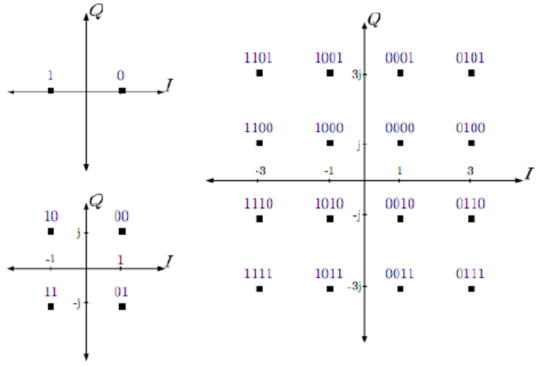

Figure 1 – Constellation Diagram of different digital modulation schemes [3]

Constellation diagrams must be used due to digital signals being made up of binary which makes these signals impossible to modulate.

  - Computer Network simulations relation to the concepts and principles of communication systems.

A computer network is a set of end devices connected to each other via internet connectivity which could be sent through either wired or wireless transmission. The main motive behind a computer network is to share files between each end device. If necessary, a network administrator could set parameters where only certain end devices can access the shared files. A communication system is implemented with communication end devices such as ‘transmissions equipment, relay stations, tributary stations and other data terminal equipment.’ [4] Both computer network simulations and communication systems relate due to both properties allow the use of data transfer alongside incoming and outgoing signals. Computer Networks and communication components such as Wireless sensor networks, radio networks and internet of things devices all support data transfer and signal receiving.

  - Fundamentals of BPSK

Binary Phase Shift Keying (BPSK) is a digital modulation scheme that is frequently used within modulation. Binary Phase Shift Keying is used to demonstrate 0 and 1s that lies within binary by two separate phases. Once the binary property changes value to the remaining property, the wave will rotate 180 degrees to represent that the binary value has changed. Below is a demonstration of the binary value changes being shown during digital modulation.

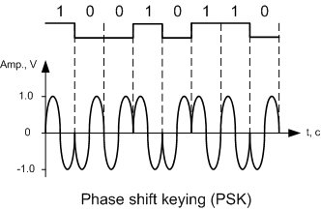

Figure 2 – Binary Phase Shift Keying [5]

As presented in the figure above, the wave shifts 180 degrees once a binary property has been changed. Representing a digital signal within an analog signal becomes achievable with the use of Binary Phase Shift Keying. Using components such as a transmitter and a receiver makes the digital signal representation possible. This allows BPSK to accurately read and transmit the data to display the digital modulation.

  - Advantages and Disadvantages of BPSK

Every digital modulation method come with advantages and disadvantages. Binary Phase Shift Keying (BPSK) is no exception. A major advantage of Binary Phase Shift Keying is the elapsed time it would take to demodulate the signal. The process of demodulating the signal is made quicker as the receiver component makes two simple conclusions which means the elapsed time would decrease significantly as less decisions need to be made. Another advantage of Binary Shift Phase Keying is that there is not much power needed to run a BPSK modulation. This is due to a decreased number of bits compared to other modulation schemes. Furthermore, another advantage of Binary Phase Shift Keying is that more ground can be covered during transmission due to that the 180-degree phase shift split the binary properties. Binary Phase Shift Keying is now used frequently by ‘cellular towers for long distance communication’ [6]. With every modulation scheme, disadvantages also accompany advantages. The main disadvantage of BPSK is that another digital modulation scheme QPSK has a much quicker data rate than BPSK due to BPSK only able to convey ‘one bit by one single analog carrier’ [6]. For this reason, Binary Phase Shift Keying isn’t the best digital modulation scheme to use if transmitting data was a major trait.

  - Implementations

Binary Phase Shift Keying is implemented in many properties due to the strength of the digital modulation scheme alongside the straightforward operation of BPSK. Wireless applications such as Wireless Local Area Network has implemented Binary Phase Shift Keying to their protocols ‘11a, b, g, n’ [7] . In addition to WLAN implementing BPSK to their protocols, other wireless standards also use BPSK as their primary digital modulation scheme. Wireless applications such as ‘CDMA and WiMAX’ [6] implement BPSK to their standards. This is because Binary Phase Shift Keying is known to be ‘more robust’ [7] in comparison to other known digital modulation schemes. Wireless applications such as ‘Satellite, DVB and Cable Modems’ [7] also use BPSK as their primary digital modulation scheme.

  - Pros and Cons of simulation methods

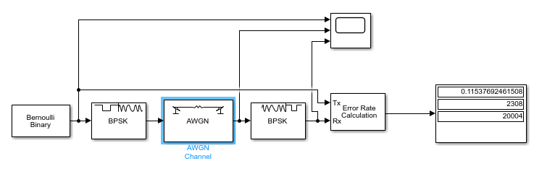
As technology has evolved over a number of years, simulation have rapidly developed. A simulation is a prediction of a real-life situation when different technological structures are implemented. Simulations permits end users to experiment what could potentially happen if certain protocols were set to certain components. For example, within wireless networks, a simulation could be ran to see how a wireless local area network would run under certain protocols implemented into the software of the virtual physical components. This method is used by many different companies to test potentially new software such as operating systems. Simulation is a preferred method due to its advantages over other methods such as testbeds and mathematical methods. One main advantage of using simulation over other known methods is that simulations are very cost effective as it ran off software instead of physical components. Another reason simulation can be a preferred method to methods such as testbeds is that simulations has less elapsed time than a physical implementation because every potential component needed will be within the simulation software unlike with a testbed where physical components will be needed to be connected. Another advantage of using Simulation methods is that the process can be contained on one PC meaning all files can easily be accessed if the end user has access to the PC. A major advantage of using simulations to other methods is that simulations has no effect on any real-life components as a simulation is a prediction of a real-life situation. With test beds, physical components are needed to complete the experiment which infers that the elapsed time would be longer than a simulation as not only did you have to acquire every physical component and connect the components but also set up those physical components with the accompanied software. Using a mathematical model over a simulation would only be preferred if the end user had an adequate background in mathematics. Furthermore, an advantage of using simulation to a mathematical model is that simulations give you a visual representation of the end users potential implementation while a mathematical model would only show mathematical logistics behind the potential implementation. Alongside these advantages come disadvantages of simulation. A major disadvantage of simulations is that the software is only as accurate as possible, meaning some results may vary within a real-life situation. This could become a factor if new physical software has been released while the simulation software has not been updated meaning the result could potentially vary. Another disadvantage of using simulations over other methods is that the PC that is used to conclude the simulation will require an adequate central processing unit alongside sufficient random-access memory storage.

  - BPSK experiment

The following experiment will demonstrate a simulation of the use of Binary Phase Shift Keying. The purpose of the following experiment is to outline how the performance of the digital modulation scheme once the level of noise (measured in decibels) have been increased/decreased. Once the simulation of the BPSK performance has been ran, three data types will be outputted using a display component. The three data types that will be outputted during the simulation are the Bit Error Rate (BER), Signal-to-noise ratio (SNR) and the amount of bits sent. The software used for this experiment is the digital modulation scheme simulating software ‘MATLAB’ [8]. Below is a demonstration of how the BPSK digital modulation scheme is set up. First, a bermouli binary generator connects to a BPSK modulator. That mentioned modulator is then connected to an AWGN channel where the level of noise can be altered. Next, a BSPK demodulator is connected to the AWGN channel. Once that is connected, an error rate calculation is implemented to receive data from the bermouli binary generator and the BPSK demodulator. That error rate calculation component then connects to a display that shows the Bit Error Rate (BER), Signal-to-noise ratio (SNR) and the amount of bits sent. To finalise the implementation, a scope is connected to output incoming data, the level of noise and how the level of noise has effected the incoming data.

Figure 3 – BPSK Simulation Implementation.

The first test of the experiment was to set the decibels at -1.4 to see how much data would get lost during transmission. The number of bits sent will be fixed at 20000. After the first test of -1.4 decibels, four more tests were conducted with the negative decibels increasing after every test. The second test was ran at -2.7 decibels, the third test ran at -5.1 decibels, the fourth test ran at -9.2 decibels while the fifth and final test ran at -14.1 decibels. Below are the outputted results from all five tests which shows the data output accompanied with a graph. The graph shows first the data inputted while the second section shows the level of noise. The final section shows the amount of data loss occurred once the level of noise was implemented.

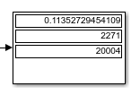
Figure 4 - -1.4 decibels data output

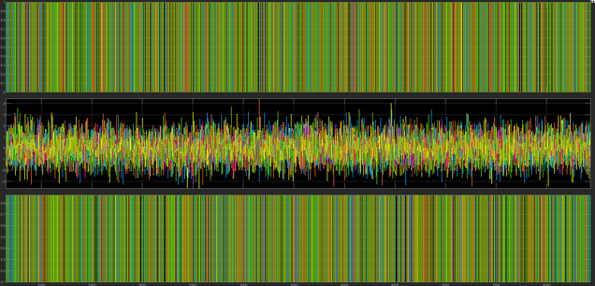

Figure 5 - -1.4 Graph

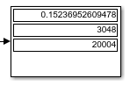
Figure 5 – -2.7 decibels data output

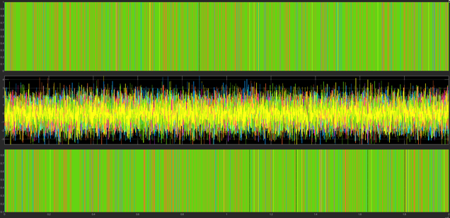

Figure 6 – -2.7 decibels graph

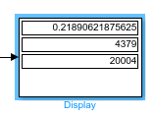

Figure 7 - -5.1 decibels data output

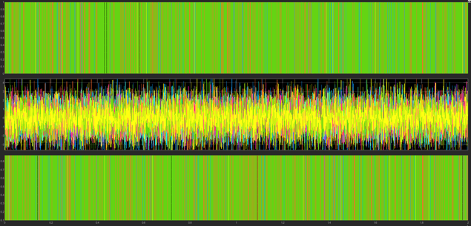

Figure 8 – -5.1 decibels graph

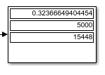

Figure 9 – -9.2 decibels data output

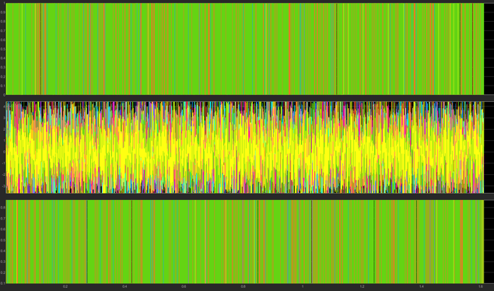

Figure 10 - -9.2 decibels graph

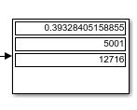
Figure 11 - -14.1 decibels data output

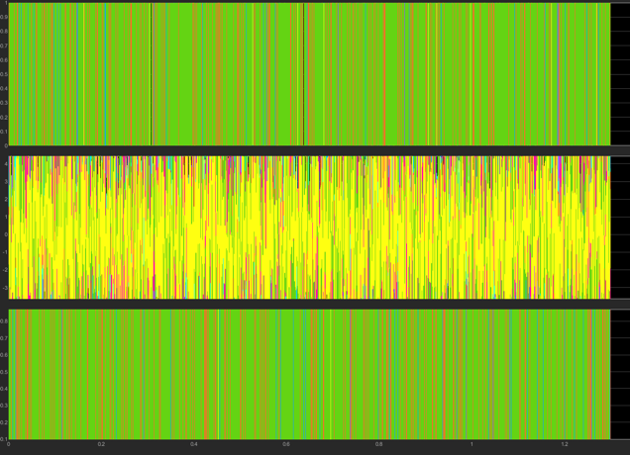

Figure 12 - -14.1 decibels graph

The end results show that once the negative number of decibels increased, the data loss became more apparent which more data being lost. Although data loss increased with the level of noise, the bit error rate remained moderately small. Before every simulation ran, the amount of errors was capped at 5000 errors meaning that once 5000 errors were reached, the simulation would end and the outputted data would show. Once the fourth experiment was simulated, the amount of errors hit the maximum of 5000 errors. This remained the case once the negative decibels increased for the final time. With the bit error rate remaining moderately small throughout the five simulations it demonstrates how Binary Phase Shift Keying is a suitable digital modulation scheme for a farm that wanted to upgrade to a smart system due to the level of noise very rarely effecting the data transfer.

- Wireless Sensor Network Design and Evaluation

In this section, an Internet of Things farm will be demonstrated with simulation using the simulation software ‘NetSim’ [9].

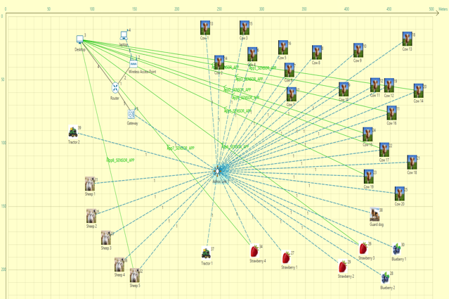

Figure 13 – Internet Of Things Farm Topology.

The figure above demonstrates that the farm contains twenty cows, five sheep, two blueberries, four strawberries, two tractors and a guard dog. Furthermore, Internet of Things components such as a Desktop, Laptop, A Wireless Access Point, A Router and a Gateway. All of these components make up the smart farms network. Every animal, strawberry growing area and blueberry growing area has a sensor attached. The sole reason for this is to track the movement of these animals using a Livestock sensor. Furthermore, a soil sensor is attached to the fruit growing area to notify the farmer if the fruit has changed in any way which will give the farmer time to act accordingly. All data will be exported to the desktop that is connected to a router. That specific router connects to a wireless access point to allow end devices such as a laptop to connect to the network and share data. This implementation allows farmers to track sensors remotely if an end device is connected to the wireless access point. To implement the network to suit purpose, the position of the wireless sensors are essential due to the radius of the sensors to the network. Furthermore, the level of noise must be considered while positioning wireless sensors.
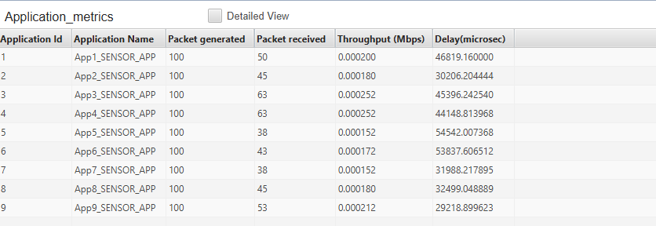

Figure 14 – Application metrics

Figure 14 simulates the number of packets received between certain sensors to PC’s. As the figure demonstrates, nine separate packet receiving tests were conducted with the number of packets generated and received were calculated. Every application generated 100 packets with every packet received becoming unique. The packets received vary due to constraints such as level of noise and the distance the wireless sensor is placed. Furthermore, the figure shows the throughput in the units Mbps and also the delay in packet transmission.

After investigating and implementing BPSK within a real-life situation, The general consensus of both tasks show that Binary Phase Shift Keying is a suitable digital modulation scheme to implement within a real-life situation such as an Internet Of Things farm as demonstrated. The conclusion that BPSK is a suitable digital modulation scheme is generated from the packets received compared to the packets sent while factors such as level of noise and distance of sensors are in place.

- Conclusion

In conclusion, The main function of a modulation scheme is to combine carrier signals with messaging signals which allows the transfer of data between one node to another. Modulations such as Frequency modulation and Amplitude modulation merge to change frequency levels to the existing audio signal. Moreover, BPSK was the discussed digital modulation scheme with the outlining of its function, the advantages and disadvantages of BPSK in comparison to other digital modulation schemes and where BPSK is used within real-life situations. Once information on BPSK was established, a demonstration on how BPSK runs was created using the simulation software ‘MATLAB’ [8]. The simulation demonstrated how the negative amount of decibels was a factor within packet transmission. Once this was demonstrated, a simulation of a real-life situation took place with the simulation software ‘NetSim’ [9]. An example of a potential network implementation within a farm was produced to show using Internet of Things devices. The software allowed the end user to simulate the packets transmitted between access points and wireless sensors. Furthermore, within this simulation it was demonstrated how the correct connections can allow the farmer to read the data off the sensors remotely at any time.

- References

Bibliography

[1] | S. S. Santry, "Modulation Schemes," Berkerley Education, 20 April 1997. [Online]. Available: https://people.eecs.berkeley.edu/~sastry/ee20/modulation/modulation.html. [Accessed 17 May 2019].
[2] | "Amplitude Modulation," [Online]. Available: https://www.sciencedirect.com/topics/engineering/amplitude-modulation. [Accessed 17 May 2019].
[3] | "BPSK, 4-QAM, and 16-QAM constellation diagrams," ResearchGate, [Online]. Available: https://www.researchgate.net/figure/BPSK-4-QAM-and-16-QAM-constellation-diagrams-10_fig4_287208899. [Accessed 17 May 2019].
[4] | "Communications Systems," Techopedia, [Online]. Available: https://www.techopedia.com/definition/18430/communications-system. [Accessed 19 May 2019].
[5] | "PSK - Phase Shift Keying," T&M Atlantic, [Online]. Available: https://www.tmatlantic.com/encyclopedia/index.php?ELEMENT_ID=10478. [Accessed 17 May 2019].
[6] | "Home of RF and Wireless Vendors and Resources," RF Wireless World, [Online]. Available: http://www.rfwireless-world.com/Terminology/Advantages-and-Disadvantages-of-BPSK.html. [Accessed 17 May 2019].
[7] | "Home of RF and Wireless Vendors and Resources," RF Wireless World, [Online]. Available: http://www.rfwireless-world.com/Terminology/BPSK.html. [Accessed 17 May 2019].
[8] | "MATLAB," MathWorks, [Online]. Available: https://www.mathworks.com/products/matlab.html. [Accessed 19 May 2019].
[9] | Tetcos, [Online]. Available: https://www.tetcos.com/. [Accessed 19 May 2019].

marking criteria and Student FEEDBACK

This section details the assessment criteria. The extent to which these are demonstrated by you determines your mark. The marks available for each criterion are shown. Lecturers will use the space provided to comment on the achievement of the task(s), including those areas in which you have performed well and areas that would benefit from development/improvement.

Common Assessment Criteria Applied (Assignment 1) | Marks available | Marks  awarded
1. Research-informed Literature
Extent of research and/or own reading, selection of credible sources, application of appropriate referencing conventions.
The report shows a basic understanding of the modulation techniques and WSN knowledge to complete each experiment. For future reference and development concentrate on obtaining sources from journals, articles, and conferences as a number of the sources used are from online sources. (Grade mark: 66.67%) | 15 | 10
2. Knowledge and Understanding of Subject
Extent of knowledge and understanding of concepts and underlying principles associated with the discipline.
The knowledge demonstrated is sufficient to make justifications and conclusions within the report. However, the lack of academic research does impact the potential to analyse the results. If the author has prior knowledge they need to obtain references to back this up. (Grade mark: 73.33%) | 15 | 11
3. Analysis
Analysis, evaluation and synthesis; logic, argument and judgement; analytical reflection; organisation of ideas and evidence
Two conclusions are stated in the report although not identified by headings. The analysis is still good and shows that there is an understanding of the subject. To aid future reports and assignments try to obtain more in depth research to assist the analysis. (Grade mark: 60.00%) | 30 | 18
4. Practical Application and Deployment
Deployment of methods, materials, tools and techniques; application of concepts; formulation of innovative and creative solutions to solve problems.
The practical solution for MatLab is basic and the testing shows knowledge of the necessary elements required for the assignment. NetSim implementation shows the required elements to deploy a WSN, the evidenced testing on part one and two could have been more visual for the reader, although this doesn't prevent the production of a final conclusion drawing in both tasks. (Grade mark: 51.43%) | 35 | 18
5. Skills for Professional Practice
Attributes in professional practice: individual and collaborative working; deployment of appropriate media; presentation and organisation.
The use of the IEEE structure is good and only has minor errors (see comments). The report was easy to follow, it may have been improved by the use of bar charts to break up the text. be mindful of the spelling and grammar throughout the report, ensure that spell check or Grammarly is used to correct issues before submission. The overall appearance looks okay and the relevant IEEE referencing is utilised remember to also use IEEE in the bibliography. (Grade mark: 40.00%) | 5 | 2

Assignment Mark (Assessment marks are subject to ratification at the Exam Board. These comments and marks are to give feedback on module work and are for guidance only until they are confirmed. ) | Late Submission Penalties (tick if appropriate) |  | 59%
 | Up to four weeks late |  | 59%
 | First Attempt? |  | 59%

