

Student name: Agomuo Onuoha Confidence Chinonyerem
Student ID:2244624

Module name: Empowering the Older Person
Module code: BMHP6027
Lecturer’s name: Dr Laila Surani

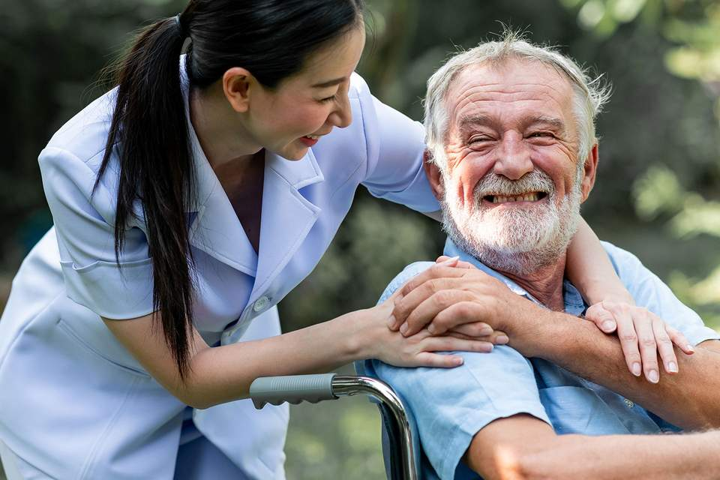 |  | Practical and physical support:  - Personal care  - Medication assistance  - Mobility assistance  Legislation and Theories  The Care Act (2014) focuses on personalized care by assessing the unique needs and desired outcomes of individuals. |  | 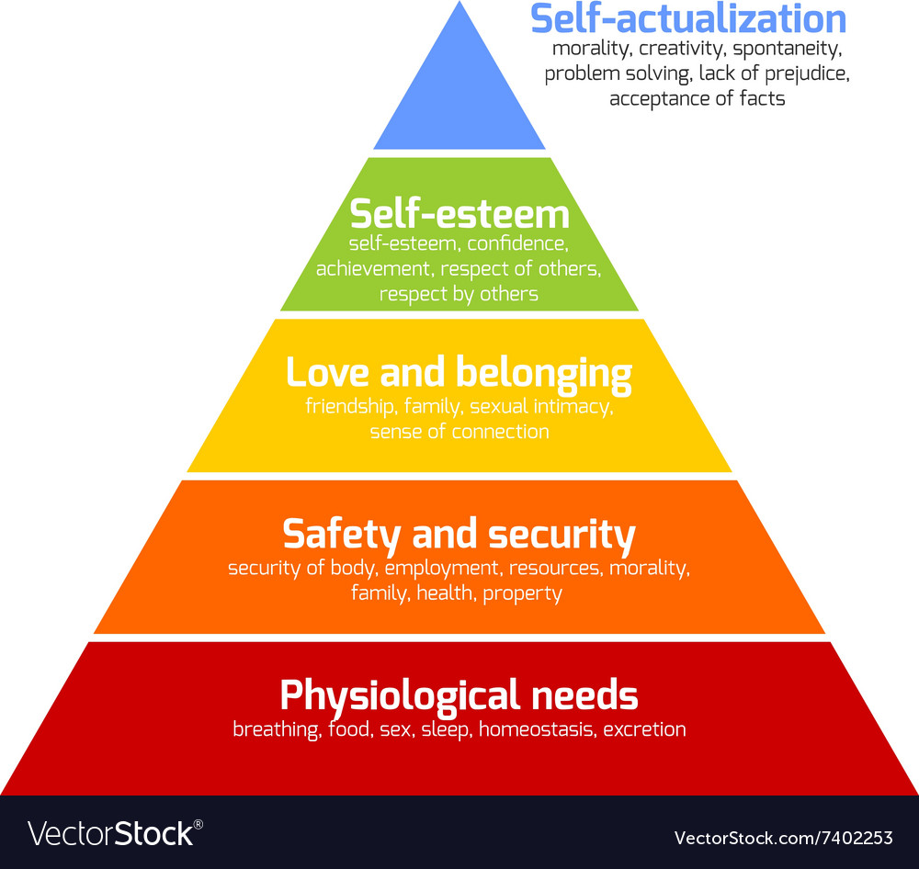
Introduction  There is no doubt that older people play a vital role in society, contributing their wisdom, expertise, experience, and value to its development and growth.  In the United Kingdom, the concept of empowerment has become a key idea in the health and social care sector, enabling older people to make active decisions concerning their health, well-being, and everyday life (Fortunian et al., 2014).  According to Age UK (2017), empowerment extends beyond meeting the physical needs of older people; it involves their emotional, psychological, and social well-being.  Care, Empowerment and Support Needs:  Empowerment is defined as the process by which an individual is given the power to make informed decisions concerning their health and take control over their actions and daily lives (WHO, 2019).  Social, emotional, and mental support:  - Companionship  - Emotional support > compassion, respect, and direct communication that values their choice and views  - Mental stimulation> This is a kind of activity that keeps the mind active, i.e. like social engagement or hobbies  Healthcare and financial support:  - Adequate healthcare  - Financial stability  - Community connection |  |  |  | Evaluation of Current UK Services  The UK has made tremendous strides in developing and implementing systems which support and empower older people.  Digital exclusion is another growing concern. As healthcare services become increasingly online-based, older people are at risk of being left behind and isolated.  The Care Act 2014 requires local authorities to assess individuals’ needs and promote their overall well-being.  Challenges to Independence  One of the significant challenges associated with older people is declining physical health. (Musich et al.,2018)  Social isolation and loneliness are the primary barriers to independence for older people. Many older people live in isolation and depression due to loss of a loved one, retirement and reduced social interaction.  Other challenges include cognitive decline, financial constraints and an inaccessible living environment.  Recommendation  Healthcare services should be more person-centred by involving the older person in planning and feedback.  Continuous training should be provided adequately for health and social care professionals on empowerment, communication, and equality.  Community support should be encouraged through mentorship, volunteering and social participation in other ways to reduce isolation.
The Equality Act (2010) protects individuals from age-related discrimination in areas such as employment. Thus, it promotes fairness and equality, ensuring that everyone is treated without bias.
Maslow's hierarchy of needs is the major theory that underpins the empowerment of older adults. (Putri and Lestari, 2018), outlined the five basic needs of the elderly person as financial security, personal security, mental health, health care and self-actualisation.
Activity theory suggests that maintaining social relationships and engaging in physical activity are key factors in making older people happy.
A lack of social or economic resources can prevent older people from engaging in activities.

Conclusion
Empowerment helps restore people's dignity, independence, and well-being. The Equality Act (2010) promotes fairness and inclusion, while the Care Act (2014) provides guidance on practical ways to support older adults. However, challenges such as policy gaps, workforce shortages, digital exclusion, and social isolation remain.

References

Age UK (2017) Human rights of older people and their comprehensive care. London: Age UK.
Fortunian, Z., Mohammadi Shahboulaghi, F., Fallahi Khoshknab, M., & Mohammadi, E. (2014). Concept analysis of empowerment in older people with chronic diseases using a hybrid model. Asian Nursing Research, 8(2), 118–127. Doi: 10.1016/j.anr.2014.04.002.
Musich, S., Wang, S.S., Ruiz, J., Hawkins, K. and Wicker, E. (2018). The impact of mobility limitations on health outcomes among older adults, Geriatric Nursing, 39(2), pp. 162–169. Doi: 10.1016/j.gerinurse.2017.08.002.
Putri, A. and Lestari, C. (2018). The ability to meet the elderly’s basic needs for Healthy ageing in low- and middle-income countries, KnE Life Sciences, 4, p. 39. Doi: 10.18502/kales. v4i1.1364.
Sobhi, F. and Sedki, M. (2021) Family support with elderly independence in fulfilling activities, physical and mental health, Journal Wetenskap Health, 2(2), pp. 22–26. Doi: 10.48173/jwé. v2i2.103.
Veazie, S., Gilbert, J., Winchell, K. et al. (2019). Addressing social isolation to improve. The Health of Older Adults: A Rapid Review. Appendix F: Social isolation and loneliness definitions and measures. Rockville, MD: Agency for Healthcare Research and Quality (US). Available at: https://www.ncbi.nlm.nih.gov/books/NBK537897/ (Accessed: 2025).
World Health Organization (2019). WHO guidelines on hand hygiene in healthcare: First global patient safety challenge is 'Clean Care is Safer Care'. Chapter 2: Patient empowerment and health care. Geneva: World Health Organization. Available at: https://www.ncbi.nlm.nih.gov/books/NBK144022/ (Accessed: 2025).

