
Fast organic groceries delivery - a supermarket at your door

Innovative Service Proposal
By
Slavena Panayotova
1906636
Module: Developing Innovation and Creativity for Business Advantage
(BMSW6102)

Table of Contents
1. Introduction 3
2. “Cheetah”, fast groceries delivery – Description, Emerging demand, Customers, SWOT Analysis, Unique Selling Point 3
3. Competitors and their Unique Selling Points. What makes “Cheetah” different? Sustaining the Innovation. 7
4. Financing 9
5. Marketing 10
6. Summary 10
7. Reference list 11

- Introduction
This paper describes an innovation proposal for creating an online supermarket called “Cheetah”. The proposal includes description and analysis of the service, brief competitors review, marketing and financing details and a summary of the proposal.
It is structured in four parts as follows:
- The First part is focused on the proposed innovation and contains detailed information about its components.
- In the second part are presented the main competitors and the differences between them and the proposed innovative service “Cheetah”.
- The focus in the third part is the budged, where a rough breakdown is presented along with funding options.
- The next part focuses on the marketing strategy in the pre-launching and sustaining phases.
- The last part summarises the proposal
2. “Cheetah”, fast groceries delivery – Description, Emerging demand, Customers, SWOT Analysis, Unique Selling Point
This section will discuss what type and category of innovation is the proposed service and will describe the innovation proposition in depth.

  - Type and category
“Cheetah” is an online supermarket with an instant 24/7 delivery service.
It is a sustaining service innovation as it comes as an expansion of existing services. It is a closed innovation as it is created within the organisation and aims to be first on the particular niche market, but it is visible to all the participants in the market and it is not (cannot be) protected as an intellectual property. The organisation also does not carry out R&D on its own, but rather uses publicly accessible data and statistics.
  - Service description
The online supermarket “Cheetah” will offer over 2000 of the most purchased food and food related products, which will be constantly available for instant delivery to the customers. The way it works is via warehouses in different areas with 24/7 staff including couriers. The supermarket operates via app and website, where a customer places an order which gets delivered within 40 minutes, very similar to Uber Eats and Deliveroo. What makes it different is the bigger variety of products, exclusively organic, as well as its own delivery system.
  - Emerging customer needs “on demand”
The third and the fourth Revolution of the Retail, also known as Retail 3.0 and Retail 4.0, are referring to the resent changes in the society’s behaviour regarding shopping. Retail 3.0 marks the period when the online shopping became part of our everyday life. The Retail 4.0 period, which started back in 2010, but it is still being adopted worldwide, refers to further engaging with the digital world and using technologies deeply integrated in our routine, such as Internet of Things (IoT), Artificial Intelligence, Cloud technologies and so on (Loh Li Har et al. 2022). In that sense, online groceries shopping, and delivery is not a new service, but it proved to be essential during the Covid crisis (Nanda, A., Zhang, F., 2021). During the lock downs over the past two years, we have seen how important is to have access to online services that could replace the traditional ones. As the demand for the service raised, the market changed and expanded, which created room for innovations, new competitors, and new methods of shopping. According to statistics visible on Figure 1 below, the online grocery expanded with nearly 150% between February 2020 and May 2021 (Statista, 2022).
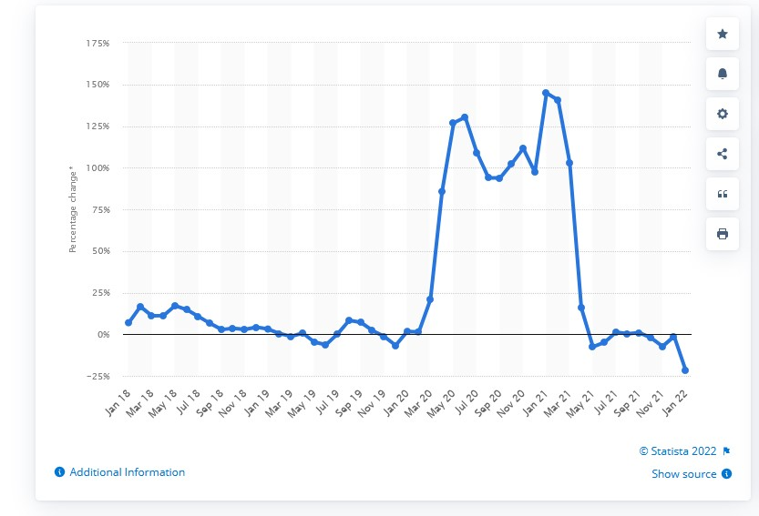
Figure 1: Percentage change in monthly internet food sales value in the United Kingdom (UK) from January 2018 to January 2022.
Furthermore, the global trend of “on demand” and instant services draw a path for future growth of this sector outside the crisis as the consumer’s behaviour are changing, and we have seen a drastic increase of supermarkets offering instant deliveries via services such as Uber Eats and Deliveroo.
But despite the growth those services could not fill the niche entirely, as either the variety is limited, or the delivery timeslots are for days and even weeks ahead. What is missing is an instant delivery of everyday food and food related products without the limitation of choice and timeframe. The service is appropriate when one wants organic products on affordable prices, but cannot go shopping, as well as when one needs just a few products, not worth the trip to the supermarket and yet not available in the near off- license shop. And it will be faster and cheaper than a trip to the supermarket, waiting in lines at checkouts, parking.
Also, the packaging and the delivery will be sustainable – no more plastic wrapped veggies, instead boxes for multiple use, that could be refilled (or return an empty one, get a full one basis), following the principles of the circular economy, zero carbon emissions as the delivery will be either by bike or by electric car.

  - Target customers:
- People with healthy lifestyles
- Busy people
- People not able to go shopping
- Younger generations
- Sustainability orientated people
  - “Cheetah” SWOT analysis
Strengths:
- No exact substitute in Birmingham – “Cheetah” will be first on the local market with that service.
- Not reliant on external order execution or delivery.
- Fast deliveries
- Good quality products- predominantly organic
- Sustainable circular and carbon neutral model – uses less packaging, less plastic, more reusable containers, tree planting and carbon free deliveries.
Weaknesses:
- Big initial investment.
- Hiring and training lots of employees at the same time.
- Lots of legal requirements.
Opportunities:
- First on the market with this service locally gives better chances of gaining bigger market share.
- Covering a niche market, that has not been addressed before properly
- Aligning with the sustainable trends to reduce plastic, use local and renewable resources, minimising the environmental impact
Threats:
- Slow regional growth – opening new warehouse for each area.
- Slow investment return
- New and existing competitors
- Limited market
- Energy/Fuel price rise
- Unforeseen circumstances, such as health or political crisis, fuel shortage, etc.
  - Unique Selling Point (USP)
Cheetah – Fast groceries delivery – a supermarket at your door.

3. Competitors and their Unique Selling Points. What makes “Cheetah” different? Sustaining the Innovation.
3.1 The main competitors can be divided into three groups:
Group A is an instant food and groceries delivery services, such as Deliveroo, Uber Eats, Amazon Fresh, Beelivery, with limited products range and unsustainable packaging/delivery; Group B - delivery services of the traditional and online supermarkets with prebooked delivery, and Group C - online sustainable supermarkets, again with prebooked deliveries.
Group A competitors and their USP:
Deliveroo USP – “Restaurant food, takeaway, and groceries. Delivered.”
Uber Eats USP – “Order food to your door /Uber Eats is the easy way to get the food you love delivered.”
Amazon Fresh USP – Same-day grocery delivery with Prime.
Group B competitors and their USP:
Ocado USP – “Whatever your schedule, there's a delivery slot just for you.”
Group C competitors and their USP:
Good club USP – “Zero waste groceries.” They offer no fresh products.
Abel&Cole USP – “Easy organic everything”
RiverFord USP – “Seasonal organic veg, slow grown for flavour & delivered fresh from the farm”. They offer very limited product range - fruit, vegetables, and few essential food products.
3.2 What makes “Cheetah” different?
The existing services left a gap, where there is no instant online delivery of sustainable grocery products. The competitors from Group A are limited in the products the supermarkets offer to the delivery services, there are often missing products, and the customer has no way of communicating with the supplier substitutes before the delivery and the packaging is almost never sustainable.
Using the traditional delivery services of the supermarkets work very well but with booking the delivery ahead and again- the sustainability issues persist.
With services provided by the competitors from Group C, the customer receives organic products with sustainable packaging (and quite often delivery), but it has to be prebooked, and sometimes the day is determined by the supplier, and not the client.
“Cheetah” will fill that gap, as the services combines organic products with sustainable model and instant delivery.
In terms of sustainability, the company will follow the concept of the circular economy and will deliver with its own carbon neutral fleet, consisting of bikes, electric bikes and electric cars. Additionally, “Cheetah” will plant trees via proxy companies, such as Ecologi.com, to guarantee its zero-carbon footprint and to be climate positive company.
Working with local organic farmers and suppliers will allow the company to keep affordable prices while supporting the local communities.
3.3 Sustaining the Innovation
Since the service will be the first for this niche market in Birmingham, it has some advantage of claiming market share, but there will be new competitors offering the same service in time and we have to ensure that the company will not only sustain its share, but also grow. With an calculated value of £11.4Billion in 2018, the UK grocery e-commerce market is one of the most established and fast growing in the world (Hood, N. et al., 2020). That draws good prognosis for further development of the market and abilities to sustain growth.
In order to gain, maintain and expand market share, the company has to ensure high quality of the products and the service. Working with local farmers and suppliers reduces the cost, but also guarantees high quality.
The customer interface of the website and the app will be user-friendly, using existing platforms proved to be reliable, such as Shopify for the website and Appy pie for creating own app. Both platforms have built in payment systems for most credit cards, PayPal, Stripe and etc., which ensures compliance with GDPR, PCI-DSS, and other legal requirements on the territory of the UK.
In terms of customer care, the company will create a loyal clients’ program, that will include gaining points with each purchase, but also awards for recommending new customers. As the business grows the company will aim to cover more areas and provide more products.
4. Financing
The budget for establishment of the company, along with the first warehouse and sustaining it for the first year, the employees, the equipment, the fees, the insurances and the supplies will be £850,000 as follows:
- Rent real Estate – warehouse, 10,000sq.ft. commercial lease - £15,000 per annum.
- Purchased equipment (storage space, freezers, cool rooms, forklifts, required by law equipment, etc.) - £100,000
- Legal fees and insurances - £100,000
- Staff – eight warehouse workers, three couriers, supervisor, manager, two maintenance employees, two customer support agents - £450,000 per annum.
- Outsourced activities – website/app maintenance, accounting, legal, marketing and advertising - £30,000 per annum.
- Pre-opening advertising - £150,000.
- Other expenses - £5,000
The company will use a mixed model of financing – 35% own funds, 15% crowd funding and 50% business loan.

5. Marketing
In order to make the service popular an aggressive marketing campaign ending with opening party will take place a month before the launching of the app and the website. The opening party will take place in the warehouse itself on the opening day and will aim to gather important figures from the related industries. The advertising channels will be as follows: all the social media channels, such as Facebook, Twitter, TikTok, Instagram, YouTube, also on Google, local radio stations and newspapers, leaflets, online media, public transport, and billboards. Later on, the sustaining campaigns will include influencers and promotional events.

6. Summary
Enhancing the smart retail experience may be critical for reaching or exceeding consumer expectations, especially in the post-pandemic world since we transformed our daily routines and were enabled to receive everything at home and on demand. Overall, the researchers anticipate that smart commerce will broaden its influence further, and that merchants will have adjust quickly to this dynamic and more and more demanding market (Priporas, C., Stylos, N., Fotiadis, A., 2017). New services, applications and tools should be utilised to fit the needs of the customers and that is what “Cheetah” is – a quality service on demand at any time.

7. Reference list

- Har, Loh L., Umi K. Rashid, Lee T. Chuan, Seah C. Sen, et al. "Revolution of Retail Industry: From Perspective of Retail 1.0 to 4.0." Procedia Computer Science 200 (2022): 1615-25.
- Hood, N., Urquhart, R., Newing, A. and Heppenstall, A., 2020. Sociodemographic and spatial disaggregation of e-commerce channel use in the grocery market in Great Britain. Journal of retailing and consumer services, [e-journal] 55, pp.102076. 10.1016/j.jretconser.2020.102076. <https://dx.doi.org/10.1016/j.jretconser.2020.102076>.
- Nanda, A., Xu, Y. and Zhang, F., 2021. How would the COVID-19 pandemic reshape retail real estate and high streets through acceleration of E-commerce and digitalization? Journal of urban management, [e-journal] 10 (2), pp.110-124. 10.1016/j.jum.2021.04.001. <https://dx.doi.org/10.1016/j.jum.2021.04.001>.
- Priporas, C., Stylos, N. and Fotiadis, A.K., 2017. Generation Z consumers' expectations of interactions in smart retailing: A future agenda. Computers in human behavior, [e-journal] 77, pp.374-381. 10.1016/j.chb.2017.01.058. <https://dx.doi.org/10.1016/j.chb.2017.01.058>.
- Statista, 2022, UK internet food sales: monthly trend 2022. [on-line] Available at: <https://www.statista.com/statistics/286361/internet-food-sales-value-trend-monthly-in-the-united-kingdom-uk/> [Accessed: Apr 6, 2022].

