Mamasir Miah Student: 1805953 Date: 03/07/2019
Email: Mamasir1805953@gmail.com
Password: uwtsd2018

Digital Skills And Research Methods
Assessment 2: Part 2

Website Design
Moving Masala is a hot food van business. It sells items such as curries, burgers, baguettes, coffees, etc.
The business is developed and run by the following people: myself, Abdul Islam (1806293), Sanu Miah (1806292), Katarzyna Kolowrocka (1805961) and Shahidur Rahman (1805959). For the Managing Enterprise module, we have prepared a business plan for Moving Masala. Each person is responsible for a certain aspect of the business. Similarly, each person is also responsible for the design of a single page on the Moving Masala website.
There is a total of six pages on the Moving Masala website. I have taken the responsibility of designing the home page and also the contact us page. Shahidur is designing the Menu page. Katarzyna is doing the Blog page. Abdul is doing the FAQ’s page and lastly Sanu is doing the Careers page. Please visit www.weebly.com and use the details provided at the tope of the page to log into our website.
It was important for me to welcome the customer as soon as they enter the website homepage. Therefore, the first thing they see is our name and mission statement. This is displayed below:
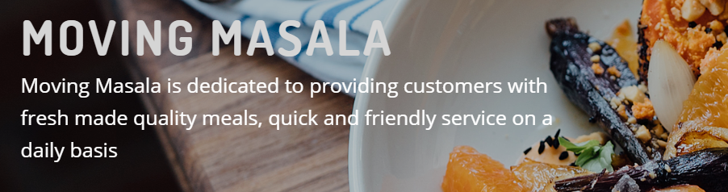
Following this, on the homepage, is a gentle introduction to the general products and services provided by Moving Masala.
The reason for this introduction is to make the customer feel familiar with the name and products and not overload them with information immediately.

On the homepage, if the customer scrolls down a little, is our company Logo as well.

This is put there again to make a good impression on the customer and gently familiarise the customer to the business.
On the “contact us” page I put a map of where the customer can find us.
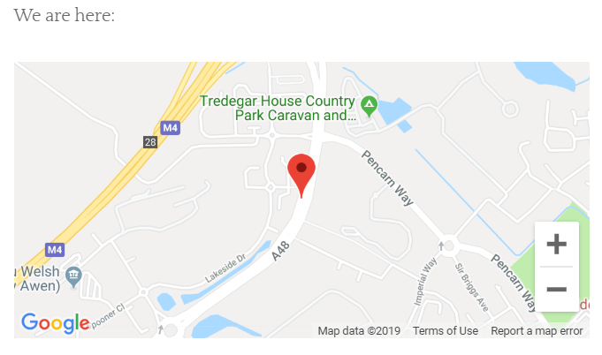
With this the customer can locate the business if they are nearby to call in. Along with this I have detailed ways for the customer to get in touch with Moving Masala. They can do this by email, phone or visiting personally.
Another thing added on the page is a comments section as shown below:
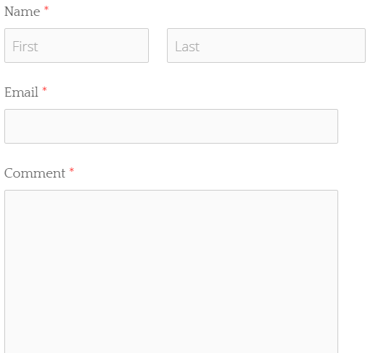
We would love to hear from the customer with regards to the quality of our products and services. Therefore, it is vital that the customer can leave comments for us. This can help us with improving our products and improving customer satisfaction.

