

Assessment 1 – Reading Task Template
UPART 1: Upload your photo of your A3 in-class notes here:

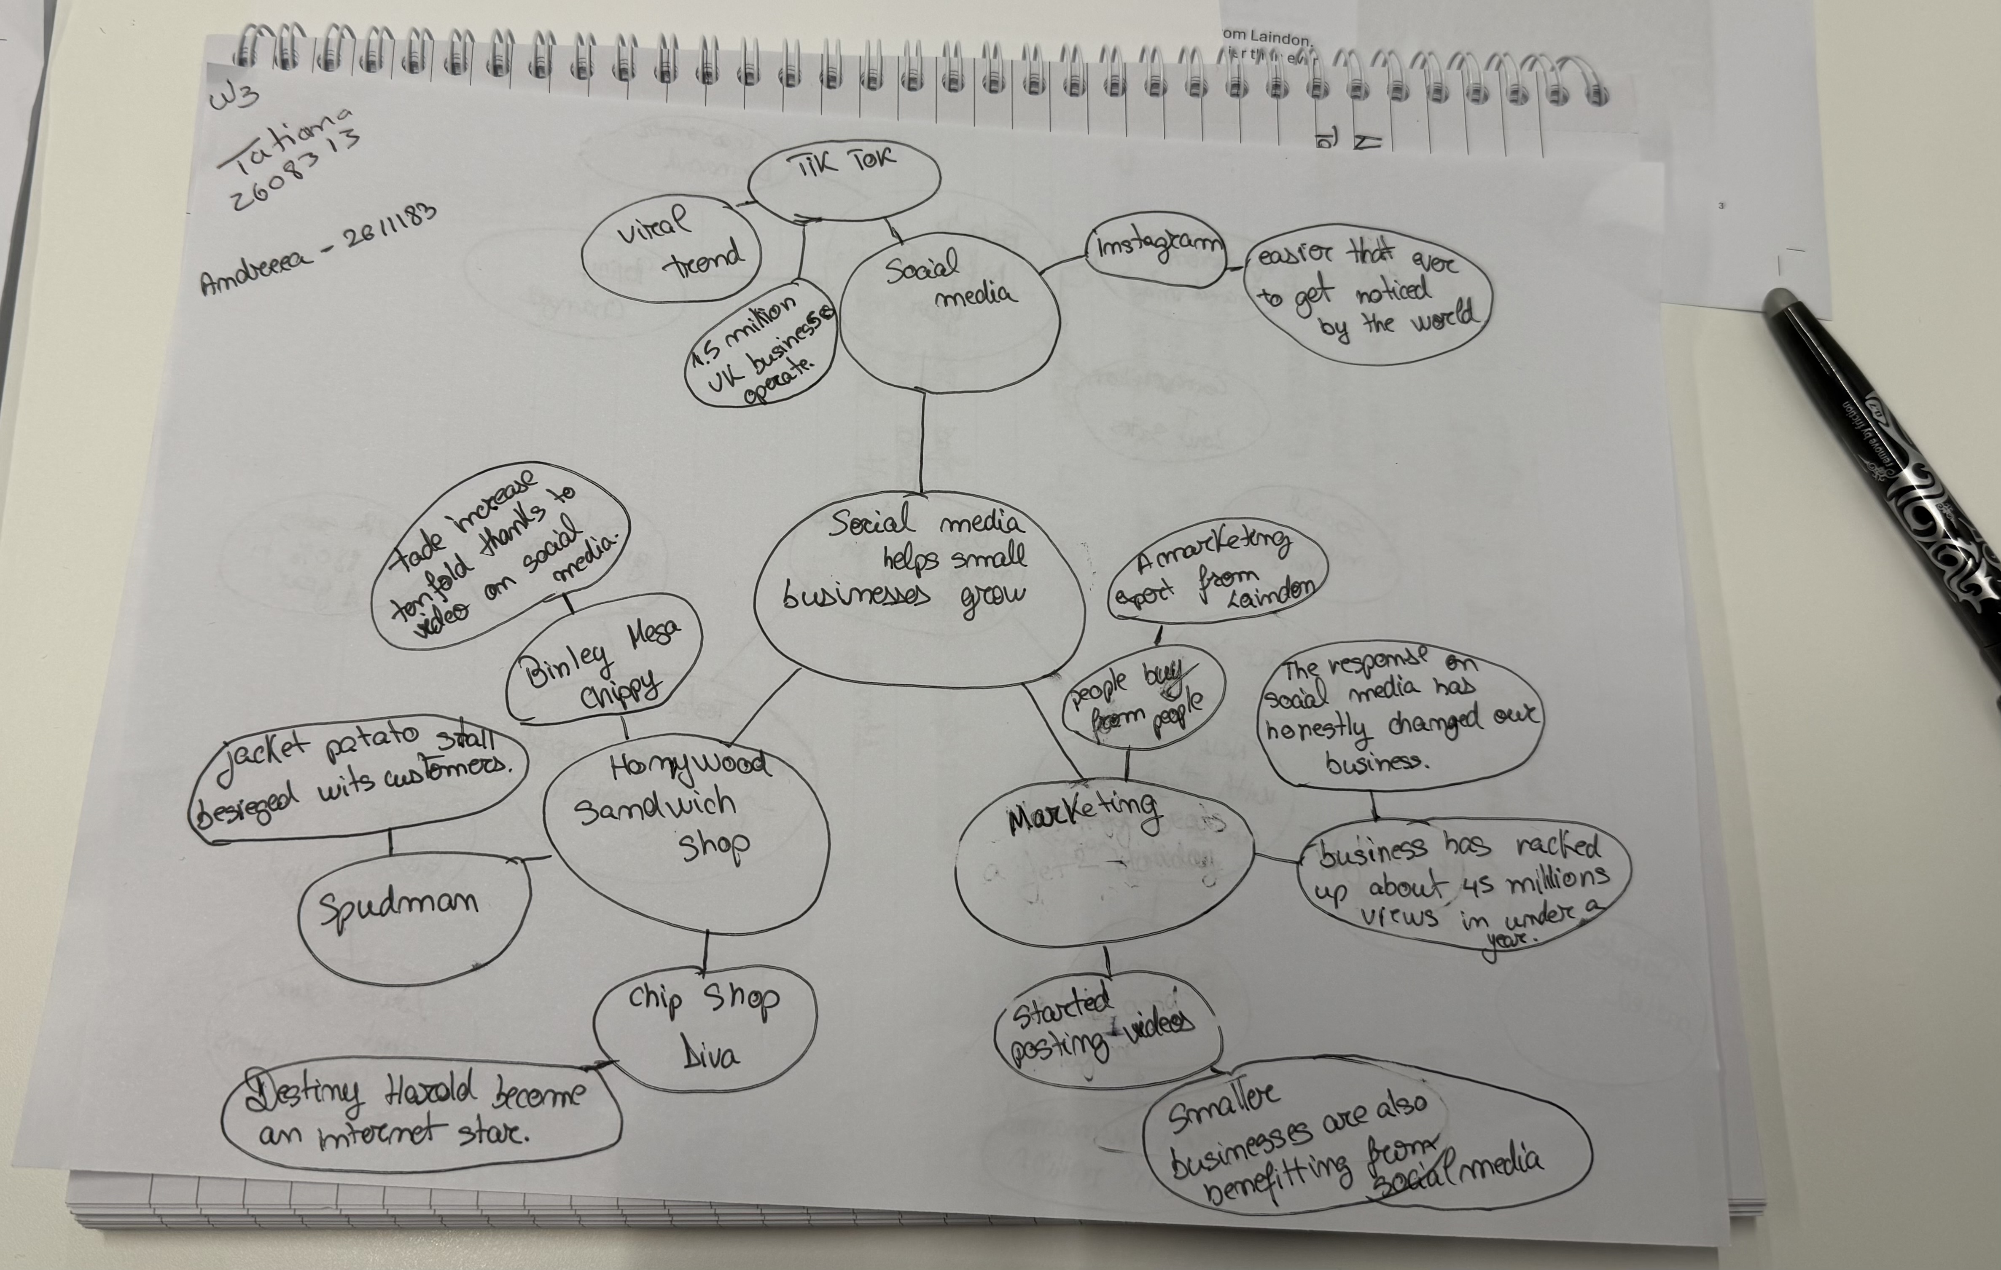

PART 2:
- Answer every question below in 1-3 full sentences.
- Use your own words. Do not use generative AI to answer these questions.
- Include a specific detail from the text when asked.
REMINDER
- The main idea is the overall message of the whole text.
- A key point helps to explain the main idea.
- A specific detail or example from the text shows that the key point is true.

- What is the main idea of the whole text?
The main ideea is social media how I help the business grow.

- What is one key point that supports the main idea, and which specific example from the text shows this?
One key point in social media is about the all application like Facebook,
TikTok, Instagram. And using this application is more easy to conected and
Communication to people.

- What is a different key point that supports the main idea, and which specific example from the text shows this?
Different key point is the marketing and delivery become using the application is more better for people see the meniu an easy for take our food.

- Which part of the text do you think is most important, and why?
I think is most important everything , like how manage the work , food , staff for I get the feedback good, and the deliveries is most important for any people.

Reflection:
- What did you find difficult in this task (including in-class components), and why was it difficult? In this task is difficult sales the product before the application and is a lots of restaurant specific like this and the restaurant don’t have any publicity for selling.

- What helped you with this difficulty, and how did it help you?
Working with my colleague helped us share our opinions and enabled me to become much more communicative something that is usually difficult for me.

