

BA Leadership and Management Skills for the Workplace
Module: Developing Relationships and Workplace Achievements
Module code: BMSW 5102
Module Leader: Charles Nwaogwugwu
Assignment Title: Individual Report on “Development of a plan by meeting the identified personal development needs and expectations of individual employees in Hilton”
Student Name: Atanas Radev
Student ID: 2119680

Table of Contents
Introduction 3
Performance Management 4
Planning 4
Monitoring 4
Reviewing 4
Rewarding 5
Critically evaluate development vehicles (performance appraisal tools and techniques) available to your organisation 6
Explain their effectiveness to which you think they are appropriate in identifying and satisfying the development needs of the individual employees to meet both individual and organisational success. 9
Constructive professional development plan 11
Recommendation 17
Conclusion 17
Reference List 18

Introduction
Personal development of employees in their respective organisational premises is required for the listing of strengths, weaknesses, needs and professional goals of individuals and matches them to set objectives (von der Heydt, 2021). This is important to create an agreement between employers and employees to outline the objectives of each member and help them attain effective growth. The report has evaluated some performance appraisal tools such as 360-degree feedback, management by objectives, the BARS method, and others. The effectiveness of these tools has been identified using some HRM theories and models. In this report, the selected project is developing a learning platform for the organisation, Hilton which will be important for providing employees with information on improvement of their current performance gaps. In this report, critical evaluation of development vehicles will be carried on with the preparation of a constructive professional development plan for the brand to meet the needs and expectations of an individual employee.

Performance Management

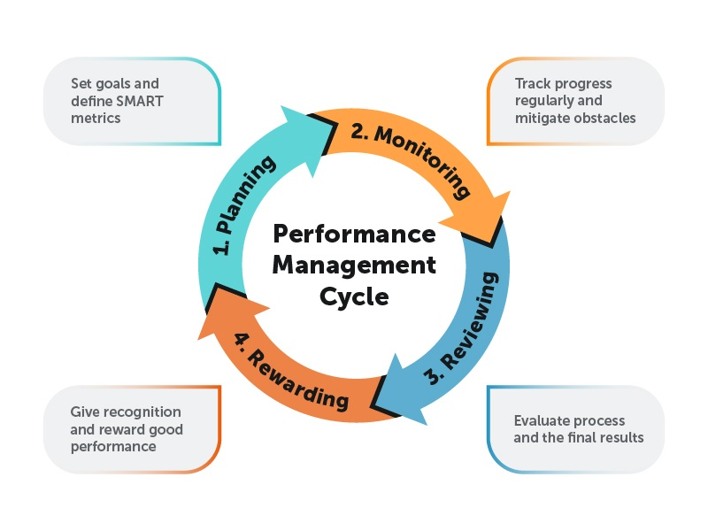
Figure 1: Performance Management Cycle
(Source: Ivan Andreev, 2023)

Planning
The first task an organisation must complete is planning. Before meeting with employees and other team members to assign them goals, management must first develop a strategy for the initial goals the organisation wishes to achieve.

Monitoring
Failure might result from planning without carrying it through. Managers used to follow up once or twice a year, but we now know that this practise might be ineffective. to make sure the staff is on track to meet their objectives there must be continuous follow-up and feedback.

Reviewing
The management conducts a review at the end of the cycle. The third cycle should just be a formality between the manager and the employees if the manager or supervisor got along with the employee well throughout the previous two cycles.

Rewarding
At this point, management rates the performance of teams and individuals. Employees who don't achieve their goals should be dealt with by management in the proper manner. If cooperation is impossible, there may be a warning, a fine or termination. On the other side, it's critical to adequately reward employees who fulfil their goals or go above and beyond.

Critically evaluate development vehicles (performance appraisal tools and techniques) available to your organisation
Several tools are utilised by an organisation to ascertain the development vehicles and performance appraisal. Some of these tools and techniques have been elucidated in the following section of the report.
360-degree feedback: This involves an assessment method in which employees in an organisation are provided with a form of confidentiality relating to their performance at work by colleagues (Fleenor, Taylor and Chappelow, 2020). Through the application of this process, Hilton Hotels can ensure that the on-ground evaluation of various facets of an employee's performance is evaluated. Moreover, it also helps in properly improving the comprehensive level of teamwork present in the organisational operations. Furthermore, the provision of 360-degree feedback also facilitates the proper identification of the various weak areas of an individual and thereby, this provides them with a chance of improving upon their ability in a significant way effectively. However, it can also lead up to a negative culture in an organisation and thereby, this diminishes the productivity prevalent in Hilton by veritable margins. Additionally, it implements a high amount of importance on areas of weaknesses that an individual has which in turn plays a major role in reducing their motivation levels and diminishes their efficiency and drive to complete work that has been allocated.
Behaviourally Anchored Rating Scale (BARS) method: According to Sjahruddin et al (2022), a behaviourally anchored rating scale helps in evaluating an employee based on predefined parameters and behavioural patterns. This aids in the proper identification of the most productive behaviours of an organisation and thereby supplements the creation of a conducive working environment effectively. However, this has been contradicted by Tsai and Wang (2019), outlining that BARS requires an in-depth understanding of employees and managers to be properly and accurate. This will limit the ability of an organisation to generate an effective appraisal method for the new project that will be developed effectively.
Management by objectives (MBO): This refers to an appraisal technique in which a manager and an employee in an organisation decide on a performance-related goal and work towards the achievement of that. As per Islam and Sarker (2020), the primary benefit of this technique of performance appraisal is that it supplements the better understanding of duties and skills required to be executed. Additionally, this is highly beneficial for the development of the career-related aspects of an individual as they can comprehend various facets of organisational operations in a faster manner (Lennon, 2023). However, as stated by Aminchi, Hadiza and Barka (2023), a major limitation of this aspect of this approach to operations involves challenges in setting goals and objectives properly. Additionally, it also outlines that, management by objectives lowers the flexibility of executing different aspects of an organisational functioning. In all, this can be used by Hiton to improve the understanding of the weak areas of employee performance and obtain a metric based on performance that can be monitored and improved.
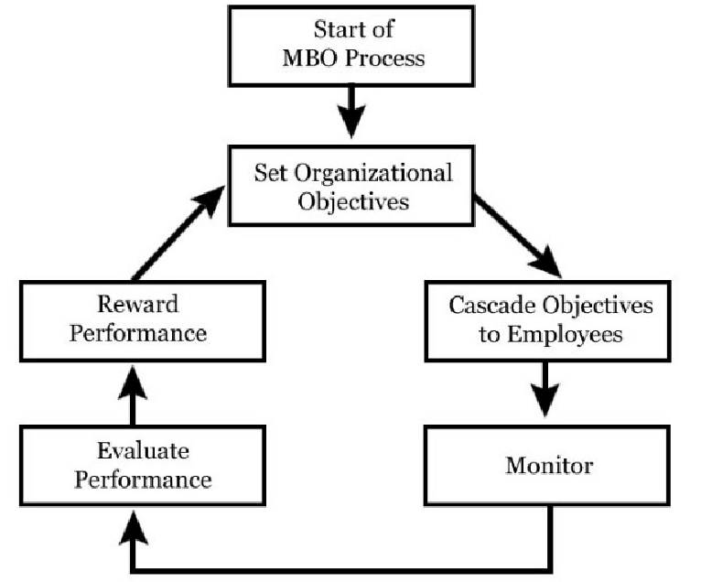
Figure 2: MBO Process
(Source: Bucata and Rizescu, 2019)
Psychological Appraisal Method: Harrison et al. (2021) describe an assessment approach that involves assessing and analysing an employee's potential abilities rather than past performance. It effectively assists in revealing an employee's hidden talent, which leads to a big improvement in the organization's performance. Additionally, because prior failures are not taken into account, it also significantly increases employee motivation. This sort of appraisal is ideal for Hilton in this situation since it can identify the need for a learning platform that employees need in order to properly upskill themselves. Kurdi and Alshurideh (2020), who claim that there is a significantly high cost associated with the implementation of the various procedures that are involved in the procedure of successfully completing this appraisal process effectively, refute all these aspects of the appraisal technique. Overall, it is clear that this method of staff evaluation may be successfully used in Hilton Hotels' operational module.
Ranking: This is one of the oldest tools that are used by organisations in measuring the performance of employees. it entails arranging employees in an increasing order inversely proportional to the performance that they illustrate. According to Peykani, Mohammadi and Emrouznejad (2021), the primary advantage of this process of appraisal is the ability to identify the better-performing employees and thereby, allocate work in a manner that suits their performance and abilities. Ranking as a tool for performance evaluation also helps in clearly pointing out the need for low-performing employees to undertake strategies to improve their performance. Herein, utilising this in the new project can be significantly important as the learning platform can serve as an optimised platform to operate in a manner that can enable them to upskill and thereby enhance the comprehensive performance that they illustrate. However, it also reduces the overall motivation among employees in the hotel and creates a work environment that involves a high amount of jealousy.
Confidential Report: In this technique for executing employee appraisal, a superior is tasked with providing feedback on the performance that has been demonstrated by a subordinate in the course of executing the assigned responsibilities effectively (Anjum, N. and Rahman, 2021). the primary advantage of this method of appraisal involves a wide-ranging evaluation of an employee involving their conduct, knowledge regarding work, punctuality and various other aspects effectively. Moreover, it ensures that the employees do not feel demeaned through the critical feedback that is provided and that the relationship between the superior and the subordinate is not degraded. Herein, Hilton Hotels essentially adopt this process of appraisal in their working process in appraisals as well as in situations of investigations (Hilton, 2023). However, this has been contradicted that this does not facilitate the improvement of the employees in any manner. Additionally, the positive impacts of the overall technique are not large.

Explain their effectiveness to which you think they are appropriate in identifying and satisfying the development needs of the individual employees to meet both individual and organisational success.
Based on the above evaluation, it can be determined that 360-degree feedback, MBO and ranking can be used by Hilton in managing the performance of the employees. This will be highly beneficial for the organisation as it outlines the key weaknesses of employees and properly apply the learning platform to upskill and develop overall productivity by a significant margin. Additionally, through the application of these processes, Hilton Hotels can ensure that the employees have the requisite skillsets to achieve the organisational goals and objectives effectively. Furthermore, this can enable the betterment of the performance of employees which can significantly enhance the self-esteem of employees. It helps in increasing the motivation of employees by identification of weak areas and learning opportunities.
Since 360-degree feedback enables properly recognising issues while working and helps in implementing a higher amount of better coordination level between employees which improves the working relationships between them. Therefore it plays a significant role in improving the satisfaction of employees. Similarly, MBO helps in establishing a mechanism through which managers and subordinates can increase their relationship. Additionally, it also helps in applying a proper metric based on which performance can be maintained and worked upon effectively. In all, this plays a significant role in increasing the importance of learning platforms, a new project to be initiated.
The effectiveness of tools can be identified using HRM models and theories including Human capital theory and The Warwick Model. Human capital states productivity of employees can be enhanced through greater skills, improved training and other areas (Greer, 2021). Based on the performance appraisal done through 360-degree feedback, ranking and another process, Hilton Hotel will be able to identify the skill and knowledge gap among its employees so that a detailed and structured training program can be developed. Therefore, it can be deduced that Human capital theory will be helpful in managing training for employees thus it can support higher employee motivation.
Considering The Warwick Model, it is found that five factors are responsible for the overall functioning of the human resource department. Widarni and Bawono (2020) demonstrated that These include outer content, inner context, HRM context, HRM content, and business strategy. The inner context and HRM content have an integral role in managing the performance of employees where the mentioned tools and techniques can be appropriate. Inner context includes company culture and leadership that creates the foundation for employee performance and development. Having a positive culture encourage employees to consider feedback and work on their weakness. Hilton Hotel leaders follow transformational leaders for which employees are supported with constructive feedback that motivates them to work towards common goals. HRM content includes factors like employee relations, reward system and others. Employee relations can be improved when employees are given support to perform well. In Hilton, based on employee performance, they are given rewards, bonuses and other facilities (Ambition Box, 2023). This performance can be measured through identified tools so that transparency can be maintained.

Constructive professional development plan
A professional development plan is engaged in the documentation of goals, skills and competency development process which is required for the accomplishment of continuous improvement and career progression (Admiraal et al., 2021). In the table below, a professional development plan has been constructed to help the employee of Hilton progress with the learning platform and improve their customer management and handling operations.
Development objectives | Priority | Activities to be undertaken | Resources | Target Start Date | Target End Date | Evaluation
To develop customer service for helping employees understand customer feedback | High | In the learning platform, dictations will be provided to employees to perceive the statements and feedback of customers | Case Studies  YouTube videos  Discussion sessions | 01.09.2023 | 12.12.2023 | It will be suitable because, with an assessment of customer feedback, the brand will be successful to create personalised services. The resources will be feasible to be blended with the learning platform. It will be acceptable to employees because of their provision of opportunities for better performance. This will be affiliated to help staff gain better recognition and rewards while working at the hotel and enhance their experience.
To improve team working capabilities to create collaboration with managers | Moderate | Through the learning platform, mentors will be assigned to employees who will encourage peer learning and feedback allocation process | Resources namely handouts, presentations and YouTube videos will be important | 02.09.2023 | 15.04.2024 | The suitability of the learning goal is immense to reduce miscommunication between teams and help employees create a positive working atmosphere. Its feasibility is aligned with the improvement of employee engagement within the brand which can influence customer-employee relationships and build a positive brand value. The acceptability of this method by employees will be prominent to abide by the training and professional values being posed by Hilton.
To enhance communication skills to speak clearly and articulately to customers | High | Employees will be included actively in the workplace communication strategy which will help them to easily collaborate with others and be concise while speaking to customers | Case studies and YouTube videos will be provided to employees to help them understand the deployment of the communication strategy plan | 04.09.2023 | 11.05.2024 | The suitability of the communication strategy plan is immense to reduce cohesion and dissatisfaction in the minds of customers for employees of the brand. The feasibility of such a plan will be articulated with the proper presentation of brand values and guides to customers and attain their engagement and trust. The acceptability of this method will be felicitated with improving the customer-employee relationship in the brand and heightening productivity.
To improve problem-solving capabilities to help employees reduce grievances of customers | High | Through the learning platforms, employees will be provided training to be attentive in the brainstorming sessions and devise their respective ideas and plans | Group discussions and books will be important to set guidelines for brainstorming sessions | 10.09.2023 | 01.02.2024 | The suitability of the brainstorming sessions is raised with the keen attention of mentors to understand the gaps of employees and improve their knowledge about varied ideas available. It will be feasible to include multiple ideas from employees and creative approaches to solve customer issues. This will be acceptable to reduce the employee-customer relationship grievances and solve enhance company values and mission to serve a diversified customer
To pay attention to details to affiliate the creation of checklists to fulfil daily details | Low | Employees will be focused on prioritisation of their tasks based on to-do list creation and training to fill in the checklists | YouTube videos and meditative audios will be impactful to drive in the attention of employees and motivate them for success | 15.09.2023 | 15.06.2024 | This will be suitable to help employees overcome their issues with lower attentiveness and record better management of daily tasks. The feasibility of this technique is recorded with an allocation of daily engagement of employers to record important tasks and their accountability to accomplish the same. Its acceptability will be marked by the improvement of the working process of staff.
Table 1: Professional Development Plan
(Source: Created by Atanas Radev)

Recommendation
Because it provides a more comprehensive, all-encompassing evaluation of employee performance, 360-degree feedback is a better choice for businesses. This open-minded strategy aids in more accurate identification of strengths and limitations, develops self-awareness, and stimulates targeted development, all of which eventually contribute to increase productivity, teamwork, and organisational success.

Conclusion
From the above report, it can be stated that Hilton Hotels have been operating for more than 7,000 hotels across the globe and has been engaged in the development of a learning platform. The importance of 360 feedback is immense to evaluate the performance of varied employees of the brand and attain an effective chance to enhance their positive working culture and reduce issues. Ranking is utilised for performance evaluation and can affiliate the development of the learning platform with important insights into the areas of growth of staff. With the professional development plan, employees will be encouraged for the enhancement of customer service provided and present proper communication with respective team members. A workplace communication strategy and checklists will be credited with brainstorming sessions for the betterment of staff performance and influence the sale of Hilton.

Reference List
Admiraal, W., Schenke, W., De Jong, L., Emmelot, Y. and Sligte, H. (2021) Schools as professional learning communities: what can schools do to support professional development of their teachers?. Professional development in education, 47(4), 684-698.
Ambition Box (2023) Hilton Available at: https://www.ambitionbox.com/benefits/hilton-benefits (Accessed: 31 July 2023)
Aminchi, D., Hadiza, B. and Barka, I. (2023) AN OVERVIEW OF THE APPLICATION OF MANAGEMENT BY OBJECTIVES (MBO) AND ITS IMPLICATION FOR ADULT EDUCATION ADMINISTRATION IN NIGERIA. Journal of Continuing and Development Education, 3(1), pp.96-100.
Anjum, N. and Rahman, M.M. (2021) Performance appraisal and promotion practices of public commercial banks in Bangladesh-a case study on acr method. SEISENSE Journal of Management, 4(3), pp.1-16.
Bucata, G. and Rizescu, A.M. (2019) Considerations on prospects for increasing the effectiveness of organizational management. Scientific Journal of the Military University of Land Forces, 51.
Engagedly. (2023,). The 4 Stages of Performance Management Cycle. Retrieved from https://engagedly.com/the-4-stages-of-a-performance-management-cycle/.
Fleenor, J.W., Taylor, S. and Chappelow, C. (2020) Leveraging the impact of 360-degree feedback. Berrett-Koehler Publishers.
Greer, C.R. (2021) Strategic human resource management. Pearson Custom Publishing.
Harrison, R., Jones, B., Gardner, P. and Lawton, R. (2021) Quality assessment with diverse studies (QuADS): an appraisal tool for methodological and reporting quality in systematic reviews of mixed-or multi-method studies. BMC health services research, 21(1), pp.1-20.
Hilton (2023) Code of Conduct Available at: https://ir.hilton.com/~/media/Files/H/Hilton-Worldwide-IR-V3/committee-composition/HW-Code-Of-Conduct-OCT2015-L26.pdf (Accessed: 31 July 2023)
Hilton (2023) Explore our brands. Available at: https://www.hilton.com/en/brands/ (Accessed: 31 July 2023).
Hilton (2023) Welcome TO HILTON. Available at: https://www.hilton.com/en/corporate/ (Accessed: 31 July 2023).
Islam, M.A.R.H. and Sarker, R.I.N.K. (2020) The effect of management by objectives on performance appraisal and employee satisfaction in commercial banks. Journal of Social and Development Sciences, 32(6), pp.4-23.
Kurdi, B. and Alshurideh, M. (2020) Employee retention and organizational performance: Evidence from banking industry. Management Science Letters, 10(16), pp.3981-3990.
Lennon, D. (2023) Career Disappointments Gnawing at You? Reset Expectations. Available at: https://jobs.localjobnetwork.com/a/t-career-disappointments-gnawing-at-you-reset-expectations-au-lennon,-dawn-articles-a5769.html (Accessed: 31 July 2023).
Peykani, P., Mohammadi, E. and Emrouznejad, A. (2021) An adjustable fuzzy chance-constrained network DEA approach with application to ranking investment firms. Expert systems with applications, 166, p.113938.
Sjahruddin, H., Hidayat, P., Moridu, I. and Sutaguna, I.N.T. (2022) Determination of The Best Employee Using The Behavioral Anchor Rating Scale. Jurnal Mantik, 6(3), pp.2753-2758.
Tsai, S.B. and Wang, K. (2019) Using a novel method to evaluate the performance of human resources in green logistics enterprises. Ecological Chemistry and Engineering S, 26(4), pp.629-640.
von der Heydt, A. (2021) Building A Coaching Culture: How Managers As Coaches Can Include And Develop New Employees Successfully. Andreas von der Heydt Coaching.
Widarni, E.L. and Bawono, S. (2020) The Basic Of Human Resource Management Book 1. BookRix.

