University of Wales Trinity Saint David
Wales Institute of Science and Art


Engine Performance Characteristics

Module: Powertrain Technology
Module Code: ACHA4029

Joshua O’Rourke
2501321
Due Date: 22/03/202
Contents
Introduction 2
Method 3
Data Gathered 5
Conclusion 10
References 11

Introduction
This report will cover and comment on experiment results gathered from an engine dynamometer test of a Honda VTEC 1.6 d16 engine. It will investigate the effects of different operating speeds and loads on the engine, and how rpm affects performance under controlled conditions to help understand the behaviour of the engine. Using raw data from an experiment, other performance characteristics can be calculated accurately and reliably, which can then be compared to engine speed to create scientific graphs for visualisation.

Method
An engine dynamometer is a machine that is used to measure an engines speed (RPM) and torque in order to calculate data such as power and thermal efficiency. The engine which is to be examined is attached to the engine dyno via a driveshaft, ensuring the engine rpm is equal to the rpm of the dyno. A sensor control module sends all of the gathered data to computers for interpretation, such as throttle position, coolant temperature, and lambda (air to fuel ratio); There is also an exhaust extraction system in which emission data can be collected. The fuel supply board has fuel being fed from the main tank through various filters and a swirl pot using pumps to a fuel regulator before going to the engine. The regulator is used in order to run both fuel-injected and non-fuel injected engines. There is a flow meter positioned before the engine that confirms the fuel being measured is actually used by the engine. (uwtsd, 2020)
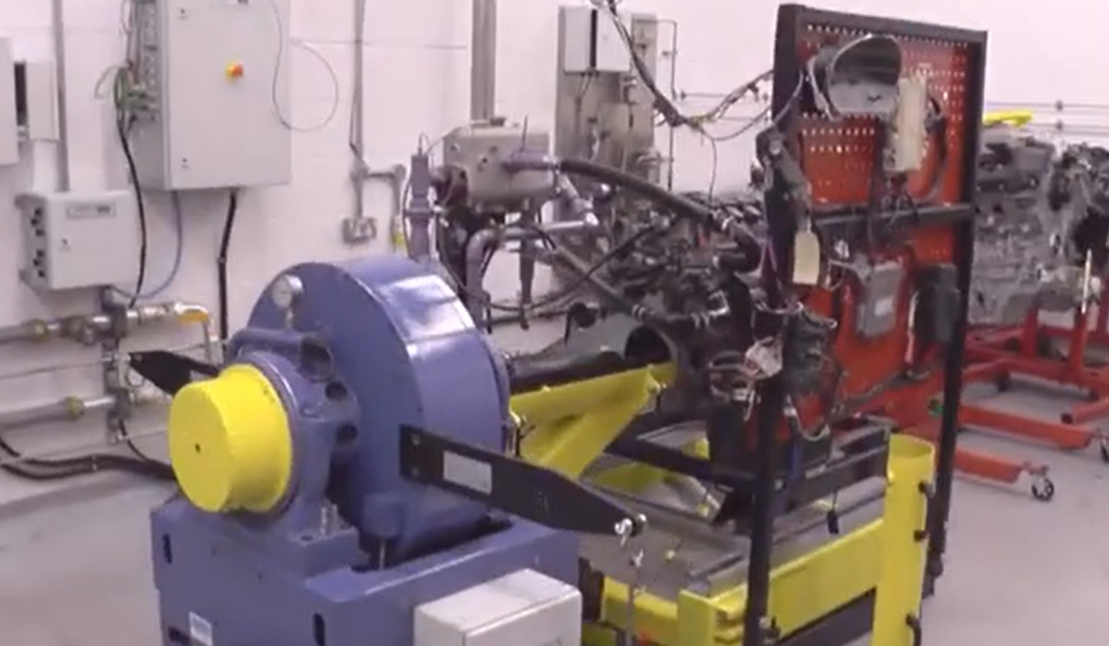
Figure 1 - Engine Dynamometer
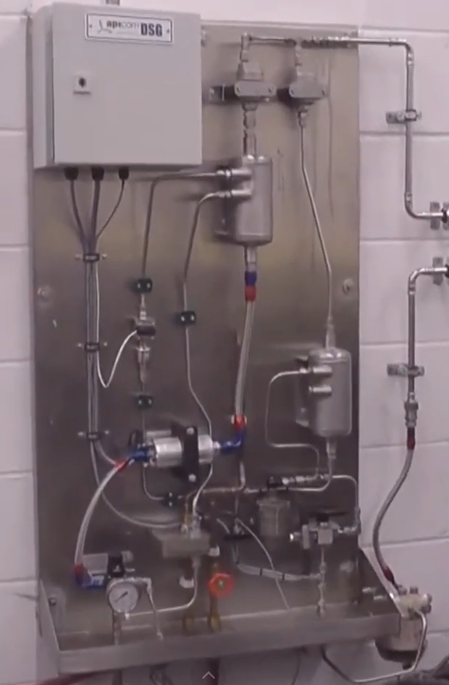
Figure 2 - Fuel Supply Board
The dyno has two calibration arms of an equal length (815.776 mm) that balance each other, and in which a load is applied (such as 10kg, 20kg etc), producing an electromagnetic field and therefore torque that tries to move the outer casing of the dyno. Torque is measured using the outer casing of the dyno, which is restrained by a strain gauge that outputs a voltage between 0 and 10 that the main control system can convert to torque by measuring the voltage change when a load is applied to the calibration arms. The dyno has its own coolant system to deter overheating – having a current running through it can generate heat. (Engine Dynamometers - SuperFlow, n.d.; Engine Dyno - Mass Racing, n.d.)

Data Gathered
The engine dynamometer at the university was faulty at the time when data was going to be practically gathered for this report. As compromise, the raw data presented below was collected prior to the dyno being inoperative by a trusted source. The engine that was tested is a 2001 Honda VTEC d16 1.6 litre petrol engine, imported model (lower powered).
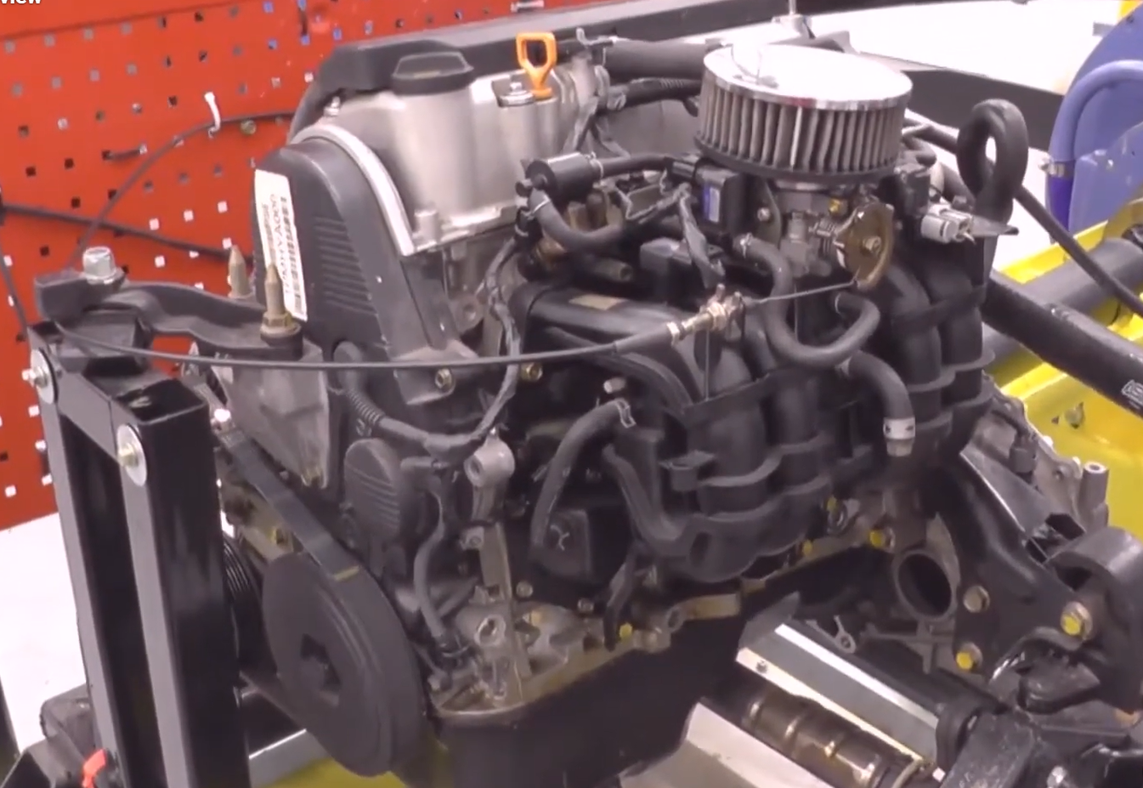
Figure 3 - Honda Engine
Using the provided raw data, other engine performance characteristics could be calculated, including power, BMEP, SFC, and overall thermal efficiency, and graphs showing the correlation between engine speed and the various other data have been created.

Figure 4 - Torque/Power vs Engine Speed
This graph shows the relationship between both torque vs engine speed and power vs engine speed for the Honda engine. As observed, torque increases as the rpm rises from idle, then plateaus in the mid range (where it is most efficient) before dropping off at the higher speeds. The reason for the peak torque at mid range – around 2500 rpm - is because the cylinder filling is at its strongest and volumetric efficiency heightens; it has the optimal airflow, pressure and combustion efficiency. This is also where the greatest acceleration of a vehicle would take place, with the greatest amount of torque; the best performance would tale place at higher rpm, where power is at its peak. (The Idiot’s Guide to Power & Torque, n.d.)
At idle, the engine is at about 20hp, and increases steadily until about 4750rpm, where it begins to drop off. The reason for this drop off is because the engine has reached the limit of airflow it can intake, decreasing power and torque as rpm still rises. Peak power occurs at roughly 4600 rpm, where the engine is making 55hp; this is generally a low maximum power output, this is because the engine is over 25 years old and was last used in a lawnmower. Hp can decrease over time as a result of wear of seals, piston rings, cam lobes, and other age related damage; anything that will impede air flow will result in a loss of power. As well as hindering air flow, other reasons for power to drop is a rise in friction within the engine, cooling system damage, and drops in combustion efficiency.(PhilKotse,2019)
Power is the rate of doing work in the engine, telling you how effectively the engine can deliver torque. The difference between torque and power is that torque is just the force, and power is determined by how quickly that force can be put to use.

Figure 5 - SFC vs Engine Speed
The SFC of an engine refers to the mass of fuel consumed per unit of power, i.e. the efficiency of the engine converting fuel into useful power - the lower the SFC, the more efficient the engine. The graph shows the SFC is not consistent with engine speed, suggesting that the engine is less efficient at both low and high rpm, with the mid rpm range being the most efficient (lowest SFC). It is important to note that most engines will fall within the low SFC range at cruising speeds, making longer drives more fuel efficient.

Figure 6 - BMEP vs Engine Speed
The break mean effective pressure (BMEP) of an engine is the theoretical average pressure that a piston could undertake to produce a brake torque at the crankshaft. Calculating the BMEP is an effective way to compare different engine sizes, as torque by itself would be larger in bigger engines just because of the size; whereas BMEP allows for a fair comparison since it normalises torque relative to the engine size - it is proportional to torque. Furthermore, BMEP converts the pressure values in a piston to work done; a higher BMEP signifies that the engine is turning pressure into torque more effectively. (EPI.inc,2019)
This engines BMEP peaks at mid range, reaching over 800 KPa, which is precisely what happens with torque as it also peaks at mid range. The mid range shows the rpm that the engine operates most powerfully. The lower BMEP occurs at the high rev range, where the volumetric efficiency is reduced so there is less pressure.
Volumetric efficiency (VE) refers to how well an engine can intake air into its cylinders compared to the theoretical maximum; an engine with 100% volumetric efficiency means that air fills the cylinders to the exact geometric displacement. Most engines generally operate at a volumetric efficiency of 75-95%, with higher performing vehicles exceeding 100% due to turbochargers and performance tuning. A higher volumetric efficiency leads to a larger pressure in cylinders, which therefore leads to increased torque, which is why it is essential for high performance vehicles to have a high VE. (Guo & Ghalambor, 2005)

Figure 7 - Thermal Efficiency vs Engine Speed
The thermal efficiency of an engine is determined by how effectively an engine converts a heat input into a useable output, and this graph depicts that the efficiency increases from idle, peaking at around 1750 rpm, before gradually declining just after the mid range to high rpm. Thermal efficiency is the ratio of the useful work produced from an engine compared to the heat energy that is supplied to it, how well the engine turns fuel into mechanical output. A higher thermal efficiency means that much less fuel is wasted to heat. On average, engines will run at 30% efficiency, meaning 70% of the engines potential power is lost to heat and friction.(Thermal Efficiency - Energy Education, n.d.)
This is similar to SCF in that it is a ratio of fuel to power output, however thermal efficiency directly refers to energy lost to heat. This graph aligns with the SFC graph in which the peak efficiency occurs in the early mid range of rpm.

Figure 8 - Lambda vs Engine Speed
Lambda is the comparison of air to fuel ration (AFR) in an engine to the stochiometric AFR, which is the optimal air to fuel ratio for combustion in an engine. The stochiometric AFR is 14.7:1 (14 parts fuel to 1 part air), and 1 lambda is equal to stochiometric AFR - the ideal lambda would be as close to 1 as possible. As observed in figure 8, the lambda of this engine at low rpm is about 1.27, which is a rather lean mixture of air to fuel, good for efficiency. Having a high lambda, therefore leaner AFR, at around 2000-2250 rpm improves efficiency at cruising speeds in conjunction with the SFC being at its lowest. It then progressively decreases down to 1.08 at 5,500 rpm, running a richer AFR to become more power focused rather than efficient, having higher airflow, and to create a more stable combustion. (HPTuners Europe – Connect > Read > Edit > Write > Drive., n.d.)

Conclusion
The engine dyno experiment provided data that contributed to an accurate investigation and understanding of the Honda VTEC 1.6 d16 engine and how the engine adapts at different speeds and operating conditions. The raw data lead to various scientific and practical graphs that proved the engine performed as to be expected, following general trends for a fuel injected, naturally aspirated engine. Torque and BMEP rose and fell with rpm similarly, as well as SFC and overall thermal efficiency being proportional, showing how the data gained from the dyno is accurate and consistent. Accurate data is imperative to researching engine performance characteristics, alongside using engineering terms and language to evaluate what has been found. Overall, the goals of the report were successfully achieved in explaining the practical applications of the data, and how this is applicable to testing other engines. To improve, personal raw data should be collected, ensuring a controlled environment, precise data collection, and data to compare and validate against.

References
4 common reasons why car engines lose horsepower over time. (n.d.). Retrieved March 22, 2026, from https://philkotse.com/car-maintenance/4-common-reasons-why-car-engines-lose-horsepower-over-time-4780
Brake Mean Effective Pressure (BMEP): The Performance Yardstick. (n.d.). Retrieved March 22, 2026, from http://www.epi-eng.com/piston_engine_technology/bmep_performance_yardstick.htm
Engine Dynamometers - SuperFlow. (n.d.). Retrieved March 22, 2026, from https://superflow.com/products/engine-dynamometers/
Engine Dyno - Mass Racing. (n.d.). Retrieved March 22, 2026, from https://massracing.co.uk/engine-dyno/
Guo, B., & Ghalambor, A. (2005). Compression and Cooling. Natural Gas Engineering Handbook, 173–197. https://doi.org/10.1016/b978-1-933762-41-8.50016-2
HPTuners Europe – Connect > Read > Edit > Write > Drive. (n.d.). Retrieved March 22, 2026, from https://www.hptuners.eu/
The idiot’s guide to power & torque. (n.d.). Retrieved March 22, 2026, from https://autoexpert.com.au/posts/power-torque
Thermal efficiency - Energy Education. (n.d.). Retrieved March 22, 2026, from https://energyeducation.ca/encyclopedia/Thermal_efficiency

uwtsd, 2020. Engine Dynamometer Overview. [Online]
Available at: https://www.youtube.com/watch?v=-WajOAp2LUE
[Accessed 21 03 2026].

