Programme: BA Primary Education with QTS
Module: Cycle 1 Professional and Pedagogical Studies: Leading the learning; what, how and why am I teaching?
Module Code: ECAD4008

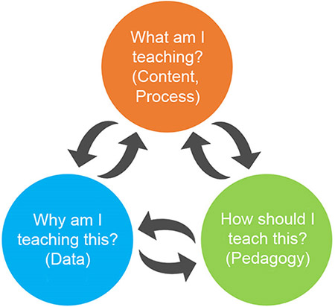

Name: Jessica Ann Milford
Student Number: 1901005
Module Lead: Carys Jennings

Targets from last assignment:
- Check your referencing techniques.
- Check your punctuation.
- Proofread your work and use educational texts to model a more academic style of writing.
Introduction
Pedagogy is the method and practice of teaching. It refers to the science of education such as the theories, teaching styles, feedback and assessment of learners. It is important for educators to have an enhanced knowledge and understanding of Pedagogy as this enables them to find ways and strategies to support their pupils individually in the classroom. There are different types of pedagogy, such as the class environment in which the practitioner is teaching in, the method and approach that they take to teaching and what they are teaching. Some theorists believe some aspects of pedagogy are more important that others, for example Bronfenbrenner believed that children’s development was affected by everything in their environment (Bronfenbrenner,1979). However, Piaget taking a constructivist view would argue that it is how the content is taught by the teacher that is most important (Piaget, 1936). What the practitioners are expected to teach is currently determined by the foundation phase framework for children’s learning 3-7 years old. The foundation phase philosophy in Wales is to focus on the needs of individual children and work at their stage of development. This involves building on what children can already do and what they already know and planning the next steps in their learning to allow them to develop their skills and knowledge. However, in 2022 the reformed curriculum will take the foundation phase framework’s place and teachers will be expected to deliver the content on this curriculum instead, as well as promote the 7 areas of learning, the 4 purposes and the 12 pedagogical principles set out by Donaldson. The purpose of Donaldson’s 12 pedagogical principles is for the teacher to identify their pupils’ greatest needs, match the need with the most appropriate pedagogical principle then assess the impact of the teaching approach through pupil progress. (Donaldson, 2018).
Good teaching and learning means employing a blend of approaches including direct teaching.
This principle implies that for teaching to be effective, the teacher must apply a broad range of techniques and methods to their practice as well as have knowledge about different types of teaching approaches. An example of a teaching method is direct teaching, developed by Siegfried Engelmann and Wesley C. Becker, which is where the teacher presents the information to pupils and supports them through it rather than allowing children to work independently (Direct instruction, 2020). Froebel believes this is an effective form of teaching as his theory suggested that education in the foundation phase should have a carefully planned curriculum based on key learning experiences and this includes structured teacher-directed activities (Nawrotzki, 2006). Another approach to teaching is pupil directed teaching which is where pupils are given more independence and more control over their studies. Montessori believes this approach to teaching is beneficial for children as it allows them to learn at their own pace. Montessori also believes the role of the teacher, when applying this method, is to create an effective learning environment and to become the ‘guardian’ of this environment, altering it as the child develops to support their learning (Maria Montessori Theory | Montessori Education Principles | Daily Montessori, 2020). Other types of approaches include Kinesthetic teaching which is supported by Howard Gardner and inquiry-based learning which is supported by Piaget, Vygotsky, Dewey and Bruner (Teaching Methods, 2020).
I have applied the direct teaching technique throughout my time on placement, in the first week I applied it to my lesson about telling the time in Welsh. I used this method as it is best for learning specific concepts and I wanted my pupils to grasp the concept and skill of applying their prior knowledge of numbers in welsh to their prior knowledge of telling the time in English. By taking the direct teaching approach I was able to draw on my pupils existing knowledge as a whole class, allowing my less confident children to listen to the responses of the ones providing the answers, hopefully reminding them of what they had previously learnt. Whereas if I took the pupil directed approach and just let them do the task independently, my lower ability groups would not have been exposed to that helpful information that enabled them to complete the task afterwards. This approach to teaching allows the teacher to make the goals and expectations clear to the student and 90% of it is a review of previously taught content which cannot be taught using pupil directed teaching. Rosenshine supports this as she states that strong teacher directiveness and supervised work as opposed to independent activities are factors associated with increased student outcomes Researchgate.net (2020). I also applied direct teaching to my practice during my second week in lessons on clothing in welsh because I wanted to practice pronunciation with the children (See Appendix 1). I also used direct teaching when covering fractions because feedback to students was immediate which is very important when it comes to correcting work in the foundation phase as this results in a decrease in errors (Robert Stromer, 1996).
I have also applied the pupil directed approach during my time on placement, for example when I had the children do their Mother’s Day Cards (See Appendix 2). I used this method for this activity because I wanted to give the children some independence and choice to enable them to make the card how they wanted it. Montessori believes this is an effective approach to apply to teaching as when the children are able to do things for themselves there is an increase in their self-esteem that they may carry on throughout their lives (Maria Montessori Theory | Montessori Education Principles | Daily Montessori, 2020). Bruner also believes this is an effective approach as he says that teachers should facilitate learning and provide students with information but allow them to organise it and discover the relationship between the bits of information themselves (Mcleod, 2020).
Other approaches I have used in my practice on placement are inquiry-based teaching and kinesthetic teaching which is where the teacher takes a very practical approach to teaching (Kinesthetic learning, 2020). I used this approach to teaching on placement when teaching about Venn Diagrams, Carroll Diagrams and turning. This particular approach was very beneficial for my lower ability group as getting them active engaged them a lot more, I created a large Venn diagram with them using hula hoops for them to place items in, created a large Carroll diagram out of card for my middle and high ability groups (See Appendix 3) and drew chalk clocks on the carpet to teach all children about turning, linking it to the skill of telling the time which they had previously covered with the class teacher (See Appendix 4). This approach to teaching is supported by Gardner as he says movement serves as an aid to children’s memory. I also used this approach when teaching the children welsh vocabulary as I used clapping to help them remember the words (How Children Learn Through the Bodily Kinesthetic Style, 2020). Inquiry-based learning is a pedagogic strategy based on constructivist and socio-constructivist theories of learning. I have used this on placement when teaching the children about Venn and Carroll diagrams. I created a sensory bag which I allowed the children to investigate through to decide which items go where in our diagram. Dewey supports this as he believes that children learn through a hands-on approach (John Dewey on Education: Impact & Theory, 2014).

Good teaching and learning sets tasks and selects resources that build on previous knowledge and experience and engage interest.
This principle suggests that to meet the wide range of needs of children, teachers must take an individualised approach to teaching to engage each child’s interest. Not all children have the same amount of knowledge, have had the same experiences or have the same interests. Therefore, it is important for the teacher to encourage children to approach learning in their own way and to provide the resources and opportunities for each child to reach their full potential in school. When planning lessons, it is essential that the teacher knows what prior knowledge the children have, to then add onto this knowledge, allowing children to make links between ideas. This is supported by Piaget as he believes that children learn best through assimilation and accommodation of knowledge which is where new information is added to the existing knowledge of children (Gray and MacBlain, 2015).
During placement, before I even started the lesson plans, I would ask my class teacher what she had previously covered and in what depth to determine the prior knowledge of my learners. I also begun every lesson with a recall of their prior knowledge as demonstrated on my lesson plans in the introductions. The form of this ranged from practical activities such as showing me a half turn clockwise to answering my questions at the start of each lesson. An example of when I linked the children’s prior knowledge with new information was when I was asked to cover the topic of turning. I knew that the children had done telling the time and therefore when I first introduced the topic of turning, I drew clocks on the floor in chalk. I said to the children that they were becoming hands of the clock and to face the 12. I would then ask them to show me a half turn clockwise for example and because they knew that half past meant the big hand was on the 6, they knew to turn to the 6 therefore linking their knowledge of telling the time with the new topic of turning. This was also taking a practical approach which is supported by Dewey and Piaget as they believed humans learn through a hands-on approach (Macblain, 2014).
Setting tasks and selecting resources that engage interest in children is important in education as children are more likely to learn and concentrate on the activity if they want to do it. Educators need to be able to guide children’s learning, engage their minds, and work collaboratively with children and not just instruct to enable each child to reach their full potential (Dewey, 1894). This can be done by the teacher observing the children to determine the experiences and topics that children are interested in (Children’s services - Child development theorists, 2020). This is also supported by Piaget as he believes that a stimulating environment involves a free-choice approach for each child to be able to follow their own interests at the level they are ready for.
In placement I spent the first week observing the class and taking on the TA role which allowed me to identify what activities engaged the children and it became clear to me that they responded well to a practical approach as I watched them play what’s the time Mr wolf when learning about telling the time. Knowing this, for my first lesson I created Venn and Carroll diagrams and brought in some sensory items for them to place in it. My learners were also most engaged when the teacher brought in her real life to the classroom – for example when making Bara Brith for St. David’s Day, she brought in pictures of her son making it with her and the children loved it. Therefore, at the start of my sorting lesson I emphasised the importance of the items I had brought in as they were from my house and this excited the children and they were very sensible with them. Another example of when I used the children’s interest to support their learning was when I did Mother’s Day cards with them. I created an example and showed the children what I was giving to my mother for Mother’s Day and they were all in awe and wanted theirs to be as good as Miss Milford’s.
Practitioners should also set tasks and select resources that build on children’s previous experiences as this allows for a more holistic approach to learning. If the teacher introduces the topic of money for example and the child has never experienced paying for something in a shop, then the concept will be meaningless to the child. Therefore, it is important to consider what the children have experienced before setting the tasks and if they haven’t experienced something, then the teacher can create those experiences for them in the classroom e.g. through a roleplay shop. This is supported by Tina Bruce as she believes that teaching young children should focus on creativity, play and first-hand experiences (Bruce, 2011). However, Bandura would challenge this as he believes that learning through experiences would not occur unless cognitive processes were at work (Mcleod, 2020).
During my time in placement, I experienced a school trip to Castell Henllys which I found very useful because I knew exactly what the children had experienced on the trip. At Castell Henllys the children helped to weave a wall and therefore I added this skill to the making of their cards (See Appendix 5). I also took the trip into account when planning a writing task for the children to tell me their favourite activity that they did there and encouraged answers that I knew they had experienced at Castell Henllys.
Good teaching and learning ranges within and across Areas of Learning and experience.
This principle implies that the Areas of Learning and Experience in the proposed curriculum should not be distinct entities or timetabled subject areas, nor should the Cross-curriculum Responsibilities and wider skills be developed in isolation. Instead they should all be promoting connections and unity within and between the Areas of Learning and Experience (Donaldson, 2015).
The current Foundation Phase Framework does not reflect this as it is split up into subject areas with the objectives and expectations for each year group alongside it. Although this goes against Donaldson’s views, it is supported by Werrett Chambers as he believed that a curriculum should consist of objectives and that these objectives should correspond to teacher-planned activities. He also believed objectives should be listed with their corresponding activities and evaluated. Harold Rugg agreed with Chambers as he believed that the curriculum should be structured into objectives with related learning outcomes and experiences (Team, 2020).
On the other hand, Donaldson emphasised the importance of preparing children for adult life in his curriculum and this is evidenced through one of his four purposes ‘Ready to lead fulfilling lives as valued members of society (Gov, 2020). This is supported by Franklin Bobbitt as he believed that the curriculum should focus on student needs and prepare them for adult life. Donaldson believed that the best way to do this was to create 6 Areas of Learning:
- Expressive Arts
- Health and Wellbeing
- Humanities
- Languages, Literacy and Communication
- Mathematics and Numeracy
- Science and Technology
Ensuring that children are able to express themselves creatively is one of Donaldson’s aims and this is evidenced through the purpose ‘Creative Contributors’. William Kilpatrick supports Donaldson as he believed that the curriculum should contain activities that focus on the student such as creative projects and small group instruction (Alvior, 2020).
In contrast to both Donaldson and The Foundation Phase Framework, John Goodlad believed that the students should be active participants in the content of the curriculum as oppose to just the professionals creating it. He also believed that the content should have a wide range of practical subjects, similarly to Donaldson as he evidenced through the subject area ‘Health and Wellbeing’ as he said the aim of this Area of Learning is to address concerns about physical activity and diet amongst children in the foundation phase (John Goodlad, 2020).
On placement I have used the Foundation Phase Framework to set objectives for my children and to plan lessons because my placement school still uses this framework rather than Donaldson’s curriculum. I used the mathematical development section of the foundation phase framework to teach the children about turning, Amser and fractions. I also applied Numeracy when teaching about sorting and applying the topic of the Celts to turning. I also covered welsh development throughout my time there in lessons such as Amser, Dillad and Mother’s Day cards in welsh. This also links into creative development as the children created Mother’s Day cards. Towards the end of placement, I also managed to cover Knowledge and Understanding of the World through teaching about the Celts, what they wore and what we had previously done in our school trip to Castell Henllys.

Conclusion
In conclusion, I have employed a blend of approaches to my teaching in order to enhance the learning of my pupils and to keep my children engaged by giving them new learning experiences. I could further develop my use of teaching approaches by using more ICT based teaching as suggested by my network lead in my joint observation report. I could also improve my differentiated instruction when teaching as although I was able to plan differentiated activities, I needed a lot of input from my class teacher to support me in doing this as I did not feel confident. My strengths for the first principle include my ability to take a sensory and practical approach to teaching as well as my knowledge of other teaching approaches that I am yet to try out in my practice. I have set tasks and selected resources that built on my children’s previous knowledge and experience and engage interest to make learning a positive experience for them all and to enhance their skills and knowledge. I could further develop the second principle by considering the children’s experience and interests more when planning as my one-week observation was not enough to fully identify how my children learn best. However, my strengths for the second principle are my ability to link new topics with children’s prior knowledge and my ability to make tasks seem engaging by applying them to my real life like the class teacher does. I have used the Foundation Phase Framework to plan my lessons within placement. I could further develop my use of the curriculum by ensuring all Areas of Learning are covered. A strength of using the Areas of Learning and experience in my time in placement was when I was teaching about the Celts. I went on a trip to Castell Henllys with the children and then had them create their own 3D models of a roundhouse based on what they had experienced on the trip (See Appendix 6).

Appendix 1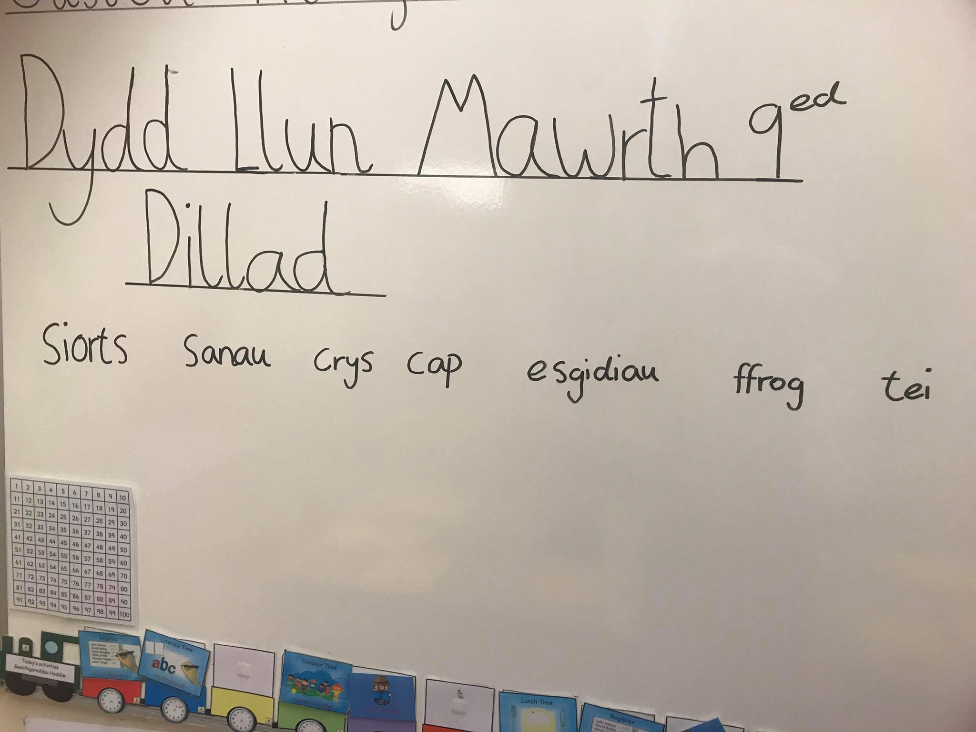

Appendix 2
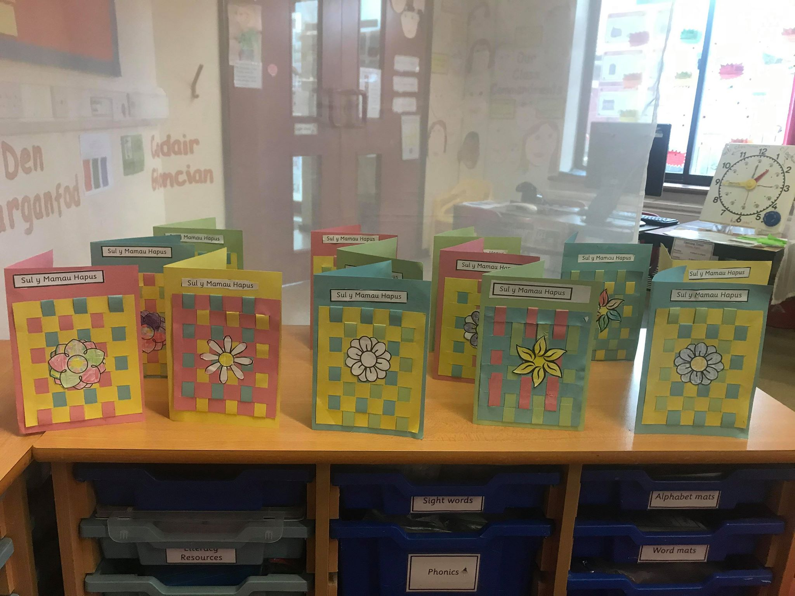

Appendix 3
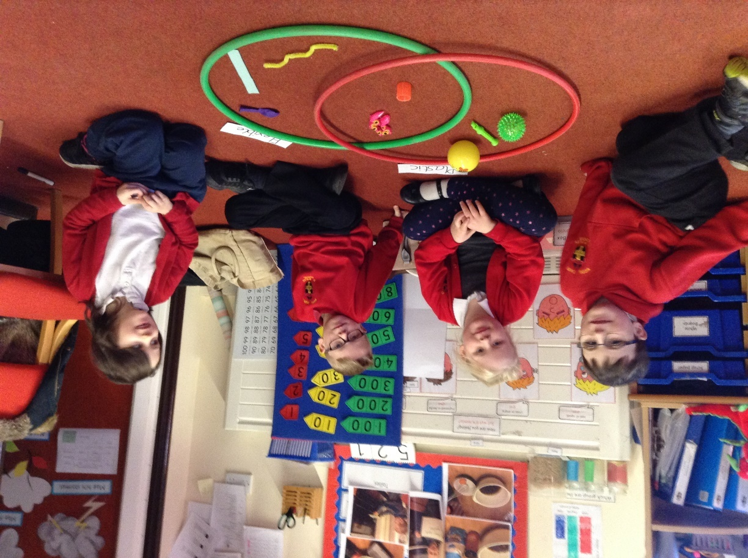

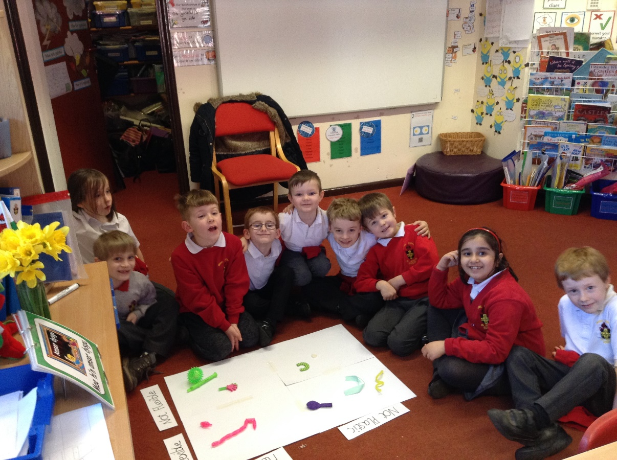

Appendix 4
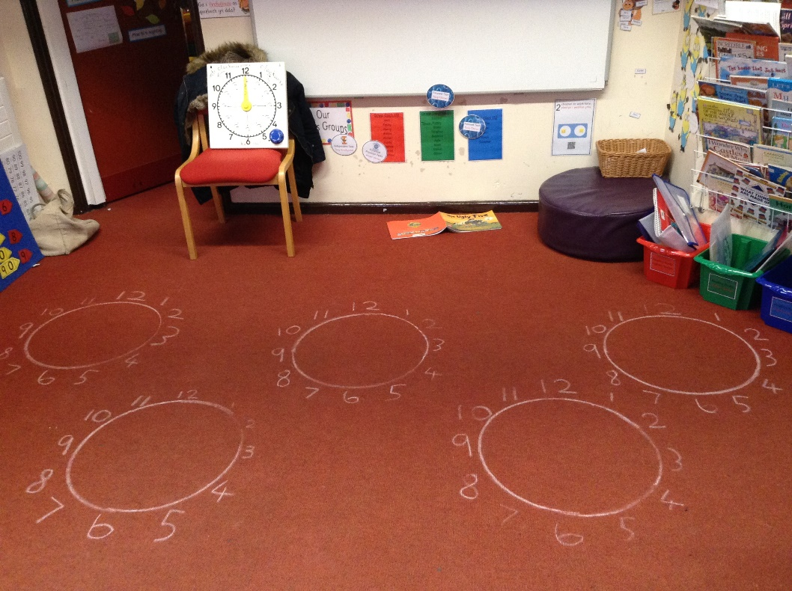

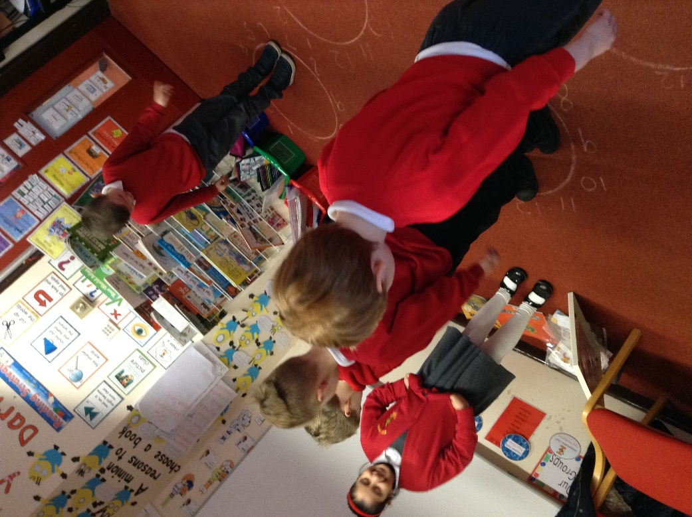

Appendix 5
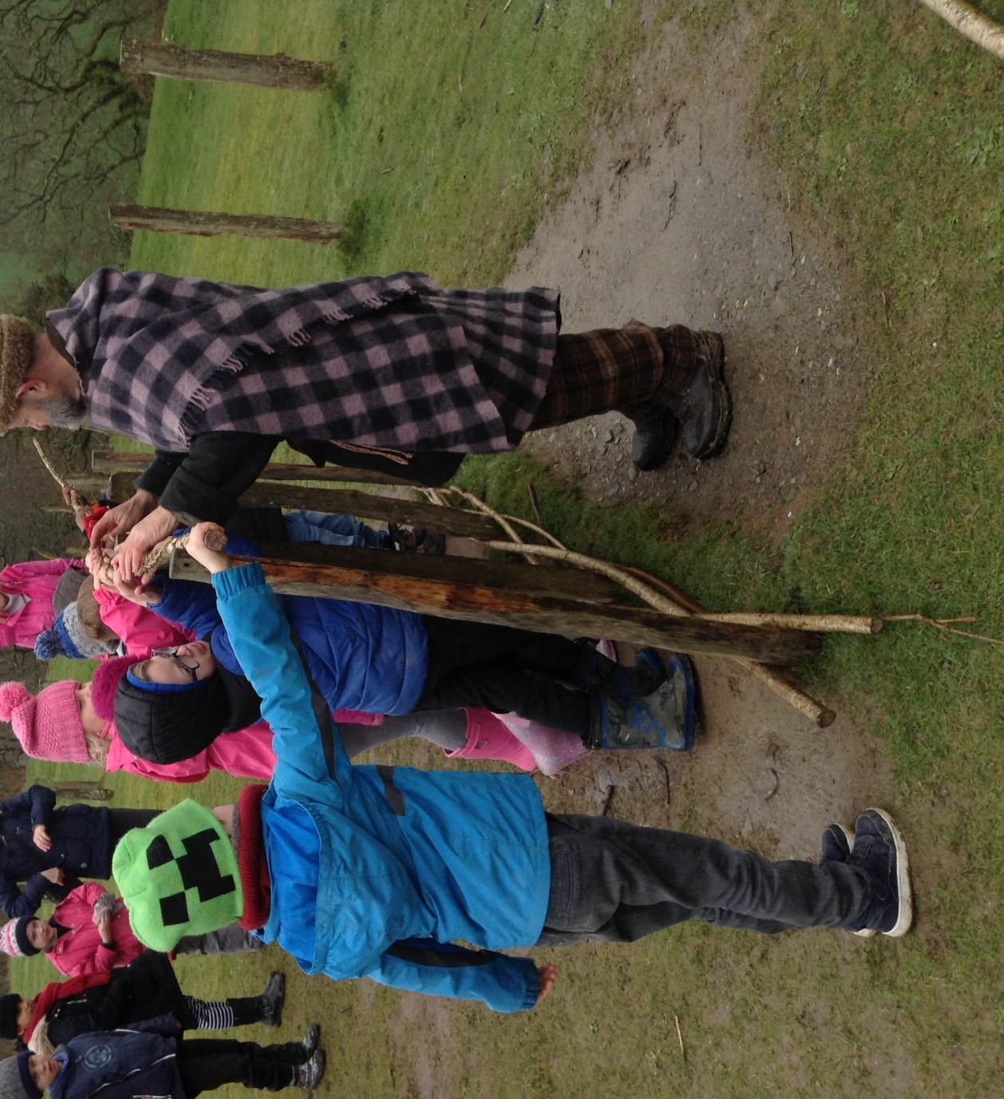

Appendix 6
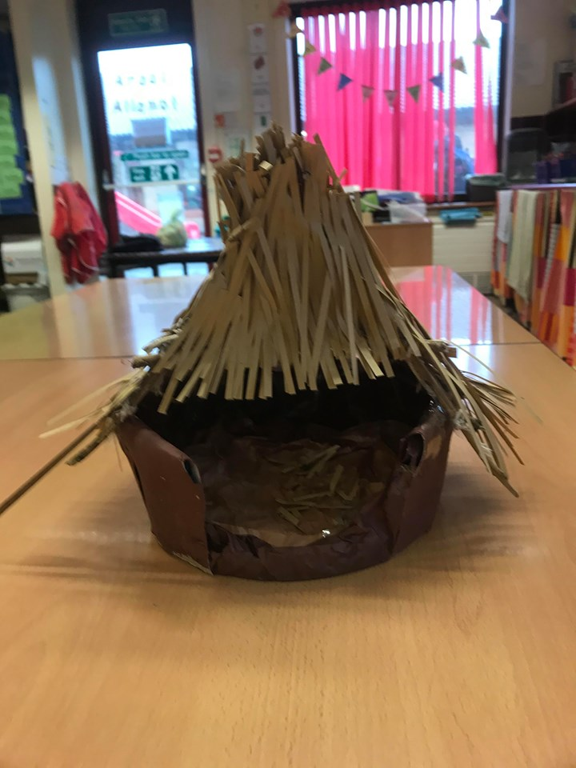

Reference List
Teach.com. 2020. Teaching Methods. [online] Available at: https://teach.com/what/teachers-know/teaching-methods/ [Accessed 23 March 2020].
Researchgate.net 2020. [online] Available at: https://www.researchgate.net/publication/230602063_Direct_instruction_An_overview_of_theory_and_practice [Accessed 23 March 2020].
Montessori Education 0 - 3. 2020. Maria Montessori Theory | Montessori Education Principles | Daily Montessori. [online] Available at: http://www.dailymontessori.com/montessori-theory/ [Accessed 23 March 2020].
Verywell Family. 2020. How Children Learn Through The Bodily Kinesthetic Style. [online] Available at: https://www.verywellfamily.com/kinesthetic-learner-characteristics-2162776 [Accessed 23 March 2020].
Gray, C. and MacBlain, S., 2015. Learning Theories In Childhood. 2nd ed. London: SAGE Publications Ltd, p.67.
Mcleod, S., 2020. Bruner - Learning Theory In Education | Simply Psychology. [online] Simplypsychology.org. Available at: https://www.simplypsychology.org/bruner.html [Accessed 25 March 2020].
Adam Jordan, 2014. John Dewey on Education: Impact & Theory. [online] Available at: https://study.com/academy/lesson/john-dewey-on-education-impact-theory.html [Accessed 25 March 2020].
Sielearning.tafensw.edu.au. 2020. Children’S Services- Child Development Theorists. [online] Available at: https://sielearning.tafensw.edu.au/MCS/CHCFC301A/12048/chcfc301a/lo/12020/index.htm [Accessed 25 March 2020].
Bruce, T., 2011. Learning Through Play. London: Hodder Education.
Mcleod, S., 2020. Albert Bandura | Social Learning Theory | Simply Psychology. [online] Simplypsychology.org. Available at: https://www.simplypsychology.org/bandura.html [Accessed 25 March 2020].
Team, G., 2020. Curriculum Theorists: Biography, Bobbitt, Caswell, Curriculum, En, Goodlad, Psychology, Student, Theorist | Glogster EDU - Interactive Multimedia Posters. [online] Edu.glogster.com. Available at: https://edu.glogster.com/glog/curriculum-theorists/1vfvv2j4225?=glogpedia-source [Accessed 25 March 2020].
Gov.wales. 2020. [online] Available at: https://gov.wales/sites/default/files/publications/2018-03/successful-futures.pdf [Accessed 25 March 2020].
Alvior, M., 2020. Six Famous Curriculum Theorists And Their Contributions To Education - Simplyeducate.Me. [online] SimplyEducate.Me. Available at: https://simplyeducate.me/2014/12/03/six-famous-curriculum-theorists-and-their-contributions-to-education/ [Accessed 25 March 2020].
Www2.southeastern.edu. 2020. John Goodlad. [online] Available at: http://www2.southeastern.edu/Academics/Faculty/nadams/educ692/Goodlad.html [Accessed 25 March 2020].
Macblain, S., 2014. How Children Learn. 1st ed. London: SAGE Publications Ltd, pp.13-28.
Study.com. 2020. [online] Available at: https://study.com/academy/lesson/bronfenbrenners-ecological-systems-theory-of-development-definition-examples.html [Accessed 26 March 2020].
Simplypsychology.org. 2020. [online] Available at: https://www.simplypsychology.org/piaget.html [Accessed 26 March 2020].
Impact.wales. 2020. [online] Available at: https://www.impact.wales/wp-content/uploads/2018/01/12-Pedagogical-Principles-1.pdf [Accessed 26 March 2020].
En.wikipedia.org. 2020. Direct Instruction. [online] Available at: https://en.wikipedia.org/wiki/Direct_instruction [Accessed 26 March 2020].
Nawrotzki, K., 2006. Froebel is Dead; Long Live Froebel! The National Froebel Foundation and English Education. History of Education, 35(2), pp.209-223.
En.wikipedia.org. 2020. Kinesthetic Learning. [online] Available at: https://en.wikipedia.org/wiki/Kinesthetic_learning [Accessed 26 March 2020].

