Module Title: International Meetings Management
for the
Hotel Industry
Module Code: BMIH6007
Student Name: Elena Daniela Gavril
Student ID: 2207241
Assignment 1: Feasibility Plan for an International Meeting

Introduction
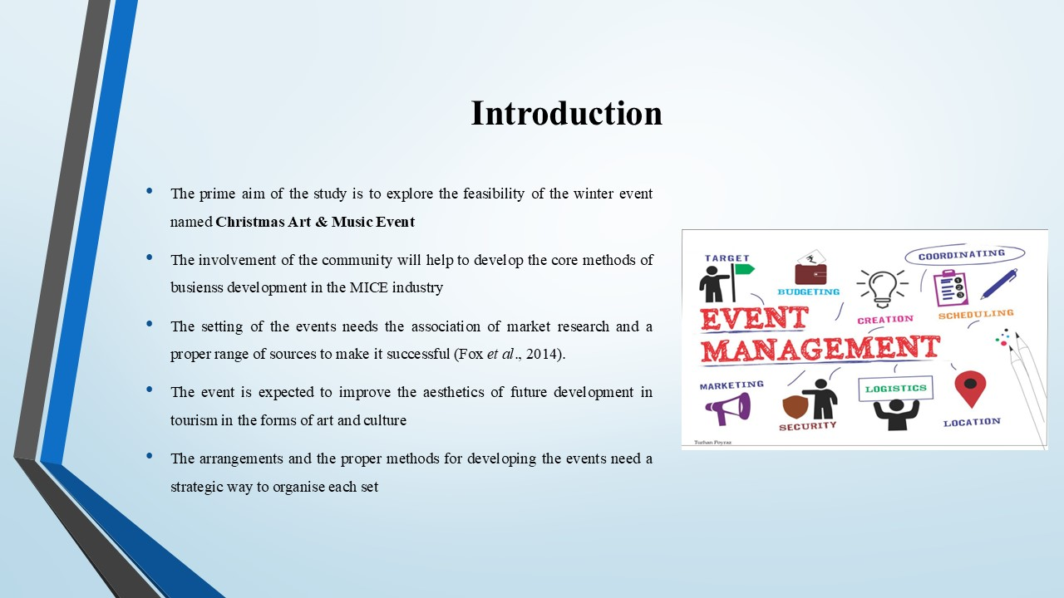
The arrangements and the proper methods for developing the events need a strategic way to organise each set. The prime aim of the study is to explore the feasibility of the winter event named Christmas Art & Music Event in the region of the UK. The setting of the events needs the association of market research and a proper range of sources to make it successful (Fox et al., 2014). The strategic way to set the platform of the event will be done by analysing the factors of market, operations and finance. The involvement of the community will help to develop the core methods of business development in the MICE industry and more tourist engagement. The event is expected to improve the aesthetics of future development in tourism in the forms of art and culture.

Event Content and Context
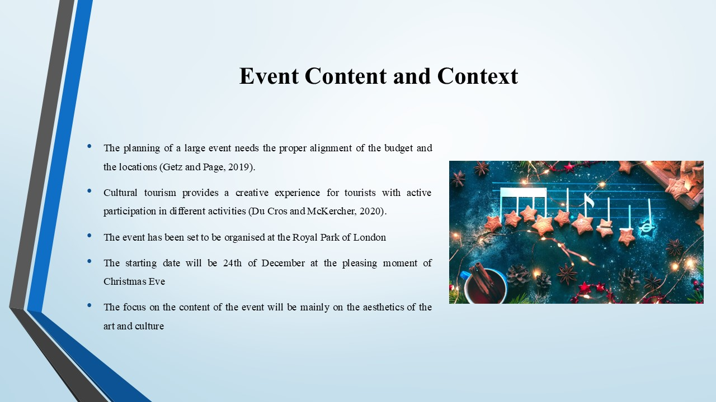
The season of winter is most popular for planning holidays and attending any kind of festival. The name of the present event will be Christmas Art & Music Event to target the audience during the time of Christmas. The focus on the content of the event will be mainly on the aesthetics of the art and culture. The planning of a large event needs the proper alignment of the budget and the locations (Getz and Page, 2019). The event has been set to be organised at the Royal Park of London. The city is well connected with the facilities of transport. It will attract the tourists to visit the event from different locations. The focus created on the promotion of the event is on the occasion of Christmas. The starting date will be 24th of December at the pleasing moment of Christmas Eve. The continuation will happen up to 1st January to celebrate the new year with different forms of delicious food items. Cultural tourism provides a creative experience for tourists with active participation in different activities (Du Cros and McKercher, 2020). The highlights of the event will be the mixture of different music and dance shows. The event is set to increase more engagement of cultural tourists from different international destinations.

Market factors
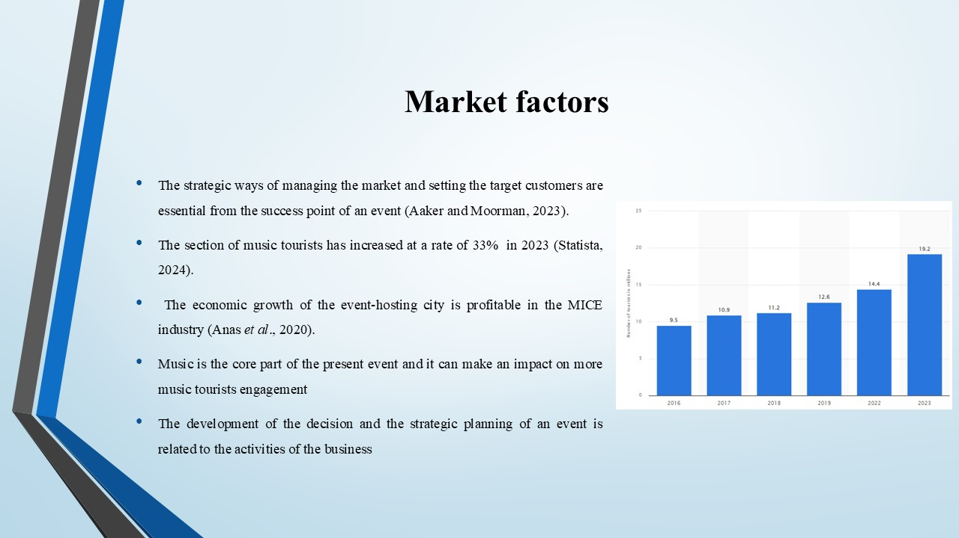
The development of the decision and the strategic planning of an event is related to the activities of the business. The strategic ways of managing the market and setting the target customers are essential from the success point of an event (Aaker and Moorman, 2023). The event Christmas Art & Music will be designed for the family individuals and tourists. The reports of a survey deliver the knowledge that 62% of family persons are interested in meeting with friends and other family members during the time of winter holidays (Statista, 2023). It shows the feasibility of the event in this case and provides the areas of successful attributes. The inbound tourism statistics and the number of inbound tourists have been high in recent years in the UK. The section of music tourists has increased at a rate of 33% in 2023 (Statista, 2024). Music is the core part of the present event and it can make an impact on more music tourists engagement. The economic growth of the event-hosting city is profitable in the MICE industry (Anas et al., 2020). The combination of the winter holidays along with music and culture can make the event successful in the eyes of the audience and visitors.
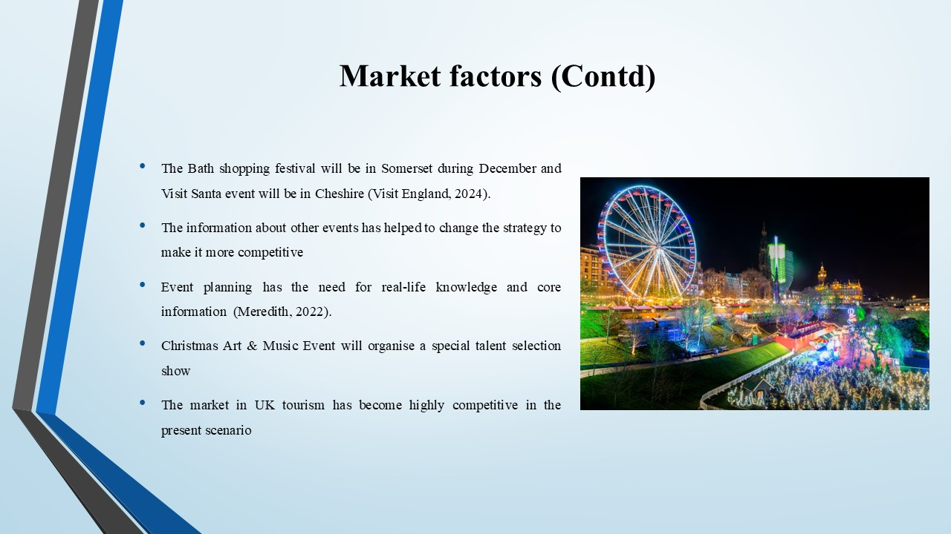
The market in UK tourism has become highly competitive in the present scenario. The present events will face competition in the gathering of the audience as multiple numbers events will take place in the winter season. The Bath shopping festival will be in Somerset during December and Visit Santa event will be in Cheshire (Visit England, 2024). The need for uniqueness in the content and the shows of the present event is needed for the competitive advantage. Christmas Art & Music Event will organise a special talent selection show. The stage competition on arts and music will be done and the winners will get the chance to grow the career opportunities in the field. Event planning has the need for real-life knowledge and core information (Meredith, 2022). The information about other events has helped to change the strategy to make it more competitive.

Operational factors
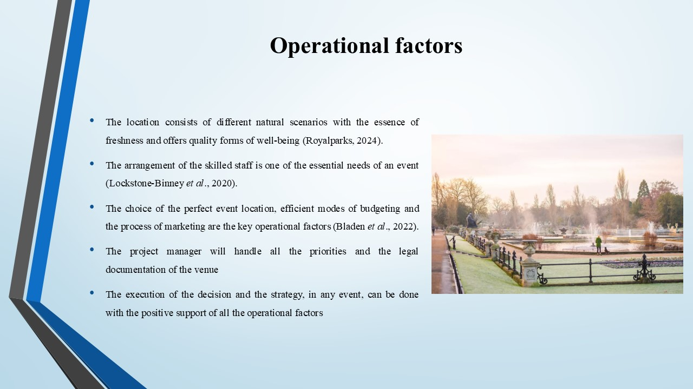
The execution of the decision and the strategy, in any event, can be done with the positive support of all the operational factors. The choice of the perfect event location, efficient modes of budgeting and the process of marketing are the key operational factors (Bladen et al., 2022). The location has been decided at the Royal Park of London. The location consists of different natural scenarios with the essence of freshness and offers quality forms of well-being (Royalparks, 2024). The arrangement of the present events will be family-centric along with the tourists. The location of the Royal Parks has a wide range of open spaces for both older age individuals and children to spend their receptive time. The project manager will handle all the priorities and the legal documentation of the venue. The arrangement of the skilled staff is one of the essential needs of an event (Lockstone-Binney et al., 2020). The skilled staff will be selected for the event on the basis of the departments and work breakdown. The essential forms of event management skills are leadership, time management and communication (Byrnes, 2022). The managing team will have to recruit the staff as per the job requirements.
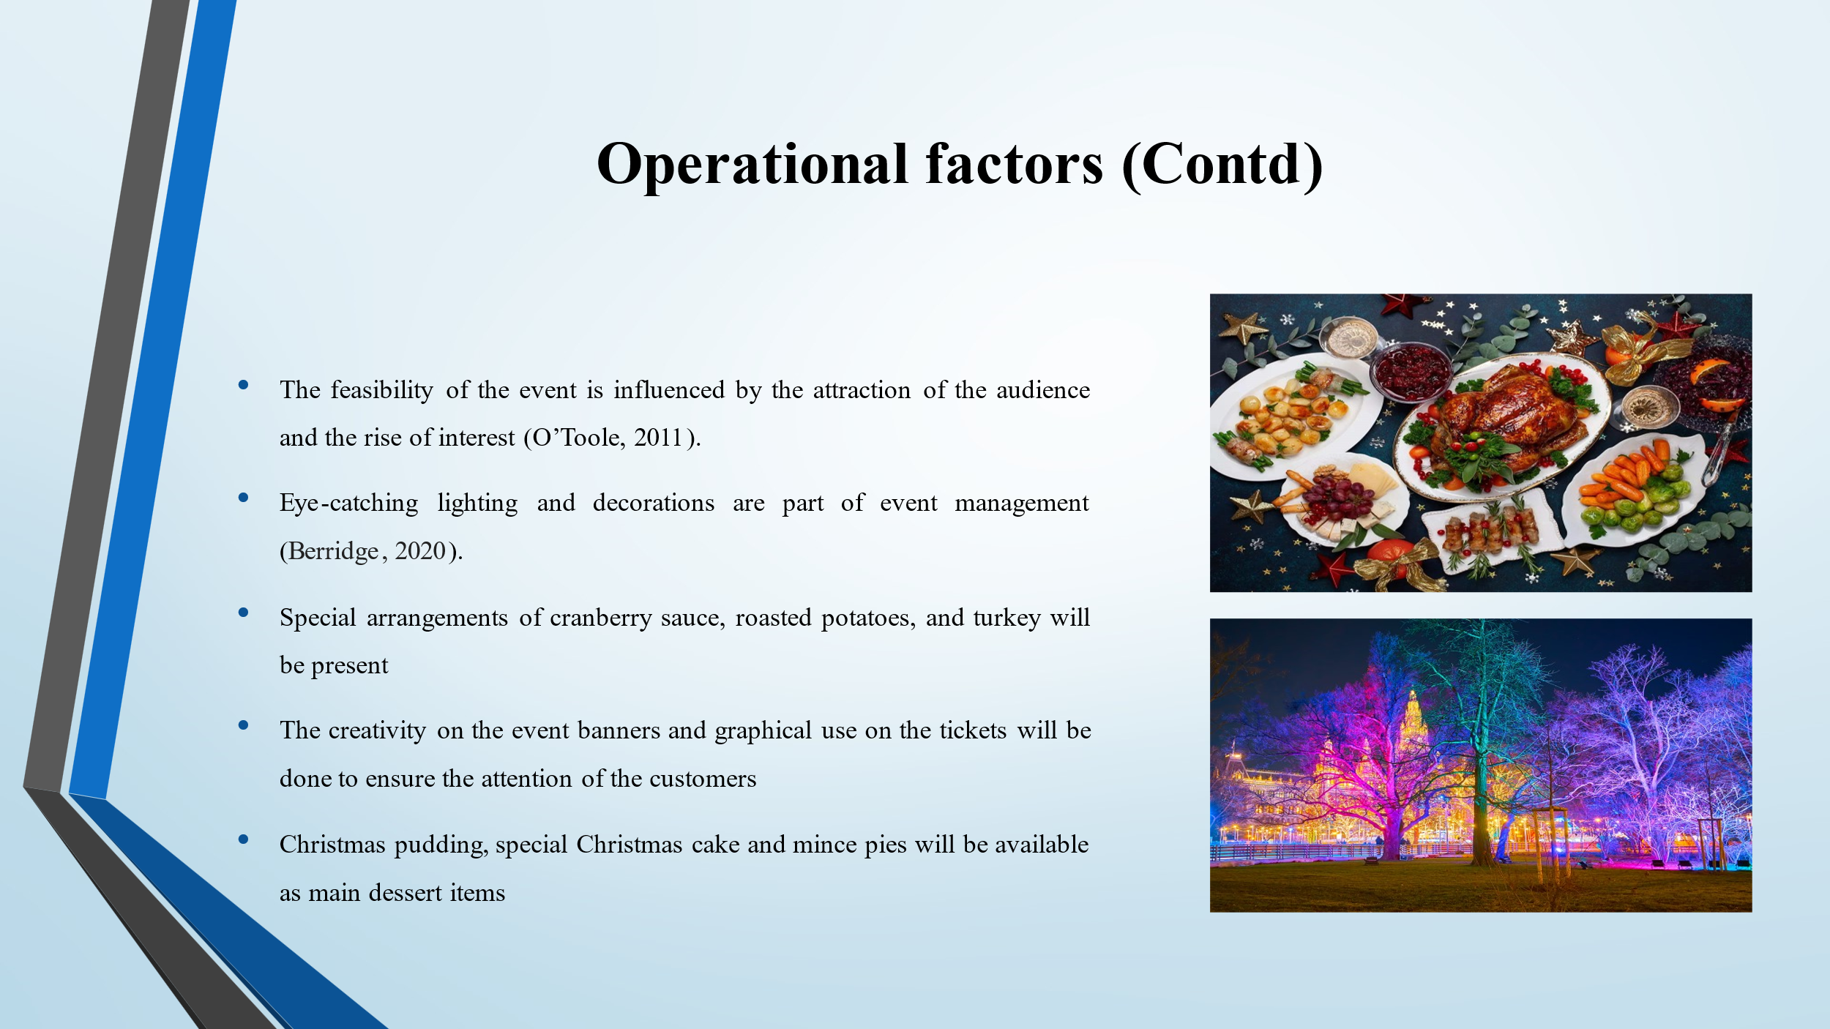
The operations in the sense of marketing include the promotion of the events to increase the reach. The feasibility of the event is influenced by the attraction of the audience and the rise of interest (O’Toole, 2011). The arrangement of the food and the eye-pleasing decorations are the main attractions of any event. Christmas Art & Music Event will have multi-cuisine items and various options for dessert. Special arrangements of cranberry sauce, roasted potatoes, and turkey will be present. Christmas pudding, special Christmas cake and mince pies will be available as main dessert items. Smoked salmon and prawns are delicious starters for the audience to enjoy the show. Eye-catching lighting and decorations are part of event management (Berridge, 2020). The use of colourful LEDs and floodlights will be done in the event. Strategic skills and knowledge are required in the business forms of events (Rogers and Wynn-Moylan, 2022). The creativity on the event banners and graphical use on the tickets will be done to ensure the attention of the customers.
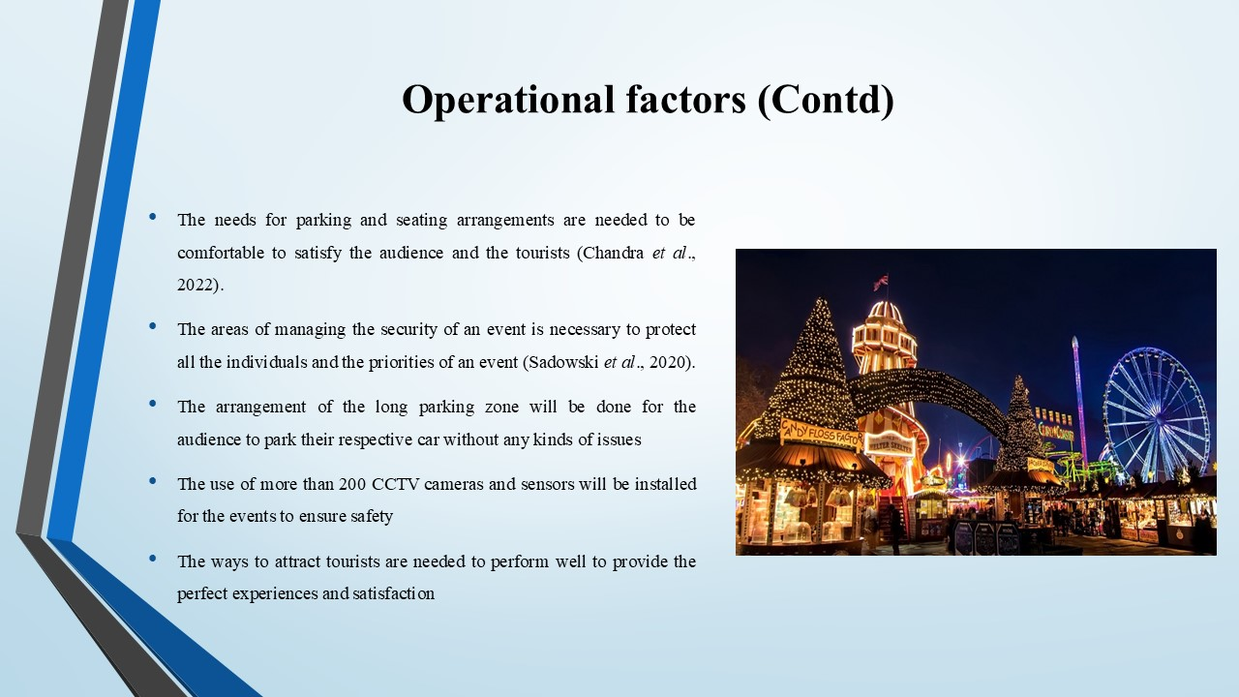
The ways to attract tourists are needed to perform well to provide the perfect experiences and satisfaction. The needs for parking and seating arrangements are needed to be comfortable to satisfy the audience and the tourists (Chandra et al., 2022). The arrangement of the long parking zone will be done for the audience to park their respective car without any kinds of issues. The seating arrangements will be for more than 20000 individuals to enjoy the concert and dance show along with eating facilities. The areas of managing the security of an event is necessary to protect all the individuals and the priorities of an event (Sadowski et al., 2020). The use of more than 200 CCTV cameras and sensors will be installed for the events to ensure safety.

Financial factors
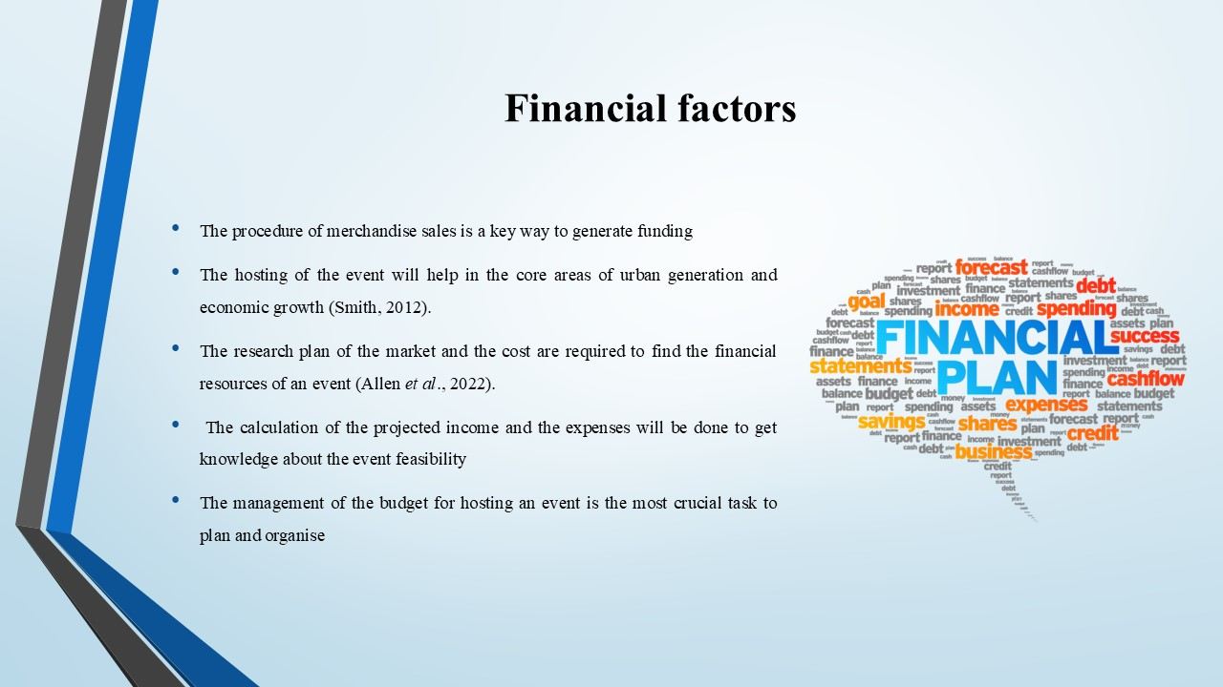
The management of the budget for hosting an event is the most crucial task to plan and organise. The research plan of the market and the cost are required to find the financial resources of an event (Allen et al., 2022). The main area of funding for the event will be sponsorship. The procedure of merchandise sales is a key way to generate funding. It will be executed to generate the funds for the event. The events have the target to attain the attention of the tourists along with the audience for a better business view. The hosting of the event will help in the core areas of urban generation and economic growth (Smith, 2012). The funding is expected to be profitable and the investors will get the satisfaction. It will show the ways to arrange more events in the MICE industry in future. The ticket sales contribute a vital part to the profit of the event (Frost and Frost, 2020). The calculation of the projected income and the expenses will be done to get knowledge about the event's feasibility.
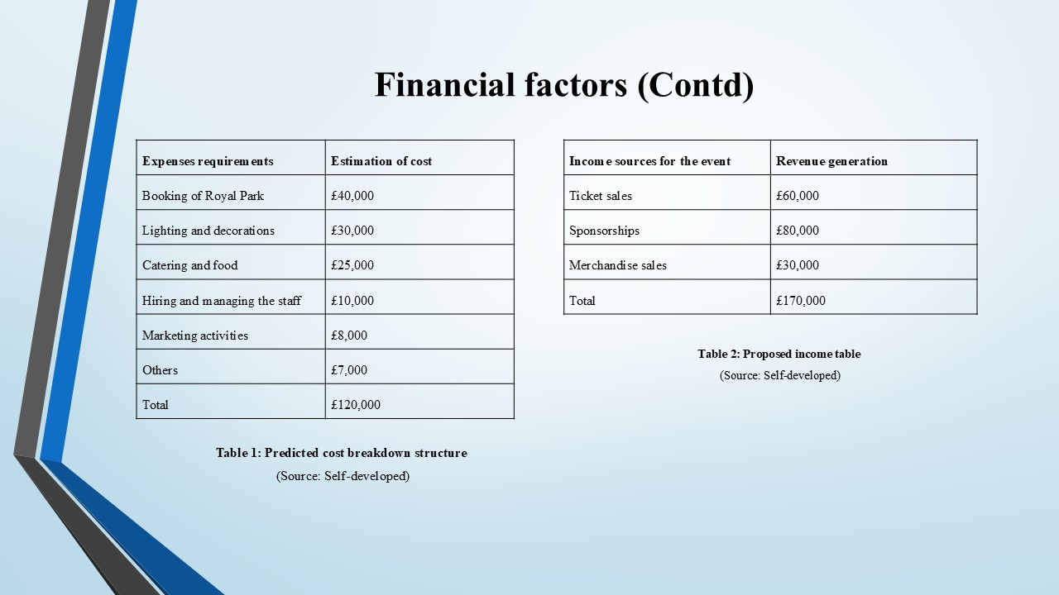
Expenses requirements | Estimation of cost
Booking of Royal Park | £40,000
Lighting and decorations | £30,000
Catering and food | £25,000
Hiring and managing the staff | £10,000
Marketing activities | £8,000
Others | £7,000
Total | £120,000

Table 1: Predicted cost breakdown structure
(Source: Self-developed)

Income sources for the event | Revenue generation
Ticket sales | £60,000
Sponsorships | £80,000
Merchandise sales | £30,000
Total | £170,000

Table 2: Proposed income table
(Source: Self-developed)

Conclusion
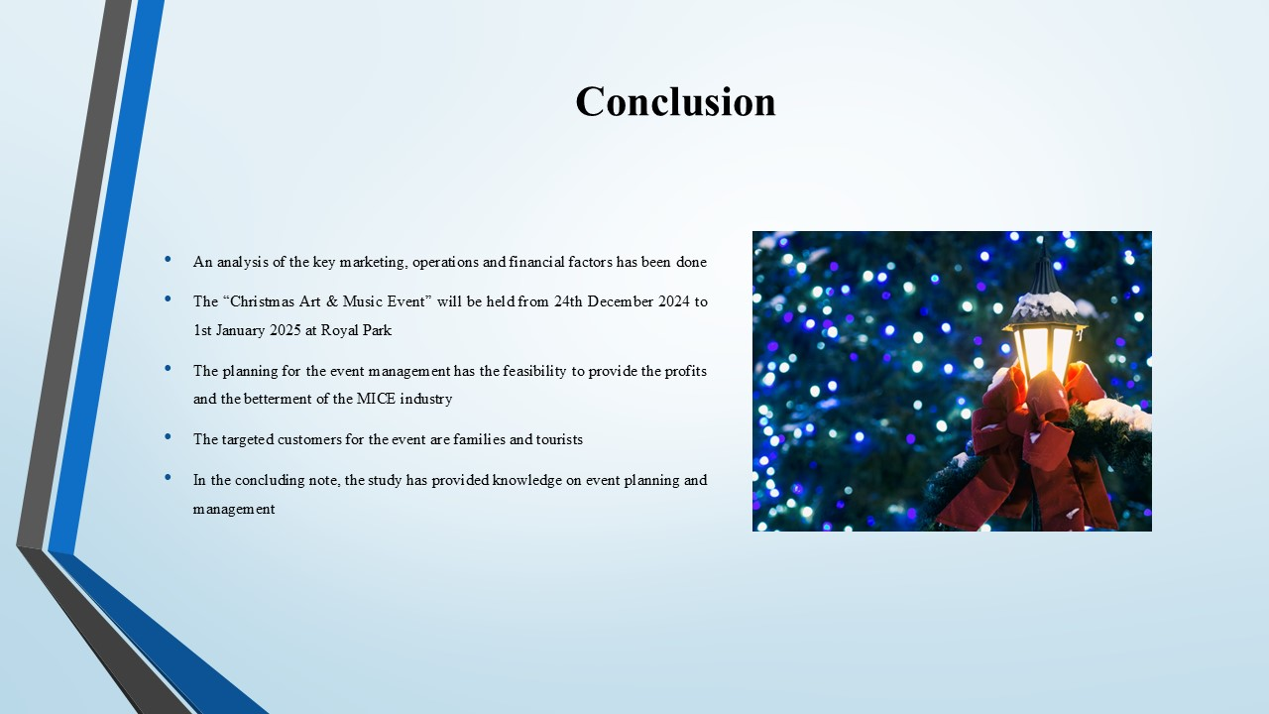
In the concluding note, the study has provided knowledge on event planning and management. The Christmas Art & Music Event will be held from 24th December 2024 to 1st January 2025 at Royal Park. The targeted customers for the event are families and tourists. An analysis of the key marketing, operations and financial factors has been done. The planning for the event management has the feasibility to provide the profits and the betterment of the MICE industry.

References
Aaker, D.A. and Moorman, C., 2023. Strategic market management. John Wiley & Sons.
Allen, J., Harris, R. and Jago, L., 2022. Festival & special event management. John Wiley & Sons.
Anas, M.S., Maddiah, N.A., Noor Eizamly, N.U.E., Sulaiman, N.A. and Wee, H., 2020. Key success factors toward MICE industry: A systematic literature review. Journal of Tourism, Hospitality & Culinary Arts (JTHCA), 12(1), pp.1-34.
Berridge, G., 2020. Designing event experiences. In The Routledge Handbook of Events (pp. 378-395). Routledge.
Bladen, C., Kennell, J., Abson, E. and Wilde, N., 2022. Events management: An introduction. Routledge.
Byrnes, W.J., 2022. Management and the Arts. Routledge.
Chandra, S., Bhalla, R. and Agarwal, S., 2022. Business events and hospitality. In The Routledge Handbook of Business Events (pp. 263-272). Routledge.
Du Cros, H. and McKercher, B., 2020. Cultural tourism. Routledge.
Fox, D. et al. 2014 Doing events research: from theory to practice. Routledge: Oxford
Getz, D. and Page, S. 2019 Event studies: theory, research and policy for planned events. 3rd Edition. Routledge: Oxford
Lockstone-Binney, L., Hanlon, C. and Jago, L., 2020. Staffing for successful events: Having the right skills in the right place at the right time. In The Routledge Handbook of Events (pp. 427-441). Routledge.
Meredith, J. 2022 Project management: a managerial approach
O’Toole, W. 2011 Events feasibility and development: from strategy to operations. Elsevier: Oxford
Rogers, T. and Wynn-Moylan, P. 2022 Conferences and conventions: a global industry. 4th Edition. Routledge: Oxford
Royalparks, 2024. Welcome to The Royal Parks [Online] Available at: <https://www.royalparks.org.uk/> [Accessed on: 8th October 2024].
Sadowski, G., Kavanagh, K. and Bussa, T., 2020. Critical capabilities for security information and event management. Gartner Group Research Note, 1.
Smith, A. 2012 Events and urban regeneration: the strategic use of events to revitalise cities. Routledge: Oxford
Statista, 2023. Activities planned over the Christmas and New Year period in Great Britain in 2019 [Online] Available at: <https://www.statista.com/statistics/503789/activities-planned-christmas-great-britain/> [Accessed on: 8th October 2024].
Statista, 2024. Number of tourists attending live music events in the United Kingdom (UK) from 2016 to 2023 [Online] Available at: <https://www.statista.com/statistics/482225/number-of-music-tourists-united-kingdom/> [Accessed on: 8th October 2024].
Visit England, 2024. Events in winter [Online] Available at:<https://www.visitengland.com/things-to-do/events-in-winter> [Accessed on: 8th October 2024].

