University of Wales Trinity Saint David
School of Engineering
Engineering Design Project
Drill Press Main Sliding Unit
Viktoria Berces
1908705
BEng (Hons) Mechanical and manufacturing Engineering
19/02/2021
ACMA4008

- Critical appraisal of drill press main sliding unit

The introduction or development of a new product can mean the production of a completely new product, or the revitalization, further development of an existing product on the market or the development of newer versions of the product. This process always requires great care and organization.
In this case, it is a question of developing and re-introducing an existing product.
A comprehensive assessment of the economic and market situation is crucial. Market segmentation is important, segments are smaller parts of the market that have similar demand characteristics.
After the market segmentation, the next step is product positioning, during which the company tries to determine the consumer needs in the given segment, the position of the competitors, the goal is to gain a competitive advantage. The goal is to better meet the needs of consumers than the products of competitors in the segment.
Drill press is used to drill materials and widen existing bores, both in width and depth. This drill press can be classified as a simple home DIY tool and is suitable for serving orders from smaller workshops, not suitable for serving large industrial orders.
With this in mind, consumer needs need to be identified. These are the following, it is important that the product is easily accessible to the target audience (shop, online ordering, delivery), it is also important that it is easy to use and maintain, safe to use, as well as the durability, the product life should be high and warranty should be provided.
In addition to the fact that the product fulfills its basic purpose, it is important to design, look, because it also helps to sell the product better.
As far as functional requirements are concerned, as I mentioned above, it is important that it be durable. It is important that it is made of a strong and resistant material to withstand the forces acting on it during operation. It should be difficult to break, resist corrosion and withstand heat as well.
As for the aesthetic appearance of the product, both the packaging and the product itself must arouse and retain the interest of the buyer. This is important because presumably not all consumers will make a choice based on the technical specifications of the product.
In terms of usability requirements, drill press parts are expected to be easy to replace and order, so the customer does not have to buy a brand new press if any part (including DPMSU) is damaged or malfunctions.

According to Martin and Schinzinger,

the engineering ethics consists of the responsibilities and rights that ought to be endorsed by those engaged in engineering, and also of desirable ideals and personal commitments in engineering. Engineering ethics the study of the decisions, policies, and values that are morally desirable in engineering practice and research.
(Martin and Schinzinger, 2000, pp.8)

So overall, engineering ethics plays a key role in the successful development of a product. They all include ethical and moral issues and practices, communication practices and collaboration between different departments, appropriate behaviours, product liability, contract agreements, accountability.

Professional engineers must adhere to the codes set by the Engineering council. The fundamental principles are the followings:
- “Honesty and integrity
- Respect for life, law, the environment and public good
- Accuracy and rigour
- Leadership and communication.”

(Engineering council, 2017)

- Design requirements

Deployment of Quality Features (QFD) is designed to recognize customer needs and incorporate them into the new product development process. Customer-centric process based on consumer needs. In this way, the company produces a product that meets the needs and expectations of consumers, and not a product that only the company thinks is suitable for the customer.
The best way to collect, systematize, and map the relationships between consumer needs and production characteristics is to use the so-called House of Quality.
House of quality has been created to determine customer requirements for the drill press and DPMSU unit (Figure 1.). Furthermore, the technical requirements have been defined.
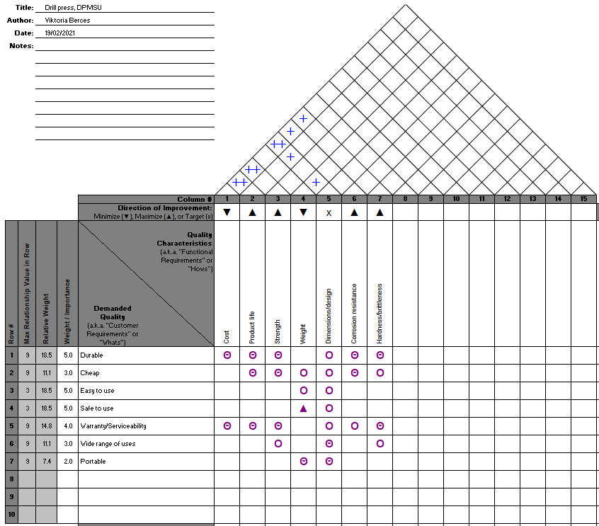
Figure 1- House of quality

The left side of the table lists the customer needs (durable, cheap, easy to use, safe to use, warranty / serviceability, wide range of uses, portable), the importance of which was weighted by numbers, and the relative weight was also established.
Properties that take into account during production, such as cost, product life, strength, weight, dimension / design, corrosion resistance, hardness, were found in the upper part of the housing.
It can be stated that the most important factors for consumers are that the product is durable, easy, and safe to use, and then that warranty and service options are available. Then the product price, scope of use and whether it is portable.
The relationships between customer and quality characteristics were then classified based on whether they were strong, moderated, or weak. For example, consumers want the product to be durable, the house of quality shows that there is a strong relationship between durability, cost, product life, strength, corrosion resistance, hardness and dimension / design. Or, for example, weight and dimension / design will determine the portability of the product.
In the case of quality characteristics, each requirement can be minimized, maximized, or marked as a target. In the case of the drill press / DPMSU, it is marked as a dimension / design target, minimizing costs and weight, while maximizing product life, strength, corrosion resistance, hardness / brittleness is marked as an area for improvement.
The relationship between each quality characteristic can also be read. Certain characteristics affect each other, it can be positive or negative. Based on this, increasing the cost of production allows to increase the life of the product, a larger budget allows changes in dimension / design to allow, for example, the use of more expensive or other raw materials, all of which would have an impact on strength, corrosion resistance, hardness. This can be called a trade-off, so changing one property also changes another or more properties.

The product specification is summarized as follows (Table 1):

Design specification
Market requirements | Life in service requirements | Production requirements | Conformance requirements
Target price would be higher than the average due to design/customer requirements. | Durable,  Target life in service 10 yrs < | Target quantity is 1000 parts/week. | ISO manufacturing standards:  ISO 9001, ISO 9013, ISO 10204, ISO 1090, ISO 14001.
Easy to use. | Appropriate user guide. | Material: 4140 steel. | General Product Safety Regulations 2005.
Safe to use. | Warranty and replaceable parts. | MIM in-house manufacturing process. | Consumer Protection Act 1987.
Available, easy to buy (online, in-store). |  |  | Health and safety Regulations.
After sales service. |  |  | General Certificate of Conformity.
Table 1 - Product specification

- Suitable manufacturing method and material

When choosing a production process, the nature of the product (design, desired surface and appearance), the cost of the materials required for production, the desired production quantity, the production cost of a piece must be taken into account.
Since DPMSU production requires high volume production, the now effective technique would be the metal injection moulding technique. It has the following advantages:
- “Cost-effective manufacture of high-volume complex parts,
- Reduced production time compared with investment casting,
- Net-shape manufacture with minimal material waste (runners, sprues recyclable in-house): more significant as materials costs rise,
- Mechanical properties superior to castings and other PM parts reflecting fine particle size and high sintered density,
- Properties equivalent to wrought alloys,
- Wide range of pre-alloys and master alloys available,
- Minimum of finishing operations.”
(Sandvik, 2021)

A metal alloy such as 4140 would be suitable as a base material. The material is characterized by corrosion resistance, toughness, abrasion resistance, fatigue strength.

It should be added that MIM technology is more expensive than die casting, but it is more efficient and more cost effective in producing high strength products.
There are 3 types of different costs incurred during manufacturing, these are material cost, labour, and manufacturing overhead (rent, utility bills, salaries etc). Assuming, that the company already has the necessary equipment for production, the installation of new machines does not involve additional costs, although their maintenance and development do.

- Product design and development

The original design has been changed. The spring is mounted on the drive shaft and connected to the top of the sliding unit and the support clamp. The support clamp allows you to adjust the height, and the spring ensures that the main drill press sliding unit returns to its starting height. The new design is shown in the following figures (Figure 2, Figure 3, Figure 4).

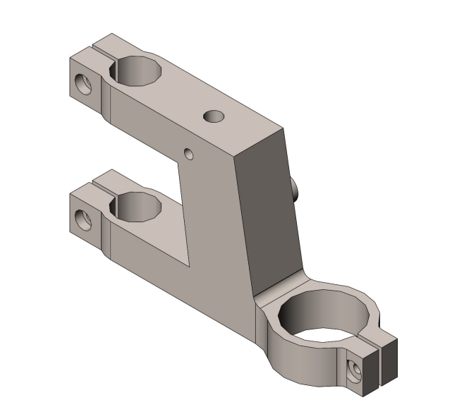
Figure 2 - Drill press main sliding unit
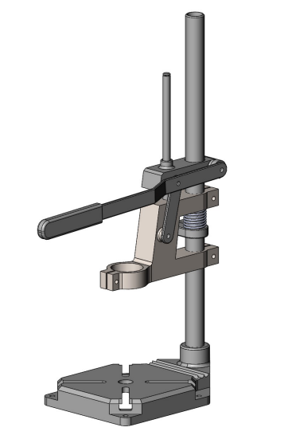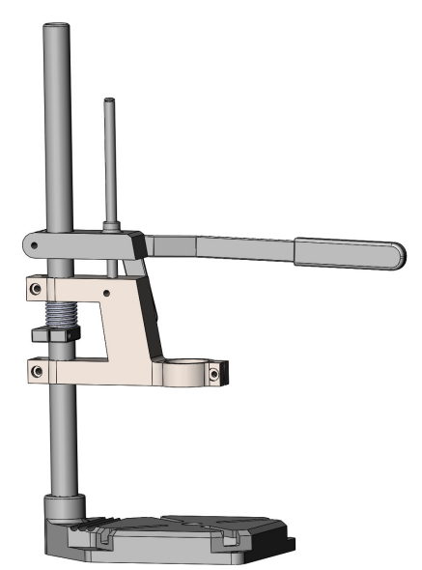
Figure 3 - Drill press Figure 4 - Drill press

The company plans to produce 1000 units / week. An average work week, which assumes an 8-hour shift per day, with two 15-minute breaks, means 37.5 working hours a week. If a company wants to produce 1,000 units in a 37.5-hour work week, it must produce 26 units per hour, which means it would have to produce one unit in just over 2 minutes. Active cost drivers are activities that directly determine how a company operates. They can be labour hours, production hours, cost of material.

- Conclusion

In the design of the product, the determining factors were durability, easy and safe use, of course with the least cost. With these in mind, the choice fell on 4140 steel because of its properties. The best procedure for machining this material is MIM, as it is possible to produce more complex designs and keep the planned production quantity.

References:

- Martin, M. W. and Schinzinger, R. (2000) Introduction to Engineering Ethics. 2nd edn. New York: McGraw-Hill.

- Engineering council, Statement of Ethical Principles (2017)
Available at: https://www.engc.org.uk/standards-guidance/guidance/statement-of-ethical-principles
(Assessed: 06/02/2021)

- Quality-One, Quality Function Deployment (2020) Available at: https://quality-one.com/qfd/ (Assessed: 08/02/2021)

- Sandvik, Advantages of metal injection moulding (MIM) (2021) Available at: https://www.metalpowder.sandvik/en/products/applications/metal-injection-moulding-mim/mim-advantages/ (Assessed: 09/02/2021)

- Velling, A. (2018) 5 ISO standards in Manufacturing Available at: https://fractory.com/5-iso-standards-manufacturers/ (Assessed: 19/02/2021)

- GOV, Product safety advice for businesses (2021) Available at: https://www.gov.uk/guidance/product-safety-advice-for-businesses (Assessed: 19/02/2021)

