
Module Code | BMSK4003
Module Title | Digital Skills and Research Methods
Lecturer’s Name | Balendran Kandasamy
Student Name | Manuela Mahwera
STUDENT’S ID | 1713706

Table of Contents
Introduction 3
Effectiveness of Technology 3
Communication: 3
File Storage: 4
Employability and accountability: 4
Safety and Security: 4
Email 5
Cloud Storage 7
Social Media at Workplace 8
Impact of social media on marketing: 9
Safety and Security Concern 10
Facebook Page attached 11
Conclusion 12
Reference 13

Introduction

Technology is one of the most important things in our daily life, without this our life is really impossible to live. People use technology for different purposes to make their life fast and easy. Workplace technology means using technology in the organization where people work and daily it's becoming updated (Schriek, 2017). This report is all about using technology in the workplace and how it's making our life easier. Using different social media like Facebook, Twitter, LinkedIn, and many others are learning to be social. The innovation in technology is really powerful and by using these we can keep secrecy in the workplace than other competitors. In the workplace, communication is a big part, technology is giving us different tools to maintain better communication with different types of people.

Effectiveness of Technology
Technology is the art, science or knowledge that put into practical knowledge to solve various problems or create something useful (Morgan, 2016). By using technology people can make different types of product or any other thing that is really important. Technology is looking forward to making our life easier and smaller. We use technology on different purposes of our life to communicate, work, creating different things, solve any problem, manage different people from anywhere in the world, theft management by tracking, control the system and many more. Modern technology is all about using different software, hardware, smart devices, social networking sites, video streaming sites and many others that are making our life so connected that people don’t feel how far they are.
Here is the importance of using modern technology:

Communication:
Technology helps us to communicate with people from different corners of the world. In the workplace, it's really important to communicate with customers and other office people to solve different problems or staying updated. When people work as a team, its necessary to communicate for passing different information to others. Technology has given us different ways like mobile phones, email, cloud sharing, social networking websites to communicate with others. For example, using Gmail or outlook for sending email in the workplace are making communication faster and secured.

File Storage:
There are different types of large or small files are created in the workplace and it's important to save file for future purposes. Different types of files are shared with people to make access to these. When these files are saved in the computer, anyone can access from the workplace and use for different purposes. Files are also shared in cloud storage that is accessed from the internet. iCloud, OneDrive, google drive and many other file sharing or storage sites are available to access it from anywhere. It makes our life so easier and anyone can get proper information in the workplace.

Employability and accountability:
Technology is helping us to increase employability and accountability by giving different modern features that make our life easy. Using online shopping, purchase different bills, send anything to anywhere helps to save workplace times. Different modern facilities and social relationships are encouraging employees to work properly in the organization.

Safety and Security:
Virtual assistance, artificial intelligence, online camera, antitheft programs, figure print sensor, face or voice recognition, and many others are keeping safety in the workplace. Without proper evidence, no can enter of make harm in the office.

Advantages of the Technology
- People can communicate with anyone easily.
- File sharing and sending make easier.
- Safety and security system for the workplace.
- Employee performance increases through proper usage.
- Social bonding and team working get an advantage.
- The monitoring system is increasing and theft is reducing.
Disadvantages of Technology
- Hacker is always making different tools for collecting information or financial benefits.
- Leaking of information is making trouble.
- Spams or antiviruses are coming through email.
- Over usage of Facebook, Twitter and other social tools make employees lazy.

Email
Email is one of the most useful inventions of technology. It helps to communicate inside or outside of the organization in a proper way. Email means distribution or message by electronic means from one mobile or computer to another using internet (Bell, 2005). Email is mostly used in the workplace for passing different information, purchasing materials, sending greetings, communicate for different business purposes. There are two types of email domain system, one is free for example Gmail, outlook, and many others. Another is a personal domain that is mainly used by the different organization for communicating and it’s costly. Currently, I am working at Wm Morrison Supermarkets plc and there is a separate domain at my workplace. I use email for different purposes, communicating with internal purposes, sending files, communicating with customers, purchasing different materials from the suppliers and many more on regular basis.
Email is a really useful tool that maintains a proper security system. Everyone needs their own id and password for accessing email, entering correct id and password helps to open this and can access by the individuals. Email is self-identity of a person and for opening any other account on the internet, a person needs an email account. If a person wants to open a Facebook or Twitter account, its important to open an email account first. People use email in the workplace on regular basis for checking any updates, information, notice or any other things.
Here is some Importance of email:
- Email is the fast and secure communication system than a letter.
- By using the internet, it can be accessed from anywhere for passing any information.
- It helps to works from home, if an employee is unable to come to the office he can access or pass any information by email.
- Communication by email is less costly than others.
- Email is a widely used communication method and the personal domain is the most secured than free domains.

Gmail and outlook both are widely used in personal or in the workplace, both have some advantages and disadvantages. Here is the comparison of Gmail and outlook features:
Features | Gmail | Outlook
1. Usage | It is widely used for personal or organization purposes | Used mostly in the organization.
2. Domain | Gmail provides a domain on the basis of an organization with fewer prices. | It also provides domains for a different person but the price is comparatively high.
3. Security | Gmail usage standard 128-bit security system and which has some security issues. | It has the highest security system for organizational purposes.
4. Storage | It provides 15 GB for free domain and has different plans for the personal domain | Provides 5gb for personal mail and different plans for a personal domain.
5. Folder or Level | Gmail provides a level system for identifying sperate emails based on its access. | Outlook follows traditional folder system for separating different emails.

Cloud Storage
Cloud storage means computing model where data is stored on a remote server that means all the data are stored in a place and using the internet it can be accessed from anywhere (Cottrell, 2011). All the data stored, maintained, managed and operated by a cloud storage service provider on a storage server through using of virtual techniques. There are different service providers, for example, Google Drive, Dropbox, OneDrive, and many more. In my workplace, different information’s are stored on google drive to access.
Here is some importance of cloud storage:
- It helps to access from anywhere only by using the internet.
- Increase overall team performance by uploading different data in the cloud.
- Increases flexibility and collaboration of team working.
- It reduces overall storage costs of the organization by using a cloud system.
- Safes data from power loss or any other diesters.
Difference between Dropbox and Google Drive:
Features | Dropbox | Google Drive
1. Storage | Dropbox has only 2 GB of storage for free users and has other plans for paid users. | It has 15 GB free storage and other plans which is cheaper than others.
2. File support | It doesn’t support any file type, after downloading the file if there its need supported software on the computer. | Supports 30 different files without downloading it.
3. Sharing files | Need to add a person that easily can be shared by permitting. | Need to send an email containing the link and separate restrictions need to make on different files.
4. Deleted files | Can be kept for 30 days with unlimited count as per storage limitations. | Keep 30 days with 100 times can edit the file.

Social Media at Workplace
Using social media in the workplace is common practice and its really important to make communication with different customers, internal employees or others. Social media let us stay connected with people and helps to do business efficient way (Cooper, 2009).
Here are the advantages and disadvantages of social media in the workplace:
Advantages:
- Social media let stay connected with different people.
- Increase overall team working and communication level that helps to build a mutual relationship.
- Increase the efficiency of working through proper communication.
- Removes conflict from the organization and make a friendly environment.
- Great advantages in terms of marketing and branding of the organization.
Disadvantages:
- Too much usage of social networking increases laziness in the workplace.
- Self-hesitation created to work that makes demotivated.
- Employees seem busy chatting rather than official work.
- Unethical practice and the passing of confidential information can be increased.

Impact of social media on marketing:
In terms of marketing, social media plays a big role. Creating a Facebook page or Twitter account, LinkedIn profile and advertise or promote the different offer in these pages helps to digital marketing. Facebook provides chat messages with customers that help to stay connected by providing different information’s. Facebook advertisement helps to reach people that cost money and make instant viral in the market. Different offers, events, notice, greetings, advertisements and many other things help to stay connected. Using social network for marketing is less price than other media and makes easy to increase the branding of the organization. Helps to increase business to customer communication relationship that is really important for business growth and development (Poynter, 2010).
Workplace communication: Social media helps to stay communicate properly at the workplace and that increase the team performance (Mackenzie, 2015). Using Facebook, Twitter or Instagram helps to post or share status that helps to get an update about different personalities. Friendly environment and social communication are increases by using social media in positive ways. Different notices, updates, information and many other things can be passed by messenger that makes easy to connect with all.

Safety and Security Concern
There are different safety and security issues are found in social networking and that makes some problem of sharing confidential information. Hackers are always looking forward to making harm and collect information that can cause several problems for the organization. Facebook is widely used social networking sites in this modern world and all employees at my workplace use Facebook to stay connected with different information. But hacking a Facebook profile can make losses or passing of information to other people that can make problem on the social media. Different types of spam, virus message, and other things are created by the hackers and by clicking this anyone can become a victim of hackers (Hoechsmann, 2012).
Competitors and other professional hacker are always trying to get the confidential information that can be harmful for the organization. That’s why it's important to make everything secured and be aware of the hackers. Sharing of personal information or basic info can humiliate on social media and can impact on the organization's improvements. There is some problem regarding Facebook that it can’t give proper security of a person or organization. That’s why personal or organizations confidential information shouldn’t be passed through Facebook.

Facebook Page attached

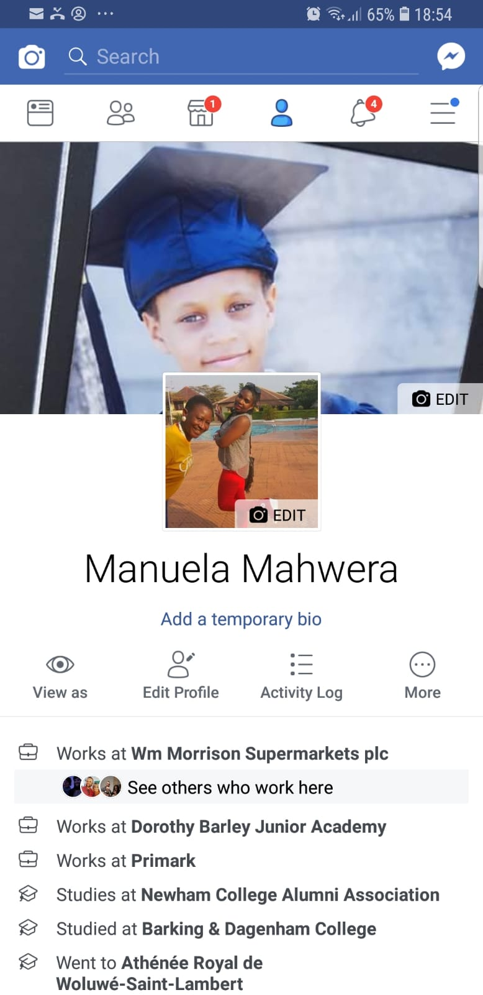

Conclusion
Technology and social media both are an important part of our daily life and using these on workplace enhance overall activities. But there must need to be remembered that passing and providing any confidential information can cause bad impact and hackers can get these. Social networking sites help to stay connected with employees and customers as well that makes bonding and marketing of the organization.

Reference

Bell, J. (2005) Doing your research project: A guide for first-time researchers in social science, education, and health. 4th edn. Maidenhead, England: Open University Press.
Cottrell, S. (2011) Critical thinking skills: Developing effective analysis and argument (Palgrave study skills). 2nd edn. Basingstoke: Palgrave Macmillan.
Emory, C.W. and Cooper, D.R. (2009) Business research methods. 4th edn. United States: Irwin Professional Publishing.
Hoechsmann, M. (2012) Media literacies: a critical introduction. Malden, MA., Wiley- Blackwell.
Mackenzie, A. (2015). Problematizing the technological: The object as an event? Social Epistemology, 19, 381–99.
Maund, A. Schriek, M. and Tinkler, P. (2017). Certificate in Higher Education: Skills for the Workplace Student Yearbook. Sage Publications.
Morgan, P. (2016). The Business Student’s Guide to Study and Employability. Sage Publications
Poynter, R. (2010) The handbook of online and social media research: Tools and techniques for market researchers. United Kingdom: Wiley.

