HTML & CSS Web Development
Module Code: ACCA4003
Module Lecturer: Kemi Ademoye
[
Student Name: Mohamad Wael Baghdadi
Student Number: 1708309
Course: Software Engineering
Date: 10/01/2018

Table of Contents
Table of Contents 1
Table of figures 2
1. Introduction: 3
2. Introduction to the author website: 4
2.1. Description about the website: 4
2.2. Site Map: 4
2.3. A wireframe 5
3. The implementation: 6
3.1. Screen shots of the author website: 6
3.2. Validation: 12
4. Evaluation: 13
4.1. An Accessibility Evaluation of the website: 13
4.1.1. WCAG 2.0: 13
4.1.2. Heading 13
4.1.3 Information structure and relationships conveyed through your HTML code 14
4.1.4 Images and another Media Content 14
4.1.5 Scalable text content: 15
4.1.6 The colours in the website: 15
4.1.7 Forms: 15
4.1.8 Navigation 16
4.2 Another error is the author has found them: 16
4.3. An evaluation of the completed website: 18
4.3.1. Design: 18
4.3.2. Usability: 18
4.3.3. Content: 18
4.4. Recommendation for the future improvements: 18
4.4.1. General recommendation: 18
4.4.2 Main page 18
4.4.3 Hotels 18
4.4.4 Airline 18
4.4.5 About Us 18
4.4.6 Contact Us 18
5. References: 19

Table of figures
Figure 1: site map of the author's website. 4
Figure 2: wireframe of main page 5
Figure 3: Main page 6
Figure 4: the top of the main page 7
Figure 5: middle of the main page 7
Figure 6: The body of the main page 7
Figure 7: Second page, Hotels 8
Figure 8: Third page, Airline 9
Figure 9: Fourth page, About us 10
Figure 10: Fifth page, Contact us 11
Figure 11: The validation for the HTML main page. 12
Figure 12: The validation for the CSS main page 12
Figure 13: Possible heading in WAVE tool. 13
Figure 14: Structure section. 14
Figure 15: main page code to proof the "alt" included. 15
Figure 16: Code for the Forms. 16
Figure 17: Check in WAVE tool for the errors. 17
Figure 18: An error in last page 17

1. Introduction:
The aim of this report is to describe and explain the author's website, what is the website talking about and how many pages including with a site map and wireframe for the main page.
The report includes screenshots for the website, HTML and CSS validations for the home page and error codes where they found.
The main thing in the report is the accessibility evaluation which talks about the accessibility for the heading, structure, images, colours, scalable text, Forms and navigation and what each one of them most have and if the author’s website has check them or if he got any error in some of them.
Also, it talks about the evaluation of the completed website like the design, usability and the content including what recommendation need to improve the future website.

2. Introduction to the author website:

2.1. Description about the website:
The site is a travel agency that is marketing for services and what are the offers for the customer who want to book a complete trip or wants to book the hotels and airlines individually by some links to other websites.
On the main page include a brief of the complete trip program with the prices, and it has a video presentation for the best places or most beautiful beaches in the world.
The site has some links to allows the customer through this links to search and compare the hotels around the world and see the hotel's pictures, location, prices, quality and their reviews for each one as well, and even for the airlines section it has another links to comparing websites to search for flights and what available routes for their destination which they are on the second and third page
The fourth page has a brief description and overview of the company's start-up and what the offers for the permanent customers and it includes a video talking about the benefits of the travel.
The last one on page five which the author called contact us, it shows the customer the contacts’ numbers for the agency and where the agency located in the real map.

2.2. Site Map:
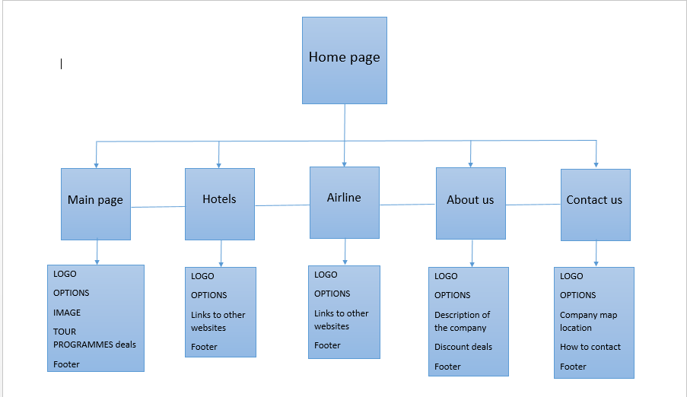
Figure 1: site map of the author's website.

2.3. A wireframe
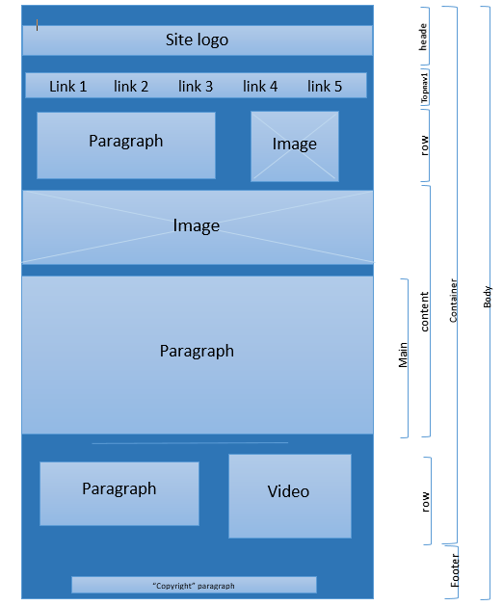
Figure 2: wireframe of main page

3. The implementation:

3.1. Screen shots of the author website:

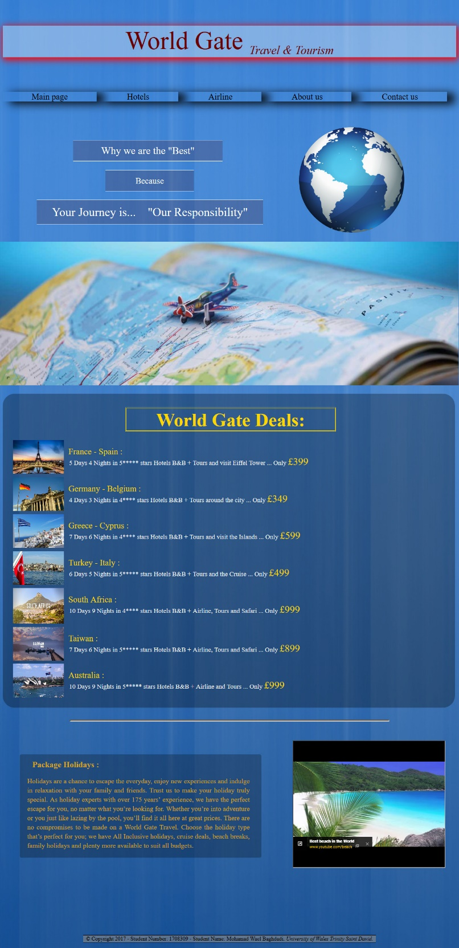
Figure 3: Main page

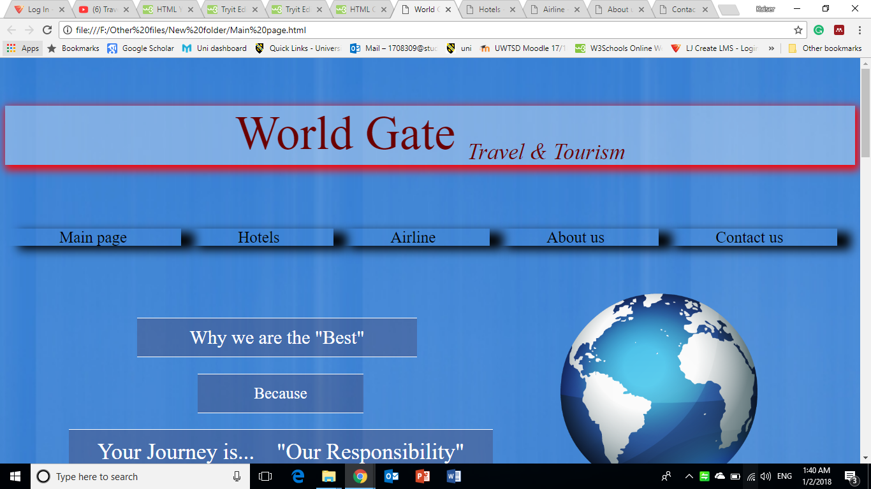
Figure 4: the top of the main page
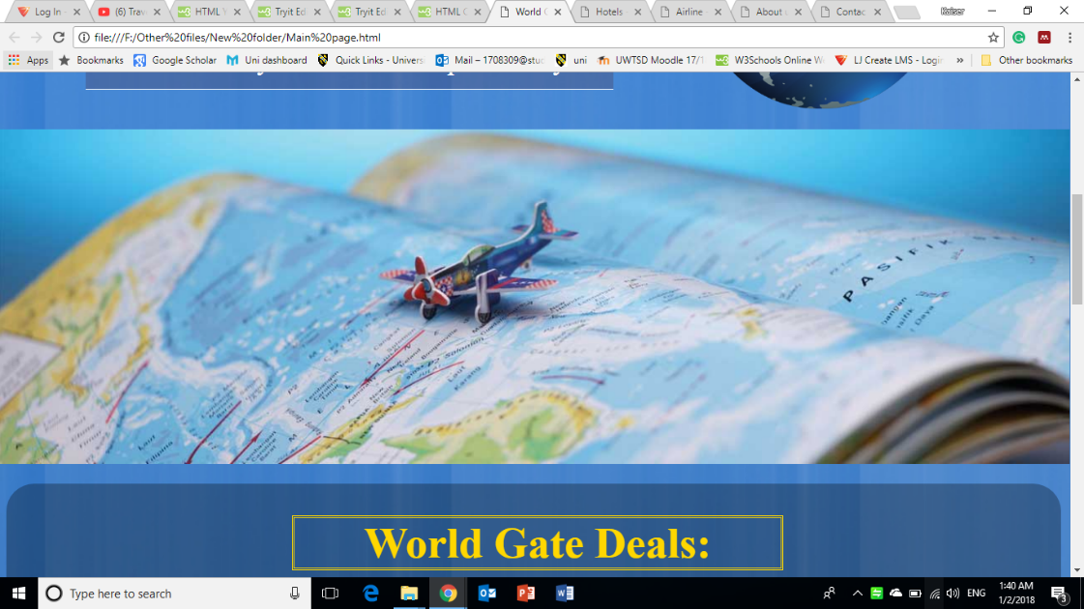
Figure 5: middle of the main page
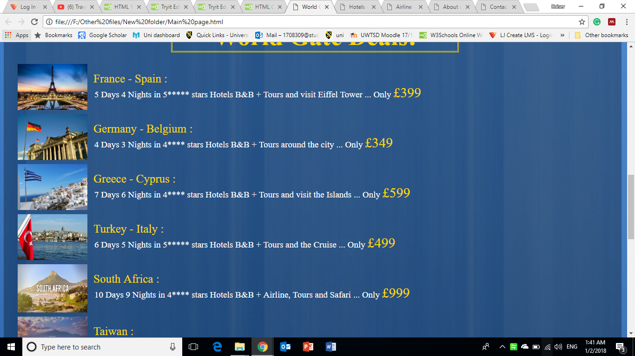
Figure 6: The body of the main page
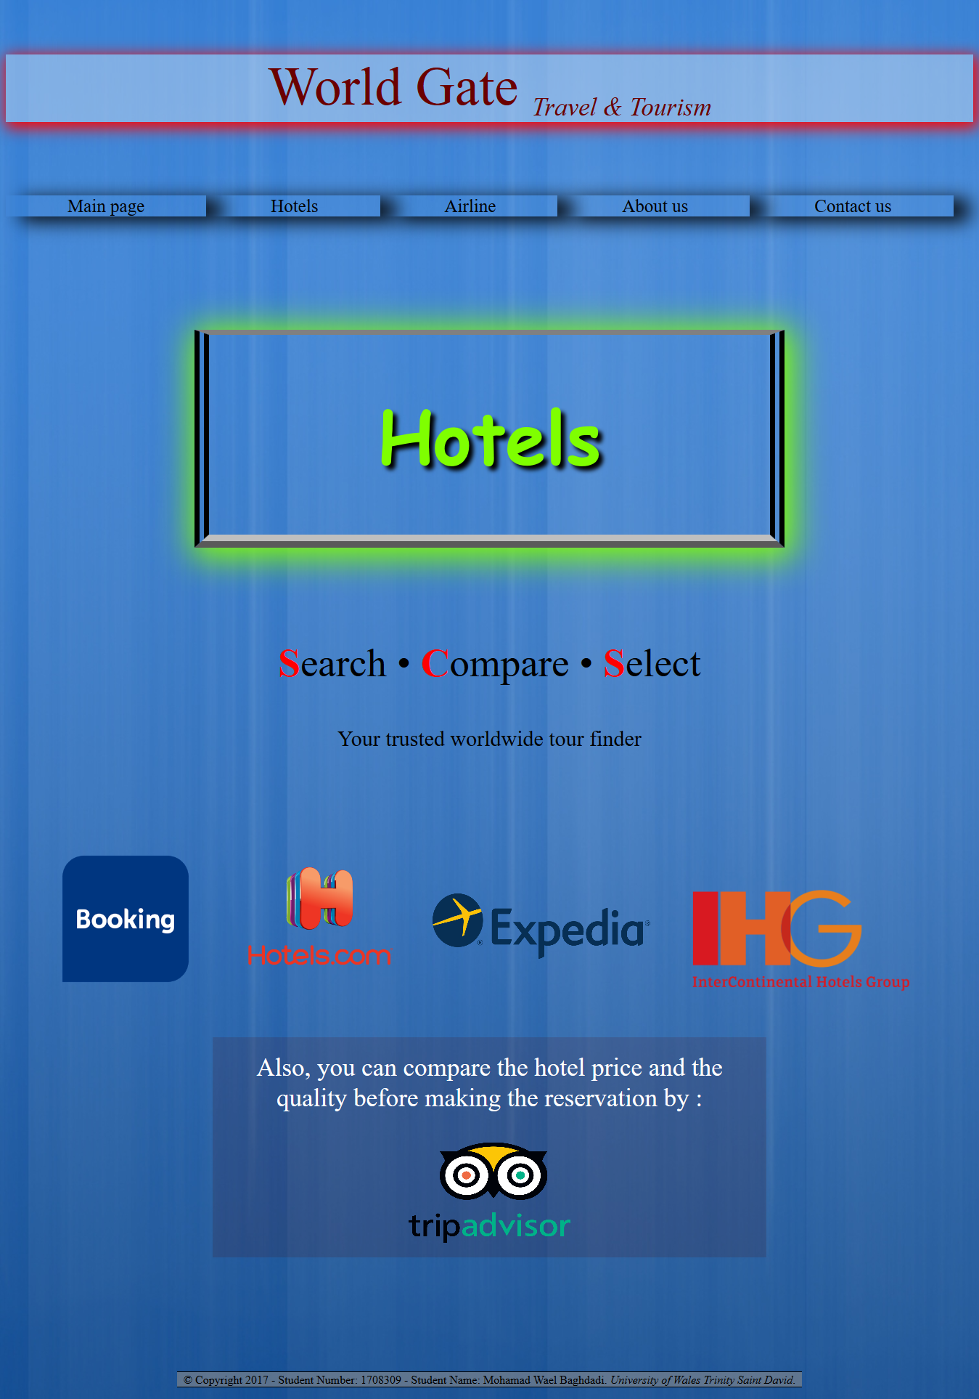
Figure 7: Second page, Hotels

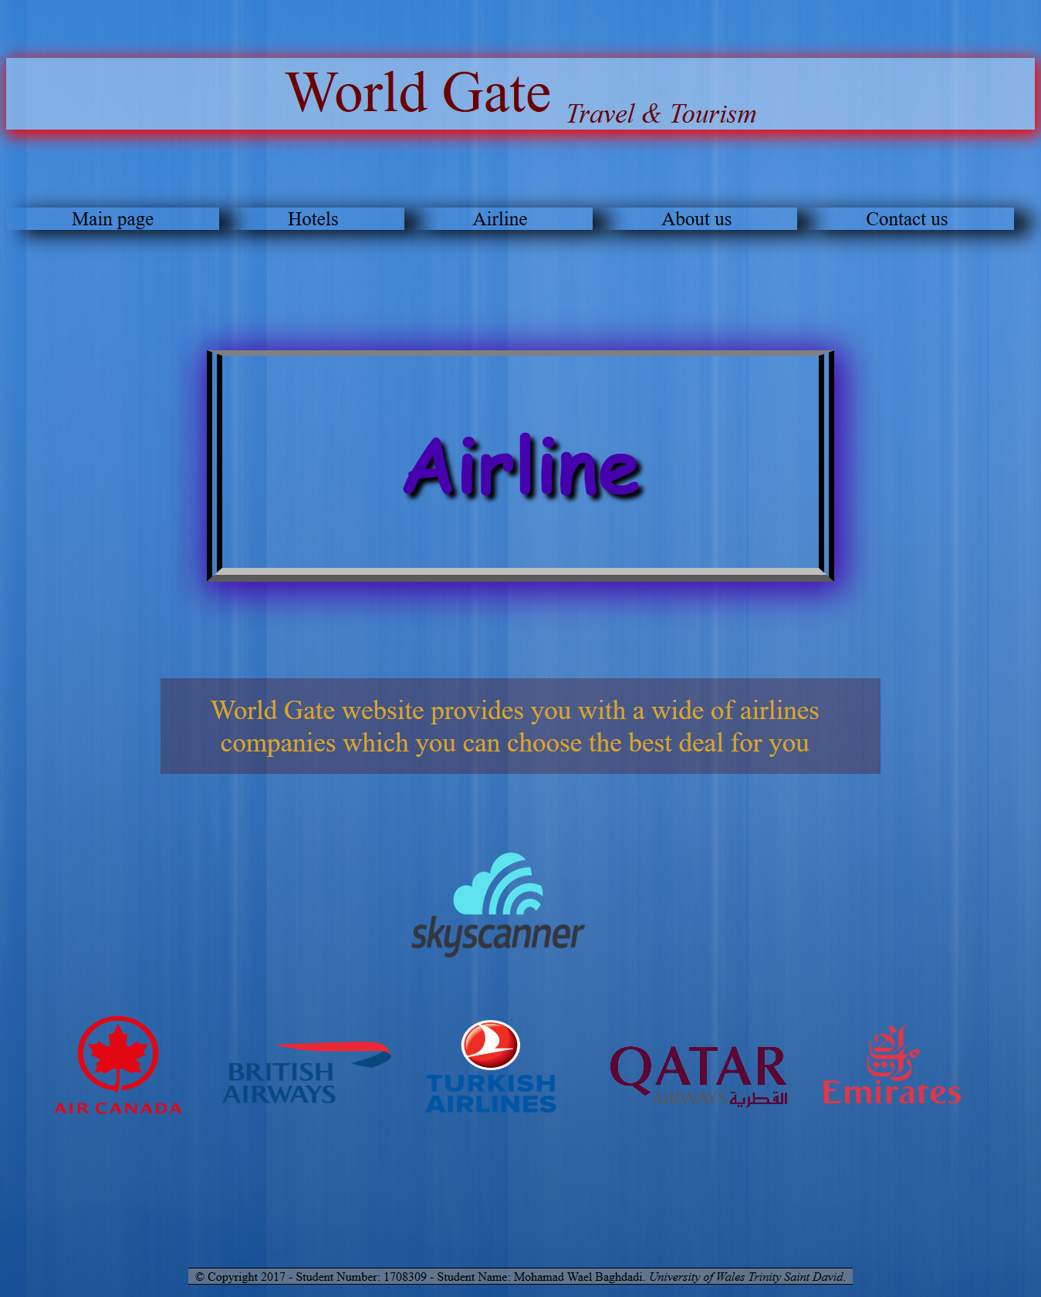
Figure 8: Third page, Airline

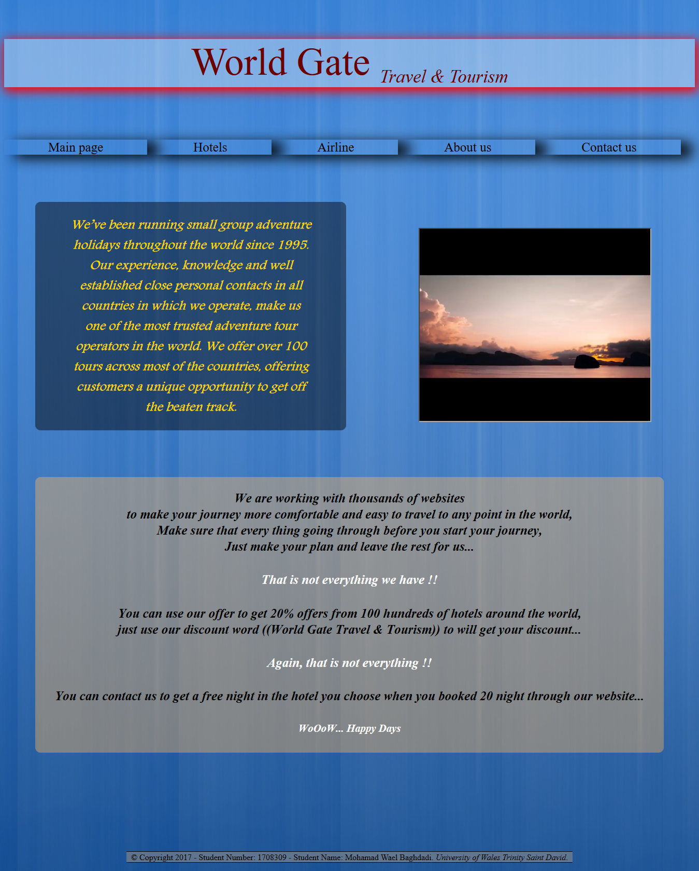
Figure 9: Fourth page, About us

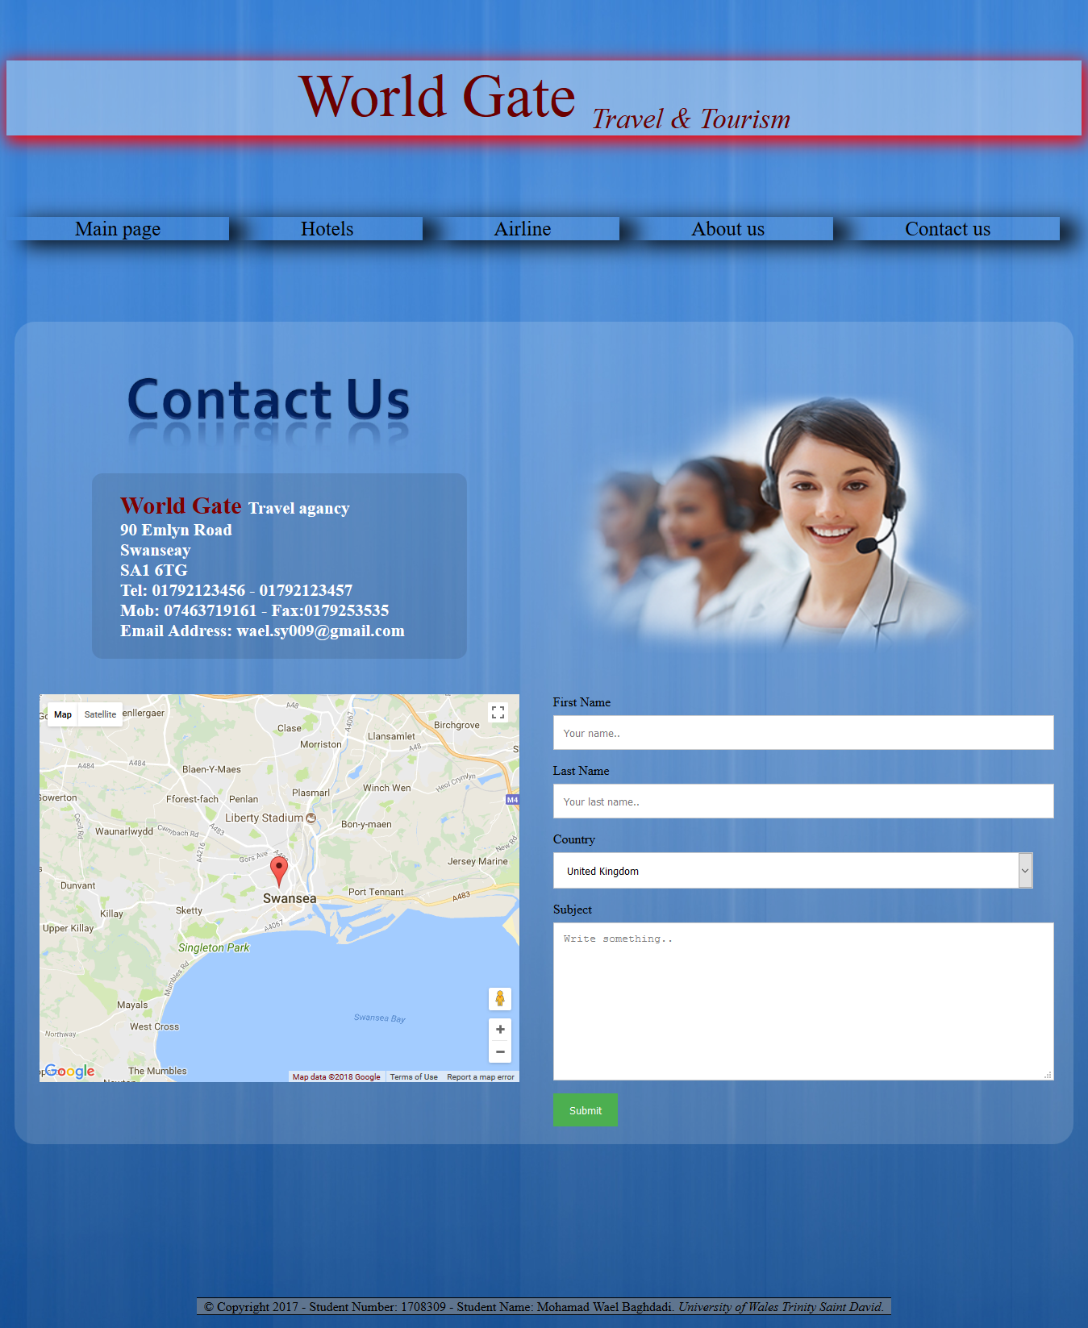
Figure 10: Fifth page, Contact us

3.2. Validation:
The result in the website[1] for the validation code in HTML main page was no errors or warning:
Document checking completed. No errors or warnings to show.
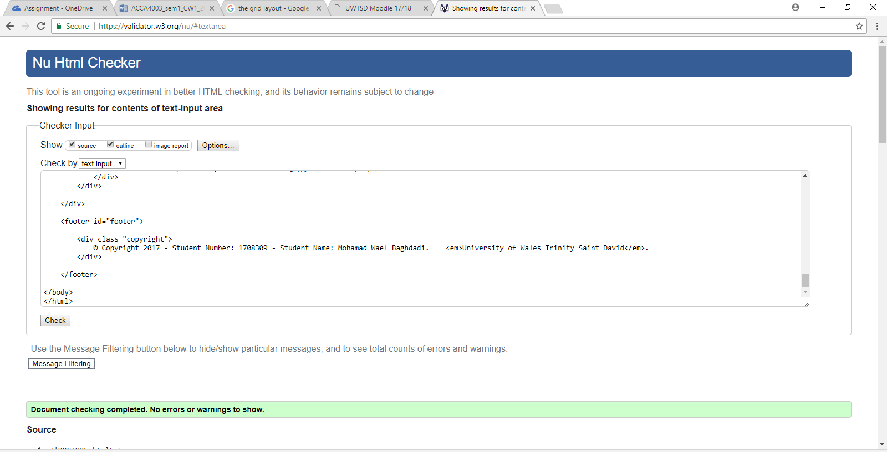
Figure 11: The validation for the HTML main page.
The validation for the CSS main page and the result [2] was no error found:
“Congratulations! No Error Found”.
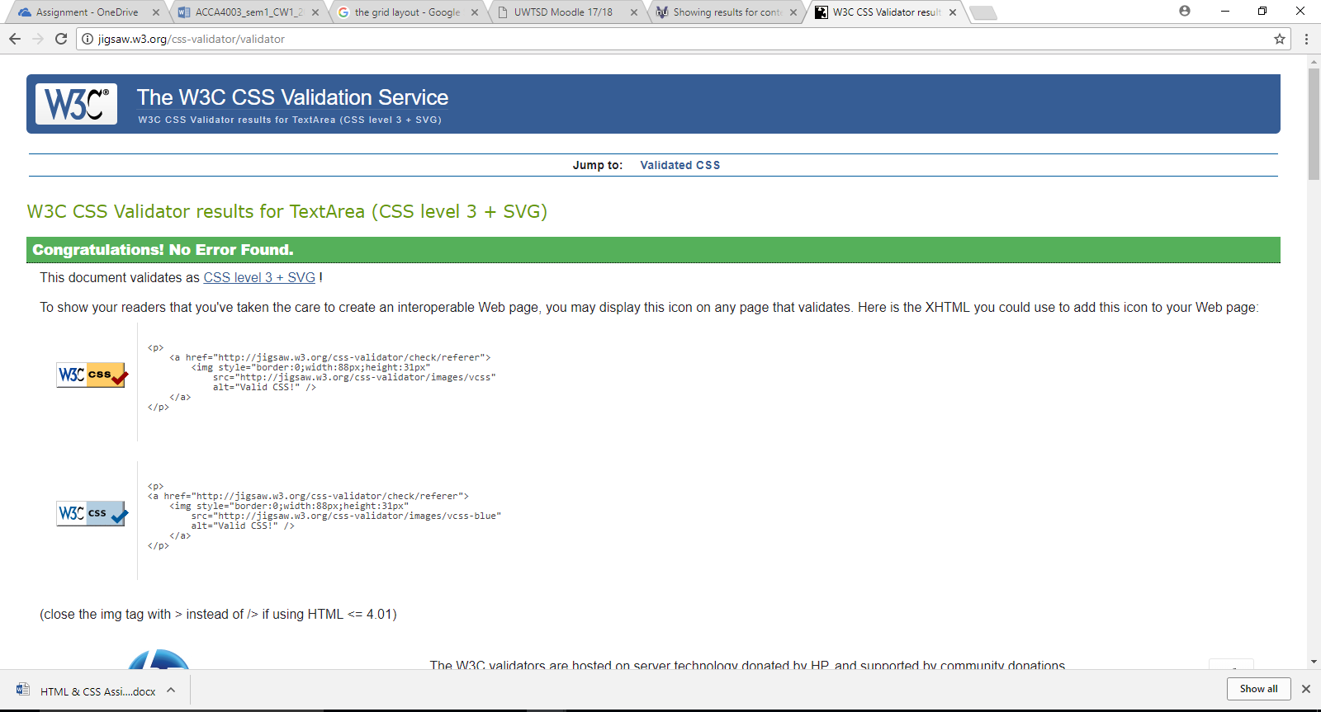
Figure 12: The validation for the CSS main page

4. Evaluation:

4.1. An Accessibility Evaluation of the website:

4.1.1. WCAG 2.0:
WCAG It is an acronym for Web Content Accessibility Guidelines (WCAG) 2.0.
The WCAG 2.0 explain how to make web design more useful for the people with disabilities including a general information like texts, images and sounds, and include a codes or mark-up that defines structure and presentation. The meaning of WCAG is for the web developers, authors and site designer, web authoring tool developers, web accessibility evaluation tools developers and for others how want to create and design a web with the accessibility.

4.1.2. Heading
According to the website [3] they have a check list to compare the accessibility of a website this check list has followed:
- The page has a heading. In almost of the all pages they should have at least one heading.
- The heading hierarchy is meaningful. Ideally the page starts with an "h1" — which is usually similar to the page title — and does not skip levels; however, these are not absolute requirements.
The author website has a heading and subheading where appropriate.
According to WAVE tools they should be three possible heading, but the author disagrees and is not appropriate for these to be headings
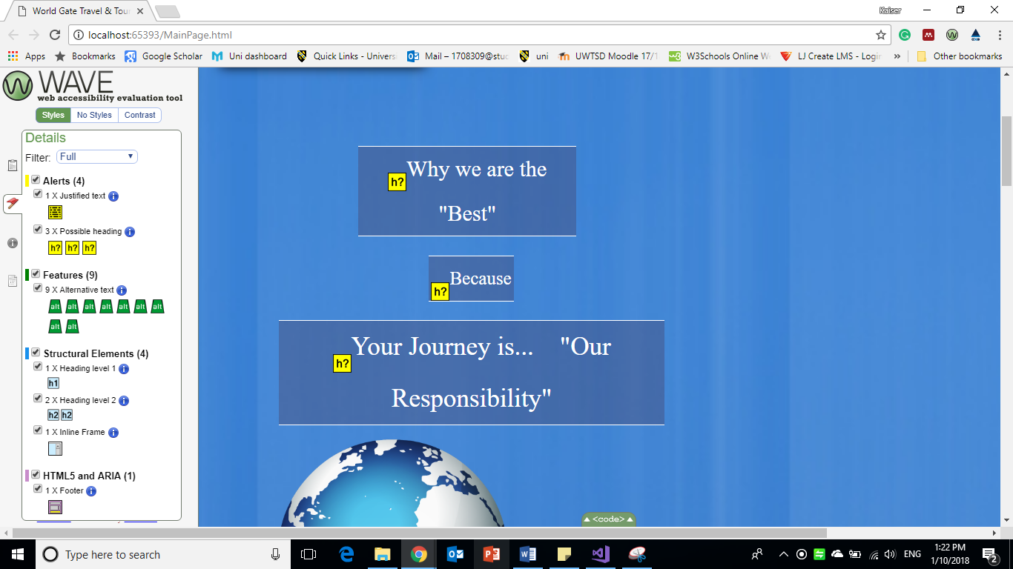
Figure 13: Possible heading in WAVE tool.

4.1.3 Information structure and relationships conveyed through your HTML code
According to the same website[3] the check list for the structure were :
- check for the information makes sense when read in the order it is shown.
- Check ”alt” the alternative text provides adequate information for the missing images.
- Check that’s blocks of information got a clear heading.
Comparing to the lists and using the WAVE tool the structure in the website has structural Elements in the Heading level 1, but the author disagrees and is not appropriate.
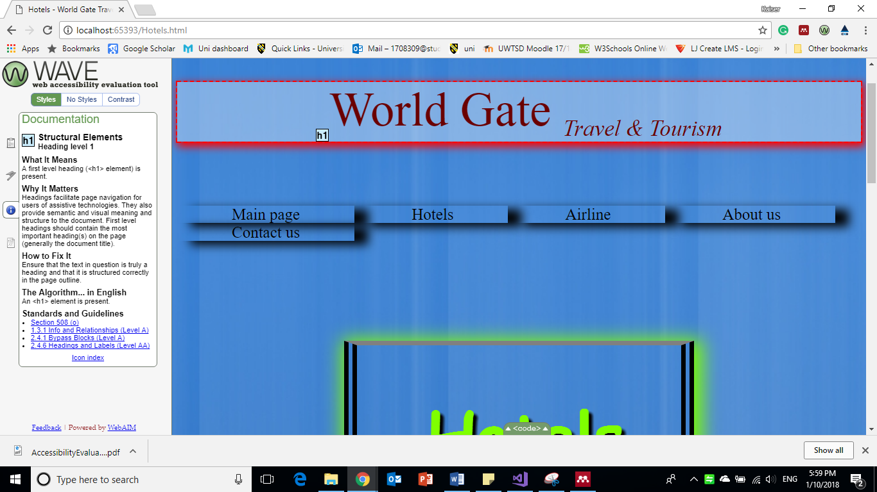
Figure 14: Structure section.

4.1.4 Images and other Media Content
Each image “img” element must specify an alternative “alt” attribute or equivalent mark-up that either defines a text alternative or identifies the image as being used for decoration, spacing or stylistic purpose.[4]
All the images in the author website has an “alt” text alternative.
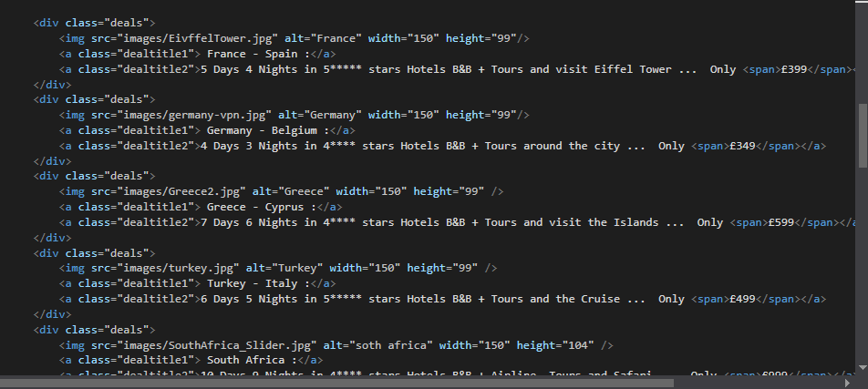
Figure 15: main page code to proof the "alt" included.

4.1.5 Scalable text content:
According to the same website[3] [5] the check list for the Scalable were :
- The texts can be bigger or larger
- The text not hidden or get cut off.
- Texts, images and contents do not interfere with each other
- All interventions, fields and buttons are visible and ready to use
In the author’s website the Text, images, texts and other content are overlap when the user need to make a zoom in for the page

4.1.6 The colours in the website:
The colours in general is
Use colour and contrast to help users see and interpret your app’s content, interact with the right elements, and understand actions. Choose primary, secondary, and accent colours for your app that support usability. Ensure sufficient colour contrast between elements so that users with low vision can see and use your app[6]
- The main colour in the website is light blue, light black, gold and some silver
- The foreground colour has white, goldenrod, and black colour[7]
- The background colour is light blue which is in the code (2C74BC)[8]
- Heading colour is in purple with a light white background colour

4.1.7 Forms:
According to the website [3] the form could be a single text box, such as Search, or could be a complex form with text fields, radio buttons, checkboxes, drop-down lists, and buttons, the list here need to be considerate in the Forms
- To check that all form controls are keyboard accessible
- To check that every form control has a label associated with it using 'label', 'for', and 'id'.
- To check that the labels are positioned correctly
Comparing to the author website, the Forms has all checked and all of them including the “id” and followed by the checklists.
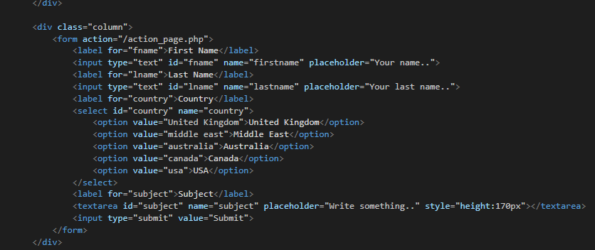
Figure 16: Code for the Forms.

4.1.8 Navigation
There are many people cannot use the mouse and rely on the keyboard to interact with the Web, people who are blind and some sighted people with mobility impairments rely on the keyboard or on assistive technologies and strategies that rely on keyboard commands, such as voice input. Accessible websites enable people to access all content and functionality — links, forms, media and controls[3][9][10]:
Tab to all, Tab away, Tab order, Visual focus, all functionality by keyboard, Drop-down lists, Check that after you tab into a drop-down list and Image links
Comparing to the author website, all the navigation steps has been checked and all of them working

4.2 Another error is the author has found them:
Talk about the errors in the website and how to fix them with screen shot and screen shot after to proof of fixing
In the second page (Hotels) the WAVE tool gives the author an error. And the same error was in the other pages, which it was to identify the document language, the author fixed the error by adding the language to all pages.
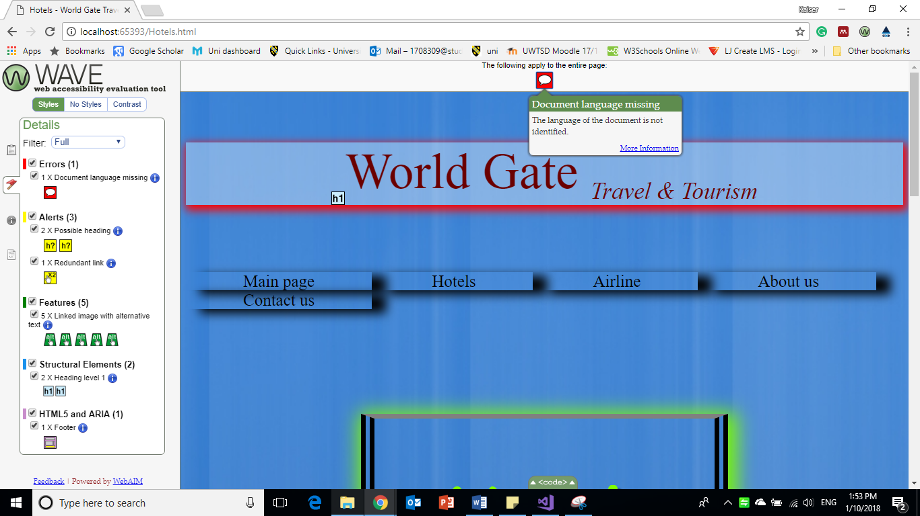
Figure 17: Check in WAVE tool for the errors.
another error in the last page (Contact Us) has founded which the first one is saying as the WAVE tool “each image must have an alt attribute. Without alternative text, the content of an image will not be available to screen reader users or when the image is unavailable.”
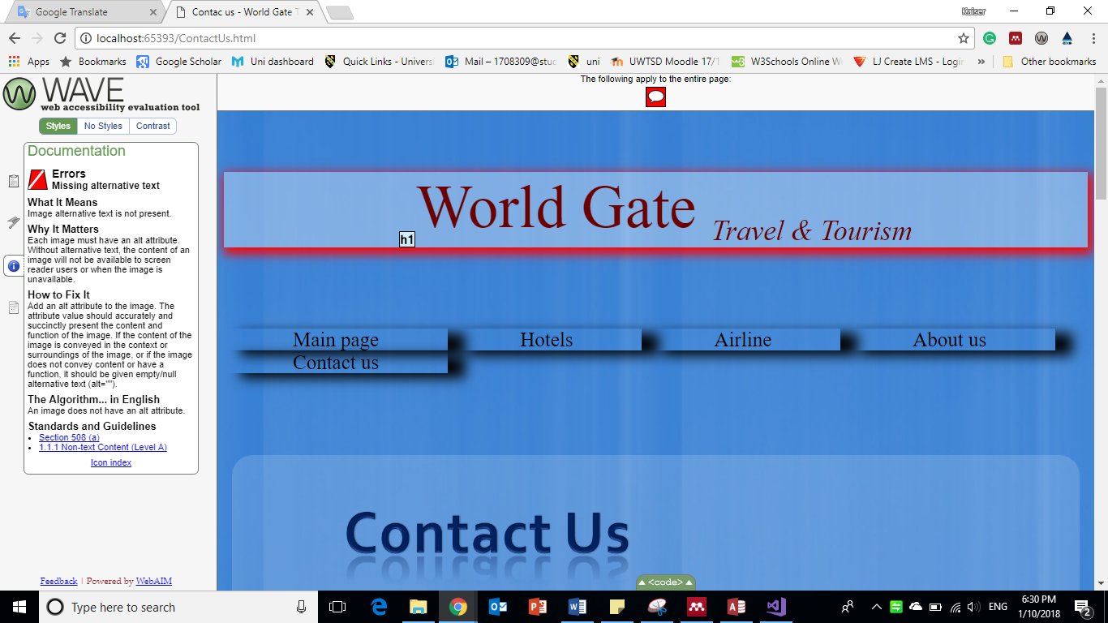
Figure 18: An error in last page

4.3. An evaluation of the completed website:

4.3.1. Design:
The design for the website is simple and not complicated to let the users know and read the information smoothly and move from the pages without hidden information and to reach to what they want easily. The most helpful website to create and design this website is w3school[11]

4.3.2. Usability:
This website is usable and links in the heading all works. The external links in the second and third page all checked and all of them working. The video in the first and fourth page both working and the first one auto play but the second one not. Google map for the location has check and working as well.

4.3.3. Content:
The website contains the links to other websites to book hotels and airlines and it contains a brief of travel programmes with the price for each one. Main page has a video with music auto play, the second page has few external links to other websites to book and compare prices for hotels, third page has few links for airline company and to compare the prices and availability, third page has a brief of the company, the fourth one is to let the users know where is the location of the company and how to contact them.

4.4. Recommendation for the future improvements:

4.4.1. General recommendation:
For the links sections in the heading it should be the background colour lighter because if someone had colour blind he cannot see the colours properly.
The footer colour should be in white or light colour also for the blind colour users will not see the colours properly.

4.4.2 Main page
Auto play in the video, may not be a good idea because internet in some places or locations is not very strong and could the page loading times more than usual, which may put some users off from using the website. But any way the music is nice and can give for the users some idea about the world when they will watch the video,

4.4.3 Hotels
The external links to other website could be clearer to the users by create some another paragraph to inform the users or use different colour.

4.4.4 Airline
The same in hotels section the external links to other website could be clearer to the users by create some another paragraph to inform the users or use different colour.

4.4.5 About Us
Need more information and what the experience the company has had before.

4.4.6 Contact Us
If it includes a live chat to speak with the users that will be more professional for the company to speak straight away to their customer.

5. References:
[1] World Wide Web Consortium, “The W3C Markup Validation Service,” World Wide Web Consortium, 2009. [Online]. Available: https://validator.w3.org/#validate_by_input. [Accessed: 09-Jan-2018].
[2] World Wide Web Consortium, “The W3C CSS Validation Service,” www.w3.org, 2012. [Online]. Available: http://jigsaw.w3.org/css-validator/#validate_by_input. [Accessed: 09-Jan-2018].
[3] W3, “Easy Checks - A First Review of Web Accessibility | Web Accessibility Initiative (WAI) | W3C,” Web Accessibility Initiative, 2016. [Online]. Available: https://www.w3.org/WAI/eval/preliminary.html#headings. [Accessed: 10-Jan-2018].
[4] “Images must have alt text : Functional Accessibility Evaluator 2.0.” [Online]. Available: https://fae.disability.illinois.edu/rulesets/IMAGE_1/. [Accessed: 10-Jan-2018].
[5] “On Scalable Text.” [Online]. Available: http://www.uiaccess.com/scaletext.html. [Accessed: 10-Jan-2018].
[6] “Accessibility - Usability - Material Design.” [Online]. Available: https://material.io/guidelines/usability/accessibility.html#accessibility-principles. [Accessed: 10-Jan-2018].
[7] Juicy Studio, “Juicy Studio: Luminosity Colour Contrast Ratio Analyser,” 2016. [Online]. Available: http://juicystudio.com/services/luminositycontrastratio.php#specify. [Accessed: 10-Jan-2018].
[8] “WCAG Contrast checker.” [Online]. Available: https://contrastchecker.com/. [Accessed: 10-Jan-2018].
[9] “Navigation: Best Practices: University of Michigan Web Accessibility.” [Online]. Available: http://webaccess.hr.umich.edu/best/nav.html. [Accessed: 10-Jan-2018].
[10] S. Trewin, “Web Accessibility.” pp. 37–46, 2008.
[11] W3C, “HTML & CSS,” WEB Desig2n and Applications, 2012. [Online]. Available: https://www.w3schools.com/html/html_css.asp. [Accessed: 10-Jan-2018].

marking criteria and Student FEEDBACK

This section details the assessment criteria. The extent to which these are demonstrated by you determines your mark. The marks available for each criterion are shown. Lecturers will use the space provided to comment on the achievement of the task(s), including those areas in which you have performed well and areas that would benefit from development/improvement.

Common Assessment Criteria Applied (Assignment 1) | Marks available | Marks  awarded
1. Research-informed Literature
Extent of research and/or own reading, selection of credible sources, application of appropriate referencing conventions.
Demonstrates an excellent level of research. (Grade mark: 80.00%) | 5 | 4
2. Knowledge and Understanding of Subject
Extent of knowledge and understanding of concepts and underlying principles associated with the discipline.
Demonstrates a fairly good understanding of the standards to design and implement a website. There is, however, room for improvement. Note that if you are creating a multi-page website, it is better to have a single, external style sheet page that you add all your CSS to and then link this single style sheet to all your pages. That way, you define your styles once, which makes it easier to ensure that your pages are consistent and if you need to make changes, you only need to do it one place. You also need to work at improving the layout and structure of your content. (Grade mark: 55.00%) | 20 | 11
3. Analysis
Analysis, evaluation and synthesis; logic, argument and judgement; analytical reflection; organisation of ideas and evidence
A very good evaluation of the implemented website has been provided, with good reference to the WCAG guidelines for the accessibility evaluation. (Grade mark: 75.00%) | 20 | 15
4. Practical Application and Deployment
Deployment of methods, materials, tools and techniques; application of concepts; formulation of innovative and creative solutions to solve problems.
A good attempt featuring a simple website with well-thought-out content. Well done. The main area for improvement is the layout and structure of your HTML content. Also note that it is good practice to name the home page of a website as either index.html or default.html. See additional comments in your report. (Grade mark: 55.50%) | 50 | 27.75
5. Skills for Professional Practice
Attributes in professional practice: individual and collaborative working; deployment of appropriate media; presentation and organisation.
The report is satisfactory, but work at improving your writing style. (Grade mark: 45.00%) | 5 | 2.25

Assignment Mark (Assessment marks are subject to ratification at the Exam Board. These comments and marks are to give feedback on module work and are for guidance only until they are confirmed. ) | Late Submission Penalties (tick if appropriate) |  | 60%
 | Up to one week late |  | 60%
 | 1st/2nd/3rd attempt? |  | 60%

