Why is psychology importnant when working as a social worker?

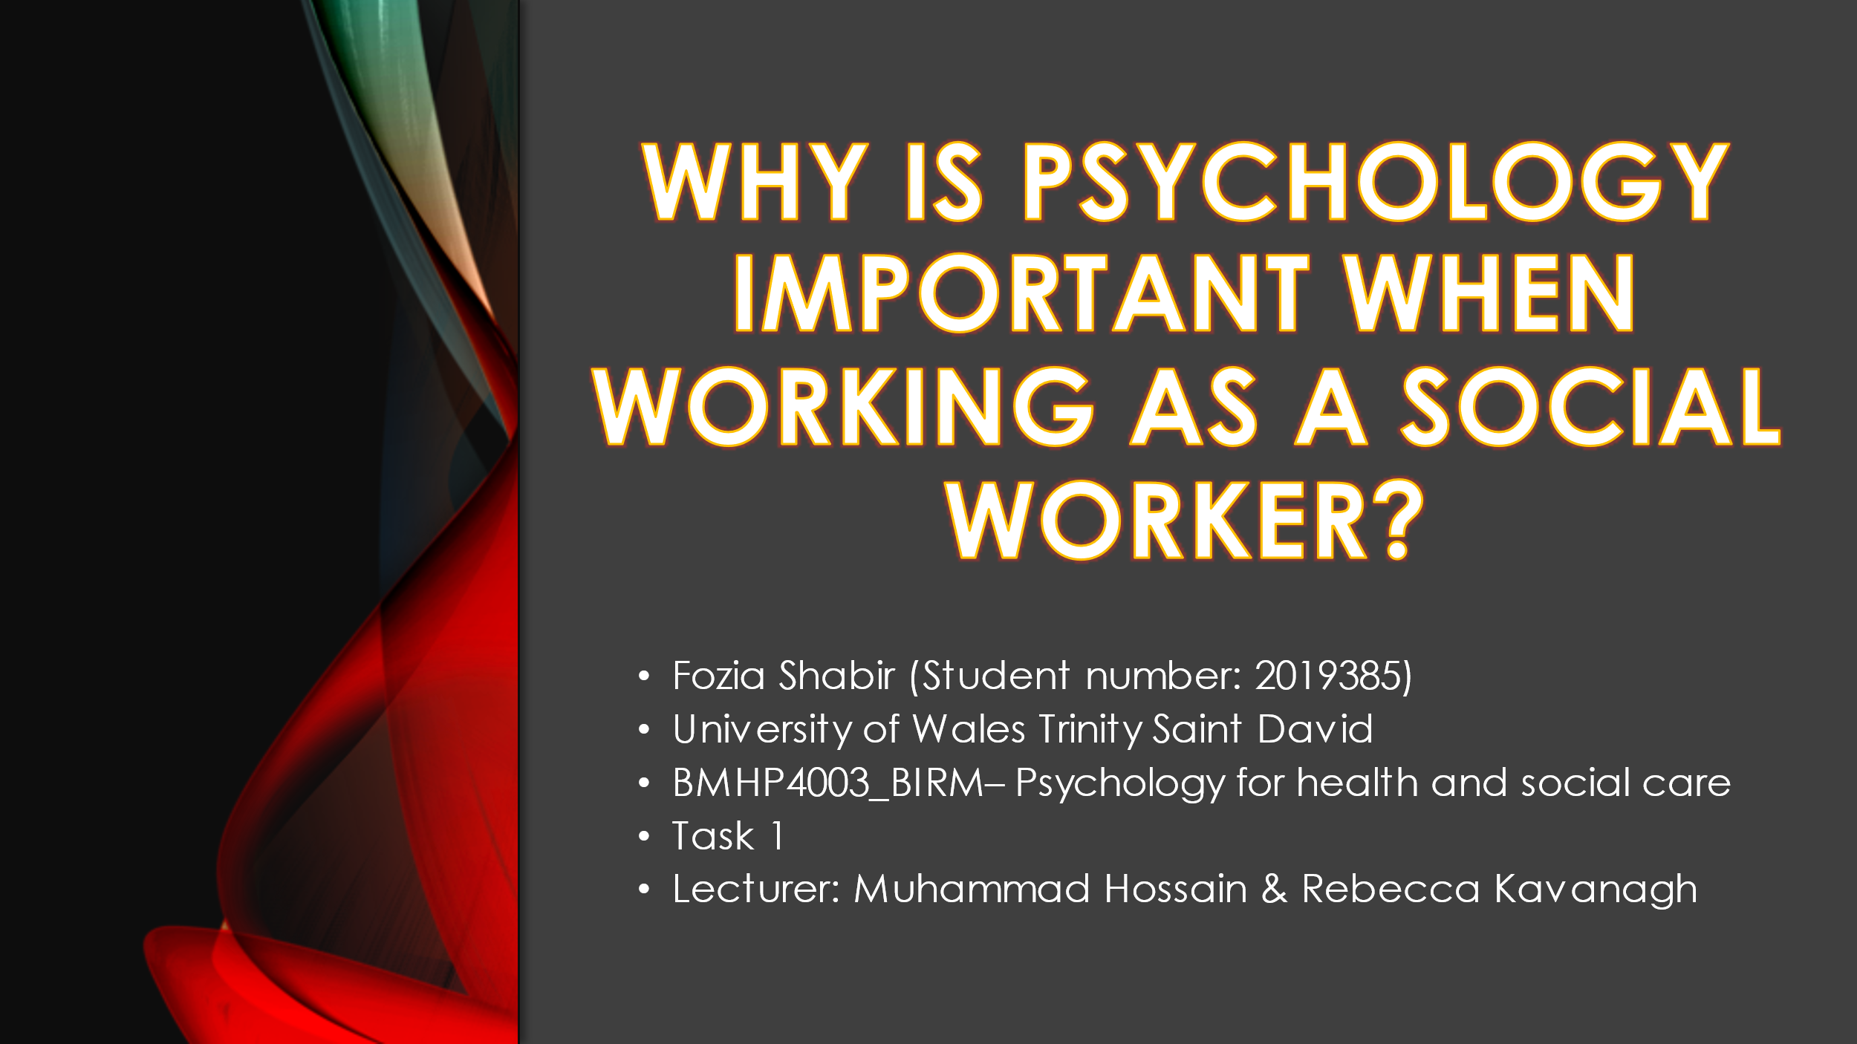 As a social worker
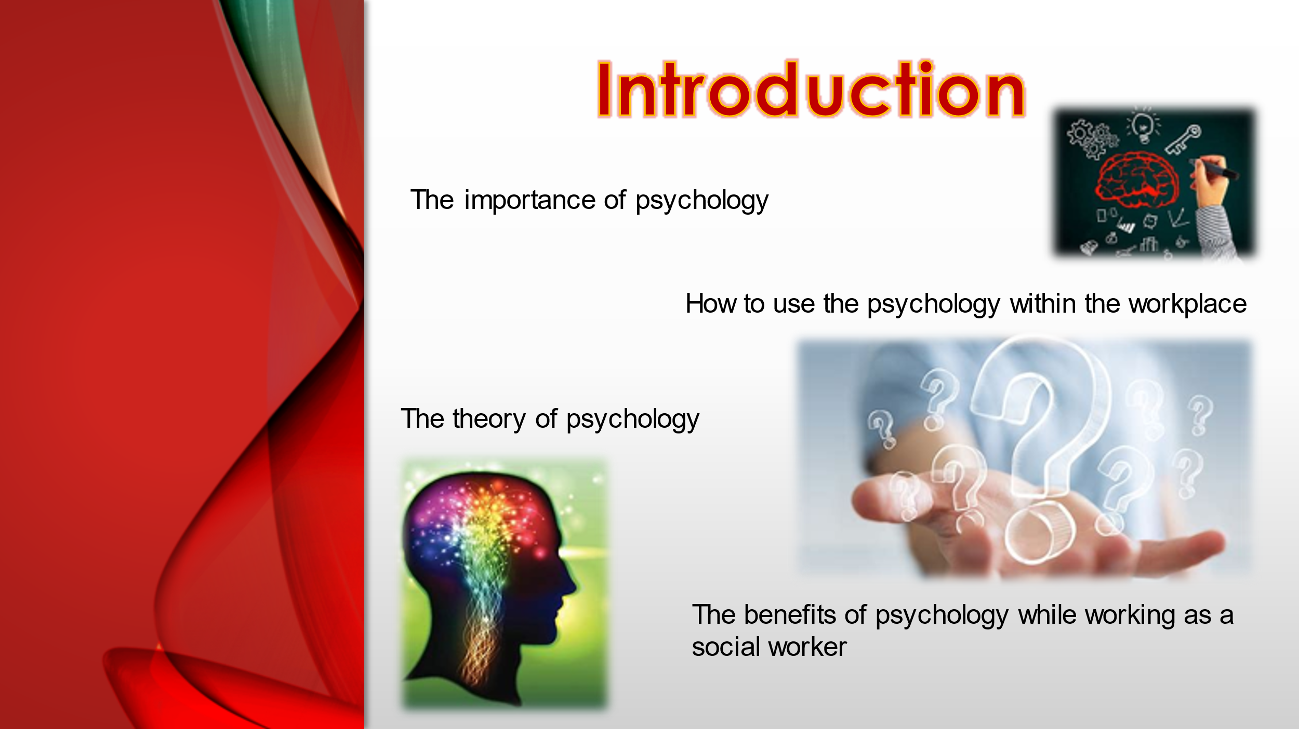
The introduction talking about what would be in the presentation and why it is important.
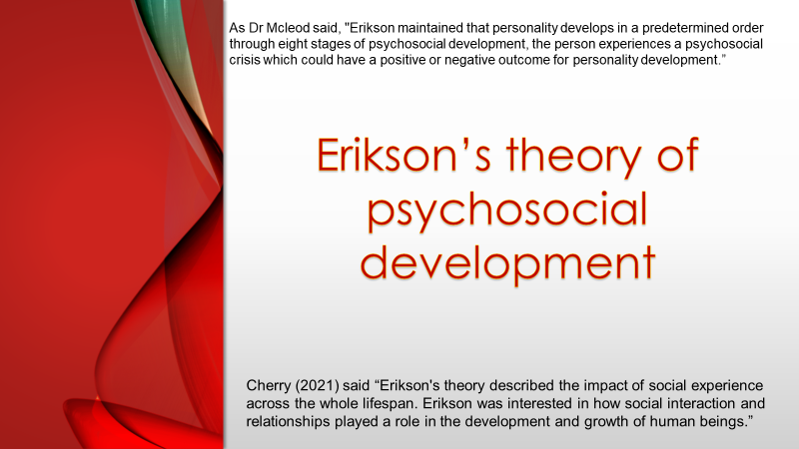
The theory I have chosen is Erikson’s theory of psychosocial development because as I did my research regards this theory I felt like this theory had more similarly to a social worker would required and how this can help.
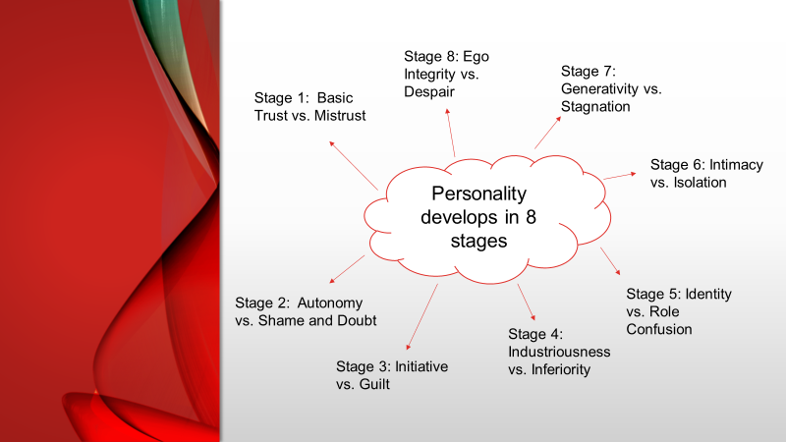
The different stages of personality develop.
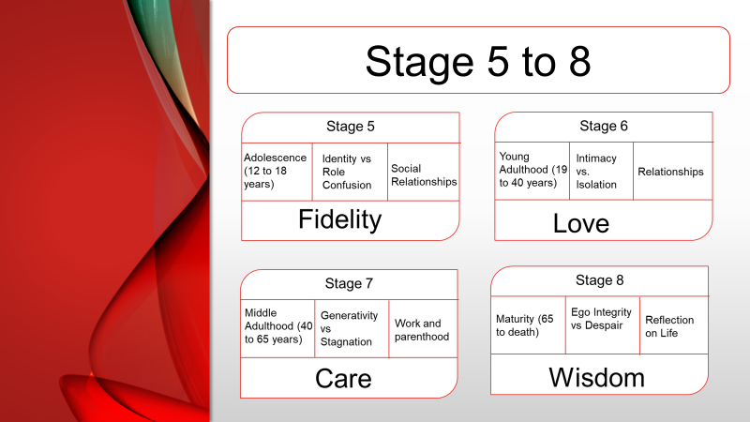
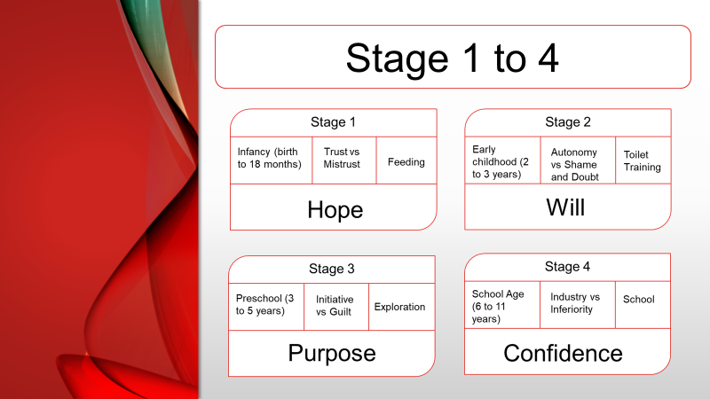
Stage 1 to 4 is for young children around the ages of from birth around the age 11 years.

Stage 5 to 8 around for children who are around the age from 12 up till becoming adults and elderly age 55 plus, mainly focusing on teenagers and adults.


