3/24/2025
University of Wales Trinity Saint David
London campus
E-Portfolio Link: https://macgogo90s-e-portfolio.editor.wix.com/edit/od/4b8ba69b-94b6-4bac-85aa-8515ff91da64?metaSiteId=cd16a90b-b279-4eaf-bbdf-db05ea977819&editorSessionId=f5accb22-961d-40dc-bda7-c0e70323a383
Module Name: Learning In the Digital Era
Module Code: ACCA 4025

Student Name: Makawe Alsir
Student ID: 2513347
Group: 1

Lecturer’s Name: Fernando

LDE Assignment 1
E-Portfolio
Table of Contents
Introduction 2
Main Body 2
Task 1: Essential Academic and Employment Skills for the future career Path 2
Task 1 (a): Report on Essential Academic and Employment Skills 2
Task 1 (b): Evaluation of Task 1 (a) based on Similarity report 2
Task 2: Collaborative Mind Map and Individual Poster 2
Mind Map (Collaborative) 2
Poster (Individual) 2
Task 3: Virtual Collaboration and RefWorks 2
Report on Virtual Collaboration 2
Step-by-step process of using RefWorks with visuals 2
Task 4: E-Portfolio Creation and Evaluation 2
Task 4 (a): E-Portfolio Creation 2
Task 4 (b): Illustrative Review of E-Portfolio tool Selection 2
Conclusion 2
References 2
Task 1 References: 2
Task 3 References: 2

Introduction
​In today’s rapidly evolving professional environment, it is essential for students to develop both academic and employability skills to succeed in their future careers. This assignment explores key academic and employment skills, collaborative learning techniques, virtual collaboration tools, and the development of an e-portfolio. It also reflects on the importance of digital tools such as RefWorks and highlights how these skills contribute to personal and professional growth.

Main Body

Task 1: Essential Academic and Employment Skills for the future career Path
(a): Report on Essential Academic and Employment Skills
Academic and employment skills are fundamental for achieving success in both education and professional life. Academic skills refer to the abilities required for effective learning, while employment skills focus on workplace performance.
Academic skills include time management, research abilities, critical thinking, and academic writing. Time management helps students meet deadlines efficiently, while research skills enable them to gather accurate and relevant information. Critical thinking allows individuals to analyse problems and make informed decisions, and academic writing ensures clear and structured communication of ideas.
On the other hand, employment skills are essential for functioning effectively in a professional environment. These include communication, teamwork, problem-solving, and digital literacy. Communication skills help individuals express ideas clearly, while teamwork enables collaboration with others to achieve common goals. Problem-solving skills are crucial for addressing challenges, and digital literacy is increasingly important due to the use of technology in modern workplaces.
In conclusion, both academic and employment skills are essential for career development. Developing these skills enhances employability and prepares individuals for future challenges.

Task 1 (b): Evaluation of Task 1 (a) based on Similarity report

The similarity report was used to evaluate the originality of this work. The results indicated that the majority of the content is original, with only minor similarities due to commonly used phrases and referenced materials. Proper citation and referencing techniques were applied to avoid plagiarism. This process ensured academic integrity and improved the overall quality of the assignment.

Task 2: Collaborative Mind Map and Individual Poster
The collaborative mind map was developed to illustrate essential skills required for career success. The central theme focused on “Essential Skills for Career Success,” with branches covering academic skills, employment skills, and digital skills.
Academic skills included research, writing, and critical thinking. Employment skills focused on communication, teamwork, and problem-solving. Digital skills included knowledge of tools such as Microsoft Office and online collaboration platforms.
This activity encouraged teamwork and idea-sharing among group members, enhancing collaboration and understanding of key concepts.

Mind Map (Collaborative)

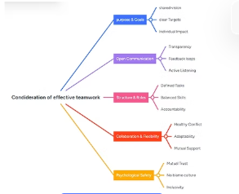

Poster (Individual)

The individual poster was designed to visually represent key employability skills. The poster included important skills such as communication, teamwork, digital literacy, and problem-solving. It used simple text and visual elements to effectively convey the importance of these skills in achieving career success.
This task helped improve creativity and the ability to present information in a clear and engaging way.

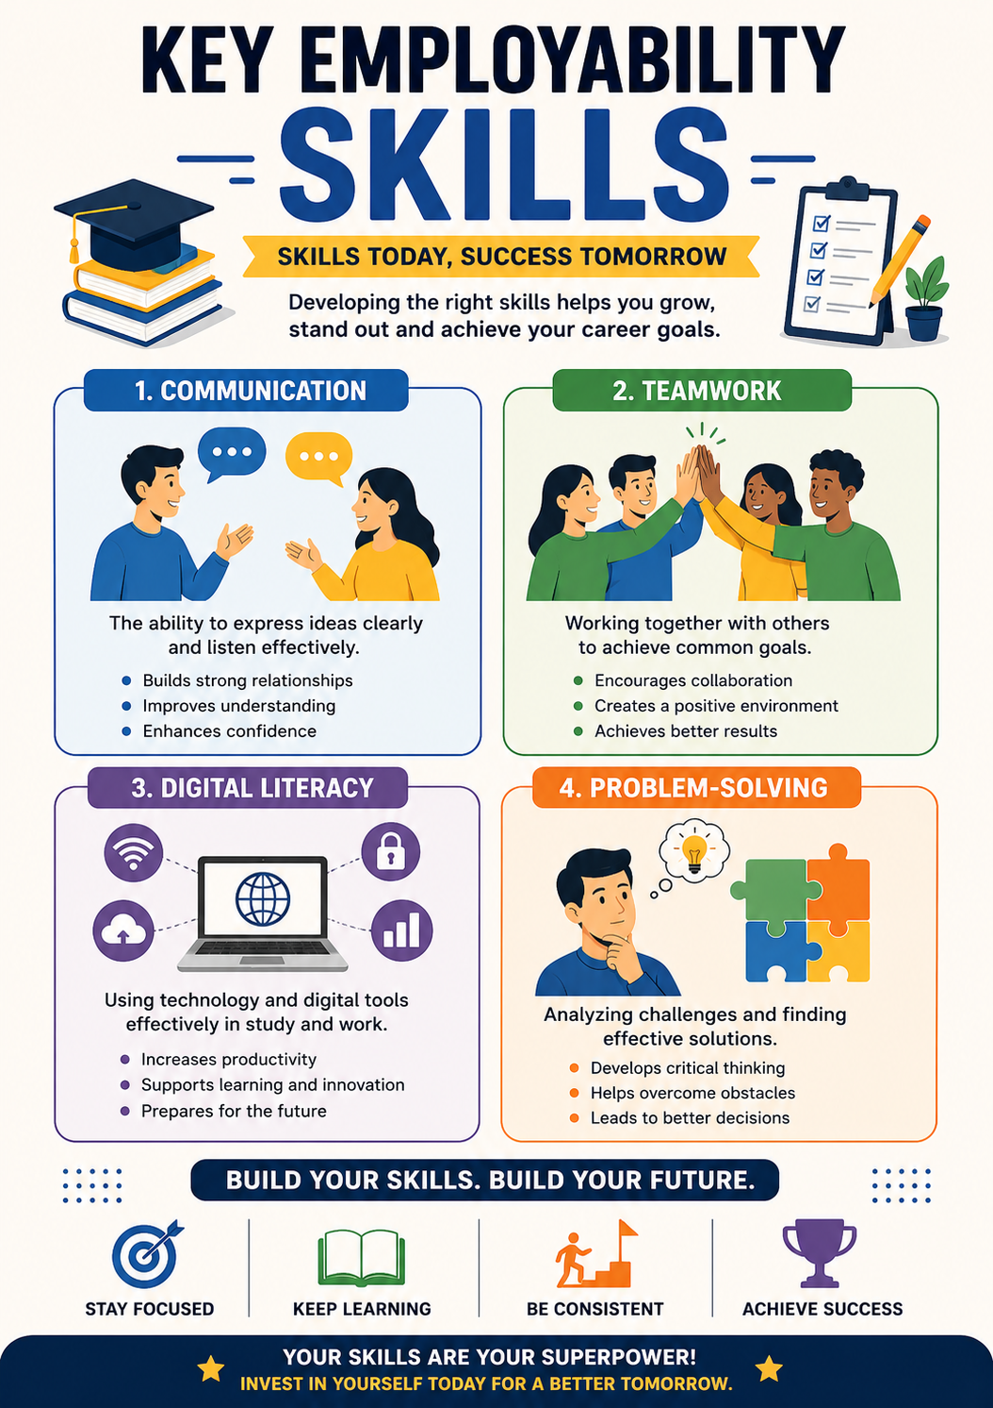

Task 3: Virtual Collaboration and RefWorks
Virtual collaboration refers to working together using digital platforms and online tools. During this assignment, tools such as Zoom, Microsoft Teams, and Google Docs were used for communication and collaboration.
Virtual collaboration allowed team members to share ideas, work on documents simultaneously, and stay connected despite physical distance. It improved communication skills and teamwork. However, some challenges were faced, such as internet connectivity issues and scheduling conflicts.
Overall, virtual collaboration proved to be an effective method for completing group tasks and developing digital communication skills.

Report on Virtual Collaboration
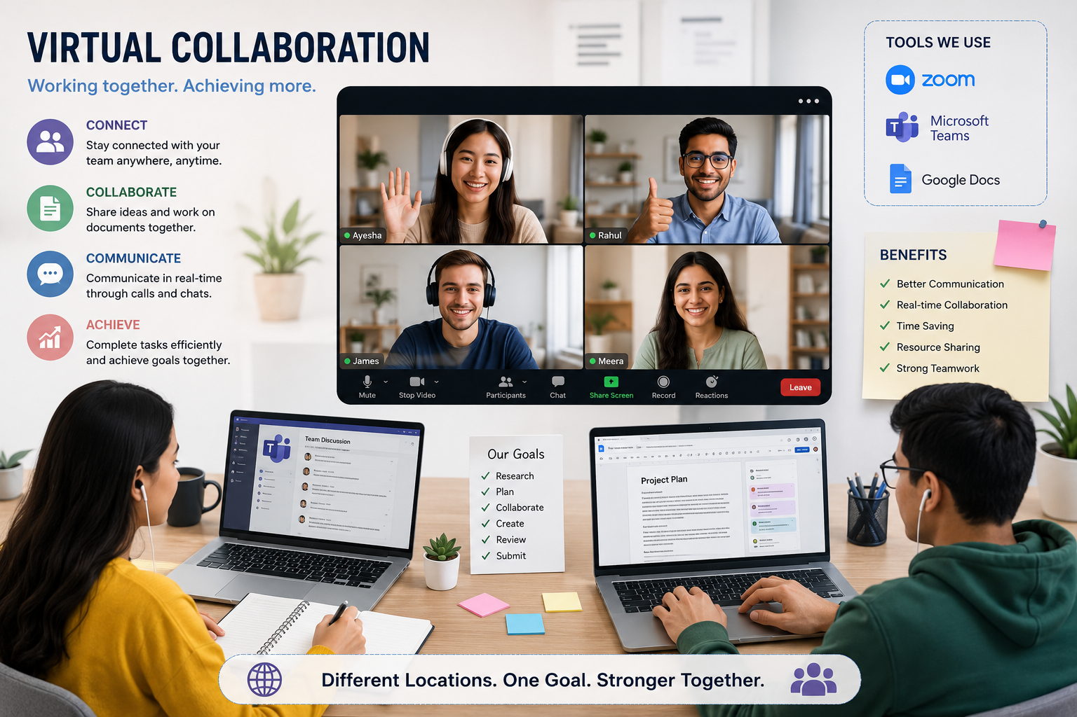

Step-by-step process of using RefWorks with visuals

Step 1:
RefWorks website log in into account.

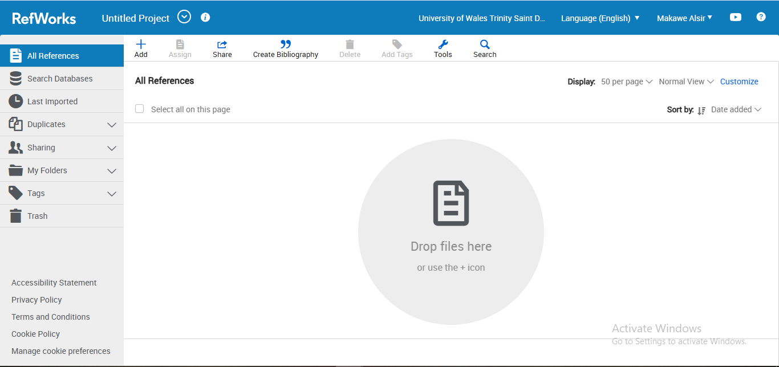

Step 2:
Creating a folder or a project to organize references.

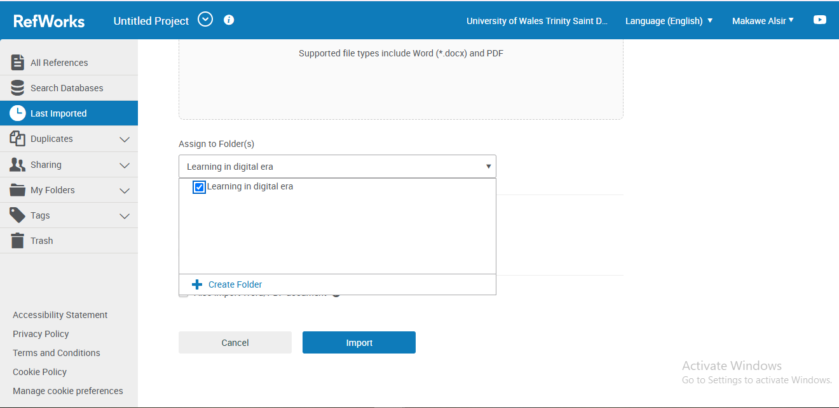

Step 3:
Add references manually or import them from academic databases such as Google Scholar.

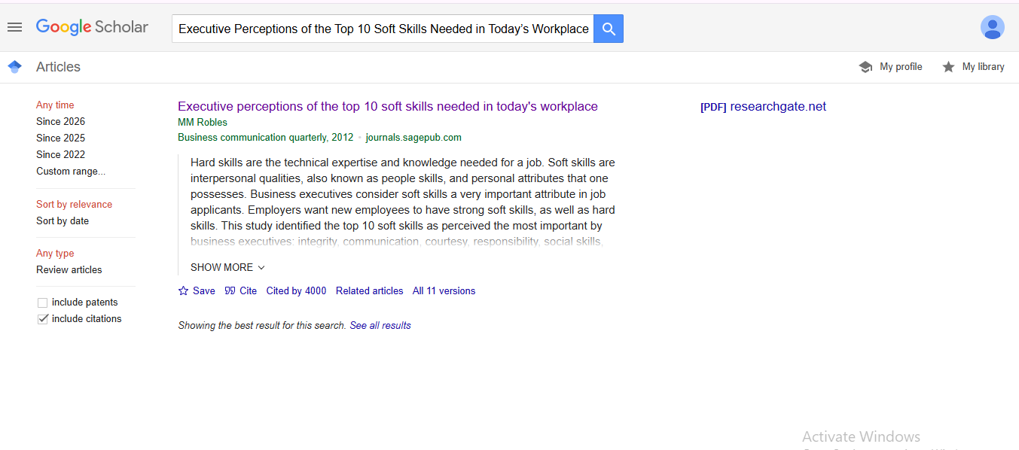

Step 4
Generate citations

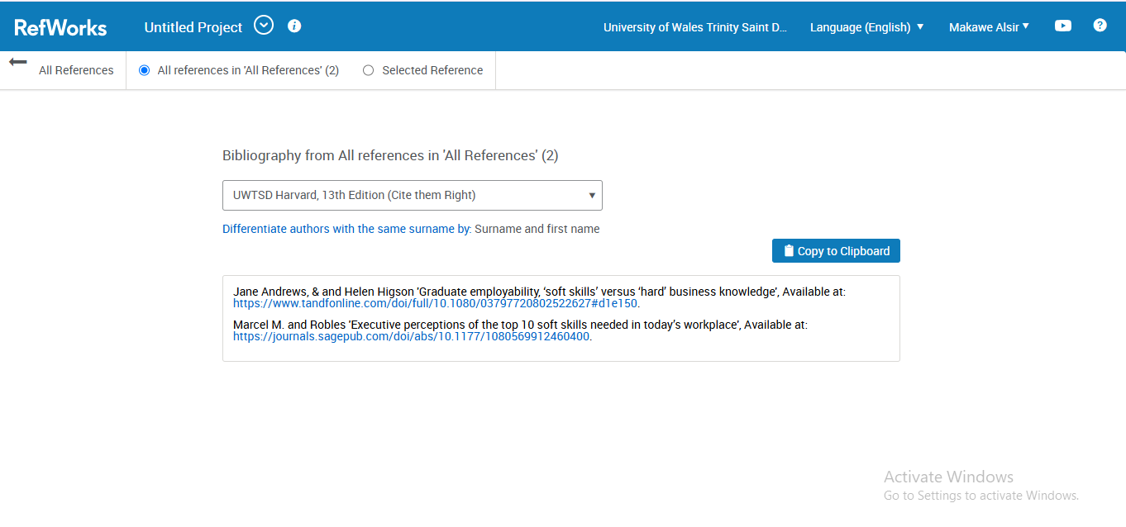

Task 4: E-Portfolio Creation and Evaluation

Task 4 (a): E-Portfolio Creation
The e-portfolio was created to showcase academic achievements, skills, and personal development. It included sections such as personal profile, skills, projects, and reflections. The portfolio was designed to present information in a clear and professional format.

Task 4 (b): Illustrative Review of E-Portfolio tool Selection
The selected e-portfolio tool was user-friendly and allowed easy customization. It provided features for organizing content, adding multimedia elements, and presenting information effectively.
One of the main advantages of the tool was its accessibility and flexibility. However, some limitations included restricted design options and limited storage capacity.
Overall, the e-portfolio serves as a valuable tool for demonstrating skills and achievements, making it useful for both academic and professional purposes.

Conclusion
In conclusion, this assignment has highlighted the importance of academic and employment skills in achieving career success. It also emphasized the role of teamwork, virtual collaboration, and digital tools such as RefWorks. The development of an e-portfolio further enhanced the ability to present skills and achievements professionally. These experiences contribute significantly to personal and professional growth.

References

Task 1 References:
- Jane Andrews, & and Helen Higson 'Graduate employability, ‘soft skills’ versus ‘hard’ business knowledge', Available at: https://www.tandfonline.com/doi/full/10.1080/03797720802522627#d1e150.
- Marcel M. and Robles 'Executive perceptions of the top 10 soft skills needed in today’s workplace', Available at: https://journals.sagepub.com/doi/abs/10.1177/1080569912460400.
- Steve Wheeler Learning with e's: Educational theory and practice in the digital age.

Task 3 References:
- https://scholar.google.com/
- https://refworks.proquest.com/
- ​https://www.youtube.com/watch?v=AvuhX1TbVe4

