

The factors associated with youths committing crime in today’s society and are environmental upbringing an issue?

Name of student: Roxanna Rees
Student number: 2029460
Degree title: BSc (Hons) Policing and Criminology
Word Count: 8699

Acknowledgements
I'd like to express my gratitude to everyone who has helped me with my studies and has given me advice when I've felt like giving up. I've been able to do informational research and present arguments for and against academic publications.
Finally, I want to express my gratitude to my parents, husband, and family for supporting me during my time at university. They have been incredibly supportive of my professional career choice over the past three years and continue to do so.

Declarations:
This work has not previously been accepted in substance for any degree and is not being concurrently submitted in candidature for any degree.
Signed: R.Rees
Date: 02/01/2024

STATEMENT 1
This dissertation is being submitted in partial fulfilment of the requirements for the degree of BA.
Signed: R.Rees
Date: 02/01/2024

STATEMENT 2
This dissertation is the result of my own independent work/investigation, except where otherwise stated.
Other sources are acknowledged by footnotes giving explicit references. A bibliography is appended.
Signed: R.Rees
Date: 02/01/2024

STATEMENT 3
I hereby give consent for my dissertation, if accepted, to be available for photocopying and for interlibrary loan, and for the title and summary to be made available to outside organisations.
Signed: R.Rees
Date: 02/01/2024

STATEMENT 4
I hereby give consent for my dissertation, if accepted, to be available on the university’s IT system to those who have consent to use the system.
Signed: R.Rees
Date: 02/01/2024

Abstract
The purpose of this dissertation's research is to examine recent studies on young people who commit crimes and the reasons behind them. To meet the objectives that are needed, a comparison between youth crime in the 19th century and today's society will be made. In the process of performing this study, it will also look into the literature that has been written about adverse childhood experiences and whether environmental factors have a role in why young people commit crimes.
Completing this study will contribute to the understanding of the elements that influence young people to commit crimes as well as the collection of raw data through a survey asking participants about their knowledge, facts, and opinions surrounding ACEs and a child environment.
A questionnaire has been constructed around the factors and research data that is available to the public to ask questions to obtain answers based on opinion and knowledge by Police officers and Police community support officers when they have had contact with youths.
It has been found that although research believes that youth crime is decreasing according to the Youth Justice Board (2023). Participants who have completed a survey believe that it is escalating. A comparison to the facts presented by the Youth Justice Board and participants it has shown that the crime youths are committing have escalated in violence compared to the 19th century where it was mainly thefts. It has also found that there is a link to environmental factors in society and ACEs on why youths are committing criminal offences.
This dissertation has concluded that there needs to be further support and research for youths and parenting to reduce children becoming subjective to ACEs as this can be prevented. It also concludes that by preventing children being exposed to ACEs, it would help prepare them to a better start in life and would reduce the risk of them committing crime.

Table of Contents:
Chapter one Introduction
1.1 Introduction Page 7
  - Background Page 7
1.3 Aim and objectives Page 8
1.4 Rationale Page 9
1.5 Structure Page 9
1.6 Conclusion Page 10
Chapter 2 Literature review
2.1 Introduction Page 11
2.2 Common Crime Committed by Youths from the 19th Century Page 12
2.2 .1 Victorian Crime Common Ages and offences Page 13
2.2 .2 Victoria Punishment Page 13
2.3 Crime being Committed by Youths in Today’s Society Page 14
2.4 What are Adverse Childhood Experiences? Page 16
2.4 .1 Environmental factors of ACEs Page 16
2.4 .2 Reducing ACEs early on Page 19
2.5 Conclusion Page 19
Chapter Three – Methodology
3.1 Introduction Page 21
3.2 Research onion Page 22
3.3 Philosophy Page 22
3.4 Research strategies Page 23
3.5 Methods and Design Page 24
3.6 Time Horizons Page 24
3.7 Techniques: Data collections and Analysis Page 25
3.7 .1 Data collection Page 25
3.7 .2 Data Analysis Page 25
3.8 Limitations Page 25
3.8 .1 Ethical considerations Page 26
3.9 Conclusion Page 26
Chapter Four - Analysis of results
4.1 Introduction Page 27
4.2 Data Analysis Page 28
4.3 Method of Analysis Page 28
4.4 Analysing the results Page 28
Conclusion Page 31
Chapter Five - Conclusion and recommendations
5.1 Conclusion Page 33
5.2 Recommendations Page 35
Appendix Page 36
Bibliography Page 51

Chapter one – Introduction
1.1 Introduction
The aim of the research is to analyse the different types of crimes youths are committing today and an evaluation of whether society is responsible. Throughout this research a comparison between historic crimes youths were committing to show whether a child’s environmental surroundings are a factor.

1.2 Background
Back in the 19th century, children were known to pickpocket and commit thefts (Walton, 2013) compared to the 21st century. The type of crime has escalated to serious assaults and knife crime, and it is also believed that society and environmental factors are responsible for this escalation. Analysing data over the past years and the awareness of adverse childhood experiences have created a link where a child who has experienced 4 or more ACEs are more likely to have committed a crime. As the Public Health Wales (No Date) states that ‘adverse childhood experiences can make children more prone to struggle academically and become involved in crimes both as victims and perpetrators. There are people who have repeated traumas as children often bring up their own children in households where instances of trauma are more frequent. A pattern of suffering during childhood can cause generations of families to become ill or participate in antisocial behaviour’.
Since the 21^{st of} March 2022, new legalisation has come into place by the Welsh government. This legalisation has been made under Children (Abolition of Defence of Reasonable Punishment) (Wales) Act (2020) which now prohibits the reasonable chastisement defence for assaulting a child.
Safeguarding Wales (2022) welcomes the new legalisation and has stated that by prohibiting physical punishment of children by parents, carers, and others acting in a parental capacity within Wales, including visitors to Wales, the Children Wales Act seeks to safeguard children's rights. Children in Wales will now receive the same level of legal protection against assault as adults.
This change will now encourage parents and carers to use positive parenting techniques and to decrease the use and acceptance of physical punishment of children in Wales (Safeguarding Wales, 2022). By this change being implemented, it may now reduce a child’s ACEs and reduce the risk of committing violence crimes in the future as research suggests. The change to the law is new and because it is new there is now a gap in research on whether the change in law will impact on the types of crimes youths will have been committing in today society compared to the 19th century.
Youths are most commonly known to committing anti-social behaviour like criminal damage or being drunk and disorderly in the community for example that is low level (Berry, no date). This does have a negative impact on the communities, but these youths can see this as fun. However, there are more serious crimes children are committing which is worrying. The BBC (2019) reports that knife crime is on the rise with youths between the ages of 10-17 years old. Could this be down to peer pressure? According to The Conversation (2020), "young people who spend the majority of their time with their peers." If a young person's family or other students don't believe that committing a crime is wrong or don't feel sorry for the victims of that act, then it's unlikely that their feelings will be affected and are unable to acknowledge the impact of their actions to those victims.
Research is needed to conduct investigation on whether parents of the youths need educating in their parenting to reduce youths committing crimes.

1.3 Aim and objectives
The aims and objectives of this research project is to study and review existing research in relation to why youths are committing crime and whether their upbringing in society is responsible. By conducting this research, an evaluation of the gap in research of the recent law changes and whether this change will make changes to a child’s ACEs and this will draw a conclusion on the research topic.
The aims and objectives will be achieved by completing the following below:
- Evaluate the types of crime youths are committing in society.
- Assess the impact ACEs have on individuals.
- Evaluate youths’ environmental factors when they have committed a crime.

1.4 Rationale

The circumstances surrounding the researcher's own rationale for undertaking this independent project are regrettably related to the growing number of instances that have been seen to have happened during their career and as well while out in public.
Whilst witnessing youths being out in the community and having witnessed youths being exposed to crime whether this is as a victim or as a suspect. There are also a growing number of concerns for children living conditions and the environments that they are residing in the community. Hotspots are being identified in communities where there is high level of youth crime, and they may have adults with them. This is not responsible parenting, therefore exploring the topics in the changing society alongside the crimes youths are committing will provide an investigation into statistics.

1.5 Structure

To ensure the study is successful and the objectives are completed, each chapter
will provide a structure to ensure that each objective is completed in a chronological order.
Chapter two of the dissertation will analyse and evaluate previous and current research on the different types of crime youths were committing back in the 19th century and the crimes that they are committing in today society. Secondly an evaluation of the current studies that has been conducted on adverse childhood experiences (ACEs) have on individuals and linking it to those who have committed criminal offences.

Chapter three will make an effort to ascertain and is going to determine the most suitable approach and research procedure for gathering primary research for this study.

Following that, chapter four will examine the data that had been collected as a direct result of the proposed method that was presented in chapter three, in search of similarities or observations that may be obtained from the research project. By comparing the raw data collect to data accessibly available online through the government websites and opinions of those who have written online journals.

Lastly, chapter five will be concluding the research for the dissertation and will ensure that all objectives have been achieved.

1.6 Conclusion
The dissertation's first chapter has been successfully finished. The background information and the kinds of resources this investigation would use have been provided. The dissertation's use of structure will give readers a structured answer that highlights each title topic. The researcher will use the clearly stated aims and objectives to make sure that they are adhered to during the course of this investigation.
The researcher came up with the research title after witnessing recurrent situations in the community and at work affecting young people. Investigating this subject will provide a thorough understanding of youth crime and a comparison with crime in the 19th century, where social and environmental conditions were different.

Chapter Two - Literature Review
2.1 Introduction
This chapter for the dissertation literature review, will study the current research that has gone into adverse childhood experiences and the link into the risk of crime being committed into adulthood. However, it is believed that there needs to be research on whether youth crime has escalated over the years due to society and environmental factors compared to the 19th Century.
To conduct this research there will be an analysis of the statistics of the type of crime that is being committed by youths on the government webpages and comparing it to historic data to be able to identify a change if any and what has changed? It will also look at what is currently in place to reduce re-offending to those who are coming into contact with the youth justice system and is this working. By conducting these studies, it may identify further factors that may need to be addressed to prevent offending youths.
An evaluation of a child upbringing by the use of online blogs resources like, Region Security guarding (2022) have said that ‘The most important role models in a child's life are their parents. Children who have parents who are positive role models and who develop trustworthy connections with them are less likely to commit crimes. This entails accepting the same ground rules, being able to work through issues, and showing support for one another’. Bateman (2020) has conducted research on why youths are committing crime, and she agrees that youths spending time with someone who provides strong morals can become law abiding citizens. Whilst this can be agreed by opinion, research will be collected to evidence this.
All data that has been accessed will contain information from a variety of sources that is available online through the government websites, google scholar, journals and the University of Wales Trinity St. David itself. By accessing the data that is publicly available to conduct this research will complete the objectives that have been highlighted for the research.

2.2 Common Crimes Committed by Youths From the 19th Century.
Back in the 19th century, in the Victoria stages, children did used to commit what we call in society today, low level crimes. These would mainly include thefts or what they know as pickpockets. In those times, adult men who engaged in pickpocketing themselves would often recruit orphans, children, or the extremely impoverished (Walton, 2013). Pickpocketing and thefts are not something that these kids discovered on their own (Walton, 2013).
The National Achieve (2021), have posted a video onto YouTube, reporting on a child called Joseph Chapman from back in the 19th Century. They reported that Joseph was a 12-year-old boy who appeared to be under nourished and this was believed because of his height and weight.
According to information found on The National Achieve (No date) website, Joseph was sentenced to six weeks of hard labour and sent to a child reformatory after stealing a chicken as a punishment. This was a school for kids with a criminal conviction, where they would learn trade skills or military training to prepare them for the army. In Joseph's instance, he was sent to Cornwall on a school ship for the training. This was a terrible place to be for a child because there was no incentive for them. This was not Joseph first time of being convicted from a crime as he had already been found guilty of stealing peas and for his punishment, he was whipped as retribution for this crime.
Another similar case was located in The National Achieve (no date) website for another child called John Green. He was 11 years old when he was convicted for stealing gooseberries and has had previous convictions for stealing coal. John Green punishment was very similar to Josephs, this was being whipped and being sent to complete hard labour work. Both of these children have a common theme to their crimes as they have both committed theft, and the potential poverty reasons for committing the crime. It is also clear that according to the ACEs provided by Help Children Live Better (2020) that they have experienced physical abuse and The Scottish Government (2018) have highlighted that children who live in in safer, low-poverty neighbourhoods are protective against offending.

2.2 .1 Victorian Crime Common Ages and offence
A 19th-century Victorian handwritten document is displayed below, courtesy of a publication by The National Achieve (no date). This document in appendix 2.2 .1 demonstrates that the individuals underlined have been involved in stealing crimes involving youngsters as young as 13 years old. Unfortunately, the children who committed the same offences as Joseph and John received the same punishments, as it was thought appropriate to do so.
2.2 .2 Victorian Punishment
Rather than children being placed in workhouses, who were thought to be susceptible of becoming rebellious due to neglectful or criminal parents, were sent to industrial schools. Approximately, nine thousand children were admitted yearly to industrial schools between the mid-1850s and the end of the 19th century, while a further 1,000 children were admitted yearly to reformatories, as per the annual judicial numbers analysed by Godfrey (2017) and his colleagues.
Those institutionalised children had relatively low rates of reconviction on average. Only 22% of children that spent time in reformatories and industrial schools committed crimes in their adult life after being released, and only 2% of them committed more than one crime after being released and when looking at their entire lives (Godfrey, B, 2017). This indicates that although the punishment for committing crime back in the 19th century can be deemed as cruel and excessive, statics are saying it has reduced reoffending.

2.3 Crime being Committed by Youths in Today’s Society.
Youth crime is referred to as children engaging in criminal activity. These acts for children tend to be handled swiftly, and education is offered to deter future offences (Region Admin, 2022). Youth cautions for offences such as violence against a person, robbery, and weapon possession have increased in number in recent years according to Region (2022).
Region Admin, (2022) are not the only person to believe that this is an ongoing issue with youths and that youth criminal activity will have a major adverse effect on young people's quality of life, education, and employment prospects. As The Scottish Government (2018) have reported that, the victims of these crimes are typically innocent and frequently suffer the consequences of the perpetrator’s actions, which may change their lives in addition to having an impact on their own. Children and adults are being treated differently by the criminal justice system, have the power to hold those responsible, to be accountable for their actions (Region Admin, 2022).
Evaluating data from the last couple of years from Youth Justice board (2023), it displays that children are still engaging in crimes of theft, but they are also engaging in more serious criminal offences such as knife crime, serious assaults, criminal damage, and drug and alcohol usage.
However, the most recent statistics that is available from the years 2021 and 2022, show that youth crime is decreasing, and it is believed that this could be a result of protective measure being put in place to reduce a child ACEs. At present between the years of 2021 and 2022, according to the Youth Justice board (2023) there were 13,800 children convicted of crimes in England and Wales between the ages of 10-17 years old. This has fallen by 79% over the last ten years. In more serious crimes like knife and offensive weapon crimes committed by children has also decreased by 3% since the end of March 2012 as shown in appendix 2.3 (Youth Justice Board, 2023).
The greatest rise was in sexual offences, which increased by 64% from around 1,700 to almost 2,900 over the previous year. Followed by an increase in arrests for offences involving violence against the person and weapon possession which had increased by 18% and 15%. Drug and fraud offences arrested also decreased by falling 20% from the previous year (Youth Justice Board, 2023) as show in the graph below. Whilst there is improvement on crime statistics in youths, it is still concerning that children are committing those offences and are having an impact on the community.
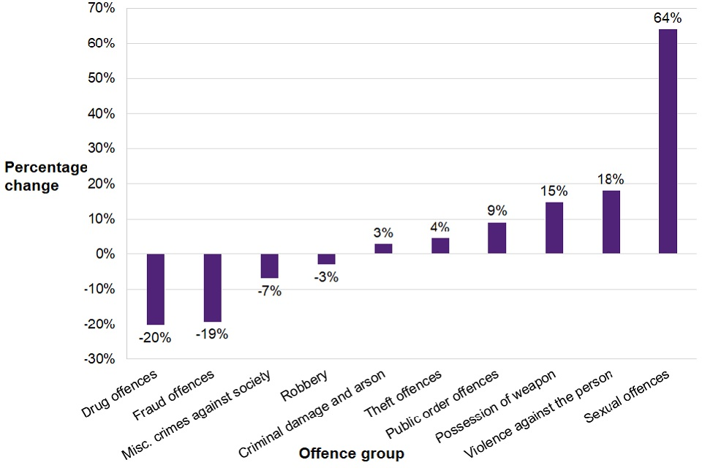

Back in 2019, there have been two incidents in the South Wales Police area which impacted the community. These were the Ely, and Mayhill riots. According to the police and media, many of the people involved in these disturbances are young adults who, like The Conversation (2019) implies in their piece, these individuals showed little concern for other people's safety or empathy. A judge has detailed the disorder's effects on the community, including harm to the community's reputation and effects on children, and a total of 27 people between the ages of 15 and 44 were charged with charges related to the riot, according to BBC News (2022). This has not provided children in those communities with the correct role modal in society, and this has exposed them to fear of violence crimes.
Though these areas highlighted are known to be areas where there is a high level of social housing and are known as socially deprived as Swansea Council (2023) have concluded in their review. Social deprivation refers to the inability of individuals or communities to obtain essential necessities such as work, money, housing, and services for a decent life. It is believed that ACEs may well be a factor. The different types of ACEs and impact these could have are detailed below.

2.4 What are Adverse Childhood Experiences?
Wisner (2022) has defined ACEs as adverse childhood experiences that happen to any child under the age of eighteen. A child that has experienced ACEs, could have lasting impacts on their general welfare, physical health, and mental health of children growing into adulthood. This means that, negative childhood experiences, or ACEs, are events that any child under the age of eighteen can encounter. The overall well-being, physical and mental health of children and young adults who have undergone Adverse Childhood Experiences (ACEs) may be permanently impacted.
The majority of people at some point in their life, have at least experienced one ACE and will have a link to some sort of criminal offence, regardless of whether they were convicted or not. These are listed below from Help Children Live Better (2020):
- Physical neglect
- Emotional neglect – emotionally unavailable
- Separation from parents due to mental health, death, illness, war etc
- Psychological abuse
- Sexual abuse
- Living with domestic abuse
- Mental illness within the household
- Parents separation or divorce
- Substance misuse
- Parent in prison or involvement with the police
- Different caregivers and inconsistent care
Scott (2020), cited in Bellis et al., 2014b that greater ACE scores have been linked with less favourable outcomes when it comes to education and employment. This has been collaborated in a report by the NHS Scotland (2017) and cited in Scottish Alliance for Childrens rights (2016) who report that childhood trauma has been linked to decreased educational performance, problems with mental and physical health, as well as difficulties in adult relationships—all of which are important contributors to poor financial consequences. Compared to their peers, children who experienced abuse and trauma will perform worse in school. A child who has gone through fear and helplessness from events outside of school finds it difficult to concentrate and study at the same level as other kids. Problems at home such as drug or alcohol abuse, homelessness, physical or mental illness, and children's caregiving duties can all have an impact on a child's education. It may be especially challenging to make it to school rested, fed, clothed, and focused because of those additional difficulties.
There is also a link that ACEs could increase the risk of those committing criminal offences, as Help Children Live Better (2022) have stated that those people with 4 or more ACEs are two times more likely to drink alcohol to an excessive level, seven times likely to participate in violence acts and criminal activities, they are eleven times more likely to end up with a custodial sentence from being involved in crime, there is also the higher risk of up to eleven times more likely to use recreational drugs, they are four times more likely to have engaged in sexual activity by the age of 15 years old.
In addition, there are negative health effects to consider. Individuals who have had four or more ACEs are four times more likely to have experienced a mental illness, eighteen times more likely to attempt suicide, and three times more likely to start smoking as adults or children, increasing their risk of lung and liver disease. Finally, there is a three times increased risk of heart disease, respiratory disease and type two diabetes (Help Children Live Better, 2022).
2.4 .1 Environmental factors of ACEs
A child’s environmental factors have an input on why there is an increased risk of them committing crime and being exposed to ACEs. ACEs don't just happen to people, for example a child's upbringing in a deprived area in society can be a factor, the family structure and morals they may have, and economic standing are all factors of potential ACEs as (Wisner, 2022) reports.
There are a large number of environmental factors which may lead to a child experiencing an ACE. Wisner (2022) has highlighted some examples in her journal, these examples include that a child coming from a low-income family, not having a close connection with their family members to speak about feelings, living in a community with high rates of violence or living in a socially deprived community where there are very few activities for children to do, for example parks and youth clubs. There may also be high levels of drug use in the area on where they live and being a victim of violence and/or being physically abusive to others themselves. This has also been supported by The Scottish Government (2018) who have also reported online a summary of the links between ACEs and criminality into adulthood.
The Welsh Government (2022) abolished the defence of reasonable punishment in March 2022 after realising the effects that physical abuse in the family home may have on children who experience it or witness it. Due to this change, children now have the same rights as adults; before this change in legal history under The children Act, it was lawful to abuse a child and use the justification of "reasonable punishment."
Although there has been a change within the law on assaulting children compared to the 19th Century where it was acceptable to physically assault a child and that it was often used as punishment. Adults are now needing to be educated on how to discipline children correctly. The damage has already been done in today society and it appears that children that are being born now to young parents, we will only see minor changes to children being exposed to one ACE factor. This still does not stop children witnessing domestic violence and being exposed to violence in their community or the other ACEs.
Region Security guarding (2022) and another source Bateman (2020) have made an opinion that ‘‘The most important role models in a child's life are their parents. Children who have parents who are positive role models and who develop trustworthy connections with them are less likely to commit crimes. This entails accepting the same ground rules, being able to work through issues, and showing support for one another’’. Furthermore, The Scottish Government (2018) have also highlighted that a strong attachment with a parent or carer, a stable family structure and parental style are all protective factors in reducing offending.
2.4 .2 Reducing ACEs early on.
Not all individuals who have endured a difficult or traumatic upbringing goes on to commit crimes or become victims of them. The Scottish Government (2018) have expressed that it is important to understand why some children succeed in life, despite being exposed to negative early experiences. By having protective factors in a child life, can reduce the impacts of childhood trauma and adversity. This will allow children to realise their full potential, reducing the likelihood of victimisation, criminality and to succeed in life.
That being said, The Scottish Government (2018) have said that resilience factors have been identified in ACEs research into a mental health and criminological research are similar in nature. For example, children that are living in safer neighbourhoods with low levels of poverty and social deprivation, could be seen as a positive and protective factor for mental health, offending and victimisation. Secondly, it also highlights those children having positive peer interactions in the community and in school will also benefit in developing new skills and being part of a thriving community. Lasty, positive parenting is by having a strong relationship bond with a child, providing a stable family life structure, correct supervision and being readily available to a child will also show a positive attitude to the child to develop the correct life skills and to keep them away from being exposed to criminal life. These are all factors in reducing a child being exposed to ACEs.

2.5 Conclusion
It is evident that ACEs have been involved since the 19th Century and this has been identified by the circumstances around the child life when they have committed the offence of theft. Every day, babies are born unaware of the potential of being exposed to ACEs. It is clear from evidence that child would picked up their behaviour from their caretakers, and there are environmental elements that have contributed to their criminal activity. Why would children be stealing food? The more intelligent way to answer this question was because they were hungry. They may have well been experiencing neglect from their caregivers and their basic needs of life were not being met. There is also the potential that they may have been experiencing poverty and needed warmth, which could be the reason why they have stolen coal.
It is similar in today society, children are still committing thefts, but also as technology has advanced since the 19th century and the country economic status has increase, this has made way for other crimes come to light for example, malicious communications and drug use. Research has been conducted on the link of ACEs and crime, which has also taken into the account the environmental factors.
It is clear that having reviewed research by utilising sources like Help Children Live better (2022) have reported, it has shown that the higher the number of ACEs a child has, they are at risk of developing physical health related issues and an increased risk of being involved in crime. They have also concluded that the research that has been conducted, has informed them that a child with four or more ACEs are more likely to engage in risk taking behaviours and crime.

Chapter Three - Methodology
3.1 Introduction
In this chapter, a questionnaire/survey will be produced and accessible to police officers and Police community support officers (PCSO) to answer a
A multiple-choice survey regarding the knowledge already acquired through experience. It is thought that Police community support workers, who frequently deal with disruptive conduct among young people, and Police officers who handle more serious criminal situations involving youth, are the best participants to recruit for primary data.
Secondary data will be gathered by use of government websites for statistics and other sources like news articles and journals that have already conducted research into adverse childhood experiences as they have already obtained the link between criminality and ACEs. Evaluating this data would gain a further understanding on the changes of society and conclusion will be obtained.
By actioning this, it should be able to identify what experiences they have had when dealing with youth crime and whether they could identify ACEs. By comparing and evaluating research data and raw data, it can ascertain whether youth crimes have environmental factors prior to committing a crime.

3.2 Research onion
When developing a research methodology, there are many decisions to be established, these can be found in Saunders' (2007) research onion model. There is an array of choices as you work through the layers inside the onion to the outside. These decisions range in complexity from high-level and philosophical to strategic and realistic. This will reflect the overall format of the chapter on methodology (Phair and Warren (2021).
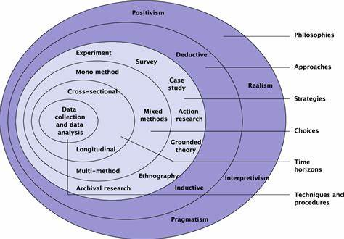
Saunders (2007) Research onion - Appendix 3.2

3.3 Philosophy
The most significant part of the research onion is research philosophy, that is situated at the top. It is a belief or an idea regarding the gathering, interpreting, and analysing of data is called a research philosophy. The term "research philosophy" describes the development of knowledge in a particular area of study. In order to reflect substantial assumptions about the persons opinions, viewpoints, and perceptions, the researcher employs this layer in a specific research project. Because of this, it will have an effect on the researcher's approach to the research plan or methodology that they choose (Zefeiti and Mohamad, 2015). Interpretivism is a part of the research topic since it allows for a range of possible, subjective responses and takes into consideration the public's perceptions of youth crime.
It is believed that youth crime has stigmatism attached to it, it is generally believed that youth are committing anti-social behaviour and because of this the crimes they are committing are escalating.

3.4 Research strategies
A research strategy is an overall strategy which assists in the selection of primary data collection methods, or a collection of methods, that tackle the research question while accomplishing the goals of the study (Melnikovas, 2018)
The questionnaire approach method has selected for the research strategy. Imperial College London (2024) has stated that anyone can utilise questionnaires for either qualitative or quantitative results and the potential of the questionnaire that are used to gather data will address the research topic and determines its worth. The questionnaire's layout and wording can have an important effect on this.
The questionnaire will be utilising a mixed method approach, by using a combination of multiple-choice questions and open-ended questions, where participants are able to select an answer based on their beliefs and the information at their disposal. Certain questions have a space designated for the participant to write their response in.
Those responses from the survey will then be placed into pie charts and graphs to compare the current data that is held by sources that is available online. This will evaluate whether crime committed by youths has change and whether society is a factor. With careful thought being placed in the questions, it should be able to answer the objectives that have been set. It will allow up to date data from front line policing, who have witness and have access to this information from reports that they attend.

3.5 Methods and Design
The choice method being used will be mixed methods. This will allow to make use of both quantitative and qualitative data by conducting a survey to analysing the results statistically and producing quantitative results in alongside your qualitative ones.
The survey consists of a multichoice questionnaire of fifteen questions, with answers that have been carefully selected to be able to analyse new data and to compare with what current data statistics are informing the public. There will also be a small number of questions that will help identify the persons age, job role and expert knowledge in the field.
The questionnaire that has been designed comes in two parts, with a total of fifteen questions to answer which was made on a website called survey monkey. The First part is for basic information about the individual, age range, job role and length of service within the Police service. This is to ensure that those participating have enough experience of youth crime and the reasons they have found on why they have committed the crime. This will be followed by the youth environmental circumstances also linking this to the crimes they commit. Collecting this information will allow confirm the data being collective is of substantive quality. The second part will obtain data of the ACEs that have been identified by those who have come into contact with the child and will obtain the participants opinion on youth crime.
A blank copy of the survey that has been conducted is attached to appendix 3.5

3.6 Time Horizons
Melnikovas (2018) has stated that the cross-sectional or short-term study methods, typically include gathering of data at a particular point in time, are utilised in this layer of the research onion to determine the time frame for the research project. Cross-sectional research is beneficial for this study because of the short period of time the study is being conducted over and given the demands of front-line policing and the limited time available for in-person interviews, it is possible to provide those who are interested with anonymous access to a survey that can be completed in five minutes or less, either at the beginning or end of their shift, on their own schedule. Conducting a short survey and opting for an anonymous approach, this will quickly gather both quantitative and qualitative data and comparing it to the most recent and long-term statistics that is readily available to the public.

3.7 Techniques: Data collections and Analysis
3.7 .1 Data collection
To keep the questionnaire simple and easily accessible to participants, it was made online and a link to access this was sent out to those who were willing to participant. When asking participants to complete the questionnaire, a large number was willing to participate in the study however only seven of those people completed it. It is thought that Police community support workers, who frequently deal with disruptive behaviour among young people, and Police officers who handle more serious criminal situations involving youth, are the best participants to recruit for primary data. It is thought that these professionals are an expert in this field of research due to the understanding of and policing perception of teenagers. This information on the kinds of crimes they have attended will be accessed through a questionnaire.
3.7 .2 Data Analysis
The researcher will be personally analysing the data from the questionnaire-based study by gathering information obtained and making a mixture of graph, this includes the pie chart and word cloud. It is thought to make the findings easier to read and understand. The data results can be accessed in the appendix 3.7 .2.

3.8 Limitations
There are limitations due to the timeframe that has been allocated to the research compared to other studies that have been conducted as there are professionals out there who have further access to raw data and those who are actually involved with families on a daily basis.
There have to be considerations on the ability of those participating in the questionnaire to be able to access the internet and a computer.
Participants may have bias views in their job role because of the way youths are in society and the stigma attached to them. By having a bias opinion that may impact the quality of the research being conducted.

3.8 .1 Ethical considerations
Ethnical considerations have been made throughout the research. Human rights and dignity, scientific integrity, and interaction between science and society all rely upon research ethics. These guidelines ensure research participants' voluntary, informed, and secure involvement in studies (Bhandari, 2018). All participants completing a questionnaire have been informed what the research is about for them to make an informed decision prior to completing the questionnaire. They have been assured by the way the structure of the questions ask, will not be able to identify who they are and will remain anonymous. In some topics, there is a risk of psychological, social, physical and legal harm to participants due to the types of topics being researched (Bhandari, 2018). This has been considered and to reduce this risk, the research topic has allowed for participants to make the decision to withdraw from the study at any time and all participants will be allowed to read the questionnaire before participating.
As previously stated, all participants remain anonymous throughout the research and all the data collect is via an online survey and remains password protected. By conducting research in this method there has been no foreseen potential harm to participants.

3.9 Conclusion
In conclusion, this chapter has examined the suitable methods to be used for organising the survey and choosing suitable participants. It has specified the length and provided an indication of the different types of questions that will be asked for the purpose to carry out an evaluation of the research topic investigation. It has also been successful in guaranteeing the accomplishment of every aim and objective.
The following chapter of the dissertation will be conducting an analyst of the results that have been collected during the questionnaire development process by using the research onion method that was created by Sauders et al (2007) and the methodology structure design that was created through research.

Chapter Four - Analysis of results
4.1 Introduction
The research project's methodology was fully explored in the previous chapter - Methodology, that employed Saunders et al. (2007) research onion model to structure a method. The next chapter is going to make an effort to provide the research conclusions after primary research has been obtained and will analyse the information obtained through the survey that was conducted.
Seven expert participants within South Wales Police who have had experience working with youths have completed the questionnaire, which was emailed to twenty-one different people in different job roles. Interestingly, many of the participants had experience with youth crime and have two or more experience in their current job role.
Because of limitations on the size of this undergraduate dissertation, a sample size of seven is more than adequate for analysis to conduct a simple.

4.2 Data Analysis
Data analysis is commonly referred to the process of collecting, modelling, and analysing data using an assortment of rational and statistical methods. Both quantitative and qualitative research form the foundation for many of these various approaches (Calzon, 2023). The data was collected and analysed online by Survey Monkey. By using this website, it made it possible to benefit from the convenience of gathering participant data and organising it into informative graphs, for instance. It made it simple, made presenting the data easy, and enabled responders to respond rapidly.

4.3 Method of Analysis
Because of the research approach was aimed at being qualitative and quantitative data. It was vital to use the correct analysing method to be able to interpretive results correctly and more effectively when going through the results of data obtained.
As the data from the questionnaire was obtained via an online survey that was created by the researcher, it was easy to create and document the results effectively and in a format that was easily readable. Due to the questionnaire being anonymous, you will not be able to identify what job role has selected what answers. The data will be based on opinion to conclude facts already known in the literature review and to compare it to historic and current data.

4.4 Analysing the results.
Part one of the questionnaire asked a variety of questions that are specific to the participant. This allowed factual data to be gathered, by collecting the age range, job role and length of service the participant. This in turn will allow data to be assessed against opinion-based data by participants throughout the remainder of the questionnaire. The reason for collecting this data is because there are different generations and upbringing. They then may form an opinion of what youth stigma is around in the society. By identifying the job role and length of service of the participant will allow for an analyse to be conducted of being exposed to youth crime and the experience they have with it. All data obtained from the survey is accessible in appendix 4.
It is evident from an analysis of the participants' work roles that 85.71% of them were police constables, with only 14.9% holding an inspector position. Police officers interact with youth in a criminal environment and are able to witness the types of crimes, the ages of the youths, ACEs, and environmental factors of those committing the crimes. This was a positive outcome, even though the questionnaire was appropriate for all those in a policing element who have been exposed to dealing with youths. Indulging into the duration of service of people who took part. This was done to assess the participants' exposure to youth criminality. According to survey data, people who took part had been in the post for at least two years and would offer expert judgement in their responses.
By collecting data regarding the age group that is participating. As children, we've experienced a range of surroundings and come from varied backgrounds. This was included in the question because, since society has evolved throughout time, children who engage in it would have varying perspectives on life. Of those who participated, 42.86% were between the ages of 35 and 40, and the same percentage were between the ages of 25 and 34. Sadly, no participants under the age of 24 were available to offer an opinion or understanding of ACEs to round out the conclusion. Subsequently, the remaining questions revolve around the participants' exposure to youth criminality and the age group that has either witnessed or experienced crime or interacted with young people in the community. Based on the questionnaire, it can be concluded that police officers typically interact with young people almost every day, as indicated by the fact that 57.14% of respondents said they do so a few times a week. I am unable to compare the 14.29% of respondents who picked a few times a month to determine whether they are front-line cops or office-based police officers due to the confidentiality of the questionnaire. This may help to explain why the majority of participants chose to be exposed to young people a couple times a week.
The fifth question delves deeper into the reasons behind those individuals' exposure to working with young people. There are many different responses derived from the assembled graph. However, the research indicates that youth engagement primarily occurs when they are either the target of criminal activity or exhibit antisocial behaviour. The young person being a victim of crime, worries about their welfare, and mental health come next.
Participants were asked the question ‘what do they believed to be the most type of crime young people commit?’. Based on these statistics, it is clear that criminal damage, assaults, and ASB are the three main types of crimes that young people conduct in today's society, as shown in Appendix 3.7 .2.
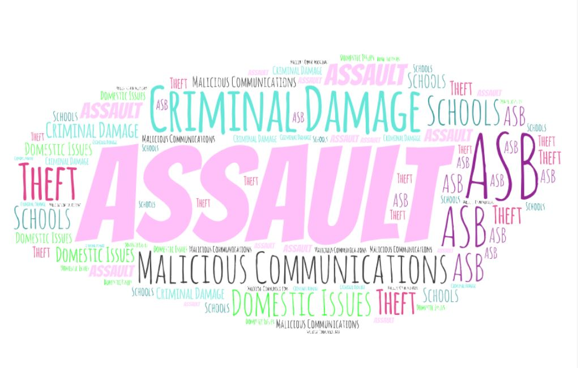

Subsequently information about the age ranges of the young people committing those offences was collected. This has demonstrated that children committing crimes as young as 11 years old, and it is believed that youth crime is escalating.
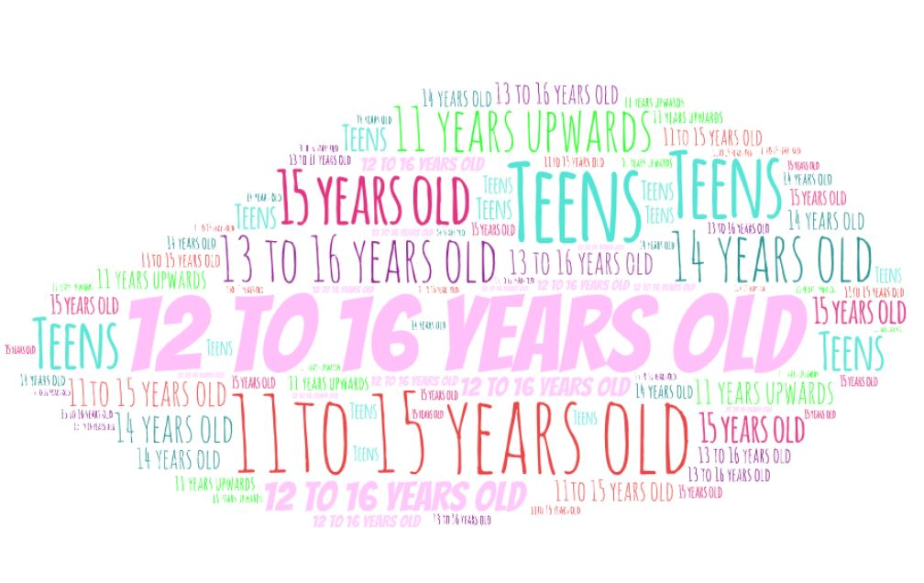
Participating police officers have stated that they think part of the reason these crimes have been committed is because of their upbringing as children. Moreover, half of participants, or 71.43%, think that a child's upbringing is a factor for those committing crimes. From the data gathered, it is clear that practically all of the children live with one of their parents; this has been classified as an ACE due to parental separation as The Scottish Government (2018) has highlighted in the 10 most common ACEs.
From the questionnaire, participants have shown that ACEs are a contributing factor in the criminal behaviour of young people. The majority of participants have come to the conclusion that the ACE most commonly identified when they have come into contact with youths is emotional neglect. In close second place is being exposed to substance and alcohol misuse. This is shown in appendix 3.7 .2. Since a parent or carer who takes drugs is unable to provide emotional stability for their child, these ACEs are actually a result of one another as show by the document provided by The Scottish Government (2018).
Despite the fact that the Welsh Government eliminated the defence of reasonable punishment in (2022) under in original legalisation, The Children Act (1989), according to data collected in the questionnaire, 66.67% of respondents believe that this will not lessen a child's exposure to ACEs and that parents should instead alter the way they raise their children. Research has also shown that kids who have experienced a high number of ACEs are more susceptible to peer pressure (Scottish Government, 2018). To align with the findings of recent research, a particular query was posed to individuals participating. In comparison to children who have no ACEs, how likely do you think it is that children with high ACEs would commit crimes? With 50% responding "very likely," 33.33% responding "likely," and the remaining number responding, "neither likely nor unlikely," the results were extremely evident as shown in appendix 3.7 .2.

Conclusion
Throughout this chapter, the researcher has conducted a satisfactory questionnaire that participants have completed to assist in the research and comparing it to research found in the literature review chapter. It has concluded that those who have participated that they believe that youth’s crime is escalating and are becoming to the attention of Police officers and other professionals. The main age group involved were as young as 11 years old to the age of 16 years old. Although the youth justice board (2023) have shown figures of the types of crime youths were committing were a majority of different ones, participants have only identified the main types of crime youths were committing as shown by the participants were of anti-social behaviour, thefts, criminal damage, assaults and malicious communication.
Participants' responses to the questionnaire are of the opinion that ACEs have a role in young people's criminal behaviour and most participants have concluded that emotional neglect is the most common ACE they have encountered in their interactions with youth. Being subjected to drug and alcohol abuse comes in close second as shown in appendix 3.7.2. According to a document supplied by The Scottish Government (2018), these ACEs are actually a result of each other for example a parent or carer who uses drugs is unable to give their child emotional stability.
Observing data gathered from the questionnaire, the majority of respondents feel that this will not lessen a child's exposure to ACEs and that parents should instead change the way they raise their children, despite the Welsh Government eliminating the defence of reasonable punishment in 2022 under in The Children Act (1989), the original legalisation.
Although research has demonstrated that children who have had a high number of ACEs are more vulnerable to peer pressure (Scottish Government, 2018). In the questionnaire participants were asked how probable do you think it is that kids with high ACEs would commit crimes compared to kids without ACEs? Given that 50% of respondents said they were "very likely," 33.33% said they were "likely," and the remaining portion said they were "neither likely nor unlikely," the percentage of respondents were very close and shown an unclear finding.

Chapter Five - Conclusion and recommendations
5.1 Conclusion
To conclude this dissertation by evaluating a range of sources that have helped throughout the study to achieve objective and aims. In Chapter one contains information about the background and the types of materials that will be used in this research. The format of the dissertation has provided readers with a well-organized response that emphasises each of the key topics. The stated goals and objectives have been identified and completed by the researcher in order to ensure that they are followed throughout the inquiry. These were to:

- Evaluate the types of crime youths are committing in society.
- Assess the impact ACEs have on individuals.
- Evaluate youths’ environmental factors when they have committed a crime.

The researcher created the study title after seeing recurring occurrences that affected young people at work and in the community. A thorough understanding of criminal behaviour among adolescents has been provided by this topic, which also enables a comparison with crime in the 19th century, when social and environmental conditions were different. By evaluating the different types of crimes youth are committing in today society and by comparing it to the 19th century crimes youths, it has concluded with research that society believe that crime is escalating by means of the crime is becoming more violent. For example, from using the Youth Justice board (2023) resource and comparing it to data the researcher has obtained, youths are now committing anti-social behaviour, sexual offences and becoming involved in knife crime compared to in the 19th century, where youths were mainly only committing thefts. This has completed the objective of evaluating the different types of crime youths are committing in today society.

Following research in the literature review and methodology chapter, which required further study into the crime youths are committing in today society and assessing whether ACEs have an impact on why they are committing crimes.
There is a common link between these children, and it appears that both 19th Century and today’s society children are still being exposed and have very similar ACEs which makes them more likely to commit criminal offences. The circumstances surrounding the child's life when the theft act was committed clearly indicate that ACEs have been involved since the 19th century. Babies are born every day with no awareness that they could be exposed to ACEs. Evidence makes it abundantly evident that children emulate the behaviours of those who look after them, and that environmental factors have also had a role in the criminal behaviour of these children. Why would kids be pilfering food? They were hungry, which was a more thoughtful response to this query. It's possible that their fundamental needs were not being satisfied and they were being neglected by their parents. It is evident from reviewing research using resources like Help Children Live Better (2022) that children who have had more ACEs are more likely to experience physical health problems as well as an increased chance of becoming involved in criminal activity. They have also come to the conclusion that a youngster who has experienced four or more ACEs is more likely to participate in risky behaviours and commit crimes, according to the study that has been done.

It has been welcomed that the Welsh Government (2022) have made attempts to protect children by abolishing the reason punishment defence which hopefully would make a small improvement of children being expose to ACEs and for parents to make changes to their parenting to no longer assault their own child, however, from the research survey conducted, it is concluded that this may not work and further research may be required on what can be done to protect children.
The overwhelming body of evidence has demonstrated that, as research by the Scottish Government (2018) indicates, ACEs indeed have a role in young people's criminal behaviour, and that social and environmental factors do play a part in exposing these children to ACEs. Parents may be the subject of more research on how to help their kids change, and education about preventing youth criminality may be a suggestion at the start of a baby’s life.
This dissertation has also shown that, in comparison with today's adolescents who commit major assaults, criminal damage, and anti-social behaviour, youngsters in the 19th century were more likely to steal necessities for survival. It has also been determined that a child's exposure to adverse childhood experiences (ACEs) is influenced by society and environmental factors, both historically and currently. Participants were able to voice the opinion that parents of young children should also alter their lifestyle choices and behaviour in order to reduce ACEs. This research has concluded and achieved objective, assessing the impact that ACEs can have on individuals and evaluate youths’ environmental factors when they have committed a crime.

5.2 Recommendations
It is thought to be evident that recommendations are made to further enhance the lives of children, have been found in this dissertation. This viewpoint has been reached after conducting study on children’s surroundings and crimes involving likelihood of exposure to adverse childhood experiences (ACEs). It is recommended that children whose parents expose them to ACEs on a frequent basis are to receive additional protection and support. Although there are other professionals in place like social services, The Police and youth justice system to reduce reoffending, the opinion of those participated in the survey have suggest it is not working. In order to assist parents in becoming better parents, further education and support it needed from those professionals. It is also recommended that children who are being found guilty of the crimes they are committing, their parents should be held responsible for their acts and have to undergo a professional evaluation to evaluate what is going wrong and what can be put right. This could only be beneficial if the correct funding in social care. The court justice system could potentially re evaluate the different types of crimes those youths, to change the law to hold parents accountable. This is in hope to reduce children being exposed to ACEs in their childhood to allow them to reach their full potential in life.

Appendix

Appendix 2.2 .1


Appendix 2.3

Appendix 2.4
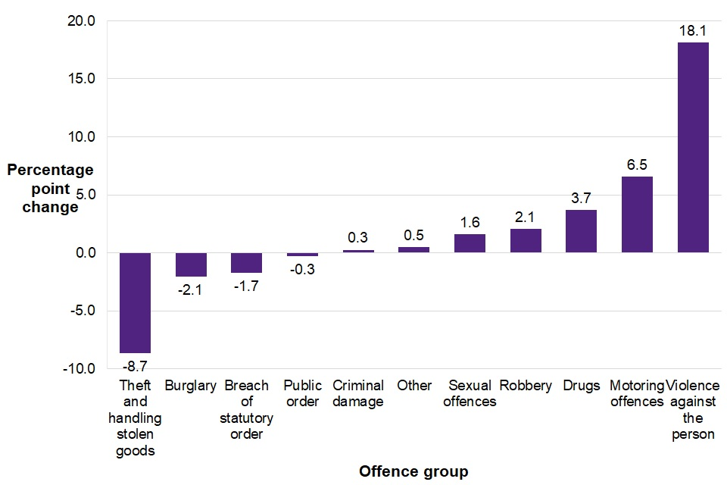

Appendix 3.2

Appendix 3.5
Questionnaire Part One:

1. What is your job role?
PCSO
Police constable
Inspector
Special constable
None of the above

2. How long have you been in your current role?
0-6 months
6-12 months
1-2 years
2-3 years
4 years and over

3. How old are you?
18-20 years old
21-24 years old
25-28 years old
29-34 years old
35-40 years old
41 years old and over

4. In your role, how often do you come into contact with youths between the ages of 11 years old and 16 years old?
Every day
A few times a week
About once a week
A few times a month
Once a month
Less than once a month

5. Why would you become involved with a youth in your job role?
Victim of a crime
Suspect of a crime
Anti-social behaviour
Noise complaints
Concern for child
Mental health
Other (please specify)

6. When you have come into contact with a youth involved in a criminal matter, victim or suspect, what type of crime would this be?

7. How old would the youth be? up to the ages of 16

8. Do you believe youth crime is escalating?
Yes
No

9. If you look at the majority of cases you have been involved in, would you say it is the youth(s) upbringing and/or circumstances on why they are committing criminal offences or being a victim?
Yes
No

10. What were the youth(s) living circumstances?
Living at home with both parents
Living at home with either parent
Grandparents
Other family member

Part Two

1. Overall, what are the common ACEs can you identify when having involvement with youths?
Physical Neglect
Emotional Neglect
Parents separation through divorce/death or abandonment
Physiological abuse
Sexual abuse
Witnessing domestic abuse
Mental illness in household
Substance/alcohol misuse
Different caregivers and/or inconsistent care
Relative who has been sent to prison

2. Do you believe ACEs are a factor on why youths are committing crime?

Strongly agree
Agree
Neither agree nor disagree
Disagree
Strongly disagree

3. Abolition of the defence of reasonable punishment was brought into Wales in 2022, do you think this would improve a youth ACEs and reduce the risk of being involved in a crime?
Yes
No
Other (please specify)

4. Do you agree or disagree that parents in today society need to change their parenting style to prevent the younger generation committing crime?
Strongly agree
Agree
Neither agree nor disagree
Disagree
Strongly disagree

5. Do you agree that a child having a high number of ACEs can make them vulnerable to peer pressure from their peers?
Strongly agree
Agree
Neither agree nor disagree
Disagree
Strongly disagree

6. How likely do you believe that children with a high amount of ACEs are more likely to commit crime than those with lower or no ACEs?
Very likely
Likely
Neither likely nor unlikely
Unlikely
Very unlikely

7. Do you believe that the crime youths are committing in today society is familiar to the 19th century?
Extremely familiar
Very familiar
Somewhat familiar
Not so familiar
Not at all familiar

Appendix 3.7 .2
Results: Part one - Question 1
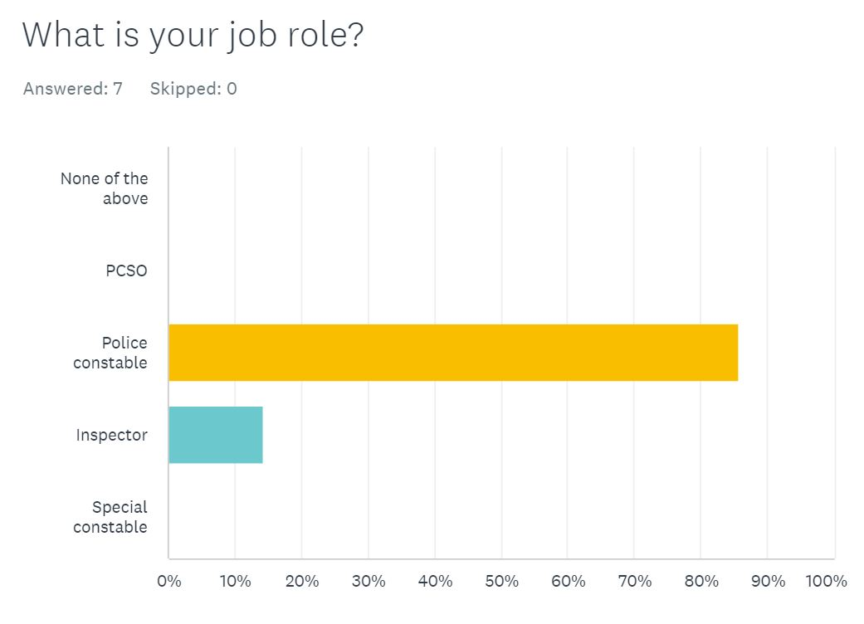

Question two
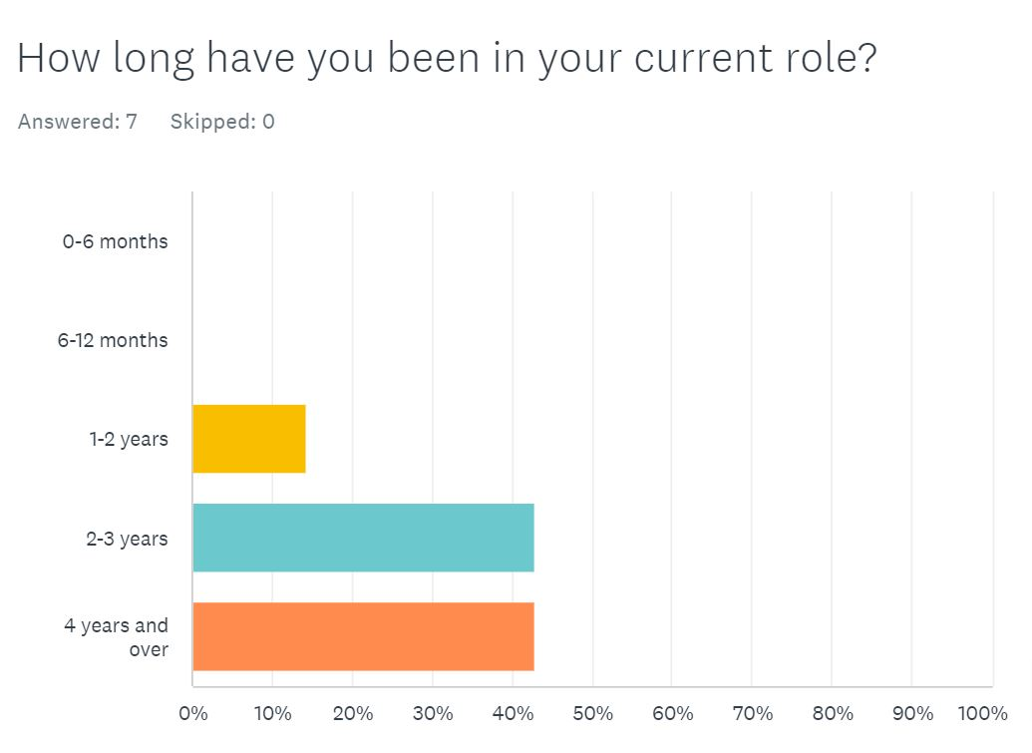
Question three
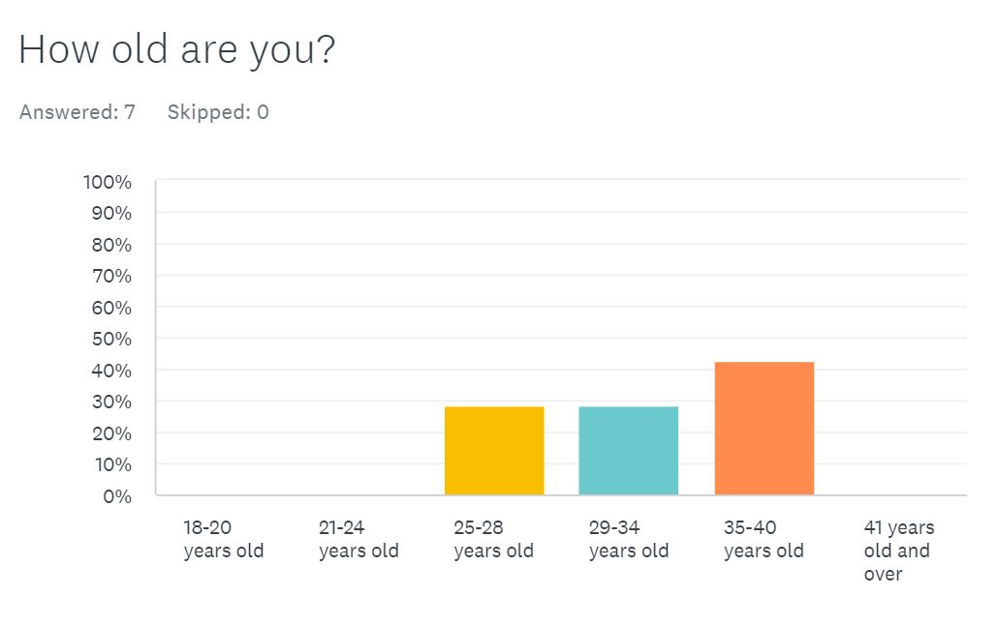

Question Four
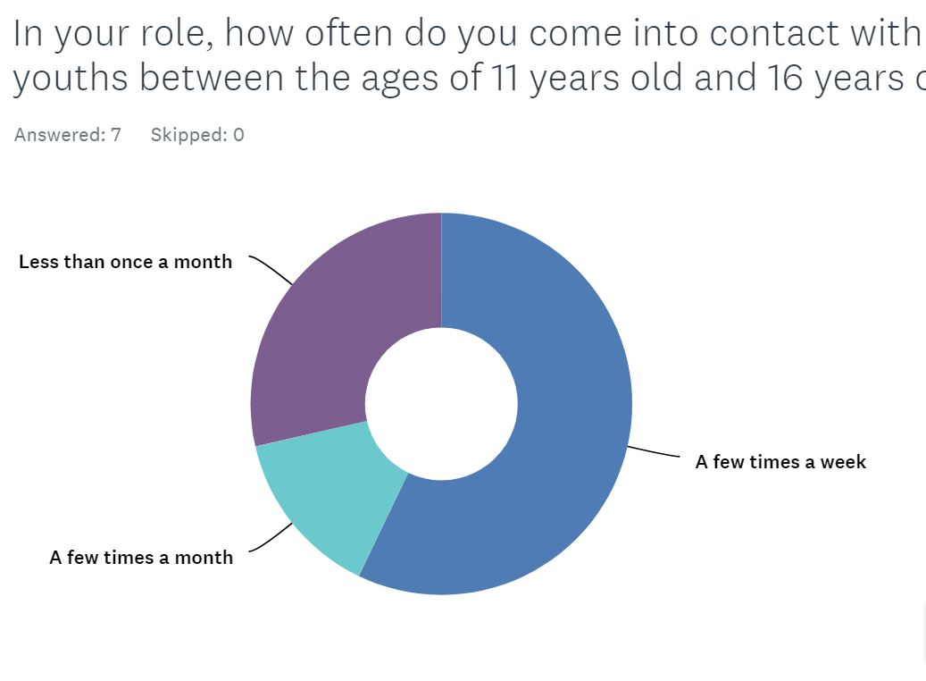

Question 5
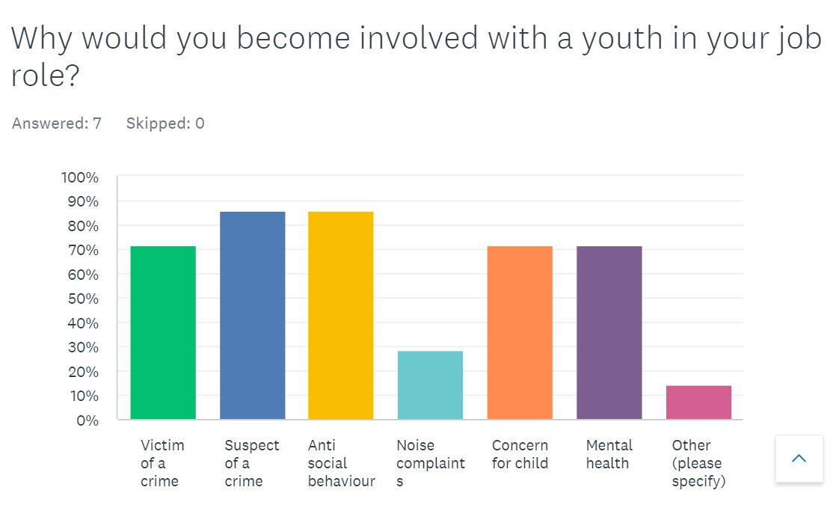

Question Six

When you have come into contact with a youth involved in a criminal matter, victim or suspect, what type of crime would this be?

Question seven

How old would the youth be? up to the ages of 16

Question eight
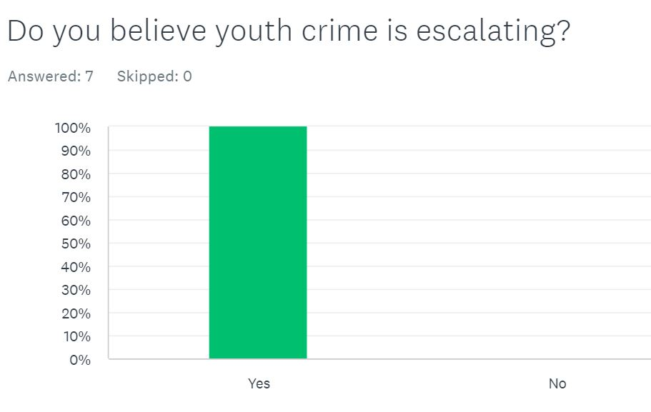

Question nine
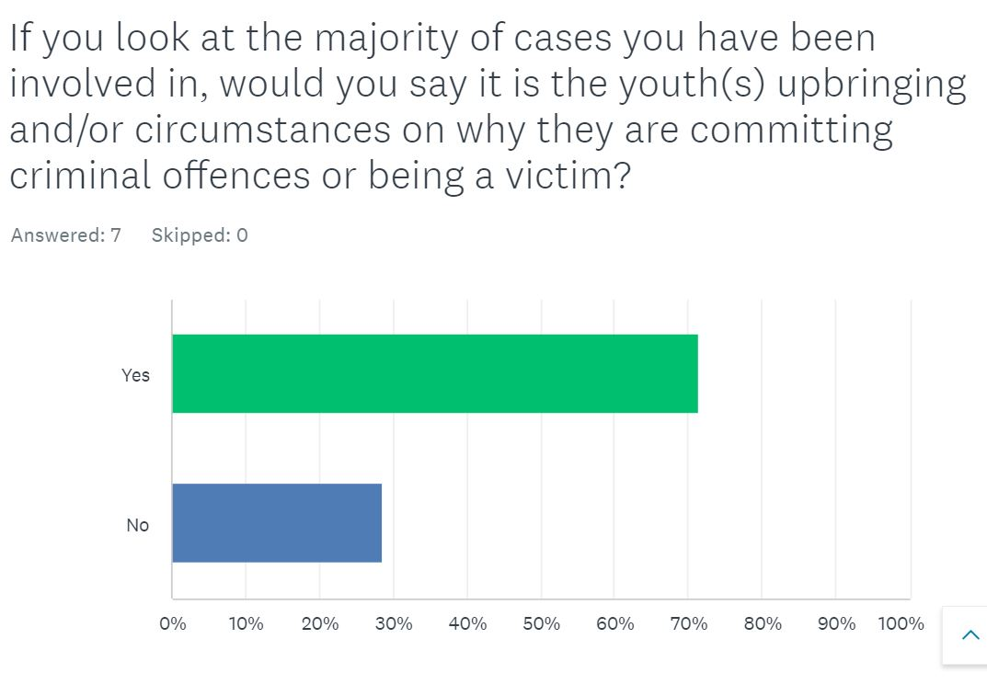

Question Ten
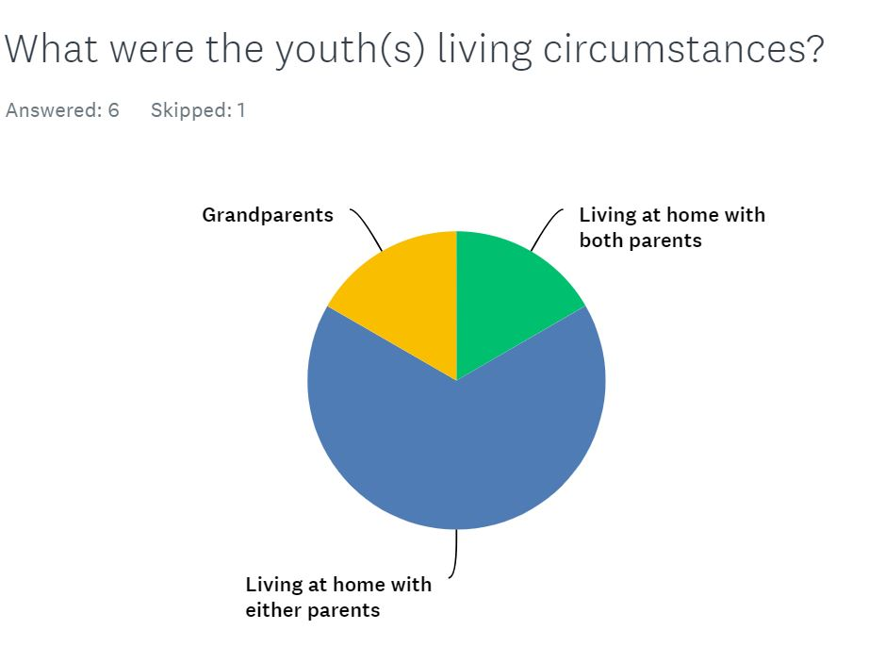

Part Two - Question one
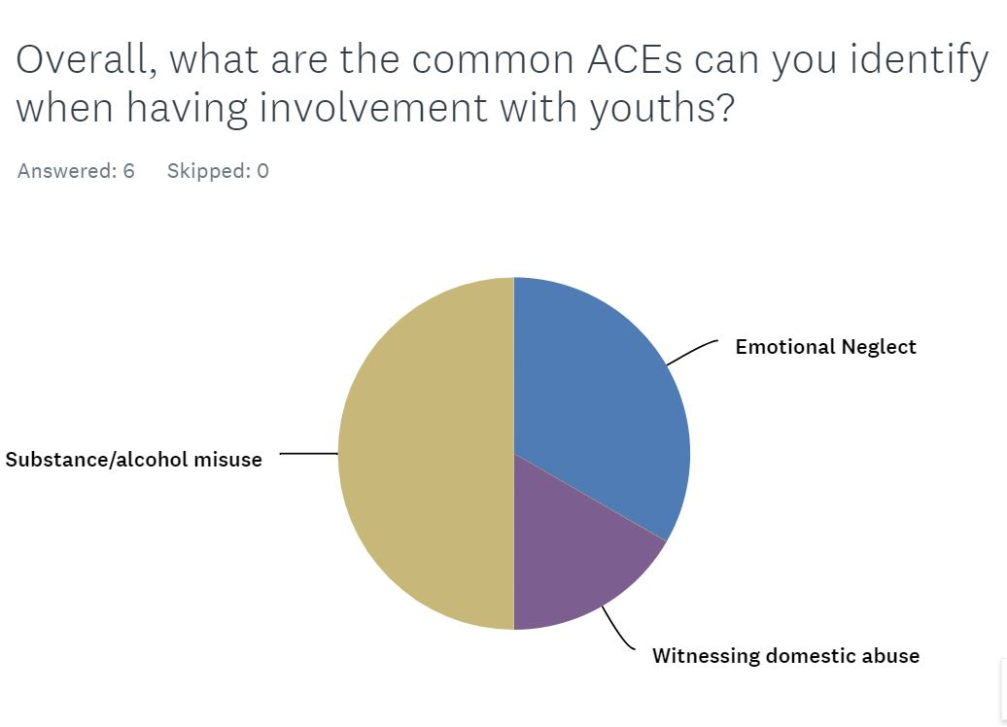

Question Two
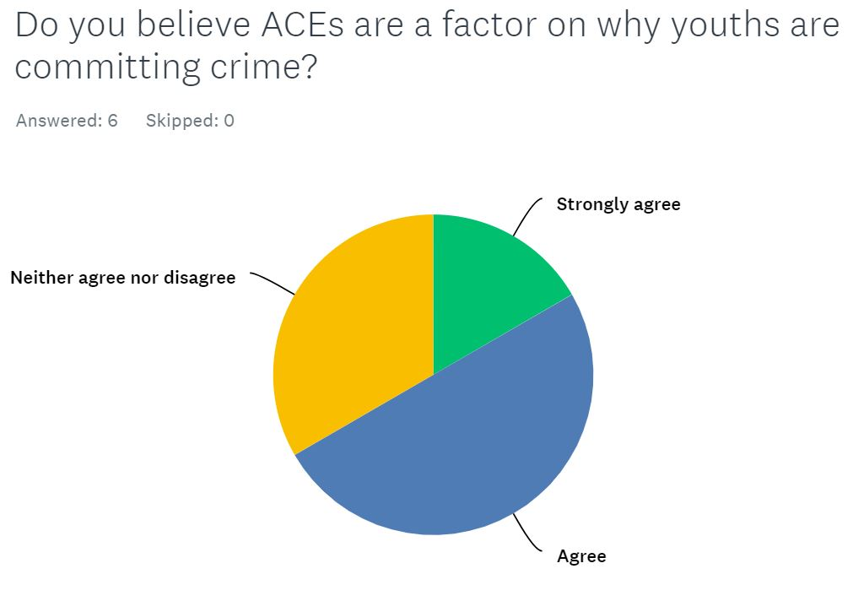

Question Three
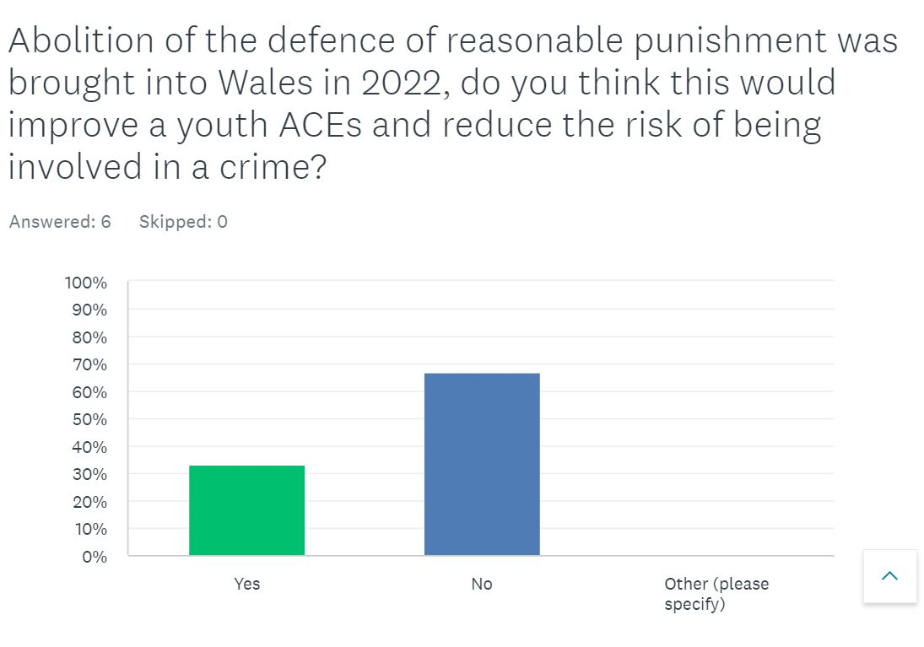

Question Four
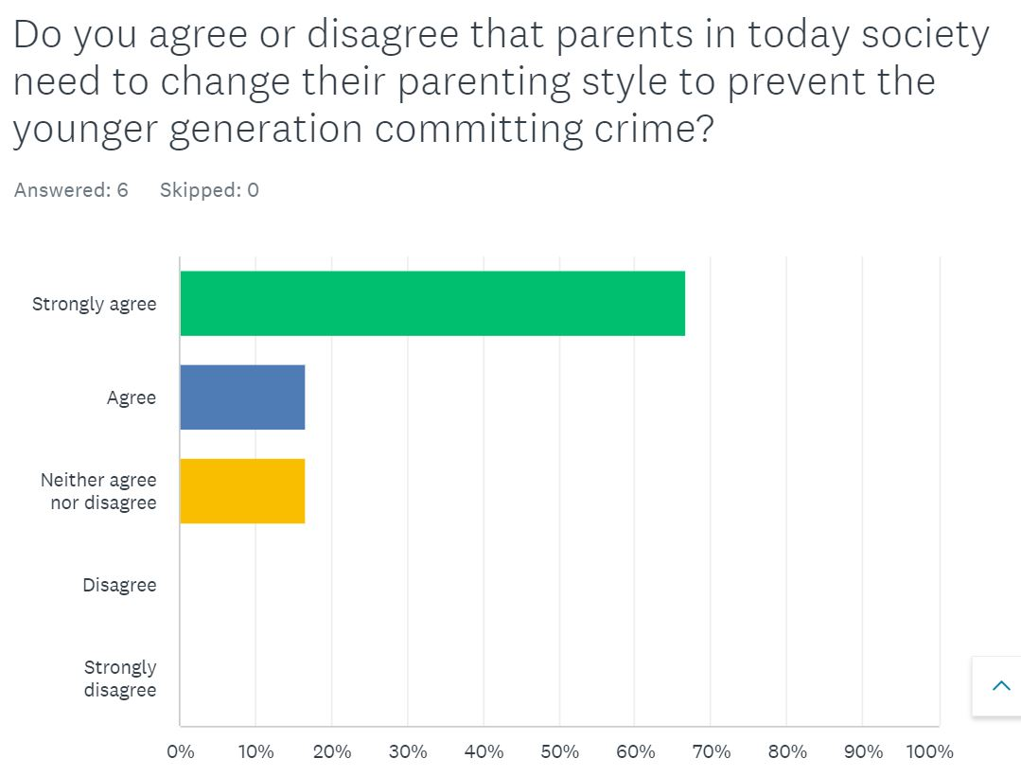

Question Five
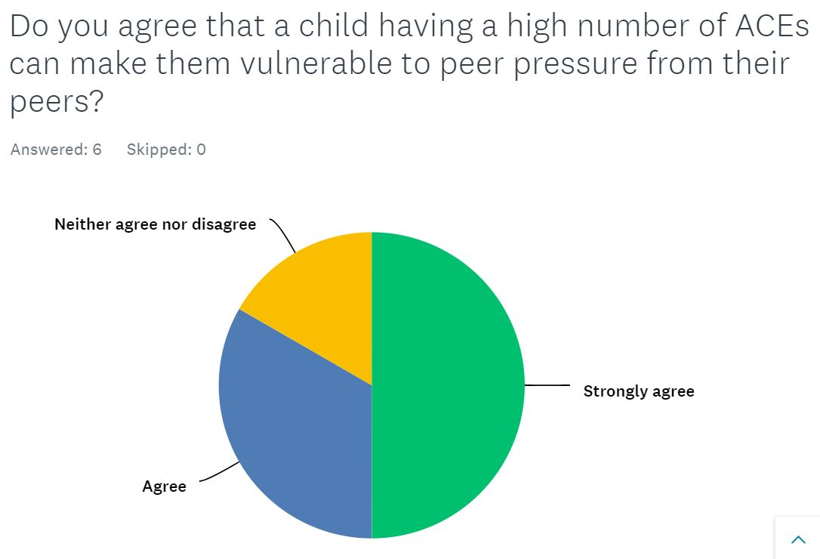

Question Six
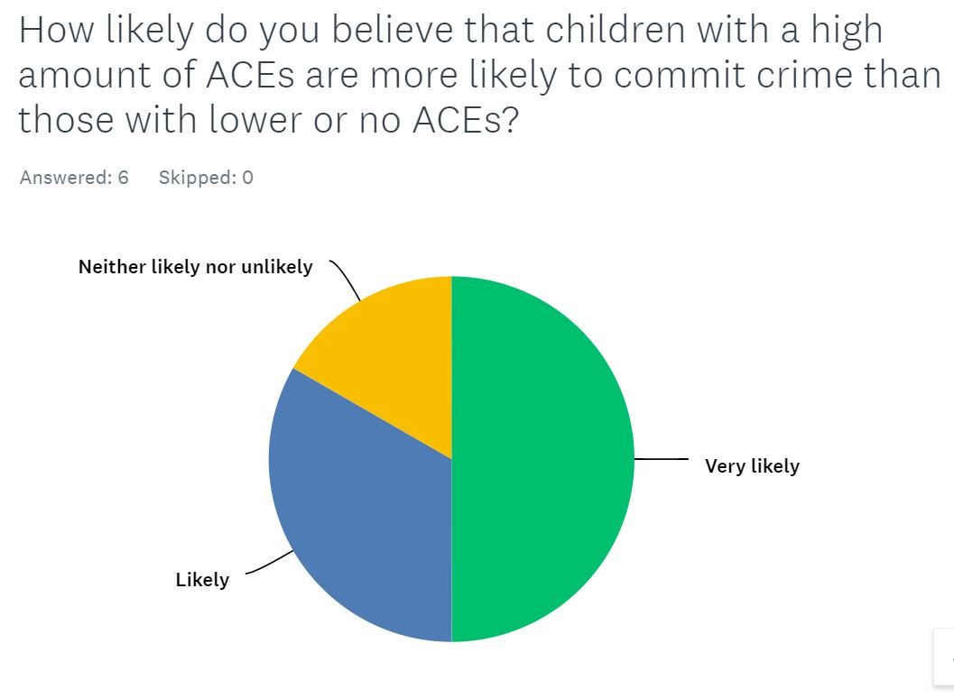

Question Seven
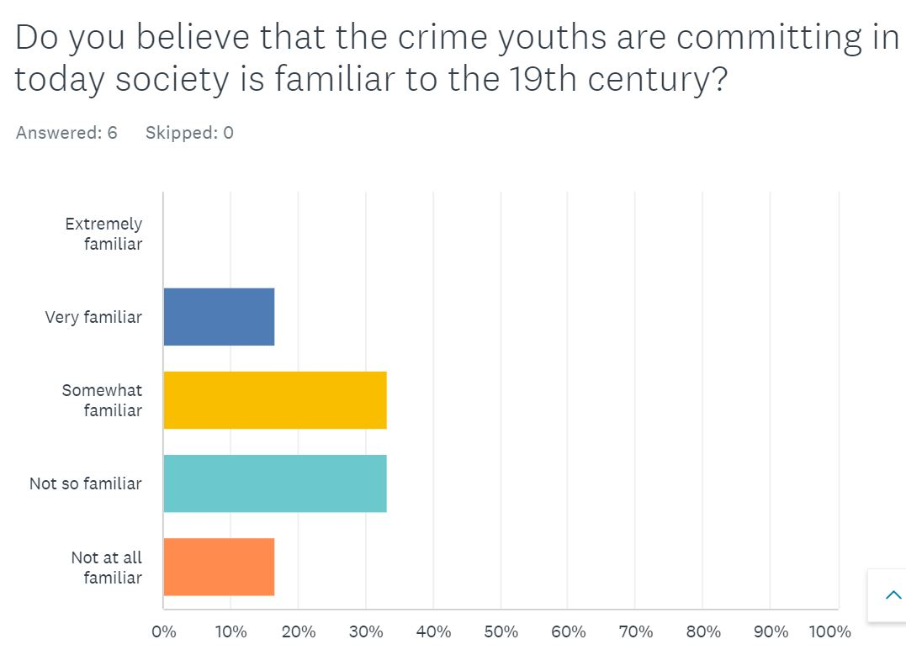

Bibliography
Bateman, N. (2020) ‘Why young people commit crime and how moral education could help – new research’ 15 May. Available at:https://theconversation.com/why-young-people-commit-crime-and-how-moral-education-could-help-new-research-131855 (Accessed: 17 January 2024)
BBC News, (2022) ‘Mayhill riots: Eighteen locked up for Swansea Violence’ BBC News, 19 December, Available at: https://www.bbc.co.uk/news/uk-wales-64029133 (Accessed: 21 September 2023)
Berry, G (No date) ‘Young People and Anti-Social Behaviour’ Crime and justice. Available at:https://www.crimeandjustice.org.uk/sites/crimeandjustice.org.uk/files/09627250308553540.pdf (Accessed: 16 January 2024)
Bhandari, P (2021) Ethnical Consideration in Research - Types & Examples. Available at: https://www.scribbr.com/methodology/research-ethics/ (Accessed: 30 September 2023)
Calzon, B. (2023) Your Modern Business Guide To Data Analysis Methods and Techniques. Available at: https://www.datapine.com/blog/data-analysis-methods-and-techniques/#data-analysis-definition (Accessed: 2 December 2023)
Children Act 2004. Available at: https://www.legislation.gov.uk/ukpga/2004/31/notes/division/2/4/5/2 (Accessed: 16 January 2024)
Godfrey, B. (2017) ‘Victorian child reformatories were more successful than today’s youth justice system’, The Conversation, Available at: https://theconversation.com/victorian-child-reformatories-were-more-successful-than-todays-youth-justice-system-85634 (Accessed: 30 September 2023)
Help Children Live better (2022) Adverse childhood experiences. Available at: https://helpchildrenlivebetter.co.uk/what-are-aces/ (Accessed: 30 September 2023)
Melnikovas, A. (2018) ‘Towards an Explicit Research Methodology: Adapting Research Onion Model for Futures Studies’ The General Jonas Žemaitis Military Academy of Lithuania, Article 29. Available at: DOI:10.6531/JFS.201812_23(2).0003. (Accessed: 1 December 2023)
NHS Scotland (2017) Tackling the attainment gap by preventing and responding to Adverse Childhood experiences (ACEs). Available at: https://www.healthscotland.scot/media/1517/tackling-the-attainment-gap-by-preventing-and-responding-to-adverse-childhood-experiences.pdf (Accessed: 17 January 2024)
Pamela ,L. (2023) ‘Parental influence & how to be a good parent role model’ 28 October. Available at: https://www.parentingforbrain.com/parental-influence/ (Accessed: 16 January 2024)
Phair, D and Warren, K. (2021) Saunders’ Research Onion: Explained Simply. Available at: https://gradcoach.com/saunders-research-onion/ (Accessed: 1 December 2023)
Public health Wales (no date) Adverse Childhood experiences. Available at: https://phw.nhs.wales/topics/adverse-childhood-experiences/ (Accessed on: 10 May 2023)
Questionnaires (2024 Imperial College London. Available at: https://www.imperial.ac.uk/education-research/resources/educational-research-methods/methods/questionnaires/ (Accessed: 1 December 2023)
Region Admin (2022) Why is youth crime a problem. Available at: https://www.regionsecurityguarding.co.uk/blog/crime/why-is-youth-crime-a-problem/ (Accessed on 15 May 2023)
Safeguarding Wales (2022) Safeguarding Children in relation to the Children (Abolition of Defence of Reasonable Punishment) (Wales) Act 2020. Available at: https://www.safeguarding.wales/en/chi-i/chi-i-c6/c6-p11/ (Accessed: 16 January 2024)
Scott, K (2021) ‘Adverse childhood experiences’, InnovAiT, 14 (1) Available at: https://doi.org/10.1177/1755738020964498 (Accessed: 1 December 2023)
Shaw, D. (2019) ‘Reality check: Are more teenagers carrying knifes?’, BBC News, 31st July. Available at: https://www.bbc.co.uk/news/uk-46153257 (Accessed on: 10 May 2023)
Swansea Council (2023) Welsh index of multiple deprivations 2019. Available at: file:///C:/Users/swp6906/Downloads/WIMD_2019_Briefing_Note.pdf (Accessed: 17 January 2024)
The Children Act 1989, Available at: https://www.legislation.gov.uk/ukpga/1989/41/contents (Accessed on 20 January 2024)
The National Achieves (2021) Unboxing the Archive: Victorian Child Criminals, YouTube. Available at: https://www.youtube.com/watch?v=5TzECLoZa1U (Accessed: 20 September 2023)
The National Achieves (No date), Victoria children in trouble with the law. Available at:https://www.nationalarchives.gov.uk/education/resources/victorian-children-in-trouble/source-3/ (Accessed: 20 September 2023)
The Scottish Government (2018) Understanding childhood adversity, resilience and crime. Available at: https://www.gov.scot/binaries/content/documents/govscot/publications/research-and-analysis/2018/05/understanding-childhood-adversity-resilience-crime/documents/00535550-pdf/00535550-pdf/govscot%3Adocument/00535550.pdf#:~:text=Research%20consistently%20shows%20a%20strong%20association%20between%20ACEs,for%20Justice%20%E2%80%93%20some-times%20associated%20with%20criminal%20be-haviour (Accessed: 1 December 2023)
The Scottish Government May (2018) Understanding childhood adversity, resilience and crime. Available at:https://www.gov.scot/publications/understanding-childhood-adversity-resilience-crime/documents/ (Accessed 17 January 2024)
Trivedi-Bateman, N. (2020) ‘Why young people commit crime and how moral education could help – new research’. The Conversation. Available at: https://theconversation.com/why-young-people-commit-crime-and-how-moral-education-could-help-new-research-131855 (Accessed on: 10 May 2023)
Walton,G. (2013) Pickpockets and pickpocketing in the 1700 and 1800s. Available at: https://www.geriwalton.com/pickpockets/ (Accessed: 2 December 2023)
Welsh Government (2022) Physically punishing children becomes illegal in Wales. Available at:https://www.gov.wales/physically-punishing-children-becomes-illegal-wales (Accessed: 23 September 2023)
Wisner, W (2022) ‘What are adverse childhood experiences (ACEs)’, Very well mind. Available at: https://www.verywellmind.com/what-are-aces-adverse-childhood-experiences-5219030 (Accessed: 20 September 2023)
Youth Justice board (2023) Youth justice statistics ‘Arrests of children by offence group’, 2021 – 2022. Available at: https://www.gov.uk/government/statistics/youth-justice-statistics-2021-to-2022/youth-justice-statistics-2021-to-2022-accessible-version (Accessed: 20 September 2023)
Zefeiti, S.M. and Mohamad, N.A. (2015) ‘Methodological considerations in studying transformational leadership and its outcomes’, International Journal of Engineering Business Management, 7, p. 10. doi:10.5772/60429.

