Building a Culture of Innovation & Future Work Practices HR Strategy

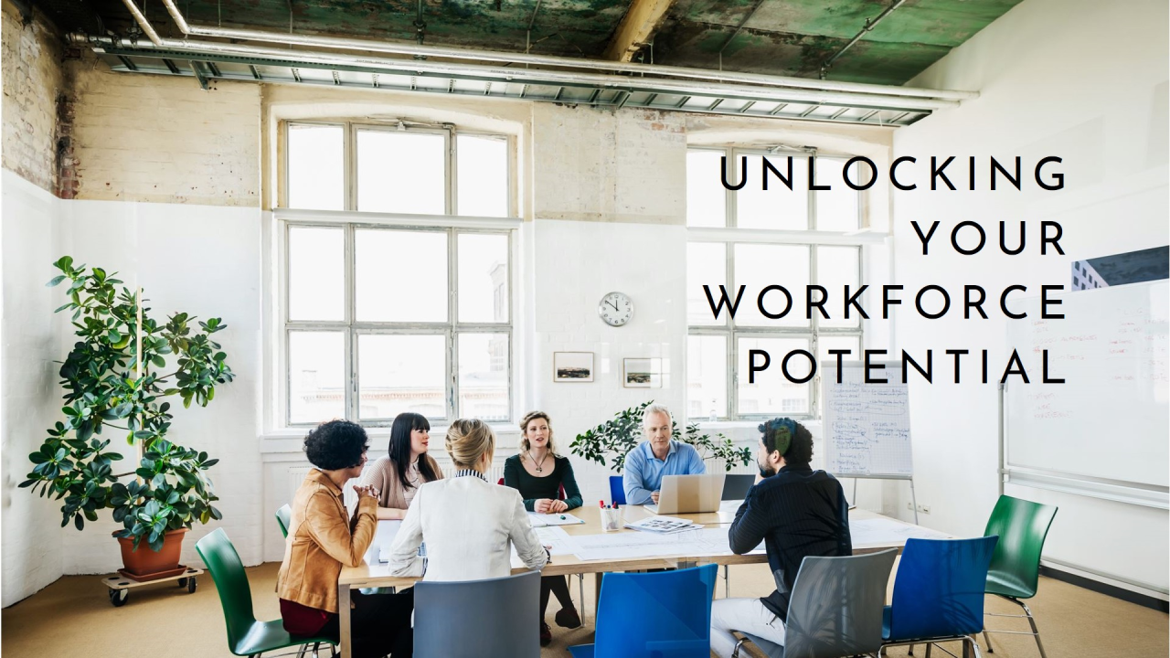

Student Name: Denise Chambers 2020342
Lecturer Name: Eno Maycock

Module: Human Capital Management
Module Code: LCMB7023
Word Count: (2486 Without References)
Submission Date: 18 February 2026
Contents

INTRODUCTION 2
CURRENT PRACTICES 2
RECOMMENDATIONS 3
PROPOSAL 4
DEMONSTRATE 5
CONCLUSION 6
REFLECTION 7
Description 7
Feelings 8
Evaluation 8
Analysis 8
Conclusion 9
Action Plan 9
Continuous Learning: 9
Structured Reflection: 9
Experimentation and Risk-Taking: 9
Feedback and Collaboration: 10
Goal Alignment: 10
Final Reflection 10
DISCUSSION 10
REFERENCES 12

INTRODUCTION
Aether Innovations are currently battling with falling customer service satisfaction, high staff turnover and flat growth. To resolve this problem this report will review current research on human resource management by looking at building a culture of innovation & future work practices. The report will assess current practices in work and culture between current tech companies.
Recommendations will be made for structural and cultural ingenuities that insert improvements to the tech company offering a future work model that encourages coworking and creativity. Validating how the new way of working would inspire and empower staff to perform to their best.
A proposal for a future hybrid work model will be put forward that supports collaboration and creativity at Aether Innovations. A demon of how this new approach will allow employees to feel motivated and enabled to perform to their finest ability.

CURRENT PRACTICES
Tech companies currently use many practices in work and culture; the most often used practices are:
Hybrid working - Many tech companies have now implemented hybrid working practices which involve remote, public and virtual workspaces, with remote suggesting you use your own private workspace at home, public meaning a company office space and virtual indicating computer generated cyberspace (Zamani, et al. 2025).
Well-Being Practices - Practices such as Mental health days, Well-being programmes and Remote work allowances are showing how companies are supporting employees’ mental, physical, social and overall health in significant ways. This allows for employee Well-being to be seen as vital for engagement, preservation and organisational performance preventing stress and burnout of their employees (Hilty, et al. 2023).
Talent & Career Development - Practices that shape how employees grow, progress, and build their careers in the fast-developing IT sector. Constantly evolving changes in IT requires employee skills to continue to grow and progress to remain successful. This ensures strong talent and career development within IT companies (Aljbour, French 2024).
Technology & AI Integration - In Most IT companies AI is now integrated to improve productivity, reduce costs, and create new products and services. Many global technology firms such as Microsoft and Google have embedded AI into their cloud platforms, enterprise solutions, and internal workflows. AI is reshaping how IT companies operate, compete, and develop talent (Van der Vlist, Helmond, Ferrari, 2024).
Collaboration & Communication - Collaboration and communication are central to how IT companies operate. Work in IT is often complex, project-based, and cross-functional, organisations rely on structured systems, digital tools, and cultural norms to coordinate teams effectively especially in hybrid and global environments (Balser, et al. 2017).

RECOMMENDATIONS
Improvements at Aether Innovation require deliberate cultural norms and structural mechanisms that encourage experimentation, collaboration, and rapid learning (Chudzikowski, Rosenblatt, 2011). This will enable cultural and structural initiatives that embed innovation the below recommendations have been made and incorporate innovation sprints, intrapreneurship and multi-functional teams.
Recognition and Incentives - Reward schemes can be implemented and will strengthen creativity with acknowledgement for patterns and prototypes, bonuses related to innovation landmarks, promotion criteria including experimentation and impact, public acknowledgement of creative problem solving (Cotton, 2022). Incentives are necessary and will in align innovation efforts that can weaken over time.
Cross Functional Teams – Aether Innovations could implement responsive methodologies that enable swift research and collaborative problem solving to include launching small autonomous cross functional teams, reducing hierarchical approval levels, allocating clear ownership roles with directly responsible individuals (Stipp, et, al, 2018). These structures enhance speed responsibility and adaptability.
Institutionalise Continuous Learning - Must be prioritised with the pace of technology change ether innovations could provide structural structured upskilling and reskilling programmes like AI cloud computing and cyber security (Billiot, 2023). Allocate annual learning budgets for certification and professional development and encourage internal knowledge sharing communities and technical forums. This will link with career progression from skill development and with reinforces a culture of ongoing innovation encouraging a growth mindset.

PROPOSAL
To stay viable in a knowledge driven economy Aether innovations should create work models that adopt collaboration, creativity and innovation while maintaining flexibility and employee well-being (Mamykina, Candy, Edmonds, 2002). A structured hybrid model rather of a fully remote model or fully office based offers optimum stability between autonomy and collective commitment. This will include employees working from domestic as well as office spaces within Aether Innovations (Hopkins, Bardoel, 2023).
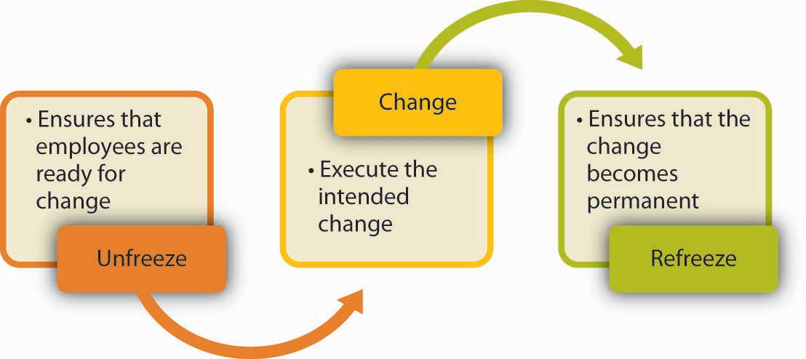
The proposed hybrid working model can be strengthened by preparation of its implementation in established organisational change theories. Embedding a hybrid work model that promotes collaboration and creativity requires structural design and cultural transformation. Lewin’s model of unfreeze, change and refreeze can be implemented here as shown in the below diagram (Levasseur, 2001).

Unfreeze - To transition towards a structured hybrid model Aether Innovations must first challenge existing assumptions about traditional office-based work this will include communicating the limitations of rigid work structures, presenting data on productivity collaboration and employee well-being engaging stakeholders in discussions about future work needs will be necessary for creating awareness and reduces resistance, psychologically preparing employees for change (Hussain, et al. 2018).
Change - during the transition phase Aether Innovations can implement structured hybrid scheduling, collaboration focused office redesign, digital first communication protocols and advanced time allocation to train managers in hybrid leadership and inclusive communication is critical at this stage and will allow Aether Innovations to foresee the outcome of the planned change (Burnes, 2004).
Refreeze - to stabilise the new work model Aether Innovations can embed hybrid policies into HR frameworks, align performance management with collaboration outcomes and establish continuous evaluation mechanisms (Levasseur, 2001). This will institutionalise new norms and ensure the sustainability of the hybrid model.

DEMONSTRATE
The effectiveness of the proposed hybrid working model can be evaluated through its impact on employee motivation and performance; by integrating structured hybrid work, innovative innovation supportive culture and enabling digital infrastructure the model addresses key psychological social and organisational drivers of optimal performance (Rodrigo, L. et al. (2022). This section demonstrates how the approach increases motivation and allows employees to achieve continued high performance.
Autonomy will allow employees to work remotely for focused tasks, provide greater control over time, environment and workflow. This will increase ownership of outcomes, reduce commuting stress and burnout and enhance engagement and accountability (Terry, 2022). Well-structured flexibility indicates organisational trust which reinforces commitment and discretionary effort.
The model embeds continuous learning, cross functional collaboration and innovation over time. These elements provide opportunities to develop new technical and problems solving skills, encourage experimentation and creative thinking and offer exposure to diverse expertise (Melton, Hartline, 2013). Aether Innovations employees will build competence and increased self-efficiency directly improving performance quality and speed.
Purposeful in office collaboration days associate work with collective innovation goals by engaging employees in brainstorming sessions, design workshops and project strategy discussions (White, Quehl, Costello, 2022). The model connects individual tasks to organisational impact and reinforces shared vision and strengthens team identity. A clear sense of purpose enhances essential motivation and persistence.
Psychological safety is critical for creating creativity and high performance. The hybrid framework encourages non blame retrospectives and open dialogue across hierarchy encouragement of idea sharing. When employees feel safe to provide ideas without fear of negative concerns, they are more likely to engage in creative problem solving and knowledge sharing which reduces error concealment and quickens innovation (Yin, et al. 2020).

CONCLUSION
Embedding modernisation at Aether Innovations requires a unified approach combining cultural transformation and structural redesign. Cultural ideas such as psychological safety, growth mindset, and associated incentives must operate alongside structural mechanisms including responsive teams, dedicated innovation units, and digital setup investment (Stipp, et, al, 2018).
The hybrid work model balances flexibility and structured interaction by combining purposeful in office collaboration, remote productivity, digital enablement and cultural reinforcement (White, Quehl, Costello, 2022). Aether Innovations can create a future work model that supports sustained creativity and innovation.
Justifying the collective hybrid innovation framework in established organisational change theories strengthens its conceptual validity and practical acceptability. Lewin’s staged approach provides a comprehensive lens for implementing a hybrid work model that sustain collaboration and creativity (Levasseur, 2001).
The hybrid model motivates and enables optimal performance by integrating autonomy skills development purposeful collaboration and psychological safety within a structured hybrid design. Supporting work structure culture and performance systems will allow this approach to enhance essential motivation, intellectual efficiency, teamwork effectiveness and employee well-being.

REFLECTION
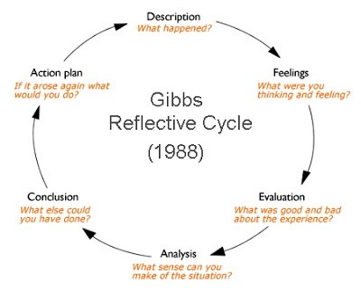
I have used Gibb’s reflective cycle to write my reflection on this module and capture my learning journey. This will also capture my learning and development methods allowing improvement of my leadership capability and adaptability in numerus circumstances (Tawanwongsri, Phenwan, 2019). The below diagram reflects how the model is used to following the six stages of the cycle.
This Photo by Unknown Author is licensed under CC BY-NC

Description
During this module, I investigated concepts linked to organisational culture, innovation, hybrid work models, collaboration, talent development, and technology integration within IT organisations. The module required critical evaluation of workplace practices and the development of strategic recommendations to improve innovation and performance at Aether Innovations.
An important section of my learning involved understanding how organisational systems such as leadership behaviours, communication structures, and performance management form employee motivation and creativity. I also inspected organisational change theories, including Lewin’s Change Model, to understand how new work tactics can be successfully applied (Burnes, 2020).
Overall, the module extended my viewpoint on how innovation is deliberately inserted through culture and structure.

Feelings
At the beginning of the module, I felt confident in my understanding of management principles. However, I underrated the depth of influence that organisational culture and structural design have on reconstruction. As I engaged with the material, I realised that innovation requires intentional leadership, psychological safety, and supportive systems.
Initially, associating theory with practical workplace applications was challenging. Though as I progressed, I gained clearness and confidence in applying theoretical frameworks to real-life contexts. Near the end of the module, I felt more purposefully aware and reflective about both organisational design and my own growth.

Evaluation
One of the most valued aspects of this module was understanding the connection between psychological safety and creativity. I learned that innovation succeeds when employees feel safe to share ideas and experiment without worry of failure. The importance on growth mindset and continuous learning also reinforced the weight of adaptability in dynamic environments such as IT.
The organised hybrid work discussions helped me identify how work design directly affects collaboration, productivity and wellbeing. Though I realised that while I can analyse these principles academically, I do not always apply them regularly in my own learning behaviour. For example, I often prioritise achieving results over testing with new approaches or implementing constructive failure in my own line of work and study.

Analysis
The module emphasised that innovation depends on many communicated reasons: culture, structure, leadership, learning systems, and strategic placement. Aether Innovations must intentionally create environments that encourage experimentation, collaboration, and continuous development.
On reflection of my own learning journey, I accepted that encouraging innovation within myself requires similar intentional design. Just as Aether Innovations needs a planned change processes, personal development requires measured reflection and behavioural adaptation.
The concept of growth mindset mostly resonated with me. I realised that delays should be viewed as opportunities for development rather than gages of limitation. Additionally, the module verified that structured collaboration boosts idea generation, encouraging me to seek diverse views in my own work.
The change models I studied in this module also apply to my personal development. I must first “unfreeze” limiting habits, implement new learning behaviours, and strengthen them through regular practice.

Conclusion
This module has provided a robust conceptual foundation for understanding innovation and organisational success. More importantly, it has given me a standard for designing my own learning and development tactic.
I have concluded that to foster a culture of innovation and growth mindset within myself, I must be deliberate about my learning, be open to feedback, and be willing to take rational risks. Innovation requires control as much as creativity.

Action Plan
To apply these visions, I will employ the following development strategies:

Continuous Learning:
I will allocate devoted weekly time for professional development, particularly in evolving technologies such as AI and digital transformation. I will also pursue relevant certifications to reinforce my expertise.

Structured Reflection:
I will use Gibbs’ Reflective Cycle regularly to gauge my learning experiences and recognise areas for improvement. Using a reflection journal will help me track my progress and support new behaviours.

Experimentation and Risk-Taking:
I will challenge myself to embrace new approaches in academic and professional tasks, even when I am uncertain of outcomes. Viewing mistakes as learning opportunities will toughen my resilience.

Feedback and Collaboration:
I will actively seek constructive feedback from peers and mentors. Engaging in cross-disciplinary discussions will broaden my thinking and enhance my creative problem-solving.

Goal Alignment:
I will set objectives that encourage my skill development rather than focusing only on performance outcomes. Pursuing learning milestones will help reinforce a growth mindset for myself.

Final Reflection
This module has extensively influenced my understanding of innovation, leadership, and organisational culture. It has proven that creativity and high performance are not only singular traits but the result of well-designed systems.
Through applying organised reflection, constant learning, and intentional experimentation, I will cultivate a sustained culture of innovation and growth mindset within myself. The knowledge gained in this module works as a strong foundation for both my professional development and future leadership targets.

DISCUSSION
As artificial intelligence continues to power routine and analytical tasks, staying relevant requires deliberate reworking rather than resistance. I recognise that AI is progressively capable of performing structured, repetitive, and data-driven functions that were usually handled by specialists. Though I view AI not as a replacement, but as tool that can boost my production and decision-making capacity.
To remain relevant, I plan to focus on developing exclusively human abilities that are difficult to automate. These include critical thinking, ethical judgment, emotional intelligence, strategic reasoning, and complex problem-solving. While AI can create insights, it cannot fully imitate contextual understanding, moral evaluation, or nuanced leadership. Bolstering these competencies will ensure that I add value past technical execution.
At the same time, I intend to actively integrate AI into my workflow. I will use AI tools for research summarisation, data analysis, drafting initial work documents, idea generation, and productivity optimisation. Automating lower-value tasks, will allow me to allocate more time to strategic thinking, innovation, and relationship-building. This positions AI as an assistant rather than a rival.
Continuous learning will be central to my approach. I plan to stay educated about emerging AI technologies, understand their limitations, and develop digital fluency. This includes learning prompt engineering, data interpretation, and AI governance principles to ensure accountable usage.
Ultimately, my goal is to operate at the joining of human intelligence and artificial intelligence. Using AI for efficiency while strengthening uniquely human capabilities, I can enhance my performance without being replaced. Flexibility, ethical awareness, and lifelong learning will be vital in sustaining long-term professional importance in an AI-driven environment.

REFERENCES
Aljbour, A., Ali, M. and French, E. (2024) “Talent management practices and the influence of their use on employee outcomes via perceived career growth,” Employee relations., 46(8), pp. 1625–1647. Available at: https://doi.org/10.1108/ER-05-2023-0245. (Accessed 02 February 2026)
Balser, T.J. et al. (2017) “Collaboration and Communication,” New directions for institutional research., 2017(175), pp. 65–79. Available at: https://doi.org/10.1002/ir.20236. (Accessed 07 February 2026)
Billiot, T. (2023) “Continuous learning and advancing technologies: a framework for professional development and training in artificial intelligence,” Development and learning in organizations., 37(3), pp. 28–31. Available at: https://doi.org/10.1108/DLO-04-2022-0064. (Accessed 04 February 2026)
Burnes, B. (2004) “Kurt Lewin and the Planned Approach to Change: A Re‐appraisal,” Journal of management studies., 41(6), pp. 977–1002. Available at: https://doi.org/10.1111/j.1467-6486.2004.00463.x. (Accessed 14 February 2026)
Burnes, B. (2020) “The Origins of Lewin’s Three-Step Model of Change,” Journal of applied behavioral science., 56(1), pp. 32–59. Available at: https://doi.org/10.1177/0021886319892685. (Accessed 17 February 2026)
Chudzikowski, K. and Rosenblatt, V. (2011) “The impact of institutional processes, social networks, and culture on diffusion of global work values in multinational organizations,” Cross cultural management., 18(1), pp. 105–121. Available at: https://doi.org/10.1108/13527601111104322. (Accessed 04 February 2026)
Cotton (2022) “Incentives and recognition: An evidence review,” The Journal of total rewards., 31(2). (Accessed 12 February 2026)
Hilty, D.M. et al. (2023) “Best Practices for Technology in Clinical Social Work and Mental Health Professions to Promote Well-being and Prevent Fatigue,” Clinical social work journal., 51(3), pp. 211–245. Available at: https://doi.org/10.1007/s10615-023-00865-3. (Accessed 11 February 2026)
Hussain, S.T. et al. (2018) “Kurt Lewin’s change model: A critical review of the role of leadership and employee involvement in organizational change,” Journal of innovation & knowledge., 3(3), pp. 123–127. Available at: https://doi.org/10.1016/j.jik.2016.07.002. (Accessed 04 February 2026)
Levasseur, R.E. (2001) “People Skills: Change Management Tools—Lewin’s Change Model,” Interfaces., 31(4), pp. 71–73. Available at: https://doi.org/10.1287/inte.31.4.71.9674. (Accessed 16 February 2026)
Mamykina, L., Candy, L. and Edmonds, E. (2002) “Collaborative creativity,” Communications of the ACM., 45(10), pp. 96–99. Available at: https://doi.org/10.1145/570907.570940. (Accessed 10 February 2026)
Melton, H.L. and Hartline, M.D. (2013) “Employee Collaboration, Learning Orientation, and New Service Development Performance,” Journal of service research., 16(1), pp. 67–81. Available at: https://doi.org/10.1177/1094670512462139. (Accessed 02 February 2026)
Stipp, D.M., Pimenta, M.L. and Jugend, D. (2018) “Innovation and cross-functional teams,” Team performance management., 24(1/2), pp. 84–105. Available at: https://doi.org/10.1108/TPM-12-2016-0056. (Accessed 05 February 2026)
Tawanwongsri, W. and Phenwan, T. (2019) “Reflective and feedback performances on Thai medical students’ patient history-taking skills,” BMC medical education., 19(1). Available at: https://doi.org/10.1186/s12909-019-1585-z. (Accessed 11 February 2026)
Van der Vlist, F., Helmond, A. and Ferrari, F. (2024) “Big AI: Cloud infrastructure dependence and the industrialisation of artificial intelligence,” Big data & society., 11(1). Available at: https://doi.org/10.1177/20539517241232630. (Accessed 02 February 2026)
Yin, J. et al. (2020) “Transformational leadership and employee knowledge sharing: explore the mediating roles of psychological safety and team efficacy,” Journal of knowledge management., 24(2), pp. 150–171. Available at: https://doi.org/10.1108/JKM-12-2018-0776. (Accessed 12 February 2026)
Zamani, E.D. et al. (2025) “The new wave of ‘hybrid’ work: An opportunity to revise assumptions and build theory,” Information systems journal., 35(2), pp. 710–719. Available at: https://doi.org/10.1111/isj.12558. (Accessed 10 February 2026)

