Client Project - Report
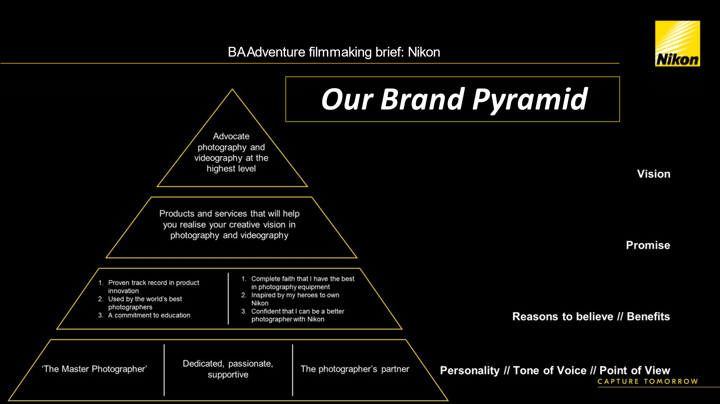
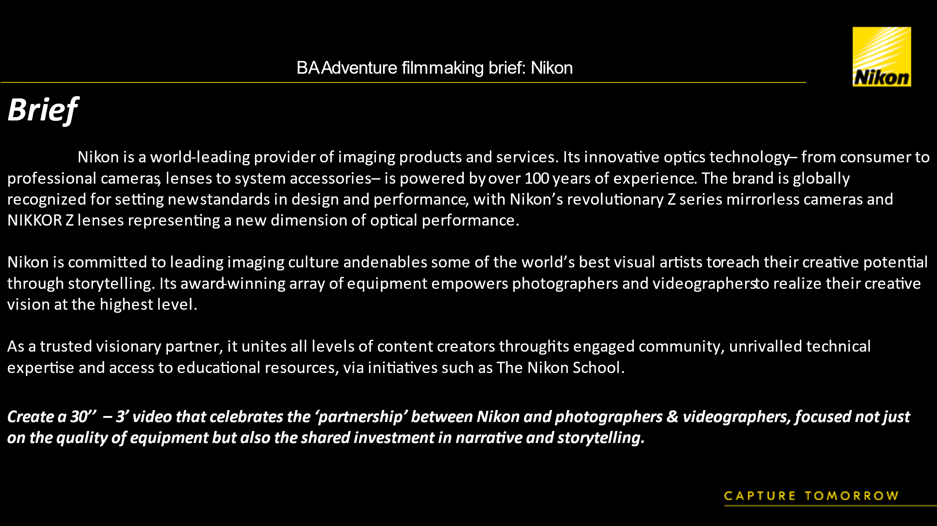

Brief
On first getting the brief from Nikon I immediately thought it was very broad and fairly open ended. My initial response to this was that it gave me a lot of freedom, however I realised with it being set out in this way I wasn’t able to easily come up with an idea. Although from the start I knew I wanted to emphasise the link a person makes when using Nikon, I didn’t know how to achieve this.
Now I’ve completed the project, I think that the brief could have outlined the deliverables and better shaped the type of video that was wanted. Although the brief and the meeting provided a lot of information there was no specific theme or specification to work to and this impacted negatively on my own decision making. Because of the amount of elements Nikon wanted to cover I initially made plans to have three different users representing the three main mirrorless cameras; The ZFC, the Z6ii (& Z7ii), and the Z9. This was done to ensure I hit as many of the mentioned ideas in the brief as possible, but it meant there was an overload of information to cover in what should be an easy to watch advert.
The brief being so vague was one of the biggest problems I faced whilst creating the ideas and finished video because I second guessed most of the decisions in the process. This is something I knew might be a problem in a real freelance – client situation so although it delayed any solid ideas being developed more I made sure to tackle the issues at hand and simplified what I personally thought needed to ultimately be portrayed in the video. I think that working with this issue was a huge learning curve as at some points I did feel a bit lost, but this ultimately is something that helped me better understand my own vision and let me develop my own creative ideas in a more for formulated way.
Outcome Of Project
Overall, I’m pleased with the end product, but I think it has a lot of room to improve and has many issues that I think were easily avoidable with better time management and planning. With my initial assembly edit and even when I had a final version of the video, I wasn’t happy with it at all, the process of filming and editing didn’t come together as well as I hoped, and I thought it lacked narrative in the visuals. After having time to reflect and receiving feedback from Nikon & OM System Brand Ambassador; Geraint Radford I came to realise that realistically as a student, one person crew and with no funding the end goal I was imagining wasn’t realistic. I think that doing this again I would make sure to manage my expectations and come to terms with the limitations I had at an earlier stage. Doing this would mean that from the start I could plan a more suitable sequence to film and give myself more time in the filming and editing stage of the project. One of the main issues I had identified when finishing the project was the voice over and music choice, ultimately the voice over worked but should have been scripted slightly better and performed in a more emotive way. The sound levels were also an issue as in some sections the V/O it is hard to hear over the music. The music choice is something I wish I had given myself more time to develop and test out as it didn’t fit the video or shape the narrative in any way, this was probably the videos biggest issue as it brings down the quality of the advert entirely and if done correctly, it would have made a huge overall difference.

Clients Response - Nikon
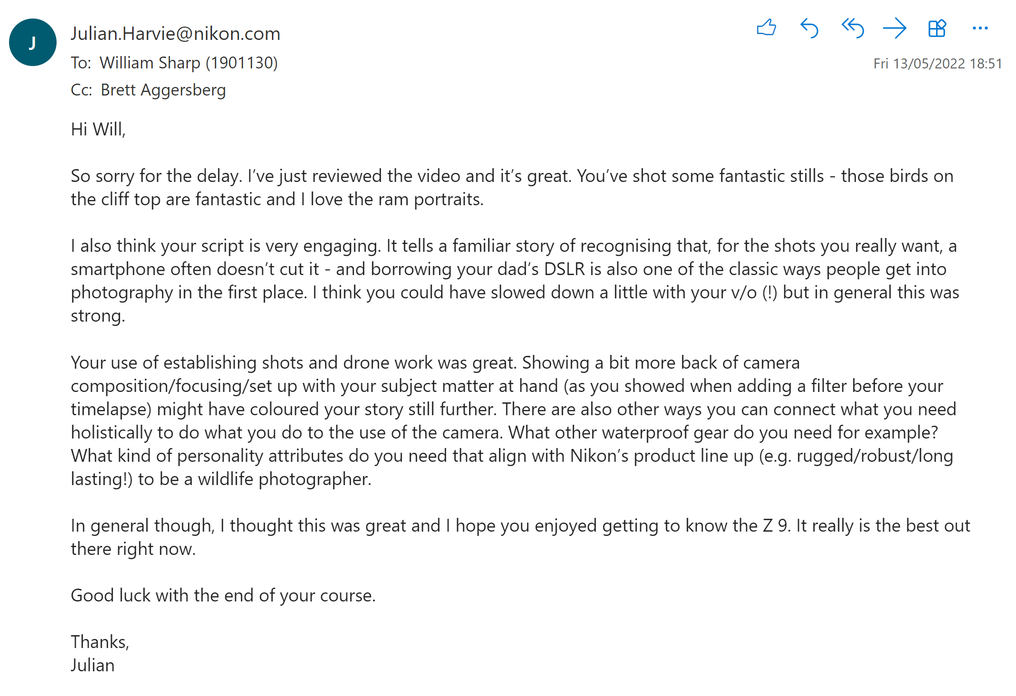

After receiving my feedback from Nikon, I was disappointed. The overall review on the video was positive but the constructive breakdown of what I had made was incredibly minimal. I felt that although some feedback had been shared it didn’t give me much on how to do better or what specifically could have been fixed. From the feedback the points I identified to be useful were:
-Script is very engaging. Could have slowed down a little with your v/o (!) but in general this was strong.
-Use of establishing shots and drone work was great.
-Show a bit more back of camera composition/focusing/set up with your subject matter at hand (as you showed when adding a filter before your timelapse)
Firstly, although I found the script to cover the necessary topics and follow an interesting arch, I don’t think it was necessarily engaging. The pointers on the V/O being too fast is something I expected and is an element I should have fixed before sending it off. I’m glad that Nikon liked the establishing shots & drone work as I also thought they added an angle on the video that gave it more depth and meant the locations that were used had more focus and became more developed characteristics of the video. Lastly the advice on showing the use of the camera more and it’s functions and settings is helpful, the video would have definitely done well to focus on the way the camera is used, through these visuals more of the subjects Nikon had mentioned in the brief could have been highlighted, this would have been a smart way to do it.
My biggest issue with this feedback was that I didn’t get any context on how to improve or what to do next. As this was feedback from Nikon, I expected better advice on how it should have been done but ended up receiving an underwhelming amount of actual feedback.
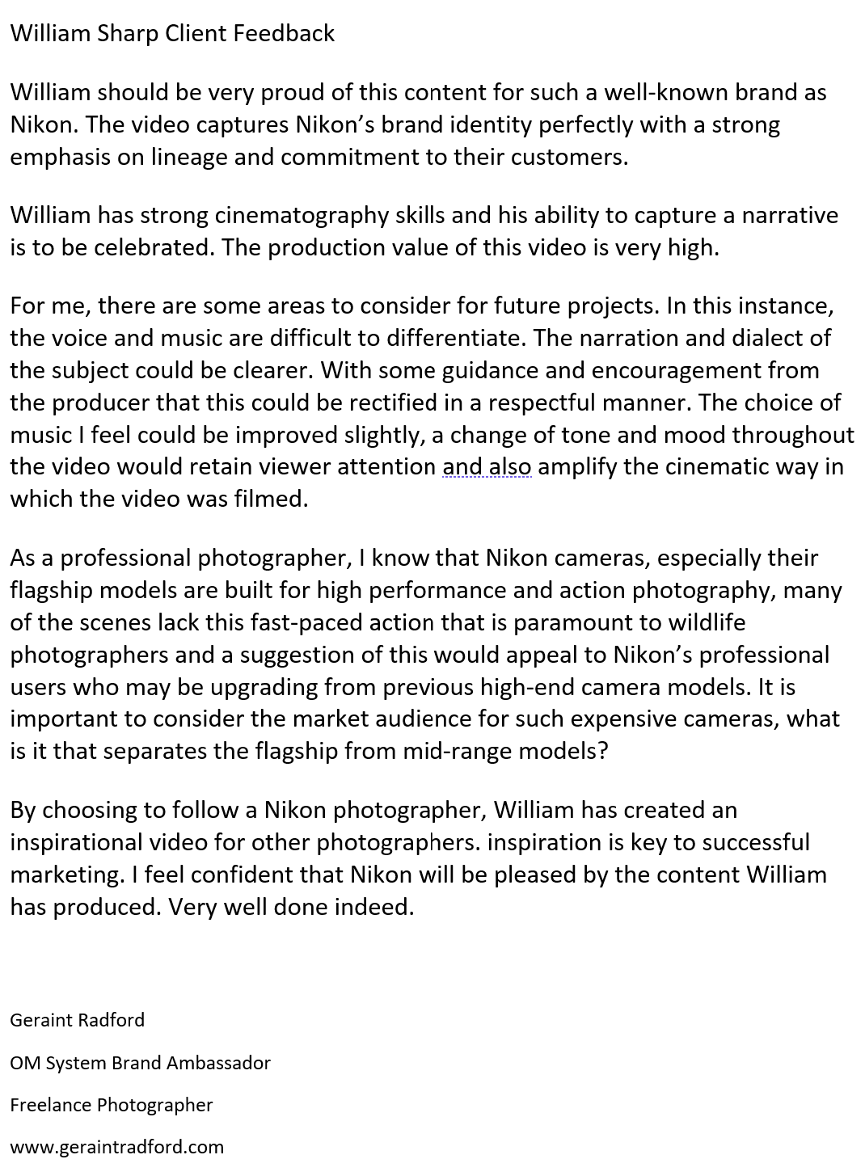
Feedback from Industry professional – Geraint Radford
As well as receiving feedback directly from Nikon I got the advice of OM System Brand Ambassador – Geraint Radford. The feedback from Geraint was a better critical analysis of the video and provided better explanations and pointers on how to improve. Getting more opinions on my work is useful as there is always things to improve and identifying them and talking about their effects is really important in building professionality & experience. From his advice, here are the main points he raised:
- The video captures Nikon’s brand identity perfectly with a strong emphasis on lineage and commitment to their customers.
- The voice and music are difficult to differentiate. The narration and dialect of the subject could be clearer. With some guidance and encouragement from the producer that this could be rectified in a respectful manner.
-The choice of music I feel could be improved slightly, a change of tone and mood throughout the video would retain viewer attention and also amplify the cinematic way in which the video was filmed.
- Built for high performance and action photography, many of the scenes lack this fast-paced action that is paramount to wildlife photographers
- What is it that separates the flagship from mid-range models?
Geraint also highlighted the choice of music and the sound levels of the audio mixing, a point of being able to fix this is true as if I had planned the narrative and music earlier, I as the producer would have been able to give better direction and music choice. Another point raised was the need for fast paced action that matched the characteristics of the high-performance camera and the action that is linked with wildlife photography. I think that had I better storyboarded and planned my sequences this could have been easily identified early on and during the filming the correct shots could have & should have been compiled. I could have also situated the class of the Z9 by highlighting how it’s better than mid-range cameras, this would have created a more prestigious and professional feel to the camera and its opportunities.
I think most of the experience I gained was to better develop a plan and preproduction stage as coming to the shooting stage I was still unsure on my overall narrative and shot list. This is something I want to make sure to rectify if I did this again as it would benefit the end product massively but also make the process easier and more enjoyable to complete. A lesson I learnt from this was that client interactions can be frustrating and hard to work with sometimes but overcoming this takes a level of professionality and patience. I also think that if I had been more decisive at the start and identified that I needed to come up with the ideas for it to move forward then the postproduction process would have been far more efficient.

